#_ 20200907_143149[eap-2.id-1].[AUDJPY-5].dir
DESKTOP
 | card ==> out
NOTE
 |  | card ==> insert
Gen : statemet file
to : C:\Users\user\AppData\Roaming\MetaQuotes\Terminal\5D28BD404C024725A623256D5EEF0486\MQL4\Files\Report_Trades
Copy statement file ==> to card
E:\fx
Copy : log files
E:\fx
C:\Users\user\AppData\Roaming\MetaQuotes\Terminal\5D28BD404C024725A623256D5EEF0486\MQL4\Files\Logs
 |  | Sdcard ==> take out from : note-pc
DESKTOP
 |  | Sdcard ==> into : desktop
 |  | copied files ==> copy from card to desktop
log files :
from : E:\fx\20200XXX[eap-2.id-1].[XXX-XX].dir
20200828_083759[eap-2.id-1].[AUDJPY-5].dir
20200827_050324[eap-2.id-1].[AUDJPY-5].dir
20200826_114239[eap-2.id-1].[AUDJPY-5].dir
 |  | to : C:\Users\iwabuchiken\AppData\Roaming\MetaQuotes\Terminal\34B08C83A5AAE27A4079DE708E60511E\MQL4\Files\Logs
statement file
from : E:\fx\DetailedStatement.(2020XXXX_XXXX).*
DetailedStatement.[a-j,M5].[id=20117143].[20200826_143940].htm
to : C:\Users\iwabuchiken\AppData\Roaming\MetaQuotes\Terminal\34B08C83A5AAE27A4079DE708E60511E\MQL4\Files\Report_Trades
 |  | build url
 |  | http://localhost/Eclipse_Luna/Cake_IFM11/fx_utilities/util_3__Gen_Trading_Result_List?param_Dpath_File_Tickets_Data=C:\Users\iwabuchiken\AppData\Roaming\MetaQuotes\Terminal\34B08C83A5AAE27A4079DE708E60511E\MQL4\Files\Logs\20200907_143149[eap-2.id-1].[AUDJPY-5].dir&param_Fname_File_Tickets_Data=[ea-6_tester-1].(20200907_143149).(tickets-data).log&param_Fname_File_Statement=DetailedStatement.[a-j,M5,sell].[id=20117981].[20200913_112022].htm&param_Dpath_File_Statement=C:\Users\iwabuchiken\AppData\Roaming\MetaQuotes\Terminal\34B08C83A5AAE27A4079DE708E60511E\MQL4\Files\Logs\20200907_143149[eap-2.id-1].[AUDJPY-5].dir
 |  | ==> access
 |  | template (url)
 |  | http://localhost/Eclipse_Luna/Cake_IFM11/fx_utilities/util_3__Gen_Trading_Result_List?param_Dpath_File_Tickets_Data=C:\Users\iwabuchiken\AppData\Roaming\MetaQuotes\Terminal\34B08C83A5AAE27A4079DE708E60511E\MQL4\Files\Logs\<XXX.dir>&param_Fname_File_Tickets_Data=<XXX.(tickets-data).log>&param_Fname_File_Statement=<DetailedStatement.XXX.htm>&param_Dpath_File_Statement=C:\Users\iwabuchiken\AppData\Roaming\MetaQuotes\Terminal\34B08C83A5AAE27A4079DE708E60511E\MQL4\Files\Logs\<XXX.dir>
 |  | file ==> gen-ed
 |  | dir | "C:\Users\iwabuchiken\AppData\Roaming\MetaQuotes\Terminal\34B08C83A5AAE27A4079DE708E60511E\MQL4\Files\Logs\20200907_143149[eap-2.id-1].[AUDJPY-5].dir\[ea-4_tester-1].(20200507_140530).(combined-data).(20200913_112658_919595).dat"
 |  |  | "C:\WORKS_2\WS\WS_Others.JVEMV6\JVEMV6\44_currency\10_prog-php\2_tester\log_JVE_44_6_2.[session-13~].ods"

- sheet ==> gen
 | file | open ==> odt file
 | file | C:\WORKS_2\WS\WS_Others.JVEMV6\JVEMV6\44_currency\10_prog-php\2_tester\log_JVE_44_6_2.[session-XXX~].ods
 | file | "C:\WORKS_2\WS\WS_Others.JVEMV6\JVEMV6\44_currency\10_prog-php\2_tester\log_JVE_44_6_2.[session-13~].ods"
 | file | DUP sheet ==> “7”  M – e > s > s > a > M – c > Ret
 | file | rename ===> “8”  M – o > s > r
 | file | move to ==> any suitable location
 | sheet | delete ==> data area
 | sheet | C/P ==> data from gen-ed file

- TASK-1.3 : sheet ==> edit
  - edit
sort : “profit” ~~> “BB-loc.-1” (DF → CU)
M – d > s
hide : cols ==> CV ~ DE
addressing ==> total, gain, loss
- DH4
- DH5
- DG6 ==> DH5 + 1
addressing ==> BB.loc
- “current”, “prev” ==> C/P
- “数式” ==> M – t > q > M – f > Ret
- replace
  - DH11 (prev,total,end) → DH8
  - DH12 (prev, loss,end) → DH9
  - DG13 (prev,loss,start) → DG10
- “数式” ==> M – t > q > M – f > Ret
  - result
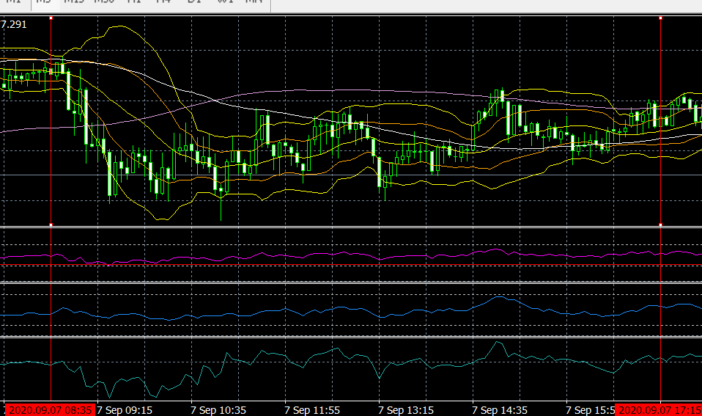

  - OBS
1 | BB.4,5 ==> gain/total is, bzw, 18%, 7%
2 | g-t-ratio is → BB.4 > BB.5 ==> yet, dif is BB.4 > BB.5
3 | 2020.09.07 09:20:00 ==> BB.5 start, plus
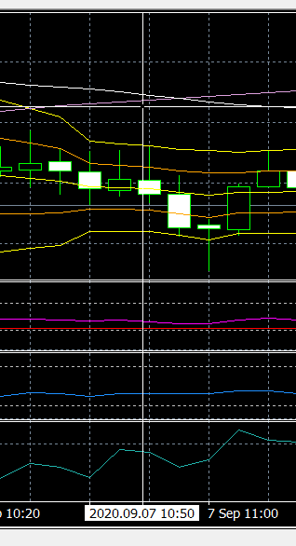
2020.09.07 10:50:00 ==> ends in minus → how ?
==> this order → ends in plus

BB.5 start, ends in minus → any sample?
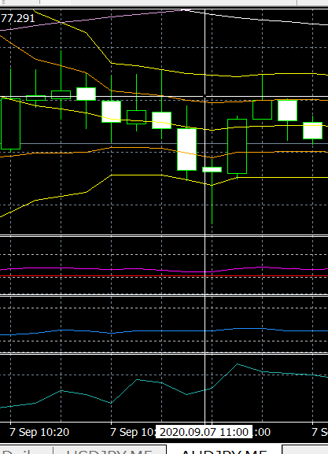
==> 2020.09.07 11:00:00
- BB.1 ==> “hammer-up”
- BB.2 ==> “faily-long-down”
  - THOUGHTS

6.2.4_15---------------------------------------------------------------------------
[16] res free# JVEMV6 44#6.2_X / 44. currency / 6. obs / 2. demo result data / 20200914_112743

#_ 20200907_143149[eap-2.id-1].[AUDJPY-5].dir
DESKTOP
 | card ==> out
NOTE
 |  | card ==> insert
Gen : statemet file
to : C:\Users\user\AppData\Roaming\MetaQuotes\Terminal\5D28BD404C024725A623256D5EEF0486\MQL4\Files\Report_Trades
Copy statement file ==> to card
E:\fx
Copy : log files
E:\fx
C:\Users\user\AppData\Roaming\MetaQuotes\Terminal\5D28BD404C024725A623256D5EEF0486\MQL4\Files\Logs
 |  | Sdcard ==> take out from : note-pc
DESKTOP
 |  | Sdcard ==> into : desktop
 |  | copied files ==> copy from card to desktop
log files :
from : E:\fx\20200XXX[eap-2.id-1].[XXX-XX].dir
20200828_083759[eap-2.id-1].[AUDJPY-5].dir
20200827_050324[eap-2.id-1].[AUDJPY-5].dir
20200826_114239[eap-2.id-1].[AUDJPY-5].dir
 |  | to : C:\Users\iwabuchiken\AppData\Roaming\MetaQuotes\Terminal\34B08C83A5AAE27A4079DE708E60511E\MQL4\Files\Logs
statement file
from : E:\fx\DetailedStatement.(2020XXXX_XXXX).*
DetailedStatement.[a-j,M5].[id=20117143].[20200826_143940].htm
to : C:\Users\iwabuchiken\AppData\Roaming\MetaQuotes\Terminal\34B08C83A5AAE27A4079DE708E60511E\MQL4\Files\Report_Trades
 |  | build url
 |  | http://localhost/Eclipse_Luna/Cake_IFM11/fx_utilities/util_3__Gen_Trading_Result_List?param_Dpath_File_Tickets_Data=C:\Users\iwabuchiken\AppData\Roaming\MetaQuotes\Terminal\34B08C83A5AAE27A4079DE708E60511E\MQL4\Files\Logs\20200908_094814[eap-2.id-1].[AUDJPY-5].dir&param_Fname_File_Tickets_Data=[ea-6_tester-1].(20200908_094814).(tickets-data).log&param_Fname_File_Statement=DetailedStatement.[a-j,M5,sell].[id=20117981].[20200913_112022].htm&param_Dpath_File_Statement=C:\Users\iwabuchiken\AppData\Roaming\MetaQuotes\Terminal\34B08C83A5AAE27A4079DE708E60511E\MQL4\Files\Logs\20200908_094814[eap-2.id-1].[AUDJPY-5].dir
 |  | ==> access
 |  | template (url)
 |  | http://localhost/Eclipse_Luna/Cake_IFM11/fx_utilities/util_3__Gen_Trading_Result_List?param_Dpath_File_Tickets_Data=C:\Users\iwabuchiken\AppData\Roaming\MetaQuotes\Terminal\34B08C83A5AAE27A4079DE708E60511E\MQL4\Files\Logs\<XXX.dir>&param_Fname_File_Tickets_Data=<XXX.(tickets-data).log>&param_Fname_File_Statement=<DetailedStatement.XXX.htm>&param_Dpath_File_Statement=C:\Users\iwabuchiken\AppData\Roaming\MetaQuotes\Terminal\34B08C83A5AAE27A4079DE708E60511E\MQL4\Files\Logs\<XXX.dir>
 |  | file ==> gen-ed
 |  | dir | "C:\Users\iwabuchiken\AppData\Roaming\MetaQuotes\Terminal\34B08C83A5AAE27A4079DE708E60511E\MQL4\Files\Logs\20200908_094814[eap-2.id-1].[AUDJPY-5].dir\[ea-4_tester-1].(20200507_140530).(combined-data).(20200914_113626_739095).dat"
 |  |  | "C:\WORKS_2\WS\WS_Others.JVEMV6\JVEMV6\44_currency\10_prog-php\2_tester\log_JVE_44_6_2.[session-13~].ods"

- sheet ==> gen
 | file | open ==> odt file
 | file | C:\WORKS_2\WS\WS_Others.JVEMV6\JVEMV6\44_currency\10_prog-php\2_tester\log_JVE_44_6_2.[session-XXX~].ods
 | file | "C:\WORKS_2\WS\WS_Others.JVEMV6\JVEMV6\44_currency\10_prog-php\2_tester\log_JVE_44_6_2.[session-13~].ods"
 | file | DUP sheet ==> “7”  M – e > s > s > a > M – c > Ret
 | file | rename ===> “8”  M – o > s > r
 | file | move to ==> any suitable location
 | sheet | delete ==> data area
 | sheet | C/P ==> data from gen-ed file

- TASK-1.3 : sheet ==> edit
  - edit
sort : “profit” ~~> “BB-loc.-1” (DF → CU)
M – d > s
hide : cols ==> CV ~ DE
addressing ==> total, gain, loss
- DH4
- DH5
- DG6 ==> DH5 + 1
addressing ==> BB.loc
- “current”, “prev” ==> C/P
- “数式” ==> M – t > q > M – f > Ret
- replace
  - DH11 (prev,total,end) → DH8
  - DH12 (prev, loss,end) → DH9
  - DG13 (prev,loss,start) → DG10
- “数式” ==> M – t > q > M – f > Ret
  - result
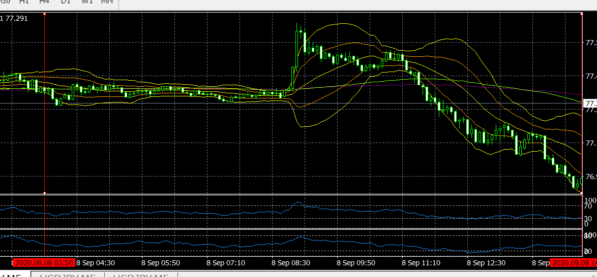
  - OBS
1 | BB.5 → 36 % and -6,000 ==> whereas, BB.4 ==> 29 %, and +2,000
2
3
  - THOUGHTS

#_ 20200909_091350[eap-2.id-1].[AUDJPY-5].dir
DESKTOP
 | card ==> out
NOTE
 |  | card ==> insert
Gen : statemet file
to : C:\Users\user\AppData\Roaming\MetaQuotes\Terminal\5D28BD404C024725A623256D5EEF0486\MQL4\Files\Report_Trades
Copy statement file ==> to card
E:\fx
Copy : log files
E:\fx
C:\Users\user\AppData\Roaming\MetaQuotes\Terminal\5D28BD404C024725A623256D5EEF0486\MQL4\Files\Logs
 |  | Sdcard ==> take out from : note-pc
DESKTOP
 |  | Sdcard ==> into : desktop
 |  | copied files ==> copy from card to desktop
log files :
from : E:\fx\20200XXX[eap-2.id-1].[XXX-XX].dir
20200828_083759[eap-2.id-1].[AUDJPY-5].dir
20200827_050324[eap-2.id-1].[AUDJPY-5].dir
20200826_114239[eap-2.id-1].[AUDJPY-5].dir
 |  | to : C:\Users\iwabuchiken\AppData\Roaming\MetaQuotes\Terminal\34B08C83A5AAE27A4079DE708E60511E\MQL4\Files\Logs
statement file
from : E:\fx\DetailedStatement.(2020XXXX_XXXX).*
DetailedStatement.[a-j,M5].[id=20117143].[20200826_143940].htm
to : C:\Users\iwabuchiken\AppData\Roaming\MetaQuotes\Terminal\34B08C83A5AAE27A4079DE708E60511E\MQL4\Files\Report_Trades
 |  | build url
 |  | http://localhost/Eclipse_Luna/Cake_IFM11/fx_utilities/util_3__Gen_Trading_Result_List?param_Dpath_File_Tickets_Data=C:\Users\iwabuchiken\AppData\Roaming\MetaQuotes\Terminal\34B08C83A5AAE27A4079DE708E60511E\MQL4\Files\Logs\20200909_091350[eap-2.id-1].[AUDJPY-5].dir&param_Fname_File_Tickets_Data=[ea-6_tester-1].(20200909_091350).(tickets-data).log&param_Fname_File_Statement=DetailedStatement.[a-j,M5,sell].[id=20117981].[20200913_112022].htm&param_Dpath_File_Statement=C:\Users\iwabuchiken\AppData\Roaming\MetaQuotes\Terminal\34B08C83A5AAE27A4079DE708E60511E\MQL4\Files\Logs\20200909_091350[eap-2.id-1].[AUDJPY-5].dir
 |  | ==> access
 |  | template (url)
 |  | http://localhost/Eclipse_Luna/Cake_IFM11/fx_utilities/util_3__Gen_Trading_Result_List?param_Dpath_File_Tickets_Data=C:\Users\iwabuchiken\AppData\Roaming\MetaQuotes\Terminal\34B08C83A5AAE27A4079DE708E60511E\MQL4\Files\Logs\<XXX.dir>&param_Fname_File_Tickets_Data=<XXX.(tickets-data).log>&param_Fname_File_Statement=<DetailedStatement.XXX.htm>&param_Dpath_File_Statement=C:\Users\iwabuchiken\AppData\Roaming\MetaQuotes\Terminal\34B08C83A5AAE27A4079DE708E60511E\MQL4\Files\Logs\<XXX.dir>
 |  | file ==> gen-ed
 |  | dir | "C:\Users\iwabuchiken\AppData\Roaming\MetaQuotes\Terminal\34B08C83A5AAE27A4079DE708E60511E\MQL4\Files\Logs\20200909_091350[eap-2.id-1].[AUDJPY-5].dir\[ea-4_tester-1].(20200507_140530).(combined-data).(20200914_115936_026272).dat"
 |  |  | "C:\WORKS_2\WS\WS_Others.JVEMV6\JVEMV6\44_currency\10_prog-php\2_tester\log_JVE_44_6_2.[session-13~].ods"

- sheet ==> gen
 | file | open ==> odt file
 | file | C:\WORKS_2\WS\WS_Others.JVEMV6\JVEMV6\44_currency\10_prog-php\2_tester\log_JVE_44_6_2.[session-XXX~].ods
 | file | "C:\WORKS_2\WS\WS_Others.JVEMV6\JVEMV6\44_currency\10_prog-php\2_tester\log_JVE_44_6_2.[session-13~].ods"
 | file | DUP sheet ==> “7”  M – e > s > s > a > M – c > Ret
 | file | rename ===> “8”  M – o > s > r
 | file | move to ==> any suitable location
 | sheet | delete ==> data area
 | sheet | C/P ==> data from gen-ed file

- TASK-1.3 : sheet ==> edit
  - edit
sort : “profit” ~~> “BB-loc.-1” (DF → CU)
M – d > s
hide : cols ==> CV ~ DE
addressing ==> total, gain, loss
- DH4
- DH5
- DG6 ==> DH5 + 1
addressing ==> BB.loc
- “current”, “prev” ==> C/P
- “数式” ==> M – t > q > M – f > Ret
- replace
  - DH11 (prev,total,end) → DH8
  - DH12 (prev, loss,end) → DH9
  - DG13 (prev,loss,start) → DG10
- “数式” ==> M – t > q > M – f > Ret
  - result
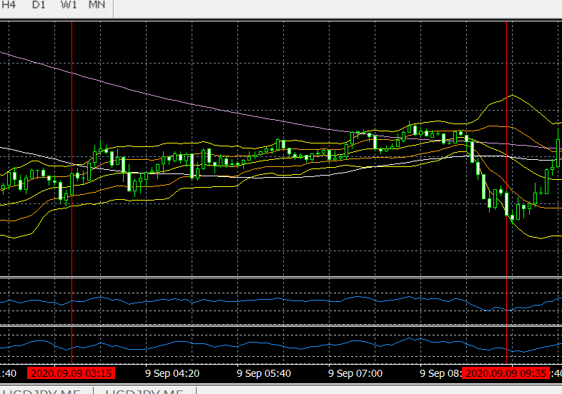

  - OBS
1 | BB.2 → 47 %, yet close to +4.000
2 | overall, いくつかの mountain-up が続いている => BB.2 +4,000 と関連あり、か
3
  - THOUGHTS

6.2.4_16---------------------------------------------------------------------------
[17] res free# JVEMV6 44#6.2_X / 44. currency / 6. obs / 2. demo result data / 20200915_163237

#_ 20200910_093925[eap-2.id-1].[USDJPY-5].dir
DESKTOP
 | card ==> out
NOTE
 |  | card ==> insert
Gen : statemet file
to : C:\Users\user\AppData\Roaming\MetaQuotes\Terminal\5D28BD404C024725A623256D5EEF0486\MQL4\Files\Report_Trades
Copy statement file ==> to card
E:\fx
Copy : log files
E:\fx
C:\Users\user\AppData\Roaming\MetaQuotes\Terminal\5D28BD404C024725A623256D5EEF0486\MQL4\Files\Logs
 |  | Sdcard ==> take out from : note-pc
DESKTOP
 |  | Sdcard ==> into : desktop
 |  | copied files ==> copy from card to desktop
log files :
from : E:\fx\20200XXX[eap-2.id-1].[XXX-XX].dir
20200910_093925[eap-2.id-1].[USDJPY-5].dir
 |  | to : C:\Users\iwabuchiken\AppData\Roaming\MetaQuotes\Terminal\34B08C83A5AAE27A4079DE708E60511E\MQL4\Files\Logs
statement file
from : E:\fx\DetailedStatement.(2020XXXX_XXXX).*
DetailedStatement.[a-j,M5].[id=20117143].[20200826_143940].htm
to : C:\Users\iwabuchiken\AppData\Roaming\MetaQuotes\Terminal\34B08C83A5AAE27A4079DE708E60511E\MQL4\Files\Report_Trades
 |  | build url #20200916_133148
 |  | http://localhost/Eclipse_Luna/Cake_IFM11/fx_utilities/util_3__Gen_Trading_Result_List?param_Dpath_File_Tickets_Data=C:\Users\iwabuchiken\AppData\Roaming\MetaQuotes\Terminal\34B08C83A5AAE27A4079DE708E60511E\MQL4\Files\Logs\20200910_093925[eap-2.id-1].[USDJPY-5].dir&param_Fname_File_Tickets_Data=[ea-6_tester-1].(20200910_093925).(tickets-data).log&param_Fname_File_Statement=DetailedStatement.[u-j,M5,sell].[id=20117981].[20200913_112022].htm&param_Dpath_File_Statement=C:\Users\iwabuchiken\AppData\Roaming\MetaQuotes\Terminal\34B08C83A5AAE27A4079DE708E60511E\MQL4\Files\Logs\20200910_093925[eap-2.id-1].[USDJPY-5].dir
 |  | ==> access
 |  | template (url)
 |  | http://localhost/Eclipse_Luna/Cake_IFM11/fx_utilities/util_3__Gen_Trading_Result_List?param_Dpath_File_Tickets_Data=C:\Users\iwabuchiken\AppData\Roaming\MetaQuotes\Terminal\34B08C83A5AAE27A4079DE708E60511E\MQL4\Files\Logs\<XXX.dir>&param_Fname_File_Tickets_Data=<XXX.(tickets-data).log>&param_Fname_File_Statement=<DetailedStatement.XXX.htm>&param_Dpath_File_Statement=C:\Users\iwabuchiken\AppData\Roaming\MetaQuotes\Terminal\34B08C83A5AAE27A4079DE708E60511E\MQL4\Files\Logs\<XXX.dir>
 |  | file ==> gen-ed
 |  | dir | "C:\Users\iwabuchiken\AppData\Roaming\MetaQuotes\Terminal\34B08C83A5AAE27A4079DE708E60511E\MQL4\Files\Logs\20200910_093925[eap-2.id-1].[USDJPY-5].dir\[ea-4_tester-1].(20200507_140530).(combined-data).(20200915_164741_549583).dat"
 |  |  | "C:\WORKS_2\WS\WS_Others.JVEMV6\JVEMV6\44_currency\10_prog-php\2_tester\log_JVE_44_6_2.[session-13~].ods"

- sheet ==> gen
 | file | open ==> odt file
 | file | C:\WORKS_2\WS\WS_Others.JVEMV6\JVEMV6\44_currency\10_prog-php\2_tester\log_JVE_44_6_2.[session-XXX~].ods
 | file | "C:\WORKS_2\WS\WS_Others.JVEMV6\JVEMV6\44_currency\10_prog-php\2_tester\log_JVE_44_6_2.[session-13~].ods"
 | file | DUP sheet ==> “7”  M – e > s > s > a > M – c > Ret
 | file | rename ===> “8”  M – o > s > r
 | file | move to ==> any suitable location
 | sheet | delete ==> data area
 | sheet | C/P ==> data from gen-ed file

- TASK-1.3 : sheet ==> edit
  - edit
sort : “profit” ~~> “BB-loc.-1” (DF → CU)
M – d > s
hide : cols ==> CV ~ DE
addressing ==> total, gain, loss
- DH4
- DH5
- DG6 ==> DH5 + 1
addressing ==> BB.loc
- “current”, “prev” ==> C/P
- “数式” ==> M – t > q > M – f > Ret
- replace
  - DH11 (prev,total,end) → DH8
  - DH12 (prev, loss,end) → DH9
  - DG13 (prev,loss,start) → DG10
- “数式” ==> M – t > q > M – f > Ret
  - result

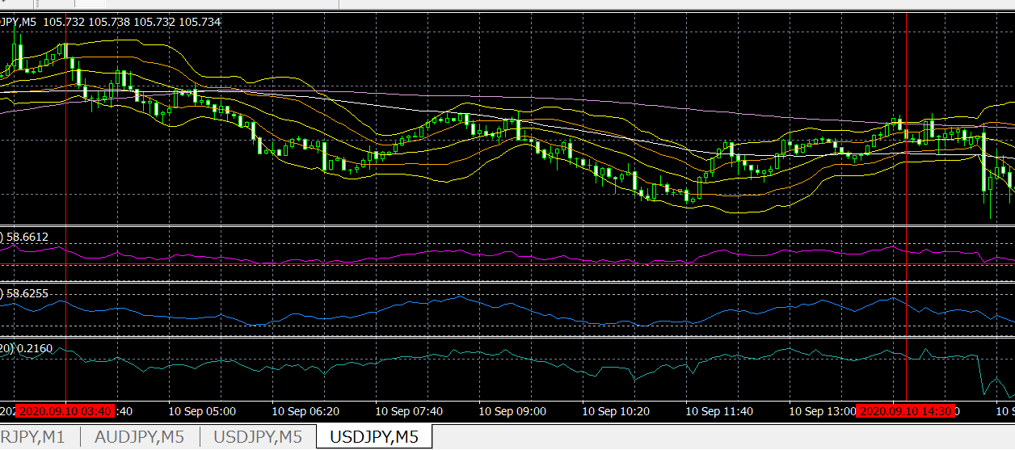
  - OBS
1 | BB.1 start ==> 7 bars / 1 bar → in minus
2 | BB.1 : 1 bar → in minus ==> what like ?  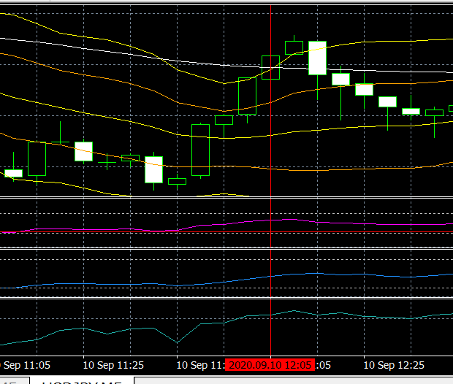  - 2020.09.10 12:05:01 / -560 / 2020.09.10 14:17:18  - loc.-1 ~ loc.5 : 5 5 3 3 1  - width : 0.004 -0.018 0.004 0.035 0.006 0.025  - 推移  - prev bottom ==> 11:45 (by : (1) この足から、過去３５本、この足の close を下回る足、なし (2) prev 35th bar, close → -12.7 pips (3) prev 35th ==> current と、この足までの間に、35th を上回るclose or open → なし  - この bottom と、opening time → ４本  - 描写  - ボトムの後の、初めの山。ピークの１つ手前で、open。  - ２つの山、続く。２つ目（通して、３つ目）の山、ピークの１つ手前。SL にかかる。  - 分析  - 直近４本、上げ。BB.5 から、BB.1 へ。open 後、BB.3 で下がり止まる。  - 続いて、上げの２個の波。２コ目で、SL。
3 | BB.1 : 1 bar → in plus ==> what like ?  - 2020.09.10 14:25:01 / 1,060  - loc.-1 ~ loc.6 => 4 3 2 2 1 1  - width => 0.002 0.015 0.018 -0.001 0.018 0.01
  - THOUGHTS
1

#_ 20200911_181722[eap-2.id-1].[USDJPY-5].dir
DESKTOP
 | card ==> out
NOTE
 |  | card ==> insert
Gen : statemet file
to : C:\Users\user\AppData\Roaming\MetaQuotes\Terminal\5D28BD404C024725A623256D5EEF0486\MQL4\Files\Report_Trades
Copy statement file ==> to card
E:\fx
Copy : log files
E:\fx
C:\Users\user\AppData\Roaming\MetaQuotes\Terminal\5D28BD404C024725A623256D5EEF0486\MQL4\Files\Logs
 |  | Sdcard ==> take out from : note-pc
DESKTOP
 |  | Sdcard ==> into : desktop
 |  | copied files ==> copy from card to desktop
log files :
from : E:\fx\20200XXX[eap-2.id-1].[XXX-XX].dir
20200911_181722[eap-2.id-1].[USDJPY-5].dir
 |  | to : C:\Users\iwabuchiken\AppData\Roaming\MetaQuotes\Terminal\34B08C83A5AAE27A4079DE708E60511E\MQL4\Files\Logs
statement file
from : E:\fx\DetailedStatement.(2020XXXX_XXXX).*
DetailedStatement.[a-j,M5].[id=20117143].[20200826_143940].htm
to : C:\Users\iwabuchiken\AppData\Roaming\MetaQuotes\Terminal\34B08C83A5AAE27A4079DE708E60511E\MQL4\Files\Report_Trades
 |  | build url
 |  | http://localhost/Eclipse_Luna/Cake_IFM11/fx_utilities/util_3__Gen_Trading_Result_List?param_Dpath_File_Tickets_Data=C:\Users\iwabuchiken\AppData\Roaming\MetaQuotes\Terminal\34B08C83A5AAE27A4079DE708E60511E\MQL4\Files\Logs\20200911_181722[eap-2.id-1].[USDJPY-5].dir&param_Fname_File_Tickets_Data=DetailedStatement.[u-j,M5,sell].[id=20117981].[20200913_112022].htm&param_Fname_File_Statement=[ea-6_tester-1].(20200911_181722).(tickets-data).log&param_Dpath_File_Statement=C:\Users\iwabuchiken\AppData\Roaming\MetaQuotes\Terminal\34B08C83A5AAE27A4079DE708E60511E\MQL4\Files\Logs\20200911_181722[eap-2.id-1].[USDJPY-5].dir
 |  | http://localhost/Eclipse_Luna/Cake_IFM11/fx_utilities/util_3__Gen_Trading_Result_List?param_Dpath_File_Tickets_Data=C:\Users\iwabuchiken\AppData\Roaming\MetaQuotes\Terminal\34B08C83A5AAE27A4079DE708E60511E\MQL4\Files\Logs\20200911_181722[eap-2.id-1].[USDJPY-5].dir&param_Fname_File_Tickets_Data=[ea-6_tester-1].(20200911_181722).(tickets-data).log&param_Fname_File_Statement=DetailedStatement.[u-j,M5,sell].[id=20117981].[20200913_112022].htm&param_Dpath_File_Statement=C:\Users\iwabuchiken\AppData\Roaming\MetaQuotes\Terminal\34B08C83A5AAE27A4079DE708E60511E\MQL4\Files\Logs\20200911_181722[eap-2.id-1].[USDJPY-5].dir
 |  | ==> access
 |  | template (url)
 |  | http://localhost/Eclipse_Luna/Cake_IFM11/fx_utilities/util_3__Gen_Trading_Result_List?param_Dpath_File_Tickets_Data=C:\Users\iwabuchiken\AppData\Roaming\MetaQuotes\Terminal\34B08C83A5AAE27A4079DE708E60511E\MQL4\Files\Logs\<XXX.dir>&param_Fname_File_Tickets_Data=<XXX.(tickets-data).log>&param_Fname_File_Statement=<DetailedStatement.XXX.htm>&param_Dpath_File_Statement=C:\Users\iwabuchiken\AppData\Roaming\MetaQuotes\Terminal\34B08C83A5AAE27A4079DE708E60511E\MQL4\Files\Logs\<XXX.dir>
 |  | file ==> gen-ed
 |  | dir | "C:\Users\iwabuchiken\AppData\Roaming\MetaQuotes\Terminal\34B08C83A5AAE27A4079DE708E60511E\MQL4\Files\Logs\20200911_181722[eap-2.id-1].[USDJPY-5].dir\[ea-4_tester-1].(20200507_140530).(combined-data).(20200916_134700_862341).dat"
 |  |  | "C:\WORKS_2\WS\WS_Others.JVEMV6\JVEMV6\44_currency\10_prog-php\2_tester\log_JVE_44_6_2.[session-13~].ods"

- sheet ==> gen
 | file | open ==> odt file
 | file | C:\WORKS_2\WS\WS_Others.JVEMV6\JVEMV6\44_currency\10_prog-php\2_tester\log_JVE_44_6_2.[session-XXX~].ods
 | file | "C:\WORKS_2\WS\WS_Others.JVEMV6\JVEMV6\44_currency\10_prog-php\2_tester\log_JVE_44_6_2.[session-13~].ods"
 | file | DUP sheet ==> “7”  M – e > s > s > a > M – c > Ret
 | file | rename ===> “8”  M – o > s > r
 | file | move to ==> any suitable location
 | sheet | delete ==> data area
 | sheet | C/P ==> data from gen-ed file

- TASK-1.3 : sheet ==> edit
  - edit
sort : “profit” ~~> “BB-loc.-1” (DF → CU)
M – d > s
hide : cols ==> CV ~ DE
addressing ==> total, gain, loss
- DH4
- DH5
- DG6 ==> DH5 + 1
addressing ==> BB.loc
- “current”, “prev” ==> C/P
- “数式” ==> M – t > q > M – f > Ret
- replace
  - DH11 (prev,total,end) → DH8
  - DH12 (prev, loss,end) → DH9
  - DG13 (prev,loss,start) → DG10
- “数式” ==> M – t > q > M – f > Ret
  - result
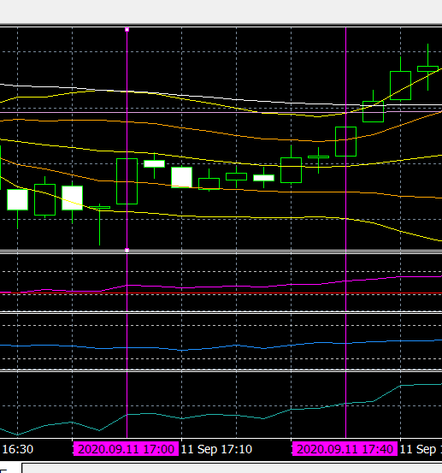
  - OBS
1 | progression of the period ==> trend-down, 4 waves / up 1 wave, two-top
2 | BB.4, BB.5 ==> each, 75 %, 73 % → almost same ==> yet, +1,500, -700
3 | BB.5, minus ==> what like ?  - 2020.09.11 17:00:01 / -580 / 2020.09.11 17:43:30  - loc.1-5 ==> 4 6 6 5 6 5  - width ==> -0.001 -0.027 -0.013 0.019 -0.015 0.001  - 描写  - 前３本 => BB.6 → 5 の上げ、BB.5 → 6 の下げ；BB.5 での、トンボ
BB.5, minus ==> what like ? (2nd example)
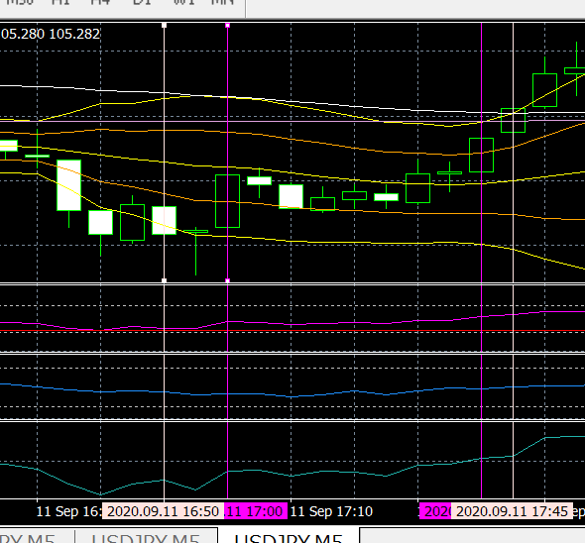
- 2020.09.11 16:50:02 / -550 / 2020.09.11 17:46:54
- loc : 6 ~ 1 ==> 3 4 4 6 6 5
- width ==> 0.01 -0.006 -0.001 -0.027 -0.013 0.019

- 分析
  - もし、この bar で入るとすると、その理由は、
    - prev-4~2 と、下げ；prev-1 で、上げ => この上げは、下がり途中の、push、と見る；そこで、sell で、入る。

  - THOUGHTS
1 | dp-idea : （１）BB.4 から BB.6 へ、連続、下げ。（２）BB.5 へ、上げ、１本 => BUY
2

#_ 20200914_095555[eap-2.id-1].[USDJPY-5].dir
DESKTOP
 | card ==> out
NOTE
 |  | card ==> insert
Gen : statemet file
to : C:\Users\user\AppData\Roaming\MetaQuotes\Terminal\5D28BD404C024725A623256D5EEF0486\MQL4\Files\Report_Trades
Copy statement file ==> to card
E:\fx
Copy : log files
E:\fx
C:\Users\user\AppData\Roaming\MetaQuotes\Terminal\5D28BD404C024725A623256D5EEF0486\MQL4\Files\Logs
 |  | Sdcard ==> take out from : note-pc
DESKTOP
 |  | Sdcard ==> into : desktop
 |  | copied files ==> copy from card to desktop
log files :
from : E:\fx\20200XXX[eap-2.id-1].[XXX-XX].dir
20200914_095555[eap-2.id-1].[USDJPY-5].dir
 |  | to : C:\Users\iwabuchiken\AppData\Roaming\MetaQuotes\Terminal\34B08C83A5AAE27A4079DE708E60511E\MQL4\Files\Logs
statement file
from : E:\fx\DetailedStatement.(2020XXXX_XXXX).*
DetailedStatement.[a-j,M5].[id=20117143].[20200826_143940].htm
to : C:\Users\iwabuchiken\AppData\Roaming\MetaQuotes\Terminal\34B08C83A5AAE27A4079DE708E60511E\MQL4\Files\Report_Trades
 |  | build url
 |  | http://localhost/Eclipse_Luna/Cake_IFM11/fx_utilities/util_3__Gen_Trading_Result_List?param_Dpath_File_Tickets_Data=C:\Users\iwabuchiken\AppData\Roaming\MetaQuotes\Terminal\34B08C83A5AAE27A4079DE708E60511E\MQL4\Files\Logs\20200914_095555[eap-2.id-1].[USDJPY-5].dir&param_Fname_File_Tickets_Data=[ea-6_tester-1].(20200914_095555).(tickets-data).log&param_Fname_File_Statement=DetailedStatement.[M5].[id=20117981].[20200917_105004].htm&param_Dpath_File_Statement=C:\Users\iwabuchiken\AppData\Roaming\MetaQuotes\Terminal\34B08C83A5AAE27A4079DE708E60511E\MQL4\Files\Logs\20200914_095555[eap-2.id-1].[USDJPY-5].dir
 |  | ==> access
 |  | template (url)
 |  | http://localhost/Eclipse_Luna/Cake_IFM11/fx_utilities/util_3__Gen_Trading_Result_List?param_Dpath_File_Tickets_Data=C:\Users\iwabuchiken\AppData\Roaming\MetaQuotes\Terminal\34B08C83A5AAE27A4079DE708E60511E\MQL4\Files\Logs\<XXX.dir>&param_Fname_File_Tickets_Data=<XXX.(tickets-data).log>&param_Fname_File_Statement=<DetailedStatement.XXX.htm>&param_Dpath_File_Statement=C:\Users\iwabuchiken\AppData\Roaming\MetaQuotes\Terminal\34B08C83A5AAE27A4079DE708E60511E\MQL4\Files\Logs\<XXX.dir>
 |  | file ==> gen-ed
 |  | dir | "C:\Users\iwabuchiken\AppData\Roaming\MetaQuotes\Terminal\34B08C83A5AAE27A4079DE708E60511E\MQL4\Files\Logs\20200914_095555[eap-2.id-1].[USDJPY-5].dir\[ea-4_tester-1].(20200507_140530).(combined-data).(20200917_105223_589102).dat"
 |  |  | "C:\WORKS_2\WS\WS_Others.JVEMV6\JVEMV6\44_currency\10_prog-php\2_tester\log_JVE_44_6_2.[session-13~].ods"

- sheet ==> gen
 | file | open ==> odt file
 | file | C:\WORKS_2\WS\WS_Others.JVEMV6\JVEMV6\44_currency\10_prog-php\2_tester\log_JVE_44_6_2.[session-XXX~].ods
 | file | "C:\WORKS_2\WS\WS_Others.JVEMV6\JVEMV6\44_currency\10_prog-php\2_tester\log_JVE_44_6_2.[session-13~].ods"
 | file | DUP sheet ==> “7”  M – e > s > s > a > M – c > Ret
 | file | rename ===> “8”  M – o > s > r
 | file | move to ==> any suitable location
 | sheet | delete ==> data area
 | sheet | C/P ==> data from gen-ed file

- TASK-1.3 : sheet ==> edit
  - edit
sort : “profit” ~~> “BB-loc.-1” (DF → CU)
M – d > s
hide : cols ==> CV ~ DE
addressing ==> total, gain, loss
- DH4
- DH5
- DG6 ==> DH5 + 1
addressing ==> BB.loc
- “current”, “prev” ==> C/P
- “数式” ==> M – t > q > M – f > Ret
- replace
  - DH11 (prev,total,end) → DH8
  - DH12 (prev, loss,end) → DH9
  - DG13 (prev,loss,start) → DG10
- “数式” ==> M – t > q > M – f > Ret
  - result
    - graph / table / chart
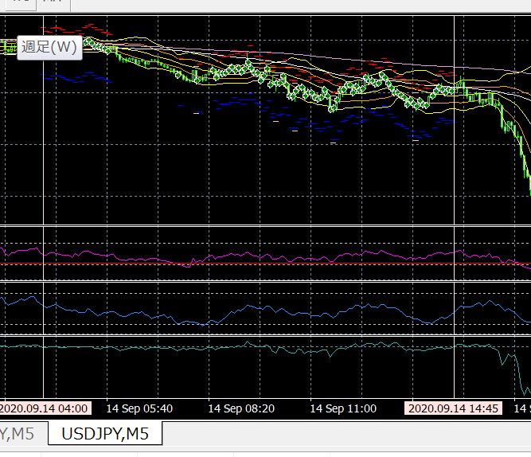
  - OBS
1 | search : prev 3 bars ==> all down (u/j,m5,sell : [ea-6_tester-1].(20200914_095555).(tickets-data).log)  - #_ setup ==> columns  - #_ sort ==> DK → DF  - result  - total = 12 / plus = 6 / minus = 6  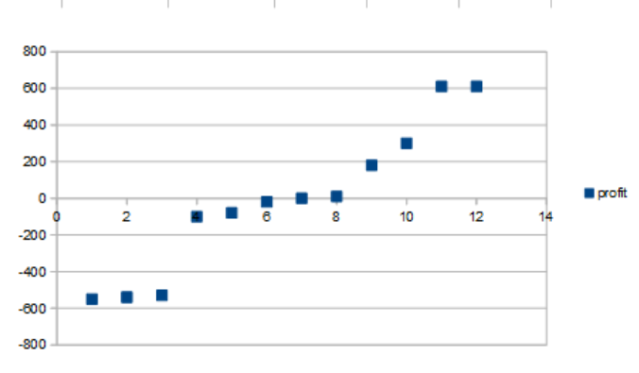  - observe : graph  - +600, -600 ==> same range  - plus-minus 600 and within |200| ==> two groups
2
3
  - THOUGHTS
1 | want-to-know  - above graph ==> plus/minus 600 bars → what like? (chart)  - 2020.09.14 13:30:02 / 2020.09.14 14:58:01 / -550  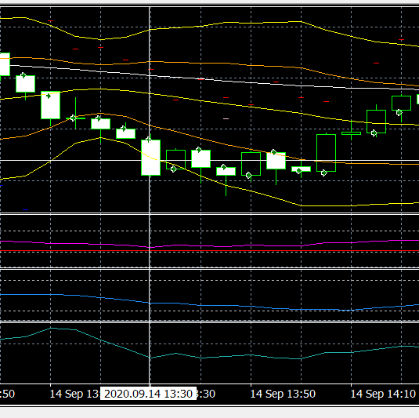  - 2020.09.14 04:35:03 / 2020.09.14 08:27:54 / 610  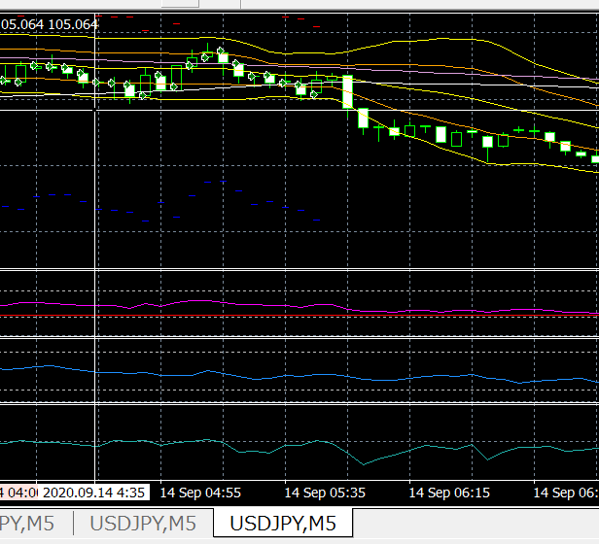  - observe, thoughts  - 先のマイナスの場合 => BB.3 から BB.5 に、一気に落ちている。
2

#_ 20200915_163128[eap-2.id-1].[USDJPY-5].dir
DESKTOP
 | card ==> out
NOTE
 |  | card ==> insert
Gen : statemet file
to : C:\Users\user\AppData\Roaming\MetaQuotes\Terminal\5D28BD404C024725A623256D5EEF0486\MQL4\Files\Report_Trades
Copy statement file ==> to card
E:\fx
Copy : log files
E:\fx
C:\Users\user\AppData\Roaming\MetaQuotes\Terminal\5D28BD404C024725A623256D5EEF0486\MQL4\Files\Logs
 |  | Sdcard ==> take out from : note-pc
DESKTOP
 |  | Sdcard ==> into : desktop
 |  | copied files ==> copy from card to desktop
log files :
from : E:\fx\20200XXX[eap-2.id-1].[XXX-XX].dir
20200828_083759[eap-2.id-1].[AUDJPY-5].dir
20200827_050324[eap-2.id-1].[AUDJPY-5].dir
20200826_114239[eap-2.id-1].[AUDJPY-5].dir
 |  | to : C:\Users\iwabuchiken\AppData\Roaming\MetaQuotes\Terminal\34B08C83A5AAE27A4079DE708E60511E\MQL4\Files\Logs
statement file
from : E:\fx\DetailedStatement.(2020XXXX_XXXX).*
DetailedStatement.[a-j,M5].[id=20117143].[20200826_143940].htm
to : C:\Users\iwabuchiken\AppData\Roaming\MetaQuotes\Terminal\34B08C83A5AAE27A4079DE708E60511E\MQL4\Files\Report_Trades
 |  | build url
 |  | http://localhost/Eclipse_Luna/Cake_IFM11/fx_utilities/util_3__Gen_Trading_Result_List?param_Dpath_File_Tickets_Data=C:\Users\iwabuchiken\AppData\Roaming\MetaQuotes\Terminal\34B08C83A5AAE27A4079DE708E60511E\MQL4\Files\Logs\20200915_163128[eap-2.id-1].[USDJPY-5].dir&param_Fname_File_Tickets_Data=[ea-6_tester-1].(20200915_163128).(tickets-data).log&param_Fname_File_Statement=DetailedStatement.[M5].[id=20117981].[20200917_105004].htm&param_Dpath_File_Statement=C:\Users\iwabuchiken\AppData\Roaming\MetaQuotes\Terminal\34B08C83A5AAE27A4079DE708E60511E\MQL4\Files\Logs\20200915_163128[eap-2.id-1].[USDJPY-5].dir
 |  | ==> access
 |  | template (url)
 |  | http://localhost/Eclipse_Luna/Cake_IFM11/fx_utilities/util_3__Gen_Trading_Result_List?param_Dpath_File_Tickets_Data=C:\Users\iwabuchiken\AppData\Roaming\MetaQuotes\Terminal\34B08C83A5AAE27A4079DE708E60511E\MQL4\Files\Logs\<XXX.dir>&param_Fname_File_Tickets_Data=<XXX.(tickets-data).log>&param_Fname_File_Statement=<DetailedStatement.XXX.htm>&param_Dpath_File_Statement=C:\Users\iwabuchiken\AppData\Roaming\MetaQuotes\Terminal\34B08C83A5AAE27A4079DE708E60511E\MQL4\Files\Logs\<XXX.dir>
 |  | file ==> gen-ed
 |  | dir | "C:\Users\iwabuchiken\AppData\Roaming\MetaQuotes\Terminal\34B08C83A5AAE27A4079DE708E60511E\MQL4\Files\Logs\20200915_163128[eap-2.id-1].[USDJPY-5].dir\[ea-4_tester-1].(20200507_140530).(combined-data).(20200918_114734_813133).dat"
 |  |  | "C:\WORKS_2\WS\WS_Others.JVEMV6\JVEMV6\44_currency\10_prog-php\2_tester\log_JVE_44_6_2.[session-13~].ods"

- sheet ==> gen
 | file | open ==> odt file
 | file | C:\WORKS_2\WS\WS_Others.JVEMV6\JVEMV6\44_currency\10_prog-php\2_tester\log_JVE_44_6_2.[session-XXX~].ods
 | file | "C:\WORKS_2\WS\WS_Others.JVEMV6\JVEMV6\44_currency\10_prog-php\2_tester\log_JVE_44_6_2.[session-13~].ods"
 | file | DUP sheet ==> “7”  M – e > s > s > a > M – c > Ret
 | file | rename ===> “8”  M – o > s > r
 | file | move to ==> any suitable location
 | sheet | delete ==> data area
 | sheet | C/P ==> data from gen-ed file

- TASK-1.3 : sheet ==> edit
  - edit
sort : “profit” ~~> “BB-loc.-1” (DF → CU)
M – d > s
hide : cols ==> CV ~ DE
addressing ==> total, gain, loss
- DH4
- DH5
- DG6 ==> DH5 + 1
addressing ==> BB.loc
- “current”, “prev” ==> C/P
- “数式” ==> M – t > q > M – f > Ret
- replace
  - DH11 (prev,total,end) → DH8
  - DH12 (prev, loss,end) → DH9
  - DG13 (prev,loss,start) → DG10
- “数式” ==> M – t > q > M – f > Ret
  - result / [ea-6_tester-1].(20200915_163128).(tickets-data).log
    - USDJPY / sell
    - graph / table / chart
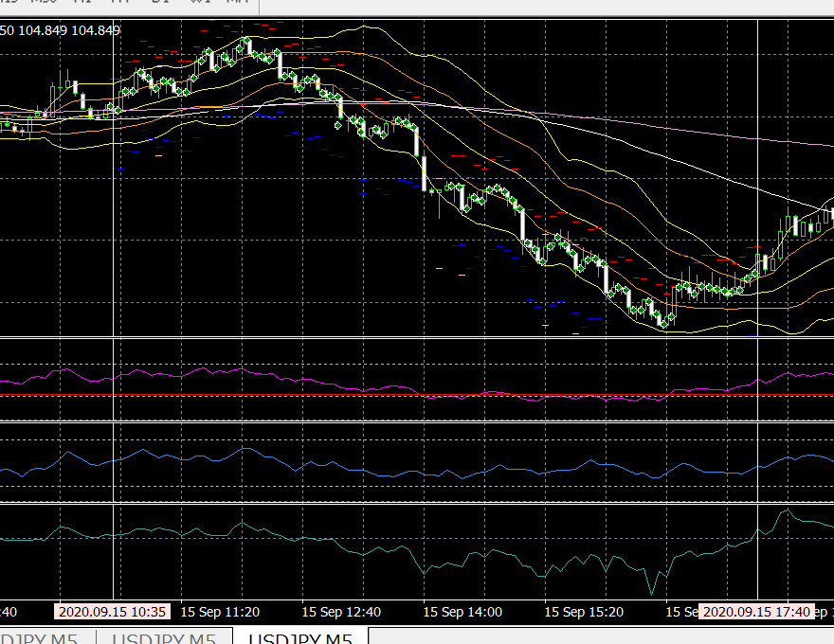
  - OBS
1 | BB.5, BB.4 ==> +9,000, +9,300, bzw. → due to : trailing (speculate)
2 | trend (overall)  - down  - first 4 dips ==> down-cascade (not down-mountain)  - 12:25 ~ 14:25  - following 5 dips ==> down-mountain  - diff of fall ==> １回ごとに、--> 小さくなっていく
3 | BB.2 ==> let's list up the orders  - detect BB.2  - sort : CU → DF  - result  - gain 5 / loss 8 / total 13  - of end-plus  - +2,170 以外 => BB.1 or 2 start  - of end-minus  - -530 以外 => BB.3 or 4 start
3
  - THOUGHTS
1
2

#_ 20200916_094242[eap-2.id-1].[USDJPY-5].dir
DESKTOP
 | card ==> out
NOTE
 |  | card ==> insert
Gen : statemet file
to : C:\Users\user\AppData\Roaming\MetaQuotes\Terminal\5D28BD404C024725A623256D5EEF0486\MQL4\Files\Report_Trades
Copy statement file ==> to card
E:\fx
Copy : log files
E:\fx
C:\Users\user\AppData\Roaming\MetaQuotes\Terminal\5D28BD404C024725A623256D5EEF0486\MQL4\Files\Logs
 |  | Sdcard ==> take out from : note-pc
DESKTOP
 |  | Sdcard ==> into : desktop
 |  | copied files ==> copy from card to desktop
log files :
from : E:\fx\20200XXX[eap-2.id-1].[XXX-XX].dir
20200916_094242[eap-2.id-1].[USDJPY-5].dir
 |  | to : C:\Users\iwabuchiken\AppData\Roaming\MetaQuotes\Terminal\34B08C83A5AAE27A4079DE708E60511E\MQL4\Files\Logs
statement file
from : E:\fx\DetailedStatement.(2020XXXX_XXXX).*
DetailedStatement.[a-j,M5].[id=20117143].[20200826_143940].htm
to : C:\Users\iwabuchiken\AppData\Roaming\MetaQuotes\Terminal\34B08C83A5AAE27A4079DE708E60511E\MQL4\Files\Report_Trades
 |  | build url
 |  | http://localhost/Eclipse_Luna/Cake_IFM11/fx_utilities/util_3__Gen_Trading_Result_List?param_Dpath_File_Tickets_Data=C:\Users\iwabuchiken\AppData\Roaming\MetaQuotes\Terminal\34B08C83A5AAE27A4079DE708E60511E\MQL4\Files\Logs\20200916_094242[eap-2.id-1].[USDJPY-5].dir&param_Fname_File_Tickets_Data=[ea-6_tester-1].(20200916_094242).(tickets-data).log&param_Fname_File_Statement=DetailedStatement.[M5].[id=20117981].[20200917_105004].htm&param_Dpath_File_Statement=C:\Users\iwabuchiken\AppData\Roaming\MetaQuotes\Terminal\34B08C83A5AAE27A4079DE708E60511E\MQL4\Files\Logs\20200916_094242[eap-2.id-1].[USDJPY-5].dir
 |  | http://localhost/Eclipse_Luna/Cake_IFM11/fx_utilities/util_3__Gen_Trading_Result_List?param_Dpath_File_Tickets_Data=C:\Users\iwabuchiken\AppData\Roaming\MetaQuotes\Terminal\34B08C83A5AAE27A4079DE708E60511E\MQL4\Files\Logs\20200916_145529[eap-2.id-1].[USDJPY-5].dir&param_Fname_File_Tickets_Data=[ea-6_tester-1].(20200916_145529).(tickets-data).log&param_Fname_File_Statement=DetailedStatement.[m5].[20200919_105608].htm&param_Dpath_File_Statement=C:\Users\iwabuchiken\AppData\Roaming\MetaQuotes\Terminal\34B08C83A5AAE27A4079DE708E60511E\MQL4\Files\Logs\20200916_145529[eap-2.id-1].[USDJPY-5].dir
 |  | ==> access
 |  | template (url)
 |  | http://localhost/Eclipse_Luna/Cake_IFM11/fx_utilities/util_3__Gen_Trading_Result_List?param_Dpath_File_Tickets_Data=C:\Users\iwabuchiken\AppData\Roaming\MetaQuotes\Terminal\34B08C83A5AAE27A4079DE708E60511E\MQL4\Files\Logs\<XXX.dir>&param_Fname_File_Tickets_Data=<XXX.(tickets-data).log>&param_Fname_File_Statement=<DetailedStatement.XXX.htm>&param_Dpath_File_Statement=C:\Users\iwabuchiken\AppData\Roaming\MetaQuotes\Terminal\34B08C83A5AAE27A4079DE708E60511E\MQL4\Files\Logs\<XXX.dir>
 |  | file ==> gen-ed
 |  | dir | "C:\Users\iwabuchiken\AppData\Roaming\MetaQuotes\Terminal\34B08C83A5AAE27A4079DE708E60511E\MQL4\Files\Logs\20200916_094242[eap-2.id-1].[USDJPY-5].dir\[ea-4_tester-1].(20200507_140530).(combined-data).(20200919_104857_053159).dat"
 |  |  | "C:\Users\iwabuchiken\AppData\Roaming\MetaQuotes\Terminal\34B08C83A5AAE27A4079DE708E60511E\MQL4\Files\Logs\20200916_145529[eap-2.id-1].[USDJPY-5].dir\[ea-4_tester-1].(20200507_140530).(combined-data).(20200919_111421_623991).dat"
 |  |  | "C:\WORKS_2\WS\WS_Others.JVEMV6\JVEMV6\44_currency\10_prog-php\2_tester\log_JVE_44_6_2.[session-13~].ods"

- sheet ==> gen
 | file | open ==> odt file
 | file | C:\WORKS_2\WS\WS_Others.JVEMV6\JVEMV6\44_currency\10_prog-php\2_tester\log_JVE_44_6_2.[session-XXX~].ods
 | file | "C:\WORKS_2\WS\WS_Others.JVEMV6\JVEMV6\44_currency\10_prog-php\2_tester\log_JVE_44_6_2.[session-13~].ods"
 | file | DUP sheet ==> “7”  M – e > s > s > a > M – c > Ret
 | file | rename ===> “8”  M – o > s > r
 | file | move to ==> any suitable location
 | sheet | delete ==> data area
 | sheet | C/P ==> data from gen-ed file

- TASK-1.3 : sheet ==> edit
  - edit
sort : “profit” ~~> “BB-loc.-1” (DF → CU)
M – d > s
hide : cols ==> CV ~ DE
addressing ==> total, gain, loss
- DH4
- DH5
- DG6 ==> DH5 + 1
addressing ==> BB.loc
- “current”, “prev” ==> C/P
- “数式” ==> M – t > q > M – f > Ret
- replace
  - DH11 (prev,total,end) → DH8
  - DH12 (prev, loss,end) → DH9
  - DG13 (prev,loss,start) → DG10
- “数式” ==> M – t > q > M – f > Ret
directory name ==> add “#” at the top
  - result

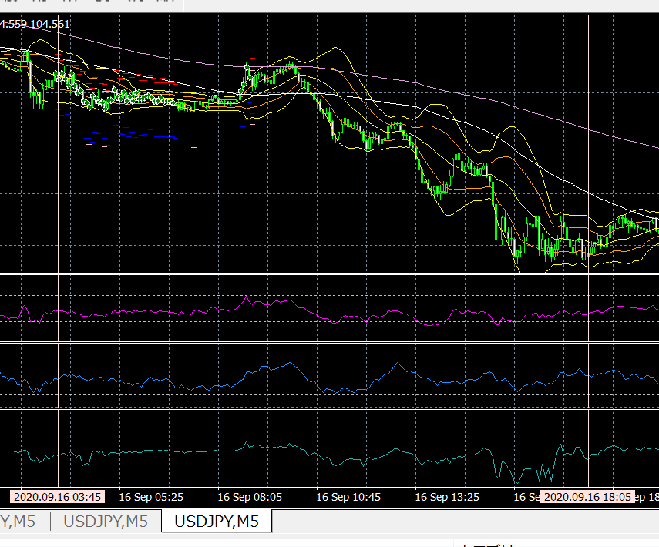
    - graph / table / chart

  - OBS
1 | trend of the day ==> down
2 | BB.2 → end in minus ==> 2 incidents  - setup : column DH  - sort data ==> CU > DF  - target data list ==> C/P to other area in the sheet  - col “BB-loc.-6” ==> insert column  - C/P ==> col “profit”  - bg-color  - row ==> end of the minus entries  - insert ==> row  - col names ==> insert  - minus entries ==> graph  - plus entries ==> graph  - +440 のorder ==> 過去６本で、BB.5 から、BB.2 に => 上がっている
3
  - THOUGHTS
1 | 直前６本の volatility と、その後の動き => 有関か？（ゆうかん）
2

6.2.4_21---------------------------------------------------------------------------
[22] res free# JVEMV6 44#6.2_X / 44. currency / 6. obs / 2. demo result data / 20200920_130626

#_ 20200917_083009[eap-2.id-1].[USDJPY-5].dir
DESKTOP
 | card ==> out
NOTE
 |  | card ==> insert
Gen : statemet file
to : C:\Users\user\AppData\Roaming\MetaQuotes\Terminal\5D28BD404C024725A623256D5EEF0486\MQL4\Files\Report_Trades
Copy statement file ==> to card
E:\fx
Copy : log files
E:\fx
C:\Users\user\AppData\Roaming\MetaQuotes\Terminal\5D28BD404C024725A623256D5EEF0486\MQL4\Files\Logs
 |  | Sdcard ==> take out from : note-pc
DESKTOP
 |  | Sdcard ==> into : desktop
 |  | copied files ==> copy from card to desktop
log files :
from : E:\fx\20200XXX[eap-2.id-1].[XXX-XX].dir
20200917_083009[eap-2.id-1].[USDJPY-5].dir
 |  | to : C:\Users\iwabuchiken\AppData\Roaming\MetaQuotes\Terminal\34B08C83A5AAE27A4079DE708E60511E\MQL4\Files\Logs
statement file
from : E:\fx\DetailedStatement.(2020XXXX_XXXX).*
DetailedStatement.[a-j,M5].[id=20117143].[20200826_143940].htm
to : C:\Users\iwabuchiken\AppData\Roaming\MetaQuotes\Terminal\34B08C83A5AAE27A4079DE708E60511E\MQL4\Files\Report_Trades
 |  | build url
 |  | http://localhost/Eclipse_Luna/Cake_IFM11/fx_utilities/util_3__Gen_Trading_Result_List?param_Dpath_File_Tickets_Data=C:\Users\iwabuchiken\AppData\Roaming\MetaQuotes\Terminal\34B08C83A5AAE27A4079DE708E60511E\MQL4\Files\Logs\20200917_083009[eap-2.id-1].[USDJPY-5].dir&param_Fname_File_Tickets_Data=[ea-6_tester-1].(20200917_083009).(tickets-data).log&param_Fname_File_Statement=DetailedStatement.[m5].[20200918_084246].htm&param_Dpath_File_Statement=C:\Users\iwabuchiken\AppData\Roaming\MetaQuotes\Terminal\34B08C83A5AAE27A4079DE708E60511E\MQL4\Files\Logs\20200917_083009[eap-2.id-1].[USDJPY-5].dir
 |  | ==> access
 |  | template (url)
 |  | http://localhost/Eclipse_Luna/Cake_IFM11/fx_utilities/util_3__Gen_Trading_Result_List?param_Dpath_File_Tickets_Data=C:\Users\iwabuchiken\AppData\Roaming\MetaQuotes\Terminal\34B08C83A5AAE27A4079DE708E60511E\MQL4\Files\Logs\<XXX.dir>&param_Fname_File_Tickets_Data=<XXX.(tickets-data).log>&param_Fname_File_Statement=<DetailedStatement.XXX.htm>&param_Dpath_File_Statement=C:\Users\iwabuchiken\AppData\Roaming\MetaQuotes\Terminal\34B08C83A5AAE27A4079DE708E60511E\MQL4\Files\Logs\<XXX.dir>
 |  | file ==> gen-ed
 |  | dir | "C:\Users\iwabuchiken\AppData\Roaming\MetaQuotes\Terminal\34B08C83A5AAE27A4079DE708E60511E\MQL4\Files\Logs\20200917_083009[eap-2.id-1].[USDJPY-5].dir\[ea-4_tester-1].(20200507_140530).(combined-data).(20200920_130808_899919).dat"
 |  |  | "C:\WORKS_2\WS\WS_Others.JVEMV6\JVEMV6\44_currency\10_prog-php\2_tester\log_JVE_44_6_2.[session-21~].ods"

- sheet ==> gen
 | file | open ==> odt file
 | file | C:\WORKS_2\WS\WS_Others.JVEMV6\JVEMV6\44_currency\10_prog-php\2_tester\log_JVE_44_6_2.[session-XXX~].ods
 | file | "C:\WORKS_2\WS\WS_Others.JVEMV6\JVEMV6\44_currency\10_prog-php\2_tester\log_JVE_44_6_2.[session-13~].ods"
 | file | DUP sheet ==> “7”  M – e > s > s > a > M – c > Ret
 | file | rename ===> “8”  M – o > s > r
 | file | move to ==> any suitable location
 | sheet | delete ==> data area
 | sheet | C/P ==> data from gen-ed file

- TASK-1.3 : sheet ==> edit
  - edit
sort : “profit” ~~> “BB-loc.-1” (DF → CU)
M – d > s
hide : cols ==> CV ~ DE
addressing ==> total, gain, loss
- DH4
- DH5
- DG6 ==> DH5 + 1
addressing ==> BB.loc
- “current”, “prev” ==> C/P
- “数式” ==> M – t > q > M – f > Ret
- replace
  - DH11 (prev,total,end) → DH8
  - DH12 (prev, loss,end) → DH9
  - DG13 (prev,loss,start) → DG10
- “数式” ==> M – t > q > M – f > Ret
directory name ==> add “#” at the top
  - result
    - graph / table / chart
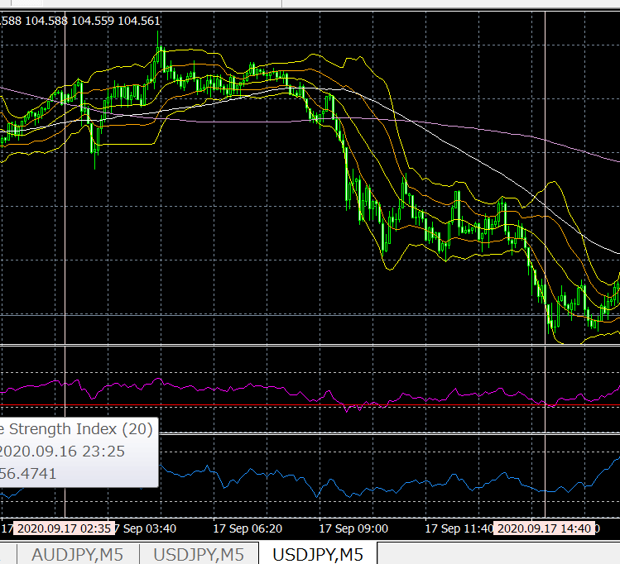
  - OBS
1 | BB.2 ==> loss/gain → 5:11  - setup : column DH  - sort data ==> CU > DF  - target data list ==> C/P to other area in the sheet  - col “BB-loc.-6” ==> insert column  - C/P ==> col “profit”  - bg-color  - #_ row ==> end of the minus entries  - insert ==> row  - col names ==> insert  - minus entries ==> graph  - plus entries ==> graph
2 | prev 4 bars ==> 連続、下げ  - setup : column DM ~ DP  - ===> 7 bars / 141 ( 5 % ) (plus 3 / minus 4)
3 | prev 4 bars ==> 連続、up  - setup : column DS ~ DW  - ===> 8 bars / 141 ( 5 % )
prev 4 bars ==> 連続、下げ → see chart forms
- sort ==> DQ > DF
- C/P ==> the area
- column names
- enter col before ==> “Close.-9”
- plus entries ==> add a row → col names
- graph : minus entries / plus

  - THOUGHTS
1
2

@@@

#_ <FILE NAME>
DESKTOP
 | card ==> out
NOTE
 |  | card ==> insert
Gen : statemet file
to : C:\Users\user\AppData\Roaming\MetaQuotes\Terminal\5D28BD404C024725A623256D5EEF0486\MQL4\Files\Report_Trades
Copy statement file ==> to card
E:\fx
Copy : log files
E:\fx
C:\Users\user\AppData\Roaming\MetaQuotes\Terminal\5D28BD404C024725A623256D5EEF0486\MQL4\Files\Logs
 |  | Sdcard ==> take out from : note-pc
DESKTOP
 |  | Sdcard ==> into : desktop
 |  | copied files ==> copy from card to desktop
log files :
from : E:\fx\20200XXX[eap-2.id-1].[XXX-XX].dir
20200828_083759[eap-2.id-1].[AUDJPY-5].dir
20200827_050324[eap-2.id-1].[AUDJPY-5].dir
20200826_114239[eap-2.id-1].[AUDJPY-5].dir
 |  | to : C:\Users\iwabuchiken\AppData\Roaming\MetaQuotes\Terminal\34B08C83A5AAE27A4079DE708E60511E\MQL4\Files\Logs
statement file
from : E:\fx\DetailedStatement.(2020XXXX_XXXX).*
DetailedStatement.[a-j,M5].[id=20117143].[20200826_143940].htm
to : C:\Users\iwabuchiken\AppData\Roaming\MetaQuotes\Terminal\34B08C83A5AAE27A4079DE708E60511E\MQL4\Files\Report_Trades
 |  | build url
 |  | http://localhost/Eclipse_Luna/Cake_IFM11/fx_utilities/util_3__Gen_Trading_Result_List?param_Dpath_File_Tickets_Data=C:\Users\iwabuchiken\AppData\Roaming\MetaQuotes\Terminal\34B08C83A5AAE27A4079DE708E60511E\MQL4\Files\Logs\(1)<XXX.dir>&param_Fname_File_Tickets_Data=(2)<XXX.(tickets-data).log>&param_Fname_File_Statement=(3)<DetailedStatement.XXX.htm>&param_Dpath_File_Statement=C:\Users\iwabuchiken\AppData\Roaming\MetaQuotes\Terminal\34B08C83A5AAE27A4079DE708E60511E\MQL4\Files\Logs\(4)<XXX.dir>
 |  | ==> access
 |  | template (url)
 |  | http://localhost/Eclipse_Luna/Cake_IFM11/fx_utilities/util_3__Gen_Trading_Result_List?param_Dpath_File_Tickets_Data=C:\Users\iwabuchiken\AppData\Roaming\MetaQuotes\Terminal\34B08C83A5AAE27A4079DE708E60511E\MQL4\Files\Logs\<XXX.dir>&param_Fname_File_Tickets_Data=<XXX.(tickets-data).log>&param_Fname_File_Statement=<DetailedStatement.XXX.htm>&param_Dpath_File_Statement=C:\Users\iwabuchiken\AppData\Roaming\MetaQuotes\Terminal\34B08C83A5AAE27A4079DE708E60511E\MQL4\Files\Logs\<XXX.dir>
 |  | file ==> gen-ed
 |  | dir | "<FILE PATH>"
 |  |  | "C:\WORKS_2\WS\WS_Others.JVEMV6\JVEMV6\44_currency\10_prog-php\2_tester\log_JVE_44_6_2.[session-21~].ods"

- sheet ==> gen
 | file | open ==> odt file
 | file | C:\WORKS_2\WS\WS_Others.JVEMV6\JVEMV6\44_currency\10_prog-php\2_tester\log_JVE_44_6_2.[session-XXX~].ods
 | file | "C:\WORKS_2\WS\WS_Others.JVEMV6\JVEMV6\44_currency\10_prog-php\2_tester\log_JVE_44_6_2.[session-13~].ods"
 | file | DUP sheet ==> “7”  M – e > s > s > a > M – c > Ret
 | file | rename ===> “8”  M – o > s > r
 | file | move to ==> any suitable location
 | sheet | delete ==> data area
 | sheet | C/P ==> data from gen-ed file

- TASK-1.3 : sheet ==> edit
  - edit
sort : “profit” ~~> “BB-loc.-1” (DF → CU)
M – d > s
hide : cols ==> CV ~ DE
addressing ==> total, gain, loss
- DH4
- DH5
- DG6 ==> DH5 + 1
addressing ==> BB.loc
- “current”, “prev” ==> C/P
- “数式” ==> M – t > q > M – f > Ret
- replace
  - DH11 (prev,total,end) → DH8
  - DH12 (prev, loss,end) → DH9
  - DG13 (prev,loss,start) → DG10
- “数式” ==> M – t > q > M – f > Ret
directory name ==> add “#” at the top
  - result
    - graph / table / chart
  - OBS
1
2
3
  - THOUGHTS
1
2

============================== TEMPLATE / 20200904_113804
#_ <FILE NAME>
DESKTOP
 | card ==> out
NOTE
 |  | card ==> insert
Gen : statemet file
to : C:\Users\user\AppData\Roaming\MetaQuotes\Terminal\5D28BD404C024725A623256D5EEF0486\MQL4\Files\Report_Trades
Copy statement file ==> to card
E:\fx
Copy : log files
E:\fx
C:\Users\user\AppData\Roaming\MetaQuotes\Terminal\5D28BD404C024725A623256D5EEF0486\MQL4\Files\Logs
 |  | Sdcard ==> take out from : note-pc
DESKTOP
 |  | Sdcard ==> into : desktop
 |  | copied files ==> copy from card to desktop
log files :
from : E:\fx\20200XXX[eap-2.id-1].[XXX-XX].dir
20200828_083759[eap-2.id-1].[AUDJPY-5].dir
20200827_050324[eap-2.id-1].[AUDJPY-5].dir
20200826_114239[eap-2.id-1].[AUDJPY-5].dir
 |  | to : C:\Users\iwabuchiken\AppData\Roaming\MetaQuotes\Terminal\34B08C83A5AAE27A4079DE708E60511E\MQL4\Files\Logs
statement file
from : E:\fx\DetailedStatement.(2020XXXX_XXXX).*
DetailedStatement.[a-j,M5].[id=20117143].[20200826_143940].htm
to : C:\Users\iwabuchiken\AppData\Roaming\MetaQuotes\Terminal\34B08C83A5AAE27A4079DE708E60511E\MQL4\Files\Report_Trades
 |  | build url
 |  | http://localhost/Eclipse_Luna/Cake_IFM11/fx_utilities/util_3__Gen_Trading_Result_List?param_Dpath_File_Tickets_Data=C:\Users\iwabuchiken\AppData\Roaming\MetaQuotes\Terminal\34B08C83A5AAE27A4079DE708E60511E\MQL4\Files\Logs\(1)<XXX.dir>&param_Fname_File_Tickets_Data=(2)<XXX.(tickets-data).log>&param_Fname_File_Statement=(3)<DetailedStatement.XXX.htm>&param_Dpath_File_Statement=C:\Users\iwabuchiken\AppData\Roaming\MetaQuotes\Terminal\34B08C83A5AAE27A4079DE708E60511E\MQL4\Files\Logs\(4)<XXX.dir>
 |  | ==> access
 |  | template (url)
 |  | http://localhost/Eclipse_Luna/Cake_IFM11/fx_utilities/util_3__Gen_Trading_Result_List?param_Dpath_File_Tickets_Data=C:\Users\iwabuchiken\AppData\Roaming\MetaQuotes\Terminal\34B08C83A5AAE27A4079DE708E60511E\MQL4\Files\Logs\<XXX.dir>&param_Fname_File_Tickets_Data=<XXX.(tickets-data).log>&param_Fname_File_Statement=<DetailedStatement.XXX.htm>&param_Dpath_File_Statement=C:\Users\iwabuchiken\AppData\Roaming\MetaQuotes\Terminal\34B08C83A5AAE27A4079DE708E60511E\MQL4\Files\Logs\<XXX.dir>
 |  | file ==> gen-ed
 |  | dir | "<FILE PATH>"
 |  |  | "C:\WORKS_2\WS\WS_Others.JVEMV6\JVEMV6\44_currency\10_prog-php\2_tester\log_JVE_44_6_2.[session-21~].ods"

- sheet ==> gen
 | file | open ==> odt file
 | file | C:\WORKS_2\WS\WS_Others.JVEMV6\JVEMV6\44_currency\10_prog-php\2_tester\log_JVE_44_6_2.[session-XXX~].ods
 | file | "C:\WORKS_2\WS\WS_Others.JVEMV6\JVEMV6\44_currency\10_prog-php\2_tester\log_JVE_44_6_2.[session-13~].ods"
 | file | DUP sheet ==> “7”  M – e > s > s > a > M – c > Ret
 | file | rename ===> “8”  M – o > s > r
 | file | move to ==> any suitable location
 | sheet | delete ==> data area
 | sheet | C/P ==> data from gen-ed file

- TASK-1.3 : sheet ==> edit
  - edit
sort : “profit” ~~> “BB-loc.-1” (DF → CU)
M – d > s
hide : cols ==> CV ~ DE
addressing ==> total, gain, loss
- DH4
- DH5
- DG6 ==> DH5 + 1
addressing ==> BB.loc
- “current”, “prev” ==> C/P
- “数式” ==> M – t > q > M – f > Ret
- replace
  - DH11 (prev,total,end) → DH8
  - DH12 (prev, loss,end) → DH9
  - DG13 (prev,loss,start) → DG10
- “数式” ==> M – t > q > M – f > Ret
directory name ==> add “#” at the top
  - result
    - graph / table / chart
  - OBS
1
2
3
  - THOUGHTS
1
2

/ ============================== TEMPLATE / 20200904_113804

original : C:\WORKS_2\WS\WS_Others.JVEMV6\JVEMV6\44_currency\10_prog-php\2_tester\log_20200520_160805.[fx_TASKS-26_move-statement-files-from-note-pc-to-desktop].odt ]20200825_170811

