---------------------------------------------------------------------- [20190810_143505]
res freeJVEMV6 52#7 29 / 52. 自然観察 n.o. / 7. 鳥 birds / 20190810_143505

- オオルリ
  - search https://www.youtube.com/results?search_query=オオルリ+鳴き声
- カワラヒワ
  - search https://www.youtube.com/results?search_query=カワラヒワ+鳴き声

---------------------------------------------------------------------- [20190811_155416]
res freeJVEMV6 52#7 30 / 52. 自然観察 n.o. / 7. 鳥 birds / 20190811_155416

- ヤマセミ
  - search https://www.youtube.com/results?search_query=ヤマセミ+鳴き声

[next]
- アカショウビン
[/ 20190811_163851]

---------------------------------------------------------------------- [XXX]
res freeJVEMV6 52#7 31 / 52. 自然観察 n.o. / 7. 鳥 birds / 20190813_141428

- アカショウビン
  - search https://www.youtube.com/results?search_query=アカショウビン+鳴き声

[next]
- ウグイス
[/ XXX]

---------------------------------------------------------------------- [XXX]
res freeJVEMV6 52#7 32 / 52. 自然観察 n.o. / 7. 鳥 birds / 20190818_155249

- コマドリ
  - search https://www.youtube.com/results?search_query=コマドリ+鳴き声

[next]
- ANY

[/ 20190818_163437]

---------------------------------------------------------------------- [XXX]
res freeJVEMV6 52#7 32-2 / 52. 自然観察 n.o. / 7. 鳥 birds / 20190819_000949

- キビタキ
  - search https://www.youtube.com/results?search_query=XXX+鳴き声
  - https://www.youtube.com/watch?v=b4YuFt3aHLc
  - スズメ目＞ヒタキ科
  - https://www.youtube.com/watch?v=b4YuFt3aHLc ==> DL
    - キビタキ（2）さえずり - Narcissus Flycatcher - Wild Bird - 野鳥 動画図鑑 [野鳥動画図鑑 - Wild Bird Japan].mp3 // C:\WORKS_2\WS\WS_Others.JVEMV6\JVEMV6\52_nature-observation\7_birds\audios
  - mp3
    - 0.454 – 5.556 : ツクツクボウシ
    - 23.697 – 34.128 : 同
- ヒヨドリ
  - 雌雄 見分け https://ameblo.jp/gaitey/entry-11901576154.html
    - https://ameblo.jp/gaitey/entry-11883912754.html
  - 営巣 https://www.youtube.com/watch?v=Zv-HzvLx-PU

[next]
- ANY

[/ 20190819_010331]

---------------------------------------------------------------------- [XXX]
res freeJVEMV6 52#7 33 / 52. 自然観察 n.o. / 7. 鳥 birds / 20190917_232316

- シジュウカラ
  - clip https://www.youtube.com/watch?v=sv4qnRHGM2w&list=PLZe1Q2NRG8YX-J4C0uElJS8YkycJmuFJU&index=12&t=0s
  - file : 117_shiju_bc.mp3
  - open the file with audacity
    - 3.454 – 6.524
      - ピー・ツツ x 5
    - 19.495 – 22.181
      - ピー・ツツ x 4 / ピッ
    - 37.685 – 40.295
      - ピー・ツツ x 4 / ピッ
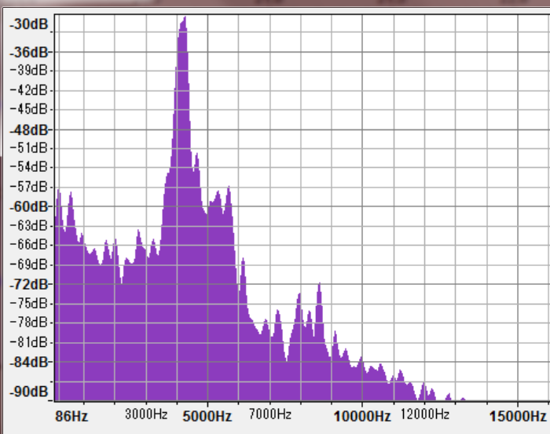
      - 「ピー」
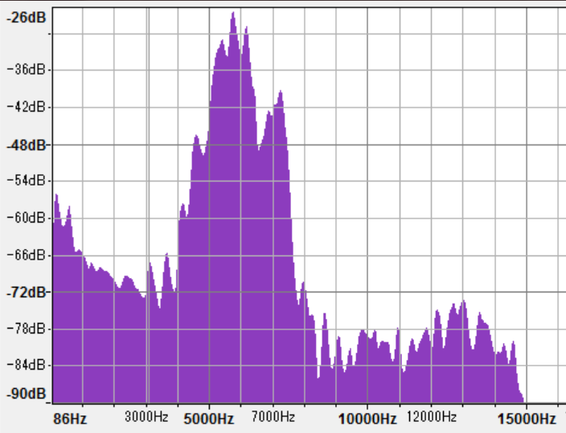
      - 「ツツ」
      - ピー３；ツ５；ツ４

[next]
- ANY

[/ 20190918_000415]

---------------------------------------------------------------------- [20190923_232249]
res free JVEMV6 52#7 34 / 52. 自然観察 n.o. / 7. 鳥 birds / 20190923_232249

- シジュウカラ
  - https://www.youtube.com/watch?v=sv4qnRHGM2w&list=PLZe1Q2NRG8YX-J4C0uElJS8YkycJmuFJU&index=13
- カワラヒワ
  - https://www.youtube.com/watch?v=6_P_ksjabDw
  - 118_kawarahiwa_bc.mp3
    - 2.060 – 2.817
      - キュ4イ5ーィ3
  - 44_kawarahiwa_bc.mp3
    - 1.060 – 2.187
      - キ5キ5キ4キ4キ3キ3
    - 2.347 – 3.693
      - キ5キ5キ5キ5キ5 – キ4キ4キ4キ4
- https://duckduckgo.com/?q=身近な野鳥+秋&t=opera&ia=web

[next]
- ANY

[/ 20190923_235207]

---------------------------------------------------------------------- [XXX]
res freeJVEMV6 52#7_35 / 52. 自然観察 n.o. / 7. 鳥 birds / 20190924_233815

- オオルリ
  - 94_ooruri_bc.mp3
  - sounds
    - 3.863 – 5.007 : utter-1
      - キュッ3キュ4キュ5ーキュ3# (4 syllables)
    - 7.933 – 9.644 : utter-2
      - キュー3ピー5キュー2#キュピッ2 (4 syllables)
    - 12.815 – 14.798
      - キリ3キリ3キリ3キュ2ル2ル2ツ5ピュ2ー
      - speed-0.16 : (12.815 + 0.075) – (xx + 0.819)
        - フ3オ4フ3オ4 – フ3オ4フ2オ4 – フ3オ4フ2オ4フ3オ4 (7 syllables)

[next]
- コマドリ

[/ 20190925_000015]

@@@
---------------------------------------------------------------------- [XXX]
res freeJVEMV6 52#7_36 / 52. 自然観察 n.o. / 7. 鳥 birds / 20190927_133446

- ムクドリ
  - 「鳴き声ノート」 ムクドリ （7ページ）.mp3
    - copy
    - rename : 5_mukudori_bs.mp3
    - 聞きなし
      - リィ3リィ4リッ5
        - 2.372 – 3.177
      - (1)ルッ1(2)ティッ2(3)ティ3ー・(4)ルッ2#(5)ティッ3(6)ティッ4
        - 4.432 – 6.384
        - audacity file : 5_mukudori_bs.mp3.[1].aup
      - (c)リィ1(d)リィ2(a)リッ4(b)リッ3
        - 11.517 – 13.570
        - c d a b
          - a > c
          - a > b
          - b < c
        - audacity file : 5_mukudori_bs.mp3.[2].aup
    - 声の種類
      - リッ (v1) 9.114 – 9.514
      - キュルッ (v2) 10.879 – 11.367
          - ==> pitch : v1 > v2

[next]

[/ XXX]

----------------------------------- [TEMPLATE]
---------------------------------------------------------------------- [XXX]
res freeJVEMV6 52#7_XX / 52. 自然観察 n.o. / 7. 鳥 birds / XXX

- XXX
  - search https://www.youtube.com/results?search_query=XXX+鳴き声

[next]

[/ XXX]

/----------------------------------- [/TEMPLATE]
---------------------------------------------------------------------- [docs] 20190810_144350
https://forum.openoffice.org/en/forum/viewtopic.php?f=9&t=8716 openoffice writer / background alternating 20190810_145027

/ ---------------------------------------------------------------------- [docs] 20190810_144350 /
---------------------------------------------------------------------- [steps] 20190810_150646
- build : list
- dl-ed files
  - @C:\WORKS_2\Downloads\4k
    - change file name
      - yt page
        - S – d > C – c (copy url)
      - sheet
        - goto : cell : KXX
        - C – v (paste)
        - ← (to the left side cell)
        - C - ↓ > C – c (copy “now” value)
        - C - ↑ > C – S – v > Ret (paste, selective)
      - yt
        - copy → title
      - sheet
        - C - ← (move to the top cell in the line)
        - → x 2 (move rightward, 2 cells)
        - C – S – v > ↓ > Ret (paste the title)
        - Space > “ []” > ← (chars for user name)
      - yt
        - copy → user name
      - sheet
        - C – v > Del > Tab (paste, then move to the right side cell)
        - C - ← x 2 (move to the top cell)
        - “XXX” > Tab (enter : serial num)
        - ↑ > C – c > ↓ > C – v (C/P the bird name)
        - → x 2 (move to col D)
        - ↑ > C – S - → > C – c (copy cells)
        - ↓ > C - ← > → (move back to col D)
        - C – v (paste)

    - move to : C:\WORKS_2\WS\WS_Others.JVEMV6\JVEMV6\52_nature-observation\7_birds\audios
  - @C:\WORKS_2\WS\WS_Others.JVEMV6\JVEMV6\52_nature-observation\7_birds\audios
    - copy files
    - change file names : use → e.g. “96_ooruri_bc.mp3”
    - copy re-named files to → C:\WORKS_2\WS\WS_Others.JVEMV6\JVEMV6\52_nature-observation\7_birds\to_mobile\list_birds_20190810_151135
  - itunes
    - folder
      - select folder
      - F2 > C – c (copy the fol name)
    - itunes
      - C – n > C – v (new playlist)
      - select → new playlist
    - folder
      - Ret (enter into the fol)
      - C – a (select new files)
      - drag/drop → to playlist window
    - itunes
      - change file name
        - select the item
        - Right click > “I” x 1 > Ret (open file info dialog)
        - click “ファイル”
        - select file name string
        - R.C. > click “C” > click “詳細” (copy)
        - “曲” text area → click
        - C – a > C – v (paste)
        - click “ok”
      - sort
        - click “プレイリストを...”
        - click “手動による順序で...”
        - click “名前”
        - click “終了”
      - sync
/ ---------------------------------------------------------------------- [steps] 20190810_150646 /
---------------------------------------------------------------------- [steps : closing] 20190810_155520
- iphone
  - create : new playlist
- git
  - console
r oj && s
g c -a
e && p

pushd C:\WORKS_2\WS\WS_Others.JVEMV6\JVEMV6\52_nature-observation\7_birds
end_apps.bat
    - r oj && s
    - g c -a

  - commit
  - console
    - p

- close apps
pushd C:\WORKS_2\WS\WS_Others.JVEMV6\JVEMV6\52_nature-observation\7_birds
end_apps.bat
  - openoffice
    - doc
    - sheet
  - git
  - itunes

/ ---------------------------------------------------------------------- [steps : closing] 20190810_155520 /

======================== EOF ========================

