6.2.4_21---------------------------------------------------------------------------
[22] res free# JVEMV6 44#6.2_X / 44. currency / 6. obs / 2. demo result data / 20200920_130626

#_ 20200917_083009[eap-2.id-1].[USDJPY-5].dir
DESKTOP
 | card ==> out
NOTE
 |  | card ==> insert
Gen : statemet file
to : C:\Users\user\AppData\Roaming\MetaQuotes\Terminal\5D28BD404C024725A623256D5EEF0486\MQL4\Files\Report_Trades
Copy statement file ==> to card
E:\fx
Copy : log files
E:\fx
C:\Users\user\AppData\Roaming\MetaQuotes\Terminal\5D28BD404C024725A623256D5EEF0486\MQL4\Files\Logs
 |  | Sdcard ==> take out from : note-pc
DESKTOP
 |  | Sdcard ==> into : desktop
 |  | copied files ==> copy from card to desktop
log files :
from : E:\fx\20200XXX[eap-2.id-1].[XXX-XX].dir
20200917_083009[eap-2.id-1].[USDJPY-5].dir
 |  | to : C:\Users\iwabuchiken\AppData\Roaming\MetaQuotes\Terminal\34B08C83A5AAE27A4079DE708E60511E\MQL4\Files\Logs
statement file
from : E:\fx\DetailedStatement.(2020XXXX_XXXX).*
DetailedStatement.[a-j,M5].[id=20117143].[20200826_143940].htm
to : C:\Users\iwabuchiken\AppData\Roaming\MetaQuotes\Terminal\34B08C83A5AAE27A4079DE708E60511E\MQL4\Files\Report_Trades
 |  | build url
 |  | http://localhost/Eclipse_Luna/Cake_IFM11/fx_utilities/util_3__Gen_Trading_Result_List?param_Dpath_File_Tickets_Data=C:\Users\iwabuchiken\AppData\Roaming\MetaQuotes\Terminal\34B08C83A5AAE27A4079DE708E60511E\MQL4\Files\Logs\20200917_083009[eap-2.id-1].[USDJPY-5].dir&param_Fname_File_Tickets_Data=[ea-6_tester-1].(20200917_083009).(tickets-data).log&param_Fname_File_Statement=DetailedStatement.[m5].[20200918_084246].htm&param_Dpath_File_Statement=C:\Users\iwabuchiken\AppData\Roaming\MetaQuotes\Terminal\34B08C83A5AAE27A4079DE708E60511E\MQL4\Files\Logs\20200917_083009[eap-2.id-1].[USDJPY-5].dir
 |  | ==> access
 |  | template (url)
 |  | http://localhost/Eclipse_Luna/Cake_IFM11/fx_utilities/util_3__Gen_Trading_Result_List?param_Dpath_File_Tickets_Data=C:\Users\iwabuchiken\AppData\Roaming\MetaQuotes\Terminal\34B08C83A5AAE27A4079DE708E60511E\MQL4\Files\Logs\<XXX.dir>&param_Fname_File_Tickets_Data=<XXX.(tickets-data).log>&param_Fname_File_Statement=<DetailedStatement.XXX.htm>&param_Dpath_File_Statement=C:\Users\iwabuchiken\AppData\Roaming\MetaQuotes\Terminal\34B08C83A5AAE27A4079DE708E60511E\MQL4\Files\Logs\<XXX.dir>
 |  | file ==> gen-ed
 |  | dir | "C:\Users\iwabuchiken\AppData\Roaming\MetaQuotes\Terminal\34B08C83A5AAE27A4079DE708E60511E\MQL4\Files\Logs\20200917_083009[eap-2.id-1].[USDJPY-5].dir\[ea-4_tester-1].(20200507_140530).(combined-data).(20200920_130808_899919).dat"
 |  |  | "C:\WORKS_2\WS\WS_Others.JVEMV6\JVEMV6\44_currency\10_prog-php\2_tester\log_JVE_44_6_2.[session-21~].ods"

- sheet ==> gen
 | file | open ==> odt file
 | file | C:\WORKS_2\WS\WS_Others.JVEMV6\JVEMV6\44_currency\10_prog-php\2_tester\log_JVE_44_6_2.[session-XXX~].ods
 | file | "C:\WORKS_2\WS\WS_Others.JVEMV6\JVEMV6\44_currency\10_prog-php\2_tester\log_JVE_44_6_2.[session-13~].ods"
 | file | DUP sheet ==> “7”  M – e > s > s > a > M – c > Ret
 | file | rename ===> “8”  M – o > s > r
 | file | move to ==> any suitable location
 | sheet | delete ==> data area
 | sheet | C/P ==> data from gen-ed file

- TASK-1.3 : sheet ==> edit
  - edit
sort : “profit” ~~> “BB-loc.-1” (DF → CU)
M – d > s
hide : cols ==> CV ~ DE
addressing ==> total, gain, loss
- DH4
- DH5
- DG6 ==> DH5 + 1
addressing ==> BB.loc
- “current”, “prev” ==> C/P
- “数式” ==> M – t > q > M – f > Ret
- replace
  - DH11 (prev,total,end) → DH8
  - DH12 (prev, loss,end) → DH9
  - DG13 (prev,loss,start) → DG10
- “数式” ==> M – t > q > M – f > Ret
directory name ==> add “#” at the top
  - result
    - graph / table / chart
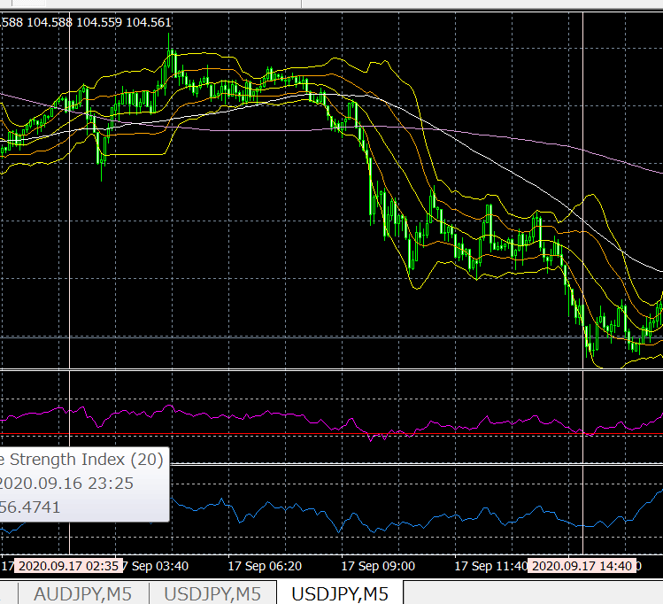
  - OBS
1 | BB.2 ==> loss/gain → 5:11  - setup : column DH  - sort data ==> CU > DF  - target data list ==> C/P to other area in the sheet  - col “BB-loc.-6” ==> insert column  - C/P ==> col “profit”  - bg-color  - #_ row ==> end of the minus entries  - insert ==> row  - col names ==> insert  - minus entries ==> graph  - plus entries ==> graph
2 | prev 4 bars ==> 連続、下げ  - setup : column DM ~ DP  - ===> 7 bars / 141 ( 5 % ) (plus 3 / minus 4)
3 | prev 4 bars ==> 連続、up  - setup : column DS ~ DW  - ===> 8 bars / 141 ( 5 % )
prev 4 bars ==> 連続、下げ → see chart forms
- sort ==> DQ > DF
- C/P ==> the area
- column names
- enter col before ==> “Close.-9”
- plus entries ==> add a row → col names
- graph : minus entries / plus

  - THOUGHTS
1
2

6.2.4_21---------------------------------------------------------------------------
[22] res free# JVEMV6 44#6.2_X / 44. currency / 6. obs / 2. demo result data / 20200920_130626

#_ 20200918_084904[eap-2.id-1].[USDJPY-5].dir
 | build url
 | http://localhost/Eclipse_Luna/Cake_IFM11/fx_utilities/util_3__Gen_Trading_Result_List?param_Dpath_File_Tickets_Data=C:\Users\iwabuchiken\AppData\Roaming\MetaQuotes\Terminal\34B08C83A5AAE27A4079DE708E60511E\MQL4\Files\Logs\20200918_084904[eap-2.id-1].[USDJPY-5].dir&param_Fname_File_Tickets_Data=[ea-6_tester-1].(20200918_084904).(tickets-data).log&param_Fname_File_Statement=DetailedStatement.[m5].[20200919_105608].htm&param_Dpath_File_Statement=C:\Users\iwabuchiken\AppData\Roaming\MetaQuotes\Terminal\34B08C83A5AAE27A4079DE708E60511E\MQL4\Files\Logs\20200918_084904[eap-2.id-1].[USDJPY-5].dir
 | ==> access
 | template (url)
 | http://localhost/Eclipse_Luna/Cake_IFM11/fx_utilities/util_3__Gen_Trading_Result_List?param_Dpath_File_Tickets_Data=C:\Users\iwabuchiken\AppData\Roaming\MetaQuotes\Terminal\34B08C83A5AAE27A4079DE708E60511E\MQL4\Files\Logs\<XXX.dir>&param_Fname_File_Tickets_Data=<XXX.(tickets-data).log>&param_Fname_File_Statement=<DetailedStatement.XXX.htm>&param_Dpath_File_Statement=C:\Users\iwabuchiken\AppData\Roaming\MetaQuotes\Terminal\34B08C83A5AAE27A4079DE708E60511E\MQL4\Files\Logs\<XXX.dir>
 | file ==> gen-ed
 | dir | "C:\Users\iwabuchiken\AppData\Roaming\MetaQuotes\Terminal\34B08C83A5AAE27A4079DE708E60511E\MQL4\Files\Logs\20200918_084904[eap-2.id-1].[USDJPY-5].dir\[ea-4_tester-1].(20200507_140530).(combined-data).(20200921_141005_518934).dat"
 |  | "C:\WORKS_2\WS\WS_Others.JVEMV6\JVEMV6\44_currency\10_prog-php\2_tester\log_JVE_44_6_2.[session-21~].ods"

  - result
    - graph / table / chart
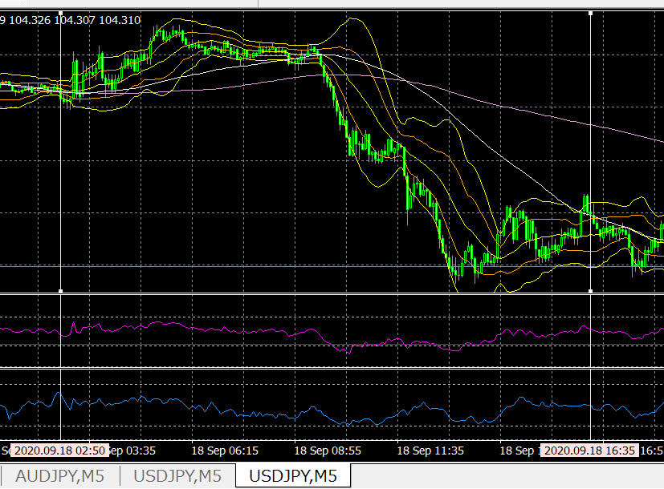
  - OBS
1 | sell で、なお、BB.5 スタートの order が、end – plus ==> 下げトレンド？  - BB.5 entries  - prev 4 bars ==> 連続、下げ  - setup : column DM ~ DP  - entries 11 / total 150 ( 7.3 % )  - sort : DQ > DF  - minus 6 / plus 5  - FOUND : 全体としては、down trend だが、４本連下げのあとは、minus が、54 %  - prev 4 bars ==> 連続、up  - setup : column DS ~ DW  - hit 6 / total 150 ( 4 % )
2 | 9/17 の日は、BB.5, BB.2 ==> ともに、plus ---> トレンドは？
3 | 9/17 の BB.2 ==> もう一度、order list → 見てみよう [다시 보자.  - log_JVE_44_6_2.[session-21~].ods / sheet 3 / id=20200921_145152  - FOUND  - end - minus ==> consecutive  - end – minus ==> chart → only BB.2 or BB.3 ==> this means : a long flat, then up  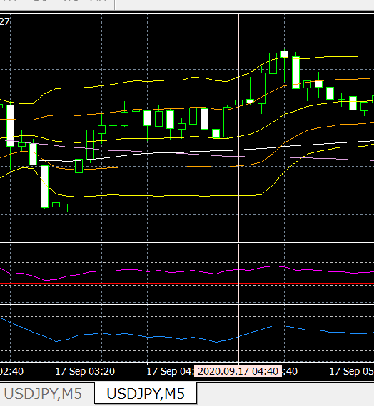  - e.g. : 2020.09.17 04:40:01 / sell / -510  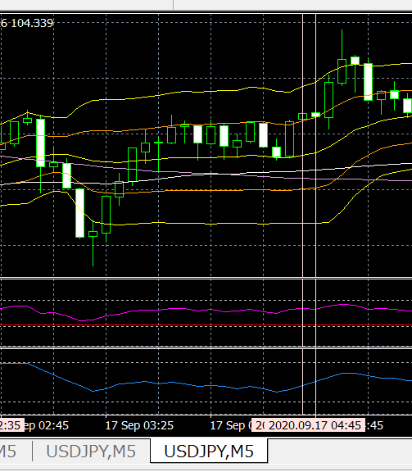  - 2020.09.17 04:45:05 / sell / -550  - 流れ：  - BB.2 to BB.6 in 5 bars  - to BB.3 in 4 bars, consecutive up  - in BB.3 for 10 bars  - in this chunk of 10 bars ==> cross up of MA75 vis-a-vis MA200
  - THOUGHTS
1 | Qs : 9/15, u/j, m5, sell ==> the trend is down(tentative) → BB.2 is in plus ==> why, BB.5 is also in plus?
2

6.2.4_22---------------------------------------------------------------------------
[23] res free# JVEMV6 44#6.2_X / 44. currency / 6. obs / 2. demo result data / 20200921_140657

20200918_084904[eap-2.id-1].[USDJPY-5].dir
OBS (prev-cont)
20200918_084904[eap-2.id-1].[USDJPY-5].dir / 4
- prev 4 bars ==> 連続、up
- setup : column DS ~ DW
- hit 6 / total 150 ( 4 % )
- sort : DW > DF
- C/P : all down entries ==> id=20200922_112243
- column names, bg-color “黄色”

#_ 20200907_134721[eap-2.id-1].[AUDJPY-5].dir
 | build url
 | http://localhost/Eclipse_Luna/Cake_IFM11/fx_utilities/util_3__Gen_Trading_Result_List?param_Dpath_File_Tickets_Data=C:\Users\iwabuchiken\AppData\Roaming\MetaQuotes\Terminal\34B08C83A5AAE27A4079DE708E60511E\MQL4\Files\Logs\20200907_134721[eap-2.id-1].[AUDJPY-5].dir&param_Fname_File_Tickets_Data=[ea-4_tester-1].(20200907_134721).(tickets-data).log&param_Fname_File_Statement=DetailedStatement.[m5].[20200921_154212].htm&param_Dpath_File_Statement=C:\Users\iwabuchiken\AppData\Roaming\MetaQuotes\Terminal\34B08C83A5AAE27A4079DE708E60511E\MQL4\Files\Logs\20200907_134721[eap-2.id-1].[AUDJPY-5].dir
 | ==> access
 | template (url)
 | http://localhost/Eclipse_Luna/Cake_IFM11/fx_utilities/util_3__Gen_Trading_Result_List?param_Dpath_File_Tickets_Data=C:\Users\iwabuchiken\AppData\Roaming\MetaQuotes\Terminal\34B08C83A5AAE27A4079DE708E60511E\MQL4\Files\Logs\<XXX.dir>&param_Fname_File_Tickets_Data=<XXX.(tickets-data).log>&param_Fname_File_Statement=<DetailedStatement.XXX.htm>&param_Dpath_File_Statement=C:\Users\iwabuchiken\AppData\Roaming\MetaQuotes\Terminal\34B08C83A5AAE27A4079DE708E60511E\MQL4\Files\Logs\<XXX.dir>
 | file ==> gen-ed
 | dir | "C:\Users\iwabuchiken\AppData\Roaming\MetaQuotes\Terminal\34B08C83A5AAE27A4079DE708E60511E\MQL4\Files\Logs\20200907_134721[eap-2.id-1].[AUDJPY-5].dir\[ea-4_tester-1].(20200507_140530).(combined-data).(20200922_113632_213037).dat"
 |  | "C:\WORKS_2\WS\WS_Others.JVEMV6\JVEMV6\44_currency\10_prog-php\2_tester\log_JVE_44_6_2.[session-21~].ods"

- sheet ==> gen
 | file | open ==> odt file
 | file | C:\WORKS_2\WS\WS_Others.JVEMV6\JVEMV6\44_currency\10_prog-php\2_tester\log_JVE_44_6_2.[session-XXX~].ods
 | file | "C:\WORKS_2\WS\WS_Others.JVEMV6\JVEMV6\44_currency\10_prog-php\2_tester\log_JVE_44_6_2.[session-13~].ods"

- TASK-1.3 : sheet ==> edit
  - edit
  - result
    - graph / table / chart

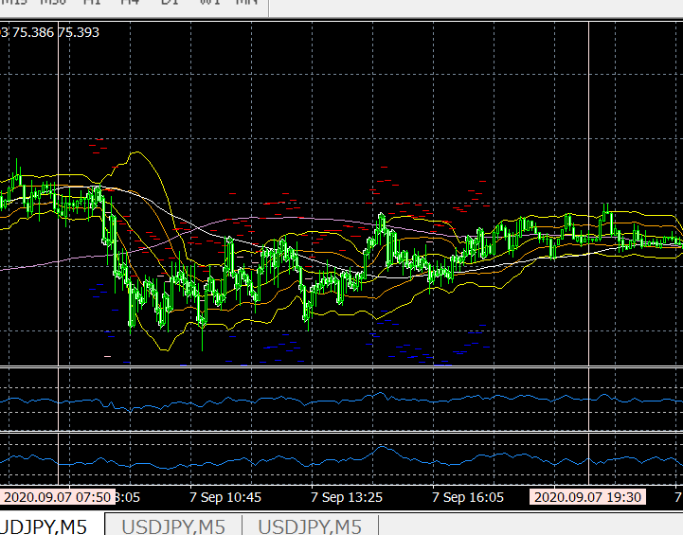
  - OBS
1 | 全体の流れ => ほぼ、ボックス。いくぶん、上げトレンド => しかし、gain は、0.5 を超える BB.loc → なし (m5 / buy)
2
3
  - THOUGHTS
1
2

#_ 20200908_103526[eap-2.id-1].[AUDJPY-5].dir
 | build url
 | http://localhost/Eclipse_Luna/Cake_IFM11/fx_utilities/util_3__Gen_Trading_Result_List?param_Dpath_File_Tickets_Data=C:\Users\iwabuchiken\AppData\Roaming\MetaQuotes\Terminal\34B08C83A5AAE27A4079DE708E60511E\MQL4\Files\Logs\20200908_103526[eap-2.id-1].[AUDJPY-5].dir&param_Fname_File_Tickets_Data=[ea-4_tester-1].(20200908_103526).(tickets-data).log&param_Fname_File_Statement=DetailedStatement.[m5].[20200921_154212].htm&param_Dpath_File_Statement=C:\Users\iwabuchiken\AppData\Roaming\MetaQuotes\Terminal\34B08C83A5AAE27A4079DE708E60511E\MQL4\Files\Logs\20200908_103526[eap-2.id-1].[AUDJPY-5].dir
 | ==> access
 | file ==> gen-ed
 | dir | "C:\Users\iwabuchiken\AppData\Roaming\MetaQuotes\Terminal\34B08C83A5AAE27A4079DE708E60511E\MQL4\Files\Logs\20200908_103526[eap-2.id-1].[AUDJPY-5].dir\[ea-4_tester-1].(20200507_140530).(combined-data).(20200924_113315_349060).dat"
 |  | "C:\WORKS_2\WS\WS_Others.JVEMV6\JVEMV6\44_currency\10_prog-php\2_tester\log_JVE_44_6_2.[session-21~].ods"

- sheet ==> gen
 | file | open ==> odt file
 | file | C:\WORKS_2\WS\WS_Others.JVEMV6\JVEMV6\44_currency\10_prog-php\2_tester\log_JVE_44_6_2.[session-XXX~].ods
 | file | "C:\WORKS_2\WS\WS_Others.JVEMV6\JVEMV6\44_currency\10_prog-php\2_tester\log_JVE_44_6_2.[session-13~].ods"
 | file | DUP sheet ==> “5”  M – e > s > s > a > M – c > Ret
 | file | rename ===> “6”  M – o > s > r
 | file | move to ==> any suitable location
 | sheet | delete ==> data area
 | sheet | C/P ==> data from gen-ed file

- TASK-1.3 : sheet ==> edit
  - edit
  - result
    - graph / table / chart
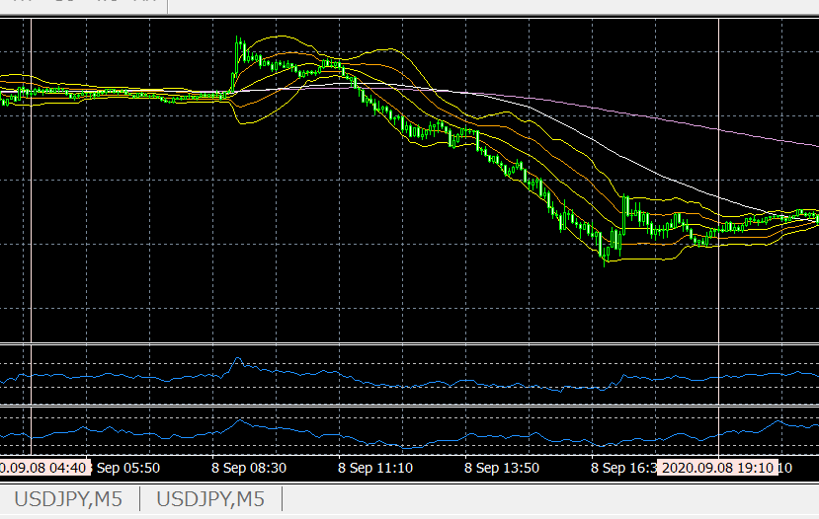
  - OBS
1 | 9:00 以降 => 一貫して、down. ==> esp. 16:50 まで、ほぼ、BB.loc-4,5 の、いずれかに、Close,Open が入っている
2
3
  - THOUGHTS
1 | BB.loc-4,5 => gain/loss ratio は、57 % ==> SL で終わっている order も、相当にある => トレンドは down だが、”pop” がいくつかある => ということか？
2

#_ 20200909_115319[eap-2.id-1].[AUDJPY-5].dir
 | build url
 | http://localhost/Eclipse_Luna/Cake_IFM11/fx_utilities/util_3__Gen_Trading_Result_List?param_Dpath_File_Tickets_Data=C:\Users\iwabuchiken\AppData\Roaming\MetaQuotes\Terminal\34B08C83A5AAE27A4079DE708E60511E\MQL4\Files\Logs\20200909_115319[eap-2.id-1].[AUDJPY-5].dir&param_Fname_File_Tickets_Data=[ea-4_tester-1].(20200909_115319).(tickets-data).log&param_Fname_File_Statement=DetailedStatement.[m5].[20200921_154212].htm&param_Dpath_File_Statement=C:\Users\iwabuchiken\AppData\Roaming\MetaQuotes\Terminal\34B08C83A5AAE27A4079DE708E60511E\MQL4\Files\Logs\20200909_115319[eap-2.id-1].[AUDJPY-5].dir
 | ==> access
 | file ==> gen-ed
 | dir | "C:\Users\iwabuchiken\AppData\Roaming\MetaQuotes\Terminal\34B08C83A5AAE27A4079DE708E60511E\MQL4\Files\Logs\20200909_115319[eap-2.id-1].[AUDJPY-5].dir\[ea-4_tester-1].(20200507_140530).(combined-data).(20200926_172726_248384).dat"
 |  | "C:\WORKS_2\WS\WS_Others.JVEMV6\JVEMV6\44_currency\10_prog-php\2_tester\log_JVE_44_6_2.[session-21~].ods"

- sheet ==> gen
 | file | open ==> odt file
 | file | C:\WORKS_2\WS\WS_Others.JVEMV6\JVEMV6\44_currency\10_prog-php\2_tester\log_JVE_44_6_2.[session-XXX~].ods
 | file | "C:\WORKS_2\WS\WS_Others.JVEMV6\JVEMV6\44_currency\10_prog-php\2_tester\log_JVE_44_6_2.[session-13~].ods"

- TASK-1.3 : sheet ==> edit
  - edit
directory name ==> add “#” at the top
  - result
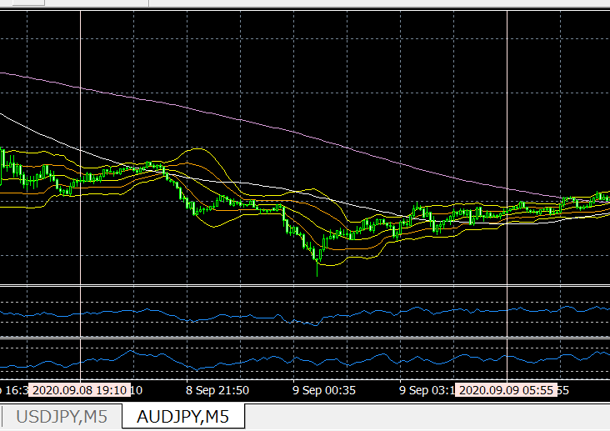
    - graph / table / chart

6.2.4_4---------------------------------------------------------------------------
[5] res free# JVEMV6 44#TASKS_49 / 44. currency / TASKS-49. combined-list-gen-stats / 20200929_135845

#_ 20200910_093548[eap-2.id-1].[AUDJPY-5].dir
DESKTOP
 | card ==> out
NOTE
 |  | card ==> insert
Gen : statemet file
to : C:\Users\user\AppData\Roaming\MetaQuotes\Terminal\5D28BD404C024725A623256D5EEF0486\MQL4\Files\Report_Trades
Copy statement file ==> to card
E:\fx
Copy : log files
E:\fx
C:\Users\user\AppData\Roaming\MetaQuotes\Terminal\5D28BD404C024725A623256D5EEF0486\MQL4\Files\Logs
 |  | Sdcard ==> take out from : note-pc
DESKTOP
 |  | Sdcard ==> into : desktop
 |  | copied files ==> copy from card to desktop
log files :
from : E:\fx\20200XXX[eap-2.id-1].[XXX-XX].dir
20200910_093548[eap-2.id-1].[AUDJPY-5].dir
 |  | to : C:\Users\iwabuchiken\AppData\Roaming\MetaQuotes\Terminal\34B08C83A5AAE27A4079DE708E60511E\MQL4\Files\Logs
statement file
from : E:\fx\DetailedStatement.(2020XXXX_XXXX).*
DetailedStatement.[a-j,M5].[id=20117143].[20200826_143940].htm
to : C:\Users\iwabuchiken\AppData\Roaming\MetaQuotes\Terminal\34B08C83A5AAE27A4079DE708E60511E\MQL4\Files\Report_Trades
 |  | build url
 |  | http://localhost/Eclipse_Luna/Cake_IFM11/fx_utilities/util_3__Gen_Trading_Result_List?param_Dpath_File_Tickets_Data=C:\Users\iwabuchiken\AppData\Roaming\MetaQuotes\Terminal\34B08C83A5AAE27A4079DE708E60511E\MQL4\Files\Logs\(1)<XXX.dir>&param_Fname_File_Tickets_Data=(2)<XXX.(tickets-data).log>&param_Fname_File_Statement=(3)<DetailedStatement.XXX.htm>&param_Dpath_File_Statement=C:\Users\iwabuchiken\AppData\Roaming\MetaQuotes\Terminal\34B08C83A5AAE27A4079DE708E60511E\MQL4\Files\Logs\(4)<XXX.dir>
 |  | ==> access
 |  | template (url)
 |  | http://localhost/Eclipse_Luna/Cake_IFM11/fx_utilities/util_3__Gen_Trading_Result_List?param_Dpath_File_Tickets_Data=C:\Users\iwabuchiken\AppData\Roaming\MetaQuotes\Terminal\34B08C83A5AAE27A4079DE708E60511E\MQL4\Files\Logs\<XXX.dir>&param_Fname_File_Tickets_Data=<XXX.(tickets-data).log>&param_Fname_File_Statement=<DetailedStatement.XXX.htm>&param_Dpath_File_Statement=C:\Users\iwabuchiken\AppData\Roaming\MetaQuotes\Terminal\34B08C83A5AAE27A4079DE708E60511E\MQL4\Files\Logs\<XXX.dir>
 |  | file ==> gen-ed
 |  | dir | "C:\Users\iwabuchiken\AppData\Roaming\MetaQuotes\Terminal\34B08C83A5AAE27A4079DE708E60511E\MQL4\Files\Logs\20200910_093548[eap-2.id-1].[AUDJPY-5].dir\[ea-4_tester-1].(20200507_140530).(combined-data).(20200929_142521_965981).dat"
 |  |  | "C:\WORKS_2\WS\WS_Others.JVEMV6\JVEMV6\44_currency\10_prog-php\2_tester\log_JVE_44_6_2.[session-21~].ods"

- sheet ==> gen
 | file | open ==> odt file
 | file | C:\WORKS_2\WS\WS_Others.JVEMV6\JVEMV6\44_currency\10_prog-php\2_tester\log_JVE_44_6_2.[session-XXX~].ods
 | file | "C:\WORKS_2\WS\WS_Others.JVEMV6\JVEMV6\44_currency\10_prog-php\2_tester\log_JVE_44_6_2.[session-13~].ods"
 | file | DUP sheet ==> “8”  M – e > s > s > a > M – c > Ret
 | file | rename ===> “9”  M – o > s > r
 | file | move to ==> any suitable location
 | sheet | delete ==> data area
 | sheet | C/P ==> data from gen-ed file

- TASK-1.3 : sheet ==> edit
  - edit memo
sort : “profit” ~~> “BB-loc.-1” (DF → CU)
M – d > s
hide : cols ==> CV ~ DE
addressing ==> total, gain, loss
- DH4
- DH5
- DG6 ==> DH5 + 1
addressing ==> BB.loc
- “current”, “prev” ==> C/P
- “数式” ==> M – t > q > M – f > Ret
- replace
  - DH11 (prev,total,end) → DH8
  - DH12 (prev, loss,end) → DH9
  - DG13 (prev,loss,start) → DG10
- “数式” ==> M – t > q > M – f > Ret
directory name ==> add “#” at the top
  - result
    - graph / table / chart
  - OBS
1
2
3
  - THOUGHTS
1
2

6.2.4_24---------------------------------------------------------------------------
[25] res free# JVEMV6 44#6.2_X / 44. currency / 6. obs / 2. demo result data / 20200930_154546

#_ 20200914_094747[eap-2.id-1].[AUDJPY-5].dir
 | file ==> gen-ed
 | dir | "C:\Users\iwabuchiken\AppData\Roaming\MetaQuotes\Terminal\34B08C83A5AAE27A4079DE708E60511E\MQL4\Files\Logs\20200914_094747[eap-2.id-1].[AUDJPY-5].dir\[ea-4_tester-1].(20200507_140530).(combined-data).(20200930_154713_036675).dat"
 |  | "C:\WORKS_2\WS\WS_Others.JVEMV6\JVEMV6\44_currency\10_prog-php\2_tester\log_JVE_44_6_2.[session-21~].ods"

- sheet ==> gen
 | file | open ==> odt file
 | file | C:\WORKS_2\WS\WS_Others.JVEMV6\JVEMV6\44_currency\10_prog-php\2_tester\log_JVE_44_6_2.[session-XXX~].ods
 | file | "C:\WORKS_2\WS\WS_Others.JVEMV6\JVEMV6\44_currency\10_prog-php\2_tester\log_JVE_44_6_2.[session-13~].ods"
 | file | DUP sheet ==> “9”  M – e > s > s > a > M – c > Ret
 | file | rename ===> “10”  M – o > s > r
 | file | move to ==> any suitable location
 | sheet | delete ==> data area
 | sheet | C/P ==> data from gen-ed file

- TASK-1.3 : sheet ==> edit
  - edit
sort : “profit” ~~> “BB-loc.-1” (DF → CU)
M – d > s
C/P
- total, loss, gain
- BB.loc : counts
- BB.loc : sums
directory name ==> add “#” at the top
  - result
    - graph / table / chart
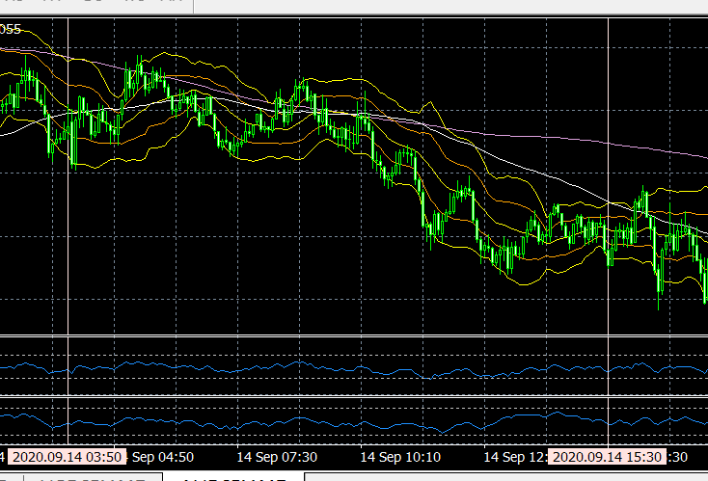

#_ 20200911_045656[eap-2.id-1].[AUDJPY-5].dir
 | file ==> gen-ed
 | dir | "C:\Users\iwabuchiken\AppData\Roaming\MetaQuotes\Terminal\34B08C83A5AAE27A4079DE708E60511E\MQL4\Files\Logs\20200911_045656[eap-2.id-1].[AUDJPY-5].dir\[ea-4_tester-1].(20200507_140530).(combined-data).(20200930_162635_464843).dat"
 |  | "C:\WORKS_2\WS\WS_Others.JVEMV6\JVEMV6\44_currency\10_prog-php\2_tester\log_JVE_44_6_2.[session-21~].ods"

- sheet ==> gen
 | file | open ==> odt file
 | file | C:\WORKS_2\WS\WS_Others.JVEMV6\JVEMV6\44_currency\10_prog-php\2_tester\log_JVE_44_6_2.[session-XXX~].ods
 | file | "C:\WORKS_2\WS\WS_Others.JVEMV6\JVEMV6\44_currency\10_prog-php\2_tester\log_JVE_44_6_2.[session-13~].ods"
 | file | DUP sheet ==> “10”  M – e > s > s > a > M – c > Ret
 | file | rename ===> “11”  M – o > s > r
 | file | move to ==> any suitable location
 | sheet | delete ==> data area
 | sheet | C/P ==> data from gen-ed file

- TASK-1.3 : sheet ==> edit
  - edit @@@
C/P
- total, loss, gain
- BB.loc : counts
- BB.loc : sums
directory name ==> add “#” at the top
  - result
    - graph / table / chart
  - OBS
1
2
3
  - THOUGHTS
1
2

============================== TEMPLATE / 20200904_113804
#_ <FILE NAME>
DESKTOP
 | card ==> out
NOTE
 |  | card ==> insert
Gen : statemet file
to : C:\Users\user\AppData\Roaming\MetaQuotes\Terminal\5D28BD404C024725A623256D5EEF0486\MQL4\Files\Report_Trades
Copy statement file ==> to card
E:\fx
Copy : log files
E:\fx
C:\Users\user\AppData\Roaming\MetaQuotes\Terminal\5D28BD404C024725A623256D5EEF0486\MQL4\Files\Logs
 |  | Sdcard ==> take out from : note-pc
DESKTOP
 |  | Sdcard ==> into : desktop
 |  | copied files ==> copy from card to desktop
log files :
from : E:\fx\20200XXX[eap-2.id-1].[XXX-XX].dir
XXXX
 |  | to : C:\Users\iwabuchiken\AppData\Roaming\MetaQuotes\Terminal\34B08C83A5AAE27A4079DE708E60511E\MQL4\Files\Logs
statement file
from : E:\fx\DetailedStatement.(2020XXXX_XXXX).*
DetailedStatement.[a-j,M5].[id=20117143].[20200826_143940].htm
to : C:\Users\iwabuchiken\AppData\Roaming\MetaQuotes\Terminal\34B08C83A5AAE27A4079DE708E60511E\MQL4\Files\Report_Trades
 |  | build url
 |  | http://localhost/Eclipse_Luna/Cake_IFM11/fx_utilities/util_3__Gen_Trading_Result_List?param_Dpath_File_Tickets_Data=C:\Users\iwabuchiken\AppData\Roaming\MetaQuotes\Terminal\34B08C83A5AAE27A4079DE708E60511E\MQL4\Files\Logs\(1)<XXX.dir>&param_Fname_File_Tickets_Data=(2)<XXX.(tickets-data).log>&param_Fname_File_Statement=(3)<DetailedStatement.XXX.htm>&param_Dpath_File_Statement=C:\Users\iwabuchiken\AppData\Roaming\MetaQuotes\Terminal\34B08C83A5AAE27A4079DE708E60511E\MQL4\Files\Logs\(4)<XXX.dir>
 |  | ==> access
 |  | template (url)
 |  | http://localhost/Eclipse_Luna/Cake_IFM11/fx_utilities/util_3__Gen_Trading_Result_List?param_Dpath_File_Tickets_Data=C:\Users\iwabuchiken\AppData\Roaming\MetaQuotes\Terminal\34B08C83A5AAE27A4079DE708E60511E\MQL4\Files\Logs\<XXX.dir>&param_Fname_File_Tickets_Data=<XXX.(tickets-data).log>&param_Fname_File_Statement=<DetailedStatement.XXX.htm>&param_Dpath_File_Statement=C:\Users\iwabuchiken\AppData\Roaming\MetaQuotes\Terminal\34B08C83A5AAE27A4079DE708E60511E\MQL4\Files\Logs\<XXX.dir>
 |  | file ==> gen-ed
 |  | dir | "<FILE PATH>"
 |  |  | "C:\WORKS_2\WS\WS_Others.JVEMV6\JVEMV6\44_currency\10_prog-php\2_tester\log_JVE_44_6_2.[session-21~].ods"

- sheet ==> gen
 | file | open ==> odt file
 | file | C:\WORKS_2\WS\WS_Others.JVEMV6\JVEMV6\44_currency\10_prog-php\2_tester\log_JVE_44_6_2.[session-XXX~].ods
 | file | "C:\WORKS_2\WS\WS_Others.JVEMV6\JVEMV6\44_currency\10_prog-php\2_tester\log_JVE_44_6_2.[session-13~].ods"
 | file | DUP sheet ==> “7”  M – e > s > s > a > M – c > Ret
 | file | rename ===> “8”  M – o > s > r
 | file | move to ==> any suitable location
 | sheet | delete ==> data area
 | sheet | C/P ==> data from gen-ed file

- TASK-1.3 : sheet ==> edit
  - edit
sort : “profit” ~~> “BB-loc.-1” (DF → CU)
M – d > s
hide : cols ==> CV ~ DE
addressing ==> total, gain, loss
- DH4
- DH5
- DG6 ==> DH5 + 1
addressing ==> BB.loc
- “current”, “prev” ==> C/P
- “数式” ==> M – t > q > M – f > Ret
- replace
  - DH11 (prev,total,end) → DH8
  - DH12 (prev, loss,end) → DH9
  - DG13 (prev,loss,start) → DG10
- “数式” ==> M – t > q > M – f > Ret
directory name ==> add “#” at the top
  - result
    - graph / table / chart
  - OBS
1
2
3
  - THOUGHTS
1
2

/ ============================== TEMPLATE / 20200904_113804

original : C:\WORKS_2\WS\WS_Others.JVEMV6\JVEMV6\44_currency\10_prog-php\2_tester\log_20200520_160805.[fx_TASKS-26_move-statement-files-from-note-pc-to-desktop].odt ]20200825_170811

