

**DEPARTMENT OF SOFTWARE ENGINEERING**

**SUPERIOR UNIVERSITY LAHORE (GOLD CAMPUS)**

**Name: MUHAMMAD USAMA**

**Roll#: SU92-BSSEM-F22-085**

**Submitted To: Sir Rasikh Ali**

**Section: 5B**

**Subject: Computer Network**

**Task #: 11**

**TASK:**

What is “DHCP, VLAN & DNS”, explain with Example (draw structure in cisco)

**Solution:**

### **1. DHCP (Dynamic Host Configuration Protocol)**

DHCP automatically assigns IP addresses and other network configuration details (subnet mask, gateway, DNS server) to devices on a network, saving time compared to manual configuration.

**Example**:

* A PC connects to a network.
* The DHCP server assigns it an IP address (e.g., 192.168.1.10) and other settings like 255.255.255.0 (subnet mask) and 192.168.1.1 (default gateway).
* The PC can now communicate on the network.

### **2. VLAN (Virtual Local Area Network)**

VLANs logically segment a physical network into multiple separate networks to improve performance and security. Devices in different VLANs cannot communicate unless explicitly allowed through routing.

**Example**:

* A company has one switch and three departments (Admin, Sales, IT).
* Create VLANs:
  + VLAN 10: Admin
  + VLAN 20: Sales
  + VLAN 30: IT
* Devices in VLAN 10 cannot access VLAN 20 or VLAN 30 directly, ensuring separation.

### **3. DNS (Domain Name System)**

DNS translates human-readable domain names (e.g., www.google.com) into IP addresses (e.g., 142.250.190.14) so devices can locate and connect to servers.

**Example**:

* You type www.google.com in a browser.
* The DNS server resolves it to 142.250.190.14.
* Your device connects to Google’s server using this IP.

### **DHCP (Dynamic Host Configuration Protocol)**

enable

configure terminal

ip dhcp pool LAN

network 192.168.1.0 255.255.255.0

default-router 192.168.1.1

dns-server 8.8.8.8

exit

interface g0/0

ip address 192.168.1.1 255.255.255.0

no shutdown

exit

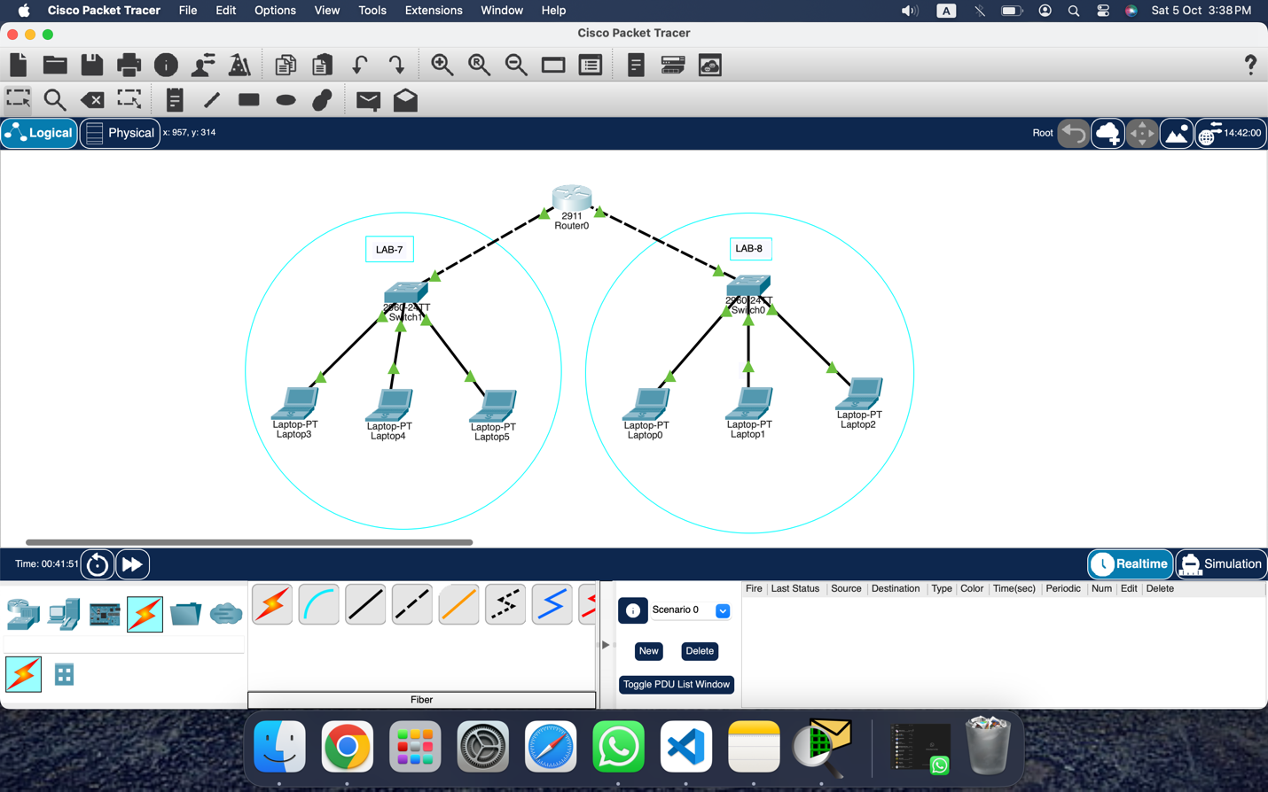

### **VLAN (Virtual Local Area Network)**

enable

configure terminal

vlan 10

name Admin

exit

vlan 20

name Sales

exit

interface fa0/1

switchport mode access

switchport access vlan 10

exit

interface fa0/2

switchport mode access

switchport access vlan 10

exit

interface fa0/3

switchport mode access

switchport access vlan 20

exit

interface fa0/4

switchport mode access

switchport access vlan 20

exit

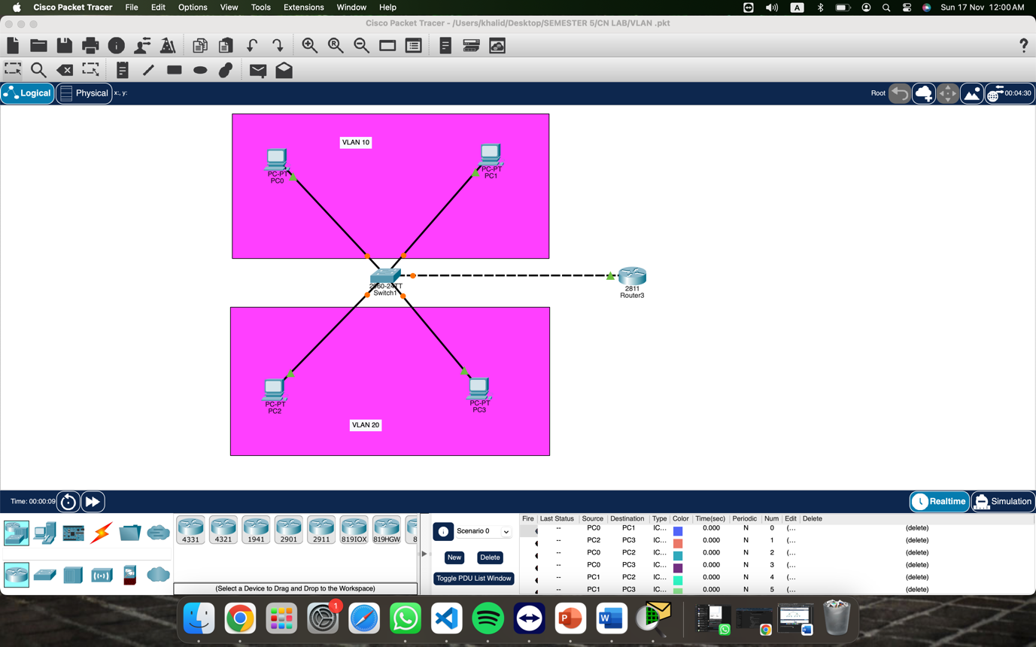

### **3. DNS (Domain Name System)**

