Author: Iwan Roberts, Mr Pink

itle: Paper about loops in Python?

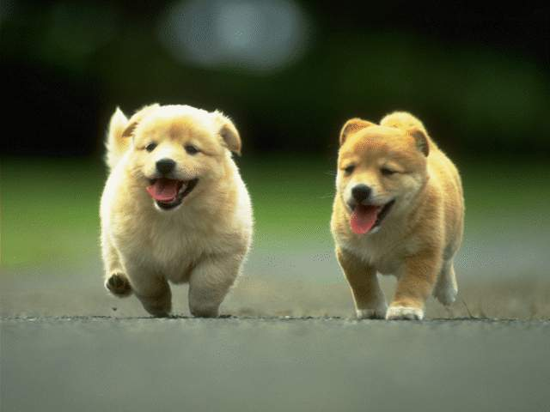

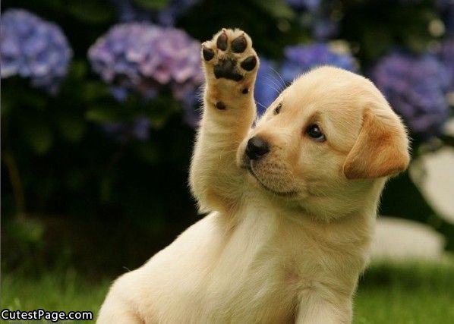

**DOG FIGHT**

1. Intro
2. **Literature review**
   1. Lots of references
3. Analysis
4. Conclusions
   1. No useful conclusions- why not?

**References**

