**Lab2 Interpolation method**

A man recorded his GPS position once per minute when he was jogging, and his position coordinates are listed in the appendix. Please use the recorded data to finish the following questions.



Position coordinates

 

t-X t-Y

(1) 50%, Use the **linear Interpolation** and the **cubic spline interpolation** methods to fit the man’s trajectory, respectively. Please implement these two methods with MATLAB, **do not use MATLAB’s function “spline”**. Draw the trajectories of these two methods in one figure and estimate the trajectory lengths (hint: you can interpolate coordinate X and Y in terms of time t respectively, then refine the time interval t=0:0.1:77, at each moment t, you can obtain interpolation value X and Y, which will be a point on the man’s trajectory. To obtain the trajectory length, you can add up the lengths of all the short lines between every two refined adjacent points on the trajectory).

|  |  |
| --- | --- |
| Methods | Trajectory length (m) |
| Linear interpolation | 7.1096e+3 |
| Cubic spline interpolation | 7.1371e+3 |

(2) 20%, Estimate the man’s speed and acceleration. Draw a figure of time vs speed as well as a figure of time vs acceleration, respectively. Compare the results of the linear method and the cubic spline method (hint: In question (1), you have already interpolated both X and Y with respect to t, so you can use some difference equations to approximate the speed (Vx and Vy) and the acceleration (Ax and Ay) at each time value, the actual speed and acceleration at each moment should be V = sqrt(Vx*Vx + Vy*Vy), and A = sqrt(Ax*Ax + Ay*Ay)).

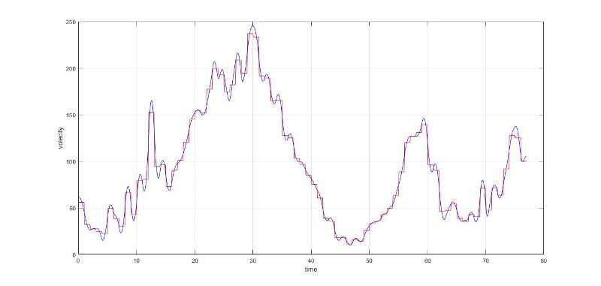

(3)30%, Use any integration method in Part 6 to estimate the area of the blue region in the following figure, compare the results of the linear interpolation and the cubic spline method (hint: you can find the most left point A and the most right point B on the trajectory, which will cut the loop into two curves: the upper bound and the lower bound, and the X and Y values ​​of both curves are mapped one by one in this problem, which means that for each X value, there will be only one corresponding Y value on the curve, so you can interpolate two curves, specifically, first order the points from the left to the right, then interpolate Y value with respect to X value. Finally, according to the interpolated curves, you can use some integration methods to calculate the area under the upper curve (Sa), and the area under the lower curve (Sb), then the area of ​​the blue region will be Sa-Sb).

|  |  |
| --- | --- |
| Methods | Area of the blue region (m2) |
| Linear interpolation | 2.7258e+06 |
| Cubic spline interpolation | 2.7330e+06 |

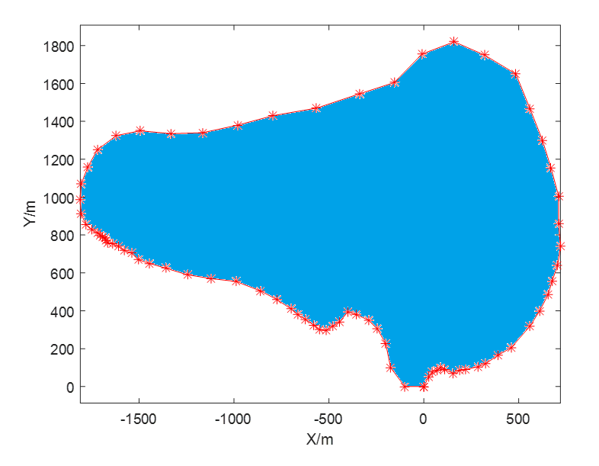

Submit a report together with your matlab code.

**Appendix:**

The first column is time (min), the second and the third columns are X (m) and Y (m) coordinate values respectively.

pos = [

0 0 0;

1 25 50;

2 45 75;

3 70 86;

4 90 100;

5 110 90;

6 155 70;

7 190 85;

8 220 90;

9 285 105

10 325 120;

11 390 165;

12 460 205;

13 560 320;

14 610 400;

15 655 485;

16 675 555;

17 705 640;

18 720 740;

19 710 860;

20 705 1005;

21 670 1155;

22 625 1300;

23 560 1465;

24 485 1650;

25 320 1750;

26 160 1820;

27 -10 1755;

28 -155 1605;

29 -340 1545;

30 -565 1470;

31 -795 1430;

32 -980 1380;

33 -1165 1340;

34 -1330 1335;

35 -1495 1350;

36 -1620 1325;

37 -1720 1250;

38 -1770 1160;

39 -1805 1070;

40 -1810 985;

41 -1805 910;

42 -1780 855;

43 -1750 830;

44 -1720 810;

45 -1705 800;

46 -1690 790;

47 -1680 785;

48 -1675 770;

49 -1665 760;

50 -1640 755;

51 -1610 740;

52 -1580 720;

53 -1540 705;

54 -1505 670;

55 -1445 650;

56 -1360 625;

57 -1245 590;

58 -1120 570;

59 -990 555;

60 -860 505;

61 -775 460;

62 -700 410;

63 -665 380;

64 -625 355;

65 -580 325;

66 -550 300;

67 -515 295;

68 -480 320;

69 -445 340;

70 -400 395;

71 -355 380;

72 -290 350;

73 -245 305;

74 -200 225;

75 -175 100;

76 -100 0;

77 0 0;

];