AIM
AP.020 Project Team Orientation Plan
<Company Long Name>
<Subject>

Author: <Author>
Creation Date: February 12, 1999
Last Updated: June 14, 1999
Document Ref: <Document Reference Number>
Version: DRAFT 1A

Title, Subject, Last Updated Date, Reference Number, and Version are marked by a Word Bookmark so that they can be easily reproduced in the header and footer of documents. When you change any of these values, be careful not to accidentally delete the bookmark. You can make bookmarks visible by selecting Tools->Options…View and checking the Bookmarks option in the Show region.

Approvals:
<Approver 1>
<Approver 2>
To add additional approval lines, press [Tab] from the last cell in the table above.
You can delete any elements of this cover page that you do not need for your document. For example, Copy Number is only required if this is a controlled document and you need to track each copy that you distribute.
Copy Number _____

Document Control

Change Record
1
Date | Author | Version | Change Reference
12-Feb-99 | <Author> | Draft 1a | No Previous Document

Reviewers

Name | Position

Distribution

Copy No. | Name | Location
 | Library Master | Project Library
 |  | Project Manager
The copy numbers referenced above should be written into the Copy Number space on the cover of each distributed copy. If the document is not controlled, you can delete this table, the Note To Holders, and the Copy Number label from the cover page.

Note To Holders:
If you receive an electronic copy of this document and print it out, please write your name on the equivalent of the cover page, for document control purposes.
If you receive a hard copy of this document, please write your name on the front cover, for document control purposes.
Contents
Document Control
Introduction
Purpose
Overview
Session Overview
Project Team Induction
Executive Project Strategy
Charters and Roles
Stakeholder Analysis
Sponsorship Profile and Authority
Application Overview
Cross-Functional Team Dynamics
Application Overview
Impact and Risk Assessment
Cross-Functional Decision Making Setup
Decision Making/Problem Solving Model
Team’s Decision Making Approach
Rules of Engagement
Operating Norms
Implementation Team Support Requirements
Change Leadership Guiding Principles and Roles
Reactions to Change
Change Model
Guiding Principles for Effective Change
Change Leadership Behaviors
Induction Checklist
Open and Closed Issues for this Deliverable
Open Issues
Closed Issues
Appendix A - Implementation Team Interview Guide
Implementation Team Insights Interview Questions
Appendix B - Project Team Performance Measures
Rules of Effective Metrics Program
Approach
Project Metrics
Project Team Performance Tracking

To update the table of contents, put the cursor anywhere in the table and press [F9]. To change the number of levels displayed, select the menu option Insert->Index and Tables, make sure the Table of Contents tab is active, and change the Number of Levels to a new value.

Introduction
Template Instructions
The Template Instructions are formatted as hidden text and are intended for the author of the document only. Delete this section after completing this document.
General hints for completing Adoption Process templates:
- This template contains suggested headings, text, and formatting intended to speed the creation of the deliverable. You may delete or add components to suit your objectives.
- To include hidden text when printing the document, select File, Print…, Option…, Print tab, check Hidden Text.
- To format (or undo) selected text as Hidden, select Format, Font…; check Hidden under Effects.
- To add lines to a table, press [Tab] from the last cell in the table.
- Text that appears between <single carrots> is either a variable to be replaced manually, or instructions for completing the field. Delete or replace all carrots before distributing the document to the organization.
- <Blue, highlighted text> represents a variable that may be defined and replaced automatically upon creation of the deliverable.
- To protect the document so that revisions will show, select Tools, Protect Document…, Revisions. Add a password if you do not want someone to be able to remove the Protect function from the document. To set options for revisions, select Tools, Revisions… and choose your option.

Purpose
The purpose of this document is to assist the project team in successfully defining and refining the project mandate for which it is accountable. The decisions related to the mandate of the <Project Name> were captured as the refined Executive Project Strategy (AP.010). Further, the project team refined the practices for successful management of its mandate, and learned about its role as change leaders. The decisions related to the detailed management of the project for <Project Name> are captured in the Project Management deliverables.

Overview
This document includes the following components:
Components | Description
Introduction | Shows the outline for the work session.
Current Project Team Induction | Exposes the current members of the team to the mandate delegated to them by the steering committee. Included here is the review of the vision, benefits, expected results, alignment with Information Technology and corporate strategy, steering committee roles and performance measures, charter (including roles and performance measures) for the project team, and finally, the decisions, made or to be made, on the implementation strategy and project environment.
Application Overview | Positions the application potential within the context of the key project decisions.
Cross-Functional Decision Making Set-Up | Highlights the dynamics of cross-functional team work, applicable to the implementation team.
Rules of Engagement | Highlights the project team members’ group operating norms.
Change Leadership Guiding Principles and Roles |  | Describes the guiding principles of change and highlights the role of the project team members as change leaders.
Induction Checklist |  | Lists the recommended steps to bring any new member on the project team.
Appendix A | Implementation Team Interview Guide
Appendix B | Sample project team performance measures
We recommend an Organizational Development Specialist complete all task steps. Alternatively, the Project Manager, Trainer, Application Specialist and Business Analyst could handle core steps 1, 2, 3, 4, 7 and 8, as defined in AIM 3.0 Process and Task Reference Handbook.

Session Overview
Assumption: Each attendee has been personally invited (as in the steering committee communication plan) to join the project team, has reviewed the highlights of the Executive Project Strategy document, and was told why he/she was chosen and the possible impact on his/her career.
Preparation Guidelines for the Work Session:
This meeting should be led by the executive sponsor.
1. Review the Facilitation Guidelines in this document (Yellow Notes)
2. Gather necessary inputs, using the Implementation Team Interview Guide in Appendix A, and fill in necessary templates from the Project Readiness Roadmap (AP.070):
- Consolidated Project Team Insights
- Interviewee Profiles (for project team’s internal use only)
- The Executive Project Strategy (AP.010).
In collaboration with the organization’s executive sponsor (or steering committee chairperson) and/or the project manager:
3. Confirm list of attendees
4. Select site for session (preferably offsite)
5. Order giveaways for the team: One of the objective of the sessions is to begin to create a sense of belonging to a team, and depending on the culture of the organization, participants might be given T-shirts, caps, tote bags, or some other items with the name of the project on it.
6. Review Planning Session Checklist template.
7. Tailor the agenda (see section below describing the outline) and send it to the attendees along with the Executive Project Strategy (AP.010), and an invitation memo (use the Invitation Memorandum template) specifying time and place, context of the session, purpose and benefits, why the attendee is selected, objectives: results and expectations, facilitator background, agenda and preparation request: (attendees are expected to read the Executive Project Strategy (AP.010) before the session and be ready to provide feedback). (See Invitation Memorandum template for sample invitation memo)
8. Coordinate with other representatives
9. Prepare materials for the session, for example, slides from the Executive Project Strategy (AP.010).
10. Prepare session scribe.

Purpose
This project team initial orientation session assembled the current members to expose them to the mandate delegated to them, and to help them understand the Executive Project Strategy initiated by the executives and the steering committee. As a result of the session, the project team could build on the initial project decisions and became ready to commit to the project.
The current members of the project team fine-tuned their rules of engagement. A module dedicated to effective change leadership guided a discussion on how the project team members would fulfill their role as change leaders within the organization.
The orientation session was highly interactive and focused on decision making around key questions to help the project team engages in a successful charter for itself:
- Why we are going ahead with this project? What the business drivers leading the project are?
- What the expectations for the project and the project team members are?
- What the terms of reference for the project are?
- How the charter of the project team and the charter of the steering committee complement one another seamlessly?
- How the project team members interact together?
- What decisions are made, by whom? What are the authority levels?
- Who owns which action? When will the action be started? Completed? What are the dependencies?
- How the project team reports back to the steering committee?
- What practices the team adopts as rules of engagement?
The orientation session looked at ways of answering these questions and examined the project issues relevant to the launch of the project team and a successful completion of the project.

Facilitation
Add background notes on the facilitator’s experience in conducting such sessions.
The work session was facilitated by <Facilitator Name> from ……...
<Facilitator Name> Biographical Notes:
In addition, <Scribe’s Name> attended the session to keep a record of all decisions made during the meeting and keep deliverables updated at all times throughout the session.

Attendees
The following people attended the initial project team orientation:
List here the names of project team leads from the organization and the contract resources.
Organization | Name of Attendees | Title
<Company Long Name>
Contract Resources

Outline of the Session
The following outlines the event conducted for the orientation session.
We recommend that the session be held off site for maximum concentration and dedication. The meeting can be broken into a number of work sessions with varying duration.
Sections | Description | Time | Duration
CURRENT PROJECT TEAM INDUCTION
Introduction  Give background for the decision to go ahead with the project  Introduce and welcome project manager and leads, including in each introduction, a brief statement of why the person is chosen.  Make the point that the participants will in turn facilitate a similar induction session with their project team members.  Describe the benefits of the project to the organization, the project team as a whole, and to the individuals who are a part of the team  Express (the executive sponsor’s) own commitment to making the project a success | Overview of the session: purpose, expectations, logistics, etc. |  | ¼ hour
Implementation Model (See Implementation Model component in the Executive Project Strategy, AP.010)  Review guidelines for successful application implementation and most common causes of failure | Highlights the model for successful application implementations; this model guides the refinement of the strategy for the project <Project Name>. |  | ¼ hour
Executive Project Strategy  Review vision, benefits, expected results (objectives and measures)  Review the project alignment with Information Technology and corporate strategy  Discuss high-level view of the impact of the project on technology, process and people  Outline risks associated with the project  Review the key project implementation decisions and their rationale  Review executive decisions already made | Provides opportunity for project team to refine the executive thinking behind the Executive Project Strategy. Confirms the importance of the project for the organization. |  | 1 ½ hours
Charters and Roles  Review charter for steering committee  Review list of steering committee members and their roles  Explain levels of decision making and accountability  Describe interaction of the steering committee and the project team  Present and refine the project team charter and the division of responsibilities between the steering committee and the project team  Discuss performance expectations, responsibilities and accountabilities of the project team | Provides the forum for the project team to refine its charter and clarify the project team role(s) and those of the steering committee. |  | ½ hour
Stakeholder Analysis  Refine Stakeholder Analysis  List anticipated reactions, potential issues and prioritize  List specific benefits to gain buy-in | Brings to the forefront the list of groups impacted (directly and indirectly) by the project. Validates the executive analysis and adds project team’s input on stakeholder analysis. |  | ½ hour
Sponsorship Profile and Authority  Discuss characteristics and functions of effective sponsors  Compare validated stakeholder map to Sponsor Profile Matrix and refine  Agree on project team own sponsorship responsibilities  Stress importance of long-term commitment and involvement essential to project’s success | Furthers the development of the sponsorship network, to include the project team sponsorship responsibilities. |  | ½ hour
Conclusion  Review any logistics pertinent to the team  Summarize information about alignment between corporate vision, business objectives and project vision  Recount benefits on all levels  Announce next work session(s) | Confirms appreciation to the project team for taking on the responsibility and restates promise of support and commitment for the duration of the project. |  | ½ hour
APPLICATION OVERVIEW
Introduction  Position the context of defining cross-functional dynamics for the project team  Review rest of agenda: Application Overview, Review of, Impact/Risk Assessment | Overview of the session: purpose, expectations, logistics, etc. |  | ¼ hour
Cross-Functional Team Dynamics  Define “team”; contrast work teams and project teams  Describe characteristic of high-performance teams  Identify challenges of cross-functional teams  Identify stages of team development  Discuss danger signs | Develops the individual and group skill sets to work efficiently and perform as a team |  | 4 hours
Application Overview  Structure  Functionality  Information flows  On-line demo | Gives project team members the overview they need to understand and plan for the ramifications of the implementation decisions. |  | 8 hours per Application Suite
Impact Assessment  For each critical implementation decision, determine level of impact on technology, process and people  Analyze the consequences of the impact | Gives a realistic picture of the technology-driven change and prepares for proactive management of the consequences of the system implementation. |  | 3 hours
Risk Assessment  Identify risks and barriers and determine actions to mitigate risks/barriers | Highlights the risks that might impair success and generates the action items that are needed to mitigate those risks, to be added to the project plan. |  | 2 hours
Project Implementation Decisions  Consolidate the action items identified to manage the impact and the risks associated with the critical implementation decisions  Develop resource projection | Validates the action items developed in the session and favors congruity. |  | 1 hour
CROSS-FUNCTIONAL DECISION MAKING SET-UP
Introduction  Position the context of identifying decision making norms for the project team | Overview of the session: purpose, expectations, logistics, etc. |  | ¼ hour
Cross-Functional Decision Making Model  Facilitate the Desert Survival or Jungle Survival activity  Present basic decision making model  Identify effective alternatives for generating options  Discuss possible approaches to decision making  Decide who will make decisions, what decisions they have the authority to make, what constraints are in place  Select approach for the project team, to be initially applied | Allows the team to define the detail of their decision making approach, using a fictitious example first, to prepare them to the upcoming AIM planning session. |  | 1 hour
AIM Planning  Determine what resources and tasks will be executed if not explicitly stated in contract with the organization. | Customizes the AIM tasks and deliverables, along with resource requirements, to the customer-specific needs. Provides a forum for the project team members to use the decision making approach they agreed to in the previous work session. |  | Up to 5 days
RULES OF ENGAGEMENT
Define procedures around all relevant areas of project management  Agree on communication standards and model for the project team  Define project team group operating norms | Highlights decisions (short and long term) around project management practices, including the team’s internal communication practices. |  | 4-6 hours
CHANGE LEADERSHIP GUIDING PRINCIPLES AND ROLES
Review examples of recent change and reactions to those changes  Discuss guiding principles for effective change leadership  Agree on roles of project team members as change leads | Highlights the 8 guiding principles to effective change leadership, describes the typical reactions to change and guides the discussion on the roles of the project team members as change leaders |  | 2 hours
INDUCTION CHECKLIST
Create a list of steps required for new team member induction | Highlights the approach and actions to facilitate the induction of a new member to the team. |  | 1 hour

Project Team Induction
Make the point that the participants might in turn facilitate a similar induction session with new project team members who join the team.

Executive Project Strategy
As you review the highlights from the Executive Project Strategy (AP.010), make sure the discussion is interactive and the project team members have a chance to clarify and refine the points discussed from their own background and contribution. Indicate that there will be a later session to further elaborate on the decisions made, the impact/risk assessment, etc.
Capture the key points in the Executive Project Strategy (AP.010).
We discussed the following from the Executive Project Strategy (AP.010):
- Background for the decision to go ahead with the project.
- Why each member was chosen.
- Benefits of the project to the organization, the project team as a whole, and to the individual leads and members.
- Implementation Guidelines for a successful application implementation project.
- Project vision and expected results (objectives and measures).
- Alignment of project vision with Information Technology and corporate strategy.
- High level impact of the project on the organization’s current technology, processes and people.
- Key project implementation decisions and their rationale
- High level risks associated with the project (for example, the impact of significant delays).
- Other executive decisions, already made.

Charters and Roles
We reviewed the following from the Executive Project Strategy (AP.010):
This discussion should enable the members to personalize and commit to the charter, roles and expectations assigned to them. Allow plenty of interaction so the participants can:
1. shape the charters and roles and buy-in to their mandate
2. clarify performance measures, involvement and commitments. Use Appendix B for a sample of performance expectations for the project team. Focus the discussion on key measures that have high impact and facilitate agreement on how the project team’s performance will be measured. The listing of these measures is the first step. The next is to agree on the reinforcement methods to be used in cases of both compliance and non-compliance with the agreed measures.
Capture the key points in the Executive Project Strategy (AP.010).

- Charter for steering committee
- List of steering committee members and roles
- Levels of decision making and authority established for the steering committee and the project team
- Project team charter and the division of responsibilities between the steering committee and the project team
- Performance expectations and the responsibilities of the project team
- Response time to the project team for critical decisions to be made by the steering committee

Stakeholder Analysis
Facilitation Guidelines: Refer to the Sponsor Profile Matrix in AP.010.
1. “Explain the term “stakeholder.”
2. Break the group in pairs or triads and ask them to identify stakeholder groups. You may use an organizational chart for the exercise.
3. Reach a group consensus on the list of stakeholder groups. Compare results to the list created by the Executives (Sponsor Profile Matrix in AP.010) and refined by the steering committee.
4. Create a revised Stakeholder Analysis which represents the best thinking of the combined groups.
5. Ask the participants to anticipate the reactions to the project on the part of each stakeholder group. List potential issues and prioritize groups needing more intense change management.

The following represents the analysis of our stakeholder constituencies:

Sponsorship Profile and Authority
Facilitation Guidelines: Using the sponsorship section from the Executive Project Strategy (AP.010):
1. Ask participants to think of the sponsor of a project (technology related or not) with whom they worked in the past. 2. Obtain clips of the following music: “The Nowhere Man” by The Beatles, “I Can’t Get No Satisfaction” by The Rolling Stones, “I Can Get By (With a Little Bit of Help From My Friends” by Jo Cocker, and “I Did It My Way” sung by Frank Sinatra.
Ask participants to select the music clip that best represents that sponsor. Play the four music clips on sponsorship styles.
3. Discuss characteristics and functions of effective sponsors., in theory and applicable to the organization’s culture.
4. Introduce the concept of the honeycomb (elaborate network, delicate but very strong that enables the bees’ work structure) to illustrate the need for a sponsorship network.
5. Compare the revised Stakeholder Analysis to the Sponsor Profile Matrix (from the updated Executive Project Strategy). Look for any stakeholder groups who do not have sponsors identified. Expand the network as necessary on the updated Executive Project Strategy.
6. End the discussion by asking the members to describe their own sponsorship responsibilities. Capture the responsibilities in the updated Executive Project Strategy.

Specific project team members’ sponsorship responsibilities include:
- Communicate positively and frequently about the project to the people with whom they come into contact
- Be supportive of the people assigned to the project and remove barriers for the people in their sub-teams
- Maintain commitment in themselves for the project throughout its lifecycle
- Use resources wisely
- Keep executive sponsor alerted of danger signals early enough so dangers can be avoided
- .....

Application Overview

Cross-Functional Team Dynamics
Facilitation Guidelines:
1. Discuss the definition of team. How does a team differ from a group? How does a project team differ from a normal work team? What are the dynamics of a cross-functional team?
2. Identify the challenges of working on a project team whose objectives is to implement complex technology. Why is this type of project inherently difficult? Discuss complexity, duration, turnover, problems with politics, resistance, and whatever else participants may have experienced in the past.
3. Ask participants to work individually and write brief descriptive phrases of the best teams they’ve ever been a part of. Compare notes. Discuss the key ideas and determine why they are important to effective teams.
4. Conduct the Staying Dry Activity: Team members are asked to stand on a board 6” x 12” in any order. They are told to imagine that the board is surrounded by water and the objective is to stay dry. They are then told to arrange themselves by height and then to rearrange themselves in the order of the month and day in which they were born starting with January 1. Use the activity as an illustration of working toward a common goal, demonstrating cooperation, leadership, communication skills, planning, problem solving and making use of resources.
5. Refine the definition of the project team by discussing problems characteristics of cross-functional teams.
6. Discuss past experiences in team development by using Tuckman’s model: Forming, Storming, Norming, Performing. Identify characteristic of each stage, ask for examples of relevant experience. Discuss what the team can expect and brainstorm ways to move to “performing” quickly.
7. Discuss danger signs. How do you know if a team is in trouble? What can you do about those danger signs?
8. Suggestion: Show the video: The Four Hour House and ask participants to look for additional ideas on how to work together well.
9. Discuss lessons that can be learnt from geese and how they work and fly together. Make comparison to working together for the life of the project.
10. Summarize key points and make the transition to the group norming activity which will be held in a further work session when participants will agree upon the behaviors which will allow them to work comfortably together as they strive to reach the “performing” stage.

Definition of a High Performance Cross-Functional Team
Cross-functional team applies to ...
Project teams differ from work teams in that ...
The characteristics of a high-performance cross-functional team are:
- common goals
- shared responsibility
- shared risks
- willingness to learn
- ability to have fun
- reliability
- interdependence
- effective communication
- high skill levels
- participative leadership
- .....

Challenges Inherent to a Cross-Functional Team
The major challenges of our cross-functional team will be:
- establishing identity/cohesion
- building interdependence
- coping with different cultural pressures
- dealing with geographical separation
- working through hierarchical issues
- establishing role clarity
- developing communication skills
- dealing with team life span and closure
- leadership responsibilities
- sponsorship responsibilities

The Stages of Team Development
A team typically goes through the following stages of development:
Stages of Development (Tuckman’s Model) | Measures to Move on to the Next Stage
Forming
Storming
Norming
Performing

Danger Signs
Typically, the team should be alert to the following danger signs:
Danger Signs | Measures to Mitigate

Application Overview
Start the Application Overview with a walk through of Project Management Plan [PJM.CR.010, initial complete], produced in task PJM.CR.030; review rationale and implications of key implementation decisions. This session is led by an applications specialist and/or instructor (trainer). The objective is to introduce the critical decisions to be executed throughout AIM. Some of these decisions may have already been made by either the executive team or the steering committee; some may have been delegated to the project team.. However, even if a decision has already been made, project team members need to understand the implications of that decision. As they receive applications training, they can listen with “educated ears” to information relating to the each of the key decisions areas, the benefits of each of the alternatives, the risks, and impacts on various parts of the organization. The applications specialist will introduce the decisions, give additional detail, and answer questions.
See Application Overview Customization template, for the review of the information gathered to allow the application overview instructor to tailor the content of the overview to the specific needs of the project team and the relevant critical implementation decisions.

Application Overview Modules
The modules included in the Application Overview are:
Identify here the appropriate modules.

Topics
The topics covered in the Application Overview are:
Tailor as needed.

- Overview
- Introduction to Applications
- Start-up and log on to Applications
- Navigate through the system
- Assign values to common profile options
- Applications Structures
- Review the basic structures on which the applications are built
- Discuss system administrator functions such as defining a user and building Alerts
- Application Functionality
- Review the functionality of each application
- Identify the dependencies between applications
- Compare data that is shared between different applications, such as customers, suppliers and accounting information.
- Follow the Information Flows Between Applications
- Review the use of open interfaces which allow Applications to receive data from external sources
- View on-line demonstration of Applications

Impact and Risk Assessment
Start by reviewing and augmenting, in the Executive Project Strategy (AP.010) and/or Project Management Plan [PJM.CR.010, initial complete], produced in task PJM.CR.030, the impact and risks/barriers and the actions to mitigate the risks. Follow the facilitation guidelines in AP.010 as appropriate.
The following are the major impact, risks and barriers, and action items discussed by the group:

Cross-Functional Decision Making Setup
Facilitation Guidelines:
Begin this session using the Desert Survival or Jungle Survival activity.
1. Ask participants to identify individually what equipment would be most valuable if they were stranded in the desert or the jungle.
2. Facilitate the negotiation of a team list.
3. Process the activity:
- Which decision came closer to being right: individual or team?
- What were the communication patterns among team members?
- How was conflict resolved?
- Did leadership emerge?
- Was the atmosphere supportive and cooperative or competitive?
- What did they learn about themselves?
- What is applicable to a cross-functional project team such as this one?

Decision Making/Problem Solving Model
The following is the decision making/problem solving model agreed to by the project team:
Facilitation Guidelines:
Present the basic decision model. Use a universal problem, for example, drugs at the local elementary school or a problem from the Memory Jogger Teamwork series as a case study., As you present the various steps and techniques of the model. Challenge thoughts/conventional wisdom/think outside the box
1. Compare the steps of the model to what the participants have used in the past in different situations
2. Discuss the differences in divergent and convergent thinking using this model. Explain the value of allowing divergent thought as options are explored and the need to reach closure as a decision is made.
3. Discuss some effective techniques for tapping into creativity as options are explored.
4. Discuss possible approaches to use in the “choose option” step. Discuss the criteria which would make an approach preferable in a given situation, that is, time frame, level or commitment required, ...
5. Emphasize the value of good execution in the implementation step.
6. Highlight the specific decision dynamics related to the cross-functional nature of a project team.
# | Step | Notes
 | Define (Opportunity or Problem) | - Who/Who not?  - Where/Where not?  - When/When not?  - ....
 | Identify Probable Causes | Use the 5 why’s
 | Develop Courses of Actions/Alternatives | Divergent vs. Convergent thinking  cover all bases – no holes or gaps, also develop contingency plan
 | Chose Options | Nominal grouping, consensus, voting, affinity diagram, let one person decide, dice, easy out, spell out, best home or balance sheet
 | Implement | Implement the solution – determine strategy to implement
 | Observe and Evaluate | Track solution implementation: Did it allow to meet the objective (or solve the problem)? If not, go back to Step 1. Refine as necessary.
 | Celebrate/Closure | Celebrate and congratulate, then move on.

Effective Techniques to Tap Into Creativity
The following techniques were reviewed for the team:
- Brainstorming
- Nominal
- Group
- Plus/Minus/Interesting
- Random Simulation
- Escape Method
- Synergistics
- …

Team’s Decision Making Approach
The project team agreed to the following approach for decision making:
Facilitation Guidelines: Refer to the Executive Project Strategy (AP.010) deliverable
1. Ask the team to think of how they will operate in the future and to identify the following:
- What types of decision the team will be making?
- What people will need to be involved in what types of decisions?
- What decisions are they empowered to make?
- What decisions can they make which must be approved?
- What approach will they take to decision making?
- What criteria will they use as they make decisions?
Ask the project team members to make these decisions on two levels: first, the general process moving forward, and second, the specific process and approach they want to use as they make decisions for the AIM Planning Session.
2. Capture the consensus (around the general process moving forward) of the project team in the appropriate PJM (Project Management) deliverables and in the project team’s communication plan for dissemination of performance measures and results.
3. Alert the AIM Planning meeting leader of the project team’s consensus for the specific process and approach they want to use as they make decisions for the AIM Planning Session.
Types of Decision | People to Involve | Empowered  Yes or No | Need Approval  Yes or No | Approach | Criteria
Routine
Resourcing
Scope
Facilities

Rules of Engagement
Assumption: This session is led by the project manager, with facilitation assistance.
Facilitating Guidelines:
1. Review the need for group norming among the project team members.
2 Facilitate discussion around norms; use the checklist below as guide. Tailor list as appropriate.
3. Define the behaviors corresponding to the list of norms and what happens if a member does not conform to the norms.
4. Discuss the relevancy of the selected norms and behaviors in a cross-functional team environment, dedicated to a technology implementation project.
5. Facilitate discussion on role clarification: starting from the discussion around the project team charter, finalize role descriptions as they apply to the project: key responsibilities, skills, decision accountability, authority levels, reporting, areas where input is expected, how the roles (and incumbents) relate to one another. Capture on Terms of Agreement.
6. Review the Project Direction and Roles components from the Executive Project Strategy (AP.010) deliverable. Include a discussion on the support requirements for the implementation team. Use the checklist in this deliverable.
7. Consolidate list of action items derived from above and capture in the Executive Project Strategy (AP.010) (or the PVCS Tracker). Include action items for project team mobilization communications.

Operating Norms

Checklist of Group Operating Norms
Typical group norms include the following:
- Agree to share responsibility for making the group work by taking initiative in starting and contributing to interaction.
- Speak only when no one else is speaking.
- Do not interrupt.
- Listen to understand rather than to rebut.
- Honor time boundaries – start times, stop times, due dates, ...
- Disclose your thoughts and feelings about the group process,
- Be objective, suggestions should facilitate solutions, not point blame.
- Say what you think and feel in the team meeting rather than saving it for discussion outside the team with only some of the team members.
- Deal with the here-and-now rather than focusing on history and incidents outside the team.
- Speak to individuals in the team rather than talking about them, when they are present or absent.
- Offer support to others.
- Offer helpful confrontation to others.
- Explore your reactions when confronted.
- Express reactions to the interactions of others.
- Speak for yourself. Do not generalize without substantiation.
- Be concrete and specific in your observations.
- Deal directly with conflict and differences.
- Acknowledge your appreciation for feedback.
- Avoid advising, interpreting, premature problem-solving, labeling/diagnosing, personalizing.
- Demonstrate initiative by participating in discussion, completing assignments, and looking for ways to improve processes.
- Address conflict, competition, and conflict avoidance openly.
- Seek an agreeable, workable solution jointly.
- Treat team members with respect and support.
- Use concrete, specific examples.
- Maintain confidentiality.

Project Team Norms and Behaviors
Our team will adhere to the following:
Norms | Corresponding Behaviors | Measures in case of non-compliance

Implementation Team Support Requirements
Consider the following when deciding how to extend technical support to the implementation team:
- training the help desk
- Technical Assistance Request (TAR) resolution procedure
- apprenticeships
- list of hardware and software requirements
- procurement of hardware and software
- installation of hardware and software
- testing environment
- learning environment
- internal service level agreements
- external service level agreements
- support of web site and/or repository
- problem resolution procedure
- upgrades or patches for software
- DBA training (starting the learning events for the DBA now can give the person a chance to get involved and learn throughout the implementation)
- passing lessons learned from implementation to help desk
- installation failure policy
- lines of delineation for budget responsibility, for example, are the business units or the Information Technology department paying for the learning events for the implementation team

Change Leadership Guiding Principles and Roles
Facilitation Guidelines:
1. Ice breaker: Suggest that participants switch their watches to their other arm for the duration of the session. At the end of the session, point out how unsettling such a little change can be.
2. Begin the session with a brief discussion of change in today’s business world, the pace, complexity, and volume. Tailor examples to the organization’s industry.
3. Discuss types of change: incremental versus transformational. What type of change are they going through? What difference does it make? Discuss technology-induced change. What makes it particularly difficult? For example, complexity, broad impact, fear factors associated with it...
4. Ask participants to describe their reaction to a recent change they experienced. Discuss “resistance”. Resistance is the normal human reaction to change. Ask if there is anything positive about resistance (yes; shows that people are alive, interested, thinking...) As a group, ask participants to brainstorm reasons why people resist. Discuss reasons which are based on reality (for example, an announced cut back in staff), those based on fear, and those which are simply a part of human nature (habit, past experience, low trust, etc.). Identify the symptoms of resistance in themselves and others. What level of resistance do they anticipate to this project in their organization?
5. Emotional reactions to change. Explain that effective leadership can help people move through reaction cycle quickly and keep the “valley of despair” shallow. Obtain from participants examples of resilience and congruence after change. As time allows, refer back to the Stakeholder Matrix and for each priority group, indicate what level of acceptance is most appropriate.
6. “Facilitating Change”; discuss what it takes for an individual to change, all the way to the behavioral level: will (information and leadership) and skill (learning and performance support).
7. “The Guiding Principles of Change.” Relate to the “Facilitating Change” model. Briefly review each principle.
8. Break the group into pairs and give each pair two principles to analyze, that is, why each principle is so important and the role project team leaders can play in putting the principles into effect.
- a) Vision: They don’t create vision so what is their role? Their role is to disseminate the project vision and keep making the tie to the business objectives.
- b) Leadership: Why is their leadership role so critical? What do they need to do? They serve as highly visible role models and must keep their decisions lined up with the project vision. They serve as sponsors for the groups they represent; they have a responsibility to build support for the project. They also need to realize that loss of commitment among project leadership is a problem. What do they need to do to prevent that in themselves and to keep their teammates motivated?
- c) Communication: What is the role of project team leaders in communication? People need to be constantly told why the project is being undertaken, why this is the best option, what is happening currently, what is about to happen, what the future will look like, what’s in it for them...
- d) Share Ownership: How can they involve the stakeholders so there is buy in across the organization?
- e) Culture: Describe the key cultural elements which impact transformational change and ask how they can impact those areas. They have a responsibility to build trust, maintain customer focus, promote teamwork, and foster risk taking and creativity.
- f) Scope Control: What role do they have in protecting the project from competing projects vying for the same resources? From creating a saturated level of change? What are their plans for preventing scope creep, the bane of technology implementations?
- g) Supporting Structure: How can they put in place the structure to reinforce the desired behaviors? They can put in place the right learning programs, rewards and recognition, etc.
- h) Learning Organization: What is one? What are its benefits? What role do they play in helping the organization learn how to learn?
9. Brainstorm strategies to overcome resistance using the eight guiding principles. Extract the leadership behaviors for the project leads. Capture on the Change Leadership Behaviors matrix.

Reactions to Change

Accelerating the Path Through the Valley of Despair
As users react to change through shock, fear and “wait and see” attitude before they commit to the new roles they must fulfill, there is a great drop in productivity. Adoption tasks aim at accelerating the cycle of reaction to change so the productivity drop is lessened and users achieve acceptance faster and generate higher productivity.
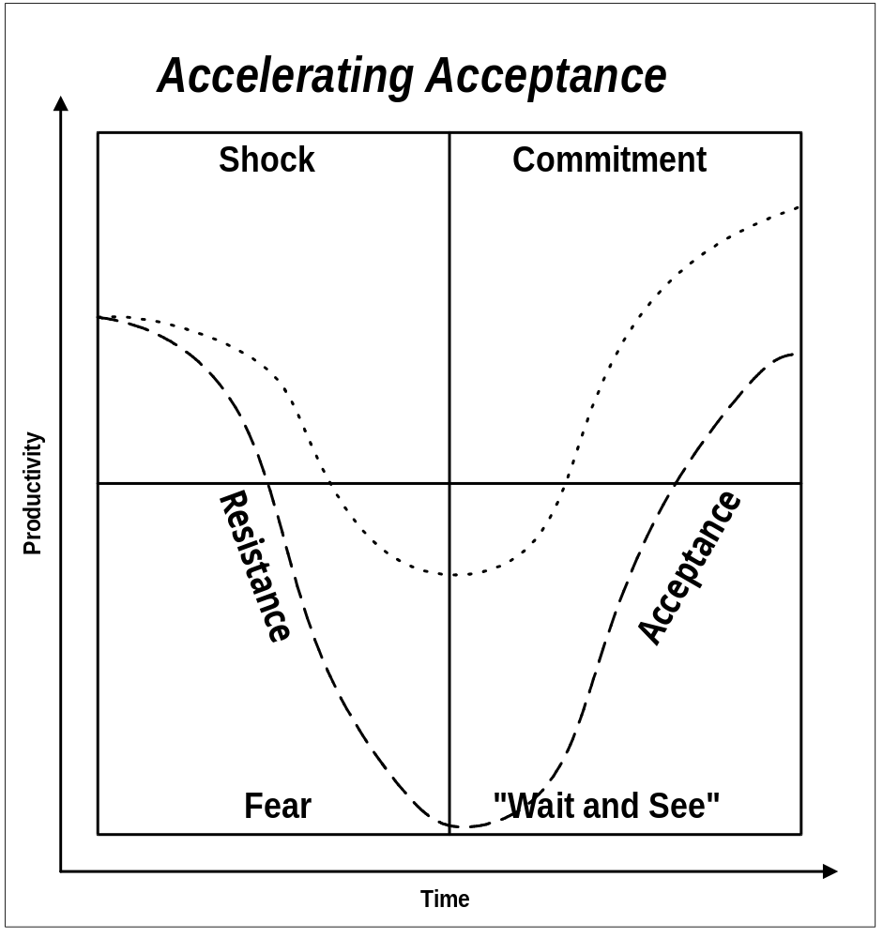

Change Model

To Change, Individuals Need the Will and the Abilities
To facilitate the change from the present to the desired situation, users need the will and the abilities to change.
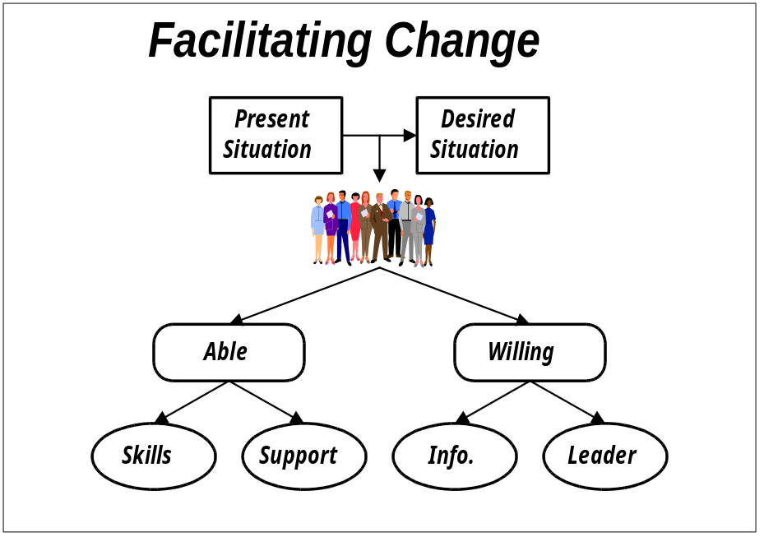

Guiding Principles for Effective Change

Leading Change From Resistance to Resilience
There are eight guiding principles for effective change.
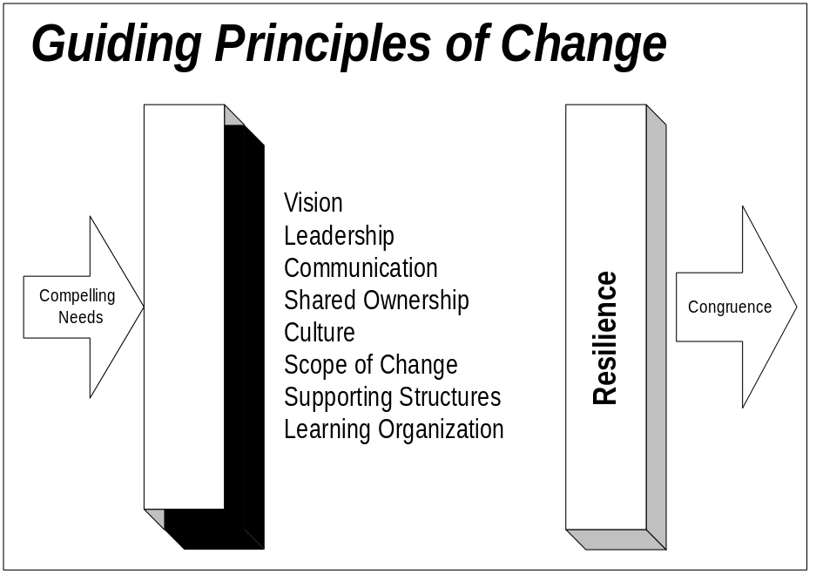

Change Leadership Behaviors
Leaders at all level must participate in the change leadership pattern across the organization. The project team agreed to the following change leadership behaviors:
Tailor the following matrix to the team’s context.
Guiding Principles | To Do | How To
Create a Clear, Compelling Vision  Give a picture of where you are headed  Describe how the vision will be achieved  Keep it concise | Promote the project vision and keep in the fore front its tie to the corporate strategy  Leaders need to be able to dream and do; get some talented dreamers to help you on the team  ..... | Think about how the project can best serve the corporate strategy; dream big.  Identify the key benefits of the project.  Distill your thoughts from step one and two above: Is there an underlying theme? Aim for elegant simplicity.  Figure out where you are now. Spend enough time to know where you are, but your main focus is on the future.  Describe the gap in terms of a compelling need to change (This is the transformation.).  Try your project vision statement on everyone you meet.  If you can’t make others understand in less than three minutes, start again.
Assess the Organizational Culture  Focus on the customer  Look for innovation and creativity  Encourage risk taking  Evaluate teamwork | Assess your current organizational and team culture.  Put the focus of the project squarely on the customer.  Create a clear path from the customers’ needs to the resources that meet those needs and to the project team.  Nurture creativity.  Don’t punish pioneers. | Assess the organization’s readiness to fulfill the project vision. Hold focus groups and gather feedback on how-we-do-things-around-here. Consider benchmarking from the outside.  Choose performance measures which tie directly to customer satisfaction.  Involve customers; they are key stakeholders in the project; ask for their feedback, and if appropriate, their participation as liaisons to change teams.  Ask your team what could be done to allow them to serve the project customers better.  Provide opportunities for ideas to surface. Recognize and reward innovation.  Recognize some important near misses.
Lead the Way  Assemble a coalition  Function as a sponsor  Serve as role model  Create a sense of urgency  Endure to the end | Begin with yourself. If you don’t role model the future, no one will.  Find influential allies who share the project vision.  Accelerate the pace just enough to create the right sense of urgency and momentum.  Create early wins and communicate those wins.  Endure to the end. | Ruthlessly examine yourself to determine how your behavior and approach to the project work, values, plans align with the project vision. Get feedback from others.  Walt the talk.  Do things highly visible to make the change real. Slay a sacred cow.  Assign all on the project team (communication agents) the task of spreading the word throughout the organization.  Use hard, cold facts to keep the compelling need for change in plain sight.  Set stretch goals. Monitor, measure, celebrate, and set new goals.  Cherry pick—find early wins, publicize, reward, celebrate.  Give presentations; conduct one-on-ones, focus groups, town hall sessions; preside at celebrations; remove barriers; find resources.
Manage the Scope of Change  Stay within people’s finite capacity to absorb change  Keep an “open system” approach: systems are inter-dependent, multi-dimensional: change one, change all  Tie to the vision, to keep the change into context | Assess the people’s capacity for change.  Lobby to kill, merge or delay any non-essential project.  Define the big picture; let people see how initiatives interrelate. Establish strong ties to the corporate strategy. | Review data to inventory current changes and detect people’s capacity to absorb change.  Gather information on all major projects. Look for objectives, overlaps, conflicts, commonality, scope, and time frames.  Help validate the project as priority.  Integrate, harmonize remaining projects.
Communicate Openly, Honestly, Relentlessly  More is better: Repeat key messages through different sources, consistently  Open two way communication channels  Manage the information; keep no secrets | Determine your organization’s preferred ways of communication.  Create a formal plan for two-way communication.  Use communication agents.  Broadcast successes.  Keep abreast of people’s needs for communication and meet those needs.  Measure the effectiveness of the communication.  Manage rumors at their onset. | Create a supportive environment for the communication agents and the two-way communication channels.  Use communications (two-way) to:  - Create buy-in  - Glean ideas you may not have thought of  - Build trust  - Build enthusiasm  - Determine where resistance lies  - Estimate the strength of the resistance  - Determine the causes of the resistance  - Clear up misconceptions  - Figure out how far and fast people can move  - Make course corrections  - Find pockets of support  - Surface concerns rather than suppress them
Promote Shared Ownership  Involve: People support what they help to create  Ownership improves quality and relevancy of decisions: involve everyone, involve them early | Identify your stakeholders.  Determine whose support is critical and whose opposition could be dangerous.  Find opportunities to create buy-in. | Create a matrix that shows impacted groups and anticipated support levels (Stakeholder matrix). In critical areas, get down to an individual level.  Identify their stake in the change.  Assess their readiness to change.  Hold focus groups with representative sample of highly impacted groups.  Hold one-on-one sessions with key stakeholders.  Involve stakeholders in supporting the project, ideas generation, focus groups, change teams, communication, and problem solving sessions.
Create Supporting Structures  Streamline decision making process  Make rewards and recognition supportive of vision  Instill measurements tied to the vision  Align human resource systems with required behaviors | Keep project bureaucracy to a minimum.  Create reward systems specially for the project.  Adopt measures to focus on the transformations critical to the project vision.  Look for disconnects between HR policies and project set up/vision. Adjust HR systems accordingly. | Keep layers in the project hierarchy to a minimum.  Push authority and accountability down.  Define the behaviors which are conducive to achieving the project vision.  Mix measures; hard, soft, financial, non-financial, process and results.  Provide the right learning events.  Make participation on the project team a career enhancer.
Build A Learning Organization  Operate on an assumption of competence  Create safe environment for learning  Promote knowledge transfer | Recruit the “best and brightest”  Encourage knowledge sharing  Promote voluntary followership  Unite people behind the project through shared vision, shared values, shared purpose  Regard mistakes as learning steps  Provide learning opportunities | Encourage individual characteristics which a learning organization should recognize and reward: self-directed learning, respect for others, empathy, curiosity, listening, systems thinking (ability to see how things are interconnected), risk taking, two way communication—dialogue, humility (being teachable), ability to learn from mistakes, self-knowledge—aware of strengths and weaknesses  Weave learning through status reporting

Induction Checklist
Use this checklist to guide the orientation of each team member to the project. This process will help all new team members receive the information they need, are put in contact with the people with whom they need to interact and overall, experience a positive integration which makes them high performing team members early on.
Assumption: All new team members have been personally invited (as detailed in the project mobilization communications) to join the team. Use the first item of this checklist to guide this first interaction.
If new team members join the team on an individual basis, a current project team member can walk through the induction process with each of them. If a number of new members join at the same time, you might consider conducting the process (all but the first step) in a group setting. Whether new team members are introduced to the project individually or as a group facilitate the process and pace its progress to the integration of the new members..
It can assist the process if each new member is assigned a “buddy” for the first few weeks in order to facilitate that member’s integration into the project team.
Each new member to the team will be oriented to the project through the following steps:
Induction Step | Action Items/Information Topics | Documentation/Equipment
Invitation to join the team (one on one conversation with the project lead) | Cover these items in your one-on-one meeting:  Role that the new member will play on the team  Expertise s/he brings  Career opportunity the project provides (what happens to his/her current organizational role)  Project vision and business objectives  Sponsorship behind project  Overview of the project: strategy, implementation decisions, ...  Review of Steering Committee and Project Team members  Where s/he fits on the project organizational chart; who s/he reports to, who s/he interacts most with  Challenges of the project  His/her authority level and accountability  Performance measures  Assign a buddy to provide support to the new team member | Information on the business environment from the proposal  Executive Project Strategy (AP.010)  Project Orientation Guide (PJM.RM.025)  Project management deliverables produced so far
Provide logistical details | Provide equipment  Inform about administrative rules  Give details on the work site including  Office/area, phone  Reception phone/fax  Access materials, passwords, ...  Parking  Security badges  Work hour  ... | Computer  Office Supplies  Email address/user name  Project Accounting  Project Numbers  Travel expense guidelines  Travel agency number  Travel profile  Employee benefits  Employee’s book (website address....)
Introduce new member to the team | Introduce the new member to the team members (person to person, during the next meeting, ...)  Introduce the new member to the sponsors  Review the meeting schedule and identify the meetings the new member needs to attend  Review the agenda and required preparation for the next meeting | Roster of all team members with contact information  Meeting Agenda  Communication Standards and Model
Explain the requirements for communication | Review the communication standards and model for the project team  Explain the purpose/importance of communication and status reporting for the team  Explain how to use the Project Library | Communication Standards and Model  Copies of past Status Reports  Project Library documentation
Review the group norms for the team | Emphasize the corresponding behaviors, including change leadership behaviors | Project Team Group Operating Procedures
Prepare the new member to play an active role | Complete the Data Gathering Tool for Project Team Skills Inventory  Review/Update learning plan for the team member  Schedule learning events and measure effectiveness  Update skills sets in member’s file  Review performance expectations and performance management process | Data Gathering Tool for Project Team Skills Inventory (in Project Team Learning Plan, AP.030)  Project team performance management process

Open and Closed Issues for this Deliverable
Add open issues that you identify while writing or reviewing this document to the open issues section. As you resolve issues, move them to the closed issues section and keep the issue ID the same. Include an explanation of the resolution.
When this deliverable is complete, any open issues should be transferred to the project- or process-level Risk and Issue Log (PJM.CR.040) and managed using a project level Risk and Issue Form (PJM.CR.040). In addition, the open items should remain in the open issues section of this deliverable, but flagged in the resolution column as being transferred.

Open Issues

ID | Issue | Resolution | Responsibility | Target Date | Impact Date

Closed Issues

ID | Issue | Resolution | Responsibility | Target Date | Impact Date

Appendix A - Implementation Team Interview Guide

Implementation Team Insights Interview Questions
The implementation team members were asked the following questions: You can also find a copy of the Implementation Team Insights Interview Questions in AP.070, Project Readiness Roadmap, appendix.
1. Review information gathered through Executive Insights (for Executive Project Strategy, AP.010 and captured in Project Readiness Roadmap, AP.070).
2. Start with project manager and other internal contacts before talking to the organization’s representatives.
3. Schedule the organization’s project manager.
4. With the project managers, identify other respondents; update interview guide as needed.
5. Schedule interview (send Interview Announcement, for example, memo describing context of the interview, purpose, time/duration, location, why respondent is selected, topics to be covered, background of interviewer, etc.). See AP.070, Interview Announcement template for a sample
6. Conduct interviews; send interview notes to interviewee within 24 hours; complete Interviewee Profile in Project Readiness Roadmap (AP.070, in appendix (for project team internal use only).
7. Consolidate notes from interview using Consolidation Matrix in Project Readiness Roadmap, AP.070, in appendix.

- Do you know what this project is about, that is, vision, expected results, etc.? How does it fit with the corporate strategy? How does it fit with other business initiatives?
- Do you know why you were selected for the team? What strengths do you bring? How is this assignment perceived?
- Do you understand your role in the team and how it relates/impacts others? Do you know who all the team members are?
- What do you hope to get out of this project?
- What are other projects you have led or in which you played a major role? (dollar amount, time frame, number of people involved, impact on organization, ...)
- What barriers exist which might hinder the project?
- What strengths/levers exist which could contribute to the success of the project?
- What has been the organization’s and your past experience in implementing technology? What has gone well? What has not gone well? What ideas do you have for improvement?
- What is your perception of the sponsorship of this project? (Visibility, commitment, urgency, authority, influence.)
- How realistic are the goals for the project?
- How would you evaluate the capability of the project team to achieve the project’s goals?
- What are the communication challenges in the organization?
- How do you typically get information/updates related to large projects?
- If you have an urgent message (issue) related to a project, how do you typically communicate it?
- How would you evaluate the levels of trust within the organization?
- How much experience have you had in working on cross-functional teams?
- What perceptions do you have concerning vendor? (The products, the organization, the people)
- If this project is successful, what benefit will there be for you? For your team? For the organization?
- How would you evaluate the resistance to this change within the organization?
- At what sites will the technology be implemented?
- How many employees at each site? How many users will there be?
- Is business process design a component of this project? If so, have the process redesigns been completed?

Appendix B - Project Team Performance Measures
This is a mechanism for complying with project team performance expectations - what and how to handle bad results must be linked to the escalation process,

Rules of Effective Metrics Program
Three rules need to be followed to have a successful metrics program, temporary or on-going:
- Measurements must support the business itself. The project measurements must reflect the way in which the project vision supports the corporate strategy.
- Measurements are not a replacement for management. Measurements are not the “be all and end all,” they help communicate and coordinate the project.
- Measurements must have organizational importance and cannot be considered as overhead.

Approach
Copy the text below from January-February 1992, Harvard Business Review article or research the latest and edit accordingly:
One useful approach to measuring business value was developed by David Norton, former president of Nolan, Norton and Co., and Robert Kaplan of the Harvard Business School. They proposed four questions to help go beyond basic financial measures:
1. How do we look to our shareholders (financial perspective)?
2. How do we look to our customers (customer perspective)?
3. What internal processes are our value drivers (internal perspective)?
4. Are we able to sustain organizational learning and improvement (innovation and learning perspective)?
The following metrics are refinement of the business value metrics, applied to the project level.

Project Metrics
The following are the metrics the project team selected for measuring the performance of the team throughout the project:
Assist the project team in selecting/adding the measures most relevant to the actual project environment.
Business Measures | Project Measures | Description
Financial | Cost | Actual project spending compared to budgeted.
Financial | Effort | Hours spent during each project phase and high level activities.
Financial | Schedule | Actual completion of project activities compared to planned project plan.
Financial | Scope Change | Number of approved changes to scope and impact on effort.
Customer | Communication | Adherence to communication metrics from communication strategy.
Customer | Implementation Timeframe | Meet needs of customer during implementation.
Customer | Transition Effectiveness | Impact of transitioning from old system to new system.
Processes | Compliance | Compliance with business drivers (as opposed to doing it to get it done).
Processes | Problem Solving | Number of issues, time to resolve, number outstanding, use of delegated authority, ...
Processes | Staffing | Ability to obtain the proper resources at the right time and project retention rate.
Learning/ Improvement | Team Morale | Satisfaction of team members working on the project.
Learning/ Improvement | Proficiency | Ability of team members to acquire and use the right skills at the right time.
Learning/ Improvement | Communication | Team members receive the timely information they need to fulfill their role.
Learning/ Improvement | Change Leadership | Ability of the team leads and members to display the behaviors of effective change leadership

Project Team Performance Tracking
Based on the project measures selected, assist the project team in defining the accountability (who is accountable, for what) and tracking mechanisms (including sources of results (for example., project reports, health checks) and frequency). Include measures for reinforcing successful performance and adjusting for lack of performance. Capture the consensus of the project team in the appropriate project management (PJM) deliverables, and put here and in the project team’s communication plan for dissemination of performance measures and results.
The project team defined as follows the accountability and tracking mechanisms for the team’s performance:
Project Measures | Accountability |  | Tracking Mechanisms
 | Who is accountable? | For what? | Data Source | Frequency | To whom the information is disseminated
Financial
Cost
Effort
Schedule
Scope Change
Customer
Communication
Implementation Timeframe
Transition Effectiveness
Processes
Compliance
Problem Solving
Staffing
Learning/Improvement
Team Morale
Proficiency
Communication
Change Leadership

