AIM
AP.050 Project Team Learning Events Administration
<Company Long Name>
<Subject>

Author: <Author>
Creation Date: May 19, 1999
Last Updated: June 4, 1999
Document Ref: <Document Reference Number>
Version: DRAFT 1A

Title, Subject, Last Updated Date, Reference Number, and Version are marked by a Word Bookmark so that they can be easily reproduced in the header and footer of documents. When you change any of these values, be careful not to accidentally delete the bookmark. You can make bookmarks visible by selecting Tools->Options…View and checking the Bookmarks option in the Show region.

Approvals:
<Approver 1>
<Approver 2>
To add additional approval lines, press [Tab] from the last cell in the table above.
You can delete any elements of this cover page that you do not need for your document. For example, Copy Number is only required if this is a controlled document and you need to track each copy that you distribute.
Copy Number _____

Document Control

Change Record
1
Date | Author | Version | Change Reference
19-May-99 | <Author> | Draft 1a | No Previous Document

Reviewers

Name | Position

Distribution

Copy No. | Name | Location
 | Library Master | Project Library
 |  | Project Manager
The copy numbers referenced above should be written into the Copy Number space on the cover of each distributed copy. If the document is not controlled, you can delete this table, the Note To Holders, and the Copy Number label from the cover page.

Note To Holders:
If you receive an electronic copy of this document and print it out, please write your name on the equivalent of the cover page, for document control purposes.
If you receive a hard copy of this document, please write your name on the front cover, for document control purposes.
Contents
Document Control
Introduction
Purpose
Overview
Administration of Learning Events for Project Team
Learning Event Log
Consolidated Learning Event Log by Functional Team
Learning Event Evaluation Form for <Organization>
Follow-Up
Business Requirements Notation
Open and Closed Issues for this Deliverable
Open Issues
Closed Issues
Appendix A - Ice Breakers
Communication
Perception
Change
Procedures and Learning the Procedures
Appendix B - Team Building Interludes
What is a Team?
Can You Not Say T E A M?
The Inquirer
Our Walk of Fame
What We Can Learn From Sports
Mini Olympics - Human Knot
Front Page
Time Capsule
Talent Scout
If... Then Exercise
What Side Are We On
Appendix C - High Performance Team Development Modules
Managing Conflict in Project Teams
Goal Alignment
Leadership Challenges in Project Environment
Communication
Supportive Team Climates (Trust-Based)
Meeting Management

To update the table of contents, put the cursor anywhere in the table and press [F9]. To change the number of levels displayed, select the menu option Insert->Index and Tables, make sure the Table of Contents tab is active, and change the Number of Levels to a new value.

Introduction
Template Instructions
The Template Instructions are formatted as hidden text and are intended for the author of the document only. Delete this section after completing this document.
General hints for completing Adoption and Learning Process templates:
- This template contains suggested headings, text, and formatting intended to speed the creation of the deliverable. You may delete or add components to suit your objectives.
- To include hidden text when printing the document, select File, Print…, Option…, Print tab, check Hidden Text.
- To format (or undo) selected text as Hidden, select Format, Font…; check Hidden under Effects.
- To add lines to a table, press [Tab] from the last cell in the table.
- Text that appears between <single carrots> is either a variable to be replaced manually, or instructions for completing the field. Delete or replace all carrots before distributing the document to the client.
- <Blue, highlighted text> represents a variable that may be defined and replaced automatically upon creation of the deliverable.
- To protect the document so that revisions will show, select Tools, Protect Document…, Revisions. Add a password if you do not want someone to be able to remove the Protect function from the document. To set options for revisions, select Tools, Revisions… and choose your option.

Purpose
The purpose of this document is to assist the preparation and conduct of the planned learning events for the project team. These learning events include tools, application, and all knowledge and skills areas deemed required for the effective functioning of the team.

Overview
This document includes the following components:
Component | Description
Introduction | Highlights the purpose and overview of this deliverable.
Administration of Learning Events for Project Team | Guides the preparation and conduct of the learning events for the project team.
Appendix A | Ice Breakers
Appendix B | Team Building Interludes
Appendix C | High Performance Team Development Modules

Administration of Learning Events for Project Team

Learning Event Log
The following lists the participants to learning events.
Use the following checklist to log the conduct of and participation to planned learning events.
Learning Event:  <Learning Event Name> | Module:  <Module> | Date:  <Learning Event Date>
Learning Agent(s):  <Learning Agent Name> |  | Location:  <Location>

No. | Name | User ID | Title | Phone | Location

Consolidated Learning Event Log by Functional Team
The following tracks learning events by functional team.
To keep track of what learning each project member has completed, use the worksheet below. Use the last columns to indicate the name of each learner - one name per column..
- In the column “Format”, indicate Instructor Led On site or in an Education Center, Computer Based Training (CBT), Coaching, etc.
Project Lead: _______________________ Functional Team: ___________________________

Learning Event Details |  |  |  |  | Learner
Learning Event | Pre-Requisites | Format | Duration | Date

Learning Event Evaluation Form for <Company Long Name>
The following captures evaluation data for the learning event.
Use the following for learning events involving instructors. Tailor the form for other selected learning events, for example, Computer Based Training, coaching, etc., as required.

Learning Event Name:  <Learning Event Name> | Module Date:  <Module Date> | Learning Agent(s):  <Learning Agent Name>

Evaluation Questions | Poor | Below Average | Average |  |  | Above Average | Excellent | NA
Content
Impact of learning on anticipated job performance was: | 1 | 2 | 3 |  |  | 4 | 5 | NA
Appropriateness of level of difficulty was: | 1 | 2 | 3 |  |  | 4 | 5 | NA
Attending this event was a good use of my time: | 1 | 2 | 3 |  |  | 4 | 5 | NA
Comments:

Facilities
The learning environment was: | 1 | 2 |  |  |  |  | 5 | NA
Meals (if applicable) were: | 1 | 2 | 3 |  |  | 4 | 5 | NA
Comments:

Staff
Instructor Name:
Instructor’s contribution beyond the learning material was: | 1 | 2 |  | 3 |  | 4 | 5 | NA
Instructor’s knowledge of the learning material was: | 1 | 2 |  | 3 |  | 4 | 5 | NA
Instructor’s organization, preparedness and use of available time was: | 1 | 2 |  | 3 |  | 4 | 5 | NA
Instructor’s ability to answer questions was: | 1 | 2 |  | 3 |  | 4 | 5 | NA
Clarity of instructor’s presentation and delivery was: | 1 | 2 |  | 3 |  | 4 | 5 | NA
Instructor’s ability to generate interest and facilitate participation was: | 1 | 2 |  | 3 |  | 4 | 5 | NA
Communication of event information was: | 1 | 2 |  | 3 |  | 4 | 5 | NA
Responsiveness to requests was: | 1 | 2 |  | 3 |  | 4 | 5 | NA
Comments:

Overall Comments
How well did this learning event meet your expectations?

In what ways do you believe this learning event will help increase your job productivity and effectiveness?
What were the most positive aspects of this learning event?
What can we do to improve this learning event?

Follow-Up
The table documents the questions that could not be answered during the learning event; the table also captures the responses to the questions.
Use this document for formally responding to questions raised by attendees that could not be adequately discussed in the learning event or required additional research

Number | Question or Topic | Learner who Raised Issue | Provider’s Response/Reference

Business Requirements Notation
The following documents the decisions made or suggested by the project team related to the project.
Use this form to record business and implementation decisions the users made during the learning event. If the instructor is not a member of the implementation team, then this must be delivered to the individual on the project team who can see to it that these decisions are raised during mapping sessions.

Learning Event Name:  <Learning Event Name> | Learning Event Date:  <Learning Event Date>
Learning Agent(s):  <Learning Agent Name> | Location:  <Location>

Number | Requirements | Recommended Solution | Process Owner
1

Open and Closed Issues for this Deliverable
Add open issues that you identify while writing or reviewing this document to the open issues section. As you resolve issues, move them to the closed issues section and keep the issue ID the same. Include an explanation of the resolution.
When this deliverable is complete, any open issues should be transferred to the project- or process-level Risk and Issue Log (PJM.CR.040) and managed using a project level Risk and Issue Form (PJM.CR.040). In addition, the open items should remain in the open issues section of this deliverable, but flagged in the resolution column as being transferred.

Open Issues

ID | Issue | Resolution | Responsibility | Target Date | Impact Date

Closed Issues

ID | Issue | Resolution | Responsibility | Target Date | Impact Date

Appendix A - Ice Breakers
As the need arises, select from the following ice-breakers the activity best suited to the need of the team.
Some of the material covered in this document is reproduced from 100 Training Games, Gary Kroehnert, McGraw-Hill Book Company, Copyright 1991.
The purpose of this Appendix is to identify learning games, role-plays and related activities to launch information sessions and project meetings and speed up the learning process. The activities outlined in this document are best used to demonstrate specific points relevant to high-team performance, such as the need for two-way communication.
The themes addressed in these activities evolve around the need for two-way communication, how perceptions can differ, reactions to change, and point out the need for learning of new business processes.

Communication
Hardly a day goes by without an article or book being published on the need for effective communication, especially during times of widespread change. For example, a Sept. 30, 1998 article in US Today discusses how communication mishaps cost money by crushing morale, eroding productivity, and leaving employers at a competitive disadvantage. There are more ways of communicating available than ever before, and many managers substitute two-way communication for less time consuming, but less effective, ways of communication, such as email. As a result, employees are often receiving the wrong message, which leads to fear, doubt, and confusion.
A variety of barriers within an organization exist that can affect effective communication – for example those barriers between managers and employees, different functions, departments, and even nationalities. For an application implementation to be effective, these barriers must be torn down, and the best way to accomplish this is through two-way communication.

Goal
The goal of this activity is to illustrate the importance of two-way communication.

Guidelines
This ice breaker unfolds as follows:
- Ask for two volunteers. One who believes he or she is good communicator and the other who believes he or she is a good listener.
- Place the volunteers back-to-back so they cannot see each other. The rest of the group should stand around the table so they can see the different moves of the “communicator” and “listener”. Ask that the group remain silent during the communication phase.
- Give each volunteer a bag containing a set of building blocks (or Legos) of identical size, but the mixture of colors should be different. Tell them that they both have a set of identically shaped blocks, but don’t tell them that mixture of blocks are different. (This will add to the confusion).
- First get the “communicator” to build something with his or her set of blocks.
- When that has been completed, tell the “communicator” to give verbal instructions to the “listener” on how to assemble exactly the same model.
- Tell the “listener” to follow the instructions given but not to talk back to the “communicator” - hence, one-way communication.
- When the instructions have been completed, allow the volunteers to look at each other’s models. (The two models are likely to be quite different).

Discussion Points
Points to discuss are:
- Can we have good one-way communication?
- What are the problems with one-way communication?
- What type of one-way communication is used on a regular basis?
- What are the essentials required for good communications?

Perception
The perceptions of the stakeholders can affect the success, or failure, of a business application implementation. For example, one reason application implementations fail is because stereotypes create unnecessary barriers that prevent cohesion and collaboration between departments. As a result, departments that must work closely together to successfully implement a business application often are at odds with each other.
“Financial guys are only concerned about cost and control, not about sales.” “Manufacturing is only concerned with schedules and forecasts, but still can’t get product out on time.” “Sales will make any promise necessary to make a deal.” These perceptions/stereotypes cause conflict, preventing departments from addressing the real problems. One way to breakdown these barriers is to take them head-on by illustrating that perceptions, and misconceptions, exist and to bring the stereotypes to light.

Goal
The goal of this exercise is to make participants aware that they are often influenced by only one point of view (that is, the functional area stovepipe syndrome), to show participants they need to gather facts and communicate before jumping to conclusions, and to show participants that problems are often systemic with hidden causes.

Guidelines
This ice breaker unfolds as follows:
- Divide the group in two.
- Hand out the Sales Point of View case study to one group and the Operations Point of View case study to the other group, but don’t let them know they have different case studies.
Note: Create case studies relevant to project.
- Give the groups five minutes to read their case study and discuss solutions to the problems, but make it clear they cannot write anything down.
- After the discussions, collect the two case studies so the groups have no reference material.
- Bring the two groups back together and have them as one team discuss how to solve the problems.

Sales Point of View | Operations Point of View
Service levels have dropped to 92.7 % and revenue has tapered off. Moreover, profit margins have decreased by 3.4%. Distribution is having difficulty getting product off the dock in time to meet the due date of customers’ orders although most of the product for the orders is in the warehouse. To get an order out the door, you have to call the warehouse supervisor personally and have him baby-sit the order. Many times the orders have to be expedited so as not to be too late. | Service levels have dropped to 92.7 % and revenue has tapered off. Moreover, profit margins have decreased by 3.4%. Sales keeps putting orders in the system “wrong” and changing them on the day they are due to the customer. The changes usually occur after lunch. Since pick lists are generated in the morning to allow time for the orders to be picked and staged for shipping, the changes are not being picked up until the following day. Many times the orders have to be expedited so as not to be too late.

Discussion Points
Points to discuss are:
- Why did each group have different solutions?
- How were perceptions manipulated?
- Does this type of thing happen in the workplace?
- Are the problems interrelated?
- What could be some of the systemic causes of the problems? (For example, perhaps the company’s legacy system doesn’t allow sales to configure orders easily, resulting in “wrong” orders. These “wrong” orders lead to distribution to question pick lists...)

Change
Of all the ideas associated with change management, resistance is probably the most thoroughly documented. Even when change is ultimately in our best interest, almost all of us push back at least a little. When we have the slightest suspicion a change might not be in our best interests, we start shoving.
In change which is enabled by technology, since the objective is usually to allow people to become more productive through new work practices, the users become the targets of the change initiative. In many organizations, leaders have operated under the delusion that simply installing the technology will automatically change the behaviors of the users by forcing them to adopt new processes while preventing them from using the old. The truth is that resistance is the normal human reaction to change, and without counter measures to create commitment and buy-in, users can potentially sabotage the project.

Goal
The goal of this activity is to demonstrate how people my be resistant to change and how uncomfortable simple change may feel, let alone “big” changes.

Guidelines
This ice breaker unfolds as follows:
- Ask the participants to fold their arms together.
- Ask them to note which arm is on top of their folded arms.
- Now ask them to fold their arms again, but this time with the other arm on top. (They should notice a discomfort).

Discussion Points
Points to discuss are:
- Did people feel okay when they changed positions?
- If it felt unnatural, why?
- Would other types of change, especially those related to work, also lead to discomfort and possibly resistance?

Procedures and Learning the Procedures
Technology has allowed companies to do faster what they have always done before. By taking manual procedures and turning them into digital processes, companies have increased the amount of work each employee can do; however, for this transformation to be successful, the technology needs a skilled and knowledgeable workforce. Therefore, it’s not just enough to document process. Learning the procedures needs to occur for a company to effectively take advantage of the technology. Procedures tell people what to do, not how to do them; employees still need to learn how to perform their job.
To paraphrase a technology magnate, “Technology amplifies the effectiveness of efficient processes and amplifies the ineffectiveness of inefficient processes.”

Goal: Part A - Procedures Interpreted Differently
The goal of this activity is to demonstrate how procedures can be interpreted differently by different people and to show how necessary it is for performers to learn procedures is to make sure they are interpreted as intended.

Guidelines
This ice breaker unfolds as follows:
- Give each participant a sheet of 8 ½” by 11” piece of paper. Then ask them to close their eyes and follow your directions. Tell them they are not to ask any questions during the instructional phase.
- Give the following directions.
- Fold the sheet in half.
- Fold it in half again.
- Fold the sheet in half yet again.
- Tear the right-hand corner off.
- Turn the sheet over and tear the left-hand corner off.
- Now get the group to open their eyes and unfold the their sheet of paper. (It should be immediately obvious that all of the group does not have the same finished product).

Discussion Points
Points to discuss are:
- If everyone had the same directions (that is., procedures), why didn’t everyone finish with the same end product?
- Were the instructions easy to follow? Why? Why not?
- If everyone had performed these procedures while watching the person giving the instructions, would the end products have been the same? Is this akin to learning procedures?

Goal: Part B - Learning New Procedures is Necessary
The goal of this activity is to is to demonstrate that procedures need to be put into context and that procedures by themselves, without learning them in context, are often ineffective.

Guidelines
This ice breaker unfolds as follows:
- Tell the group that they are going to be shown a very clear procedure, which they will be able to review for two minutes.
- Show the first diagrammed procedure to the participants and ask them if these procedures could be followed. (They should also be told that if they recognize the procedure, they are to raise their hand without telling others).
- After the two minutes is up, show the group the second diagrammed procedure and now ask them if the procedures could be followed.

Discussion Points
Points to discuss are:
- Do procedures always have to be put into context for them to be effective?
- How do procedure documentation and learning differ?
- What is the best way to see to it that procedures will be implemented as intended?
- When developing procedures around wide-spread change projects, do “things” exist?

First Procedure
The following shows the procedure for this ice breaker.
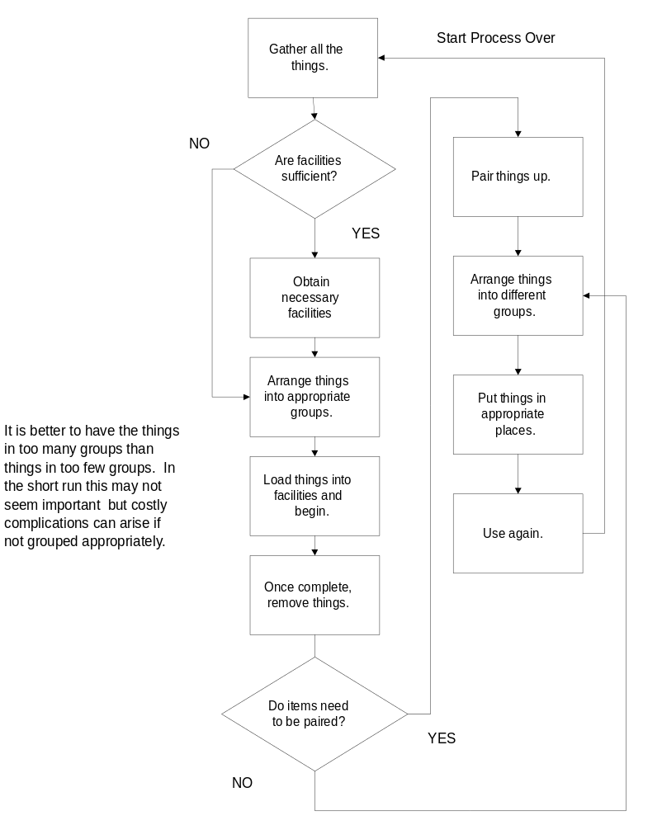

Second Procedure (Replacing “things” with “clothes”):
The following shows the second procedure for this ice breaker.
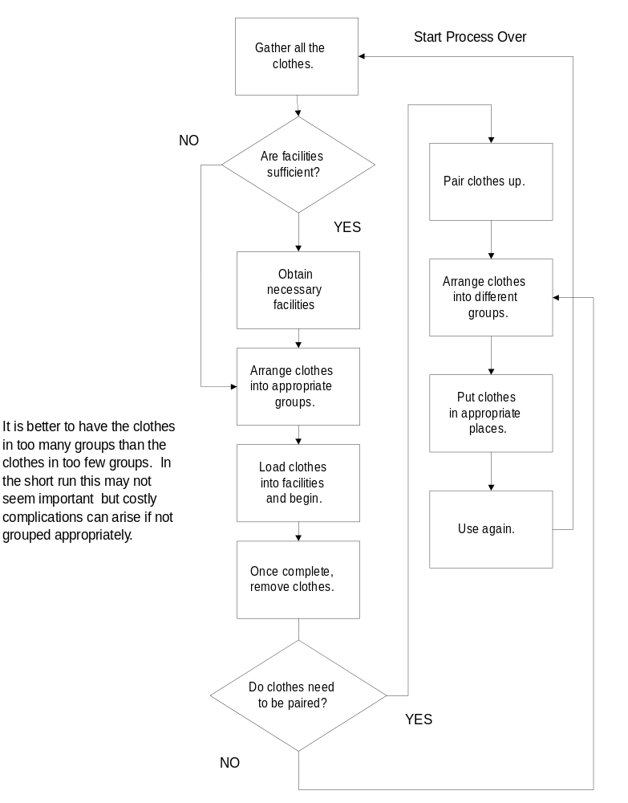

Appendix B - Team Building Interludes
As the need arises, select from the following the short team building activity best suited to the need of the team.
This section includes a number of short team building events to jump-start the team’s ability to function as a high performing team. These “interludes” are intended to be beneficial and fun. They will energize, enlighten and integrate your team.
The team building activities included in the section are:
Activity | Goals
Can You Not Say TEAM? | Provide a fun context and shared challenge while encouraging team members to engage in dialogue.
The Inquirer | Get acquainted and learn one thing about another person’s attributes.
Our Walk of Fame | Devise a team identification/name and develop group unity.
What We Can Learn From Sports | Learn from the lessons that apply to both business and sports.
Mini Olympics - Human Knot | Experience the concept of space and proximity in a team setting.
Front Page | Create a common vision by projecting a future state as a team.
Time Capsule | Foster personal commitment to common goals and encourage follow up for progress measurement.
Talent Scout | Bring awareness to the whole group of the unique/hidden talents of all team members.
If… Then Exercise | Help team members see how the values/team strategy of the organization can help determine daily actions and activities.
What Side Are We On | Provide a fun context while learning about one another.

What is a Team?
A team is a group of people who center around a vision or a clear, elevated goal. It can be a committee, a work group, a task force, a management team, or a volleyball club. What makes them a team is that their individual roles are integrated to achieve a defined goal, to accomplish a vision.
Some teams are highly structured, like an Operating Room team. Each team has a highly specialist role and does it with precision. Other teams, may come together for a brainstorming session in the afternoon, and then quickly disperse.
The best teams have some common denominators:
As per Teamwork, Frank La Fasto and Carl Larson, 1989

- a clear, elevated goal;
- competent team members;
- principled leadership;
- results-driven culture;
- unified commitment;
- a collaborative climate;
- standards of excellence;
- external support and recognition.
The best teams experience clear communication, often at regular time intervals. They often have open relationships and address problems before they become unalterable.
Strong teams develop their commitment as they work on the project. They are accountable to each other; stay on track; and remain focused on the vision and clear measurable goals.
Teams stimulate creativity through brainstorming and allow for all ideas to be considered to maximize the powers of teamness. Teams provide a place for human beings to belong, to be listened to, and to be encouraged and challenged.

Can You Not Say T E A M?

Time
10-20 minutes

Materials
2 large pieces of paper - one with the letters: T E A M each circled and crossed out, the other with the letters not crossed out.

Goal
The goal of this interlude is:
- To provide a “fun” context and shared challenge while encouraging team members to engage in dialogue.

Guidelines
This interlude unfolds as follows:
- Ask each team member to introduce themselves to their team. The introduction can be half a minute to 1 ½ minutes long.
- Have the paper with T E A M in big letters showing.
- Just prior to the first person starting, say “Oh, yes. There is one catch… the speech cannot contain any words that start with a T or E or A or M…”
- Show the piece of paper with the letters T E A M crossed out.
- Conclude with talking about how hard it is to operate without a TEAM. Show once again the letters not crossed out.

The Inquirer

Time
10-15 minutes

Materials
20-40 pictures of famous people in the center of the table.

Goals
The goals of this interlude are:
- To get acquainted
- To learn one thing about another person’s attributes

Guidelines
This interlude unfolds as follows:
- Ask everyone to look at the pictures of famous people in the middle of their table and pick one that best describes them, is representative of his / her personality / attributes.
- Once everyone has picked a picture, each person should go around their tables and say why they picked that person in 1-2 sentences.

Our Walk of Fame

Time
15 minutes

Materials
A box of markers, card stock paper cut out in stars, gold glitter, stickers with space to write and stars, stuffed animals and action figures. Stars can already be created to save time.

Goals
The goals for this interlude are:
- To get the team members acquainted
- To devise a team identification/name
- To develop group unity

Guidelines
This interlude unfolds as follows:
- Ask the teams to come up with what their team’s “star” on the Hollywood Walk of Fame would be. It can be as creative / crazy / serious as they want. Use action figures and stuffed animals to initiate creativity, such as a Team Mascot.
- Tell the teams they will present their team name to the rest of the group at the conclusion of the activity.
- Have each group write their team name on the star and on name stickers to wear during the week.
- Creativity is strongly encouraged
Note: The team name does not need to relate to any of the pictures chosen by individuals in the previous activity (The Inquirer).

What We Can Learn From Sports

Time
15 minutes

Materials
Pictures of sports (examples of sports include: football, baseball, relay swimming), paper and pens to write.

Goal
The goal for this interlude is:
- To learn from the lessons that apply to both business and sports.

Guidelines
This interlude unfolds as follows:
- Each group will receive a picture of a sports activity.
- The group will write down as many answers as they can think of to the following question:
How is this sport similar to teams we are in every day as consultants?
- When the teams have finished their list of answers (or when time is up) each teams will share one of their answers with the rest of the group.
- Encourage creativity!
Note: Depending on the length of time for the activity, the team can answer more questions to add to the depth of the discussion.
Additional Questions
- How are we interdependent?
- How closely do we work together?
- What is the basic work unit - an individual, a group, a subset of a group?
- How do we coordinate with one another?
- How do we get better?
- What kind of coach do we need?

Mini Olympics - Human Knot

Time
10 minutes

Materials
None

Goal
The goal for this interlude is:
- To experience the concept of “space” and proximity in a team setting.

Guidelines
This interlude unfolds as follows:
- Describe the activity to the group. Tell the group that people will be physically close to one another.
- Ask for 1 to 3 volunteers from each group who want to observe and coach the team in undoing the human knot.
- Have the remaining individuals in the group form a tight circle, standing and facing each other, shoulder to shoulder.
- Everyone extends their hands into the circle, and intermingling their arms, grasp hands with other members of the group.
- Instruct people to be sure “ the two hands you are holding are not the same person” and not directly next to you.
- Instruct the volunteer observers to watch and take notes about how the team is operating. The observers can also take a more active role in helping the team if desired.
- Now instruct the group to untie the knot they have made.
- The only rule the team must follow is that no one can let go of another person’s hand during the activity.

Additional instructions for longer activities:
To prolong the duration of this interlude:
- When there are multiple teams, have the teams that finish first begin to review the following questions.
- Have all the teams discuss the activity once all the teams have finished untying the knot.
Questions to review after activity:
- What was challenging? What was not?
- Was everyone in the group heard?
- Were any good ideas lost?
- Did your first approach work? Why or why not? How many times did you have to try to get the knot untied?
Notes:
- It is advisable to have a time clock on the activities, if a team can not untie themselves in less than 10 minutes, the facilitator may tell one or more of the individuals to change hands or drop one hand to make the process simpler.
- For advanced teams, additional challenges can include having half the group close their eyes, making some of or all of the team unable to talk, etc.

Front Page

Time
10-15 minutes

Materials
Pens and paper, paper can have news headlines on it.

Goal
The goal for this interlude is:
- To create a common vision by projecting a future state as a team, i.e., team members will write the headline of the local/national paper describing the team’s successes in 1999, 2005, and 2010.

Guidelines
This interlude unfolds as follows:
- It is June 1999 (June 2005, June 2010) at our Practice meeting. You are celebrating incredible, unprecedented successes. A local / national newspaper is here to write about the successes - What will the title be?
- Encourage creativity.
- Have team members post the headlines on the walls and encourage everyone to read them during the breaks.
Note:
Front Page can be expanded to a front page story, gossip column, etc., depending on the length of time allotted for the activity.

Time Capsule

Time
10-15 minutes

Materials
Pens and paper, craft suppliers, container for the time capsule

Goal
The goal of this interlude is:
- To foster personal commitment to common goals and encourage follow up for progress measurement

Guidelines
This interlude unfolds as follow:
- Give each team member the time to write on a card a word or statement, or draw an image, that captures how they translate the projections for FY99 into a personal commitment, that is, what will they do personally to contribute to the goals.
- Each team member will insert their card into an envelop that they will seal and deposited into the time capsule.
- The time capsule will stay sealed until the next practice meeting when we will open it up again.

Talent Scout

Time
10 minutes

Materials
Blank index cards, pens and pencils at tables
Prizes for 5 individuals, 1 prize for team with most/all correct matches.

Goals
The goals for this interlude are:
- Bring awareness to the whole group of the unique/hidden talents of all team members.
- Provide a forum for sharing of talents across the group.

Guidelines
This interlude unfolds as follows:
- Tell each participant to pick up an index card and write on it something truly unique about themselves that no one else knows. Examples: List a talent or skill that most of the group does not know about you. Alternatively indicate a previous career, or current hobby or specialty that is also unknown.
- Collect the cards.
- Tell everyone they will receive a card other than their own. Their task is to find the individual who has described their unique talent on the card.
- Randomly pass out the shuffled index cards to the audience.
- Allow each team member 10 minutes to find the person who matches the card they have selected.
- The first five individuals who correctly scout out and identify the talent win a prize; first team with all or most correct matches gets a prize

If... Then Exercise

Time
10-15 minutes

Materials
Flip chart, colored markers

Goals
The goals for this interlude are:
- To spell out what the Strategic Intent looks like as the practice continues to evolve. How will we act, behave, think.
- To help team members see how the values / team strategy of the organization can help determine daily actions and activities
- To clarify acceptable and unacceptable behaviors
- To act as a guide for daily decisions in unclear areas

Guidelines
This interlude unfolds as follows:
- Give each team one of the strategic intents - it is okay if more than one team has the same one.
- Ask each team to come up with 10 or more real behaviors that exemplify this strategic intent. Give an example:
Example: If our strategic intent is to be partners… then our behavior looks like: Making sure we know all the sales / consultants names on the account.
Example: If our strategic intent is to be One Team…. then our behavior looks like: Making sure no one stays up working on proposals, deliverables alone with out offering help.
- After the exercise, have each team discuss and place their flip chart up so everyone can read and be enlightened

What Side Are We On

Time
20 minutes

Materials
None

Goal
The goal for this interlude is:
- To create a fun context while learning about one another.

Guidelines
This interlude unfolds as follows:
Have the group stand in the middle of the room.
Read the following directions to the group:
“I will read out a list of statements. If the statement is true, go to the left side of the room. If the statement is false for you, go to the right side of the room. For example, I will say, I grew up in the Midwest. If you did grow up in the Midwest, go to the left side of the room. If you did not grow up in the Midwest, go to the right side of the room.
Once you have gone to the correct side of the room, you must quickly introduce yourself to 2 people you do not know. We will have about 10 to 12 questions. Are you ready? Any questions?”
The Statements for the session are:
- I have been in my current role for more than 9 months.
- I am an only child.
- My birthday is in May.
- I have a cell phone.
- I have not been grocery shopping in over 5 days.
- I like red wine.
- This is my first time in ….
- I can name all the people on ...

Appendix C - High Performance Team Development Modules
As the need arises, select from the following the team building activity best suited to the need of the team to accelerate its ability to function as a high performing team.
This section includes a number of team development events (of up to 2 hours each) to accelerate the team’s ability to function as a high performing team. These modules are intended to be facilitated as “work session,” that is, using actual issues experienced in the project team. They will facilitate the team’s evolution through the four stages of team development: forming, storming, norming, and performing.

Managing Conflict in Project Teams
The following charts the activities and topics to facilitate this module:
# | Activity/Topic | Duration
 | Review causes of conflict | 10 minutes
 | Discuss amount of conflict | 5 minutes
 | List behaviors in conflict; gather in conflict styles | 15 minutes
 | Address self-perception of conflict | 5 minutes
 | Agree on the value of conflict | 5 minutes
 | Discuss how technology projects are a set up for conflict, for example, time frame, cross-functional impact, scope creep, misaligned goals, etc. | 20 minutes
 | Simulate a conflict: Get participants to identify how they react to conflict, what they bring to it, how it affects the team  - Describe how conflict affects the various conflict styles  - Describe the impact on the team and the project  - Brainstorm strategies to overcome those problems  - Capture lessons applicable to the team’s ability to overcome conflict | 20 minutes
 | Facilitate “Win as much as you can” or “The Yellow-Green exercise”  - What were the assumptions?  - Did you practice the lessons learned?  - Witness the raise in stress level | 20 minutes
 | Summarize by asking participants to share lessons they learned in life to handle conflict effectively  - Compare to a recommended list (Fischer-Uri model)  - Emphasize the role of communication skills, for example., listening | 10 minutes

Goal Alignment
The following charts the activities and topics to facilitate this module:
# | Activity/Topic | Duration
 | Review vision and the drivers behind the goals out of alignment | 10 minutes
 | Discuss the “what” being defined and the need to determine the “how” | 5 minutes
 | Discuss need for alignment  - Why is it critical  - How goals get out of alignment  - The impact of misalignment | 10 minutes
 | Brainstorm strategies for maintaining alignment | 15 minutes
 | Complete a core goal matching  - Write the top 10 goals (currently out of alignment)  - Prioritize them  - Agree upon list of goals and how they are stated | 20 minutes
 | Reconcile the goals out of alignment | 30 minutes
 | Develop statements for the goal that meet the SMART acronym | 10 minutes

Leadership Challenges in Project Environment
The following charts the activities and topics to facilitate this module:
This module is intended for project managers and leads.
# | Activity/Topic | Duration
 | Review the Lao Tzu writings | 10 minutes
 | Debrief: scariest leadership situation to face; in such a situation, leadership style reverts to a survival mode | 5 minutes
 | Discuss the factors to content with:  - Time crunch: specifications will always change but time won’t.  - Burnout (signs and how to minimize the effects)  - Ambiguity  - Stress  - Boundary crossing  - Politics/bureaucracy  - Conflicting priorities  - Turnover (within company, supplier, third party, sponsors, project team, support staff….)  - Scope creep  - ...... | 30 minutes
 | Review the model on Authority and Influence. Discuss Covey’s Circle of Influence: Influencers  - Are respected  - Have a reputation for honesty  - Are good communicators  - Have good self-control  - Display ethical behavior  - Role model | 30 minutes
 | Facilitate a case study, preferably from actual team experience. | 30 minutes

Communication
The following charts the activities and topics to facilitate this module:
This module is intended for project managers and leads.
# | Activity/Topic | Duration
 | Introduce module with the Three Mile Island case | 10 minutes
 | Discuss communication model: highlight mode, interference, channels, frequency, process, content, feedback loop, ... | 25 minutes
 | Facilitate an exercise on non-verbal communication | 15 minutes
 | Demonstrate Senge’s left hand/right hand column | 10 minutes
 | Review fundamental attribution error | 20 minutes
 | Review active listening skills; Apply | 20 minutes
 | Summarize by transposing key points to the actual team communications. | 20 minutes

Supportive Team Climates (Trust-Based)
The following charts the activities and topics to facilitate this module:
# | Activity/Topic | Duration
 | Discuss the kind of environment required for a supportive team.  How do you create such an environment in project teams?  What kinds of things matter?  What creates trust between team members? | 10 minutes
 | Discuss the behaviors that support a positive team climate | 10 minutes
 | Discuss the consequences of lack of trust or lack of support | 5 minutes
 | Discuss how to reinforce those behaviors | 10 minutes
 | Conduct an activity to build trust: how can we accelerate the trust process and the high performing team process? | 15 minutes
 | Capture key points of session and use to update Group Operating Norms for the team. | 10 minutes

Meeting Management
The following charts the activities and topics to facilitate this module:
# | Activity/Topic | Duration
 | Brainstorm the features of effective meetings. Address:  Purpose  Process  Payoff  Preparation  Agenda Creation and Use  Minutes  Eddie Debono’s six thinking hats  Typical roles in meetings: chair, facilitator, time keeper, scribe, gate keeper, ...  Facilitation guidelines for effective meeting | 40 minutes
 | Assess the team’s meetings against the list of features brainstormed above. | 20 minutes
 | Identify action items to improve meetings. | 30 minutes

This activity can be used in an hour long session. Additional materials needed: flip charts, color markers, and detailed descriptions of the sports activities. The team would use these materials to capture their ideas and facilitate a lengthier discussion.

