AIM
AP.060 Business Unit Managers Readiness Plan
<Company Long Name>
<Subject>

Author: <Author>
Creation Date: May 20, 1999
Last Updated: June 4, 1999
Document Ref: <Document Reference Number>
Version: DRAFT 1A

Title, Subject, Last Updated Date, Reference Number, and Version are marked by a Word Bookmark so that they can be easily reproduced in the header and footer of documents. When you change any of these values, be careful not to accidentally delete the bookmark. You can make bookmarks visible by selecting Tools->Options…View and checking the Bookmarks option in the Show region.

Approvals:
<Approver 1>
<Approver 2>
To add additional approval lines, press [Tab] from the last cell in the table above.
You can delete any elements of this cover page that you do not need for your document. For example, Copy Number is only required if this is a controlled document and you need to track each copy that you distribute.
Copy Number _____

Document Control

Change Record
1
Date | Author | Version | Change Reference
20-May-99 | <Author> | Draft 1a | No Previous Document

Reviewers

Name | Position

Distribution

Copy No. | Name | Location
 | Library Master | Project Library
 |  | Project Manager
The copy numbers referenced above should be written into the Copy Number space on the cover of each distributed copy. If the document is not controlled, you can delete this table, the Note To Holders, and the Copy Number label from the cover page.

Note To Holders:
If you receive an electronic copy of this document and print it out, please write your name on the equivalent of the cover page, for document control purposes.
If you receive a hard copy of this document, please write your name on the front cover, for document control purposes.
Contents
Document Control
Introduction
Purpose
Overview
Session Overview
Business Unit Managers’ Induction
Executive Project Strategy
Stakeholder Analysis
Sponsorship Profile and Authority
High Level Systems Overview
Application Modules
Topics
Organizational Performance Improvement Strategy
Organizational Performance Improvement Model
Organizational Performance Measurement Grid
Organizational Performance Improvement Checklist
Organizational Performance Transition
Change Leadership Guiding Principles and Roles
Reactions to Change
Change Model
Guiding Principles for Effective Change
Change Leadership Behaviors
Open and Closed Issues for this Deliverable
Open Issues
Closed Issues
Appendix A - Business Unit Managers’ Interview Guide
Business Unit Managers’ Insights Interview Questions
Appendix B - Table of Common Information Technology and Organizational Development Terms
Table of Common Terms

To update the table of contents, put the cursor anywhere in the table and press [F9]. To change the number of levels displayed, select the menu option Insert->Index and Tables, make sure the Table of Contents tab is active, and change the Number of Levels to a new value.

Introduction
Template Instructions
The Template Instructions are formatted as hidden text and are intended for the author of the document only. Delete this section after completing this document.
General hints for completing Adoption and Learning Process templates:
- This template contains suggested headings, text, and formatting intended to speed the creation of the deliverable. You may delete or add components to suit your objectives.
- To include hidden text when printing the document, select File, Print…, Option…, Print tab, check Hidden Text.
- To format (or undo) selected text as Hidden, select Format, Font…; check Hidden under Effects.
- To add lines to a table, press [Tab] from the last cell in the table.
- Text that appears between <single carrots> is either a variable to be replaced manually, or instructions for completing the field. Delete or replace all carrots before distributing the document to the organization.
- <Blue, highlighted text> represents a variable that may be defined and replaced automatically upon creation of the deliverable.
- To protect the document so that revisions will show, select Tools, Protect Document…, Revisions. Add a password if you do not want someone to be able to remove the Protect function from the document. To set options for revisions, select Tools, Revisions… and choose your option.

Purpose
The purpose of this document is to assist the business unit managers in understanding the project vision, how it will impact their business unit, and how they can best get involved to achieve the targeted business benefits. The business unit managers chiefly lead the effort that will determine how the organization will improve its performance, enabled by the new technology. Also, this document helps the business unit managers define their role as change agents throughout the life of the project <Project Name>.

Overview
This document includes the following components:
Component | Description
Introduction | Shows the outline for the work session(s).
Business Unit Managers’ Induction | Exposes the business unit managers to the highlights of the project. Included here is the review of the vision, benefits, expected results, alignment with Information Technology and corporate strategy, and the overall project strategy. Exposes the business unit managers to the features and functions of the systems, in terms of how the applications can improve the way the business units operate.
High level Systems Overview | Provides a template for an overview of the relevant applications.
Organizational Performance Improvement Strategy | Guides the business unit managers in selecting the performance areas that can best be improved with the benefit of the technology and in determining how to roll-out the organizational performance improvement throughout their business units. Guides the business unit managers in planning the achievement of the business benefits for their business unit starting with the go live date.
Change Leadership Guiding Principles and Roles | Describes the guiding principles of change and highlights the role of the business unit managers as change leaders.
Appendix A | Business Unit Managers’ Interview Guide
Appendix B | Table of Common Information Technology and Organizational Development Terms

Session Overview
Business Unit Managers: The business unit managers are the high-level leaders who own the operational areas most heavily impacted by the technology change. They are generally at the vice president or director level, and they should be part of the sponsorship network.
Assumption: The executive sponsor has held a one-on-one meeting/conversation with each attendee, as per the executive sponsor communication plan, and told him/her the highlights of the project.
Preparation Guidelines for the Work Session:
This meeting should be led by the executive sponsor.
1. Review the Facilitation Guidelines in this document (Yellow Notes)
2. Gather necessary inputs (Business Unit Managers’ Insights).
In collaboration with the organization’s executive sponsor (or steering committee chairperson) and/or the project manager:
3. Confirm list of attendees
4. Select site for session (preferably offsite)
5. If appropriate for this level of attendees, order give aways for the team: One of the objectives of the sessions is to begin to create a sense of belonging to a team, and depending on the culture of the organization, participants might be given T-shirts, caps, tote bags, or some other items with the name of the project on it.
6. Review Planning Session Checklist template.
7. Tailor the agenda (see outline below) and send to attendees along with the Executive Project Strategy (AP.010), and an invitation memo specifying time and place, context of the session, purpose and benefits, why attendee is selected, objectives: results and expectations, facilitator background, agenda and preparation request: (attendees are expected to read the Executive Project Strategy before the session and be ready to provide feedback). (See Invitation Memorandum template for a sample).
8. Coordinate with other representatives.
9. Prepare materials for the session, for example, slides from the Executive Project Strategy
10. Prepare session scribe.

Purpose
This business unit managers’ readiness session assembled the business unit managers to expose them to the vision of the project, and to help them define how their respective business unit could best improve their organizational performance with the benefit of the technology. As a result of the session, the business unit managers become ready to lead the organizational improvement strategy that trickles down throughout the business units.
The work session(s) were highly interactive and focused on decision making around key questions to make sure that the organization could achieve the targeted business objectives:
- In which organizational performance areas can we achieve the highest improvement impact, with the advent of the new technology?
- How can we best involve middle management and first line management in the development of the organizational performance improvement strategy?
- What measures do we need to put in place to achieve the targeted performance improvements?
- How can business unit executives fulfill their role as business sponsors for the project?
The work session(s) looked at ways of answering these questions and examined the organizational issues relevant to the organizational performance improvement strategy and a successful achievement of the targeted business benefits.

Facilitation
Add background notes on the facilitator’s experience in conducting such sessions.
The work session was facilitated by <Facilitator Name> from .
<Facilitator Name> Biographical Notes:
In addition, <Scribe’s Name> attended the session to keep a record of all decisions made during the meeting and keep deliverables updated at all times throughout the session.

Attendees
The following participants attended the work session:
List here the names of business unit managers who will attend from the organization, and other participants from contract resources.
Organization | Name of Attendees | Title
<Company Long Name>
Contract resources

Outline
The following outlines the activities conducted for the work session:
We recommend that the session(s) be held off site for maximum concentration and dedication to the decision making process. The meeting can be broken into a number of work sessions with varying duration.
Sections | Description | Time | Duration
Introduction  Give background for the decision to go ahead with the project  Introduce and welcome business unit managers, including in each introduction, a brief statement of how important each person is to the success o the project.  Make the point that the participants will in turn lead a similar induction session with middle managers reporting to them.  Describe the benefits of the project to the organization, to the business units and to the individuals themselves.  Express (the executive sponsor’s) own commitment to making the project a success | Overview of the session: purpose, expectations, logistics, etc. |  | ¼ hour
Business Unit Managers’ Induction  Review vision, benefits, expected results (objectives and measures)  Review alignment with Information Technology and corporate strategy  Discuss high-level view of the impact of the project on technology, process and people  Outline risks associated with the project  Review executive decisions already made  Introduce steering committee and project team members and roles  Refine the stakeholder matrix  Review the sponsorship program | Provides opportunity for business unit managers to understand the importance of the project for the organization and for their business units. |  | 2 hours
High Level Systems Overview  Conduct high level systems overview | Highlights how the business units can benefit from the features and functions of the new systems to improve their organizational performance. |  | 2-6 hours
Organizational Performance Improvement Strategy  Review the process for performance improvement  Select improvement objectives  Define cascade approach to further refine the improvement objectives  Define performance transition strategy  Capture action items | Provides the forum for the business unit managers to lead the organizational performance improvement strategy throughout their business unit. |  | 2-4 hours
Change Leadership Guiding Principles and Roles  Review examples of recent change and reactions to those changes  Discuss guiding principles for effective change leadership  Agree on role as change leaders | Highlights the 8 guiding principles to effective change leadership, describes the typical reactions to change and guides the discussion on the roles of the business unit managers as change leaders. |  | 2 hours

Business Unit Managers’ Induction
Make the point that the participants will in turn facilitate a similar induction session with the managers reporting to them.

Executive Project Strategy
As you review the highlights from the Executive Project Strategy (AP.010), make sure the discussion is interactive and the business unit managers have a chance to clarify and understand the points discussed from the perspective of their business unit.
We discussed the following from the Executive Project Strategy (AP.010) and other project deliverables:
- Background for the decision to go ahead with the project
- Benefits of the project to the organization, the business units, and to the individual managers
- Implementation guidelines for a successful application implementation project
- Project vision and expected results (objectives and measures)
- Alignment of project vision with Information Technology and corporate strategy
- High level impact of the project on the organization’s current technology, processes and people
- High level risks associated with the project
- Executive decisions, already made
- The members and roles of the steering committee and project team
- Project team charter and the division of responsibilities between the steering committee and the project team
- Performance expectations and the responsibilities of the project team

Stakeholder Analysis
The following lists the key stakeholders identified by the business unit managers:
Facilitation Guidelines:
1. “Explain the term “stakeholder.”
2. Break the group in pairs or triads and ask them to review the Stakeholder Matrix from the Executive Project Strategy (AP.010) and identify any missing groups.
3. Ask the participants to anticipate the reactions to the project on the part of each stakeholder group. List potential issues and prioritize groups needing more intense change management.
Capture on the Stakeholder Matrix.

Sponsorship Profile and Authority
Facilitation Guidelines: Using the sponsorship section from the Executive Project Strategy (AP.010):
1. Obtain clips of the following music: “The Nowhere Man” by The Beatles, “I Can’t Get No Satisfaction” by The Rolling Stones, “I Can Get By With a Little Bit of Help From My Friends” by Jo Cocker, and “I Did It My Way” sung by Frank Sinatra.
Play music clips on technology implementation. Ask participants to choose the music which best describes their most memorable experience with an implementation, with this or another organization.
2. Lead a discussion on why projects fail. Show “Standish” slide. Point out that lack of sponsorship is ubiquitous on list of reasons for troubled implementations.
3. Ask participants to think of the sponsor of a project (technology related or not) with whom they worked in the past.
4. Ask participants to select the music clip that best represents that sponsor. Play the four music clips on sponsorship styles.
5. Discuss characteristics and functions of effective sponsors, in theory and applicable to the organization’s culture.
6. Introduce the concept of the honeycomb (elaborate network, delicate but very strong that enables the bees’ work structure) to illustrate the need for a sponsorship network.
7. Compare the revised Stakeholder Analysis to the Sponsor Profile Matrix (from the Executive Project Strategy, AP.010). Look for any stakeholder groups who do not have sponsors identified. Expand the network as necessary on the Executive Project Strategy (AP.010).
8. End the discussion by asking the business unit leaders to describe their own sponsorship responsibilities. Capture the responsibilities in the Executive Project Strategy (AP.010).
Specific business unit managers’ sponsorship responsibilities include:
- Communicate positively and frequently about the project to the people with whom they come into contact
- Provide the “best and brightest” people to the project team
- Be supportive of the people assigned to the project and remove barriers for the people from their business units
- Maintain commitment in themselves for the project throughout its lifecycle
- .....

High Level Systems Overview
See On-Site High Level Systems Overview Customization Template, for the review of the information gathered to allow the instructor to tailor the content of the overview to the specific needs of the business unit managers and to the relevant business processes. The instructor who led the Application Overview with the executives and project team can tailor this session to build on the key points already discussed

Application Modules
The following modules were part of this overview:
Identify here the appropriate modules.

Topics
The following topics were covered in this overview:
Build the list of topics based on the needs of the business unit managers.

- Highlights
- Introduction
- Structure
- Functionality
- Information Flows
- On-line Demo

Organizational Performance Improvement Strategy
Preparation: Ask in advance one of the business unit managers to volunteer to participate in the sample discussion; work with him/her to develop the sample.
Facilitation Guidelines:
Introduction -
1. Position the need to translate the high-level business objectives to the business unit level.
2. Define the model of business performance improvement around the following key questions:
- How will the current project (technology implementation) change the expectations of the organizational performance of your unit?
- How do the corporate business objectives translate at the unit level?
- What should the unit objectives be?
- Can you define those objectives in isolation or do you need to negotiate with other business unit leaders?
(See more comprehensive checklist of questions below)
Discuss the organizational performance improvement model, inspired from the balanced scorecard management technique, as an ongoing process that begins with defining the business results expected by the technology implementation and deciding what business processes are critical to achieving these goals. Determining the best ways to measure the effectiveness of the new business processes requires choosing key organizational performance indicators. Inquire about the measurement tools currently in place and assess suitability. The next step is to cascade performance expectations and measures from the organization to the business unit level, to the department level, to the role level and finally to the Full Time Equivalent (FTE) level. Make sure that the measures the individual departments and work groups link back consistently to the overall business expectations.
Sample Business Unit Organizational Improvements -
3. Using one unit as an example (ask for a volunteer), ask the group to brainstorm possible improvements in organizational performance expectations resulting from the implementation. Start with the performance area listed in the Organizational Performance Measurement Grid, as they apply to the key business processes in that business unit. (If this activity is perceived as being too sensitive, give a sample set of corporate objectives, and use a mythical business unit.)
4. Follow the brainstorming session with an initial discussion of how the corporate business unit objectives could translate into organizational objectives at the business unit level Show how the units may need to plan together to achieve the high-level business results. For instance, an objective to reduce head-count as a result of automation of tasks and the need to use more highly skilled people may mean that the Human Resource (HR) department may actually need to add resources to their own staffing plan to provide the extra re-skilling events, while other units may need to plan on attrition.
Organizational Performance Measurement Grid:
5. Explain the Organizational Performance Areas and indicate that participants will be asked to prioritize two or three of the Organizational Performance Areas that can best help their business unit improve its performance. They will then start identifying organizational performance objectives for those areas at the unit level. These objectives can be chosen for short, medium or long term results. The next steps are to assign the completion of the grid to the mid-level managers and to decide upon a roll out strategy. Review the Organizational Performance Improvement Checklist.
Organizational Performance Transition:
6. Lead a discussion about the expectations concerning the time frames when those business objectives will be realized in relationship to the “go live” date. Most organizations realized that not only will the anticipated results not be realized on that date, but that productivity will probably drop initially. The objective of this discussion is to begin the process of setting expectations and creating strategies to deal with anticipated reactions to the actual change from the old system to the new from both the organization’s and the employees’ points of view. Review the risks and advantages of various scenarios. Suggest that business unit managers might want to create their own timeline which maps their expectations and captures key milestones. Brainstorm with them some of the tentative milestones which would need to be achieved between the “go live” date and the achievement of the business expectations. Refer to the Organizational Performance Transition Checklist to fuel the development of the transition strategy at the organizational level.
Summary:
7. Review the importance of Organizational Performance Measures at all levels. Review next steps for this group:
- Decide on Priority Performance Areas and corresponding Organizational Performance Objectives for their business unit
- Delegate completion of the organizational improvement measures at the department level. The organizational performance improvement model, inspired by the balanced scorecard management technique, is a powerful change management tool when everyone in the organization feels a sense of ownership and sees its value. Tying compensation to the achievement of the organizational improvement objectives is another way to encourage employee ownership.
- Develop organizational performance transition strategy

Organizational Performance Improvement Model
From Score a HIT, CIO Enterprise, Section 2, Nov.15, 1998 edition & The Balanced Scorecard, Kaplan, Robert S. And Norton, David P. (1996), Boston, MA, Harvard Business School Press.
This model is inspired by the balanced scorecard, a comprehensive balanced system that measures key areas of organizational performance and links long-term strategies with short-term actions. It is a key tool to drive new strategic goals, including those enabled by the new technology, more rapidly through the enterprise. This organizational performance improvement model helps communicate corporate performance strategies throughout the organization, and is used to set individual and team goals, allocate resources, compensate employees, and plan budgets. It can also provide feedback on an ongoing basis as to how individuals, departments and business units are performing in each of the areas the leadership has selected as critical to the organization’s success.
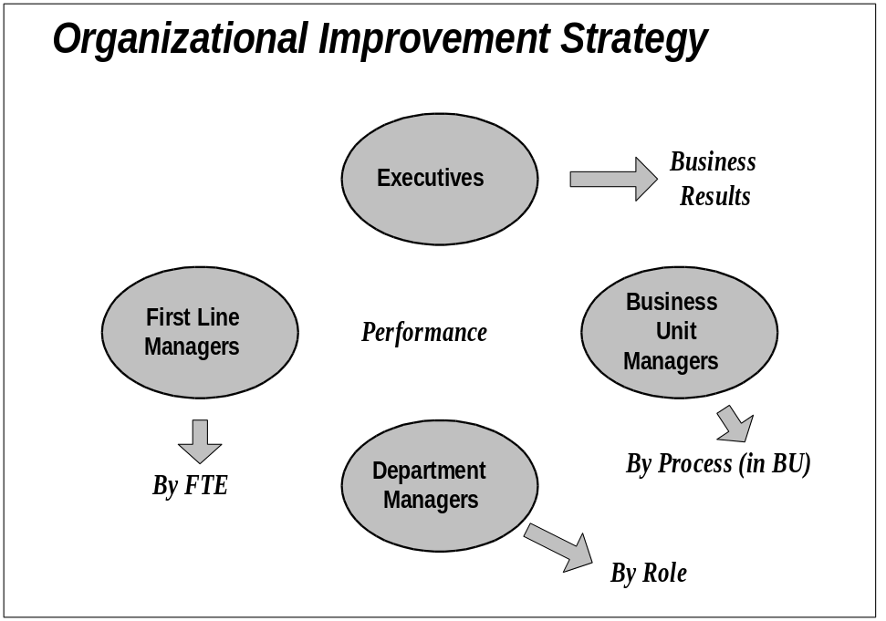

Organizational Levels | Improvement Levels | Activity
Executive/Steering Committee/Project Team | Organizational  Project | Give performance orientation, that is, business drivers, business impact  Define business results expected
Business Unit Managers | Business Unit | Prioritize organizational performance areas by process and define performance objectives for business units  Identify process ownership  Create infrastructure and delegate completion of business unit measures
Department Heads (middle managers) | Departments  Roles | Identify key process activities  Tailor the activities performance matrix  Lead task forces to update human performance support systems  Define role expectations
First Line Managers | FTEs (Full Time Equivalent)  Work groups | Validate and implement new human performance support systems to achieve FTE performance expectations

Organizational Performance Measurement Grid
The following defines key organizational performance areas:
Organizational Performance Area | Definition: How the organization...
Customer Service | Serves, relates to and cares about customers
Productivity (Quality and Quantity) | Meets the standard quality for products/services and how effectively/efficiently it uses its resources
Information | Optimizes the knowledge gained from people and data
Authority/Accountability | Gives employees the freedom to make decisions
Environment | Optimizes the physical, psychological and cultural aspects of work
Teamwork | Combines intellectual capital and skills around work groups to reach organizational objectives
Learning | Continuously applies the knowledge gained from success and failures

Organizational Performance Improvement Checklist
The following checklist guided the development of the initial organizational performance improvement strategy:
- How will the implementation of these applications impact the performance expectations of my business unit?
- Which key business processes will be impacted?
- How do the corporate business objectives translate at my business unit level?
- What members of my team do I want to consult with about these organizational performance improvement measures?
- Can I produce these measures in isolation or do I need to negotiate with other business unit leaders?
- Which of the organizational performance area (see checklist below) do I want to select as a focus area(s)?
- What are my priorities among the organizational performance areas I selected?
- How will I delegate the completion of the organizational performance improvement strategy to my middle managers?
- What is my strategy for rolling out those measures to my unit?
Tailor this grid to the organizational performance area selected and the organization situation. Business unit managers should focus on prioritizing the organizational performance areas they select and identifying the improvement objectives most suited to their respective business units. Middle management should then determine how the improvement objectives in each organizational performance areas can convert to Indicators, Measurement Actions and Criteria for their respective departments.
Priority | Organizational Performance Area | Improvement Objectives | Indicators | Measurement Actions | Criteria
 | Customer Service | Increase customer satisfaction | Positive responses on customer satisfaction survey  Add-on business from current customers | Conduct customer satisfaction survey | __% of our customers describing themselves as “satisfied” or “highly satisfied”  Number of additional products and services ordered by existing customers
 |  | Increase referenceability | Customers are referenceable | Track number of customers who are willing to provide references | __% of customers are willing to provide references by <date>
 |  | Retain current customers | High percent of retained customers | Track customer retention | __% of current customers retained
 |  | Anticipate customers’ needs | New product/services which are purchased by customers | Do a market analysis  Set up a customer focus group on future trends | One new product or service purchased by __% of customers by <date>
 |  | Improve order fulfillment process | Short time elapsed between receiving order and delivery to customer | Measure task flow in order-fulfillment process | Reduce order-fulfillment time to __ working days
 |  | Improve response to customer complaints | Positive customer perception of complaint resolution | Conduct follow-up calls to determine customer perception of resolution  Track the authority levels of employees who resolve customer complaints | Achieve at __% satisfaction rate by <date>  Conduct __% learning events by <date>on resolving complaints and using new authority levels
 |  | Reduce customer complaints | Low number of complaints received | Track complaints.  Capture information from complaints and give feedback to appropriate teams so issues can be resolved. | Reduce complaints by __% over the next __ weeks.
 |  | Improve contract compliance | Low number of customer complaints referred to legal department | Track number of complaints, suits, and settlements dealt with by the legal department. | Reduce rate of suits or settlements by __% over the next __ months.
 | Productivity (Quantity and Quality) | Increase output ratio | Same amount of work done by fewer people, in less time, or with less money or increased amount of work done by same number of people | Track productivity by Full Time Equivalent (FTE) | Produce __% more with __% less resource
 | Improve productivity | Document, analyze, and streamline processes | Processes are streamlined; non-value activities are eliminated | Track changes in the amount of time required for a process or the physical or human resources required  Do a cost-benefit analysis | __fewer resources needed to complete this process by <date>  Track number of non-value add activities eliminated over __ months
 |  | Implement a proactive systems’ maintenance program | Systems optimally functioning | Measure systems’ up time | System up time increase by __% over __days
 |  | Increase number of shifts | Appropriate number of shifts | Track time logs and production schedules | Shifts increase to __ by <date>
 |  | Reduce rework | Reduced rework | Measure rework | Rework reduced __ % by <date>
 | Improve quality of products/ services | Reduce number of customer rejections/ returns | Reduced number of customer rejections/ returns | Track customer rejections/returns | Reduce number of rejections/returns by __% over the next __ days
 |  | Achieve zero defects | Zero defects | Track defects | __% of decrease in defects by <date>
 |  | Establish continuous improvement as a standard approach | Continuous improvement program working | Measure learning events deployed to employees on continuous improvement | __% of teams have participated in first round of learning events on continuous improvement
 |  | Implement non-conformance report | Non-conformance report analysis | Track instances and reason for non-compliance | Report implemented by <date>
 |  | Implement corrective action procedures | Dissemination and implementation of corrective action  Solicit employee and organization input | Track problem resolution  Track input from employees and organizations | Learning events on corrective action completed by <date>  __ focus groups completed by <date>  __ interviews conducted by <date>
 |  | Reward employees for improvements | Continuous improvement program | Track result of improvement initiatives | Recognition and reward system in place by <date>  Continuous improvement program in place by <date>
 |  | Achieve ISO certification | ISO Certified | Track milestones toward completion of ISO/QS9000 award | Receive award by <date>
 | Information | Give people access to information they need to work effectively | Employees are satisfied with the information they receive  Employees get the information they need to make good decisions | Employee survey which include communication questions  Track decision problems caused by lack of accurate or timely information through status reporting | __% of employees agree or strongly agree with the following statements:  1. I get the information I need to do my work effectively  2. I have opportunities to give feedback on the information I’m given  3. I get accurate information  4. I don’t have to rely on the grapevine for information  __ reduced number of incidents of decisions made in the absence of good information
 |  | Create an information channel infrastructure | People have access to information through multiple channels  People get information tailored to them, delivered in a timely manner, through the most effective media | Employee survey which includes a question to determine where people get information and the quality and timeliness of that information | __% of employees agree or strongly agree with the statements:  1. I get information through multiple channels  2. The information I receive is relevant to my daily functions  3. The information I receive is timely
 |  | Develop a communication plan | Two-way information communication | Develop a communication plan  Assign a communication team  Designate a communication coordinator  Create standardized communication formats  Measure flow of communication | Communication plan in place by <date>  Communication team selected by <date>  Communication coordinator designated by <date>  Communication standards defined by <date>  Communication flow analysis completed by <date>
 |  | Improve information security | Information is secure | Track number of breaches of security | Security plan completed by <date>
 | Authority/ Accountability | Give people the authority and accountability they need to make the right decisions | No work delays attributed to multi-layered decision-making process | Using status report or project post-mortem, gather data on delays caused in decision-making process | __ delays reduced __% over a __ month period
 |  | People are satisfied with the authority and accountability given to them | Positive response on employee satisfaction survey | Employee survey which includes questions on authority | __% of employees agree or strongly agree with the statements:  1. I have the authority I need to carry out my assignments  2. I am held accountable for the work I do  3. In my work group, because of our ability to get a decision made, we do not incur delays  4. I have the opportunity to give input on decisions which affect me  5. I am told what I need to do, but I decide how to do it.
 | Environment | Create a safe physical environment | Accident-free work place | Track learning events deployed to employees to create a clean, safe environment  Track number of accidents | Learning events on safety deployed to all employees by <date>  __ accident-free days by <date>  Rewards program for <duration> without an accident in place by <date>
 |  |  | No OSHA (Occupational Safety & Health Agency) violations | Institute an OSHA (Occupational Safety & Health Agency) compliance audit | __% reduction in OSHA (Occupational Safety & Health Agency) violations by <date>
 |  |  | No occupational injuries | Track occupational injuries | __% reduction in occupational injuries
 |  | Create an environment which will attract and retain the best employees | Employee benefits on par with competitors | Do benefits competitive analysis  Employee survey which includes a question on perception of benefits | Benefits analysis and adjustment (if needed) completed by <date>  __% of employees agree or strongly agree with the statement: “The benefits provided by this organization are comparable to those provided by other companies in the industry.”
 |  |  | Employee compensation is market competitive | Do compensation competitive analysis  Employee survey which includes a question on perception of compensation | Compensation analysis and adjustment (if needed) completed by <date>  __% of employees agree or strongly agree with the statement: “My salary is comparable to salaries paid at other organizations in this industry”
 |  |  | Organization has a performance-based reward structure | Determine performance measures and corresponding reward | Performance-based reward program in place by <date>
 |  |  | Organization has a low turnover of high performers | Measure retention of high performers  Track reasons given for voluntary termination and look for recurring problems | Turnover reduced by __% by <date>  Begin exit interviews by <date>
 |  |  | High employee satisfaction levels | Annual employee satisfaction survey | __% of employees agree or strongly agree with the statements:  1. I would recommend this organization as a good place to work  2. I am treated with respect  3. I am a highly valued employee  4. I have opportunities to achieve my career goals
 |  |  | Referrals for new hires from existing employees | Track employee referrals | __% increase in employee referrals by <date>
 | Teamwork | Increase teamwork to maximize productivity | Reward and recognition system focused on team contributions  Management By Objective (MBO) program in place  Teams’ MBOs (Management By Objective) achieved | Track output and Management By Objective (MBOs) of work teams  Provide learning events in conflict management, decision making, cross-functional teamwork and communication | Number of teams achieving or exceeding goals  Management By Objective (MBOs)and Reward system in place as of <date>  __% of employees agree or strongly agree with the statement: “I know what the goals for my team are”  Learning events deployed to all employee by <date>
 |  |  | Increased span of control | Measure span of control  Track decision-making authority at the team level | Span of control reaching determine __ by <date>  <Number> of employees have the authority to make decision which involve spending less than $___
 |  |  | Satisfaction with team experience is high | Employee survey to measure employee satisfaction with his/her team | __% of employees agree or strongly agree with the statements:  1. On my team we work together effectively  2. My team makes the best use of everyone’s skills  3. On my team we know what our goals are  4. On my team we know how to manage conflict
 |  | Create flexible teams | Ad hoc teams are common  Temporary assignments are available | Track use of ad hoc teams  Track shadow or job exchange assignments | __% increase in number of ad hoc teams by <date>  Number of shadowing or job exchanges in past __ months
 |  | Support cross-functional initiatives | Cross-learning is a part of the organization’s culture | Use skills profile to track newly acquired skills as a result of cross-learning  Track back-ups for key roles | Number of skills added to employee’s profile as a result of cross-learning  __% increase in number of back-ups for key roles
 |  |  | People are made available for mission-critical projects | Use 360 degree evaluation to measure managers on willingness to free up good people | Manager performance evaluation altered to include support of cross-functional initiatives as a measurement by <date>  <Number> of managers rated as supportive to highly supportive of cross-functional initiatives
 | Learning | Create a culture which supports organizational learning | Mistakes are regarded as learning experiences | Employee survey includes a question on management’s attitude toward mistakes | __% of employees agree or strongly agree with the statement: “In this organization, mistakes are regarded as stepping stones to learning.”
 |  |  | Employees perceive risk taking is supported | Employee survey includes a question on risk taking | __% of employees agree or strongly agree with the statement: “This organization encourages intelligent risk taking”
 |  |  | Leaders understand and embrace the concept of a learning organization | Track availability and use of management learning events on learning organization | Complete management learning events by <date>
 |  |  | Management MBO (Management By Objective) includes support of learning organization | Use managers’ performance appraisal to measure support of learning organization  Use Balanced Scorecard to track learning organization objective | Performance appraisal revised by <date>  Number of managers who reach learning organization objectives
 |  |  | Leaders are rewarded for achieving learning organization goals. Sacred cows are eliminated | Track rewards given leaders for achieving learning organization goal | Number of leaders rewarded for reaching learning organization goal
 |  | Encourage knowledge transfer from person to person | People share information, skills, competencies | Track coaching and mentoring programs  Track availability and participation in learning events on coaching and mentoring | Number of coaching relationships  Learning events on effective coaching is completed by <date>  <Number> of employees have participated in learning events on effective coaching in the past __ months
 |  | Enhance people competency | People are continually gaining new skills which enhance the organization’s core competencies | Track learning events deployed on organizational core competencies  Implement and tracking individual role-based learning plans aligned with business objectives and values  Certify incumbents for all job roles  Identify critical roles; Define critical global competencies; Associate competencies with roles  Identify subject matter experts by role  Perform analysis of gap between required skills and actual skills | <Number> of people who are evaluated by their supervisor as possessing specific core competencies  Number of learning plans in place  Incumbents certified by <date>  Critical roles identified by <date>  <Number> of succession plans for key roles  Competencies defined by <date>  Competencies and roles associated by <date>  Subject Matter Experts (SMEs) identified by <date>  Skill gap reduced by __%j
 |  |  | Implement knowledge management procedure for all “lessons learned,” deliverables, processes | Track contribution and access to knowledge management data base | __% of employees contributing to and learning from the knowledge base by <date>
 |  | Increase career opportunities | People perceive the career potential within the organization | measure inter- and intra-departmental transfers for cross-learning and temporary to permanent assignments | <Number> of inter or intra departmental transfers within <time>
 |  |  | Career plans are in place for all employees | Track number of employees who have a career plan | <Number> of employees with completed career plans
 |  |  | Employees have access to a job posting bank | Track use of job posting bank of available positions with identified criteria | <Number> of jobs acquired through the use of job posting bank by <date>

Organizational Performance Transition
Performance transition in the computer/software industry means installing the new series of products and planning for the achievement of business benefits. In addition to converting from one system to another, organizational performance transition means figuring how to get people to use the system correctly - learning events, manuals, help desk, job aids, etc.
Organizational performance transition is different from technology transition (See Table of Common Information Technology and Organizational Development Terms in Appendix B). Organizational performance transition is moving users from their current work systems, skills, knowledge, activities, biases, limits, comfort zones, to different work systems, skills, knowledge, activities, biases, and limits of a new technology. It’s about managing productivity degradation across the technology swap to minimize negative consequences. It’s about achieving the productivity gains expected by creating an environment that sustains these productivity gains into the future, from both the organization’s and the employees’ point of view.
This table comes from a special edition of the Journal of Applied Behavioral Science (Vol.34, Number 3, September 1998) that focuses on Achieving Breakthrough Performance.
Organizational Shift  For its employees, the organization must: | Employee Shift  Employees must act in new ways so that they:
Offer participation in overcoming challenges and discovering new ways | Challenge reality, let go of old ways. Look at the big picture, beyond their own individual work spaces
Provide full information about what is happening | Share what they know with everyone
Provide opportunities for self-development | Take up self-development and learning opportunities
Support emotional upheaval of change | Strategically redefine their work
Respect employees as people | Recommit to their teams
Implement changes with credibility, honesty, and fairness | Seed personal meaning in work

Scenarios and Consequences
Tailor the following scenarios to the implementation strategies selected.
The following table overviews a fixed set of transition events. These scenarios are not all inclusive.
Scenarios | Risks | Advantages
Incremental process improvement (step by step phase-in) | Lacks urgency to learn and use new technology  Fosters user resistance  Long learning curve  Customer service decrements  Environment may change over the life of the process | Lower risks of system failure and end-user resistance  Allows for implementation strategy modifications
Big Bang | Incomplete transition for users (may not have assimilated learning)  Reconciliation problems  User resistance  Customer service decrements | Sense of urgency to complete tasks  Compress last minute pressures  Steep learning curve
Performance approach - area by area (productivity, customer service, ...) | Limits output amount (productivity)  User resistance | Maintains customer service quality
Do nothing-maintain status quo throughout the implementation | Y2K non-compliance  Lack of competitive advantage in relation to competitors | Lack user preparation

Organizational Performance Transition Checklist
The following checklist guided the discussions around the organizational performance transition strategy:
Use the checklist of questions below to facilitate a discussion that can lead to the organizational performance transition decisions required to support a successful achievement of expected business benefits. Capture below the decisions derived from the discussion.

- By what date do you anticipate achieving your business results?
- Are all the business results of equal importance? What is the level of tolerance around failure to achieve 100% of the business objectives?
- What productivity gains do you anticipate on day one of “go live”?
- Would an initial drop in productivity be probable? How long do you think it might last?
- How will you track productivity during the transition?
- If you experience productivity drops, how will you distinguish people-issues versus system-issues?
- What barriers do you anticipate which might impede progress toward improved organizational performance?
- How will you know if new processes are working?
- How will you know if you’ve conducted enough learning events?
- How will you know if people are using the full functionality of the system?
- Is funding allocated for temporary staff to support job performance during and post cut-over?
- Do you have enough support staff to handle the need for additional help during the transition?
- Will the support staff need any additional training to function effectively during the transition?
- What is the strategy for handling customer complaints during transition?
- How do you plan to measure customer impact?
- What is your plan for communication with your customers during this time?
- Will you need any additional resources to handle customer issues?
- What are the milestones you expect to achieve as you move toward achievement of business results, that is, what percent of each goal do you expect to achieve by what date?
- What are the key indicators you will track to see if you are on schedule?
- What contingency plans do you have?
- how will you track employee morale during this period?
- What are your plans for communicating progress toward business objectives during this time?
 | Go Live |  | Milestone 1 |  | Milestone 2 |  |  | Milestone 3
Expected Business Results in Selected Organizational Performance Areas | Contingency Strategies | Intermediary Results | Contingency Strategies | Intermediary Results |  | Contingency Strategies | Intermediary Results |  | Contingency Strategies | Intermediary Results

Change Leadership Guiding Principles and Roles
Facilitation Guidelines:
1. Ice breaker: Suggest that participants switch their watches to their other arm for the duration of the session. At the end of the session, point out how unsettling such a little change can be.
2. Begin the session with a brief discussion of change in today’s business world, the pace, complexity, and volume. Tailor examples to the organization’s industry.
3. Discuss types of change: incremental versus transformational. What type of change are they going through? What difference does it make? Discuss technology-induced change. What makes it particularly difficult? For example, complexity, broad impact, fear factors associated with it...
4. Ask participants to describe their reaction to a recent change they experienced. Discuss “resistance”. Resistance is the normal human reaction to change. Ask if there is anything positive about resistance (yes; shows that people are alive, interested, thinking...) As a group, ask participants to brainstorm reasons why people resist. Discuss reasons which are based on reality (for example, an announced cut back in staff), those based on fear, and those which are simply a part of human nature (habit, past experience, low trust, etc.). Identify the symptoms of resistance in themselves and others. What level of resistance do they anticipate to this project in their organization?
5. Discuss the emotional reactions to change. Explain that effective leadership can help people move through this cycle quickly and keep the “valley of despair” shallow. Obtain from participants examples of resilience and congruence after change. As time allows, refer back to the Stakeholder Matrix and for each priority group, indicate what level of acceptance is most appropriate.
6. Discuss “Facilitating Change”; discuss what it takes for an individual to change, all the way to the behavioral level: will (information and leadership) and skill (learning and support).
7. Discuss “The Guiding Principles of Change.” Relate to the “Facilitating Change” model. Briefly review each principle.
8. Break the group into pairs and give each pair two principles to analyze, that is, why each principle is so important and the role business unit managers can play in putting the principles into effect.
- a) Vision: They don’t create the vision so what is their role? Business unit managers have the responsibility of making the project vision come to life for their people. Their role is to disseminate the project vision and keep making the tie to the business objectives.
- b) Leadership: Why is their leadership role so critical? What do they need to do? They serve as highly visible role models and must keep their decisions lined up with the project vision. They serve as sponsors for the groups they represent; they have a responsibility to build support for the project to the end and create other leaders/supporters. They see the compelling need, describe it for everyone, create convert, find the necessary resources, remove barriers, and relentlessly spread the word. Few leaders realize that in the midst of championing change, they may experience some of the same feelings of loss and insecurity that plague the employee who just heard about it. Leaders need to develop strategies to cope with those feelings. If a leader looses interest or faith, or reduces the intensity of his/her commitment, the rest of the organization usually picks up on the change almost immediately, and people lose heart.
- c) Communication: Doing what you say you will do is the first step toward building trust; communicating effectively is the second. A rule of thumb is “However much you think you need to communicate during a time of major change, you need to communicate more.”
- d) Share Ownership: Involving everyone is the antidote to “not-created-here.” The goal is to take people from “It’s not my idea,” to “It’s my baby.” This approach makes sense because it’s hard to oppose a plan you’ve had a voice in creating. The axiom is: involve everyone and involve them early.
- e) Culture: Describe the key cultural elements which impact transformational change and ask how they can impact those areas. Change-friendly cultures are customer focused, have high trust levels, are risk tolerant, promote innovation and are good at cross-functional teamwork. The question to ask is: How congruent is our current culture with the culture required to make this implementation successful?
- f) Scope Control: Tackling multiple transformational change initiatives can put all projects in jeopardy. However, a more common problem is the scope creep associated with a single project. When it comes to building a house, most people understand the concept of change control rather well; they know that when the building is almost complete, it’s folly to say, “I think I want a basement after all.” In technology implementations, much of that understanding seems to disappear, and as multiple unplanned new requirements are added, the drain on the resources needed to implement the change increases. A key responsibility of a change leader is to make sure that effective processes are in place to keep scope creep under control.
- g) Supporting Structure: Administrative policies, processes and procedures have to reflect both what you want to accomplish and how you want to accomplish it. Another version of walking the talk is to make sure that your policies mirror the messages that are being sent. How can they put in place the structure to reinforce the desired behaviors? They can put in place the right learning activities, rewards and recognition, etc.
- h) Learning Organization: The pace of change has moved learning out of the “nice-to” category and put it high on the list of things that are necessary for survival. Rapid changes in technology, laws, policies, marketplaces, and industries make it almost impossible to remain competitive unless people acquire new skills, attitudes, and behaviors quickly. In most organizations, learning is becoming a core competency.
9. Brainstorm strategies to overcome resistance using the eight guiding principles. Extract the leadership behaviors for the project leads. Capture on the Change Leadership Behaviors matrix.

Reactions to Change

Accelerating the Path Through the Valley of Despair
As users react to change through shock, fear and “wait and see” attitude before they commit to the new roles they must fulfill, there is a great drop in productivity. Adoption tasks aim at accelerating the cycle of reaction to change so the productivity drop is lessened and users achieve acceptance faster and generate higher productivity.

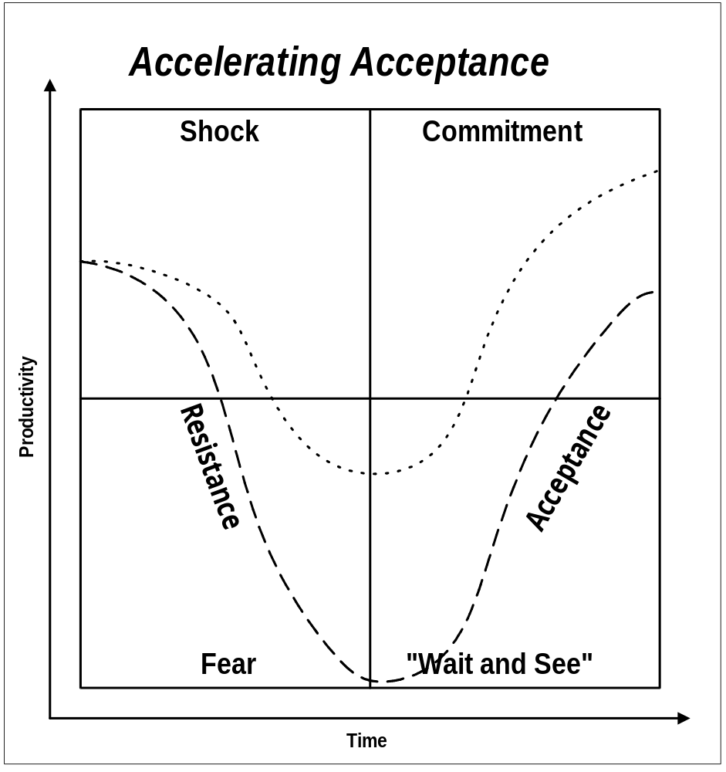

Change Model

To Change, Individuals Need the Will and the Abilities
To facilitate the change from the present to the desired situation, users need the will and the abilities to change.
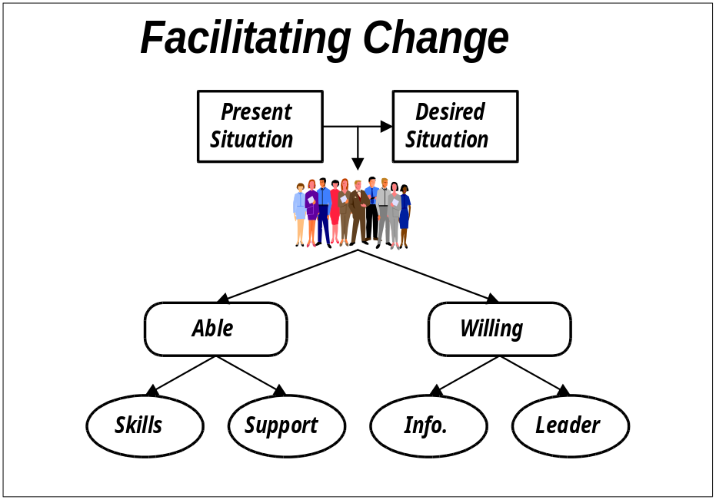

Guiding Principles for Effective Change

Leading Change From Resistance to Resilience
There are eight guiding principles for effective change.
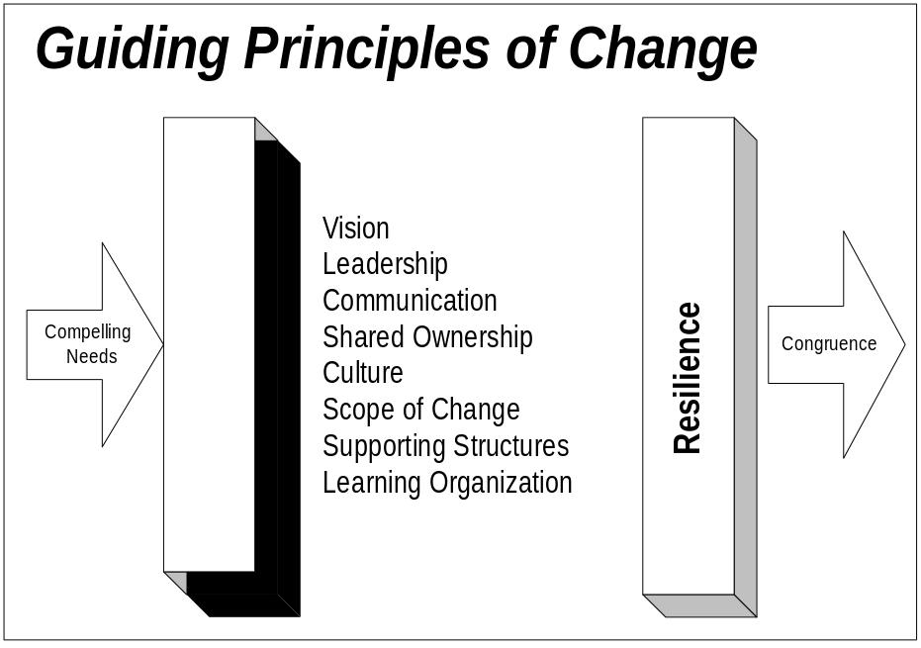

Change Leadership Behaviors
Leaders at all level must participate in the change leadership pattern across the organization. The business unit managers agreed to the following change leadership behaviors:
Tailor the following matrix to the participants’ context as business unit leaders.
Guiding Principles | To Do | How To
Create a Clear, Compelling Vision  Give a picture of where you are headed  Describe how the vision will be achieved  Keep it concise | Promote the project vision and keep in the fore front its tie to the corporate strategy  Leaders need to be able to dream and do; get some talented dreamers to help you on the team  ..... | Think about how the project can best serve your business unit strategy; dream big.  Identify the key benefits of the project for your business unit and the organization.  Distill your thoughts from step one and two above: Is there an underlying theme? Aim for elegant simplicity.  Figure out where you are now. Spend enough time to know where you are, but your main focus is on the future.  Describe the gap in terms of a compelling need to change (This is the transformation.).  Try your project vision statement on everyone you meet.  If you can’t make others understand in less than three minutes, start over.
Assess the Organizational Culture  Focus on the customer  Look for innovation and creativity  Encourage risk taking  Evaluate teamwork | Assess the current organizational and team culture in your business unit.  Put the focus of the project squarely on the customer.  Create a clear path from the customers’ needs to the resources that meet those needs and to the project team.  Nurture creativity.  Don’t punish pioneers. | Assess your business unit’s readiness to fulfill the project vision. Hold focus groups and gather feedback on how-we-do-things-around-here. Consider benchmarking from the outside.  Choose performance measures which tie directly to customer satisfaction for your business unit.  Involve customers; they are key stakeholders in the project; ask for their feedback and if appropriate their participation as liaisons to change teams.  Ask your middle managers and employees what could be done to allow them to serve the project customers better.  Provide opportunities for ideas to surface throughout your business unit. Recognize and reward innovation.  Recognize some important near misses.
Lead the Way  Assemble a coalition  Function as a sponsor  Serve as role model  Create a sense of urgency  Endure to the end | Begin with yourself. If you don’t role model the future, no one will.  Find influential allies who share the project vision.  Accelerate the pace just enough to create the right sense of urgency and momentum.  Create early wins and communicate those wins.  Endure to the end. | Ruthlessly examine yourself to determine how your behavior and approach to the project work, values, plans align with the project vision. Get feedback from others.  Walt the talk.  Do things highly visible to make the change real. Slay a sacred cow.  Assign the managers reporting to you (communication agents) the task of spreading the word throughout the business unit.  Use hard, cold facts to keep the compelling need for change in plain sight.  Set stretch goals. Monitor, measure, celebrate, and set new goals.  Cherry pick—find early wins, publicize, reward, celebrate.  Give presentations; conduct one-on-ones, focus groups, town hall sessions; preside at celebrations; remove barriers; provide resources.
Manage the Scope of Change  Stay within people’s finite capacity to absorb change  Keep an “open system” approach: systems are inter-dependent, multi-dimensional: change one, change all  Tie to the vision, to keep the change into context | Assess your people’s capacity for change.  Lobby to kill, merge or delay any non-essential project in your business unit and across the organization.  Define the big picture; let people see how initiatives interrelate. Establish strong ties to the corporate strategy. | Review data to inventory current changes in your business unit and detect people’s capacity to absorb change.  Gather information on all major projects. Look for objectives, overlaps, conflicts, commonality, scope, and time frames.  Help validate the project as priority.  Integrate, harmonize remaining projects.
Communicate Openly, Honestly, Relentlessly  More is better: Repeat key messages through different sources, consistently  Open two way communication channels  Manage the information; keep no secrets | Determine your business unit’s preferred ways of communication.  Create a formal plan for two-way communication.  Use communication agents.  Broadcast successes.  Keep abreast of people’s needs for communication and meet those needs.  Measure the effectiveness of the communication.  Manage rumors at their onset. | Create a supportive environment for the communication agents and the two-way communication channels throughout your business unit..  Use communications (two-way) to:  - Create buy-in  - Glean ideas you may not have thought of  - Build trust  - Build enthusiasm  - Determine where resistance lies  - Estimate the strength of the resistance  - Determine the causes of the resistance  - Clear up misconceptions  - Figure out how far and fast people can move  - Make course corrections  - Find pockets of support  - Surface concerns rather than suppress them
Promote Shared Ownership  Involve: People support what they help to create  Ownership improves quality and relevancy of decisions: involve everyone, involve them early | Identify opinion leaders in your business unit.  Determine whose support is critical and whose opposition could be dangerous.  Find opportunities to create buy-in among managers reporting to you and employees.. | Create a matrix that shows impacted groups within your business unit and anticipated support levels (Stakeholder Matrix). In critical areas, get down to an individual level.  Identify their stake in the change.  Assess their readiness to change.  Hold focus groups with representative sample of highly impacted groups.  Hold one-on-one sessions with key stakeholders in your business unit.  Involve stakeholders in your business unit in supporting the project, ideas generation, focus groups, change teams, communication, and problem solving sessions.
Create Supporting Structures  Streamline decision making process  Make rewards and recognition supportive of vision  Instill measurements tied to the vision  Align human resource systems with required behaviors | Keep bureaucracy to a minimum.  Create reward systems specially for the project.  Adopt measures to focus on the transformations critical to the project vision.  Look for disconnects between Human Resource (HR) policies and project set up/vision. Adjust Human Resource (HR) systems accordingly. | Keep layers in the hierarchy to a minimum.  Push authority and accountability down.  Define the behaviors which are conducive to achieving the project’s business vision.  Mix measures; hard, soft, financial, non-financial, process and results.  Provide the right training.  Make participation on the project team a career enhancer for the resource selected from your business unit.
Build A Learning Organization  Operate on an assumption of competence  Create safe environment for learning  Promote knowledge transfer | Lend the “best and brightest” to the project  Encourage knowledge sharing  Promote voluntary followership  Unite people behind the project through shared vision, shared values, shared purpose  Regard mistakes as learning steps  Provide learning opportunities | Encourage individual characteristics which a learning organization should recognize and reward: self-directed learning, respect for others, empathy, curiosity, listening, systems thinking (ability to see how things are interconnected), risk taking, two way communication—dialogue, humility (being teachable), ability to learn from mistakes, self-knowledge—aware of strengths and weaknesses  Weave learning through status reporting

Open and Closed Issues for this Deliverable
Add open issues that you identify while writing or reviewing this document to the open issues section. As you resolve issues, move them to the closed issues section and keep the issue ID the same. Include an explanation of the resolution.
When this deliverable is complete, any open issues should be transferred to the project- or process-level Risk and Issue Log (PJM.CR.040) and managed using a project level Risk and Issue Form (PJM.CR.040). In addition, the open items should remain in the open issues section of this deliverable, but flagged in the resolution column as being transferred.

Open Issues

ID | Issue | Resolution | Responsibility | Target Date | Impact Date

Closed Issues

ID | Issue | Resolution | Responsibility | Target Date | Impact Date

Appendix A - Business Unit Managers’ Interview Guide

Business Unit Managers’ Insights Interview Questions
Business Unit Managers were asked the following questions:
You can also find a copy of the Business Unit Managers’ Insights Interview Questions in AP.070, Project Readiness Roadmap, appendix.
1. Review information gathered through Executive and Implementation Team Insights (captured in Project Readiness Roadmap, AP.070).
2. Select respondents from the VP/Director ranks and tailor interview guide as needed.
3. Schedule interview (send Interview Announcement, for example, memo describing context of the interview, purpose, time/duration, location, why respondent is selected, topics to be covered, background of interviewer, etc.).
4. Conduct interviews; send interview notes to interviewee within 24 hours; complete Interviewee Profile in Project Readiness Roadmap (AP.070), in appendix (for project team internal use only).
5. Consolidate notes from interview using Consolidation Matrix in Project Readiness Roadmap, AP.070, in appendix.

Interview Guide for VPs/Director levels
- What do you know about the implementation project at this point? How does it fit with the corporate strategy?
- What are the performance indicators in your business unit? Does the performance measurement support the vision of the organization?
- How are your managers informed of the key performance indicators, progress, etc.?
- How do your managers use the performance indicators within their departments?
- What tools support your performance indicators? Are rewards systems appropriately tied to the performance indicators?
- How are your managers held accountable to meet performance objectives?
- What are the corrective measures in place when performance expectations are not met? What are the rewards when performance expectations are met or exceeded?
- What are your strongest areas of performance, for example productivity (quality and quantity), customer service?
- How much decision-making authority goes down to the User levels? How do you empower your people from the top down? Can you give me examples where people actually used the power delegated to them?
- What strategies have you used in the past to lead change which were effective?
- What do you know about the applications (to be installed)? How will they help you improve the performance of your business unit?
- What barriers do you see in the implementation of the application and new performance measures?
- How receptive will your people be to the new system? How have they reacted in the past to such a project?
- Who are the key players in your business unit?
- Who are top performers in your organization? How receptive are they to change?
- To what extent does the culture of the organization support performance measurement?
- To what extent will the technological implementation challenge the targeted pilot or installation sites?
- What types of information do you share with your direct reports? How do you communicate up and down the organization? How do you get meaningful feedback?
- What other projects are impending that may affect successful learning? How are they being addressed relative to the commitment of resources for this project?
- Discuss your business goals and how you see these applications enhancing these goals.

Appendix B - Table of Common Information Technology and Organizational Development Terms
When working on the organizational aspects of technology-driven change, it is helpful to understand that common terms are used in both performance and technology transitions. The following table illustrates how the same term might have different meanings whether we are using it in an Information Technology context or in an Organizational Development context.

Table of Common Terms
This table comes from a special edition of the Journal of Applied Behavioral Science (Vol.34, Number 3, September 1998) that focuses on Achieving Breakthrough Performance.
The following compares common terms in two respective domains: Information technology and Organizational Development:
Term | Information Technology Common Usage | Organizational Development Common Usage
System | A collection of computer and communications hardware, coupled with software, all designed to perform according to a defined set of requirements. | The whole organization in all its complexity including the patterns, interconnections, and relationships with its environments.
Process | An ordered series of work steps that transform a set of inputs into a set of higher value output. | The “how” we go about doing something as distinct from the “what” we are doing , which is content.
Role | The work performed by an individual or organizational unit, usually related to a process or organizational goal. | The part played by an individual (for example, manager), usually including how the role is played and its relationship with other roles.
Interface | The boundary between systems or system components or between a system and a system user. | The boundary between organizational components (for example, departments)
Communication | Transfer of information between or within systems or between individuals or organizations. | Process used for the transfer of information between and among individuals.
Communications | The area of technology having to do with the transfer of data between or with systems. | Information transferred between and among individuals, groups, and/or organization.
Data | Objective representations of the values assumed by predefined parameters. | Observations systematically gathered for a defined purpose.
Information | Aggregations, histories, or other analyses of data; may also include inferences drawn from data analyses; may also include images, video, voice, etc. | Data grouped, reduced, and/or analyzed for meaning; any knowledge transfer.
Function | An operation or set of operations performed by a system, often related to a defined business requirement. | A set of tasks performed for and by a particular organizational component; also refers to the component.
Requirement | A statement of need or condition that a system is designed to satisfy; may include technical, business (functional), and environment needs/conditions. | A stated need.

