AIM
AP.070 Project Readiness Roadmap
<Company Long Name>
<Subject>

Author: <Author>
Creation Date: May 20, 1999
Last Updated: September 15, 1999
Document Ref: <Document Reference Number>
Version: DRAFT 1A

Title, Subject, Last Updated Date, Reference Number, and Version are marked by a Word Bookmark so that they can be easily reproduced in the header and footer of documents. When you change any of these values, be careful not to accidentally delete the bookmark. You can make bookmarks visible by selecting Tools->Options…View and checking the Bookmarks option in the Show region.

Approvals:
<Approver 1>
<Approver 2>
To add additional approval lines, press [Tab] from the last cell in the table above.
You can delete any elements of this cover page that you do not need for your document. For example, Copy Number is only required if this is a controlled document and you need to track each copy that you distribute.
Copy Number _____

Document Control

Change Record
1
Date | Author | Version | Change Reference
20-May-99 | <Author> | Draft 1a | No Previous Document

Reviewers

Name | Position

Distribution

Copy No. | Name | Location
 | Library Master | Project Library
 |  | Project Manager
The copy numbers referenced above should be written into the Copy Number space on the cover of each distributed copy. If the document is not controlled, you can delete this table, the Note To Holders, and the Copy Number label from the cover page.

Note To Holders:
If you receive an electronic copy of this document and print it out, please write your name on the equivalent of the cover page, for document control purposes.
If you receive a hard copy of this document, please write your name on the front cover, for document control purposes.
Contents
Document Control
Introduction
Purpose
Overview
Work Session(s) Overview
Executive Summary
Highlights
Key Quotes
Groups of Respondents
Roadmap Process
Assessment Approach
Stakeholder Groups
Respondent Sampling
Constraints
Roles
Data Gathering Techniques
Reporting Findings
Change Readiness Strategy
Role of Change Readiness in Technology-Induced Change
Objectives of Change Readiness Strategy
Findings
Recommendations
Organizational Implementation Decisions
Decision Checkpoints
Recommendations
Communication Strategy
Role of Communication in Technology-Induced Change
Objectives of the Communication Strategy
Established Communication Structure
Creating Change Momentum
Risks of an Ineffective Communication Strategy
Success Criteria for Effective Communication Strategy
Components of Communication Strategy
Communication Involvement
Findings
Recommendations
Learning Strategy for Users
Generating Will and Ability
Objectives of the Learning Strategy for Users
Types of Users
Key Findings
Recommendations
Detailed Findings
Plan for Learning Needs Analysis
Open and Closed Issues for this Deliverable
Open Issues
Closed Issues
Appendix A - List of Respondents by Group
List of Interviewers
Appendix B - Interview, Focus Groups and Survey Questions per Group of Respondents
Executive Insights Interview Questions
Implementation Team Insights Interview Questions
Functional Managers’ Insights Interview Questions
User Insights Interview Questions
Learning Subject Matter Specialists Insights Interview Questions
Focus Group Facilitation Guide
Bank of Questions for Readiness Survey
Communication: Sample of Interview Announcement
Appendix C - Consolidated Insights per Group of Respondents
Interview Profile (for project team internal use only)
Consolidation of Insights

To update the table of contents, put the cursor anywhere in the table and press [F9]. To change the number of levels displayed, select the menu option Insert->Index and Tables, make sure the Table of Contents tab is active, and change the Number of Levels to a new value.

Introduction
Template Instructions
The Template Instructions are formatted as hidden text and are intended for the author of the document only. Delete this section after completing this document.
General hints for completing Adoption and Learning Process templates:
- This template contains suggested headings, text, and formatting intended to speed the creation of the deliverable. You may delete or add components to suit your objectives.
- To include hidden text when printing the document, select File, Print, Option, Print tab, check Hidden Text.
- To format (or undo) selected text as Hidden, select Format, Font…; check Hidden under Effects.
- To add lines to a table, press [Tab] from the last cell in the table.
- Text that appears between <single carrots> is either a variable to be replaced manually, or instructions for completing the field. Delete or replace all carrots before distributing the document to the organization.
- <Blue, highlighted text> represents a variable that may be defined and replaced automatically upon creation of the deliverable.
- To protect the document so that revisions will show, select Tools, Protect Document…, Revisions. Add a password if you do not want someone to be able to remove the Protect function from the document. To set options for revisions, select Tools, Revisions and choose your option.

Purpose
The purpose of this document is to capture key findings and recommendations toward the development of:
- A Change Readiness Strategy: consists of insights, findings and recommendations based on the eight guiding principles of effective change leadership.
- Organizational Implementation Decisions: tracks progress on key organizational decisions identified so far by the executives, steering committee, project team and business unit managers.
- A Communication Strategy: suggests the approach for creating effective communications to all stakeholder groups throughout the life of the project.
- A Learning Strategy for Users: contains a high-level plan for leveraging the current capabilities of the organization and conducting an analysis of the organization’s specific learning needs, further in the life cycle of the project.
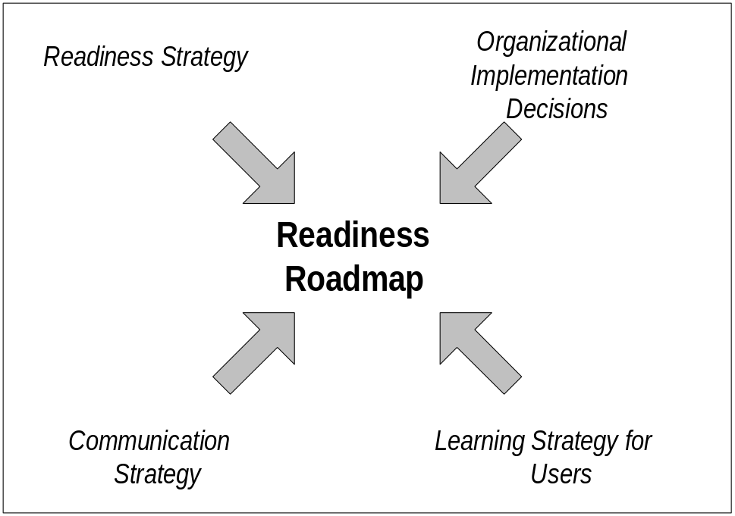

Overview
This document includes the following components:
Component | Description
Introduction | Shows the outline for the work session to co-develop the organizational recommendations.
Executive Summary | Highlights key findings and recommendations in the areas of the organizational assessment.
Roadmap Process | Describes the process used to develop this roadmap.
Change Readiness Strategy | Highlights key findings and recommendations around the organization’s readiness to embrace the technology-induced change.
Organizational Implementation Decisions | Consolidates and reports progress on the key organizational decisions made by the Executives, the steering committee, the project team and the Business Unit Managers.
Communication Strategy | Highlights key findings and recommendations around the organization’s communication needs.
Learning Strategy for Users | Highlights key findings and recommendations around the organization’s learning needs for users.
Appendix A | List of Respondents by Group.
Appendix B | Interview, Focus Groups and Survey Questions per Group of Respondents.
Appendix C | Consolidated Insights per Group of Respondents.
We recommend an assessment specialist, in conjunction with a communication specialist and adult learning specialist, complete all steps. Alternatively, the project manager could handle core steps 1, 2, 12, and 13, as defined in AIM 3.0 Process and Task Reference.

Work Session(s) Overview
The Project Readiness Roadmap work session is a day-long session where we work with the organization to create an action plan to improve the change readiness of the organization. Following are key steps to undertake in preparing and conducting the work session This section of the document then summarizes the outcome of the work session.
In collaboration with the executive sponsor (or steering committee chairperson) and/or project manager:
1. Confirm list of attendees
2. Select site for session (preferably off site). Because people tend to become defensive about findings, there is inevitably some stress involved in this session. Selecting a site where people can dress casually and where snacks can be available tends to ameliorate that situation.
3. Review Planning Session Checklist template.
4. Tailor Agenda (see outline section below) and send to attendees along with the Project Readiness Roadmap (with all documentation except for recommendations), and an invitation memo specifying time and place, context of the session, purpose and benefits, why attendee is selected, objectives: results and expectations, facilitator background, agenda and preparation request (See Invitation Memorandum for sample invitation memo)
5. Coordinate with other representatives.
6. Prepare session scribe.
Prepare Findings:
Definition: A finding is a descriptive statement that reflects a trend in data or an observation pertinent to the assessment goals.
Findings are the conclusions we draw based on analysis of the data gathered in the assessment. Organizations usually value assessments to discover strengths in their organizations which can be used to increase the likelihood of a successful implementation and areas of weakness which can be eliminated or lessened. A major part of the value we bring is dependent on our ability to present findings which allow our customers to make business decisions based on accurate, reliable information.
1. Provide strong support for each finding: Each finding should be substantiated with evidence from the data collected during the assessment information gathering process. Some findings may be difficult for the organization to accept, so the more you can substantiate your statement, the better. On the other hand, organizations may easily skim over findings when they feel, “Yes, we already knew that.” Well documented and supported findings allow the organization to see the extent of a problem, give him new insights into root causes, or suggest possible impacts which may not have been considered.
2. Paint a picture for the organization: As you review the findings with the organization, give the data life and immediacy by including quotes as well as numbers. Also, use graphs, charts, tables and diagrams to make numerical data easy to comprehend and to show findings in relationship to one another.
3. Tie findings to the principles of successful implementation and change leadership and to anticipated business results: The framework you use to present the findings is usually a logical extension of the type of assessment you have done. For example, when presenting the Readiness Strategy, use the Eight Guiding Principles to organize the findings.
4. Keep an eye out for the organization’s customer: Watch for either positive or negative findings which have proximity to the organization’s customer. Anything which touches the organization’s customer is a priority.
5. Keep the language associated with the findings neutral: a report of facts, not your judgment of them. Be careful not to use language that the organization may view as judgmental. If an emotionally charged word really seems to convey findings accurately, (for example: “The Finance and Sales groups see their relationship as adversarial.”), use it, but be sure to have quotes and quantifiable data that really support that word choice.
6. Clearly document non-empirical findings: You may feel you want to report conclusions which are based on inference, intuition, or as a result of your past experience, but you have little empirical data to support those findings. If you choose to document those perceptions for the organization, make sure the organization is aware of the source of the information.
7. If appropriate, share the key findings in one-on-one meetings with the key leaders in advance of the work session to avoid any “bad surprises” or a “lose-face” situation in a group setting.
Prepare Recommendations:
Organizations pay professionals to bring their expertise, experience, and creativity to help them solve their change management issues. We realize that if we fail to involve them in the process of creating recommendations, we miss the opportunity to tap into their expansive knowledge of their own organization, and we also risk creating recommendations which never will be implemented because the organization never assumed ownership. Creating good recommendations is difficult; coaching, guiding, and mentoring organizations to create good recommendations is an art form.. The basic rule of thumb is: “Work to help the organization create its own recommendations.”
Definition: A recommendation is a suggested approach to either solving a problem or leveraging a strength which will help the organization achieve the anticipated results of the implementation.
1. Maintain format continuity for findings and recommendations: Although recommendations often provide integrated solutions to the strengths and opportunity areas identified in the findings, it helps to organize them in the same framework used to report the findings. This provides the organization with continuity and emphasizes the assessment goals once more. A more sophisticated organization may not need this same framework and may be more comfortable with integrated recommendations/strategies. The best-practices contained within the Adoption and Learning Process are recommendations in and of themselves. Protect both the organization’s time and resources by pointing out solutions to problems which are being addressed or will be addressed by an Adoption and Learning Process task. For example, most communication problems will be solved by following up on the well-designed communication activities built into Adoption and Learning Process. If you have a recommendation for an issue not addressed by the Adoption and Learning Process (a cultural issue, for example) use the Guiding Principles as your initial framework but show how your recommendation blends with the tasks of the Adoption and Learning Process.
2. Come prepared with suggested recommendations, but delay making them until the organization has had a chance to come up with ideas of its own. The organization brings the knowledge of organizational reality; the consultant brings creativity, experience with similar situations in other organizations, and the collective experience of the practice in problem solving. When you do suggest solutions, tap into the organization’s expertise by asking, “Will this approach cause any political problems? How appropriate is this recommendation for your culture? Will this idea fly? Do you have the capability to implement this solution? How radical does this recommendation seem to be? How much risk is associated with it? How much money will it cost? Is this solution too complex? How would you actually accomplish that here?”
3. Create a straw man: but delay making your recommendations until the attendees have had a chance to come up with ideas of their own. Use a strawman only if the attendees need something to stimulate thinking and discussion. If possible, guide the attendees in the generation of their own ideas.
Facilitation Guidelines for the Introduction Part of the Work Session:
1. Review purpose for the session and agenda. Emphasize that the session is focused on the future. The objective is not to either give praise or lay blame for past actions. The past is what it is; at least in part, the future will be shaped by the decisions made in this session.
2. Briefly introduce the attendees by highlighting the unique contributions each brings to the group.
3. Review roles, ground rules, etc.
4. Review attendees’ expectations for the work session (Capture on flipchart)
5. Review your own role, expectations and background as the facilitator for the session to build credibility.
6. Briefly review the Eight Guiding Principles of Effective Change and position as context for the session.
7. Discuss the characteristics of effective recommendations.
Present Findings:
1. Emphasize both strengths and areas for improvement as you present findings: Stress the positive impact of leveraging anything that is working well and the benefits of immediately recognizing those who have contributed to the success. (As a sanity check, immediately after data analysis give the organization a high-level overview of the findings. What may seem to be a negative finding to you may not seem negative to the organization.)
2. Move from data to effect: the “so what” piece or the discussion. Data by itself usually raises more questions than it answers; a frequent organization reaction is, “How bad is this?” or “What does this mean?”
3. Build consensus around priorities: Assist the attendees in determining criteria for prioritization and then prioritize findings using the nominal voting technique.
Facilitate Co-Development of Recommendations:
1. Tie recommendations to findings: There must be a clear reason for investing the energy needed to implement a recommendation. Make the connection between the finding that has been documented, the impact it could have (“So What?”), and then move to the recommended solution. Organizations need to see the reasoning behind each recommendation. Challenge them to think through their own reasoning. When you see a “to-do” list forming, force them to illuminate their reasoning by asking questions such as, “What findings are leading you to think of that idea? Why do you think that will improve the transition period? How can we improve on that idea to make sure we capitalize on some of the strengths we have, while minimizing some of the potential barriers?”
2. Force yourself (and coach your organization) to write specific recommendations: Organizations seem to instinctively move toward generalities which can be summed up as “We need to do better.” A typical organization-designed recommendation would be, “Improve our decision-making process,” which is so vague it really gives very little direction. Ask the attendees, “How should the process be improved? What steps need to be taken?” A stronger recommendation would be, “Streamline the decision-making process by mapping the layers and the flow of approvals. Look for bottlenecks, redundancy, opportunities to move authority down, and evidence of bureaucracy.”
3. Pull organizations toward innovation. Organizations will be most comfortable with recommendations which sound familiar. Unfortunately, this leads to in-the-box solutions. Coming up with creative approaches requires everyone to find the line between recommendations which are innovative yet still appropriate for a culture and recommendations which are simply the same thing that has been tried a dozen times. For example, most organizations immediately decide on “more communication” as a solution to at least two-thirds of their problems. By “more communication” they mean they will talk more, give more presentations, send out newsletters, memos and e-mail messages. Those things may need to be done, but interventions which would require leaders to listen would give them infinitely more mileage. The next step is to ask what feedback channels would work well in their environment and have enough novelty that people would realize something new is afoot.
4. Allow attendees to teach themselves to create good recommendations: Use questions to guide attendees through the thought process which will lead them to discover better approaches. For example, “What benefits might come to the organization if your people had more input into decisions which affect them? How could you structure your communications plan so you’d have more opportunities to get ideas from your people? How could you find out what your people are thinking? If you chose to do that, would people realize that a change is being made?”
5. Look for leverage points: Identify those issues which are really critical and will give the organization a high return. Is there a show stopper? Point it out. Be sure to identify the criteria for the prioritization. Is something critical because it will cause the change effort to fail, because it will cost extra money, or because it will slow down the implementation. How do you know if a finding is a show stopper? Most of the time that depends on the environment and culture of the organization. However, across the board, findings which indicate low trust levels, lack of understanding of the need for change, lack of understanding of the benefits of change, lack of two-way communication, lack of consistency in message and behavior in leaders, and lack of employee buy-in are automatic priorities because they have such far-reaching effects.
6. Look for underlying causes: For example, if you discover that an organization’s culture is risk averse, cross check to see if you have any findings which indicate trust levels are low. Cultures which are risk averse may simply be highly conservative and/or deeply bureaucratic; they may be led by people who are intensely controlling, or there may be trust issues which make employees afraid to take a chance.
7. Look for opportunities to cherry pick. If there are some fast, easy solutions (even if they aren’t top priorities) don’t miss the chance to stack a few small successes. Emphasize the need for publicity around these quick hits. (If organizations don’t communicate these successes loudly, they’ll miss the opportunity to generate trust and momentum.) However, counsel your organization not to do anything which seems artificial or “staged”; successes must be real and they must have some significance.
8. Limit the number of recommendations: Don’t come up with a list of twenty or thirty recommendations. Realistically, most organizations will be doing well if they can tackle five. Organizations instinctively will want to come up with a plan to solve every issue; one of the most important contributions consultants can make is to guide them in keeping the plan practical.
9. Prioritize and sequence. Even though the list of recommendations may see manageable, some will need to be in place before others are effective. Others will work best during certain phases of the implementation. The organization naturally will want to tackle everything right away. Help them by having them evaluate, prioritize, sequence and break their plan into manageable chunks. For instance, you might have the organization list the recommendations that should be completed immediately, those to be completed within the next six months, those that should be completed within one year (but may need planning to begin soon), and those that can wait to begin planning until one year out. Always step back in the end to check the plan against necessary resources, implementation milestones, other change initiatives, and environmental factors (community, competitors, political activity, etc.)
10. Create an action plan: Break attendees into pairs or triads and give them a copy of the updated Recommendations Matrix. Assign each pair or triad to convert the selected recommendations into action items: a) Identify tasks steps; b) Assign accountability; c) Determine time frame; d) Establish measures and milestones. Reconvene the larger group; report decisions; reach consensus. Incorporate the action plan into the other project plans or PVCS Tracker.
11. Include action items to communicate the consensus.

Purpose
Implementation experience has shown that the formula for helping organizations achieve the business results they desire has three critical elements: technology, process and people. Successful implementations factor in and integrate these three equally important aspects of the technology-induced change. This Project Readiness Roadmap work session focused on the people piece of the equation, and as the name suggests, it was meant to be a guide to move toward the expected goals. The people piece addressed the system users rather than the more technical system installation activities, and included user profiling, user communications, user acceptance, learning and ongoing support.
This Project Readiness Roadmap work session assembled key members of the steering committee, project team and key stakeholder leadership to help them refine the strategies required to favor the organization’s acceptance and use of the new system. They were gathered to convert the assessment findings into effective recommendations compatible with their culture and their budget. The recommendations were accompanied by an action plan which included the person who is responsible, the anticipated date of completion, and the milestones and measures associated with the action.
The work session was highly interactive and focused on decision making around key questions to make sure that the organization could engage in a successful technology-induced change. Questions addressed included:
The Adoption and Learning Process contains best-in-class organizational practices around the implementation of technology, and in that sense, the interventions themselves are the vendor’s recommendations for achieving the desired business results from an project. However, because each organization has a unique culture, and each organization makes different decisions concerning the way the technology will be implemented, it becomes inevitable that we need to tailor our offerings to match the organization’s needs. The Project Readiness Roadmap, which is a milestone deliverable in the Adoption and Learning Process, outlines an approach which shows how the best-in-class practices can be adapted, refined, augmented, or simply used as they are to fit the specific needs of the organization.

- Who are the system users? How will they relate to the new technology? What changes will affect them?
- How ready is the organization currently to embark in this change?
- What are the areas of strength that can be leveraged? What are the vulnerable areas that need addressing?
- How can we best ready the business to take advantage of the technology?
- How can we best involve the stakeholder groups to participate in a smooth implementation?
- How aligned are our organizational decisions so far?
- How can we best use communications to involve and create buy-in among our stakeholders?
- What do we need to put in place to analyze the organization’s learning needs?
The work session reviewed the findings around these questions and helped explore the best course of action in each of the key areas. Recommendations address how the change should be facilitated, communication leveraged, risks mitigated, learning and post-implementation support made available.

Facilitation
Add background notes on the facilitator’s experience in conducting such sessions.
The work session was facilitated by <Facilitator Name> from …..
<Facilitator Name> Biographical Notes:
In addition, <Scribe’s Name> attended the session to keep a record of all decisions made during the meeting and keep deliverables updated at all times throughout the session.

Attendees
The following people participated in the work session:
List here the names of steering committee Members, project team members, and key stakeholder group leaders from the organization, and contract resources. Recommended attendance is limited to 8-12 leaders who represent the key stakeholder populations.
From the Organization:
- One of these attendees will be the Executive Sponsor for the project who also will be a member of the steering committee
- The project manager
- The change team lead
- Business unit leaders representing key stakeholder populations
From vendor:
- The assessment specialist
- The project manager
- Session scribe
Organization | Name of Attendees | Title
<Company Long Name>
Contract Resources

Outline
The following outlines the activities included in the conduct of the work session:
We recommend that the session be held off site for maximum concentration and dedication to the decision making process. The meeting can be broken into two work sessions for an approximate duration of 8 hours.
Sections | Description | Time | Duration
Introduction | Overview of the session: purpose, expectations, logistics, etc. |  | ½ hour
Review Background Information  Review the 8 Guiding Principles of Effective Change Leadership  Review the characteristics of effective recommendations | Sets the stage for the understanding of the findings and the creation of recommendations by establishing the fundamental principles of change leadership as framework. |  | ½ hour
Review Key Findings  Highlight key results  Build consensus around priorities | Highlights the key results and diagnostics from the assessment. |  | 1 ½ hours
Co-Develop Recommendations  Review the Adoption and Learning Process tasks which may impact findings  Brainstorm an initial list of <Company Long Name> recommendations tied to findings  Select criteria for evaluation  Evaluate the recommendations  Prioritize the selected recommendations | Guides the <Company Long Name> on co-developing in a highly interactive format, recommendations that are clear, specific and practical, are innovative and interesting, are within budget, are compatible with the organization’s culture, stand a good chance of making the organization more resilient, and more importantly, generate buy-in. |  | 3 ½ hours
Develop an Action Plan  List tasks steps  Assign accountability  Determine time frame  Determine necessary resources  Establish measures and milestones to track progress  Add communication items  Integrate with project plan (or PVCS Tracker) | Identifies the details around implementing the recommendations. |  | 1 ½ hours

Executive Summary
This section highlights the key findings and recommendations in the areas of assessment.
Capture here the high-level key findings and the recommendations from the work session. Map the recommendations to the findings.

Highlights
The following documents the key findings and recommendations from the assessment:
Assessment Area | Key Findings | Key Recommendations
Change Readiness
- Vision
- Leadership
- Communication
- Culture
- Supporting Structures
- Shared Ownership
- Scope of Change
- Learning Organization
Organizational Implementation Decisions
Communication Strategy
Learning Strategy for Users

Key Quotes
The following documents quotes representative of the key findings and recommendations:
Capture here key quotes that best represent the findings/recommendations above. You may organize them by assessment area.

Groups of Respondents
A total of __ people participated in the assessment, from the following groups of respondents:
- Executive leadership team
- Project team
- Business Unit leadership team
- Middle Managers
- First Line Managers
- Users

Roadmap Process
Document here the roadmap process followed. All the information found in this section is boiler-plate, detailed and instructional. When completing this for the organization, you need only include the actual techniques used to generate the findings. Any additional detail required as support or general background should be added into the Appendix. Keep the main body of the roadmap as simple as possible by including only the techniques used with a limited explanation or rationale..

Assessment Approach
The Project Readiness Roadmap resulted from an organizational assessment that evaluated the organization’s ability to adapt to major technology-induced change. The readiness roadmapping activity started by identifying how the users across the organization would interact with the new system and the strengths/risks inherent in the culture and nature of the organization. Next, it identified user “roles,” which were driven by what users would be expected to be able to do with the new system: which users would interact with the new system within each function/process that the system supports? The understanding of users and stakeholders was important to formulating an overall assessment of how much change users are expected to absorb. This analysis drove the readiness, communication and learning strategies necessary for the system to be successful.
Our philosophy of organizational change management is based on the Eight Guiding Principles of Change which are high-leverage, high-impact practices shown to have a profound effect on groups undergoing a large technology implementation. These principles form the basis of both the leadership approach we recommended and the foundation for the topics which we explored in the assessment. In the Roadmap Assessment we looked at the organization’s change history, its culture, and the infrastructure it had in place to support the technology project. We also looked for evidence of resistance, fear, and skepticism so these typical reactions could be addressed proactively. The information gathered through the assessment served as a first measurement against which further measurements will be compared to track progress. Finally, the assessment itself was a mechanism for getting people involved in the change process and also was used as an early step in disseminating information.

Assessment Topics
Through a combination of data gathering techniques, for example, interviews, focus groups, survey, the Project Readiness Roadmap focused on key topics for successful acceptance and use of the new technology:
Assessment Areas | Topics
Change Readiness | - Vision  - Leadership  - Communication  - Culture  - Supporting Structures  - Shared Ownership  - Scope of Change  - Learning Organization
Organizational Implementation Decisions | - Business Results Expected  - Project Charter  - Organizational Alignment of Project and Corporate Strategy  - Organizational Performance Improvement Strategy
Communication Requirements | - Communication Culture and Preferences  - Current Knowledge of Project  - Communication Agents
Learning Requirements | - Current Learning Capability and Preferences  - Steps Required to Conduct Learning Needs Analysis for users

Assessment Process
To provide a quality product, the Roadmap Assessment followed a structured methodology.
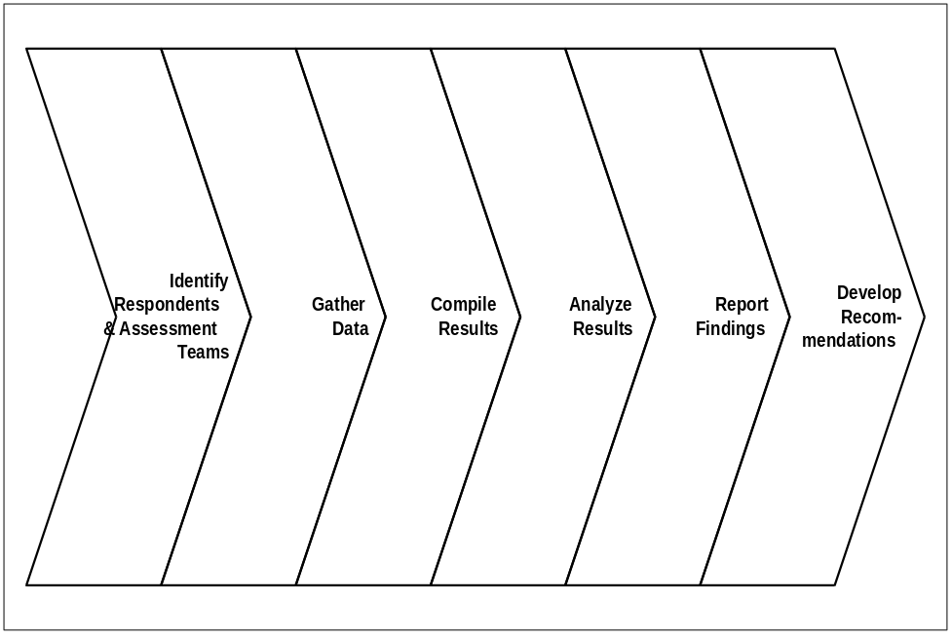

Stakeholder Groups
Copy here the updated Sponsor Profile Matrix from the Executive Project Strategy (AP.010).
The first step in identifying user-related issues is sometimes referred to as “user or stakeholder profiling.” During the Executive Project Strategy (AP.010) work sessions, the executive team identified the key stakeholder groups and captured that information using the Sponsor Profile Matrix. Their work was validated first by the project team during their induction process and then by business unit managers in their induction. Stakeholders are those people who have a vested interest in the change and are the primary targets for the roadmap assessment because, ultimately, their ability and willingness to use the new technology will determine whether or not the anticipated business results are obtained. The validated Sponsor Profile Matrix which appears below was used to identify the groups targeted for the assessment.

Respondent Sampling
Based upon the above stakeholder information, a sample population was selected to participate in the assessment process. To obtain a representative sample of the total target population, various sampling techniques were used including purposeful selection, and stratified random selection. The assessment sample population that participated in the assessment is shown in the table below.
Population Groups | Impact | Population Numbers | Actual Sample Numbers | Sampling Method | Data Gathering Method | Number
Key Users
Total Key Users
Other Users
Total Other Users
Other Stakeholders
Total Other Stakeholders
Total Population Sample

Constraints
Use this section to describe any constraints to the assessment process and how they were addressed. For example, budget constraints, resource limitations, multiple locations, unavailability of key stakeholders, or political issues.
The following constraints were addressed as described:
Description of Constraint | How it was addressed

Roles
Edit following table as necessary.
The following people were involved as described, to lead, guide, assist and otherwise participate in the assessment process. The list of respondents can be found in Appendix A.
Role | Responsibility
<Company Long Name> Executive Sponsor  <Name> | - Ensured resources are available for the assessment at all involved sites.  - Managed external risks to the assessment.  - Signed or arranged for introduction of the assessment to the organization.  - Made, or made sure that others made, timely decisions.  - Communicated the vision of the project and the role of the assessment in its success.
<Company Long Name> Project Manager  - <Name> | - Selected assessment agents.  - Communicated and coordinates with managers outside the assessment team.  - Identified required subject matter specialists (SMSs).  - Assigned tasks to assessment agents.  - Monitored staff progress.  - Managed risks and escalated issues from assessment team.  - Directed issues to appropriate individuals for resolution.  - Signed off on assessment tools and instruments.  - Coordinated the data collection process.
<Company Long Name> Project Coordinator  - <Name> | - Assumed responsibility for day-to-day management of the assessment.  - Provided <Company Long Name> project manager with general administrative support.  - Supported and distributed status reports.
<Company Long Name> Subject Matter Specialists/Advisors  - <Name>  - <Name>  - <Name> | - Acted as spokespersons for their constituency, solicit and represent needs and environment of constituency.  - Guided, advised on, and/or validated key decisions.  - Represent key stakeholder constituencies.  - Facilitated use and leveraging of existing resources.  - Acted as liaison to other related projects and functions.  - Communicated business and organizational needs in specific areas.  - Determined job functions for jobs impacted by technology.  - Assumed responsibility for providing timely and accurate information to be used during the assessment process.
<Company Long Name> Assessment Specialists  - <Name>  - <Name> | - Provided organizational development, change readiness expertise.  - Conducted interviews or focus groups.  - Tailored and administered data-gathering tools.  - Evaluated data gathered in assessment.  - Documented process and findings.  - Presented assessment findings to project team.  - Co-developed and documented recommendations for Project Readiness Roadmap.

Data Gathering Techniques
In this section, be sure to list only those techniques used in this Project Readiness Roadmap. Any detailed definition or description of activities should be placed in the Appendices to keep the final core document as concise as possible.
Several approaches were used to make sure there was a comprehensive, valid assessment. The data gathering techniques used to gather information included in this Roadmap include the following:
- Interviews
- Focus Groups
- Survey
We were always careful to avoid wasting time and energy through duplicated effort. Consequently, we structured our data gathering techniques to allow us to collect information for more than one purpose.

Interviews
One-on-one interviews were conducted with a sampling of the executive leadership team, the project team, the business unit leadership team, middle managers, first line managers, and users.
One-on-one interviews provided a richness and depth of information unavailable through any other means of data gathering. Consequently, we used this approach with those audiences who could provide the critical background information we needed in order to start assessing the organization’s readiness.
We focused on such topics as:
- The alignment between the organizational and project visions.
- Expected business results.
- Perceptions concerning the readiness of the organization for major change.
- The history of technology-related change in the organization.
- The history of sponsorship.
- Business drivers.
- Customer impacts.
- Expectations of vendor.
- Anticipated obstacles.
- Empowerment.
- Performance measurement.
In addition, we focused on the following topics per group of respondents:
Groups of Respondents | Topics
All | - The alignment between the organizational and project visions, expected business results, perceptions concerning the readiness (or resistance) of the organization for major change, the history of technology-related change in the organization, the history of sponsorship, business drivers, customer impacts, expectations of vendor, anticipated obstacles, empowerment, and performance measurement
Executive Team | - Business results expected, corporate performance measures, target groups for learning events, sponsorship, skills available, barriers, history of change
Implementation Team | - Target groups for learning events, project goals, capabilities of project implementation team, communication
Business Unit Managers | - Business results expected, business unit performance measures, communication, competing projects, incentives, key players, culture, desired behaviors
Middle Managers | - Department performance measures, key processes, work flows, key players, skills, knowledge, abilities, behaviors, evaluation technique, barriers, job functions, incentives, expectations per roles, work organization
First Line Managers | - Work flows, performance measurement per role, key players, tools, communication, skills, barriers, past learning experience, incentives, skills transfer, shifts, locations, job descriptions/competencies, job functions, behaviors
Users | - Barriers, rewards, performance measurement, work environment, tools, communication, problem solving, risk taking, key players, goals, learning environment, behaviors
Project Learning Team | - Educational backgrounds, evaluation techniques, past learning experiences, locations, shifts, number of users, size and capabilities of learning department, attitudes toward learning, measurement of learning effectiveness

Sampling Approach
Interview participants were selected because of their key positions in the organization, their ability to provide insights, their historical perspective of the organization, their vested interest in the project, or their formal or informal leadership role in the organization. The lists of people interviewed and of interview questions are included in Appendix A and B respectively.

Interview Data Compilation
The compilation approach for interview data occurred in two steps: Merge and Classify
- Merge: comments that are repeatedly made on the same subject from different respondents were grouped together
- Classify: the content of each group of comments was analyzed to determine the underlying issue
As we compiled information gathered from interviews, we asked questions such as the following:
- Is this opinion based on subjective or objective data?
- Is this an isolated opinion or is it pervasive?
- What is the interviewee’s frame of reference?
- What is this interviewee’s personal stake in this project?
- Are there common themes in these interviews?
- Are these comments influenced by personal relationships?
- Which issues have the most emotion attached to them?
- Are any of the issues interrelated?
- Are there any obvious priorities among the concerns expressed?
- Are there any areas of satisfaction upon which we can build?
- What inferences can be made about the interaction pattern among the sponsors?
- What additional inferences can be made through observation of body language, tone, and general attitude?

Focus Groups
A focus group consisted of a cross-sectional sample of people brought together to discuss issues related to the change initiative. Because multiple viewpoints were brought to the discussions, comments from one participant stimulated thinking in others and allowed the facilitator to collect large volumes of data in a short time. A structured agenda, cross-representation of participants, and an objective facilitator were critical factors that were present for a focus group to be successful.
During the weeks of ___ and ___ focus groups representing key stakeholder populations gathered to participate in focus groups to discuss the following issues:
- History of change in the organization.
- Structures which support major change such as learning events, recognition and rewards, hiring, and decision making.
- Sponsorship for the project.
- Communication patterns within the organization and communication preferences.
- The culture of the organization, including such topics as: trust levels, risk taking, innovation, customer focus, and teamwork.
- Individual perspectives of the impact of the change.
The following focus groups were conducted: The detailed list of respondents and focus group questions are in Appendix A and B respectively.
Focus Group | Number of Attendees
Total:

Survey
Surveys have the advantage of collecting large amounts of data in a reliable, inexpensive, timely manner. Survey questions focused primarily on the respondents’ perception of various issues. A stratified random sample of the stakeholders in <Company Long Name> was selected to receive the validated Change Readiness Questionnaire. Our sampling strategy was designed to achieve a confidence level of 95% with a sampling error of plus or minus 3 percent. The topics, which map to the Guiding Principles of Change, were as follows:
- Vision.
- Leadership.
- Culture.
- Communication.
- Shared Ownership.
- Supporting Structures.
- Scope of Change.
- Learning Organization.
A copy of this survey is also included in Appendix B.

Data Entry and Analysis
The data from the surveys was entered into a software tool which calculated the mean and the median as measures of central tendency, used the range and the standard deviation as measures of spread, and also calculated a gap analysis for those items where we used a double Likert scale (A double Likert scale consists of a statement such as “I trust my manager” followed by an “Agreement” scale and an “Importance” scale.). The tool’s robust analysis functionality allowed us to analyze the data by the demographics selected by the <Company Long Name>, that is by stakeholder groups, by location, by length of time with the corporation, and by the role of the respondent

Reporting Findings

Findings from Survey
The findings from survey were reported using the following table in the next sections:
Question/Item Related to Topic | Group | Mean | Median | Standard Deviation

Table Heading Definition
The following definitions assisted in the reporting of the finding tables:
Table Heading | Definition
Group | The group refers to the particular group of assessment participants that responded this way. Because the demographic data allows us to pull the data from various groups, we can report findings that show a contrast of opinion between groups or highlight a particular finding for a specific group.
Mean | The mean is the arithmetic average of all scores. It is calculated by adding all the scores together and then dividing by the total number of scores. Usually, it is the most meaningful statistic, but it is highly influenced by extreme scores (outliers), and as a result, a few extreme scores can pull the mean up or down..
Median | The median is the exact midpoint in any distribution, or the point that separates the upper half from the lower half. It is calculated by arranging scores in order of magnitude and then selecting the middle number in the sequence. When a distribution has outliers, the median is likely to be more typical of the majority of items in the distribution. The median is sensitive to the number of items with higher and lower values, but it is not sensitive to how much the values are higher or lower.
Standard Deviation | Standard Deviation measures how values are spread around a mean , in other words, whether they clump together or are widely spread. The average standard deviation on a seven point scale is about 1.5. A low score 1.0 or less indicates a high degree of consensus. At high standard deviation 1.8 or more indicates a wide diversity of opinion.

Change Readiness Strategy

Role of Change Readiness in Technology-Induced Change
The ability to manage large, complex change is one of the key competitive advantages any organization can have. Implementing new technology is a complex change that has far reaching impact on any organization, not just on its technology infrastructure, but also its business processes and its people. <Company Long Name> embarks upon the systems implementation, it faces many risks that may jeopardize the success of the implementation and lead to a costly failure - in terms of productivity loss, revenue loss, expense and employee morale. The organization’s skill in adapting to such changes quickly and effectively is its change readiness.
According to a study of more than 7,500 IT projects conducted in 1998 by research firm Standish Group International, 28% of all IT projects are canceled or never implemented. Another 46% languish behind schedule or go over budget. The reason for such a failure rate is not technical, but centers around proper planning and awareness of the human and organizational factors involved in such a transition.
A recent year-long IBM study involving twenty-four companies transitioning to client/server technology yielded the following results: “The successful implementation of a new system is directly related to an organization’s ability to accept and adopt to change.”
As indicated, many leaders underestimate the impact of an organization which has not ensured that its business goals, its information technology direction, and its people are synchronized with the change at hand. Ultimately, the best technology coupled with the best business process documentation will result in a huge loss to the organization if the people are not prepared or willing to move forward with the new way of doing business.
It is a natural human reaction to resist change. As intelligent beings, we should question upsetting a status quo that may be working smoothly. It is a very intelligent decision to resist a change being imposed if no apparent or sensible reason is perceived or understood. The process of having to adapt to a change is virtually the same for everyone, and can be summarized in the following four stages: Shock, Resistance, “Wait and See”, and Commitment. Still, individuals express their experience in different ways and move through the stages at a different pace, depending on their frames of reference, the information they possess, and their comfort levels.
An awareness of the human reaction to change is one important factor in managing complex change well. However, the importance of this model becomes emphasized when <Company Long Name>’s productivity is considered. As people spend energy dealing with the change at hand, productivity suffers accordingly. If we were to look at the productivity levels in an organization throughout this change process, we would see the following red curve.
As employees begin dealing with the change, productivity drops. As they pass through Resistance and Wait and See, productivity hits its lowest point. As employees continue through the Commitment phase, they see some benefits of the change; they understand it more, and they begin working in conjunction with the new system and processes. In the final stage of Commitment, the employees are comfortable with the new system, and they’ve reached a productivity level greater than was present before the change, as shown in the yellow curve. This becomes the new status quo until the next complex change cycle begins
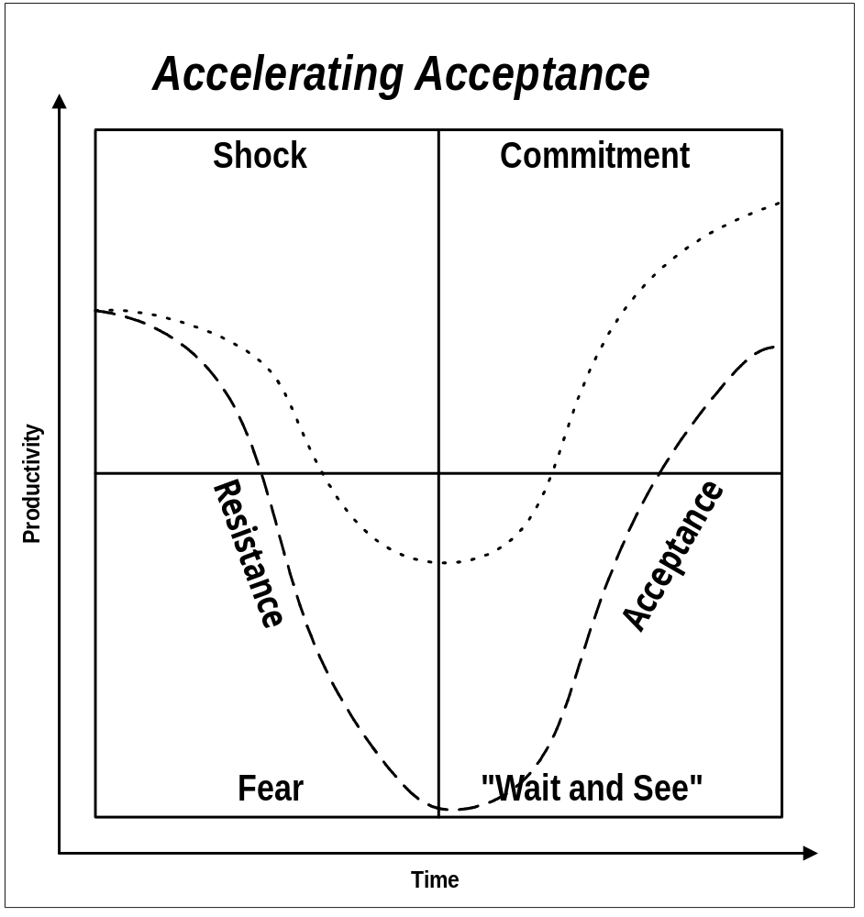
This human reaction to change will occur at <Company Long Name>. The resulting productivity loss will occur at <Company Long Name>. However, the loss in productivity need not be dramatic, and the amount of time spent in lower productivity levels need not be as long. The key is to move people through the stages of change more quickly than they would on their own. Change readiness activities help this effort. Listening to employee issues, communicating effectively, involving employees in shaping the change, providing effective sponsorship, proper learning and support are some of the many factors that help to manage the human reaction to change.

Guiding Principles of Change Leadership
The skills employed to improve <Company Long Name>’s change readiness are the Eight Guiding Principles of Change Leadership. These principles are actions which leaders can take to enhance the readiness of the organization to adapt to a major change. They focus on the planning, leadership, and involvement needed to help people through the change and adapt more readily to the vision that they helped create. The Eight Guiding Principles are:
- Create a clear, compelling vision
- Assess the organizational culture
- Lead the way
- Manage the scope of change
- Communicate openly, honestly, relentlessly
- Promote shared ownership
- Create supporting structures
- Build a learning organization

Objectives of Change Readiness Strategy
The Change Readiness Strategy is aimed at helping <Company Long Name> adapt to the new technology and its new organization. It will guide leaders to help employees through the transition process and provide a means for them to gain commitment to the change. The objectives of the Change Readiness Strategy are to:
- Reduce productivity loss during implementation
- Speed the implementation process
- Improve business performance gain
- Build future change readiness capability

Findings
The findings are reported below using the framework of the Eight Guiding Principles of Change. The focus group discussions and survey questions focused on the stakeholders’ perceptions of the application of these principles. Quantitative responses to the survey items, representative comments made in focus group questions, and written survey comments are captured here.

Impacted Groups
The following groups have been identified as the most impacted by the technology-induced change project:

These groups, organized by stakeholder populations, are the subject of the guiding principles that follow.

Guiding Principle: Create a Clear, Compelling Vision
Summarize here key findings and detail in the table below.
Key findings:
Question/Item Related to Topic | Group | Mean | Median | Standard Deviation

Sample of Representative Comments

Guiding Principle: Lead the way
Summarize here key findings and detail in the table below.
Key findings:
Question/Item Related to Topic | Group | Mean | Median | Standard Deviation

Sample of Representative Comments

Guiding Principle: Communicate Openly, Honestly, Relentlessly
Summarize here key findings and detail in the table below.
Key findings:
Question/Item Related to Topic | Group | Mean | Median | Standard Deviation

Sample of Representative Comments

Guiding Principle: Assess the Organizational Culture
Summarize here key findings and detail in the table below.
Key findings:
Question/Item Related to Topic | Group | Mean | Median | Standard Deviation

Sample of Representative Comments

Guiding Principle: Create Supporting Structures
Summarize here key findings and detail in the table below.
Key findings:
Question/Item Related to Topic | Group | Mean | Median | Standard Deviation

Sample of Representative Comments

Guiding Principle: Build Shared Ownership
Summarize here key findings and detail in the table below.
Key findings:
Question/Item Related to Topic | Group | Mean | Median | Standard Deviation

Sample of Representative Comments

Guiding Principle: Manage the Scope of Change
Summarize here key findings and detail in the table below.
Key findings:
Question/Item Related to Topic | Group | Mean | Median | Standard Deviation

Sample of Representative Comments

Guiding Principle: Create a Learning Organization
Summarize here key findings and detail in the table below.
Key findings:
Question/Item Related to Topic | Group | Mean | Median | Standard Deviation

Sample of Representative Comments

Recommendations
The following documents recommendations and associated actions:
Recommendations | Priority  (1,2,3 where 1 is high) | Degree of difficulty  (1-10 where 1 is easy) | Action | Accountability Assigned to | Measures and Milestones | Time Frame

Organizational Implementation Decisions

Decision Checkpoints
Throughout the Adoption and Learning Process so far, decisions have been made at multiple levels which are critical to the success of the implementation. As the executives met in the early stages of the project, they created a list of key decisions which they either needed to address or to delegate; the steering committee went through a similar activity, and the project team was also involved in a decision-making session. Most of the decisions made may have long since been operational, but a few may have been changed or simply lost. The business unit managers initiated decisions around the Business Performance Improvement Strategy. The following table provides a checkpoint where we revisited key decisions to make sure that nothing was neglected inadvertently and that these decisions were aligned with the decisions resulting from the Readiness Roadmap.

Decisions | Identified by:  - Executive Team  - Steering Committee  - Project Team  - BU Managers  - Others | Delegated To: | Time Frame for Completion | % Completed | Risk associated with lack of follow through
 |  |  |  | %
 |  |  |  | %
 |  |  |  | %
 |  |  |  | %
 |  |  |  | %
 |  |  |  | %

Recommendations
In addition to the decisions documented above, the following recommendations were formulated:
Recommendations | Priority  (1,2,3 where 1 is high) | Degree of difficulty  (1-10 where 1 is easy) | Action | Accountability Assigned to | Measures and Milestones | Time Frame

Communication Strategy
This section:
- defines the communication structure throughout the lifecycle of the implementation
- specifies the communication objectives to support the change effort
- highlights the communication approach for all change leaders
- identifies the target groups for whom the communication campaign is designed
- defines the communication needs of each target groups

Role of Communication in Technology-Induced Change
Nothing instills anxiety and fear of change more than lack of information. Therefore, a primary component for implementation success from the users’ perspective is an effective and ongoing communication program that migrates users from their existing comfort zone to full involvement and buy-in.
One of the biggest challenges for an organization during a technological change is to create buy-in and make sure there is that all people impacted by the changes participate in the change vision in a positive way. The change teams and the stakeholders play an active role, at their respective levels, in achieving the goals of the change. They support a positive change effort if they are involved in and well informed about the project, and if they understand the rules of the change and the way it is to be managed. They also cooperate if they see congruency between the change leaders’ and teams’ behaviors and messages. Consequently, they seek information, formal and informal, and they interpret events in order to understand rather than resist what they are facing.
The following paragraph is according to Duck, J. D., (1993), “Managing Change: The Art of Balancing”, Harvard Business Review, November-December.
Whatever is done or not done sends a message -- even the appointment of a task force sends an important message. For this reason, all change projects need a Communication Strategy. This is an essential step to creating motivation, sharing responsibilities and managing emotions in a new work environment.
The Communication Strategy brings people on board and will assist ins effective dialogue and listening among the key players. Its approach helps manage the human side of the change in terms of achieving the implementation objectives. Depending on the organizational culture and change history, the Communication Strategy will reach people through the leadership, political power, networking ability and technical expertise, emotional appeal or communication strength of the key players.

Objectives of the Communication Strategy
The purpose of the Communication Strategy is to shape the communication during the <Project Name> so that information is shared between groups, stakeholders get involved in the implementation, human issues are addressed and expectations managed during the change effort.
The specific communication objectives targeted by the communication strategy are:
- Develop awareness of the benefits of the technology-induced change: “What is this thing all about?”
- Generate understanding by addressing the question: “What’s in it for me?” and keep people informed of the progress of the project.
- Reduce anxiety by answering the question: “What will my job be like after the system is implemented?”
- Instill involvement by establishing a two-way communication mechanism.
- Use communication agents as a channel to hear the various groups’ needs.
- Ensure buy-in throughout the phases of the project.
- Create distributed environment for information (versus selective distribution).

Established Communication Structure
At this point, the communication process already has begun with the executive communication plan and the communication standards and models defined for the project team.
To address the on-going communication needs of all groups of stakeholders for the duration of the project, a communication program was designed around a multi-step campaign with different elements for the different target audiences. This campaign provides a mechanism to manage the two-way communication flows as it defines key messages per audience, media, frequency, sequence, delivery resources, reinforcement and measurement methods. For example, the awareness messages can be delivered organization-wide with posters, bulletins, contests. The “what’s in it for me” question can be answered with more specific, personalized communications (one-on-one conversations, emails, ...) to a more limited audience. Demonstrations and hands-on events can be orchestrated to address the “what will my job be like after the system is implemented?” question. Finally, many other components and techniques, including project newsletters, success stories, testimonials, open line, could be included in the overall communication campaign.
<Company Long Name> is committed to conducting formal communications aligned with implementation milestones. The communication strategy follows established management and organizational channels within the respective business units. Informal channels of communication also need to be orchestrated to complement formal communications. The communication campaign will be administered by the project communication team, with the support of communication agents.

Communication Dynamics
Summarize here findings on the organization’s current communication dynamics. Again, detail only the techniques actually used in the roadmap process and include other background on communication techniques in an Appendix.
Communication Culture: Tie the communication culture to the organizational culture:
- traditional hierarchical culture: communication filters down from the upper echelons to the rest of the organization, using passive one-way modes of communication such as memos. People tend to respond to such communication with a passive wait-and-see attitude
- informal culture: communication flows through a decentralized information process. The organization uses an electronic medium to communicate and people appreciate receiving short communications with few announcements. People respond only when they feel concerned or impacted by projects.
- participative culture: communication flows through formal and informal channels. All projects are flooded with input from the top down, from the bottom up, as well as cross-functionally. The organization readily uses formal and informal leaders to carry messages and create two-way communication. People react proactively and willingly participate in communication events. Each person is accountable for his/her communication responsibilities.
A communication strategy requires more than one communication style, depending on the organizational culture and its past experience with change. Our organizational culture can be summarized as .... Historically, communication within <Company Long Name> has followed < traditional hierarchical, informal, participative culture>.
Based on the current communication needs for this project, we used the following styles consistent with the existing culture <or promoting new cultural values> and conducive to the acceptance and use of new technology.

Cascade Communication
For effective people involvement, <Company Long Name> will use the cascade method which begins at the top by having managers inform the people who report directly to them, who then inform the people who report directly to them, etc., so that information cascades down the organizational hierarchy until all stakeholders have received the necessary information. It is effective in building commitment and cooperation among stakeholders, as most individuals prefer to receive information from their immediate supervisor.
The formal leaders are involved in the communication strategy and play an active role in passing the information on to their people. They assume the role of communications agent: “an individual who implements a communication activity, such as a communication event, and/or who acts as a communication/information resource or channel.”

Two-Way Communication
For effective dissemination through disclosure, and inclusion and involvement of the stakeholders, <Company Long Name> opts for a two-way communication. This method of communication collects input at different levels of the organization through mechanisms established for voicing stakeholders’ suggestions and concerns. Employees can attend feedback sessions, meet with their manager or go to the web site, etc. to communicate with the project team. This communication method brings the stakeholders on-board and conveys the correct tone to the people impacted by the new technology.
Both formal and informal leaders are involved in two-way communications to facilitate multidirectional communication among departments, change teams and stakeholders. This communication fosters ownership, involvement, commitment and cooperation among the change leaders and the people impacted by the changes.

Peripheral Communication
For effective communication among business partners, <Company Long Name> will use peripheral to inform its vendors, business partners or organizations about the new technology. In addition, some of them will be invited to participate in the changes by taking part in organization focus groups or in customer approach validation. This communication method positions the technological changes outside the organization and brings new input to the change process.
The organizational leaders create dialogue with business partners and organizations and include them in the change effort. This communication method creates effective involvement when the new business process changes the way business is done and impacts partners and organizations in different ways. These peripheral communications define the level of transparency that will be achieved with our communications during the technological implementation.

Creating Change Momentum
The communication strategy addresses issues the executives, steering committee and project team anticipated and which can be minimized or managed with efficient communication. It includes all the activities needed to understand, gather information on and document these issues. It also includes actions to involve the people impacted by the changes and who can help put in place a strategy to prevent and manage issues. The communication strategy uses listening, information, discussion, and different channels of communication to be effective.
In the first column of the matrix below, report the issues that you want addressed in the Communication Strategy.. You can tailor the matrix to your own objectives and situation based on the objectives listed above.
Issues | Objective 1 | Objective 2 | Objective 3 | Objective 4
Stakeholder expectations are unrealistic
Rumors create confusion
Strong pockets of resistance
Current communication insufficient
Difficulty in anticipating stakeholder reactions
Political infighting
Climate of distrust

Risks of an Ineffective Communication Strategy
<Company Long Name> is aware of the risks of an ineffective communication strategy:
- The users will not understand the benefits of the new system and may be unable or unwilling to use the technology effectively.
- Adverse reactions to the project from audiences that have the ability to make their views known at senior levels can delay or even derail the implementation of the new technology.
- Staff commitment to expanding their knowledge base could be low, which would diminish performance and reduce <Company Long Name>’s return on its investment in technology.
- The communications are ambiguous, inconsistent, and create uncertainty and anxiety.
- The information is perceived as incomplete and has a negative effect on the leadership of the project sponsors.
- The change is experienced as negative and creates a passive wait-and-see attitude or, even worse, resistance behaviors.

Success Criteria for Effective Communication Strategy
An effective Communication Strategy is vital to managing the human side of the technological changes and creating project buy-in and involvement. This strategy builds trust and credibility in the project and involves people at different levels of the organization. The stakeholders will feel reassured about the communication and cooperate openly if the project is correlated with the following:
- Demonstration of top-level support for the communications.
- Identification of someone with authority in the process to play an active role and lead the Communications Strategy.
- Involvement of target groups in designing the communication campaign.

Components of Communication Strategy
The following describes the components of the communication strategy developed:
Component | Description
Communication Standards and Model   | The Communication Standards and Communication Model define the way the project leads and their teams communicate during the <Project Name>. We created a repository to store and track information, we adopted templates for reports and required frequent meeting to follow project progresses and manage potential issues. <Name of Communication Lead>is accountable for the Communication Standards and making sure that our Communication Model will be used by all team members. See Project Team Orientation Plan (AP.020)..
Communication Team  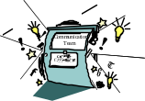 | The communication team provides the necessary support to all business units to ease the implementation of <Project Name>. The communication team outlines the high-level guidelines enabling communication work to go forward. It also coordinates the production of the communication tools. Our Communication Lead is <Name of Communication Lead>.
Communication Agents   | The communication agents are selected for their ability to serve as a “bridge builder”, by communicating both within a particular group and between other groups. People look to them for information and advice. The Communication Agents will pass on information to their constituency and back. Their role is to implement a communication activity, such as a communication event, and/or who acts as a communication/information resource or channel. <Name of Communication Lead> is accountable to supervise the Communication Agents.
Formal and Informal Leaders   | Informal and formal leaders support an efficient communication strategy by their ability to influence opinion within their constituencies. With or without the formal authority of a hierarchical position, they enroll people in the project and facilitate the change in a positive climate. <Name of Communication Lead> is accountable to oversee the involvement of the informal and formal leaders.
Target Groups   | Our Communication Strategy targets the groups of people who are the most impacted by the technology-induced changes. Concerns, needs and expectations of the target groups are the drivers of the communications, ensuring that the communications are created for the right people at the right time with the right messages and medium. <Name of Communication Lead>is accountable to identify the Target Groups.
Feedback   | For supporting the two-way communication, our Communication Strategy includes a feedback process, through ... <Name of Communication Lead> is accountable to identify and monitor feedback processes.
Measurement   | Measurements will be conducted to make sure that the Communication Strategy is efficient and its objectives are achieved. The following measurements are used:... <Name of Communication Lead> is accountable to conduct measurements
Communication Campaign   | A Communication Campaign will be created to manage the series of activities undertaken to achieve the communication objectives for each particular audience. The Communication Campaign will focus on the following phased communication milestones:  - Project Vision  - Project Kick Off  - Change Impact  - Project Progress  - Go-Live  <Name of Communication Lead> is accountable to create, deploy and supervise the Communication Campaign.

Communication Involvement
The Communication Strategy facilitates two-way communication and involves people from the top down as well as cross-functionally, and invites stakeholders to participate actively by voicing their needs and concerns. Formal and informal leaders participate in communications according to their personal talents and professional knowledge. The sponsors reinforce the communication mechanisms and lend their own credibility to the process.

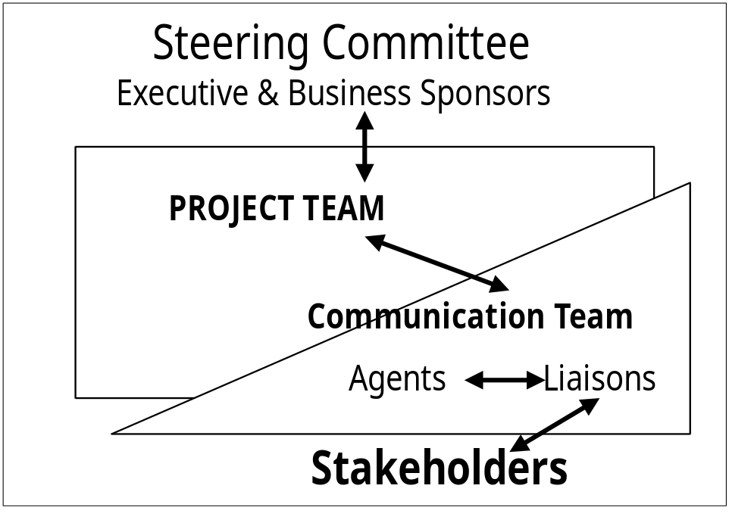

Management Involvement
Leaders and managers play an important role in the acceptance and implementation of new ideas and methods. The formal and informal leaders act as role models. The way they communicate, or do not, impacts the acceptance of new technology. They need to begin communicating early in the project and before information can become distorted through unofficial channels. They also need to encourage feedback from the stakeholders during the project. The ability to listen and communicate is therefore certainly part of the implementation’s success.
Managers have access to many audiences both formally and informally. They give credibility to the project when they use their personal and professional communication channels to broadcast of the project announcements. Managers create:
- mobilization and motivation by being in touch with people
- perception of trust and honesty with proactive and open communications
- buy-in through involvement

Stakeholder Involvement
The stakeholders are the ones who ultimately decide whether or not the system’s full capability will be used. They have the power to either participate in or resist the process. Their involvement accordingly dictates whether or not the performance criteria will be achieved. The Communication Strategy addresses their concerns, their information needs, and is tuned to facilitate their involvement.

Communication Team
The communication team lead by <Name of Communication Lead>, will facilitate the follow up and the realization of the Communication Strategy. The mandate of the communication team is to provide the necessary support to all business units to ease the implementation of <specify the new management information system(s)>. The communication team outlines the high-level guidelines enabling communication work to go forward. It also coordinates the production of the communication tools
The communication team is essential to the success of <Project Name>. The members represent the various communication audiences and other stakeholders. The composition of the team is cross-functional, interdepartmental, and crosses levels. Team members are genuine leaders. Leaders include not only those in key positions, but also informal leaders, who, regardless of title, are widely-respected by their peers and whose opinions serve as barometer for whole work groups and units.
More specifically, communication team members are selected for their professional and personal talents, to include:
Ability |  | Description
Leadership |  | have credibility  have people’s trust  able to speak freely
Communication ability |  | know how to actively listen to people  communicate openly  express messages clearly  understand the importance of communication for the success of this project  can serve as an advocate for various audiences  can lead and facilitate discussions  can keep confidences  can distinguish rumor from facts
Creativity |  | open to change  question the status quo  imagine new communication events to capture attention  generate trust and candid input
Cultural Knowledge |  | respectful and/or representative of diversity in the organization  sensitive to the psychological dynamics of change
Flexibility |  | availability  have his/her manager’s approval and support
Expertise |  | has the experience as/in <specify the field of expertise> area  has the knowledge and general experience in <specify the field of expertise> area
All members of the team are individuals who respect and encourage the challenging of their ideas. The team is able to speak freely and to be innovative. They are the resources who will be involved in the communication team.
- the Project Communication Lead is <Name>.
- the Communication Subject Matter is <Name>.
- the IT Subject Matter is <Name>.
- from the <Department Name>, the communication member is ; <Name>.
- from the <Department Name>, the communication member is ; <Name>.
- from the <Department Name>, the communication member is ; <Name>.
- from the <Department Name>, the communication member is ; <Name>.
- from the Human Resources Department the communication member is <Name>.
- other.
The budget for the communication will be <$…..>. This amount will cover all communication production (video, poster, newsletter, celebration events, etc.).

Communication Roles
The table below shows the roles and responsibilities of the people involved in achieving effective communication within the project by carrying out the Communication Strategy.
Title /Role | Activities
Executive: The executives provide the project’s direction, the change vision and the performance expectations for the implementation | - Provide vision of the project and performance criteria.  - Identify the vital issues of the implementation.  - Define the key messages they want to communicate to their employees.
Steering Committee: The steering committee guides the communication strategy and supports all communication efforts through its visible sponsorship. Its leaders are familiar with the political issues and the organizational challenges of the project. Their involvement gives the project some authority and supports the credibility of the communications. | - Endorse the Communication Strategy.  - Approve the appointment of the Project Communication Lead.  - Identify a spokesperson for the organization.  - Communicate their support to the project team.  - Specify the level of transparency of communications during the change effort.  - Define the levels of accountability for communication and decision-making.
Project Team: The project team plays an active role in the creation of the communication strategy. It provides orientations, highlights issues, and its leaders act as spokesperson. It will recommend an internal resource to create a communication team. | - Approve the Communication Strategy.  - Identify a Project Communication Lead.  - Provide an overview of communication issues.  - Identify the target groups who will be the most impacted by the change efforts.  - Highlight political issues.
Managers: The managers communicate messages and get the people impacted by the changes involved. They get the stakeholders involved in the project to promote a sense of participation. The ways they communicate and listen strongly impact the project buy-in. The managers are a key audience for the Communication Strategy. In fact, they are in a strategic position to support or boycott the changes. The way they react impacts departments, employees and future cooperation among the teams. | - Deploy the communication campaign.  - Play the role of Communication Agent/ responsible for continuous communication.  - Identify the best organizational communication channels to reach and involve people.  - Identify channel of communication for their own constituents.  - Identify resistance and issues to anticipate and manage.  - Identify target groups of users.
<Company Long Name> Communication Specialist: The Communication Specialist brings both communication and organizational expertise for the development of the communication. | - Develop and assist with the Communication Strategy.  - Educate the communication agents on their roles.  - Provide information on the organizational culture.  - Identify the most efficient communication channel.
Communication Specialist: The Communication Specialist assists the organization on the strength of his/her communication expertise and experience with communications in other implementations. | - Provide organizational development and organizational communication expertise.  - Advise on and supervise the Communication Strategy and its deliverables.  - Provide guidance, assistance and deliverables, as necessary, to complete the communication strategy.  - Provide assessment expertise.
Users: Users are the target audiences for the communications and react to the messages. They help validate the generic and tailored messages and participate in the measurement activities to determine the effectiveness of the communications. | - Provide informal leadership.  - Voice their concerns effectively.  - Inform about rumors from the department or plants.  - Provide feedback on effectiveness of communications.
Communication Agents: They have the ability to serve as a “bridge builder,” by communicating both within a particular group and between groups. | - Implements a communication activity, such as a communication event  - Acts as a communication/information resource or channel.  - Pass on information to their constituents and back.
Others

Findings
The following captures the key findings related to the communication topics:
Question/Item Related to Topic | Strength | Area for Concern | Red Flag | Findings
Clarity of information
Timeliness of information
Honesty/accuracy
Number of channels
Two-way communication
Cultural preferences

Sample of Representative Comments

Recommendations
The following captures the recommendations and associated actions related to the communication strategy:

Recommendations | Priority  (1,2,3 where 1 is high) | Degree of difficulty  (1-10 where 1 is easy) | Action | Accountability Assigned to | Measures and Milestones | Time Frame

Learning Strategy for Users

Generating Will and Ability
A Learning Strategy for Users documents the known requirements and outlines the approach to gather the information needed to make wise decisions about who should participate in learning events, when, where, how, and assisted by whom. Ultimately, the goal is to make sure that people are able to use the full functionality of the new technology so business results can be realized.
When people prepare to use a new technology, there are two critical factors which determine the outcome:
Factors | Description | Comments
Willing   | Are they willing? The Project Readiness Roadmap tells how close we are to winning their heart. | The Project Readiness Roadmap looks at motivation, resistance, attitudes, and environmental elements.
Able   | Are they able? The Learning Strategy for Users tells us what we know and what we need to prepare their minds to reach the projected performance levels. | The Learning Strategy for Users is the first step in determining how we will assess performance readiness and create learning plans which will make sure key contributors get just-in-time and just enough learning and performance support.

Objectives of the Learning Strategy for Users
The objective of the Learning Strategy for Users is to create a clear understanding and agreement about the scope and basic direction of the learning approach. Before any resources are deployed, a series of fundamental decisions related to learning keeps the focus of the project sharp and efforts of everyone involved in alignment. The decisions fall into the following broad categories:
- Who will participate in learning events? (by roles and or process)
- When will learning events occur?
- What learning options will be used?
- What will the content of the learning be?
- How will the learning be reinforced?
- What are the requirements for support during and post-learning?
- How will the effectiveness of the learning be measured?
- Who will assist with the learning events?
- What is the organizational culture associated with learning?
- What is the organization’s current capability for a learning process?

Types of Users
There are typically two types of users and one generic description for “users:” The description below will clarify the use of the types in this section.
Types | Description
Power/Super Users | Likely to be computer literate and to expect “expert paths” or “shortcuts”; power users also expect more advanced technical system characteristics, such as fast response time and streamlined navigation.
Casual Users | Other end of the spectrum from the “Power users:”; they expect a graphical, friendly interaction with the new system, built-in help and they may resist the shift to the new system.
Users | All groups of employees and management who interact with the system, to input data, analyze data and/or use reports.

Key Findings
The following documents the key findings related to the learning strategy for users:
Question/Item Related to Topic | Strength | Area for Concern | Red Flag | Findings
Target Populations for Learning
Learning Media/ Options
Learning Content
Learning Reinforcement
Learning Measurement
Organizational Culture regarding Learning
Organization’s Current Training Capability
Project Learning Team

Sample of Representative Comments
The following quotes are representatives of the key findings:

Recommendations
The following table documents the key recommendations and associated actions related to the learning strategy for users:
Recommendations | Priority  (1,2,3 where 1 is high) | Degree of difficulty  (1-10 where 1 is easy) | Action | Accountability Assigned to | Measures and Milestones | Time Frame

Detailed Findings

Target Populations for Learning
The following grid represents a high-level estimate of non-management and management users.
NON-MANAGEMENT STAKEHOLDERS IN EACH DEPARTMENT
Department | Number | Location | Work Hours/Shift | Educational Background
MANAGEMENT STAKEHOLDERS AND OTHERS
Department/Organization | Number | Location | Shift | Position
 |  |  |  | Business Unit Managers
 |  |  |  | Middle Managers
 |  |  |  | First Line Managers
 |  |  |  | Project Team Members
 |  |  |  | Suppliers
 |  |  |  | Customers

Learning Options Favored
Record here information about the formats in which learning has been offered in the past in this organization and the reaction of the participants and their managers. The objective is to see what cultural bias may exist toward a specific learning option.
The following learning options have been used in the past.
Option | Frequency:  - Always, Sometimes, Never | Participants’ Reaction:  - Positive, Neutral, Negative | Managers’ Evaluation  - Effective, Ineffective, Don’t Know | Barriers to this option?
Instructor-led
Computer-Based Learning
Web-Based
Mentoring/Coaching
Desk Manuals
Learning Labs
Job Aids
Videos or other media-based learning

Learning Content
Record any information gathered thus far about the target skills for each population.
The bulk of the information needed to define learning content will be gleaned after the process and human performance support systems work when we identify new roles, new competency per role, etc. The currently perceived needs are captured below by target population.
TARGET POPULATION: ______________
Content | Skills Required |  | Current Skills Level
Systems literacy:
- ...
- ...
- ...
Procedural skills
- ...
- ...
- ...
Business skills
- ...
- ...
- ...

Learning Reinforcement
The following describes the approach favored to reinforce learning in the organization. In conclusion, we plan to...
Question/Item Related to Topic | Findings
Current approach for reinforcing learning
Suggested reinforcement mechanisms, media, and methods
Current rewards and recognition programs
Suggested rewards and recognition programs
Current process to transfer learning to workplace, for example, help desk, local specialists, quick and easy reference aids, learning agents available for a period of time after initial rollout, on-line help, ...
Suggested process to transfer learning to workplace

Learning Measurement
The following describes the approach favored to measure learning effectiveness. In conclusion, we plan to....
Measurements | Currently in place | Desired in Future | Estimated cost to implement
Learner Reaction (Did you like the learning event?)
Self-Assessment of Learning (Can you perform the skills you learned?)
Relevance to Performance (Can you use in the workplace the skills you learned?)
Use of control groups
Learner Verification
Business Results (Have the employees’ new skills improved business performance?)

Learning Culture
In the following grid, capture information which reveals the attitudes toward learning in general.
The following values are attributed to learning.
Question/Item Related to Topic | Very Positive | Positive | Negative | Very Negative
Users’ attitude toward learning
Users’ commitment to participate in learning events
Managers’ willingness to send people to learning events
Funding available for learning events
Resource contingency plans, support for back-fill during learning events

Organization’s Current Capability in the Learning Process
The following capability relevant to the project’s learning process has surfaced. In conclusion, we plan to....
Question/Item Related to Topic | Findings
Learning Scheduling/Tracking System | The following systems are currently in use to assist in the learning events administration and tracking: .....
Learning Resources Available* | The following resources can be made available: (designate by name or available FTE in time frame)  Adult learning specialists:  Curriculum designers:  Curriculum developers:  Multi-media designers:  Existing learning materials (relevant to business skills, procedural skills, systems literacy):  Learning facilities:  Technical capabilities:
(*) Availability of Learning Events Resources: The options considered to combine <Company Long Name> and additional resources are:
- <Company Long Name> staff develop the learning materials using Tutor as the main tool.
- Vendor assists in the development and delivery of learning events on-site.
- <Company Long Name> relies on external agency to supply instructional designers and learning agents.
- <Company Long Name> staff attend public scheduled learning events at Oracle Education.
Use of Resources | Pros | Cons
<Company Long Name> develops and delivers learning events | <Company Long Name> project team members know the business processes  <Company Long Name> knows their Applications  Maintenance of learning into the longer term is provided for, assuming that project team members do not leave | Time and budget likely to come under pressure if there is slippage in other activities, for example, testing. Key staff may not be sufficiently available for learning events as they become critical for other activities. This creates a risk to the quality of the events.  <Company Long Name> project team members are not necessarily experienced in learning development or delivery. Without previous technical training experience or guidance, there is a risks that learning will not be well structured or put into context so that learners can connect with the events and their content. Leaning events are less than fully effective if project team members do not have good instructional, facilitation, technical and communication skills
Vendor participates in the development and delivery of learning events | Less time is required for preparation; Subject Matter Specialists are experienced and professional instructional designers/learning agents who are fully knowledgeable about the applications and bring business and andragogy experience  Subject Matter Specialists are familiar with the specifics of the project implementation | There is no inherent maintenance provided. A specific approach for ongoing maintenance and delivery must be incorporated.

Project Learning Team Staffing
The following people have been identified as additional members for the learning events team: In conclusion, we plan to....
Name | Position/Title | Location | % of Time Available | Recommended by: | Qualifications

Plan for Learning Needs Analysis
The next step in creating a Learning Plan (AP.140) for <Company Long Name> is to conduct a User Learning Needs Analysis (AP.130). A User Learning Needs Analysis, performed in the Design phase of the implementation, gives us a greater level of detail about the knowledge, skills and aptitudes of the people in the new roles which have been created as a result of the implementation.
The additional input required to conduct the more detailed User Learning Needs Analysis (AP.130) will be gathered when developing the User Profiles. The Learning Plan (AP.140) will identify who needs to participate in the learning events and will specify per role:
- Learning Objectives.
- Learning Paths.
- Content Recommendations.
- Reinforcement Recommendations.
- Reward and Recognition Recommendations.
- Measurement Recommendations.

Learning Targets
The following will assist in determining the target groups for the learning events:
Decision Criteria | Description | Benefits | Risks | Importance Rating 1-5  (5 = high importance)
Roles tied to business priorities | Analysis of the relationships between critical success factors and learning needed on the products and procedures which support these factors | Maximum Return on Investment (ROI).  Learning is targeted toward those users who will have a heavy impact on the business results | Without considering this criteria, dollars may be spent unwisely and business results may be delayed or blocked
Skill Levels | Analysis of the gap between current skills and future state | Clear idea of the starting position, that is, who needs what | Learning events may be offered to people who already have a skill level sufficient for their current job or super-users may receive inadequate training
Location | Identification of the location of those who are candidates for learning events | Accurate information to use in making decisions about estimating learning costs and determining feasibility of learning plans | Estimates of cost may be inaccurate; decisions about the type of learning to offer may be impractical
Proximity to the Customer | Identification of those users who have direct contact with the customer | Even if customer satisfaction is not listed as a business objective, unhappy customers will make our customers unhappy | The customer may be the first to feel the impact of the employees lack of competence with the new technology
Politics | Identification of political issues which impact the selection of those who will participate in the learning events | Support from people who have a wide base of influence | Resistance and hostility in some part of the organization because someone’s “toes” were stepped on

Assumptions
The new roles and their associated competencies and performance metrics are defined throughout the human performance support systems upgrade activities.

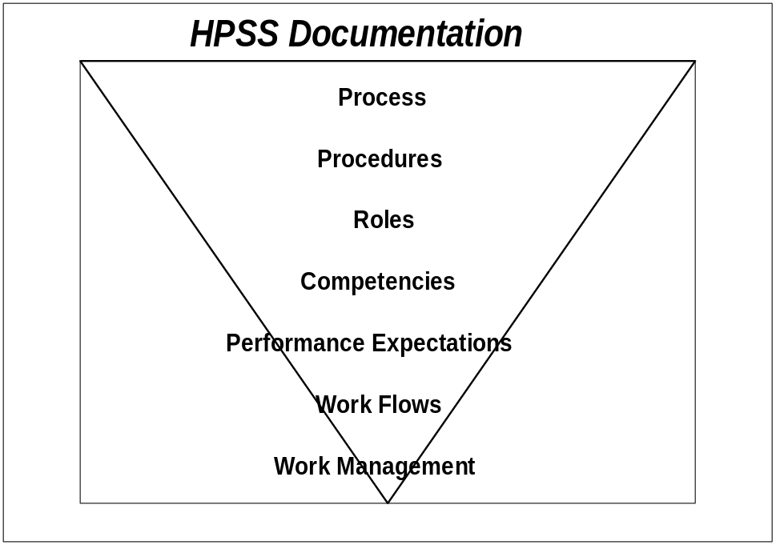

Approach
- One-on-one interviews: We have chosen one-on-one interviews as our data gathering technique for two reasons: (1) We want qualitative rather than quantitative data, and (2) We want the to opportunity to probe for depth, breadth, and clarity as we focus on the knowledge, skills, and abilities of the people who are about to assume new roles.
- Interview topics: To this point, our interviews have covered a fairly broad range of topics and have asked for information at a high level. In contrast, the User Learning Needs Analysis (AP.130) topics are very specific and hone in on the gap between current and needed skills by role, learning reinforcement, learning rewards and recognition and learning measurement.
- Purposive Sampling Strategy: Our sampling strategy will be purposive which means we will chose the people to be interviewed based on our perception of the kinds of information they can provide. Interview participants will be selected because of the number of stakeholders in key roles on their teams, their ability to provide insights into the knowledge, skills and abilities of the stakeholder groups, their knowledge of how processes and roles will change as a result of the implementation, their knowledge of the learning environment, and their ability to provide insight into the organizational culture.
- Target Respondents: Users from all management and employee groups are the target respondents for the User Learning Needs Analysis (AP.130). They will be asked to provide information on skills gaps for their own roles and for the other new roles in their organizations. Our approach is to conduct interviews with a cross-section of users. The following table shows a list of those we plan to interview:
Name | Title | Department | Location | Number of Roles in his/her Group | Work Hours/Shift

- User Learning Needs Analysis Risks: The following risks have been identified as possibly affecting the User Learning Needs Analysis during its progression:
- Aggressive schedule.
- People unavailable for interviews.
- Lack of visible management support for the User Learning Needs Analysis.
- User Learning Needs Analysis Roles and Responsibilities:
Role | Responsibility
<Company Long Name> Change Leader (or Learning Team Leader) | Aids in the selection of the Target Respondents  Ensures resources are available to assist with the User Learning Needs Analysis  Coordinates resources for multiple sites  Signs for or arranges for introduction of the User Learning Needs Analysis to the organization  Communicates the importance of the User Learning Needs Analysis to the organization  Validates Interview Guide
Project Learning Team Members | Helps in the selection of the Target Respondents  Selects interviewers  Works directly with vendor’s User Learning Needs Analysis specialist to develop project plans  Validates Interview Guide  Assigns tasks to interviewers  Assembles and distributes status reports from the <Company Long Name> side  Directs issues to the appropriate person for resolution  Coordinates the data collection process
Interviewers | Schedules Interviews  Conducts Interviews  Consolidates data gathered into Consolidated Insights  Assists in the development of User profiles
Learning Needs Analysis Specialist | Provides Learning Needs Analysis expertise  Conducts interviews  Tailor interview guides  Develops learning materials and provides training for Interviewers  Evaluate data gathered in interviews  Generate User Learning Needs Analysis findings  Develop and deliver recommendations for the User Learning Plan

- User Learning Needs Analysis Interview Guide for Managers
- In view of your new role and the competencies associated with it, what is the gap between where you are now and where you need to be in the following areas:
- Systems literacy.
- Procedural skills, including managing to the new roles and performance expectations.
- Business skills.
- Think of the different roles which will exist within your group, what are they?
- By role, let’s discuss the gap between where the users of the new system are and where they need to be in terms of their systems literacy, procedural and business skills.
- What suggestions do you have to bridge the gap? What kinds of learning do you think would work well?
- What plans do you have for helping employees reinforce their learning and transfer their skills to the workplace after the learning events?
- How do you plan on measuring the impact of employees’ skills and behaviors on your work group’s success?
- Preliminary User Learning Needs Analysis Plan
Step | Role
Define/validate User Learning Needs Analysis target groups | Learning Needs Analysis Specialist  Project Learning Team  <Company Long Name> Change/Learning Lead
Update User Learning Needs Analysis work plan | Learning Needs Analysis Specialist  <Company Long Name> Change/Learning Lead
Develop User Learning Needs Analysis communications | Communication Specialist
Communicate start of User Learning Needs Analysis | <Company Long Name> Change/Learning Lead
Tailor and validate Interview Guide | Learning Needs Analysis Specialist  Project Learning Team
Select interviewers | Project Learning Team
Develop learning materials for interviewers | Learning Needs Analysis Specialist
Train interviewers | Learning Needs Analysis Specialist
Schedule/confirm interviews | Interviewers
Conduct interviews and capture findings | Interviewers
Develop Users’ Profiles | Interviewers  Project Learning Team  Learning Needs Analysis Specialist
Develop User Learning Plan | Project Learning Team  Learning Needs Analysis Specialist

Open and Closed Issues for this Deliverable
Add open issues that you identify while writing or reviewing this document to the open issues section. As you resolve issues, move them to the closed issues section and keep the issue ID the same. Include an explanation of the resolution.
When this deliverable is complete, any open issues should be transferred to the project- or process-level Risk and Issue Log (PJM.CR.040) and managed using a project level Risk and Issue Form (PJM.CR.040). In addition, the open items should remain in the open issues section of this deliverable, but flagged in the resolution column as being transferred.

Open Issues

ID | Issue | Resolution | Responsibility | Target Date | Impact Date

Closed Issues

ID | Issue | Resolution | Responsibility | Target Date | Impact Date

Appendix A - List of Respondents by Group
The following people participated in the assessment process as respondents:
Name | Title/Position/Department | Data Gathering Technique  - Interview  - Focus Group | Date
Executives:
- ...
- ...
- ...
Project Team:
- ...
- ...
- ...
Business Unit Managers
- ...
- ...
- ...
Middle Managers
- ...
- ...
- ...
First Line Managers
- ...
- ...
- ...
Users
- ...
- ...
- ...
Others:
- ...
- ...

List of Interviewers
The following people participated in the assessment process as interviewers:
Name | Interviewer’s Details |  |  | Data Gathering Technique
 | Title | Position | Department | Interview | Focus Group | Other (please detail)
- ...
- ...
- ...

Appendix B - Interview, Focus Groups and Survey Questions per Group of Respondents
This Appendix includes the following sections:
Section | Description
Executive Insights Interview Questions | Interview Guide for interviews with account manager and top executives.
Implementation Team Insights Interview Questions | Interview Guide for interviews with members from the project team.
Functional Managers’ Insights Interview Questions | Interview Guide for interviews with VPs/Directors, Middle Managers and 1st Line Managers
User Insights Interview Questions | Interview Guide for interviews with users.
Training Subject Matter Specialists Insights Interview Questions | Interview Guide for interviews with Learning Subject Matter Specialists.
Focus Group Questions | Facilitation Guide for interview with Focus Group.
Bank of Questions for Readiness Survey | List of questions to use in the readiness survey administered to a sample of stakeholders.
Communication | Sample of Interview Announcement

Executive Insights Interview Questions
Executives were asked the following questions:
Facilitation Guidelines: This might be done as preparation for the Executive Project Strategy (AP.010)
1. Gather all information already existing, for example, Sales BluePrint, One Source, SCOOP, etc.
2. Select respondents (limit to key executives)
3. Schedule interview (send Interview Announcement, for example, memo describing context of the interview, purpose, time/duration, location, why respondent is selected, topics to be covered, background of interviewer, etc.) See Communication below
- Start with Vendor Sales Representative and other internal contacts before talking to the organization’s representatives.
- First schedule your key organization’s representative
- Identify other respondents; update interview guide as needed
4. Conduct interview; send interview notes to interviewee within 24 hours; complete Interviewee Profile below (for project team internal use only)
5. Consolidate notes from interview. Use Consolidated Matrix in Appendix C.
6. Fill out Project Vision and Objectives section of AP.010.

Account Manager (or <Vendor Sales Representative>) Interview Guide
- Has this <Company Long Name> worked with the vendor before? If so, what is their experience with the vendor?
- What is the <Company Long Name> trying to accomplish with the implementation of these applications?
- Is it mission-critical, a business change, a process change or only a technology change?
- What is the extent of the departments/sites impacted? Is it enterprise-wide or limited to a specific business unit(s)?
- How many sites are there in the organization? (Local and in other countries?)
- What applications are they considering?
- What number of licenses?
- Are there any other third parties involved (Integrators, Big 4, other product suppliers)? What is the nature of the <Company Long Name> relationship with this third party?
- What is the size of the enterprise and the supporting IT infrastructure?
- Does the organization have a clear understanding of how this project supports their business objectives? Is there a business case documenting the benefits for the technological change?
- What implementation approach are they considering, for example, incremental, big bang, parallel period, etc.?
- What time frame are they considering and how aggressive is it?
- What is the availability of skilled resources in the organization? Technical and non-technical? How committed is the organization to free up the skilled resources for the project?
- Who are the key players? Do they correspond to the power sources in the organization? What is your relationship with these key players?
- How strong is the sponsorship behind this project? At what level?
- Who is the visible sponsor? What is your relationship with this sponsor?
- Who are the blockers?
- Is it a unionized environment?
- What are the key characteristics of the <Company Long Name>’s organizational culture?
- What inhibitors do you foresee? Technical, organizational, etc.
- How do you rate the ability of the enterprise to absorb the business and cultural change that will result from this implementation?
- What are the financial restrictions?
- Are they using a standard implementation methodology?
- Is the <Company Long Name> considering outsourcing for any of the key implementation roles, for example, installation, learning, support, etc.?

Executive Stakeholder Interview Guide
Executive Stakeholders include the Chief Executive Officer (CEO), Chief Operations Officer (COO), Chief Financial Officer (CFO), Chief Information Officer (CIO) and other high-level executives from impacted business units.
- What do you want to accomplish with the implementation of these applications? What is the business case? What benefits/performance improvement do you want to achieve in your organization/department? What are you willing to do to make this happen?
- How does this project support your organization’s business strategy? Your department’s?
- What are the specific business benefits you want to realize for your organization/department?
- How does the implementation of Applications relate to your other business projects?
- Do you want to use the current technological change to initiate other changes in other areas such as customer service, management culture, work structure, etc.?
- How aggressive are the goals?
- What do you see as leverage points for this project?
- What do you see as major obstacles to this project?
- Is it likely to be supported by the management team? By the users?
- Will your customers feel a direct impact from the project?
- Do you have the resources and skills necessary to implement successfully?
- How will success be measured?
- Who is responsible for delivering results?
- What has your organization’s experience been with major change?
- How do you rate the ability of the enterprise to absorb the business and cultural change that will result from this implementation?
- What role do you and your team play in this implementation? What are your performance expectations for the steering committee and for the project team? Who are the key players to involve in the communication process during the project?
- What type of support are you expecting from the vendor?
- What is the history of sponsorship of IT projects?
- How technology literate is your organization?
- What are concurrent projects that might compete for resources, for example, acquisitions, divestiture?
- How do you communicate with your team, from your direct reports all the way to the front line? What is the most effective way for the organization to give/get real information (high-touch and/or high-tech)?

Implementation Team Insights Interview Questions
The implementation team members were asked the following questions:
Facilitation Guidelines: This might be done as preparation to conduct the initial project team orientation (AP.020)
1. Review information gathered through Executive Insights.
2. Select respondents from the team as they are identified.
3. Schedule interview (send Interview Announcement, for example, memo describing context of the interview, purpose, time/duration, location, why respondent is selected, topics to be covered, background of interviewer, etc). See Communication below.
- Start with project managers and other internal contacts before talking to the organization representatives.
- First schedule your key organization project manager
- Identify other respondents; update interview guide as needed
4. Conduct interview; send interview notes to interviewee within 24 hours; complete Interviewee Profile below (for project team internal use only).
5. Consolidate notes from interview using Consolidation Matrix in Appendix C.
- Do you know what this project is about, that is, vision, expected results, etc.? How does it fit with the corporate strategy? How does it fit with other business initiatives?
- Do you know why you were selected for the team? What strengths do you bring? How is this assignment perceived?
- Do you understand your role in the team and how it relates/impacts others? Do you know who all the team members are?
- What do you hope to get out of this project?
- What are other projects you have led or in which you played a major role? (dollar amount, time frame, number of people involved, impact on organization, ...)
- What barriers exist which might hinder the project?
- What strengths/levers exist which could contribute to the success of the project?
- What has been the organization’s and your past experience in implementing technology? What has gone well? What has not gone well? What ideas do you have for improvement?
- What is your perception of the sponsorship of this project? (Visibility, commitment, urgency, authority, influence.)
- How realistic are the goals for the project?
- How would you evaluate the capability of the project team to achieve the project’s goals?
- What are the communication challenges in the organization?
- How do you typically get information/updates related to large projects?
- If you have an urgent message (issue) related to a project, how do you typically communicate it?
- How would you evaluate the levels of trust within the organization?
- How much experience have you had in working on cross-functional teams?
- What perceptions do you have concerning the vendor? (The products, the organization, the people)
- If this project is successful, what benefit will there be for you? For your team? For the organization?
- How would you evaluate the resistance to this change within the organization?
- At what sites will the technology be implemented?
- How many employees at each site? How many users will there be?
- Is business process design a component of this project? If so, have the process redesigns been completed?

Functional Managers’ Insights Interview Questions
The functional managers were asked the following questions:
Facilitation Guidelines: This might be done as preparation to develop the Business Unit Managers’ Readiness Plan (AP.060).
1. Review information gathered through Executive and Implementation Team Insights.
2. Select respondents from the VP/Director ranks, the middle managers and first line managers.
3. Schedule interview (send Interview Announcement, for example, memo describing context of the interview, purpose, time/duration, location, why respondent is selected, topics to be covered, background of interviewer, etc.) See Communication below.
- First schedule your key organization representatives
- Identify other respondents; update interview guide as needed
4. Conduct interview; send interview notes to interviewee within 24 hours; complete Interviewee Profile below (for project team internal use only)
5. Consolidate notes from interview using Consolidation Matrix in Appendix C.

Interview Guide for VPs/Director levels
- What do you know about the implementation project at this point? How does it fit with the corporate strategy?
- What are the performance indicators in your business unit? Does the performance measurement support the vision of the organization?
- How are your managers informed of the key performance indicators, progress, etc.?
- How do your managers use the performance indicators within their departments?
- What tools support your performance indicators? Are rewards systems appropriately tied to the performance indicators?
- How are your managers held accountable to meet performance objectives?
- What are the corrective measures in place when performance expectations are not met? What are the rewards when performance expectations are met or exceeded?
- What are your strongest areas of performance, for example productivity (quality and quantity), customer service?
- How much decision-making authority goes down to the User levels? How do you empower your people from the top down? Can you give me examples where people actually used the power delegated to them?
- What strategies have you used in the past to lead change which were effective?
- What do you know about the applications (to be installed)? How will they help you improve the performance of your business unit?
- What barriers do you see in the implementation of the application and new performance measures?
- How receptive will your people be to the new system? How have they reacted in the past to such a project?
- Who are the key players in your business unit?
- Who are top performers in your organization? How receptive are they to change?
- To what extent does the culture of the organization support performance measurement?
- To what extent will the technological implementation challenge the targeted pilot or installation sites?
- What types of information do you share with your direct reports? How do you communicate up and down the organization? How do you get meaningful feedback?
- What other projects are impending that may affect successful learning? How are they being addressed relative to the commitment of resources for this project?
- Discuss your business goals and how you see these applications enhancing these goals.

Interview Guide for Middle Managers
- What do you know about the implementation project at this point? How will the applications help you improve the performance of your department? Discuss your business goals and how you see these applications enhancing these goals.
- What does your department do? How are you organized? How effective are your current work flows? Which process(es) need improvement?
- Which functions in your department are the most critical to your department’s success?
- What are your strongest areas of performance, for example, productivity (quality and quantity), customer service?
- What are the performance indicators in your department? How do your supervisors use the performance indicators within their departments?
- How are your supervisors held accountable to meet performance objectives? How are they rewarded if they meet or exceed them? What measures are in place if they do not meet the performance objectives?
- How do you empower your people from the top down? Can you give me examples where people actually used the power delegated to them?
- What behaviors are encouraged in your department? How?
- What is the union’s involvement in decisions about the performance measures?
- When you managed change in the past, what strategies proved most effective?
- What barriers do you see in the implementation of the application and new performance measures?
- How receptive will your people be to the new system?
- Who are the key players in your department?
- Who are top performers in your organization?
- To what extent does the culture of the organization support performance measurement?
- To what extent will the technological implementation challenge the targeted pilot or installation sites?
- How does your organization support teamwork? How do you support teamwork?
- What information do you share with your direct reports? How do you communicate up and down the organization? How do you get meaningful feedback?
- How supportive is your HR department?
- What rewards system are in place? What do they reward? What feedback do you get from employees on the reward systems?
- What are the challenges or barriers to performing your job as a manager?
- What job functions will we be assessing? How many? Across how many departments, locations, shifts? Within IT? Outside IT?
- How many individuals will fall into the scope of this effort? How different do you think their learning needs will be?
- Do you have a clear picture of the skills, knowledge, and abilities you want to see in this audience (performance goals)? What changes in the knowledge, skills and abilities will give you the most benefit? What percentage of the audience already have them?
- What motivation or incentives currently exist? Do employees’ possess the necessary morale and attitude to perform effectively?

Interview Guide for First Line Managers
- What do you know of the implementation project at this point? How will the applications help you improve the performance of your team? Discuss your business goals and how you see these applications enhancing these goals.
- What does your team do? How are you organized?
- How effective are your current work flows? Which process(es) need improvement?
- Which functions in your team are the most critical to your success?
- What are your strongest areas of performance, for example, productivity (quality and quantity), customer service?
- How do you use the performance indicators within your group?
- How are your people held accountable to meet performance objectives? What are the rewards/corrective measures in place when performance expectations are met/exceeded or not met?
- Describe the characteristics of your top performers. Who are they?
- What information do you share with your direct reports? How do you communicate up and down the organization? How do you get meaningful feedback?
- How are people empowered from top down in the organization? How much decision-making authority goes down to the User levels? To what extent do your people use the decision making authority within their level in doing their jobs? Can you give me examples where people actually used the power delegated to them?
- What behaviors are encouraged in your team? How are they encouraged?
- What barriers do you see in the implementation of the application and new performance measures?
- How receptive will your people be to the new system? How has your team reacted to major change in the past?
- How do you give performance feedback to your direct reports? (frequency, method, follow up, …)
- What are the challenges or barriers to performing your job as a manager?
- What are the challenges or barriers to improving your employees’ skills?
- Will you have a difficult time gaining users’ commitment to attend learning events?
- What learning have your employees received in the past? What has been their response? How well was it received? Were they able to perform afterward? Why or why not?
- When someone has a problem with existing systems, to what or to whom do they turn to for help?
- If we did the User Learning for this project perfectly, how would you see it happening? What would be the outcome?
- What job functions will we be assessing? How many? Across how many departments, locations, shifts? Within IT? Outside IT?
- How many individuals would fall into the scope of this effort? How different do you think their learning needs will be? Do you know who the super-users are? What are their educational backgrounds and work experience?
- Do you have a clear picture of the skills, knowledge, and abilities you would like to see in this audience (performance goals)? What changes in the knowledge, skills and attitudes would give you the most benefit? How will you help employees use their skills when they return to their jobs?
- What motivation or incentives currently exist? Do employees’ possess the necessary morale and attitude to perform effectively?
- Are job descriptions and/or competencies readily available? Do they accurately reflect what people do?

User Insights Interview Questions
Users were asked the following questions:
Facilitation Guidelines:
1. Review information gathered through Executive, Implementation Team and Functional Managers Insights.
2. Select respondents from a sampling of the user community..
3. Schedule interview (send Interview Announcement, for example, memo describing context of the interview, purpose, time/duration, location, why respondent is selected, topics to be covered, background of interviewer, etc. with copy to the interviewee’s manager.) See Communication below.
4. Conduct interview; send interview notes to interviewee within 24 hours; complete Interviewee Profile below (for project team internal use only)
5. Consolidate notes from interview using Consolidation Matrix in Appendix C.

Interview Guide for Users
- Describe the key aspects of your role. What barriers do you have to overcome in your daily responsibilities?
- What are you rewarded for?
- How are you held accountable to meet performance objectives? How do you know whether you are doing a good job? How do you receive performance feedback? (frequency, method, follow up, …) When did you last receive feedback on your performance?
- Which behaviors are encouraged in the organization? In your group?
- What are the performance indicators in your group?
- Which functions in your group are the most critical to your group’s success?
- How does your supervisor encourage you to learn and improve your capabilities?
- What do you know about the goals and objectives of the organization, department, group, self?
- What can the organization do to improve the work environment?
- How does the organization foster collaborative/competitive relationships? How does your manager? How do your colleagues?
- How does the organization foster customer (internal and external) service?
- How much professional contact do you have with other groups?
- What information does your supervisor share with you? How?
- When you have a question/problem on the job, who do you ask? Supervisor, colleague, outside source?
- How do you get/give information effectively?
- What happens if an employee does not meet the performance objectives? What are the corrective measure in place when performance expectations are not met?
- What are your strongest areas of performance, for example, productivity (quality and quantity), customer service?
- Who are the key players in your group?
- Who are top performers in your group? What are their key characteristics?
- To what extent are the employees listened to when making improvement suggestions in the way they do their job?
- How much latitude do you have to manage your own work?
- What do you know about the applications (to be installed)? How will they help you improve the performance of your group? Your job?
- What barriers do you see in the implementation of the application and new performance measures?
- How receptive will the people be to the new system?
- Describe your most effective learning experience.

Learning Subject Matter Specialists Insights Interview Questions
Facilitation Guidelines:
1. Review information gathered through Executive, Implementation Team, Functional Managers and User Insights.
2. Select respondents from a sampling of the Learning Subject Matter Specialists’ community..
3. Schedule interview (send Interview Announcement, for example, memo describing context of the interview, purpose, time/duration, location, why respondent is selected, topics to be covered, background of interviewer, etc. with copy to the interviewee’s manager.) See Communication below.
4. Conduct interview; send interview notes to interviewee within 24 hours; complete Interviewee Profile below (for project team internal use only)
5. Consolidate notes from interview using Consolidation Matrix in Appendix C.
- What kind of learning have employees received in the past?
- What has been their response? How well was it received?
- Were learners able to perform afterward? Why or why not?
- If we did the user learning perfectly, what would the outcome be? Do you envision actually testing skill levels (learner verification), or would you be content with a survey where people self-assess?
- What job roles will we be assessing? How many do you foresee? Across how many departments?
- Do you have a clear picture of the skills, knowledge and abilities you would like to see in this audience? (Performance goals?)
- What change in the knowledge, skills and abilities would give you the most benefit?
- How many individuals will fall into the scope of this learning effort? Are job descriptions and/or competencies readily available?
- What are the locations of the job roles impacted/to be assessed? Work hours/shift information?
- How different do you think their learning needs will be?
- What are their educational backgrounds and work experience?
- Do you know who the super-users are?
- Who are the key players you need involved in this learning project?
- Describe the current training department that is, number of people, types of skills, types of learning events offered?
- What role would you like to play in the User Learning Plan?
- How would you like us to interact/communicate with you?
- Are the other department/contractors aware of your plans for the learning effort? How can we involve them to leverage our efforts and facilitate success?

Focus Group Facilitation Guide
In the focus groups run, discussion topics focused on many of the same areas addressed in the other assessment activities, such as one-on-one interviews. Be sure to select and list the questions used in the focus groups in this section.
The following questions were asked of participants tin the focus group sessions:
For example,
- What kind of learning have employees received in the past?
- What has been their response? How well was it received? ...

Bank of Questions for Readiness Survey
Instructions: The following items were presented to ask a variety of questions about the organization in general and how it conducts itself. For each of these items, respondents were asked to indicate the extent to which they agree or disagree with the statement. The actual survey instrument used was organized on a Likert scale with a range of 5 options from strong agreement to strong disagreement. The questions are presented below for reference.

Risk Taking
- This company is willing to take good business risks
- Taking a risk on a new product or service is valued here

Trust
- I feel I can trust people in the organization
- Managers in this organization will take advantage of you if you let them
- This organization cares more about money and equipment than people

Customer Focus
- We make decisions based on customer needs
- This organization is focused on customer satisfaction

Competition
- We closely monitor our competition
- We know who our competitors are

Open Atmosphere
- The atmosphere in this organization encourages open communication
- I can talk openly with my leader about the organization
- Leaders do not withhold important information

Lateral Flow of Information
- Our communication with other teams is one of our strengths
- In this organization, we communicate well across organizational lines

Innovation
- Finding a better way to do things is valued
- New and different ideas are always being tried out

Creativity
- I am supported in using creative approaches to my work
- Creativity is encouraged in my organization

Change Teamwork
- My co-workers and I will find it necessary to work closely with other groups to make this change successful
- Accomplishing this change will require strong teamwork

Cross-Functional Team Work
- In this organization, there is a high degree of cross-boundary interaction
- In this organization, we work well across organizational lines

Teamwork Skills
- The people on my team have the skills to adapt
- My team can adjust to new situations

Team Goal Clarity
- Our team has a clear sense of what we are trying to accomplish
- Our team has clear objectives

Goal Alignment
- My team know how our goals tie to the organization’s goals
- People on my team understand our contribution to the larger organization

Endurance/Commitment
- Our leaders are able to maintain their enthusiasm for a project over long periods of time
- Leaders in this organization are good at maintaining their commitment to a change effort

Early Wins
- We typically celebrate “early wins” as we are implementing a major change.
- Our leaders build opportunities to celebrate success early in a project.

Urgency
- Our leaders have communicated a sense of urgency in connection to this project
- Leaders in this organization are communicating a sense of urgency about the current change initiative

Role Model
- Our leaders walk the talk
- Our leaders’ actions are consistent with their words

Trust
- I don’t trust the leadership of this organization
- I trust my leader

Sponsorship
- Leaders in this organization will remove barriers that could cause this change to fail
- I believe the leaders of this organization will provide the resources this change requires

Change Staffing
- People who have been assigned to work on this change have excellent reputations
- Highly talented people have been assigned to work on this change

Coalition
- The executive sponsor of this change effort has built a strong team of allies
- Formal and informal leaders who are held in high regard are supporting this change initiative

Priorities
- Major initiatives have been prioritized so we know where to concentrate our energy
- This organization is clear about change priorities

Change Impact
- Our leaders have a realistic view of how this change will impact my team
- Leader in this organization have no idea of the impact of this change

Measures
- We have measures in place to track our progress on this change
- The appropriate measures have been developed for this change

Rewards
- We will be rewarded for contributions that will make this change successful
- Our reward system does not recognize contributions to making this change successful

Learning
- Our learning programs can adapt to support the current change initiative
- I know that learning events will be made available to meet the changes in my job caused by the current initiative

Decision Making
- We get decisions made in a timely manner
- We have well-defined processes for decision making

Retention
- We have strategies to retain our best employees
- We have strategies to help us retain those employees who acquire new skills to support this technology change

Change History
- I have had predominantly positive experiences with change projects
- We have a history of successful change projects

Cross-Functional Learning
- We do a lot of cross-learning in this organization
- We have a process which promote cross-functional learning

Success
- A history of success doesn’t make us complacent
- Even when we experience success, we don’t become complacent

Quality
- In this organization, people strive for excellence
- We produce high-quality products and/or services

Humility
- We get good ideas from outside our organization
- We don’t feel that everything has to be invented here

Problem Solving
- I am allowed to question assumptions
- We are encouraged to look at the big picture when we are solving problems

Buy-in
- I have a feeling of personal responsibility for the success of this project
- I understand the reason why this change is important for the organization
- I know how this change will benefit me

Participation
- I have had the opportunity to participate in this change effort
- I feel included in this change

Input
- Our leaders are willing to listen to other points of view about this change
- If I have a suggestion about this change, I know it will be considered seriously

Honest Communication
- Leaders in this organization communicate honestly
- Honest communication is a characteristic of this organization

Accurate Communication
- I have been given accurate information about this change project
- I get reliable information about this change effort

Timely Communication
- I get information in a timely manner
- I feel I am given information at the appropriate time

Feedback
- I get praised for work well done
- I get frequent feedback on my performance

Stakeholder Identification
- Leaders have accurately identified the groups who will be impacted by this change
- We know who has a vested interest in this change

Clear Vision
- Our vision creates a clear picture of where we are headed
- Senior leaders have done a good job of describing their vision of the future

Compelling Vision
- The vision for our organization inspires people to want to push forward
- Our vision is more than just words

Business Driver
- I know what the business case is behind this change project
- I am clear about why we need to change

Change Impact
- This change will have a large impact on our corporate culture
- This change will impact almost the entire organization

Communication: Sample of Interview Announcement
If appropriate, consider sending a copy of the memo confirming the interview to the interviewee’s manager.
Below is a sample of an interview announcement.
Dear <Name of the interviewee>,
You have been selected by <xxx> as a key source of input regarding the <name of the project>, aimed at <objective of the project>. Thank you for agreeing to be interviewed. The information you contribute will feed into the planning which lays the foundation for a successful technology implementation. Your interview has been scheduled for <date> at <time> in <location>. <Name of the interviewer>, the <lead consultant from the Oracle team>, will be conducting your interview.
The interview will last approximately one hour. Your responses will be used in several ways: first, the information you give will allow us to use the time in <executive> work sessions efficiently, and second it will allow us to tailor the content of the tasks and deliverables for your organization. With your permission, we will share your responses to some of the questions with the rest of the <executive> team on an <anonymous> basis. <Name of the interviewer> will take notes during the interview, and you will have the opportunity to review the notes and make any changes you feel are appropriate before anyone else sees them. The notes will be consolidated into our Project Readiness Roadmap; this roadmap will identify the steps required in the organization to execute a smooth transition to the performance levels now made possible with the availability of the new technology.
You’ll find a copy of the interview guide attached to this <memo>. If you have any questions about the process, <name of the interviewer> can be contacted at <phone number or email>.

Appendix C - Consolidated Insights per Group of Respondents
This Appendix includes the following sections:
Section | Description
Interviewee Profile | FOR ORACLE INTERNAL USE ONLY: matrix to capture interviewees’ key dispositions and issues regarding the project
Consolidation of Insights | Grid to capture main topics from interviews.

Interview Profile (for project team internal use only)
This document consolidates key dispositions and issues regarding the project.
Name/Role | Disposition: Pro, Con, Neutral, Indifferent | Required Disposition (Note minimum critical stance) | Key Issues and Concerns | Influence: High, Medium, Low… | Date last updated

Consolidation of Insights
Use the following as the front piece of the interview notes you send back to each interviewee to capture the demographics and logistics data. Complete the section before the interview.

Interview Notes

Interviewer Name:
Interviewee Name:
Interviewee Demographics:
Department:
Title:
Position:
Years in position:
Years with <Company Long Name>
Other job positions/ departments at <Company Long Name>
Time of Interview:
Duration of Interview:

Consolidated Notes
The following table captures the consolidated notes from the interviews.

Use the following grids to consolidate the individual interview notes. Review the individual interview notes and complete a consolidation grid for each question:
1. Write in the number and text of the question on top of the grid
2. Identify the main topics raised by the interviewees and indicate next to Topic, in their respective columns.
3. Indicate the name of the interviewees in the left column, under “Interviewees”.
4. Capture the key points made by each interviewee who raised the topics identified.
5. Use the “Comments” column for additional detail on each interviewee’s insights.
Respondent Group:
Question #
Interviewee | Topic: | Topic: | Topic: | Topic: | Topic: | Comments

Assumes that respondents are currently unaware of the systems implementation project.

