AIM
AP.090 Managers Readiness Plan
<Company Long Name>
<Subject>

Author: <Author>
Creation Date: May 20, 1999
Last Updated: June 4, 1999
Document Ref: <Document Reference Number>
Version: DRAFT 1A

Title, Subject, Last Updated Date, Reference Number, and Version are marked by a Word Bookmark so that they can be easily reproduced in the header and footer of documents. When you change any of these values, be careful not to accidentally delete the bookmark. You can make bookmarks visible by selecting Tools->Options…View and checking the Bookmarks option in the Show region.

Approvals:
<Approver 1>
<Approver 2>
To add additional approval lines, press [Tab] from the last cell in the table above.
You can delete any elements of this cover page that you do not need for your document. For example, Copy Number is only required if this is a controlled document and you need to track each copy that you distribute.
Copy Number _____

Document Control

Change Record
4
Date | Author | Version | Change Reference
20-May-99 | <Author> | Draft 1a | No Previous Document

Reviewers

Name | Position

Distribution

Copy No. | Name | Location
 | Library Master | Project Library
 |  | Project Manager
The copy numbers referenced above should be written into the Copy Number space on the cover of each distributed copy. If the document is not controlled, you can delete this table, the Note To Holders, and the Copy Number label from the cover page.

Note To Holders:
If you receive an electronic copy of this document and print it out, please write your name on the equivalent of the cover page, for document control purposes.
If you receive a hard copy of this document, please write your name on the front cover, for document control purposes.
Contents
Document Control
Introduction
Purpose
Overview
Session Overview
Managers’ Induction
Executive Project Strategy
Stakeholder Analysis
Sponsorship Profile and Authority
Application to Process Overview
Application Modules
Topics
Organizational Performance Improvement Strategy
Documentation Task Force
Human Performance Support Systems (HPSS) Task Force
Change Leadership Guiding Principles and Roles
Reactions to Change
Change Model
Guiding Principles for Effective Change
Change Leadership Behaviors
Managers’ Communication Guide
The Need to Involve People
Purpose of this Guide
Role of Your Communication Team in the <Project Name>
Your Communication Structure for the <Project Name>
Your Communication Campaign
The Communication Team
Your Contribution
Effective Day to Day Communications
Your Own Strategies to Support Communication Efforts
Sponsor a Communication Team Initiative
Communication to Manage Resistance
Open and Closed Issues for this Deliverable
Open Issues
Closed Issues

To update the table of contents, put the cursor anywhere in the table and press [F9]. To change the number of levels displayed, select the menu option Insert->Index and Tables, make sure the Table of Contents tab is active, and change the Number of Levels to a new value.

Introduction
Template Instructions
The Template Instructions are formatted as hidden text and are intended for the author of the document only. Delete this section after completing this document.
General hints for completing Adoption and Learning Process templates:
- This template contains suggested headings, text, and formatting intended to speed the creation of the deliverable. You may delete or add components to suit your objectives.
- To include hidden text when printing the document, select File, Print…, Option…, Print tab, check Hidden Text.
- To format (or undo) selected text as Hidden, select Format, Font…; check Hidden under Effects.
- To add lines to a table, press [Tab] from the last cell in the table.
- Text that appears between <single carrots> is either a variable to be replaced manually, or instructions for completing the field. Delete or replace all carrots before distributing the document to the organization.
- <Blue, highlighted text> represents a variable that may be defined and replaced automatically upon creation of the deliverable.
- To protect the document so that revisions will show, select Tools, Protect Document…, Revisions. Add a password if you do not want someone to be able to remove the Protect function from the document. To set options for revisions, select Tools, Revisions… and choose your option.

Purpose
The purpose of this document is to assist the middle and first line managers in understanding the project vision, how it impacts their department and teams, and how they can best get involved to achieve the targeted business benefits. Middle and first line managers participate in the effort to determine how the organization will improve its performance, enabled by the new technology and lead the effort to convert the business benefits at the role level performance expectations. Also, this document helps middle and first line managers define their role as change agents throughout the life of the <Project Name>.

Overview
This document includes the following components:
Component | Description
Introduction | Shows the outline for the work session(s).
Managers’ Induction | Exposes middle and firstline managers to the highlights of the project. Included here is the review of the vision, benefits, expected results, alignment with Information Technology and corporate strategy, and the overall project strategy. Exposes middle and firstline managers to the features and functions of the application to the processes, in terms of how the application can improve the way the departments operate.
Application to Process Overview | Identifies the modules and associated topics relevant to the departments’ processes.
Organizational Performance Improvement Strategy | Guides the middle managers to convert the organizational performance objectives to the role levels and to lead the task forces to define the procedure documentation (Oracle Tutor) and the new required human performance support systems.
Change Leadership Guiding Principles and Roles | Describes the guiding principles of change and highlights the role of middle and firstline managers as change leaders.
Managers’ Communication Guide | Highlights the role middle and firstline managers play as communication agents/liaisons.

Session Overview
Middle Managers: The middle managers are the level of managers who report to the vice presidents and directors, who own the operational areas most heavily impacted by the technology-induced change. They are the leaders who are closest to business processes and who can bring the business unit measures down to role-specific expectations. Project team members frequently report to this level of management and these people often lead the task forces associated with the change.
first line managers: First line managers have direct supervisory responsibility over the roles impacted by the new technology. They are on the first line of operations and the largest number of users report to them.
Assumption: The business unit managers have held a one-on-one meeting/conversation with each attendee within their business unit, as per their communication plan, and described to them the highlights of the project.
Cascade Approach: First, assemble middle managers. After the agenda for the readiness session has been presented, the point should be made that middle managers will in turn be facilitating readiness meetings similar to the one in which they are participating, with their first line managers. The readiness meetings with first line managers should be led by a middle manager or a member of the project change team. First-line managers have the responsibility of communicating information about the systems implementation to their teams. First-line leaders may want to devote a team meeting to explaining the business reasons for the change and the link with the objectives for the project, describing the impacts on the processes they use and the individuals on the team, and answering questions. This session is geared to prepare them to carry out that responsibility
Preparation Guidelines for the Work Session:
This meeting should be led by the business unit manager for the middle managers in his/her unit and later in turn by the middle manager for the first line managers in his/her department.
1. Review the Facilitation Guidelines in this document (Yellow Notes)
2. Gather necessary inputs (review the Business Unit Managers Readiness Plan, AP.060).
In collaboration with
-the business unit managers and/or the project manager for the middle manager sessions
- the middle managers for the first line managers or a member of the project change team
3. Confirm list of attendees
4. Select site for session (preferably offsite)
5. If appropriate for this level of attendees, order give aways for the team: One of the objective of the sessions is to begin to create a sense of belonging to a team, and depending on the culture of the organization, participants might be given T-shirts, caps, tote bags, or some other items with the name of the project on it.
6. Review Planning Session Checklist template.
7. Tailor Agenda (see outline section below) and send to attendees along with the Executive Project Strategy (AP.010), Project Readiness Roadmap (AP.070) (optional) and Business Unit Managers Readiness Plan (AP.060), and an invitation memo specifying time and place, context of the session, purpose and benefits, why attendee is selected, objectives: results and expectations, facilitator background, agenda and preparation request: (attendees are expected to read the documents sent to them before the session and be ready to provide feedback). (See Invitation Memorandum template for sample invitation memo)
8. Coordinate with other representatives.
9. Prepare materials for the session, for example, slides from the Executive Project Strategy
10. Prepare session scribe.

Purpose
This Managers Readiness session assembled the middle managers to expose them to the vision of the project, and to help them define how their department through its various activities could best contribute to organizational performance improvement with the benefit of the technology. As a result of the session, the middle managers converted the organizational performance improvement strategy to the role level and initiated tasks forces to document procedures and update the human performance support systems for the newly defined roles. They then held similar work sessions with their first line managers for further involvement in the change process.
The work sessions were highly interactive and focused on decision making around key questions to make sure that the organization could achieve the targeted business objectives:
- How are the changes in business processes impacting the performance of my department/team?
- How do the role-based performance expectations map to the department performance goals?
- What measures do we need to put in place to achieve the targeted organizational performance improvements?
- Who should be involved in the update of the Human Performance Support Systems (HPSS) and what are the HPSS high-level requirements?
- How can middle managers and first line managers fulfill their role as business sponsors for the project?
The work sessions looked at ways of answering these questions and examined the organizational issues relevant to the organizational performance improvement strategy at the department and role levels for a successful achievement of the targeted business benefits.

Facilitation
Add background notes on the facilitator’s experience in conducting such sessions.
The work session was facilitated by <Facilitator Name> from ….
<Facilitator Name> Biographical Notes:
In addition, <Scribe’s Name> attended the session to keep a record of all decisions made during the meeting and keep deliverables updated at all times throughout the session.

Attendees
The following attendees participated in the readiness events:
List here the names of middle managers or first line managers who will attend from the organization, and other participants from contract resources.
Organization | Name of Attendees | Title
<Company Long Name>
Contract Resources

Outline
The following outlines the activities conducted in the sessions:
We recommend that the session(s) be held off site for maximum concentration and dedication to the decision making process. The meeting can be broken into a number of work sessions with varying duration.
Sections | Description | Time | Duration
Introduction  Give background for the decision to go ahead with the project  Introduce and welcome managers, including in each introduction, a brief statement of how important this person is to the success o the project.  For session with middle managers: Make the point that the participants will in turn lead a similar induction session with the first line managers reporting to them  Describe the benefits of the project to the organization, to the departments in the business unit and to the individuals themselves.  Express (the executive sponsor’s) own commitment to making the project a success | Overview of the session: purpose, expectations, logistics, etc. |  | ¼ hour
Managers’ Induction  Review vision, benefits, expected results (objectives and measures)  Review alignment with Information Technology and corporate strategy  Discuss high-level view of the impact of the project on technology, process and people  Outline risks associated with the project  Review executive decisions already made  Introduce steering committee and project team members and roles  Refine the stakeholder matrix  Review the sponsorship program | Provides opportunity for managers to understand the importance of the project for the organization and their department. |  | 2 hours
Application to Process Overview  Conduct session to overview application to process | Highlights how the application modules, relevant to the business processes applicable to the departments’ operations, can benefit the departments to improve their performance. |  | 4-6 hours
For Middle Managers: Organizational Performance Improvement Strategy  Review the Organizational Performance Improvement Strategy defined for the business unit  Give an example of how to drill the organizational performance objectives down to the role and activity level (to be done outside the session)  Capture action items | Provides the forum for the middle managers to convert the organizational performance improvement strategy to their department, by focusing on role and activity performance expectations.. |  | 2 hours
Change Leadership Guiding Principles and Roles  Review examples of recent change and reactions to those changes  Discuss guiding principles for effective change leadership  Agree on role as change leaders | Highlights the 8 guiding principles to effective change leadership, describes the typical reactions to change and guides the discussion on the roles of the middle managers and first line managers as change leaders. |  | 2 hours
Managers’ Communication Guide  Review the communication responsibility of managers  Link to communication campaign  Agree on role as communication agents | Highlights the communication role of managers and provides guidance to help manager fulfill their role as communicator. |  | 1 hour

Managers’ Induction
Make the point that the middle managers who are the first participants of this session will in turn facilitate a similar induction session with the first line managers reporting to them.

Executive Project Strategy
As you review the highlights from the Executive Project Strategy (AP.010), make sure the discussion is interactive and the managers have a chance to clarify and understand the points discussed from the perspective of their department.
We discussed the following from the Executive Project Strategy (AP.010) and other project deliverables:
- Background for the decision to go ahead with the project
- Benefits of the project to the organization, the business units, the departments, and to the individual managers
- Implementation Guidelines for a successful application implementation project
- Project vision and expected results (objectives and measures)
- Alignment of project vision with Information Technology and corporate strategy
- High level impact of the project on the organization’s current technology, processes and people
- High level risks associated with the project
- Executive decisions, already made
- The members and roles of the steering committee and project team
- Project team charter and the division of responsibilities between the steering committee and the project team
- Performance expectations and the responsibilities of the project team
- Highlights from the Project Readiness Roadmap (AP.070)

Stakeholder Analysis
The following have been identified as key stakeholders by manager:
Facilitation Guidelines:
1. “Explain the term “stakeholder.”
2. Break the group in pairs or triads and ask them to review the Stakeholder Matrix from the Executive Project Strategy (AP.010) and the Communication Campaign (AP.080) and identify any missing groups.
3. Ask the participants to anticipate the reactions to the project on the part of each stakeholder group. List potential issues and prioritize groups needing more intense change management.
Capture on the Stakeholder Matrix. Link to the Project Vision and Kick off communications.

Sponsorship Profile and Authority
Facilitation Guidelines: Using the sponsorship section from the updated Executive Project Strategy (AP.010):
1. Obtain clips of the following music: “The Nowhere Man” by The Beatles, “I Can’t Get No Satisfaction” by The Rolling Stones, “I Can Get By With a Little Bit of Help From My Friends” by Jo Cocker, and “I Did It My Way” sung by Frank Sinatra.
Play music clips on technology implementation. Ask participants to choose the music which best describes their most memorable experience with an implementation, with this or another organization.
2. Lead a discussion on why projects fail. Show “Standish” slide. Point out that lack of sponsorship is ubiquitous on list of reasons for troubled implementations.
3. Ask participants to think of the sponsor of a project (technology related or not) with whom they worked in the past.
4. Ask participants to select the music clip that best represents that sponsor. Play the four music clips on sponsorship styles.
5. Discuss characteristics and functions of effective sponsors, in theory and that which is applicable to the organization’s culture.
6. Introduce the concept of the honeycomb (elaborate network, delicate but very strong that enables the bees’ work structure) to illustrate the need for a sponsorship network.
7. Compare the Stakeholder Analysis to the Sponsor Profile Matrix (from the Executive Project Strategy, AP.010). Look for any stakeholder groups who do not have sponsors identified. Expand the network as necessary on the Executive Project Strategy (AP.010). Link to the Project Vision and Kick-off communication.
8. End the discussion by asking the managers to describe their own sponsorship responsibilities. Capture the responsibilities in the Executive Project Strategy (AP.010).
Specific managers’ sponsorship responsibilities include:
- Communicate positively and frequently about the project to the people with whom they come into contact
- Provide the “best and brightest” people to the project team
- Be supportive of the people assigned to the project and remove barriers for the people from their departments
- Maintain commitment in themselves for the project throughout its lifecycle
- Analyze and document the changes to the operations, procedures and human performance support systems

Application to Process Overview
See On-Site Application to Process Overview Customization template, for the review of the information gathered to allow the instructor to tailor the content of the overview to the specific needs of the managers. Consider dovetailing this overview with other events, such as demos, communication meetings, etc. The instructor who led the Application Overview with the executives, project team and business unit managers can tailor this session to build on the key points already discussed

Application Modules
The following lists the modules included in the Application to Process Overview:
Identify here the appropriate modules.

Topics
The following lists the topics included in the Application to Process Overview:
Build the list of topics based on the needs of the business unit managers.

- Highlights
- Introduction
- Structure
- Functionality
- Information Flows
- On-line Demo

Organizational Performance Improvement Strategy
This session is intended for the middle managers only (not the first line managers):
Preparation: Ask in advance one of the department managers to volunteer to participate in the sample discussion; work with him/her to develop the sample.
Facilitation Guidelines:
Introduction -
1. Position the need to translate the high-level business objectives from the business unit level to the role and activity level for each department.
2. Define the model of organizational performance improvement strategy, derived from the balanced scorecard management technique, around the following key questions:
- How will the current project (technology implementation) change the expectations of the performance of departments?
- How do the corporate business objectives translate at the unit and department levels?
- How should the unit objectives convert to the department level (roles)?
(See more comprehensive checklist of questions below)
Position the organizational performance improvement model, derived from the balanced scorecard management technique, as an ongoing process that begins with defining the business results expected by the technology implementation and deciding what business processes are critical to achieving these goals. Review the objectives and organizational performance indicators selected by the business unit managers to measure the effectiveness of the new business processes. The next step is to cascade performance expectations and measures from the organization and business unit levels, to the department level, to the role level and finally to the Full Time Equivalent (FTE) level. Make sure that the measures selected for the individual departments and work groups link back consistently to the overall business expectations.
Sample Department Improvements:
3. Using one unit as an example (ask for a volunteer), ask the group to brainstorm possible organizational improvements in business performance expectations resulting from the implementation. Start with the organizational performance area and objectives selected by the business unit managers in the Organizational Performance Measurement Grid, as they apply to the key business processes in that department. (If this activity is perceived as being too sensitive, give a sample set of corporate objectives, and use a mythical department.)
4. Follow the brainstorming session with an initial discussion of how the corporate and business unit objectives could translate into organizational performance criteria at the department level (and role). Show how the departments may need to plan together to achieve the high-level business results.
Organizational Performance Measurement Grid:
5. Explain the Organizational Performance Areas and review the work done by the business unit managers.
6. Initiate the work on the Department Measurement Grid per Role. Determine plan for managers to complete the grid and validate it.
Organizational Performance Transition -
7. Lead a discussion about the expectations concerning the time frames when those business objectives will be realized in relationship to the “go live” date. Review the work done so far by the business unit managers to begin the process of setting expectations and creating strategies to deal with anticipated reactions to the actual change from the old system to the new from both the organization’s and the employees’ points of view. Review the risks and advantages of various scenarios. Review the business unit leaders’ key milestones. Refine the milestones which need to be achieved between the “go live” date and the achievement of the business expectations. Refer to the Organizational Performance Transition Checklist to fuel the development of the transition strategy at the department level.
Summary:
8. Review the importance of Organizational Performance Measures at all levels. Review next steps for this group:
- Launch the Human Performance Support Systems (HPSS) tasks forces to help in the completion of the Department Measurement Grid per Role
At the department level, the performance expectations are defined per role and activity for each process.
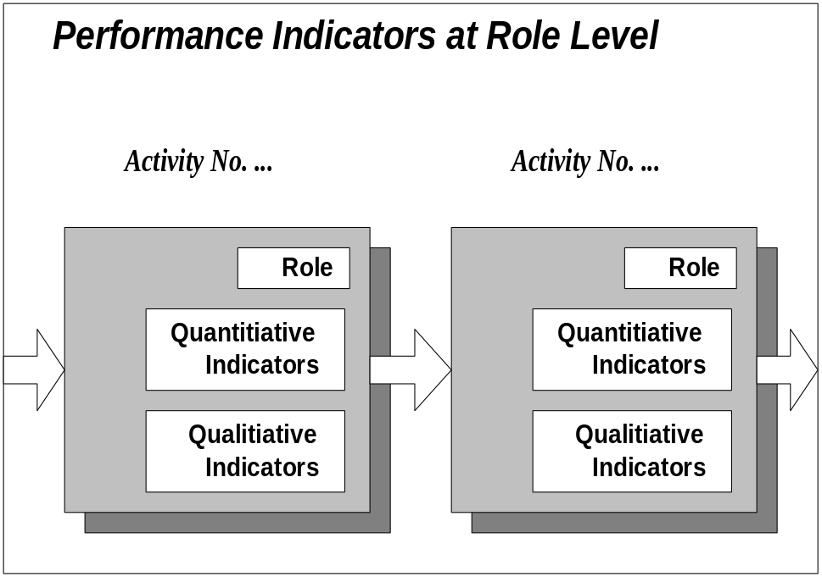

Import here the work done by the business unit managers in the Organizational Performance Improvement Strategy component of the Business Unit Managers Readiness Plan (AP.060).
Tailor this grid to the department level and the applicable modules/processes.

Impacted Process/ Procedure (Level 4 - 5 of Oracle Business Model) | Activities | Role Expectations | Corresponding Organizational Performance Objectives | Criteria
Financial - Accounts Receivable (AR)
Accounts Receivable | Meet Accounts Receivable Deadlines | Meet accounting deadlines |  | Meet internal customer expectations
Credit checks | Process incoming order related to credit checks | Determine type of credit type  Validate customer viability accurately  Maintain credit records |  | Define credit types  Check all questionable reports  Less than 5% receivables are aged over 30 days  Anything over 30 days is brought to management’s attention
Invoices | Process invoices | Process invoices for completed shipments within one working day |  | Notify management of delays and reasons
Financial - Accounts Payable (AP)
Approval | Complete the approval process  Maintain Electronic Funds Transfer (EFT) data | Approve 100% of all invoices  Transfer correct funds |  | Work within preset approval ranges  Work within limits
Close | Complete the closing process | Meet all accounting period driven deadlines  Reconciliation completed within accounting guidelines |  | Work within the predefined accounting schedule
Invoice | Complete invoices | Process invoices within AP guidelines |  | Work within the predefined accounting guidelines
Payments | Process outgoing payments | Process invoices for best cash management practices |  | Work within the predefined accounting guidelines
Returned Goods | Follow quality procedures | Process to make sure of credit or reshipment |  | Comply with money back guarantee and return policy
Financial - Assets
Manage Assets | Maintain evaluation of fixed and depreciable | Value assets to country specific tax codes  Depreciate assets to appropriate tax codes  Report status of assets |  | Work within predefined accounting guidelines
Financial - General Ledger (G/L)
Close G/L | Complete the closing process | Balance chart of accounts |  | Work within predefined accounting guidelines
Maintain G/L | Maintain G/L components and chart of accounts | Import other business unit journals  Re-value accounts and post entries |  | Work within the predefined accounting guidelines
Financial - Cost
Calculate item cost | Set fair market value of produced items | Set labor cost  Contract vendors  Assign fixed costs |  | Work within the predefined accounting guidelines
Manufacturing - Bill of Materials (BOM)
Maintain BOM | BOM System | Define BOM components |  | Follow guidelines to assemble BOMs that match customer requirements
Item Maintenance | BOM System | Identify differences between existing/new/changed BOMs  Modify existing BOMs to meet new customer specs |  | Follow guidelines to assemble BOMs that match customer requirements
Manufacturing - Quality
Reliability | Reliability process | Implement monitoring processes  Handle item failures and Return Material Authorization (RMA) |  | Work with customer and manufacturing team to establish item specific quality plans
Ship product | Ship criteria | Perform inspections  Pack and test products |  | Work with customer and manufacturing team to establish item specific test/ship plans
Manufacturing - Materials
Materials Inventory | Manufacturing | Maintain inventory levels |  | Analyze manufacturing orders and Work In Progress (WIP) to make sure of adequate raw materials inventory
Manufacturing - Purchasing
Suppliers | Supply chain | Qualify suppliers to meet item requirements  Execute purchase orders to support manufacturing needs  Establish autosourcing agreements  Put shipments into inventory |  | Implement quality standards and processes suppliers must maintain  All purchase orders will be processed according to priority definition  Establish agreements with critical components that enable shipment from automated system notice  Verify raw material acceptance criteria
Front Office - Sales & Marketing
Customer Service | Number of positive interactions  Number of negative interactions  Elapsed time to service requests  Customer retention rate | Achieve referral status for 20% of client base  Reduce issues by 50% from previous measures  Average response time to improve 20% over previous quarter  Rate to exceed industry standard by 10% |  | Exceed customer expectations  Meet customer expectations  Coordinate inter-company communication to effectively respond  Exceed customer expectations
Customer Process | Error rate  Data accuracy | Reduce errors to <10%> of previous measure  Reduce ship/communication errors by <5%> of previous measure |  | Accurately record and verify new and revised information  Research errors and correct customer data
Customer Relationship Management | Forecast cycle time  Order processing cycle time  Delivery cycle time | Increase accuracy of sales forecast by <10%> over previous measure  Reduce time from request to acknowledgment to one working day  Decrease time between order and shipment by <20%> on existing items |  | Implement defined processes and software  Use technology based order entry system  Use the customer service center to coordinate order processing

Documentation Task Force
Edit if the organization has not purchased Oracle Tutor™.
Oracle Tutor™ is the tool the implementation team is using to document procedures and curriculum, on a role basis, using the library of application supported procedures and courseware.
Like any tool, a successful Oracle Tutor project requires proper staffing of key project functions. The following list describes the functions necessary for a successful Oracle Tutor project. Each function may require multiple full or part-time people, or multiple functions may be filled by a single individual - as determined by the project complexity and skills of the individuals. The vendor can provide skilled resources if required.
As the department heads, the middle managers are the closest to the business processes and the people who are involved in the improvement of the processes. They are the ones who set up the required Oracle Tutor task force.
Make sure to orient the new members to the implementation team, using the Induction Checklist in Project Team Orientation Plan (AP.020).

Function | Description | Skills Set/Knowledge | Traditional Candidates | Workshop to Attend
Organization Project Manager  Always required  Part-time for life of project | Has overall responsibility from start through delivery of completed project.  Provides management of procedure and courseware development and document publishing.  Delivers progress reports to the executive sponsor  Works with the Oracle Tutor lead and learning coordinator (LC) to define learning plan and monitor delivery, while providing guidance to the LC during the execution of all learning activities. | Managing cross functional projects, leadership, working with employees at all levels.  Relationships between basic business functions, company policies, business issues | Application implementation team manager  User training manager  Training department manager  Information Technology project manager | Kickoff  Procedure Editing  Courseware  Publisher I and II
Oracle Tutor Lead  Always required  Level of effort dependent on customer’s ability to use the tool and manage such project | Provide guidance to the organization’s project manager on the management of the Oracle Tutor implementation.  Acts as the primary point of contact on Oracle Tutor issues. | Oracle Tutor implementation cycle and activities  Management expertise  Organization skills  Project management  Leadership. | Oracle OCM (OEPC in US) | Kickoff  Procedure Editing  Courseware  Publisher I and II
Process Owner/Subject Matter Specialist (SMS)  Always required  Involvement part time during procedure editing/development; Ideally, one owner per functional area. Hand off to business process owner at completion of project. | Is responsible for, and provides expertise during, the documentation of business procedures | Leadership, working with employees at all levels  Relationships between basic business functions, company policies. | Department managers  Department supervisors  Project team members | Kickoff  Procedure Editing
Courseware Owner  Always required  Full time involvement of one or more people during courseware modification/development | Is responsible for, and has final decision about the courseware development and modifications | Leadership  Working with employees at all levels  Application knowledge  Instructional design  Relationship between basic business functions and company policies | Training department staff  Project team member | Kickoff  Courseware
Application Implementation Subject Matter Specialist (SMS)  Required when process owner is not part of application implementation project team  Part-time during development | Provides knowledge of the Oracle applications implementation including any extensions and modifications | Application knowledge  Relationship between basic business functions | Oracle application team member | Kickoff  Procedure editing  Courseware
Document Controller  Always required  Full time involvement during development. Part to full time ongoing | Controls the publishing and distribution of all documentation, procedures and courseware  Provides and manages Oracle Tutor Author editing support for all procedures and courseware documents, based on input form document owners  Orchestrates the maintenance of the Oracle Tutor documents  Develops/delivers document progress reports | Oracle Tutor Author expertise  Touch typing skills (speed not required but helpful)  Personal computing on an IBM or compatible, using Windows, Word processing using Microsoft Word for Windows  Following up  Working with other employees at all levels  Knowledge of company policies, procedure writing standards | Documentation group manager  Training group manager  Desktop publishing manager  Courseware developer  Oracle OCM (OEPC in US) | Kickoff  Procedure Editing  Courseware  Publisher I and II
Document Specialists  Always required  Full time involvement during development. Number of people needed depends on number of modules and amount of customization | Provides Oracle Tutor Author editing support for all procedure and courseware documents based on input from process and courseware owners  May also participate in curriculum design and development | Oracle Tutor Author expertise  Touch typing skills (speed not required but helpful)  Personal computing on an IBM or compatible, using Windows, Word processing using Microsoft Word for Windows  Following up  Working with other employees at all levels  Knowledge of company policies, procedure writing standards | Word Processor  Technical Writer  Oracle OCM (OEPC in US) | Kickoff  Procedure Editing  Courseware  Publisher I and II
Workshop Facilitator  Always required  1 resource for Kickoff  2 resources for Procedure Editing Workshop  1 resource for Courseware  1 resource for Publisher I and II | Conducts Oracle Tutor workshops | Oracle Tutor workshop details  Classroom management  Organization  Presentation  Working with employees at all levels | Oracle OCM (OEPC in US) | Facilitates:  Kickoff  Procedure Editing  Courseware  Publisher I and II
Learning Agents  Always required  Part or full time involvement depends on learning events schedule | Facilitate learning events for end users | Andragogy  Working with people at all levels  Organization  Instructional design a plus | Implementation team member  Training department  Oracle OCM (OEPC in US) | Courseware
Delivery Skills Facilitator  Required when organization provides Learning agents  3 days per workshop (approximately 10 participants per workshop) | Facilitates workshop with organization’s trainers to build andragogy and facilitation skills | Topical knowledge  Train the Trainer experience  Leadership  Facilitation | Oracle OCM (OEPC) | N/A other than for awareness
Learning Needs Analyst  Required when detailed task analysis is needed  Level of effort depends on number of applications and size of user audience | Provides task level analysis of roles to support the documentation on procedures and to identify organization’s user learning requirements. | Communication with people at all levels  Organization  Instructional designer  Human performance technologist  Documentation writing  Analyst | Oracle OCM (OEPC) | N/A other than for awareness
Learning Coordinator  Always required  Part or full time involvement: Depends on learning strategy and size of audience as well as role to the Oracle Tutor lead (above) | Coordinates learning activities including scheduling, registration and attendance  Works with Oracle Tutor lead and Organization Project manager to define the learning plan and support its execution. | Oracle education expertise  Project management  Organization  Communication with people at all levels  Training deployment | Training group staff  Oracle OCM (OEPC) | N/A other than for awareness
Network Administrator  Always required  4+ days per Oracle Tutor install site | Provides technical support for the installation of the Oracle Tutor documentation files at organization site  Responsible for setting up proper file backup procedures | Directory and file structures  Networking  Client/Server  Web server  System administration | System administrator  Systems analyst  Network technician  Oracle Education Technical Operations | N/A other than for awareness
Education Technician  Always required  Level of effort depends on number of modules and learning facilities | Provides technical support for classroom set-up and learning database refresh  Responsible for assisting organization with installation of the Oracle Tutor product and technical workshop requirements | Oracle Tutor technical knowledge  Database  System administration  Applications technical | System administrator  Systems analyst  Oracle Education Technical Operations | N/A other than for awareness

Human Performance Support Systems (HPSS) Task Force
Edit if the organization does not embark in role upgrade or new business processes. The Human Performance Support Systems (HPSS) Task Force will next get involved in the development of the HPSS Strategy and contribute to the Business Improvement Matrix per role, once they are re-defined.
In addition to the Oracle Tutor team, a Human Performance Support System task force is required to assist in the upgrade of the new roles. Starting from the new business process defined/improved, the Human Performance Support Systems (HPSS) task force gets involved with:
Human Performance Support Systems (HPSS) Areas | Example of Activities
Work flows, job structure and organizational structure | Creating/designing job descriptions and work flows, reorganizing departments and business units
Job Performance | Determining new competency models, as well as productivity expectations and other metrics, recommending human resource allocation
Job Evaluation and Classification | Evaluating jobs to assign grade levels, classifications, and possibly compensation ranges
Performance Support Practices, Tools and Systems | Developing tools and procedures: to interview, select, and appraise the performance of those filling new roles; to guide in goal-setting, provision of feedback, and career development, to reward and recognize new behaviors, etc.
Job-Person Matching (when accompanied by a skills assessment) | Developing new skills profiles; may include recommending training and other learning opportunities, as well as succession planning

The Oracle Tutor team members can transition into the Human Performance Support Systems (HPSS) task force as the procedure and content are documented. In addition to the Organization’s Tutor project manager, process owner/Subject Matter Specialist (SMS), courseware owner, application implementation SMS, document specialist, workshop facilitator and learning agent, the HPSS task force requires the following functions:
Function | Description | Skills Set/Knowledge | Traditional Candidates
Organizational Development/Human Performance Technologist  Required if business processes are changed/improved  Level of effort depends on the scope of business process change/improvement | Creates/designs job descriptions and work flows, reorganizes departments and business units  Determines new competency models, as well as productivity expectations and other metrics, recommends human resource allocation  Develops HR management tools | Organizational development  Business Process Improvement  Human Performance Technology  Human Resource Management  Oracle Business Models  Experience with technology implementations | Oracle OCM (OEPC in US)  Organization Human Resource/Organizational Development (HR/OD) department specialists
Compensation Specialist  Required if new roles defined are of a different classification  Level of involvement depends on the number of new roles | Evaluates jobs to assign grade levels, classifications, and possibly compensation ranges | Compensation analysis and design | Oracle OCM (OEPC in US)  Organization Human Resource/Organizational Development (HR/OD) department specialists

Change Leadership Guiding Principles and Roles
Facilitation Guidelines:
1. Ice breaker: Suggest that participants switch their watches to their other arm for the duration of the session. At the end of the session, point out how unsettling such a little change can be.
2. Begin the session with a brief discussion of change in today’s business world, the pace, complexity, and volume. Tailor examples to the organization’s industry.
3. Discuss types of change: incremental versus transformational. What type of change are they going through? What difference does it make? Discuss technology-induced change. What makes it particularly difficult? For example, complexity, broad impact, fear factors associated with it...
4. Ask participants to describe their reaction to a recent change they experienced. Discuss “resistance”. Resistance is the normal human reaction to change. Ask if there is anything positive about resistance (yes; shows that people are alive, interested, thinking...) As a group, ask participants to brainstorm reasons why people resist. Discuss reasons which are based on reality (for example, an announced cut back in staff), those based on fear, and those which are simply a part of human nature (habit, past experience, low trust, etc.). Identify the symptoms of resistance in themselves and others. What level of resistance do they anticipate to this project in their organization?
5. Discuss the emotional cycle of change. Explain that effective leadership can help people move through this cycle quickly and keep the “valley of despair” shallow. Obtain from participants examples of resilience and congruence after change. As time allows, refer back to the Stakeholder Matrix and for each priority group, indicate what level of acceptance is most appropriate.
6. Discuss “Facilitating Change”; discuss what it takes for an individual to change, all the way to the behavioral level: will (information and leadership) and skill (learning and support).
7. Discuss “The Guiding Principles of Change.” Relate to the “Facilitating Change” model. Briefly review each principle and tailor it to the middle managers’ level.
8. Break the group into pairs and give each pair two principles to analyze, that is, why each principle is so important and the role managers can play in putting the principles into effect.
- a) Vision: They don’t create the vision so what is their role? managers have the responsibility of making the project vision come to life for their people. Their role is to disseminate the project vision and keep making the tie to the business objectives for their department/group.
- b) Leadership: Why is their leadership role so critical? What do they need to do? They serve as highly visible role models and must keep their decisions lined up with the project vision. They serve as sponsors for the groups they represent; they have a responsibility to build support for the project to the end and create other leaders/supporters. They see the compelling need, describe it for everyone, create converts, find the necessary resources, remove barriers, and relentlessly spread the word. Few leaders realize that in the midst of championing change, they may experience some of the same feelings of loss and insecurity that plague the employee who just heard about it. Leaders need to develop strategies to cope with those feelings. If a leader loses interest or faith, or reduces the intensity of his/her commitment, the rest of the organization usually picks up on the change almost immediately, and people lose heart.
- c) Communication: Doing what you say you will do is the first step toward building trust; communicating effectively is the second. A rule of thumb is “However much you think you need to communicate during a time of major change, you need to communicate more.”
- d) Share Ownership: Involving everyone is the antidote to “not-created-here.” The goal is to take people from “It’s not my idea,” to “It’s my baby.” This approach makes sense because it’s hard to oppose a plan you’ve had a voice in creating. The axiom is: involve everyone and involve them early.
- e) Culture: Describe the key cultural elements which impact transformational change and ask how they can impact those areas. Change-friendly cultures are customer focused, have high trust levels, are risk tolerant, promote innovation and are good at cross-functional teamwork. The question to ask is: How congruent is our current culture with the culture required to make this implementation successful?
- f) Scope Control: Tackling multiple transformational change initiatives can put all projects in jeopardy. However, a more common problem is the scope creep associated with a single project. When it comes to building a house, most people understand the concept of change control rather well; they know that when the building is almost complete, it’s folly to say, “I think I want a basement after all.” In technology implementations, much of that understanding seems to disappear, and as multiple unplanned new requirements are added, the drain on the resources needed to implement the change increases. A key responsibility of a change leader is to make sure that effective processes are in place to keep scope creep under control.
- g) Supporting Structure: Administrative policies, processes and procedures have to reflect both what you want to accomplish and how you want to accomplish it. Another version of walking the talk is to make sure that your policies mirror the messages that are being sent. How can they put in place the structure to reinforce the desired behaviors? They can put in place the right learning programs, rewards and recognition, etc.
- h) Learning Organization: The pace of change has moved learning out of the “nice-to” category and put it high on the list of things that are necessary for survival. Rapid changes in technology, laws, policies, marketplaces, and industries make it almost impossible to remain competitive unless people acquire new skills, attitudes, and behaviors quickly. In most organizations, learning is becoming a core competency.
9. Brainstorm strategies to overcome resistance using the eight guiding principles. Extract the leadership behaviors for the project leads. Capture on the Change Leadership Behaviors matrix.

Reactions to Change

Accelerating the Path Through the Valley of Despair
As users react to change through shock, fear and “wait and see” attitude before they commit to the new roles they must fulfill, there is a great drop in productivity. Adoption tasks aim at accelerating the cycle of reaction to change so the productivity drop is lessened and users achieve acceptance faster and generate higher productivity
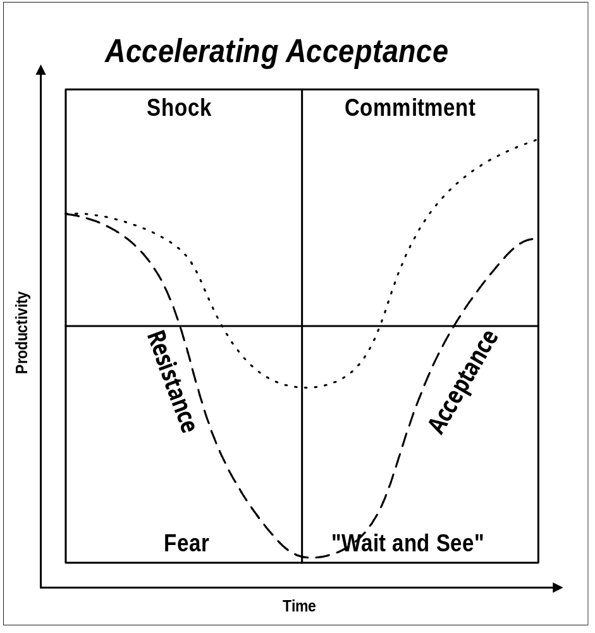

Change Model

To Change, Individuals Need the Will and the Abilities
To facilitate the change from the present to the desired situation, users need the will and the abilities to change.
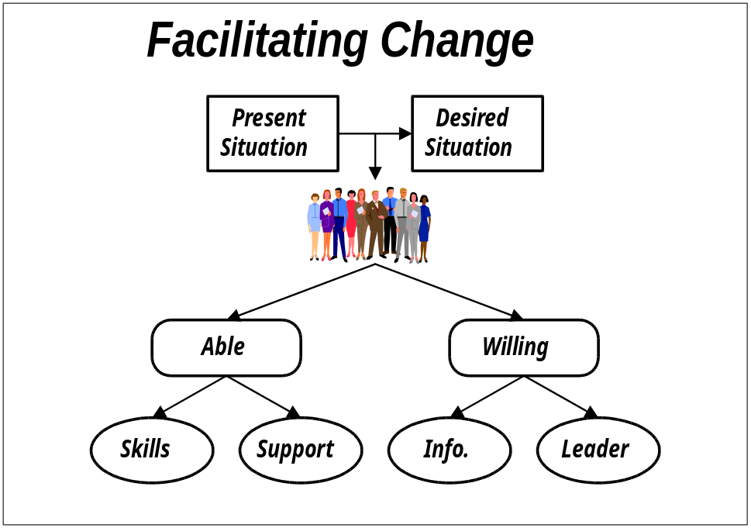

Guiding Principles for Effective Change

Leading Change From Resistance to Resilience
There are eight guiding principles for effective change.
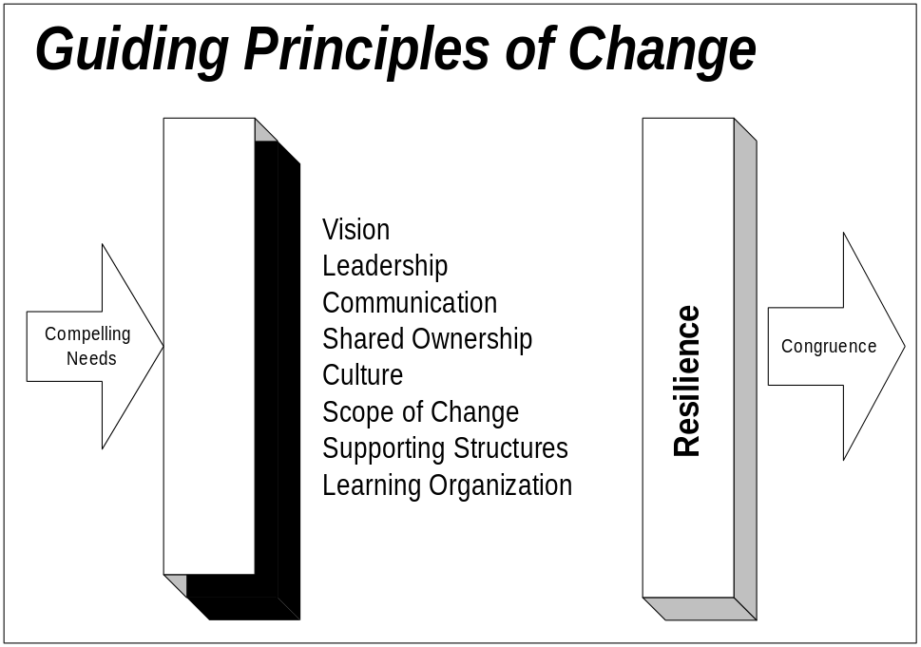

Change Leadership Behaviors
Leaders at all level must participate in the change leadership pattern across the organization. The managers agreed to the following change leadership behaviors:
Tailor the following matrix to the participants’ context as middle or first line managers.
Guiding Principles | To Do | How To
Create a Clear, Compelling Vision  Give a picture of where you are headed  Describe how the vision will be achieved  Keep it concise | Promote the project vision and keep in the fore front its tie to the corporate strategy  Leaders need to be able to dream and do; get some talented dreamers to help you on the team  ..... | Think about how the project can best serve your department strategy; dream big.  Identify the key benefits of the project for your department and the organization.  Distill your thoughts from step one and two above: Is there an underlying theme? Aim for elegant simplicity.  Figure out where you are now. Spend enough time to know where you are, but your main focus is on the future.  Describe the gap in terms of a compelling need to change (this is the transformation.).  Try your project vision statement on everyone you meet.  If you can’t make others understand in less than three minutes, start over.
Assess the Organizational Culture  Focus on the customer  Look for innovation and creativity  Encourage risk taking  Evaluate teamwork | Assess the current organizational and team culture in your department.  Put the focus of the project squarely on the customer.  Create a clear path from the customers’ needs to the resources that meet those needs and to the project team.  Nurture creativity.  Don’t punish pioneers. | Assess your department’s readiness to fulfill the project vision. Hold focus groups and gather feedback on how-we-do-things-around-here. Consider benchmarking from the outside.  Choose performance measures which tie directly to customer satisfaction for your department.  Involve customers; they are key stakeholders in the project; ask for their feedback and if appropriate their participation as liaisons to change teams.  Ask your first line managers and employees what could be done to allow them to serve the project customers better.  Provide opportunities for ideas to surface throughout your department. Recognize and reward innovation.  Recognize some important near misses.
Lead the Way  Assemble a coalition  Function as a sponsor  Serve as role model  Create a sense of urgency  Endure to the end | Begin with yourself. If you don’t role model the future, no one will.  Find influential allies who share the project vision.  Accelerate the pace just enough to create the right sense of urgency and momentum.  Create early wins and communicate those wins.  Endure to the end. | Ruthlessly examine yourself to determine how your behavior and approach to the project work, values, plans align with the project vision. Get feedback from others.  Walk the talk.  Do things highly visible to make the change real. Slay a sacred cow.  Assign the managers reporting to you (communication agents) the task of spreading the word throughout the department.  Use hard, cold facts to keep the compelling need for change in plain sight.  Set stretch goals. Monitor, measure, celebrate, and set new goals.  Cherry pick—find early wins, publicize, reward, celebrate.  Give presentations; conduct one-on-ones, focus groups, town hall sessions; preside at celebrations; remove barriers; provide resources.
Manage the Scope of Change  Stay within people’s finite capacity to absorb change  Keep an “open system” approach: systems are inter-dependent, multi-dimensional: change one, change all  Tie to the vision, to keep the change into context | Assess your people’s capacity for change.  Lobby to kill, merge or delay any non-essential project in your department and across the organization.  Define the big picture; let people see how initiatives interrelate. Establish strong ties to the corporate strategy. | Review data to inventory current changes in your department and detect people’s capacity to absorb change.  Gather information on all major projects. Look for objectives, overlaps, conflicts, commonality, scope, and time frames.  Help validate the project as priority.  Integrate, harmonize remaining projects.
Communicate Openly, Honestly, Relentlessly  More is better: Repeat key messages through different sources, consistently  Open two way communication channels  Manage the information; keep no secrets | Determine your department’s preferred ways of communication.  Create a formal plan for two-way communication.  Use communication agents.  Broadcast successes.  Keep abreast of people’s needs for communication and meet those needs.  Measure the effectiveness of the communication.  Manage rumors at their onset. | Create a supportive environment for the communication agents and the two-way communication channels throughout your department.  Use communications (two-way) to:  - Create buy-in  - Glean ideas you may not have thought of  - Build trust  - Build enthusiasm  - Determine where resistance lies  - Estimate the strength of the resistance  - Determine the causes of the resistance  - Clear up misconceptions  - Figure out how far and fast people can move  - Make course corrections  - Find pockets of support  - Surface concerns rather than suppress them
Promote Shared Ownership  Involve: People support what they help to create  Ownership improves quality and relevancy of decisions: involve everyone, involve them early | Identify opinion leaders in your department.  Determine whose support is critical and whose opposition could be dangerous.  Find opportunities to create buy-in among managers reporting to you and employees.. | Create a matrix that shows impacted groups within your department and anticipated support levels (Stakeholder matrix). In critical areas, get down to an individual level.  Identify their stake in the change.  Assess their readiness to change.  Hold focus groups with representative sample of highly impacted groups.  Hold one-on-one sessions with key stakeholders in your department.  Involve stakeholders in your department in supporting the project, ideas generation, focus groups, change teams, communication, and problem solving sessions.
Create Supporting Structures  Streamline decision making process  Make rewards and recognition supportive of vision  Instill measurements tied to the vision  Align human resource systems with required behaviors | Keep bureaucracy to a minimum.  Create reward systems specially for the project.  Adopt measures to focus on the transformations critical to the project vision.  Look for disconnects between HR policies and project set up/vision. Adjust HR systems accordingly. | Keep layers in the hierarchy to a minimum.  Push authority and accountability down.  Define the behaviors which are conducive to achieving the project’s business vision.  Mix measures; hard, soft, financial, non-financial, process and results.  Provide the right learning events.  Make participation on the project team a career enhancer for the resource selected from your department.
Build A Learning Organization  Operate on an assumption of competence  Create safe environment for learning  Promote knowledge transfer | Lend the “best and brightest” to the project  Encourage knowledge sharing  Promote voluntary followership  Unite people behind the project through shared vision, shared values, shared purpose  Regard mistakes as learning steps  Provide learning opportunities | Encourage individual characteristics which a learning organization should recognize and reward: self-directed learning, respect for others, empathy, curiosity, listening, systems thinking (ability to see how things are interconnected), risk taking, two way communication—dialogue, humility (being teachable), ability to learn from mistakes, self-knowledge—aware of strengths and weaknesses  Weave learning through status reporting

Managers’ Communication Guide
Facilitation Guidelines: Tailor the following based on the Communication Strategy defined in the Project Readiness Roadmap (AP.070) and link to the Communication Campaign (AP.080).
1. Lead a discussion on the importance of communication to the success of the project. Ask managers to describe the role they usually play in organizational communication. How will that role need to be enhanced if the project is to succeed? What types of information will they typically be communicating? What responsibility do they have in establishing a two-way flow?
2. Introduce the Managers’ Communication Guide and explain its use. Ask each manager to list his/her own communication responsibilities.
3. Review the communication responsibilities of the middle and first line managers. Reference the Communication Strategy component in the Project Readiness Roadmap (AP.070).
Reminder: Remind middle managers to plan for the first line managers’ readiness sessions which they will lead.

The Need to Involve People
People are at the heart of all change, especially technological change, as suggested by the picture below. People impacted by change often experience fear, anger, and anxiety because their professional (as well as personal) equilibrium is threatened. They must adjust the way they work (technology), the way they cooperate with co-workers or other teams (process), and the roles they play in the company’s business strategy (strategy).
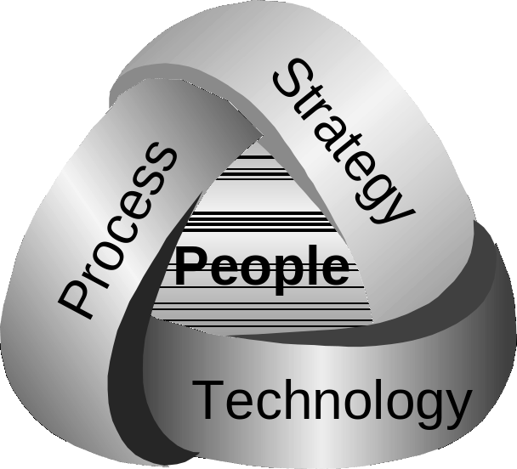
People at the heart of change
The reference of 74% failure rate is excerpted from Standish International survey, conducted in 1998. Research the latest and update as needed.
People will decide whether to use technology to its fullest or only for administrative convenience. Seventy-four percent of system implementations fail to meet expectations or are only partly used. Technological implementations fail because organizations neglect to manage the change. People must be involved in any change project to enhance the likelihood of success.
<Company Long Name> wants to positively manage change and its impact on their employees. <Company Long Name> wants to actively involve their people in this process. The first steps toward achieving this goal require good communication with employees, sensitivity to their concerns, their participation in and input to the process and, naturally, management of their expectations.

Purpose of this Guide
This guide provides information and an orientation to support your involvement in and your commitment to the communication process for <Project Name>.
You will see how you can enhance the communication process and how to fulfill your role as a manager supporting people through change. This guide covers:
- importance of communications to the success of <Project Name>;
- mandate of the communication team;
- communication strategies to use during change;
- tactics to manage reactions and resistance.

Role of Your Communication Team in the <Project Name>
We know that people are the key to successful change. To be in touch with them, it’s important to communicate openly, honestly and consistently.
Communications are a chief focus of the <Project Name> team. We are committed to conducting formal communications that will proceed in a "cascading" manner and be aligned with the implementation milestones. These cascading communications target details appropriate to each particular message and flow through established management and organizational channels from within the respective departments to frontline employees. As managers, you play an active role in this cascading communication.

Your Communication Structure for the <Project Name>
A communication team is in place to provide the necessary support to all business units, departments and work groups to ease the implementation of the <Project Name>. The project communication team outlined the high-level guidelines enabling communication work to go forward based on the communication orientations (See Communication Strategy in the Project Readiness Roadmap, AP.070). It involves formal and informal leaders to manage all communication channels. It also coordinates the production of communication tools.
The communication team is essential to the success of <Project Name>. The members represent the various communication audiences and other stakeholders. The specific role of the managers is to support communication with his/her stakeholders.
Your might add here the communication team chart from the Communication Strategy (Project Readiness Roadmap, AP.070).
Here are the people involved in this team for <Project Name>:
- the executive project sponsor is <Name>,
- the business project sponsors are <Names>,
- the project team includes <Names>,
- the communication agents are <Names>, and
- the communication liaisons are <Names>.

Your Communication Campaign
The communication team develops a communication campaign that best meets the needs and concerns of each project audience (groups).

Purpose of the Communication Campaign
The purpose of the Communication Campaign is to:
- support the technological implementation;
- manage ambiguity and reduce chaos;
- create a rallying point for people;
- help people tie individual and team efforts to a larger cause;
- create momentum for change;
- address issues;
- satisfy the hunger for information;
- control and channel rumors;
- give each audience a channel for two-way communication with the <Project Name> team.

Steps to Develop the Communication Campaign Materials
The Communication Campaign materials are created through a series of steps:
- clarify change objectives of the project and change leader’s vision;
- identify and assess audiences (specific groups impacted by the project) as to their communication needs, and to identify concerns as well as cultural preferences;
- tailor messages and events for each audience;
- plan, develop, and roll-out the campaign;
- measure the effectiveness of the Communication Campaign and adjust it as needed;
- create specific communications targeted to situations which could create resistance, political struggle, or ambiguity.

The Communication Team
The communication team leads all dedicated communications related to <Project Name>. It includes communication agents and liaisons.

Communication Agents
The communication agents are involved in all steps of the communication campaign. The specific role of the communication agents is to lead the following tasks with input from communication liaisons:
- help prepare audience analysis and tailor key messages for each audience and communication needs;
- recommend communication effectiveness measurement method(s);
- develop the communications per phase;
- solicit nominations for communication liaisons;
- develop communication liaison preparation materials and deploy the communication campaign;
- assist communication liaisons in their role;
- provide guidance for local communication;
- measure results of the campaign;
- plan celebration events and recommend individuals and teams to be recognized.

Communication Liaisons
The role of the communication liaison is key to the two-way, tailored approach to communication for <Project Name>. You play an advocacy and ambassadorial role. The project needs your energy, your enthusiasm, your commitment, your candor and your diplomacy.
With the assistance of the communication agents, communication liaisons will:
- help identify people or groups (audiences) who will be the most impacted and tailor communications to address their concerns;
- represent their constituency with their needs, concerns, hopes and issues;
- open the two way communication channel between their constituency and the project team;
- make sure that all people who will be impacted by the change understand the change;
- build common understanding and informed support during the project;
- provide, throughout the project, maximum responsiveness;
- create processes for rumor control.
Managers will support this communication effort, by being aware of the communication events which will impact their department/plant. You are the official communication channel and are the voice of your people in all two-way communication. In fact, you contribute and benefit from the synergy of the communication team. Your participation with communication measurements (feedback, focus group, survey, etc.) can influence the Communication Campaign and enhance its key messages and communication events.

Your Contribution
Managing change on a daily basis while experiencing it yourself is difficult. You find yourself challenged to communicate clearly while dealing with the ambiguity of transition. In addition, running the business during change requires flexibility and leadership to keep people moving forward. Managers face this reality during technological change and make sure that their people receive all the support they need to embrace the changes and continue to perform in the new business process.
In this situation, effective communications encourage a successful transition and reduce barriers to productivity, which are:
Copy the text below, from Mercier, Inc., “53 CEO in Manufacturing Area”, Personal Journal, Fall 1996 or research the latest:
- resistance to change (21%)
- poor communication (17%)
- lack of motivation (19%)

People will grieve for the “good old days”, and this is okay. Effective managers will support people through the process by listening to them, answering their questions, moving through their reactions toward commitment, and creating an atmosphere conducive to open communication.

Your Leadership
Managing people’s reactions obviously demands leadership on the part of the managers. We are referring here to both personal and professional talents. In fact, communicating during change relies more on the managers’ personal skills than on their knowledge. These skills are the very source of all good management but are even more indispensable in a context of change, where strong reactions and deep resistance require skilled intervention.
<Company Long Name> requires your leadership to create an environment that fosters an openness to change and that readily leads to the adoption of new ways of doing things and people follow because you:
- have the reputation of being trustworthy and honest;
- believe in this project;
- say the truth;
- speak openly;
- address their needs and concerns.

Your Communication Ability
As manager you have formal and informal opportunities to communicate with your people. You know what is the most efficient medium (meeting, memo, individual discussion, etc.) to pass messages and encourage discussion. You are in a position to support two-way communication and make sure project buy-in. <Project Name> requires your communication ability to:
- actively listen to people;
- pass messages clearly;
- support the communication strategy for the success of this project;
- serve as an advocate for your <Department/Plant> and your people;
- lead and facilitate discussions;
- solicit feedback;
- distinguish rumor from facts for your people.

Your Flexibility
Every day throughout the change you will have to make sure that your people measure up to their individual and group goals. You will have to win them over and keep them involved. Manager flexibility is crucial to the organization reaching its change goals. <Company Long Name> needs your flexibility to:
- question the status quo;
- encourage people to challenge ideas;
- develop good ideas for the transition phase;
- support communication events to keep employees involved;
- generate trust and candid input.

Your Cultural Sensitivity
Managers build the organizational culture every day. Sensitivity to the culture helps the implementation team to be:
- aware of and concerned with your people;
- respectful of diversity in the organization;
- sensitive to the psychological dynamics of change;
- able to use creativity to identify strategies to involve people in the project.

Your Expertise as Manager
Your personal <Department/Plant> expertise will enhance the discussion and add value to the <Project Name>. Your involvement in the communication campaign supports changes at all levels of the organization. Your participation is crucial to strengthening the link between the <Project Name> team and your people.

With You
Your role is key to the success of <Project Name>. Through you:
- people impacted by the <Project Name> will have a clear understanding of the importance of the project and specifically how it will impact them;
- communication agent and communication liaison will have strong sponsors.

Effective Day to Day Communications
This section provides you with information on how to deal day after day with people impacted by change. You will face positive and negative reactions. Both are normal but need to be managed to keep expectations realistic and reduce resistance.
The following paragraph is inspired by Doherty, N., Poles Apart? Integrating Business Process Redesign and Human Resources Management, 1994, Vol.1, No. 4, 49-56

People undergo a specific psychological process before they arrive at a new work situation. They need to be supported in overcoming the fears that change generates. To counteract the fear of the unknown and to support mobilization and motivation in favor of the change, managers have to communicate honestly, relentlessly, and in a different manner. This section provides suggestions to support communication initiatives.
The communication flow is very sensitive in organizations and may create political issues if ignored or not supported by the managers. Information flowing through informal channels is particularly powerful. That’s why sharing information is an art. What you can and should say is not always clear. The most effective way to communicate is: say the truth.

Tell the Truth
Say the truth and clearly communicate what will be done. It’s alright to say “I don’t know”, to admit bad news, or to acknowledge that change often scares people. Saying the truth respects people’s intelligence. We all prefer the truth rather than a political statement. The worst thing for an audience is to feel manipulated, or unheard.
There is a way to say the truth and describe the realistic picture. The approach must:
- be credible;
- be honest;
- be open;
- be timely,
- invite input and participation;
- display active listening;
- provide opportunities to share in the decision-making process;
- be genuine.
Use your strengths to communicate: humor, demonstration, concrete examples applicable to your group, etc. Most important is to communicate with integrity and with congruence, where your words, your tone, and your body language all communicate the same message. To make sure that what you say and how you say it are in sync, you must be comfortable with your message and how you communicate this message.
Honesty and forthrightness are a new practice in many organizations and could surprise many people. They will need time to believe and trust the new communication model. Relentless communication is the key to developing that belief and trust. We believe in practicing the “7 x 7 Communication Model." This means that we need to convey our message 7 times, in 7 different ways. The reason is simple: people are individuals, and all of us hear and respond in different ways to different forms of communication.

Respect Effective Timing
You will be exposed to a voluminous flow of information. Some of that information needs to be timed, that is, must be communicated at the right time by the right person and with a specific medium. If the manager does not respect that need, there is a risk of communications becoming garbled, and the possibility of failure and significant negative consequences such as:
- generation of rumors;
- implementation delays;
- creating political issues;
- building resistance at different levels;
- losing sponsorship from target audiences;
- creating confusion between the implementation team and the project communication team;
- reducing project communication team credibility;
- creating a scapegoat;
- losing momentum.
Consequently it’s very important to be aware of the communication plan and support its events in your department/plant. The information will be communicated, but success depends on timing. In some cases, prematurely giving out or unnecessarily delaying information would reduce its value and impact. As managers, you:
- sponsor some communication events to make sure of mobilization;
- support the communication process to give visibility;
- communicate some key messages to support building momentum;
- know the calendar of communication events to emphasize the importance of the information;
- use your own communication channels to reinforce communication efforts;
- advise the communication team of new communication needs in your sector.

Your Own Strategies to Support Communication Efforts

Renew Your Understanding of Your People
One strategy to keep in touch with your people during change, is to renew your understanding of employees’ attitudes toward the project. Use the following information-gathering activities to enhance your communication process:
- listen and share comments overheard;
- use informal, impromptu discussions;
- pose a few key questions to informal leaders;
- question-and-answer sessions following a formal communication;
- review existing publications for concerns or comments.
The best strategy for efficient communications is “the three to one rule”: talk… listen, listen, listen…., talk… listen, listen, listen….

Facing Reactions
Here are some tactics to deal with real negative behaviors and attitudes:

Encouraging healthy skepticism
You can redirect people's reactions to change. In fact, you can create an effective communication channel, but still face people who are slow to embrace the change being communicated. People adopt and adapt to change at different rates. For example, someone may not seem to be honoring the new project or might be asking a lot of questions. This behavior can reflect a valid “Show me, prove it to me” attitude. When this healthy skepticism is addressed, we often find that these people become true disciples. Other people in the organization often watch to see how these “bellwether” types are perceived and treated. Creating an environment where openness, candor, and questions are encouraged could make sure that employees will be part of the solution and not part of the problem.

Handling challenging situations
- with an autocrat (a person who wants to control everything, criticizes opposite opinions, could be aggressive): reinforce your point by using this type of person’s own logic coupled with your own message: “as you said last week, all people need to be involved in this project.. that’s why we want to be in touch with you.” “I agree with you, we can’t manage change without learning … for this reason we will assess the stakeholders.” Do not fall into this person’s trap by using aggressive behavior, it would only worsen the situation. Always be calm and assertive, not aggressive. Refuse or report the discussion if this person is too cynical or violent.
- with a bungler (a person who starts rumors, uses indirect strategies to resist, uses ambiguity in communications): identify this person’s communication channel and use it for your communication. Clarify your message when this person tries to introduce confusion and if necessary put the message in writing. Enlist the support of informal leaders to stick to the clear message.
- with a know-it-all (a person who never makes mistakes, who always has the answer and could be condescending): present your opinions in question form. In meetings, ask this type of person to summarize ideas, give power to other people and cut off that person’s speaking, if necessary. Hold to your facts.
- with a shrinking violet (a person who has information, but it’s not easy for that type of person to communicate it; that person is afraid of conflicts, doesn’t speak a lot and has good ideas): open an individual conversation with this person. Use your nonverbal skills to support that person’s speaking and give that person your support. Express how you appreciate that person’s comments.

When You Make Presentations or Facilitate a Meeting
Presentations are used to make sure of communication, that is, to create two-way communication with employees, to involve people in the project, to clarify messages, and to open discussion. Each presentation must be relevant if you want to keep people’s participation and interest.
Remember, in many cases, the time spent preparing the communication is as significant to the success of the communication as the presentation itself. Use the material the communication team provides to you. For the presentation:
- be concrete and use examples for optimal relevancy so people will not have the feeling that you want to trap them in theoretical concepts;
- capture your two or three key messages and reinforce them by presenting their content in different forms (remember the 7x7 model);
- keep in mind that people have seven basic questions about the project: who, what, when, where, why, how and What about Me?;
- making a presentation doesn’t mean that the presenter does not listen. A presentation is an interactive process: give people time to ask questions, comment on information, exchange ideas, and discuss issues in small groups;
- manage your presentation to focus on a few vital issues. It could be difficult to solve all issues in one exchange with people;
- use the medium as a message itself and don’t forget that flashy doesn’t always equal compelling or creative;
- if “location, location, location” are the three most important rules in real estate, then the three most important elements of presentations are: “rehearse, rehearse, rehearse”.
Here are a few points to consider for your presentations:
Presentations
- The first message of the presentation is the most important. People always remember how you open a presentation;
- Be concrete;
- Speak clearly, with good pronunciation and look at your audience (don’t read text);
- Be interactive with the audience: ask questions, invite comments, use group or personal experiences;
- Generate effective interaction: rephrase some important interventions, move, smile, use humor if you are comfortable with it;
- Have your introduction and conclusion summarize the discussions;
- Be attentive to your nonverbal communication, to make sure of your congruence;
- Keep in your mind where the presentation fits in the Communication Campaign;
- Clarify all misunderstandings that arise during the discussion period: repeat your key messages;
- Target specific issues.

Sponsor a Communication Team Initiative
Co-facilitation is a team effort. Having a manager as co-facilitator can increase communication credibility and emphasize the message. This strategy is useful for creating depth and varied communication. Some conditions have to be present to make sure of success with this activity:
- follow the communication objectives;
- define roles to be consistent and efficient during the presentation;
- present the key messages;
- respect both person’s contributions;
- split responsibilities between facilitators.
If these conditions are not present, you risk:
- creating a climate of domination in which everybody loses;
- speaking at the same time and creating confusion for the audience;
- generating inconsistent messages;
- showing disagreement;
- increasing resistance.
As sponsor you could answer stakeholders’ concerns and clarify some points, a concrete demonstration of cooperation and teamwork during the change process. The sponsor influences people to support the change. You could create coalitions around the project and bring your own social network into the project. Your commitment gives credibility to the change and exercises an important influence on the project.
You might help the communication initiatives if you:
- speak to your informal channels and reinforce the communication activities;
- provide your analysis of the political situation;
- validate some strategies with communication agent or communication liaison;
- are involved in conflict resolution;
- co-facilitate in a presentation.

Communication to Manage Resistance
The individuals who resist are not necessarily operating in bad faith. They are primarily looking for assurance that their needs and requests will be honored. For them, change raises the specter of losing their personal security, typically developed with great effort over a period of many years. Other groups/individuals resist change until they fully understand the foundation and motives for the change, and still they remain skeptical.
In the organization you find people resisting change because they will be losing their membership group and their affiliations (department mergers, structural changes). In fact, some changes jeopardize the hierarchy of power between employee groups. Others disrupt emotional and social ties between individuals. The loss of power (corporate resistance) and affiliation (social resistance) can create resistance.
Key components of any action strategy to manage resistance are the “interpersonal” skill of the managers who guides employees through the change. The way they communicate with people who might be manifesting resistance makes the difference between having people for the change, or against it, between success, or failure.
The following material is derived from the Change Management: Reference Guide, Training and Development Department, Government of Canada, 1994. Research the latest and update accordingly.

Here are some tactics for dealing with resistance. Be aware that action strategies for handling resistance are not recipes. They are examples currently used by various organizations to dispel resistance. You may draw on these strategies, but you will have to adapt them to your own organization’s culture. Those most likely to succeed will be selected according to the skills, strengths, and political forces at play within the organization

Rational Resistance: Inform, Listen, and Provide Opportunities for Input
The individuals and groups who show rational resistance assign credibility to the transparency of communications, to the logic of arguments, and to the congruence of messages. They are therefore especially sensitive to any inconsistency on the part of the manager. In fact, these groups and individuals prefer to hear a harsh truth over an evasive answer, and an imperfect message over a delayed response. Communications with rational people must:
- explain the why and the how of change;
- provide information on upcoming stages;
- create opportunities for them to say what they think and put their ideas to use;
- repair all miscommunications to prevent rumors;
- acknowledge when there is not yet an answer to the question and remind people that this is a normal phenomenon associated with the transition phase;
- discuss with them (individually, in groups, or through a workshop);
- argue both sides of change: raising the cost of not changing (loss of competitive edge, loss of market, etc.) instead of mentioning only the advantages of the change. In some cases, you must also communicate what will not change;
- address the loss and sadness involved, since change also exacts an emotional toll.

Emotional Resistance: Validate Emotions and Relate It to Change
Copy the text here. Research the latest and update accordingly:
This quote by Gilbert Tordjman accurately sums up the way emotional types think: “There is always a price to pay for our transformations, our progress, our advances, as well as for our lapses…None of it can occur without vulnerability, without tears and lamentations.”

For many individuals experiencing fear, anxiety, or anger, all they need in order to relieve their discomfort is someone to listen. Others are reassured by the opportunity to discuss their feelings openly with another individual or with a group. Some are appeased by the knowledge that their concerns are normal and accepted by their immediate superior.
Employees who manifest emotional resistance are generally employees who assign a great deal of importance to the work climate, and to their relationships with coworkers. These are employees for whom communication is vital. Communications with people expressing emotional reactions must:
- validate emotions and situate them in the normal context of change;
- use symbolic communication. Messages associated with visual symbols (a link with the market, the profession, the type of work) or literary symbols (normal, specialized, or humorous language ) can strengthen the message and add another level of understanding, while enhancing their receptivity. Marking technological implementation milestones with events that have symbolic connotations (launch a demo with an invitation to hit golf balls or to attend the new system’s christening) can help demystify the change or make it more accessible;
- reach employees who talk little and who operate in isolation. Initiate individual conversation with them to avoid passive reaction (illness, declining job performance, etc.) and prevent disengagement;
- use emotional leaders to pass the information and open communication with silent people;
- use informal channels to reach people who do not speak but have important things to say on the change process;
- acknowledge and bring conflicts into the open to restore communications between belligerents;
- acknowledging loss is essential to the grief process. Some organizations even launch the final phase of the change with a ceremony honoring the past;
The bullet above is excerpted from Doherty, N.: Poles Apart? Integrating Business Process Redesign and Human Resources Management, Vol.1, No.4, 49-56, 1994.

- demonstrate a concern for fairness in a context of transparency.

Cultural Resistance: Recognize Everyone’s Value
Obviously, the values and standards of the organizational culture will be affected by technological changes. The organization, like the individuals, is susceptible to change and can also manifest resistance through its managers. Indeed, changes to the culture impact personal values by confronting both organizational values as well as those of the group in question.
The culture of change colors every new attempt to interrupt the status quo. In the case of corporate mergers, culture shock can be the root of failed integration. The problem of acculturation is one of the most difficult to manage.
According to Cartwright and Cooper, a third of all mergers fail, not for financial or technical reasons, but more because of poorly managed acculturation. This reference comes from Cartwright, S., Cooper, C.L. (1994), Trends in Organizational Behavior, John Wiley & Sons Ltd. Research the latest and update accordingly.
In a cultural change context, communications must:
- integrate key messages to turn cultural differences between groups into assets;
- avoid the creation of sterile cultural communications with which no one identifies;
- present cultural differences as enriching rather than confronting;
- officially acknowledge the complementary contribution of workers from different backgrounds or groups;
- respect the language used by each profession to avoid creating a dominant culture;
- support celebratory events to reinforce the new organizational culture;
- enhance content that encourages openness to the cultures within the organization (tolerance, listening);
- provide information about the organization’s policies, client approach, etc.;
- highlight success stories during implementation to support the new emerging culture.

Social Resistance
The loss of power (corporate resistance) and affiliation (social resistance) can create resistance and start competition, or more overt conflicts, between groups having different interests. In this case, some groups use the incoherence of the conveyed messages to reposition themselves according to their social or corporate interests. In this situation, people resist change because they will be losing their membership group and their affiliations (department mergers, structural changes). In addition, some changes exacerbate internal disputes between employee groups (for example, between sales and operations, between unionized and non-unionized staff).
Communications in a social resistance context must:
- reinforce by its messages that the administrative standards, the task assignment process, wage adjustments, and so on are being applied fairly for all groups;
- emphasize that the client is the organization’s reason for being and remains the focus of every effort;
- hold rallying events around a common interest;
- reinforce key messages on the Organizational Vision;
- spotlight efforts headed in the direction proposed by the change;
- strengthen the sense of belonging and reduce competitiveness between groups by highlighting collective initiatives and achievements;
- avoid messages that use language containing negative symbols: sarcastic allusions, or black humor, aimed at a specific employee group should be avoided in all formal and informal communications by managers.

Open and Closed Issues for this Deliverable
Add open issues that you identify while writing or reviewing this document to the open issues section. As you resolve issues, move them to the closed issues section and keep the issue ID the same. Include an explanation of the resolution.
When this deliverable is complete, any open issues should be transferred to the project- or process-level Risk and Issue Log (PJM.CR.040) and managed using a project level Risk and Issue Form (PJM.CR.040). In addition, the open items should remain in the open issues section of this deliverable, but flagged in the resolution column as being transferred.

Open Issues

ID | Issue | Resolution | Responsibility | Target Date | Impact Date

Closed Issues

ID | Issue | Resolution | Responsibility | Target Date | Impact Date

