AIM
AP.100 Business Process Organizational Impact
<Company Long Name>
<Subject>

Author: <Author>
Creation Date: March 29, 1999
Last Updated: May 26, 1999
Document Ref: <Document Reference Number>
Version: DRAFT 1A

Title, Subject, Last Updated Date, Reference Number, and Version are marked by a Word Bookmark so that they can be easily reproduced in the header and footer of documents. When you change any of these values, be careful not to accidentally delete the bookmark. You can make bookmarks visible by selecting Tools->Options…View and checking the Bookmarks option in the Show region.

Approvals:
<Approver 1>
<Approver 2>
To add additional approval lines, press [Tab] from the last cell in the table above.
You can delete any elements of this cover page that you do not need for your document. For example, Copy Number is only required if this is a controlled document and you need to track each copy that you distribute.
Copy Number _____

Document Control

Change Record
4
Date | Author | Version | Change Reference
29-Mar-99 | <Author> | Draft 1a | No Previous Document

Reviewers

Name | Position

Distribution

Copy No. | Name | Location
 | - Library Master | - Project Library
 |  | - Project Manager
- The copy numbers referenced above should be written into the Copy Number space on the cover of each distributed copy. If the document is not controlled, you can delete this table, the Note To Holders, and the Copy Number label from the cover page.

Note To Holders:
If you receive an electronic copy of this document and print it out, please write your name on the equivalent of the cover page, for document control purposes.
If you receive a hard copy of this document, please write your name on the front cover, for document control purposes.
Contents
Document Control
Introduction
Purpose
Overview
Organizational Model
Open Systems
Five Main Systems of an Organization
Components of the Five Systems
Dynamic Relationship Between the Five Systems: Change in One Brings Change in the Others
Technological Change Impacts Multiple Layers of an Organization
Change Impact by Organizational System
Plan for Alignment and Acceptance
Open and Closed Issues for this Deliverable
Open Issues
Closed Issues

- To update the table of contents, put the cursor anywhere in the table and press [F9]. To change the number of levels displayed, select the menu option Insert->Index and Tables, make sure the Table of Contents tab is active, and change the Number of Levels to a new value.

Introduction
- Template Instructions
The Template Instructions are formatted as hidden text and are intended for the author of the document only. Delete this section after completing this document.
General hints for completing Adoption and Learning Process templates:
- This template contains suggested headings, text, and formatting intended to speed the creation of the deliverable. You may delete or add components to suit your objectives.
- To include hidden text when printing the document, select File, Print…, Option…, Print tab, check Hidden Text.
- To format (or undo) selected text as Hidden, select Format, Font…; check Hidden under Effects.
- To add lines to a table, press [Tab] from the last cell in the table.
- Text that appears between <single carrots> is either a variable to be replaced manually, or instructions for completing the field. Delete or replace all carrots before distributing the document to the organization.
- <Blue, highlighted text> represents a variable that may be defined and replaced automatically upon creation of the deliverable.
- AutoText: To insert AutoText, select Edit, AutoText…; highlight the name of the AutoText entry, and choose Insert.
- Add a red flag < , AutoText entry = red flag> to information in the document that signals an adverse impact on the project, for example, lack of a mission statement or poor vision alignment
- To protect the document so that revisions will show, select Tools, Protect Document…, Revisions. Add a password if you do not want someone to be able to remove the Protect function from the document. To set options for revisions, select Tools, Revisions… and choose your option.

Purpose
The purpose of this document is to help the organization better understand the extent and the ramifications of the change brought about by the new or improved business processes so it is better able to manage that change. It focuses on the question: How much change is a new or improved process imposing on:
- the activities and procedures to do the work
- the people performing that work,
- the physical setting where the work is done,
- the organizational culture in which the work is done and
- the organizational structure that supports the way the work is done?
From the documentation of the change impact resulting from the update and/or improvement of the business processes, the organization can develop a plan to manage the impact, align the organizational systems and facilitate acceptance and use.

Overview
This document includes the following components:
Component | Description
Introduction | Introduction to this document.
Organizational Model | Illustrates the model to analyze the change impact on the organization.
Change Impact by Organizational System | Highlights the extent and ramification of the new/improved business processes on each organizational system.
Plan for Alignment and Acceptance | Guides the development of the plan to manage the impact of the change from the new/improved business process.

Organizational Model

Open Systems
The model used to analyze the impact of new/improved business process on the organization is issued from the open systems theory of organizations, adapted from the congruence model.
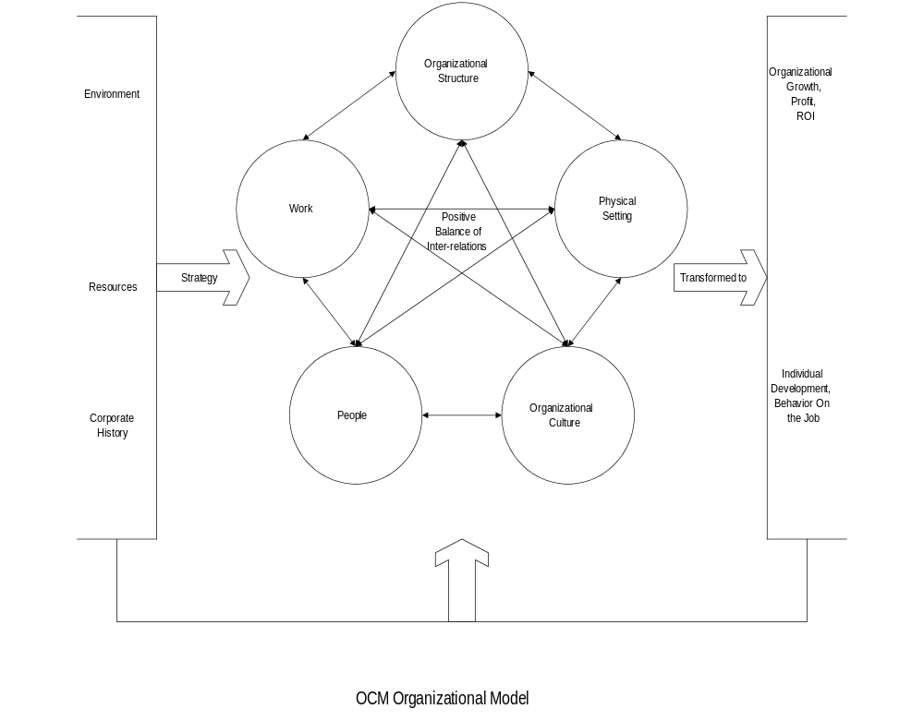

Background of Organizational Theory
The basic elements of organizations have remained relatively constant throughout history. Organizations are based on purposes; they acquire and allocate resources to accomplish goals, use some form of structure to divide and coordinate activities, and rely on certain members to lead or manage others. Although these elements have remained relatively constant, their purposes, structures, procedures, and methods for coordinating activities have always varied widely. These variations largely reflect the organization’s adaptation to its environment. In this sense, organizations are “open systems,” which are influenced by and have an impact on the world around them. Inherently, organizations are a part of the society and culture in which they function. Human behavior, both within and outside of organizations, is heavily influenced by culturally rooted beliefs, values, assumptions, and behavioral norms.

Organizations as Interrelated and Interdependent Systems
Contemporary organizational theories integrate the various elements that contribute to the whole organization. The underlying theme is that of systems; organizations are seen as systems of mutually interrelated and interdependent subunits. Actions occurring in one area not only affect that particular unit, but are likely to have a ripple effect throughout all the subsystems of the organization. The implication of this being, therefore, that events do not simply happen, but rather evolve from multiple pressures and can provoke multiple outcomes
Systems theory also brought forth the contrast between organizations as either open or closed systems. A closed system is one that is completely self-contained and does not interact with its environment. In contrast, open systems are influenced by external forces and interact with their environment. Organizations, for example, are influenced by a plethora of environmental inputs such as availability of materials, technological changes, competitive forces, changing worker values, and government policy (to name a few). The primary advantage to these theories is their ability to provide a framework for thinking about organizations in more complex and dynamic terms. The application of this perspective is especially useful when assessing the needs for major organizational change by encouraging managers to think about how change in one area will affect other areas of the organization.

Congruence Among Systems: Inputs May Alter the Balance
- The Congruence Model is inspired from Nadler and Tushman, 1992.
The organizational model shown above is an adaptation of the congruence model. Here the emphasis is on the transformative process and specifically reflects the system property of interdependence. The general model views strategy as driven primarily by company history, resources, and the firm’s environment (organizational context or “inputs”). These inputs provide the material with which the organization can work.
Company history, for example, includes not only the major stages of the organization’s development over a period of time, that is, where they lie in the corporate lifecycle, but also the current impact of past strategic decisions, behaviors, past crises and the responses to them, and the evolution of organizational values and norms. A second input, company resources, includes not only technology, capital, employees, and information, but also less discernible assets such as the market’s perception of the organization or the organizational climate. Both the value and the malleability of these resources affect how the organization can utilize them. The final input is the environment which includes externalities such as markets, regulatory bodies, competitors, unions, and financial institutions. These environmental factors can make demands or constrain organizational action, but also provide the organization with opportunities to explore.
Reflecting these inputs, and acting as a type of mediating input, is strategy. Strategy refers to the more fundamental notion of organizational purpose and objectives in addition to the specific tactics used to achieve these objectives.

Five Main Systems of an Organization
The strategy sets the template for the inner-workings of the organization, consisting of five main areas:
- work
- people
- organizational structure
- organizational culture
- physical layout
Optimally these five areas reinforce each other, creating a consistent message throughout the organization. This congruence, or lack thereof, is then transformed to outcomes on both the organizational, group, and individual level.
On the organizational level we can measure this through Return On Investment (ROI), growth, revenue and profit. On the group level this is reflected in the ability of the various groups to function as a unit. Feeding into the groups, yet with a separate dynamic are individuals, who can experience both personal and job related growth, measured by behavior on the job.
All three processes, system, group, and individual, provide feedback to both the organization’s inner workings and context, affecting strategy and relations between the five areas. The order in which they are presented is random and not intended to imply any sort of ranking or linear order.

Work
One of the five areas is work. In general this area refers to the basic tasks of the organization, those elements that relate specifically to the work itself. It includes, for example, work flow and role interdependencies, task planning, technical requirements, productivity metrics, procedures, and task-related learning.

People
The second, people, refers to both the characteristics of the individuals involved, what each person contributes to interactions and processes, and the ways in which organizational practices affect them. These include Human Resource practices (what actually occurs rather than the policy), leadership, individual demographics and experience, individual perceptions and expectations, needs and preferences, skills and knowledge, and competencies

Organizational Structure
A third area is organizational structure. Structure consists of the formal processes and methods designed to permit individuals to perform tasks. It includes information channels, decision-making processes, organizational layers and hierarchy, mechanisms for coordination and control, business processes, departmentalization, Human Resource systems, systems of reward, and policies related to ethics, budget and the like.

Organizational Culture
Fourth is organizational culture. Culture refers to the emerging relations of the organization, interpretations of life in the organization, and the meanings that flow from them. Included are the subcultural norms and values, relations both within and between groups, conflict management, patterns of communication and influence, informal networks, organizational style and climate, and non-formalized sources of power.

Physical Setting
The final area is physical setting. Physical setting includes location, the physical properties of the building, furniture and equipment, the quality of lighting and air, amenities such as cafeterias and parking, and considerations of safety and access.

Components of the Five Systems
The following table lists the facets included in each of the five systems:
Systems | Facets | Description
Work: Relating to the task itself | Work Flow/Role Interdependencies | The ways in which one job, or its outputs, leads to the next; the interdependence between jobs related to the structure of the task.
 | Role Requirements | Skills needed and demands required by a particular task, job design, routineness, performance demands to meet strategy
 | Planning/Goal Setting | Expectations of the task in meeting production goals
 | Technical Requirements: Hardware/Software | Technological tools used for specific task requirements
 | Metrics (that is, Productivity Indices) | Measures of productivity and task goal attainment; output measures
 | Procedures | The way tasks are accomplished; the methods used to create a specific output
 | Training | Method by which employees new to the department or job are taught the task role and specifics
People | Human Resource Practices/Orientation | How Human Resource policies “perceive” people, are actually practiced, and the effects on employees
 | Leadership | Formal and informal leaders; the qualities which promote being listened to, managerial style, leader behavior
 | Demographics | Unchangeable factors about an individual which may affect the way they approach the world, that is, cultural or ethnic identity, gender, age, socio-economic background
 | Experiential Background | Individual experiences which may affect behavior, that is, work experience, personal lifestyle
 | Perceptions and Expectations | Individual sensemaking and interpretation of what did and does exist leading to expectation of what should happen in the future, sense (or lack) of organizational effectiveness, trust
 | Needs and Preferences | Psychological needs and preferences of the individual; fulfilling these is motivating on an individual level, commitment
 | Skills/Knowledge | Skills and knowledge of the individuals
 | Competencies | Abilities and the capacity to follow through on them, personal growth
Organizational Structure | Informational Channels | Routes inherent in the structure by which information is able to flow
 | Decision-making Process | Accountability for decisions, channels of approval, institutionalized procedures for making decisions, consensual, autocratic or by vote
 | Organizational Layers and Hierarchy | Vertical levels on the organizational chart, reporting relationships, distribution of formal authority
 | Coordination and Control Mechanisms | Formal cross-departmental communication and planning; written goals and production quotas
 | Business Processes | Complete response that a business makes to an event; entails the execution of one or more process steps; has a clearly defined deliverable or outcome
 | Departmentalization | Formal division of labor, division into area responsibilities
 | Human Resource Management Systems | Systems in place for the purpose of managing Human Resource, written Human Resource policies and procedures, channels designed to deal with recruitment, hiring, firing, job evaluations, assessment of employee morale, resolution of personal conflict
 | Reward Systems | Compensation programs, promotion systems, bonus programs, reinforcement, perquisites
 | Policies: ethics, issue resolution. Grievance, budget | Written policies addressing issues of business ethics, resolution of conflict (non-personal), grievance channels and procedures, issues of budgetary policy, fiscal responsibilities and priorities
Organizational Culture | Subcultures: Norms/Values | What behavior is expected and accepted in subunits of and across the company, apparent shared values underlying behavior, bases of subcultures (that is, function, hierarchy level, ethnicity, gender, race)
 | Inter- and Intra-group Relations | Relations between people both within their own groups and between groups, boundary spanners, social interaction on and off the job, team functioning, subordinate attitude towards management, meeting and group processes
 | Conflict Management | Informal conflict resolution (personal), level of conflict considered appropriate
 | Communication and Influence Patterns | Amount and ease of communication both within and between groups, use of information as source of influence or power, use of gatherings to address company issues, political bartering, use of outsiders to influence
 | Informal Networks | Relationships between individuals not related to job function, “the grapevine”
 | Style and Climate | “Feel” of the company, general work atmosphere, formal vs. informal, individual vs. team, participative vs. directive, impersonal vs. warm, competitive vs. collaborative
 | Non-formalized Sources Of Power | Uses of personal power, control of data and information, access to resources, leader of informal subculture
Physical Setting | Location | Where the company is located; city or rural, downtown, industrial or suburban district
 | Building | Physical layout of the building; open spaces, closed-in offices, distribution of work spaces, departments’ physical relation to each other, physical condition of the building
 | Furniture | Adaptation of furniture to work needs, comfort, ergonomics, aesthetics
 | Equipment | Availability and ease of access to needed tools, condition of equipment
 | Lighting | Type and amount of lighting both for reduced eyestrain and ambiance
 | Air | Quality of air, fresh or recycled, temperature, scent
 | Cafeteria | Existence of on-site nourishment, quality and price of available food, seating arrangements, conduciveness to pleasant “downtime”
 | Parking | Availability of on-site parking, distance to workplace, covered or open, covered walkway to workplace, cost, lighting after dark
 | Safety | Safety concerns addressed, emergency plans in place, communication of emergency plan to all levels, existence of security during and after normal work hours, Occupational Safety & Health Agency (OSHA) guidelines understood and in practice, protective clothing and accessories when applicable
 | Access | Location of building accessible to workforce, building entrance/exit accessible, distance from air and other public transportation etc.
 | Virtual Setting | Space where home office work occurs, including availability of connectors, speed of connection, etc.

Dynamic Relationship Between the Five Systems: Change in One Brings Change in the Others
The organization can be thought of this set of components: work, people, structure, culture, and physical layout. However, more important than the contents of the components, or any weighting that might be assigned to them, is the relationship between them and the nature of their interaction. Conceptualizing the organization as dynamic is a way to capture the constantly shifting interdependencies and intricate interactions between the components. Because of these interdependencies, a transition in one affects the others, for example, a change in business processes, the advent of a new technological system. Sometimes the effects are apparent immediately, but often they remain hidden until the organization experiences an obvious, and often public, setback.

Alignment Among Systems is Key to Organizational Effectiveness
For the organization to function well as a whole, the various parts must be both consistent with and support each other, maintaining alignment. Organizational effectiveness is determined by this relationship between parts rather than any inherent characteristic of an individual component. To achieve this relationship of congruence, altering any area, such as business processes and technological systems, requires an overall re-evaluation and change process, carefully designed to bring the parts into alignment.
Further, there is continuous feedback, not only between the parts that we think of as the organization, but also with its context of inputs and outputs, areas often considered external to the organization. It is important to recognize these dynamics and their potential effects in disrupting the alignment of the internal organization. Because organizations operate in varying environments or under different constraints (for example, due to resources or competition), these dynamics vary enormously and no one approach will be appropriate. What is important is to address the organization as a whole and the dynamics between its interacting areas

Technological Change Impacts Multiple Layers of an Organization
Because of this, an induced change in technology and the business processes it supports has implications and effects at multiple layers of the organization, ones that are more pervasive than most other types of change. At first, the most obvious sphere in which technological change occurs is that of work. Certain technologies alter the task itself, the work flow, and task interdependencies; role requirements shift as do the measures of productivity, learning goals and so forth. However, the human factors are by no means secondary. Technological change can only be implemented by people, and the types of considerations discussed earlier (for example, perceptions, expectations, needs, competencies, experience) all converge to facilitate either the success or failure of the change. Organizational structure and culture provide the context through which these human factors will be enacted.
Given the indeterminate nature of social systems, there is no one best approach. The model does, however, allow an evaluation of the potential consequences of the change. By assessing the specific dynamic interactions between the five areas, it is possible to predict with some accuracy the potential for the change effort to succeed. The resulting adaptation of structures and communication patterns, work dimensions, and other specifics will positively impact the people involved by providing them with the reassurance of a well-planned-for change.

Change Impact by Organizational System
The following section documents for the business processes updated or improved the changes that they will affect on the organizational systems.
- Complete a table for each new/improved business process with the help of the team that worked on the process and a representative group from the departments impacted. Involve the project change lead.
Systems | Facets | Description of change
Business Process:
<Operations (Manufacturing and Assembly)>
<Planning and Forecasting>
<Procurement>
<Financial Management>
<Post-Sales Service>
<New Product Development>
<Order Fulfillment>
<Market Management>
<Human Resource Management>
<Management Information and Decision Support>
<Information Technology Management>
Work: Relating to the task itself | Work Flow/Role Interdependencies
 | Role Requirements
 | Planning/Goal Setting
 | Technical Requirements: Hardware/Software
 | Metrics (that is, Productivity Indexes)
 | Procedures
 | Training
People | Human Resource Practices/Orientation
 | Leadership
 | Demographics
 | Experiential Background
 | Perceptions and Expectations
 | Needs and Preferences
 | Skills/Knowledge
 | Competencies
Organizational Structure | Informational Channels
 | Decision-making Process
 | Organizational Layers and Hierarchy
 | Coordination and Control Mechanisms
 | Business Processes
 | Departmentalization
 | Human Resource Management Systems
 | Reward Systems
 | Policies: ethics, issue resolution, grievance, budget
Organizational Culture | Subcultures: Norms/Values
 | Inter- and Intra-group Relations
 | Conflict Management
 | Communication and Influence Patterns
 | Informal Networks
 | Style and Climate
 | Non-formalized Sources Of Power
Physical Setting | Location
 | Building
 | Furniture
 | Equipment
 | Lighting
 | Air
 | Cafeteria
 | Parking
 | Safety
 | Access
 | Virtual Setting

Plan for Alignment and Acceptance
In light of the change impact described in the previous section, the following actions will help manage the impact, restore alignment and facilitate acceptance.
- Facilitate the development of this plan around the suggested areas. Edit as needed.
If the extent of the changes is massive, consider developing the plan by the new/improved process or if not, consider consolidating.
Integrate the actions into the project management plans in effect (or the PVCS Tracker).

Areas | Actions | Responsibility | Timeline
Work
People
Organizational Structure
Organizational Culture
Physical Setting

Open and Closed Issues for this Deliverable
- Add open issues that you identify while writing or reviewing this document to the open issues section. As you resolve issues, move them to the closed issues section and keep the issue ID the same. Include an explanation of the resolution.
When this deliverable is complete, any open issues should be transferred to the project- or process-level Risk and Issue Log (PJM.CR.040) and managed using a project level Risk and Issue Form (PJM.CR.040). In addition, the open items should remain in the open issues section of this deliverable, but flagged in the resolution column as being transferred.

Open Issues

ID | Issue | Resolution | Responsibility | Target Date | Impact Date

Closed Issues

ID | Issue | Resolution | Responsibility | Target Date | Impact Date

The five areas are by no means presented here as the unique view of the inner organization. Many different models exist, each has its own advantages and disadvantages. The model here has been adapted as the best fit with our view of organizations.

