AIM
AP.140 Learning Plan
<Company Long Name>
<Subject>

Author: <Author>
Creation Date: March 29, 1999
Last Updated: June 4, 1999
Document Ref: <Document Reference Number>
Version: DRAFT 1A

Title, Subject, Last Updated Date, Reference Number, and Version are marked by a Word Bookmark so that they can be easily reproduced in the header and footer of documents. When you change any of these values, be careful not to accidentally delete the bookmark. You can make bookmarks visible by selecting Tools->Options…View and checking the Bookmarks option in the Show region.

Approvals:
<Approver 1>
<Approver 2>
To add additional approval lines, press [Tab] from the last cell in the table above.
You can delete any elements of this cover page that you do not need for your document. For example, Copy Number is only required if this is a controlled document and you need to track each copy that you distribute.
Copy Number _____

Document Control

Change Record
1
Date | Author | Version | Change Reference
29-Mar-99 | <Author> | Draft 1a | No Previous Document

Reviewers

Name | Position

Distribution

Copy No. | Name | Location
 | Library Master | Project Library
 |  | Project Manager
The copy numbers referenced above should be written into the Copy Number space on the cover of each distributed copy. If the document is not controlled, you can delete this table, the Note To Holders, and the Copy Number label from the cover page.

Note To Holders:
If you receive an electronic copy of this document and print it out, please write your name on the equivalent of the cover page, for document control purposes.
If you receive a hard copy of this document, please write your name on the front cover, for document control purposes.
Contents
Document Control
Introduction
Purpose
Assumptions
Overview
Learning Objectives by Role
Job Role Summary
Learning Objectives by Role
Learner Profiles
Learning Paths by Role
Learning Approach
Selecting the Media
Learning Paths per Role
Learning Reinforcement, Rewards, and Recognition Methods
Reinforcement Summary Grid
Learning Rewards and Recognition Process
Learning Measurement Methods
Baseline Measures
Measurement Methods
Material Development Recommendations
Resource Requirements
Learning Administration Process
Learning Schedule
Materials Distribution Plan
Roles & Responsibilities
Open and Closed Issues for this Deliverable
Open Issues
Closed Issues
Appendix A - Media Selection Flowchart
The Decision Flowchart
Appendix B - Electronic Performance Support Systems (EPSS)
Overview
Selecting an Electronic Performance Support Systems
Appendix C - Legal Implications for Learner Verification

To update the table of contents, put the cursor anywhere in the table and press [F9]. To change the number of levels displayed, select the menu option Insert->Index and Tables, make sure the Table of Contents tab is active, and change the Number of Levels to a new value.

Introduction
Template Instructions
The Template Instructions are formatted as hidden text and are intended for the author of the document only. Delete this section after completing this document.
General hints for completing Adoption and Learning Process templates:
- This template contains suggested headings, text, and formatting intended to speed the creation of the deliverable. You may delete or add components to suit your objectives.
- To include hidden text when printing the document, select File, Print, Option, Print tab, check Hidden Text.
- To format (or undo) selected text as Hidden, select Format, Font…; check Hidden under Effects.
- To add lines to a table, press [Tab] from the last cell in the table.
- Text that appears between <single carrots> is either a variable to be replaced manually, or instructions for completing the field. Delete or replace all carrots before distributing the document to the organization.
- <Blue, highlighted text> represents a variable that may be defined and replaced automatically upon creation of the deliverable.
- To protect the document so that revisions will show, select Tools, Protect Document…, Revisions. Add a password if you do not want someone to be able to remove the Protect function from the document. To set options for revisions, select Tools, Revisions and choose your option.
This document contains a detailed learning plan which recommends the most appropriate approaches and content to re-skill the target groups of users. It draws on the decisions captured in the Learning Strategy for Users (in the Project Readiness Roadmap, AP.070) and the information gathered in the User Learning Needs Analysis (AP.130) to define learning objectives, content, media, paths and environmental factors. In addition, it describes recommendations for reinforcement mechanisms, reward and recognition processes, and measurement methods.

Purpose
This document contains the detailed approach to a learning approach tailored to the needs of those targeted learning groups who will ultimately determine whether or not business results are achieved. The plan is designed to align with the organization’s culture, environment, and business needs. As this plan is deployed, be careful to use budgeted funds wisely, minimize the intrusion of the learning approach on the day-to-day functioning of the organization, and be sensitive to the emotional and social needs of those participating in the learning events.
The purpose of the User Learning Plan is to:
- Propose a learning approach which meets the needs of targeted users by customizing the learning objectives, paths, and components for those groups.
- Recommend an approach which helps users to achieve the performance goals necessary for the organization to achieve the business results anticipated from the implementation.
- Recommend a reinforcement mechanism, as well as rewards and recognition process, that facilitates the transfer of newly-acquired skills to on-the-job performance.
- Recommend valid methods to measure the effectiveness of the learning events.
- Identify and remove any barriers caused by organizational, environmental, or logistical issues.

Assumptions
The following assumptions were confirmed:
- The Learning Strategy for Users (Project Readiness Roadmap, AP.070) is complete and drives this User Learning Plan
- New roles have been identified and competencies for each role have been determined (Human Performance Support Systems, AP.110).
- The User Learning Needs Analysis (AP.130) is complete, and profiles which show the gaps between future and current skills have been created for each role.

Overview
This document includes the following components:
Component | Description
Introduction | Highlights the purpose, assumptions and overview.
Learning Objectives by Role | Lists the learning objectives for each targeted role.
Learner Profiles | Describes the mandatory, highly recommended and optional learning needs by role.
Learning Paths by Role | Describes the approach, content and media, and sequence for learning.
Learning Reinforcement, Rewards and Recognition Methods | Lists the methods selected to facilitate the transfer and maintenance of skills acquired.
Learning Measurement Methods | Describes the means to gauge the success of the learning project.
Material Development Recommendations | Details the approach to develop the materials required.
Resource Requirements | Gives an overview of the physical and psychological issues to address for the learning project.
Learning Administration Process | Outlines the roles and tools to administer the learning events.
Appendix A | Media Selection Flowchart
Appendix B | Electronic Performance Support Systems
Appendix C | Legal Implications for Learning Verification
We recommend an Adult Learning Specialist complete all task steps. Alternatively, the Trainer could handle core steps 1, 2, 3, 10 and 11, as defined in AIM 3.0 Process and Task Reference Handbook.

Learning Objectives by Role

Job Role Summary
The following summarizes highlights of job roles:
Identify the job roles & descriptions for the users who will participate in the learning events; include number of people in each role and location. This information should be provided by the User Learning Needs Analysis (AP.130).
The Oracle Skills and Procedures can be generated by the role-based content from Oracle TutorTM. Additionally, the User Profiles created in the User Learning Needs Analysis (AP.130) provide details on the systems literacy requirements as well as procedural and business skills.
Job Role | Skills Summary (Systems Literacy, Procedure and Business) | Number of Users | Location

Learning Objectives by Role
All learning is aimed at improving performance whether it involves providing employees with knowledge they do not have currently, skills they have yet to master, or motivating them to make better use of their abilities. Learning objectives based on the results of the User Learning Needs Analysis (AP.130) provide a clear direction for learning.
A Learning Objective describes what the learner will be able to do at the conclusion of the learning. The format for a Learning Objective includes three elements which provide a framework for the content: performance, condition, and criteria. These elements answer three questions:
- What should the learner be able to do?
- Under what conditions should the learner be able to do it?
- How well must it be done?
The following template was completed for each of the roles impacted by the systems implementation.
Complete the following table for each role identified.
Role 1  Systems Literacy | Performance  (The employee will be able to do X) | Condition  (Given X) | Criteria (To the standard required by the job activity)
Procedural Skills | Performance | Condition | Criteria
Business Skills | Performance | Condition | Criteria

Learner Profiles
The User Learning Needs Analysis (AP.130) gave us a starting point for creating a learning approach by identifying target groups of users and the required competencies and gaps in their knowledge, skills, and aptitudes. The User Profiles mapped out the competencies by role and defined the ending point, that is, where we want users to be when the learning is completed. The Learner Profiles build on the User Profiles and the skills gaps by defining what people need to know, or learn, or do, in order to reach those objectives. The Learner Profiles include the learning prerequisites to develop competencies that include systems literacy, the procedure and business skills as defined in the User Learning Needs Analysis (AP.130).
Because of budget and time constraints, we further segmented our recommendations by identifying those pieces of the curriculum which are critical to the success of the implementation project. Each component has been labeled as:
- Mandatory
- Strongly recommended
- Optional

Build on the User Profiles developed in the User Learning Needs Analysis (AP.130) and label each component/competency as mandatory, strongly recommended or optional. These labels are applied to the systems literacy, procedural and business skills identified.
Systems Literacy  Competency Area | Average Current Skill Level | Desired Skill Level | Skill Gap | Recommendations (Mandatory, Strongly Recommended, Optional)

Business Skills
Competency Area | Average Current Skill Level | Desired Skill Level | Skill Gap | Recommendations (Mandatory, Strongly Recommended, Optional)

Procedural Skills
Competency Area | Average Current Skill Level | Desired Skill Level | Skill Gap | Recommendations (Mandatory, Strongly Recommended, Optional)

Learning Paths by Role
In creating the Learning Paths by Role, our goal was to determine the optimal methods for transferring the needed skills to each group of learners, given their unique needs and the constraints or the opportunities provided by the organization environment. Once again, we focused on the full range of the learning experience, that is, the pre-learning preparation, the support offered during learning, and the follow up when the learners return to the job.

Learning Approach
With a systematic approach, the results of a learning program can be greatly increased. The learning process can be optimized in a number of ways. If learning is approached as a system bigger than the critical mass event only—the actual learning—the possibility of performance improvement is greatly enhanced. The systematic approach ranges from pre-learning preparation for users, support during learning and follow-up on-the-job. This includes visible participation and upper management involvement, users involvement in the learningware development process, clarification of new competency standards following the learning events, time allocation for actual learning, appropriate physical facilities and other performance support, mentorship programs, etc.

Selecting the Media
This section outlines the media or combination of media selected to meet the users’ needs. Based on sound instructional decisions, the selection of the media and/or combination most appropriate to the target groups of users included a thorough understanding of the user population.
The media we chose have the following characteristics:
- Seemed most likely to produce the expected learning outcomes
- Fit the learning needs of the target group of learners
- Mirrored real work conditions and environment
- Were cost justified
- Fit the learners’ culture
- Were practical to package, implement, and update
- Fit the organization’s culture and history
We also considered the following factors in making the choices:
- Number of locations
- Number of learners
- Budget
- Turn-around time
- Available resources
- Need for repetition
The decision flowchart and media selection matrices used to select the media is contained in Appendix A.

Types of Media Considered
The following media were selected:
List here only those media seriously considered for use in delivery.
Appendix B contains basic information on Electronic Performance Support Systems (EPSS), technology-based media, to help determine whether EPSS can be a viable alternative.
Types of Media | Media Examples
Information (The learner is not held responsible for specific actions or measurable performance.) | Conference Call  E-mail memo  On-line message  Newsletter
Instructor-Led Learning | Case Method  Demonstration  Lecture/Presentation  One-on-one Coaching  Workshop or Lab
Paper-Based Learning | Job Aid  Desk Top Manual
Technology-Based Learning | Video-Based Learning  Computer-Based Learning  Web-Based Learning  Audio -Based Learning  Interactive Distance Learning  Multimedia-Based Learning (CD-ROM/CD)  Oracle Tutor-Based Learning  Just-in-time Learning through an Electronic Performance Support System

Learning Preferences Considered
In defining learning paths by role with appropriate media, understanding learner preferences was critical. The following learning styles were considered to facilitate enhanced delivery and retention for users:
Topics | Groups | Description
Learning Styles | Audio | Audio learners absorb, retain, and recall information best when learned by hearing the information. Lecture, audio tapes, and reading methods of instruction are in this group.
 | Bodily-Kinesthetic Intelligence | Kinesthetic learners absorb, retain, and recall information best when learned by manipulating objects, hands-on experiences, and trial and error.
 | Visual | Visual learners absorb, retain, and recall information best when they look at graphic representations of data and concepts (graphs, pictures, models, etc.).
 | Environmental Elements | Learners respond uniquely to their immediate environments when they are trying to learn something new. These elements are biological and relate to one’s physical well being. These elements are sensitivities to sound, light, temperature, and design.
 | Emotional Elements | Each learner has a unique emotional state that affects the learner’s ability to absorb, retain, and recall information. These elements appear to be an outgrowth of both the environment and each person’s emotional makeup. These elements include motivation, persistence, responsibility/conformity, and structure.
 | Social Elements | Learners have preferences for working by themselves, in pairs, in teams, with colleagues, with authority, or with groups of diverse people. These elements appear to be environmentally based.
 | Physical Elements | Learners have differing physical needs related to learning. These elements are biological in origin. These elements include perceptual strengths, intake needs, time, and mobility.
 | Psychological Elements | Learners have differing psychological needs related to learning. These elements appear to be both biological and environmental in origin. These elements include global/analytical thinking, hemispheric preferences, and impulsive/reflective behavior.
 | Linguistic Intelligence | Linguistic learners gather information from textbooks or other literature and enjoy writing stories, essays, and reports.
 | Musical Intelligence | Musical learners enjoy composing songs and ballads about subjects rather than writing reports.
 | Logical-Mathematical Intelligence | Logical-mathematical learners enjoy doing research on subjects to gather the facts. They enjoy fact-based games, such as “Jeopardy” or “What’s My Line.”
 | Spatial Intelligence | Spatial learners enjoy viewing films, pictures, charts, and maps. They use their imaginations to paint vivid pictures about subjects.
 | Interpersonal Intelligence | Interpersonal learners enjoy activities that require them to interact with others. For example gathering information from interviews and enacting events, such as a meeting of King Arthur’s knights of the Round Table, appeal to these learners.
 | Intrapersonal Intelligence | Intrapersonal learners enjoy choosing a subject for in-depth research. They prefer to work independently to discover information.
 | Analyzers | Analyzers respond to instructional strategies that include formalized lecture, data-based content, financial/technical case discussions, textbooks and bibliographies, program learning, and behavior modification.
 | Organizers | Organizers respond to instructional strategies that include thorough planning, sequential order, organizational and administrative case discussions, textbooks, behavior modification, program learning, structure, and lectures.
 | Personalizers | Personalizers respond to instructional strategies that include experiential opportunities, sensory movement, music, people-oriented case discussions, and group interaction.
 | Visualizers | Visualizers respond to instructional strategies that include spontaneity, free flow, experiential opportunities, experimentation, playfulness, future-oriented case discussions, visual displays, aesthetics, and being involved.

Learning Paths per Role
The Learning Path combines the content, the media, and the sequence to create a flow of learning events for each targeted learning group. Learning Paths were developed with a variety of components, as illustrated below:
Create learning paths for each targeted learner role.
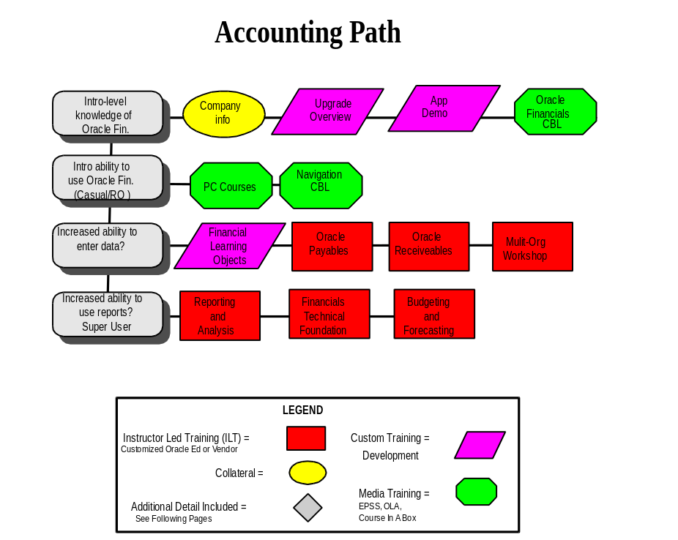
The following shows another sample learning path for the role of a clerk in Accounts Payable.

Role/Event | Learning Content in Sequence | Delivery Media
Accounts Payable Clerk  Pre-Learning Activities | Project Overview  Tailored messages “What to expect”  Preview/demos | Video  Email  Learning Lab
Learning Events | Introduction to Financials  General Ledger  Accounts Payable | Course-in-a-Box  Instructor-led course  Instructor-led course
Post-Learning Follow-up | “Using the Help Desk”  Job aid design  New hire learning | Lunch-and-learn session  Job aid reviewer  Coaching new hires

Learning Reinforcement, Rewards, and Recognition Methods
This section lists the methods selected to facilitate the transfer and maintenance of skills acquired during learning to the learner’s job environment. The selection process included reviewing the learning objectives for the key roles and the associated learning paths, determining the range of options available to augment the learning path, selecting appropriate reinforcement options, and creating recommendations for each target group of learners.
Use the Reinforcement Summary Grid to record the reinforcement methods selected for each targeted learner group.

Reinforcement Summary Grid
The following summarizes reinforcement measures selected for targeted groups of learners:

Targeted Groups of Learners | Job Aid | Coach/Mentor | Desk Manual | User Group | Help Desk
Role 1
Role 2
Role 3
Role 4

Learning Rewards and Recognition Process
Everyone wants to be recognized for accomplishments and rewarded for increased productivity and contribution to the success of the organization for which they work. A proven tool for motivating employee performance is recognition for a job well-done. A job well-done which is recognized provides an incentive for yet more productivity and improved performance. This plan includes guidelines to celebrate learners’ accomplishments and encourage them to continue to use and strengthen their new skills. The suggested guidelines target each group of learners and specify the time frame in which they should be given. Three time frames for recognition are suggested:
- During learning
- At the end of learning; and
- On the job, following learning

Guidelines for Recognition Given During Learning:
The following are guidelines for recognition measures given during learning:
- Informal
- Fun
- Opportunities for everyone to participate
- Spontaneous
- Varied
- Culturally sensitive

Guidelines for Recognition Given at the End of Learning:
The following are guidelines for recognition measures given at the end of learning:
- Formal
- Highly-public
- Matched to achievement

Guidelines for Recognition/Rewards Given on the Job, Following Learning:
The following are guidelines for recognition and rewards measures given on the job, following learning:
- Personal, that is, tailored to the individual
- Matched to achievement
- Timely
- Cumulative
Use the following template to capture the Reward and Recognition process per target group of learners.

Reward and Recognition Process Chart
The following summarizes the recognition measures by target group of learners:

Target Group of Learners | Suggested Recognition During Learning | Suggested Recognition at the End of Learning | Suggested Recognition/Reward following learning
Role 1
Role 2
Role 3
Role 4

Learning Measurement Methods
The general goal of developing the learning measurement method is to create a means of gauging the success of the learning project and shape recommendations for ongoing learning.

Baseline Measures
The User Profiles by Role in the User Learning Needs Analysis captured pre-learning data about the target groups of learners and thus provided the first measurement data. By comparing the baseline data with data collected after learning, it is possible to determine how much learning has occurred. Using a control group is a further step in validating measurement data. <Company Long Name> has/has not decided to use a control group.
In this section, record the measurement methods which have been selected using Donald L. Kirkpatrick’s four levels as a framework (from Evaluation of Training). Under “Learning Measurement” indicate whether or not a Learner Verification program is underway.
Legal implications around learner verification must be considered in selecting, defining and deploying your measurement methods. See Appendix C for legal issues and implications to consider.

Measurement Methods
The following measurement plan, broken out by levels of measurement, has been designed for the learning project.
- Reaction Measures
- Learning Measures
- Skills Transfer Measures
- Result Measures
In Donald L. Kirkpatrick’s four levels of evaluation, Learner Verification is a Level II evaluation, measuring learning; and Performance Assessment is a Level III evaluation, measuring behavior. Learning is defined as” the extent to which participants change attitudes, improve knowledge, and/or increase skill as a result of participating in the learning event.” Behavior is defined as “the extent to which change in behavior has occurred because the participant participated in the learning event. Level III, then, describes learners’ behavior on the job; what learners actually do as a result of the learning event. Do they use their newly-acquired knowledge, skills, and aptitudes in the desired manner when they return to their workplaces after learning.
The type of evaluation measures a fairly exact transfer of learning to performance. Behavioral evaluation requires skillful, up-front analysis as the performance objectives are created. Evaluators must know the task in detail in order to determine if the learners know how to perform appropriately. And since the evaluation must happen at the workplace, evaluators cannot control when, or even, whether, the learners will have to use their new skills.

Measurement Matrix
The following documents the considerations per measurement level:
 | I - Reaction | II - Learning | III - Skills Transfer | IV - Results
What we want to know
What might be measured
Measurement dimensions
Sources of data
Data-gathering methodology
Evaluation criteria

Selected Measures by Target Learner Group
The following table charts the measures selected by target group of learners for each level of measurement:
Target Learner Groups | Reaction Measure | Learning Measure | Skills Transfer Measures | Result Measures

Material Development Recommendations
This section details the approach to developing the materials required in order to deliver the recommended learning. Wherever possible, available courseware will be used in order to minimize the effort required. Material development requirements will vary with the type of media selected, particularly when using on-line learning, multi-media or web-based options. Resource requirements related to these technical media are provided in the following section.
Development activities will be focused on the production of:
Amend the suggested list below to reflect the recommendations you are making. The suggestions below lend themselves for use with all media.

- Quick Reference Guides
- Learning Event Overviews
- Detailed Modular Learningware including:
- Module Objectives
- Business Process Maps
- Examples
- Step-by-step instructions
- Exercises to confirm understanding and develop skills
- Instructor Slide Packs - Originals for making reproductions
- A learning database populated with relevant data to support the execution of the learning events
The following table summarizes the development materials, together with categorizing them into those which are tailored from existing courseware and those which are to be created:
Edit the table below to reflect the materials list. Where materials exist, indicate their source.
No | Materials | Amend Only | How | Source | Create
1
2
3
4
5
6
Insert the organization, module names and estimates of development effort required in the table below. Update the totals by selecting the table and pressing F9.
The estimate of materials development effort required is summarized here:
No | Materials | Vendor  Man Days | <Company Long Name>  Man Days | Total
1 |  | 0 | 0 | 0
2 |  | 0 | 0 | 0
3 |  | 0 | 0 | 0
4 |  | 0 | 0 | 0
5 |  | 0 | 0 | 0
6 |  | 0 | 0 | 0
 | Total | 0 | 0 | 0

Resource Requirements
An effectively designed learning environment supports learning. In order to create a good learning environment it is important to pay attention to both the psychological and physical environments. This section provides an overview of the learning environment issues at <Company Long Name>. These include the following:
Strive for specifics about the optimal physical place for the learning event. This includes any special requirements, such as particular size room or building, lighting, acoustics, etc.
Include plans for items such as blackboards, desks, tables, chairs, carrels, audiovisual equipment, projectors, screens, white boards, easels, etc.
Learning database: If appropriate, check the learning database is available and has been updated with the data required for your learning.
Check technical support personnel will be available to during the instruction and practice periods.
Area | Description
Facility and sites | Finding optimal space if a requirement for each media type requires a special facility. Instructor led learning immediately comes to mind, but many delivery scenarios have a space requirement implied. For example, if video is the option selected, where will the person watch video? If one-on-one coaching is the method of choice, where will the coaching take place? Planning in advance helps make sure of the success of the option selected.  If audio/built-in sound clips/shockwave files, are critical components, headphones may be required or a facility where sound can be used. This is critical when using multimedia options, for example, Oracle On-line Learning Application.
Equipment Requirements | Most learning methods require some sort of equipment. Sometimes the equipment is obvious, that is, a tape player to listen to an audio tape, but many times the equipment requirements are complex and some of them only become apparent when the learning event is about to begin. Think about such things as graphics pads, scanners, or printers, CD players, or terminal projection equipment.  Computers: Assure appropriate computer workstations with sufficient space, drivers, and so on., are available with access to the appropriate applications and visual display capability. For multimedia-based products-mix, the computers must support graphics and animation or other components which support the content.
Supplies | Pencils, pens, paper, visual aid materials, workbooks, and so on. What publication issues need to be resolved?
Materials | Manuals, quick-reference cards, audio tapes, videotapes, keyboard templates, on-line exercises, etc.
Miscellaneous | Required security clearances, special transportation, parking, requirements, attendance tracking, and so on.  Access to Applications must be provided for in advance of certain web-based products-mix, such as On-line Learning Application.

Learning Administration Process
This section outlines the following:
- Learning Schedule
- Materials Delivery Plan
- Roles & Responsibilities
- Learning Events Tracking Mechanism
- Learning Events Communication
- Contact Information
- Open/Closed Issues

Learning Schedule
This following table outlines the schedule for group learning at <Company Long Name> .

Date | Job Role/Function | Event Title | Prerequisites | Location

Materials Distribution Plan
Self-Guided learning involves the use of materials such as desk manuals, job aids, CBTs , and workbooks. The following table shows the plan for distributing those materials.

Learner | Location | Materials | Date Needed | Person Responsible

Roles & Responsibilities
The learning approach relies on multiple people playing multiple roles for the project to be successful. They are:
To identify those roles, answer the following questions: Who is responsible for -
- Signing off on the User Learning Plan?
- Communicating with the organization about the User Learning Plan?
- Making sure that necessary materials are developed?
- Ensuring that tracking mechanisms are in place and working?
- Inviting learners to the events?
- Making sure resources are available when needed?
- Issuing progress reports?
- Ensuring that the proper equipment is available and technical requirements have been met?
- Creating and distributing recognition and rewards?
- Tracking the agreed upon measures

Open and Closed Issues for this Deliverable
Add open issues that you identify while writing or reviewing this document to the open issues section. As you resolve issues, move them to the closed issues section and keep the issue ID the same. Include an explanation of the resolution.
When this deliverable is complete, any open issues should be transferred to the project- or process-level Risk and Issue Log (PJM.CR.040) and managed using a project level Risk and Issue Form (PJM.CR.040). In addition, the open items should remain in the open issues section of this deliverable, but flagged in the resolution column as being transferred.

Open Issues

ID | Issue | Resolution | Responsibility | Target Date | Impact Date

Closed Issues

ID | Issue | Resolution | Responsibility | Target Date | Impact Date

Appendix A - Media Selection Flowchart

The Decision Flowchart
Respond to the questions in the media selection decision flow charts to narrow the number of alternatives by reasonable decisions. As you move through the flow chart, refer to the Table: Media Selection Matrix and review the list of unique characteristics for each media.

Abbreviations used in the Flow Chart:
The following lists the abbreviations used in the flow chart:
- IDL: Interactive Distance Learning
- ILL: Instructor Lead Learning
- PBL: Paper Based Learning
- TBL: Technology Based Learning

Notes on some of the Criteria in the Matrix:
The following are intended to augment the understanding of the criteria in the matrix:
- Information: The learner is not held responsible for measurable, specific actions or performance.
- Instruction: The receivers of the instruction are exposed to information and are to give demonstrable proof that they have learned.
- Function: The more functions the media includes, the more likely the learners are to be effective:
- The learner is mainly exposed to the content of the change.
- The learner can observe someone modeling the behavior(s) expected and/or has the opportunity to model the behavior(s) expected.
- The learner has the opportunity to practice skills.
- The learner has the latitude to repeat his/her exposure to content and/or practice of skill for better understanding, retention and mastery.
- The learner’s progress is reinforced during learning and back on-the-job.
- Dynamic: High interaction and participation, rationales, relevancy and on-the-job reinforcement are recommended for more in depth mastery and proficiency on-the-job.
- Interactive level: Extent to which the learner can interact and participate within the learning media.
- Background rationale: The content includes benefits of the change to overcome learners’ potential resistance to change and support motivation to acquire the new knowledge/behaviors expected.
- Examples: The content includes specific application relevant to the learners to make the change more concrete.
- On the job use: The media lends itself to easy use on the job as performance support until the learner achieves the required comfort, confidence, knowledge and mastery levels. On-the-job use is specially recommended in instances where a complex procedures does not need to be memorized and instances when a procedure is not often used.
- Pace: Learner controlled pace allows a better match to various competency levels and learning styles.
- Intake Mode: Multiple intake modes are recommended for longer attention spans, more in depth mastery and longer retention.
- Feedback on Learning: Immediate feedback is more motivational as the learner can have a better sense of progress. Timely feedback makes sure that the appropriate knowledge and skills are being acquired; if not, corrective information must be provided along with the feedback for optimal results.
- Exercise responses, for example: the learner can complete exercises that test his/her comprehension/abilities and compare his/her responses to the Solution Key provided in the media.
- Self-administered measurement, for example, the learner grades him/herself by assessing the number of correct responses to exercises.
- Individualized feedback, for example, the learner gets customized feedback on knowledge or skills with additional information or practice needed by that specific learner throughout the learning process.
- Programmed measurements, for example, by design, the learning media keeps track of the learner’s results to tests and may also compare them to norms.
- The nature of questions asked can give some indication of the level of comprehension of learners.
- Ad hoc, for example, if the computer user makes a mistake due to the change, an error message with explanation of the change may appear on the screen.
- Retention Rate: High learner interaction and participation, multiple intake modes, relevancy, immediate and individualized feedback, all contribute to higher and longer term retention levels.
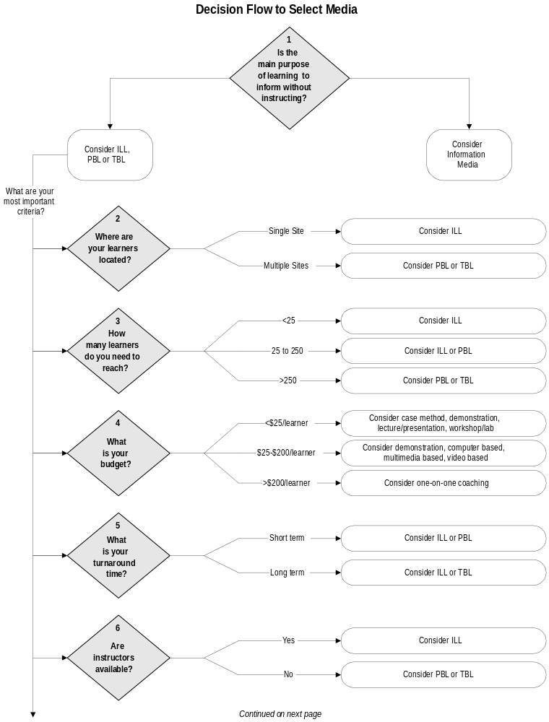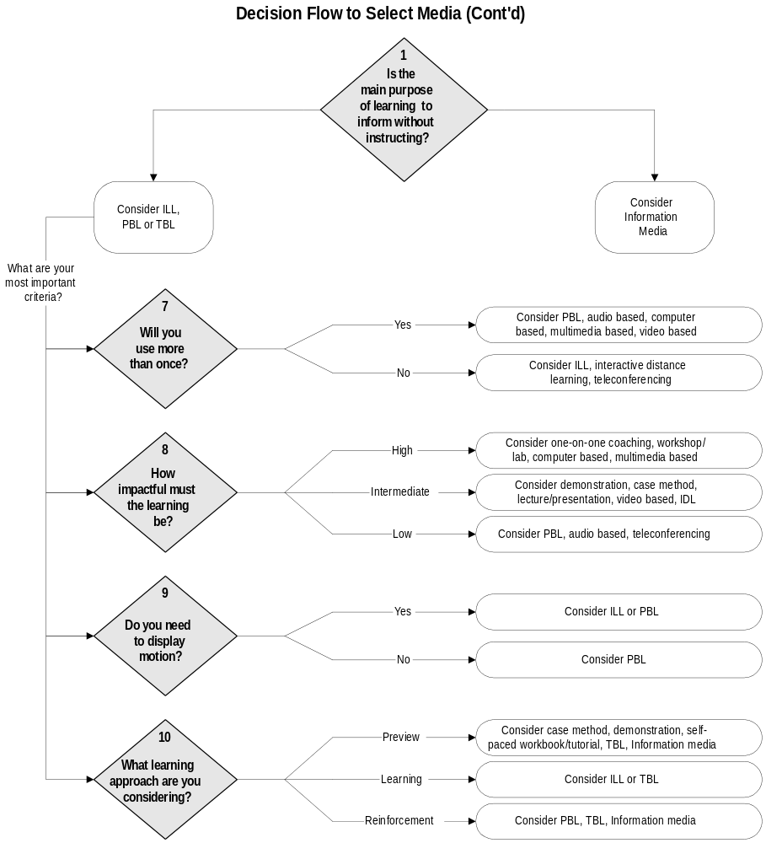

Learning Media Selection Matrix
The tables on the following pages provide a comparison of the following characteristics:
Audience Size | Purpose | Learning Level
Function | Dynamic | Pace
Intake Mode | Feedback on Learning | Retention Rate
Production Demand | Equipment Required | Reproducibility
Flexibility | Accessibility | Convenience of Use
Design/Development Cost | Production/Reproduction Cost | Delivery Cost
Delivery Efficiency | Communication Cost | Average Ballpark Cost

Characteristics are highlighted for each of the following learning media: The table only shows the most likely highlight(s) for each characteristic charted, that is, what media most likely lends itself to within each category of characteristics.
Class of Media | Media
Information | Conference Call  Documentation  E-mail memo/Bulletin Board  On-line Message (for example, Help screen)  Printed Memo/Newsletter
Instructor Lead Learning | Case Method  Demonstration  Lecture/Presentation  One-on-One Coaching  Workshop/Lab
Paper Based Learning | Job Aid  Self-Paced Workbook/Tutorial
Technology Based Learning | Audio Based Learning  Computer Based Learning  Interactive Distance Learning  Multimedia Based Learning (CD-ROM/CD-I)  Teleconferencing  Video Based Learning

Media Selection Matrix – Chart 1A: Information
The following criteria apply to information media:
 | Conference Call | Documentation | E-mail memo/ Bulletin Board | On-line Message (for example, Help Screen) | Printed Memo/Newsletter
Audience Size | Large group | Individual | Individual | Individual | Individual
Purpose | Information | Information | Information | Information | Information
Learning Level | Knowledge  Attitude | Knowledge | Knowledge | Knowledge  Thinking skills | Knowledge
Function | Exposure to content | Exposure to content  Preview/Review of other media | Exposure to content | Exposure to content | Exposure to content
Dynamic | Little interaction  Background rationale | No interaction  Background rationale  On-the-job use | No interaction  Background rationale | No interaction  On-the-job use | No interaction  Background rationale
Pace | Pre-set by initiator | Learner controlled | Learner controlled | Pre-set by developer | Learner controlled
Intake Mode | Auditory | Visual | Visual | Visual | Visual
Feedback on Learning | None except based on questions asked | None | None | Ad-hoc | None
Retention Rate | Low level  Short term | Low level  Short term | Low level  Short term | Low level  Medium level if repeated use | Low level  Short term
Production Demands | Low | Low | Low | Low | Low
Equipment Required | Telephone conferencing | Desktop publishing  Printer | Computer hardware & software | Computer hardware & software | Desktop publishing  Printer
Reproducibility | Not applicable | Very easy | Automatic | Automatic | Very easy
Flexibility | One time use | Reusable  Easy to modify | One time use  Easy to modify | Ad hoc use  Easy to modify | Reusable  Easy to modify
Accessibility | Through telephone  Spread out use | Self-controlled  Spread out use | Through computer  Spread out use | Through computer  Spread out use | Self-controlled  Spread out use
Convenience of Use | High:  — On-the-job  — At home  Pre-set timing  Somewhat time consuming | Very high:  — On-the-job  — At home  Not very time consuming | Very high:  — On-the-job  — At home  Not time consuming | Very high:  — On-the-job  — At home  Not time consuming | Very high:  — On-the-job  — At home  Not very time consuming
Design/ Development Cost | Ratio: 2:1 (low): preparation, scheduling & coordination | Low: design, development & testing  None if existing | Low: 2 hr/screen: development | Low: integration & development | Variable: low to medium development
Production/ Reproduction Cost | Based on time and number of people | Low per printed master  Low per unit | No cost | No cost | Low for printed master  Low per unit
Delivery Cost | Callers’ time  Phone | Mail  Readers’ time | Phone  Readers’ time | Readers’ time | Mail  Readers’ time
Delivery Efficiency | High for single occurrence  Low for multiple occurrence | High for single site  High for multiple sites | High for single site  High for multiple sites | High for single site  High for multiple sites | High for single site  High for multiple sites
Communication Cost | Medium (long distance) | Distribution | Minimum where system exists | Minimum where system exists | Low to medium depending on quality

Media Selection Matrix – Chart 1B: Instructor Lead Learning
The following criteria apply to instructor lead media:

 | Case Method | Demonstration |  | Lecture/ Presentation | One-on-One Coaching (On-the-job) | Workshop/Lab
Audience Size | Individual  Small group | Individual  Small group | Small group  Large group |  | Individual | Small group
Purpose | Instruction | Instruction | Information |  | Instruction | Instruction
Learning Level | Knowledge  Thinking skills | Knowledge  Ability | Knowledge  Attitude |  | Knowledge  Thinking skills  Ability  Attitude | Knowledge  Thinking skills  Ability  Attitude
Function | Exposure to content  Practice of thinking  Repetition  Reinforcement | Exposure to content  Observation/ Modeling  Preview/  Review of other media | Exposure to content |  | Exposure to content  Observation/ Modeling  Practice of skill  Repetition  Reinforcement | Exposure to content  Observation/ Modeling  Practice of skill  Repetition  Reinforcement
Dynamic | Little interaction  Examples | High interaction if learner controlled  Examples | No interaction  Background rationale  Examples |  | High interaction  Background rationale | High interaction  Background rationale  Examples
Pace | Learner controlled | Learner controlled | Lecturer controlled |  | Learner controlled | Balance of learner control and instructor control
Intake Mode | Visual | Tactile  Visual (with motion)  Auditory | Auditory  Visual (if overheads or slides) |  | Tactile  Visual (with motion)  Auditory | Tactile  Visual (with motion)  Auditory
Feedback on Learning | Solution Key  Self-administered measurement | None except based on questions asked | None |  | Immediate  Individualized  Programmed measurements | Immediate  Individualized  Programmed measurements
Retention Rate | Medium level  Medium term | Medium level  Short term | Low level  Short term |  | High level  Long term | High level  Long term
Production Demands | Low | Low to medium | Low |  | Low | Medium
Equipment Required | Desktop publishing  Printer | Actual samples or models | Slide or overhead projector |  | Actual samples or models | Slide or overhead projector  Videotape player
Reproducibility | High with same instructor  Medium with multiple instructors | High with same instructor  Medium with multiple instructors | High with same lecturer  Medium with multiple lecturers |  | High with same coach  Medium with multiple coaches | High with same instructor  Medium with multiple instructors
Flexibility | Non-reusable  Easy to modify | Easy to modify | Easy to modify |  | Easy to modify | Relatively easy to modify
Accessibility | Self-controlled  Spread out use | In demonstration room: on site or off site  Based on availability of instructor | In lecture room: on site or off site  Base on availability of lecturers |  | Based on availability of coaches | In workshop room: on site or off site  Based on availability of workshop instructors
Convenience of Use | High:  — On-the-job  Somewhat time consuming | Medium  Travel can be required  Pre-set timing  Not very time consuming | Low  Travel can be required  Pre-set timing  Somewhat time consuming |  | Low  Travel can be required  Pre-set timing  Very time consuming | Low  Travel can be required  Pre-set timing  Very time consuming
Design/ Development Cost | Ratio: 10/1 (low): design, development & testing | Ratio: 10/1 (low): design, development & testing | Ratio: 20/1 (low): design, development & testing |  | Ratio: 2/1 (low): design, development & testing | Ratio: 10/1 (low): design, development & testing
Production/ Reproduction Cost | Low per printed master  Low per unit | Based on complexity  Medium per unit | Low per overhead master  Low per unit |  | Low per printed master  Low per unit | Low per overhead/  slide  Low per printed master  High for video master  Low per unit
Delivery Cost | Instructors’ time  Learners’ time | Travel costs  Site rental  Instructors’ time  Observers’ time | Travel costs  Site rental  Equipment rental  Lecturers’ time  Attendees’ time |  | Travel costs  Coaches’ time  Learners’ time | Travel costs  Site rental  Equipment rental  Instructors’ time including Train the trainer cost if more than one instructor  Attendees’ time
Delivery Efficiency | High for single site  Low for multiple sites | High for single site  Low for multiple sites | High for single site  Low for multiple sites |  | High for single site  Low for multiple sites | High for single unit  Low for multiple sites
Communication Cost | Low | Variable depending on system demonstrated | Variable depending on presentation technology |  | Variable depending on subject coached | Variable depending on subject of lab

Media Selection Matrix – Chart 1C: Paper Based Learning
The following criteria apply to paper based media:

 | Job Aid | Self-Paced Workbook/Tutorials
Audience Size | Individual | Individual
Purpose | Instruction | Instruction
Learning Level | Knowledge  Thinking skills | Knowledge  Thinking skills  Ability
Function | Exposure to content  Preview/Review of other media | Exposure to content  Practice of skill  Repetition  Reinforcement  Preview/Review of other media
Dynamic | No interaction  On-the-job use | Medium interaction  Background rationale
Pace | Learner controlled | Learner controlled
Intake Mode | Visual | Visual
Feedback on Learning | None | Solution key  Self-administered measurement
Retention Rate | High if repeated use | High level  Medium term
Production Demands | Low | Low
Equipment Required | Desktop publishing  Printer | Desktop publishing  Printer
Reproducibility | Very easy | Very easy
Flexibility | Reusable  Easy to modify | Easy to modify
Accessibility | Self-controlled  Spread out use | Self-controlled  Spread out use
Convenience of Use | Very high:  — On-the-job  — At home  Not time consuming | Very high:  — On-the-job  — At home  Not very time consuming
Design/Development Cost | Ratio: 20/1 (low): design, development and testing | Ratio: 20/1 (low): design, development and testing
Production/Reproduction Cost | Low per printed master  Low per unit | Low per printed master  Low per unit
Delivery Cost | Mail  Users’ time | Mail  Learners’ time
Delivery Efficiency | High for single site  High for multiple sites | High for single site  High for multiple sites
Communication Cost | Low | Low

Media Selection Matrix – Chart 1D: Technology Based Learning
The following criteria apply to technology based media:

 | Audio Based | Computer Based | Interactive Distance Learning | Multimedia Based (CD-ROM, CD-I) | Tele-conferencing | Video Based
Audience Size | Individual  Small group | Individual | Small group  Large group | Individual  Small group | Small group  Large group | Individual  Small group  Large group
Purpose | Information | Instruction | Instruction | Instruction  (Combines the benefits of CBT, videotape & documentation) | Instruction | Instruction
Learning Level | Knowledge  Attitude | Knowledge  Thinking skills  Ability  Attitude | Knowledge  Thinking skills  Ability  Attitude | Knowledge  Thinking skills  Ability  Attitude | Knowledge  Thinking skills  Attitude | Knowledge  Thinking skills  Ability  Attitude
Function | Exposure to content  Observation/ Modeling  Practice of skill  Repetition  Preview/ Review of other media | Exposure to content  Observation/ Modeling  Practice of skill  Repetition  Reinforcement  Preview/ Review of other media | Exposure to content  Observation/ Modeling  Practice of skill  Repetition  Reinforcement | Exposure to content  Observation/ Modeling  Practice of skill  Repetition  Reinforcement  Preview/ Review of other media | Exposure to content  Observation/ Modeling | Exposure to content  Observation/ Modeling  Practice of skill  Repetition  Reinforcement  Preview/ Review of other media
Dynamic | Little interaction  Background rationale  Examples | High interaction  Background rationale  Examples | Low to medium interaction  Background rationale  Examples | High interaction  Background rationale  Examples | High interaction  Background rationale | Little interaction  Background rationale  Examples
Pace | Pre-set by designer | Learner controlled | Instructor controlled | Learner controlled | Pre-set by initiator | Pre-set by designer  Learner can stop and rewind
Intake Mode | Auditory | Visual  Auditory | Visual  Auditory | Visual (with motion)  Auditory | Visual  Auditory | Visual (with motion)  Auditory
Feedback on Learning | Solution key  Self-administered measurement | Immediate  Individualized  Programmed measurements | Solution key  Programmed measurements | Immediate  Individualized  Programmed measurements | None except based on questions asked | Solution key  Self-administered measurement
Retention Rate | Low level  Short term | High level  Long term | High level  Long term | High level  Long term | Low level  Short term | High level  Medium term
Production Demands | Medium to high | Very high | Low to medium | Very high | High | High
Equipment Required | Audio recording studio  Audio tape player | Computer hardware & software  LAN/WAN | Satellite hook up  Video cameras and players | CD-I/CD-ROM playback capability | Video conferencing hardware | Video recording studio  Videotape player
Reproducibility | Easy | Very easy | Easy (can be reproduced as a CD-I or CD-ROM disk) | Easy | Not applicable | Very easy
Flexibility | Reusable  Hard to modify | Reusable  Somewhat easy to modify | Easy to modify | Very hard to modify | Easy to modify | Reusable  Hard to modify
Accessibility | Self-controlled  Spread out use | Through computer  Spread out use | Through links  Spread out use | Through computer  Spread out use | At teleconferencing site  Spread out use | Through videotape player  Spread out use
Convenience of Use | Very high:  — On-the-job  — At home  Somewhat time consuming | Very high:  — On-the-job  — At home  Very time consuming | Low:  — On-the-job  Somewhat time consuming | Very high:  — On-the-job  Very time consuming | Low  Travel can be required  Pre-set timing  Somewhat time consuming | Very high:  — On-the-job  — At home  Not very time consuming
Design/  Development Cost | Ratio: 25/1 (medium): design, development & testing | Ratio: 150/1 (high): design, development & testing | Ratio: 50/1 (medium):  development, scheduling, production | Ratio: 300/1 (high): design, development & testing | Ratio: 2/1 (low): preparation, scheduling & coordination | Ratio: 500/1 (high): design, development and testing
Production/  Reproduction Cost | Medium for tape master  Low per unit | High for master | High | High for master  Low per unit | Based on time and number of sites | High for tape master  Low per unit
Delivery Cost | Mail  Listeners’ time | Learners’ time | High per hour for studio | Learners’ time | Travel costs  Site rental  Equipment rental  Satellite time  Uplink/ Downlink charges  Attendees’ time | Mail  Learners’ time
Delivery Efficiency | High for single site  Very high for multiple sites | Very low for single site  Very high for multiple sites | Very low for single site  Very high for multiple sites | Very low for single site  Very high for multiple sites | Very low for single site  Very high for multiple sites | High for single site  High for multiple sites
Communication Cost | Low | Low | Very high: for uplink | Medium | High at this time | Low to medium

Appendix B - Electronic Performance Support Systems (EPSS)

Overview
Electronic Performance Support Systems (EPSS) typically means a computerized system designed to support the actual performance of the user at the time of need, thereby increasing productivity. EPSS allows users to perform with a minimum of support and intervention from others as users receive job task support while working and are taught “by doing.” This support is available on demand as the job is done and results in completed work.
An EPSS can contain all processes (manual and automated) of the relevant part of the organization and can prescribe the administrative procedures to be used. By using a central electronic repository, which can be linked context sensitive to the application, users have access to the administrative answer o their problem and to the way they should operate the application. In this respect, users are to a large extent autonomous. Furthermore, there is no need for them to learn every detail of the system before they actually start working with it. The introduction learning can be shorter; it will emphasize concepts and general use of the system (user interface) and teach users to find answers o actual problems, by using the EPSS.
Copy the text below or research the latest and edit accordingly:
There are few examples of fully-developed performance support systems, but Gloria Gery’s book, Electronic Performance Support Systems, describes various examples of support systems that companies have produced. Popular examples of performance support tools include Microsoft’s Wizards in Access, Excel, Word or PowerPoint. Wizards help you create a database, spreadsheet, document or presentation resulting in the actual product rather than just teaching or telling the user about it.

An integrated performance support system provides a combination of specialized knowledge, searchable references and data, granular learning (cue cards and explanation), and automated tools (interest calculations, spreadsheets, templates). To develop such an integrated system requires a multidisciplinary team for proper system design, maximum efficiency, and speed. It should consist of instructional designers to establish proper objectives, functionality, and solutions, subject matter specialists for content integrity, applications architects for multimedia and graphics, and developers.

Selecting an Electronic Performance Support Systems
Following are key questions to consider when determining if EPSS is the best media:
- Do users have easy and constant access to computing?
- Is the task/job that requires support complex enough to warrant an EPSS?
- How stable is the task/job? (if it changes often, an EPSS may be more appropriate as it is easier to maintain, update and disseminate)
- How critical is the task/job? What is the cost of non-compliance or poor performance?
- Is time available for support? (some tasks are so time critical that consulting an EPSS is not realistic)
- Do users possess the necessary characteristics to use an EPSS, in terms of computer literacy, computer expertise or motivation?
- Is turnover among potential users of the EPSS high? (high turnover may justify EPSS as it is more accessible than many other forms of learning)
- Are the logistics of getting people to other alternatives, such as a classroom course, so complicated and expensive that EPSS is a more efficient approach?
- Will the EPSS be used for empowering users to support their compliance with performance standards?
- Is the task repeated frequently? (if not, EPSS may be a sound alternative)
- Are complex decisions involved in the task?
- Can an EPSS be supported/maintained? How will it be updated?

Appendix C - Legal Implications for Learner Verification
The implications for Learner Verification become increasingly apparent with the institution of a performance assessment. As learners are put into the visible and experiential situation of measurement, it becomes more important to provide a fair and positive environment.
Legal issues become correspondingly more apparent in this situation, as the perception of personal risk increases among learners. The user who feels his/her job, rank, or performance evaluation may be affected by the outcomes of the measurement or Learner Verification process may want to challenge the evaluation program. At the very least, morale may suffer.
To eliminate potential user discontent or the raising of legal issues, the <Company Long Name> may want to follow recommended practices. The major points are summarized below.
The following is derived from “Legal Considerations for a Certification Testing Program,” Daniel Blair, Manager of Human Performance Technologies and Systems for Hewlett Packard and “Liability and the HRD Practitioner,” published in the 1997 Annual: Volume 1, Learning (1997, Pfeiffer). Research the latest and edit accordingly.

Areas to Address
Areas to address in creating a legally-defensible testing program
- test validity evidence
- test reliability evidence
- opportunity-to-learn evidence
- adequate test-taker notification
- avoidance-of-bias evidence
- cut score setting
- management of all contractors in testing process
- use of specialists to monitor test development
- provisions for the test retake and grievance processes
- test retake remediation documentation

Stakeholders
Stakeholders must be identified and involved in the process throughout. Stakeholders include the following:
- test-takers
- employers (managers and supervisors)
- test developers and users (managers, administration)
- HRD/legal
- instructional designers and instructors

Communication
Communication of the assessment program needs to start early in the learning cycle and continue through the follow-up phase. The communication model includes
- purpose of assessment
- forms of assessment
- delivery methods
- time frames
- policies for taking tests
- policies concerning re-taking of tests
- opportunities for extended learning

Legal Concepts
Legal issues center on the following concepts, among which there is some overlap
- Due Diligence should be exercised to reduce or eliminate errors in measurement resulting in inaccurate classification of individuals
- Fairness refers to the absence of bias, the presence of validity, and the equal protection of all groups of test-takers
- Validation of test items will make sure of the legal defensibility of the assessments
- Disparate Treatment and Disparate Impact refer to the equal protection clause. Disparate treatment involved overt illegal discrimination; disparate impact involve employment practices that appear to be neutral, but in fact affect two groups differently. In the event of a legal challenge, plaintiffs have the responsibility to show disparate impact, except in the case of minorities, where the burden of proof shits to defendants, who are required to demonstrate that tests are job-related and professionally-developed.
- Adverse impact refers to a negative impact on the test-takers job or position, based on test results.
- ADA (Americans with Disabilities Act) concerns encompass physical considerations as well as diagnosed learning disabilities (for example, Dyslexia)
- EEOC (Equal Employment Opportunity Commission) requires that all employees be given equal access to learning opportunities

