AIM
AP.150 User Learningware
<Company Long Name>
<Subject>

Author: <Author>
Creation Date: March 29, 1999
Last Updated: June 4, 1999
Document Ref: <Document Reference Number>
Version: DRAFT 1A

Title, Subject, Last Updated Date, Reference Number, and Version are marked by a Word Bookmark so that they can be easily reproduced in the header and footer of documents. When you change any of these values, be careful not to accidentally delete the bookmark. You can make bookmarks visible by selecting Tools->Options…View and checking the Bookmarks option in the Show region.

Approvals:
<Approver 1>
<Approver 2>
To add additional approval lines, press [Tab] from the last cell in the table above.
You can delete any elements of this cover page that you do not need for your document. For example, Copy Number is only required if this is a controlled document and you need to track each copy that you distribute.
Copy Number _____

Document Control

Change Record
4
Date | Author | Version | Change Reference
29-Mar-99 | <Author> | Draft 1a | No Previous Document

Reviewers

Name | Position

Distribution

Copy No. | Name | Location
 | Library Master | Project Library
 |  | Project Manager
The copy numbers referenced above should be written into the Copy Number space on the cover of each distributed copy. If the document is not controlled, you can delete this table, the Note To Holders, and the Copy Number label from the cover page.

Note To Holders:
If you receive an electronic copy of this document and print it out, please write your name on the equivalent of the cover page, for document control purposes.
If you receive a hard copy of this document, please write your name on the front cover, for document control purposes.
Contents
Document Control
Introduction
Purpose
Objectives
Assumptions
Overview
Learning Materials
List of Materials
Legend of Icons
Technical/Software Tools and Materials
Participant Guide
Learning Reinforcement, Reward, and Recognition Materials
Reinforcement Mechanisms
Learning Reward and Recognition Materials
Measurement Materials
Learning Administration Materials
Schedule of Learning Events
Learning Event Tracking Mechanism
Learning Event Communication Template
Participation List
Contact Information
Learning Agents Materials
Learning Agents
Agent Materials
Open and Closed Issues for this Deliverable
Open Issues
Closed Issues
Appendix A - Development Checklist
Appendix B - Communication Template
Purpose of Learning Event
Specific Objectives for the Event
Event Details
Appendix C - Learning Event Participation List

To update the table of contents, put the cursor anywhere in the table and press [F9]. To change the number of levels displayed, select the menu option Insert->Index and Tables, make sure the Table of Contents tab is active, and change the Number of Levels to a new value.

Introduction
Template Instructions
The Template Instructions are formatted as hidden text and are intended for the author of the document only. Delete this section after completing this document.
General hints for completing Adoption and Learning process templates:
- This template contains suggested headings, text, and formatting intended to speed the creation of the deliverable. You may delete or add components to suit your objectives.
- To include hidden text when printing the document, select File, Print, Option, Print tab, check Hidden Text.
- To format (or undo) selected text as Hidden, select Format, Font…; check Hidden under Effects.
- To add lines to a table, press [Tab] from the last cell in the table.
- Text that appears between <single carrots> is either a variable to be replaced manually, or instructions for completing the field. Delete or replace all carrots before distributing the document to the organization.
- <Blue, highlighted text> represents a variable that may be defined and replaced automatically upon creation of the deliverable.
- To protect the document so that revisions will show, select Tools, Protect Document…, Revisions. Add a password if you do not want someone to be able to remove the Protect function from the document. To set options for revisions, select Tools, Revisions and choose your option.

Purpose
The purpose of the User Learningware is to document and build the materials to be used in delivering the learning recommended in the Learning Plan (AP.140). Specifically:
- Customized learning materials addressing specific learning objectives, such as attitude, knowledge, skills acquisition and development, and skills transfer.
- Skills Change Rewards, Recognition and Reinforcement materials, selected as per the Learning Plan (AP.140), to support transfer of skills acquired to the job.
- Skills Change Measurement materials, as determined in the Learning Plan (AP.140)

Objectives
The objectives of building the User Learningware are to:
- Tailor available templates and create new learningware and other skills change materials to fulfill learning objectives.
- Produce final learningware and other skills change materials that are user-friendly, attractive and meet good communication standards.
- Finalize logistics and mechanics for learning deployment.

Assumptions
The following assumption was confirmed:
- The User Learning Needs Analysis (AP.130) is complete and all decisions regarding reward, recognition and measurement mechanisms have been made.

Overview
This document includes the following components:
Components | Description
Introduction | Includes the document purpose, overview.
Learning Materials | Identifies learning materials by learning path and role.
Learning Reinforcement, Reward, and Recognition Materials | Provides templates for tracking performance reward and recognition programs and tools for reinforcement.
Measurement Materials | Outlines the measurement process and provides templates for measuring performance.
Learning Administration Materials | Presents learning schedule, contact information and other administrative mechanisms.
Learning Agents Materials | Includes the materials to provide learning to the learning agents in their role in learning events.
Appendix A | Development Checklist
Appendix B | Communication Template
Appendix C | Learning Event Participation List

Learning Materials
Customized learning materials mapped to roles and learning paths are presented here.

List of Materials
The following table describes the learning materials:
Create a master list of all materials built to support the delivery of the Learning Plan (AP.140). Organize the materials according to learner paths by role.
Provide a brief description of the materials which outlines its contents and overall purpose. A sample is provided in the table below.
Materials developed should reflect the various media used. For example, Facilitator Guides would be appropriate to support Instructor-led learning events while a hard-copy job aid and an on-line help tool would be more appropriate to support learning delivered via Oracle’s On-line Learning Application. Materials generated by Oracle Tutor TM include Student Handbooks, and User Guides.
The following terms are used to differentiate among the roles used in delivering learning events. “Learning agents” is an inclusive term used to identify any professional assisting a learning event. Instructors are the professionals providing Instructor-led Learning events delivered to many users. Facilitators are professionals running learning events for multiple users that are more interactive, such as workshops. Coaches provide personal/direct support to individuals or small groups of individuals. Coaches might be super-users providing one-on-one assistance to the user.
Material | Description
Agenda | Provides a high-level breakdown of module flow.
Guidelines | Provides suggestions on how to facilitate the learning events and cover the key points, including time frames, copies of slides, and cautions.
Facilitator Guides | Provides an outline of the instructional strategies for delivering the content, as well sample pages of the participant guide for reference.
Participant Guides | Consists of many individualized learner guide sheets, each focusing on one lesson within a series of related learning experiences, or guides participants in instructor-centered, group-paced instruction.
Participant Note Pages | Includes content pages from the Participant Guide as well as blank pages for notes.
Glossary | Includes all terms used in the learning that may be unfamiliar to participants.
Appendix | Includes any supporting materials, such as masters for handouts and visuals, pre-work assignment masters, answer keys, articles for supplemental reading, and so forth.
References | Provides a bibliography for all resources used in the development of the session, including books, articles, and URLs.
A checklist for making sure all materials are properly developed and built is contained in Appendix A.

Legend of Icons
The following table identifies icons used in the materials to enhance the learners’ and learning agents’ understanding and use of the materials:
Revise this table to reflect icons used in materials. Keep in mind the diversity of your target learners and make sure icons used are culturally-appropriate.
Icons | Meaning
☺ | Group Discussion
 | Use of Slide
 | Reference to Participant Hand Outs
□ | Use of Blank Flip chart page
 | Time Allocation
 | Handing out of Materials
✪ | Interactive Event
 | Showing of video clip(s)
 | Caution
 | Key Points to Make

Technical/Software Tools and Materials
The following table documents key details of the technical and software tools and materials:
While the materials developed for each organization will vary according to the situation, the materials customized and used should be presented here, if possible. For technical/software tools and materials, you should at least provide a summary of the tool or material, how it is accessed, etc. The table below can be used to document such materials. An example is included in the first row.

Material/Tool | Format | File Name | Location | Steps to Access | Key Contact
Self-tutorial | HTML file | Tut_1.html | <http://www.projecthomepage.com/> | Press button on organization homepage | John Doe

Participant Guide
This examples presents the components of a Participant Guide
- There are two ways to set up participant guides, according to Rothwell and Kazanas: Learner-driven and instructor-centered.
- Set up the format so that the manual consists of many individualized learner guide sheets, each focusing on one lesson within a series of related learning experiences.
- The following table compares the two approaches for formatting participant guides:

Components of a Participant Guide
The following lists the selected components of participant guides:
Individualized Learning | Instructor-Centered, Group-Paced Learning
Program description | Program description
Statement of program purpose | Statement of program purpose
Performance objectives | Terminal performance objectives
Relationships between lessons (organization of the series) | Relationships between lessons (organization of the series)
Equipment and supplies required for completing the instruction
Self-check activities or tests to assess learner progress
 | Program contents
 | Handouts
 | Activities
 | Tests
 | Note-taking space
 | Other material

Story Board
For learning events delivered in technology-based media, for example video, computer-based learning or on-line learning, story boards were created to document the learning content. Following are the story boards used to design the technology-based learningware for <Company Long Name>.
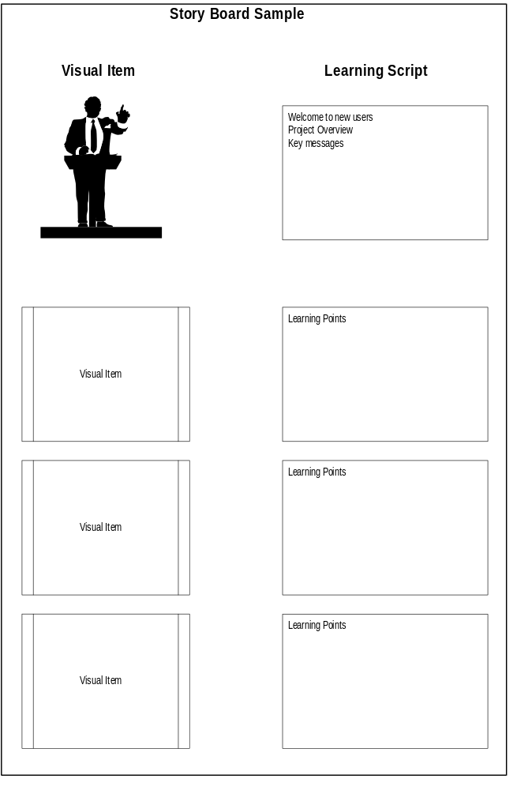

Learning Reinforcement, Reward, and Recognition Materials

Reinforcement Mechanisms
The following lists reinforcement materials:
Based on the agreed processes for reinforcement, develop customized materials to support the process. For example, you would include here the job aids, description of coaching programs and coaches, and desk manuals. List these here.

Learning Reward and Recognition Materials
The following lists learning reward and recognition materials:
Based on the agreed processes for reward and recognition, develop customized materials to support the process. For example, you would include here the communications used to inform users about the processes, a description of the programs, key contacts etc. List these here.

Measurement Materials
The following lists measurement materials:
Based on the agreed processes for measurement, develop customized materials to support the process. For example, you would include here the learner verification materials. List these here

Learning Administration Materials
This section contains the following materials used to administer delivery of the learning as defined in the Learning Plan (AP.140).

Schedule of Learning Events
This should be taken from the Learning Plan (AP140) and updated as required.
This following table outlines the schedule for learning events at <Company Long Name>.
Date | Job Role/Function | Event Title | Prerequisites | Location
10-Nov-99 | AP Clerk | Introduction to Financials | Navigation | Hill Building, Room 122
 |  | General Ledger | Introduction to Financials | Hill Building, Room 122

Learning Event Tracking Mechanism
The following tracks learning events:
Event Title | Date | Time | Location | Attendees | Evaluation Complete?

Learning Event Communication Template
The templates for learning communication can be found in Appendix B. The template should be used to invite client participants to <Company Long Name>’s learning events, including necessary instructions. Use the following table to determine the communication events and appropriate templates:

Template # | Target Audience/Role | Source | Channel | Date
1 | Senior Executives | Steering Committee | Video Conference | dd/mm/yy

Participation List
See Appendix C.

Contact Information
This section outlines the contact information for learning events at <Company Long Name>:

Learning Event Coordinator(s)/Contacts
The following provides details on the learning coordinators:
Use the following worksheet for contact information for learning event coordinators, both for the vendor and the client.
Site | Learning Coordinator | Address | Phone

Technical Contact Information
The following provides details on the technical contacts:
Use the following worksheet for technical contact information—vendor support and on-site client support that will be available.

Site | Technical Contact | Address | Phone #1 | Phone #2

Learning Agents Materials
Learning agents are those users and/or managers in <Company Long Name>, who were identified to support the deployment and delivery of the Learning Plan (AP.140). All materials developed to skill these agents and prepare them for their roles are presented here.

Learning Agents
The following provides detail information on the learning agents:
Use the following table to list the Learning Agents by role and name. An example is included in the first row.
Learning Agent Name | Role as Agent | Area of Responsibility | Type of Event | Preparation Required | Contact Information
John Doe | Facilitator | Financial Processes | Cross-functional workshops | Review Process maps  Attend Workshop Skills learning event | jdoe@organization.com

Agent Materials
Present all agent materials here. An example is provided for the Facilitator’s Guide.

Facilitator’s Guide
The following lists the sections selected for our facilitator guides:
For the Facilitator Guide, Rothwell and Kazanas recommend the following sections and content for a facilitator guide:
Section | Contents
Overview | Performance objectives  Module outline  Slide master list  Handout master list  Suggested learning time
Introduction | Description of learning needs assessment  Learning materials and aids  Delivery preparation checklist  Description of follow-up procedures  Questionnaire for follow-up
Related materials | A list of books, articles, videotapes, and other aids to be used in delivering the learning event
Lesson Plan for the Event | Lesson outline (points to be covered during the learning event)  Instructional notes (directions and information for the learning agent)
Slide masters | Master copies of any visuals from which slides can be made
Handout masters | Master copies of all handouts for the learning event
Following is a suggested template for the actual Facilitator’s Guide, with an example included.

Sample of Facilitator’s Guide
The following illustrates the format for our facilitator’s guide:
Segment | Introduction | Duration | 15 minutes
Objective | Introduce facilitator and orient participants to content for learning event. | Equipment: | Flip Chart Easel
Learning Aids | Introductions Flip Chart Page | Learning Strategy | Interactive
✪ | Direct participants’ attention to the flip chart page containing instructions for completing the tent cards for introductions.
Flip Chart Page 3 | Display Agenda flip chart page. Review the agenda for the module.
 | Refer participants to page 1 in their guides.  Review the objectives for the module.
Personal Notes

Open and Closed Issues for this Deliverable
Add open issues that you identify while writing or reviewing this document to the open issues section. As you resolve issues, move them to the closed issues section and keep the issue ID the same. Include an explanation of the resolution.
When this deliverable is complete, any open issues should be transferred to the project- or process-level Risk and Issue Log (PJM.CR.040) and managed using a project level Risk and Issue Form (PJM.CR.040). In addition, the open items should remain in the open issues section of this deliverable, but flagged in the resolution column as being transferred.

Open Issues

ID | Issue | Resolution | Responsibility | Target Date | Impact Date

Closed Issues

ID | Issue | Resolution | Responsibility | Target Date | Impact Date

Appendix A - Development Checklist
Use the following checklist to facilitate the design and development process for learningware:
- Have you developed and sequenced your learning objectives appropriately?
- Have you stated the performance objective(s) for the learning experience so as to clarify what is to be learned, how the learner can demonstrate the desired performance, and how performance will be judged?
- Have you explained the importance of the learning experience?
- Have you provided crucial background information that the learner must have to achieve the performance objectives?
- Have you demonstrated the behavior?
- Have you provided guided practice?
- Have you allowed for unguided practice?
- Have you provided mechanisms for evaluating the learner’s performance and knowledge base?
- Have you provided mechanisms for providing feedback and direction for future learning?
- Have you given yourself enough time to plan and test the instruction?
- Have you used a structured writing methodology to appropriately organize information?
- Have you determined how learners will use the learningware materials after the learning event concludes?
- Have you incorporated learning strategies that appeal to the different learning styles?
- Do you have an equal representation of visuals, activities, and self-assessments in each lesson?
- Have you conducted educational, editorial, and content soundness reviews?
- Have you tested the learningware materials to be sure they meet the desired learning outcomes?
- Have you developed a style guide to facilitate consistency in your materials?
- If you have a team working on the materials, have you created prototypes to facilitate consistency?

Appendix B - Communication Template
Tailor this template to invite the participants to the scheduled learning events.
You have been invited to attend the _________ <Learning Event Name> on <Learning Event Date> at <Location>.

Purpose of Learning Event
This learning event is designed to give participants knowledge of the new <Process Name> processes being introduced under the new <Project Name> and to provide an overview of the new <Specific Application> application systems that will be used.

Specific Objectives for the Event
By the end of this event, participants will be able to:
- Understand why the new <Process Name> processes are being introduced.
- Understand the impact of introducing the new <Process Name> processes on the working practices, roles and responsibilities of staff in the <Department Name> function.
- Recognize how <Company Long Name> specific <Function> practices will impact the new <Process Name> process.
- Understand the functionality of the new <Application Name> application systems being introduced under <Project Name>.
- Navigate around the new <Application Name> application system and generate high-level reports, for example <Report Name Examples>.
- Understand the new skills that will be required for staff to operate the new processes.

Event Details
The following details the learning events:
- Date:
- Location:
- Time:
- Length:
- Number of participants:
- Materials:
- Audience:
- Prerequisites:

Appendix C - Learning Event Participation List
The following table lists the people who participated in the learning event indicated:
Learning Event Name:  <Learning Event Name> | Learning Event Day:  <Learning Event Day (for example 1 of 3)> | Learning Event Date:  <Learning Event Date>
Learning Agent(s):  <Learning Agent Name> |  | Location:  <Location>

No. | Name | User ID | Title | Phone | Location

