AIM
BP.010 Business and Process Strategy
<Company Long Name>
<Subject>

Author: <Author>
Creation Date: May 11, 1999
Last Updated: May 28, 1999
Document Ref: <Document Reference Number>
Version: DRAFT 1A

Title, Subject, Last Updated Date, Reference Number, and Version are marked by a Word Bookmark so that they can be easily reproduced in the header and footer of documents. When you change any of these values, be careful not to accidentally delete the bookmark. You can make bookmarks visible by selecting Tools->Options…View and checking the Bookmarks option in the Show region.

Approvals:
<Approver 1>
<Approver 2>
To add additional approval lines, press [Tab] from the last cell in the table above.
You can delete any elements of this cover page that you do not need for your document. For example, Copy Number is only required if this is a controlled document and you need to track each copy that you distribute.
Copy Number _____

Document Control

Change Record
1
Date | Author | Version | Change Reference
11-May-99 | <Author> | Draft 1a | No Previous Document

Reviewers

Name | Position

Distribution

Copy No. | Name | Location
 | Library Master | Project Library
 |  | Project Manager
The copy numbers referenced above should be written into the Copy Number space on the cover of each distributed copy. If the document is not controlled, you can delete this table, the Note To Holders, and the Copy Number label from the cover page.

Note To Holders:
If you receive an electronic copy of this document and print it out, please write your name on the equivalent of the cover page, for document control purposes.
If you receive a hard copy of this document, please write your name on the front cover, for document control purposes.
Contents
Document Control
Introduction
High-Level Enterprise Model
Process Flow Diagram
Existing Organization and Roles
Mission Statement
Goals and Objectives
Business Drivers
Core Capabilities and Assessment
Critical Success Factors
Key Performance Indicators
Process Clusters, Sequence, and Dependency
Initial Change Assessment
Process Improvement Projects
<Improvement Project 1>
<Improvement Project N>
Business Strategy
Process Strategy
Preliminary Business Case
Open and Closed Issues for this Deliverable
Open Issues
Closed Issues

To update the table of contents, put the cursor anywhere in the table and press [F9]. To change the number of levels displayed, select the menu option Insert->Index and Tables, make sure the Table of Contents tab is active, and change the Number of Levels to a new value.

Introduction
Modify this list if any of the items have not been covered or if there are additional items.
The major sections of this document summarize the business and process strategy of <Company Long Name>. This records the strategy that will be used to improve business organization and refine the business processes. It addresses the following issues:
- key industry dynamics
- business objectives
- key opportunities
- analysis of the current situation
- key business issues
- current initiatives related to the proposed solution using Oracle Applications
- financial justification for the solution

High-Level Enterprise Model
Add additional text relevant to the client and the specific project.
The enterprise model provides a high-level view of the current processes of the <Subject of the Implementation>. It documents relevant information that will be used as a basis for the process improvement work to be carried out as part of the Business Process Architecture (BP) process of AIM.

Process Flow Diagram
Include a process flow diagram of the flows relevant to this project, at a very high level.
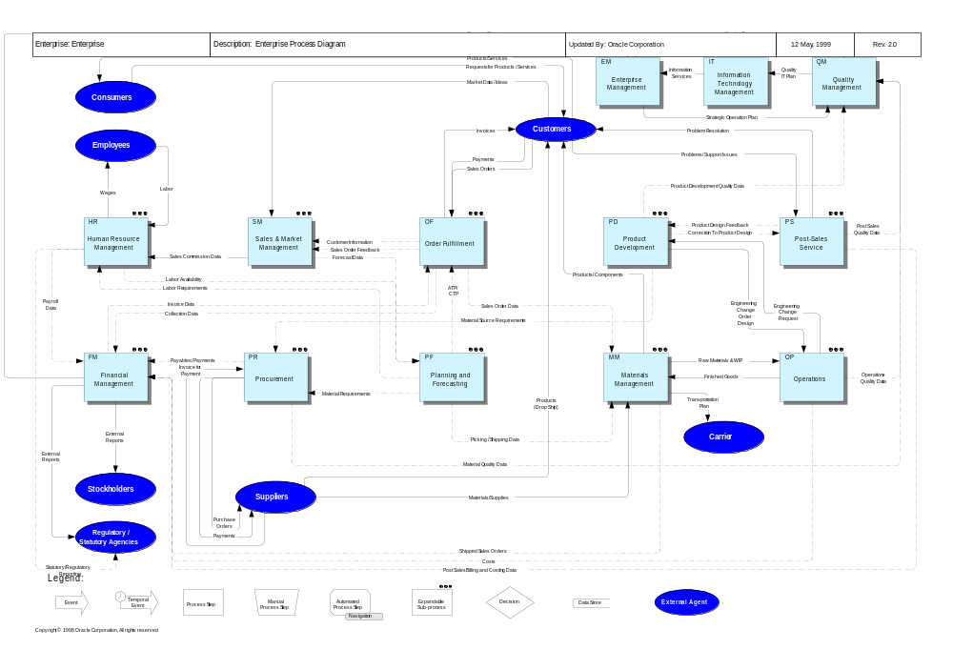

Existing Organization and Roles
Provide a description and diagram of the existing organization relevant to this project. Include a list of key roles relevant to the processes within the scope of this project.

Mission Statement
Provide the client’s current mission statement for the processes covered by this project. If no mission statement exists, it may be possible to help the client to develop one relevant to this project.

Goals and Objectives
Describe the goals and objectives of each business unit and business process within the scope of this project.

Business Drivers
Describe the business drivers for the processes within the scope of this project. Business drivers are the key influences on a business that determine its choices and behaviors.

Core Capabilities and Assessment
A “core capability” is defined as “a ranking, relative to best of breed, of those attributes that allow the business to survive, compete, and excel in its operations.” Provide a description of the client’s core capabilities - focus on the processes within the scope of this project. In addition, provide an assessment, done in conjunction with client staff, of those capabilities.

Critical Success Factors
A “critical success factor” is defined as “a business event, dependency, product, or other factor that, if not attained, would seriously impair the likelihood of achieving a business objective.” Provide a description of the CSFs relevant to the processes within the scope of this project.

Key Performance Indicators
A “key performance indicator (KPI)” is defined as “a significant measure used on its own, or in combination with other key performance indicators, to monitor how well a business is achieving its quantifiable objectives.” Provide a list of current KPIs used to measure the performance of the client’s business, along with their current values.

Process Clusters, Sequence, and Dependency
List the process clusters relevant to <Subject of the Implementation> and provide the rationale for grouping process components into these clusters, focusing on common elements between components.
As a general rule, processes should be clustered when they are strongly interconnected and when changes to one of these processes has a significant impact on the others in the cluster.
In addition, indicate where there are interactions between process clusters and how these interactions will be contained during the project.

Initial Change Assessment
Document findings made during work and analysis sessions base on the high-level vision of the change implications.
The initial change assessment provides a high-level view of the implications, in terms of changes on cost, business performance, and working practices of the <Subject of the Implementation>.

Work

People

Organizational Structure

Organizational Culture

Physical Layout

Process Improvement Projects
List the process improvement projects that will be carried out as part of the project. Relate each project to the process clusters identified in the previous chapter. For each project, describe the following.
This section of the document lists all of the existing process improvement projects of <Company Long Name>.

<Improvement Project 1>
Describe this in terms of process clusters.

Scope

If the program of process improvement projects has been planned, describe the sequence of these projects and the place of this project. Also describe any dependencies on other process improvement/reengineering projects and organization change initiatives.

Sequence and Dependency

Provide the expected duration of the phase within the AIM project where this improvement project will be carried out.

Expected Duration

List the main objectives for the phase within the AIM project where this improvement project will be carried out.

Chief Objectives for the Project Phase

List the stakeholders in the process improvement project - the key members of the client’s staff and the project team that will be involved in the improvement project.

Potential Team Constituency

<Improvement Project N>
Repeat for each improvement project.

Business Strategy
The strategy outlines the recommended business change programs which will best address identified opportunities, and identifies the business processes to concentrate on (for example, those that will contribute most to achieving the organization’s vision).
If a business strategy has already been prepared prior to this task, summarize it in this component. Also discuss proposed and current initiatives related to the proposed solution using Oracle Applications.
The business strategy document the actions for strengthening <Company Long Name>’s competitive position, satisfying customers, and achieving performance targets.

Process Strategy
This will probably include an evaluation of existing processes and the directions that the organization intends to take in improving them. It may also include key process measures and goals for their improvement.
The process strategy focus on <Company Long Name>’s strategy for improving its business processes and aligning them with the applications to be implemented.

Preliminary Business Case
The preliminary business case provides a business case to justify the business and process strategy at a high-level.
Normally, a cost-benefit analysis will be included to justify the proposed investment.

If a Solution Value Assessment (SVA) was carried out prior to the project, make use of the financial justification resulting from that work. The following shows a sample financial analysis from an SVA.

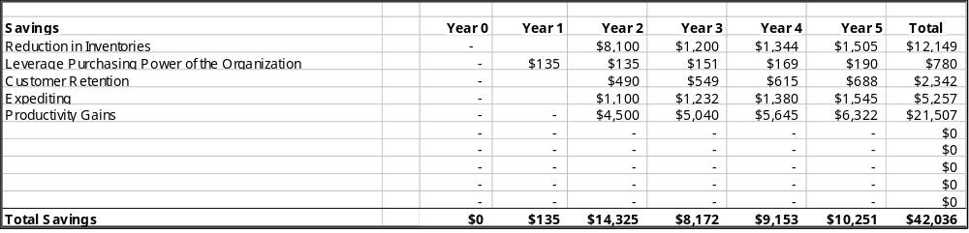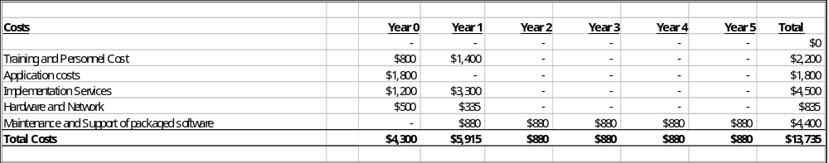
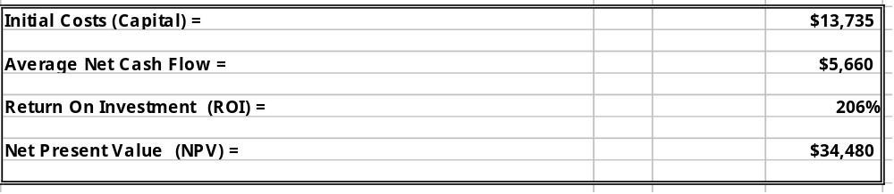

S A M P L E

Open and Closed Issues for this Deliverable
Add open issues that you identify while writing or reviewing this document to the open issues section. As you resolve issues, move them to the closed issues section and keep the issue ID the same. Include an explanation of the resolution.
When this deliverable is complete, any open issues should be transferred to the project- or process-level Risk and Issue Log (PJM.CR.040) and managed using a Project Level Risk and Issue Form (PJM.CR.040). In addition, the open items should remain in the open issues section of this deliverable, but flagged in the resolution column as being transferred.

Open Issues
ID | Issue | Resolution | Responsibility | Target Date | Impact Date

Closed Issues
ID | Issue | Resolution | Responsibility | Target Date | Impact Date

