AIM
BP.040 Current Process Model
<Company Long Name>
<Subject>

Author: <Author>
Creation Date: May 1, 1999
Last Updated: May 28, 1999
Document Ref: <Document Reference Number>
Version: DRAFT 1A

Title, Subject, Last Updated Date, Reference Number, and Version are marked by a Word Bookmark so that they can be easily reproduced in the header and footer of documents. When you change any of these values, be careful not to accidentally delete the bookmark. You can make bookmarks visible by selecting Tools->Options…View and checking the Bookmarks option in the Show region.

Approvals:
<Approver 1>
<Approver 2>
To add additional approval lines, press [Tab] from the last cell in the table above.
You can delete any elements of this cover page that you do not need for your document. For example, Copy Number is only required if this is a controlled document and you need to track each copy that you distribute.
Copy Number _____

Document Control

Change Record
8
Date | Author | Version | Change Reference
1-May-99 | <Author> | Draft 1a | No Previous Document

Reviewers

Name | Position

Distribution

Copy No. | Name | Location
 | Library Master | Project Library
 |  | Project Manager
The copy numbers referenced above should be written into the Copy Number space on the cover of each distributed copy. If the document is not controlled, you can delete this table, the Note To Holders, and the Copy Number label from the cover page.

Note To Holders:
If you receive an electronic copy of this document and print it out, please write your name on the equivalent of the cover page, for document control purposes.
If you receive a hard copy of this document, please write your name on the front cover, for document control purposes.
Contents
Document Control
Enterprise Process Model
Core Process Models
Process Flow Diagrams
Event Catalog
Descriptive Overview for <High-Level Business Function>
Event Catalog for <High-Level Business Function>
Process Descriptions for <High-Level Business Function>
Process Relationships for <High-Level Business Function>
Performance Measures
Open and Closed Issues for this Deliverable
Open Issues
Closed Issues

To update the table of contents, put the cursor anywhere in the table and press [F9]. To change the number of levels displayed, select the menu option Insert->Index and Tables, make sure the Table of Contents tab is active, and change the Number of Levels to a new value.

Enterprise Process Model
Prepare a high-level context diagram showing the major business process areas or core processes, and the information flows between them.
If you have carried out the Define Business and Process Strategy (BP.010) task, then reuse the enterprise process model diagram from that task, for this component.
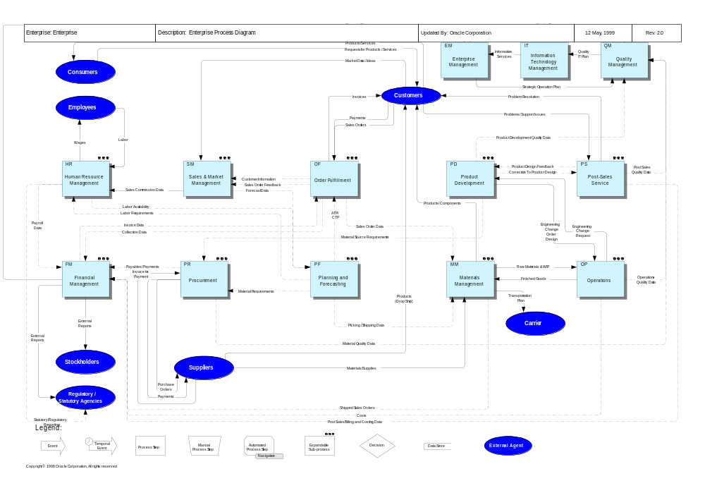

Core Process Models
Construct a process flow model showing the activities in the process for each core process, as identified in the enterprise model.
Use application-supported process flows, such as Oracle Business Models (OBM), as a starting point for creating the current core process flow diagrams.

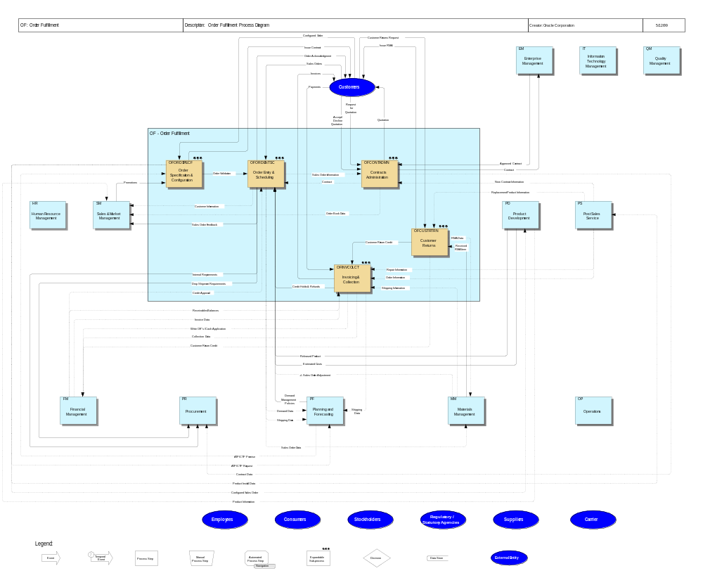

Process Flow Diagrams
Use solution sets and process models for Oracle Applications, such as Oracle Business Models (OBM), as a focal point to stimulate discussion of the organization’s current business processes. Modify them as required to reflect the organization’s view of their current business and their operations.
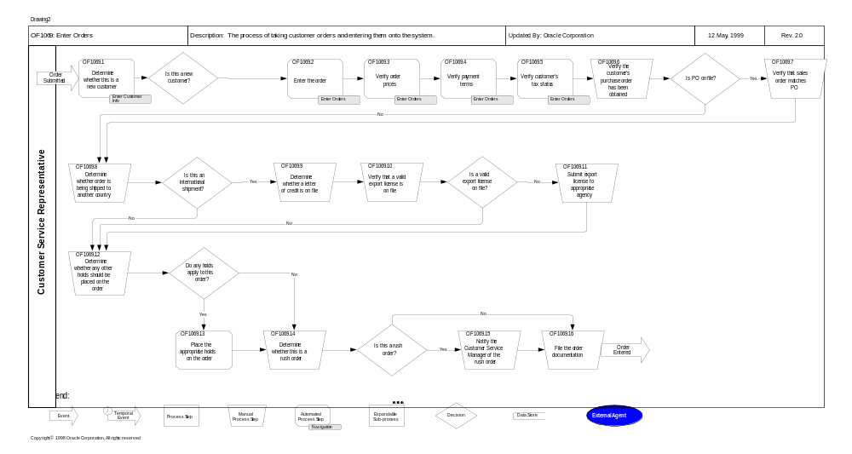

Event Catalog
This component describes each of the high-level business functions and the processes that it performs. Each business function contains the following sections:
- descriptive overview
- event catalog
- process descriptions
- process relationship

Descriptive Overview for <High-Level Business Function>
<Enter a descriptive overview of the functions performed by this business area.>

Event Catalog for <High-Level Business Function>
The event catalog is used to record all events that the business function responds to.
An example of an event is a customer order. In responding to the customer, order the business executes a process.
Fill out the following information for each event that is identified:
Event: An occurrence in a business’s environment to which that business must respond.
ID: Give each event a unique identification.
Name: Name each event as clearly as possible.
Type: Events may be external, internal, or temporal (for example, occur at a predetermined time).
Description: Briefly describe the event.
Responding Process: The sequential execution of functions triggered by one or more events.
It is conceivable that a process could be the response to multiple business events.

Event | ID | Name | Type | Description | Responding Process

Process Descriptions for <High-Level Business Function>
<Enter a description for each of the processes within this business function.>
Process ID. | Event | Process Title | Description of Process | Output

Process Relationships for <High-Level Business Function>
<Enter a description of the relationships between the various processes.>

Performance Measures
This section lists the performance measures used to measure current process performance for each core process.
Core Process | Measure Area | Current Measure | Description
Materials Management | Quality | 85 | % “Perfect Orders”
Materials Management | Quality | 900 | # of Invoice Adjustments Due to Inaccurate Deliveries
Materials Management | Quality | 3 | % Handling Damage
Materials Management | Quality | 100 | # of RMAs due to improper picking/shipping
Materials Management | Quality | 89 | % Cycle Count Accuracy

Open and Closed Issues for this Deliverable
Add open issues that you identify while writing or reviewing this document to the open issues section. As you resolve issues, move them to the closed issues section and keep the issue ID the same. Include an explanation of the resolution.
When this deliverable is complete, any open issues should be transferred to the project- or process-level Risk and Issue Log (PJM.CR.040) and managed using a project level Risk and Issue Form (PJM.CR.040). In addition, the open items should remain in the open issues section of this deliverable, but flagged in the resolution column as being transferred.

Open Issues
ID | Issue | Resolution | Responsibility | Target Date | Impact Date

Closed Issues
ID | Issue | Resolution | Responsibility | Target Date | Impact Date

