AIM
BP.070 High-Level Process Designs
<Company Long Name>
<Subject>

Author: <Author>
Creation Date: February 12, 1999
Last Updated: August 19, 1999
Document Ref: <Document Reference Number>
Version: DRAFT 1A

Title, Subject, Last Updated Date, Reference Number, and Version are marked by a Word Bookmark so that they can be easily reproduced in the header and footer of documents. When you change any of these values, be careful not to accidentally delete the bookmark. You can make bookmarks visible by selecting Tools->Options…View and checking the Bookmarks option in the Show region.

Approvals:
<Approver 1>
<Approver 2>
To add additional approval lines, press [Tab] from the last cell in the table above.
You can delete any elements of this cover page that you do not need for your document. For example, Copy Number is only required if this is a controlled document and you need to track each copy that you distribute.
Copy Number _____

Document Control

Change Record
1
Date | Author | Version | Change Reference
12-Feb-99 | <Author> | Draft 1a | No Previous Document

Reviewers

Name | Position

Distribution

Copy No. | Name | Location
 | Library Master | Project Library
 |  | Project Manager
The copy numbers referenced above should be written into the Copy Number space on the cover of each distributed copy. If the document is not controlled, you can delete this table, the Note To Holders, and the Copy Number label from the cover page.

Note To Holders:
If you receive an electronic copy of this document and print it out, please write your name on the equivalent of the cover page, for document control purposes.
If you receive a hard copy of this document, please write your name on the front cover, for document control purposes.
Contents
Document Control
Generic Process Designs
Event Catalog
Process Descriptions
Process Step Catalog
Process Flow Diagram
Open and Closed Issues for this Deliverable
Open Issues
Closed Issues

To update the table of contents, put the cursor anywhere in the table and press [F9]. To change the number of levels displayed, select the menu option Insert->Index and Tables, make sure the Table of Contents tab is active, and change the Number of Levels to a new value.

Generic Process Designs
Modify the introduction to match what was actually done in the task and will be included in this deliverable. The following is a sample introduction.
This document consists of the high-level design the new organization will operate after the systems are implemented in this project. The High-Level Process Designs takes into account the costs, benefits, and risks of changing the application as well as the processes.
The High-Level Process Designs included in this document are generic and intended to apply across the whole of the organization. Designs for variants, such as business units or departments, will be produced in a later deliverable, the Future Process Model (BP.080). The generic process model explains in high-level terms how work will flow in the future and who will be responsible for completing the activities. It is composed of the following components:
- Event Catalog—Lists significant events to which the business responds and which are within scope of the process designs.
- Process Descriptions—A high-level, textual description of the process that is executed in response to each event, together with an identification of the process’ main inputs and outputs.
- Process Step Catalog—The main process steps that make up the process. Each step should have a brief, descriptive title. The agent responsible for the execution of each step is also recorded.
- Process Flow Diagram—A description of the high-level design in graphical form.

Event Catalog
List the significant events to which the business responds and that are within scope of the process designs.
The following events are considered significant and are expected to have an impact on this process:

Process Descriptions
Provide a high-level, textual description of the process that is executed in response to each event in the previous chapter, together with an identification of the process’ main inputs and outputs.
No. | Event | Description of the Response to the Event | Inputs | Outputs

Process Step Catalog
Describe the main process steps that make up the process. Each step should have a brief, descriptive title. The agent responsible for the execution of each step is also recorded.

No. | Step Title | Description of the Step | Agent Responsible for Execution

Process Flow Diagram
Provide a description of the high-level design in graphical form. This could be in the format of an OBM diagram. It may have been produced during a visioning workshop as a modification from one or more of the standard OBM models.
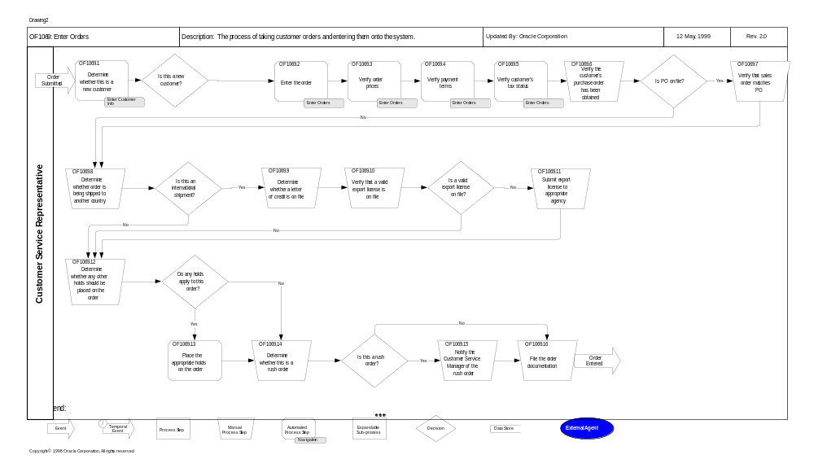

Open and Closed Issues for this Deliverable
Add open issues that you identify while writing or reviewing this document to the open issues section. As you resolve issues, move them to the closed issues section and keep the issue ID the same. Include an explanation of the resolution.
When this deliverable is complete, any open issues should be transferred to the project- or process-level Risk and Issue Log (PJM.CR.040) and managed using a project level Risk and Issue Form (PJM.CR.040). In addition, the open items should remain in the open issues section of this deliverable, but flagged in the resolution column as being transferred.

Open Issues

ID | Issue | Resolution | Responsibility | Target Date | Impact Date

Closed Issues

ID | Issue | Resolution | Responsibility | Target Date | Impact Date

