AIM
BP.080 Future Process Model
<Company Long Name>
<Subject>

Author: <Author>
Creation Date: February 12, 1999
Last Updated: May 28, 1999
Document Ref: <Document Reference Number>
Version: DRAFT 1A

Title, Subject, Last Updated Date, Reference Number, and Version are marked by a Word Bookmark so that they can be easily reproduced in the header and footer of documents. When you change any of these values, be careful not to accidentally delete the bookmark. You can make bookmarks visible by selecting Tools->Options…View and checking the Bookmarks option in the Show region.

Approvals:
<Approver 1>
<Approver 2>
To add additional approval lines, press [Tab] from the last cell in the table above.
You can delete any elements of this cover page that you do not need for your document. For example, Copy Number is only required if this is a controlled document and you need to track each copy that you distribute.
Copy Number _____

Document Control

Change Record
1
Date | Author | Version | Change Reference
12-Feb-99 | <Author> | Draft 1a | No Previous Document

Reviewers

Name | Position

Distribution

Copy No. | Name | Location
 | Library Master | Project Library
 |  | Project Manager
The copy numbers referenced above should be written into the Copy Number space on the cover of each distributed copy. If the document is not controlled, you can delete this table, the Note To Holders, and the Copy Number label from the cover page.

Note To Holders:
If you receive an electronic copy of this document and print it out, please write your name on the equivalent of the cover page, for document control purposes.
If you receive a hard copy of this document, please write your name on the front cover, for document control purposes.
Contents
Document Control
Event Catalog
<High-Level Business Function>
Process Listing and Process Descriptions
<High-Level Business Function>
Process Relationships for <High-Level Business Function>
Function Hierarchy
<High-Level Business Function>
Process Step Catalogs
<Process Name>
Process Flow Diagrams
To-Be Activities
Open and Closed Issues for this Deliverable
Open Issues
Closed Issues

To update the table of contents, put the cursor anywhere in the table and press [F9]. To change the number of levels displayed, select the menu option Insert->Index and Tables, make sure the Table of Contents tab is active, and change the Number of Levels to a new value.

Event Catalog
An example of an event is a customer order. In responding to the customer order the business executes a process. Fill out the following information for each event that is identified:
Event ID: Give each event a unique identification.
Name: Name each event as clearly as possible.
Type: Events may be external, internal or temporal (for example, occur at a predetermined time).
Description: Briefly describe the event.
Frequency: Indicate frequency; for example, 10/hour, 1/week, or monthly.
The events here may be the same ones identified earlier during the Current Process Model (BP.040). If so, use the event catalog developed there. There may be new events that will need to be responded to based on future business strategies, or there may be new internal events that trigger a process to respond.
This component lists all events to which the business responds.

<High-Level Business Function>
Event ID | Name | Type | Description | Frequency

Process Listing and Process Descriptions
Enter a description for each of the processes within this business function.

<High-Level Business Function>
Process ID | Event | Process Title | Description of Process | Output

Process Relationships for <High-Level Business Function>
Enter a description of the relationships between the various processes.

Function Hierarchy

<Company Short Name>  Function: <Function Name> | Function Owner:  <Function Owner> | Date:  <Date>
Description:
<Function Description>

<High-Level Business Function>
Use one row per business function. Follow these guidelines in using the columns:
1) Function ID #: A unique sequence number for each elementary business function.
An elementary business function is a business function which, if started, must either complete successfully or, if it cannot complete successfully, must undo any effects that it has had up to the point of failure; it is the lowest available unit of work or task; it corresponds to a process step in a business process.
2) Function Description: A brief description, beginning with an action verb, that captures the functions purpose and deliverable task (note: each task should have one deliverable).
3) Function/Owner: Title of person executing the function.
4) Type: A combination of Manual or System-Assisted, and Internal or External.
5) Note: Additional relevant information about the function.

Function  ID # | Function Description | Function Owner | Type | Notes

Process Step Catalogs

<Process Name>
The process step catalogue identifies the process steps that make up the business process.
It is optional to perform this step here; when the Gather Business Requirements (RD. 050) are constructed you will also be developing process steps for each process.
ID: Supply a process step ID. Think about a systematic way for numbering processes and process steps. It might make sense to build significance into the process ID; for example, BM 01 might represent the first step in the Bill of Material process.
Description: Record the process step as clearly as possible. If possible, use a simple verb noun format, but do not hesitate to add information for clarity. For example, answer phone, record (order) information and so on.
Frequency: State the frequency that the process step occurs; hourly, weekly, every other order, every third piece, and so on.
Notes: Record notes as appropriate to clarify the nature of the step or record any issues which it raises. It is possible to “key word” notes in order to later retrieve all notes with the same key word.
Agent: Identify the party who is responsible for the execution and completion of the step.
Automation: Identify whether the step is manual or system-assisted.
ID | Description | Frequency | Notes | Agent | Automation

Process Flow Diagrams
Provide a diagram for any process with conditional steps or more than two steps.
You can use application-supported process flows, such as those provided in Oracle Business Models as a starting point for creating the future process flow diagrams. You can then augment these process steps by adding the process steps required by the organization to support their unique processes.

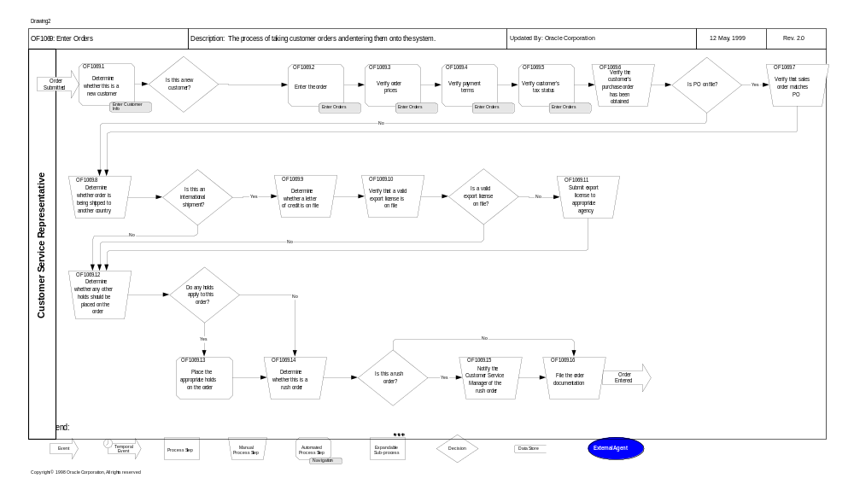

To-Be Activities
Where there are variants of a generic process, corresponding variants of activities must also be described for each process flow.

This component provides details of the activities to be carried out as part of the process flow.

Open and Closed Issues for this Deliverable
Add open issues that you identify while writing or reviewing this document to the open issues section. As you resolve issues, move them to the closed issues section and keep the issue ID the same. Include an explanation of the resolution.
When this deliverable is complete, any open issues should be transferred to the project- or process-level Risk and Issue Log (PJM.CR.040) and managed using a project-level Risk and Issue Form (PJM.CR.040). In addition, the open items should remain in the open issues section of this deliverable, but flagged in the resolution column as being transferred.

Open Issues

ID | Issue | Resolution | Responsibility | Target Date | Impact Date

Closed Issues

ID | Issue | Resolution | Responsibility | Target Date | Impact Date

