AIM
BR.050 Integration Fit Analysis
<Company Long Name>
<Subject>

Author: <Author>
Creation Date: May 4, 1999
Last Updated: June 2, 1999
Document Ref: <Document Reference Number>
Version: DRAFT 1A

Title, Subject, Last Updated Date, Reference Number, and Version are marked by a Word Bookmark so that they can be easily reproduced in the header and footer of documents. When you change any of these values, be careful not to accidentally delete the bookmark. You can make bookmarks visible by selecting Tools->Options…View and checking the Bookmarks option in the Show region.

Approvals:
<Approver 1>
<Approver 2>
To add additional approval lines, press [Tab] from the last cell in the table above.
You can delete any elements of this cover page that you do not need for your document. For example, Copy Number is only required if this is a controlled document and you need to track each copy that you distribute.
Copy Number _____

Document Control

Change Record
4
Date | Author | Version | Change Reference
4-May-99 | <Author> | Draft 1a | No Previous Document

Reviewers

Name | Position

Distribution

Copy No. | Name | Location
 | Library Master | Project Library
 |  | Project Manager
The copy numbers referenced above should be written into the Copy Number space on the cover of each distributed copy. If the document is not controlled, you can delete this table, the Note To Holders, and the Copy Number label from the cover page.

Note To Holders:
If you receive an electronic copy of this document and print it out, please write your name on the equivalent of the cover page, for document control purposes.
If you receive a hard copy of this document, please write your name on the front cover, for document control purposes.
Contents
Document Control
Introduction
Purpose
Scope and Application
Related Documents
Application Replacement Mapping
External Integration Point Replacement Mapping
External Integration Point Diagram
Distributed Data (Internal) Integration Points
Distributed Data (Internal) Integration Point Diagram
Open and Closed Issues for this Deliverable
Open Issues
Closed Issues

To update the table of contents, put the cursor anywhere in the table and press [F9]. To change the number of levels displayed, select the menu option Insert->Index and Tables, make sure the Table of Contents tab is active, and change the Number of Levels to a new value.

Introduction

Purpose
The purpose of the Integration Fit Analysis document is to document the integration fit analysis of the existing system to the projected new system. This document identifies how the existing integration points (interfaces) evolve in the new system. This deliverable is part of the Business Requirements Mapping process of version 3.0 of the Application Implementation Method (AIM).
The purpose of this document is to provide the project team a single reference for:
- Integration points between heterogeneous applications in the new system.
- Integration points between distributed data installations of Oracle Applications™ in the new system.
- Supported application interface points available for implementation of the identified integration points as automated interfaces.

Scope and Application
The division of integration points into external and distributed data (internal) is to some extent arbitrary, since you may view integration of two heterogeneous applications as a distributed data system. The point is to segregate those integration points between heterogeneous applications. We do this by separating those where there is a clean hand-off of processing (and which usually end up as batch interfaces) from those which provide the integration of separate core processing financial/ERP installations. This second type often includes more complex data transfer and synchronization requirements.
If the current implementation project is one phase of a multi-phase roll-out of applications, make sure you document which phase or phases of the roll-out this analysis is valid for. Remember, the integration fit analysis will vary as we replace applications in the existing system. If you need to, include analyses for the different rollout phases.
This deliverable covers the following types of integration points:
- External integration points. These are integration points between heterogeneous applications and cover:
- Integration between a retained legacy application and a new application.
For example: existing retained ADP Payroll to newly implemented Oracle General Ledger.
- Integration between two newly implemented heterogeneous applications.
For example: newly implemented Manugistics to newly implemented Oracle Purchasing.
- Distributed data integration points. These are integration points between separate installations of the same application or application suite:
For example: newly implemented Oracle General Ledger in the Corporate data center to newly implemented Oracle General Ledger in a regional data center.

Related Documents
The following are key documents related to the present deliverable:

TA.020 - Current Technical Architecture Baseline
The Current Technical Architecture Baseline deliverable provides key input to this deliverable about the nature and details of the existing technical infrastructure including applications, databases, interfaces, hardware, and networks.

TA.130 - Application Deployment Plan
The Application Deployment Plan deliverable provides key input to this deliverable.

BR.060 - Information Model
The Information Model deliverable builds upon the Integration Fit Analysis deliverable. The Information Flow Model further identifies key information flows across the integration points within the new system, and between retained components of the existing system and the new system.

Application Replacement Mapping
Perform the approximate replacement mapping of the applications below. If developed in-house, the vendor of the existing application is the internal organization that developed the application, usually the IS organization. If you wish to create a complete list of the application mapping, you should include the non-replaced applications, with a status of Retained.
The intention of this analysis of replaced and retained applications is not to replace the rigorous analysis of application usage derived from mapping the business processes (as BRSs) onto system application functions and modules.
This section describes the approximate replacement mapping of existing to new applications.

Existing |  | Replacement
Application | Vendor | Application | Vendor
MANMAN/GL | ASK | General Ledger | Oracle
MANMAN/AP | ASK | AP | Oracle
Payroll | ADP | *Retained*

External Integration Point Replacement Mapping
In the following table, if an existing integration point (interface) is going to need replacement with another integration point between applications, designate the integration point as Replace. If you designate Subsume, this implies that application functions once performed on either side of an application interface are now contained within a single application in the new system. In some cases, it designates that we no longer need the functions in the new system. If the integration point is New, it has no counterpart in the existing system. The suggestion is that you only draw a distinction between application modules in the same suite where a vendor-supported interface does not exist. For example Oracle OE and AR have a supported interface point so that you would not need to highlight whether the existing applications map onto OE or AR - merely, that they map onto Oracle Applications. It depends on the level of detail you wish to include in your analysis. Documenting all the interface points in a complex ERP suite of applications like Oracle Applications would require a lot of work.
This section describes the integration points of the new application system. The documented details of the existing external interfaces in <Company Short Name>’s technical architecture are in the Current Technical Architecture Baseline (TA.020). The analysis also identifies supported interface points (a.k.a. Application Programmatic Interfaces or APIs) in the applications available for utilization in the implementation of any new automated interface needed to support the integration.

Existing Integration Point |  |  | Replacement Integration Point
Application 1 | Application 2 | New/ Replace/ Subsume | Application 1 | Application 2 | Supported Application Interface Points?
ADP Payroll | MANMAN/GL | Replace | ADP Payroll | Oracle GL | Oracle: Journal Import Open I/F
Key: New - Integration point that has no counterpart in the existing system
Replace - Integration point that has a direct counterpart in the new system
Subsume - Existing integration point no longer required in the new system

External Integration Point Diagram
Diagrams should be a mandatory component of this deliverable. They are the best means to convey the future application map (and new interfaces required). The standards and the complexity of the implementation you are working on will affect this diagram.
The following is a diagram of the integration points in the new <Company Short Name> business system:
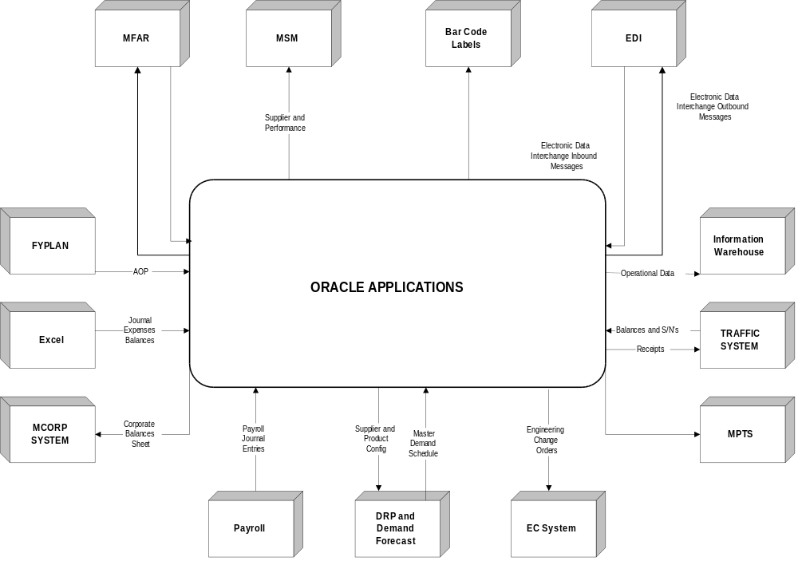

Distributed Data (Internal) Integration Points
This section applies specifically to the new integration points that will need support between the distributed Oracle Applications databases in the new architecture.

Application 1 | Data Center 1 | Application 2 | Data Center 2 | Supported Application Interface Points?
Oracle GL | Corporate | Oracle GL | West Region Financial | Journal Import  Budget Upload
Oracle GL | Corporate | Oracle GL | East Region Financial | Journal Import  Budget Upload

Distributed Data (Internal) Integration Point Diagram
The intention of the sample diagram included here is to provide a very simple example. You may enhance the diagram in many ways. For instance color coding the classification of the applications into Financial, HR, Distribution, or MFG. The standards and the complexity of the implementation you are working on will affect this diagram.
The following is a diagram of the distributed data integration points in the new <Company Short Name> business system:

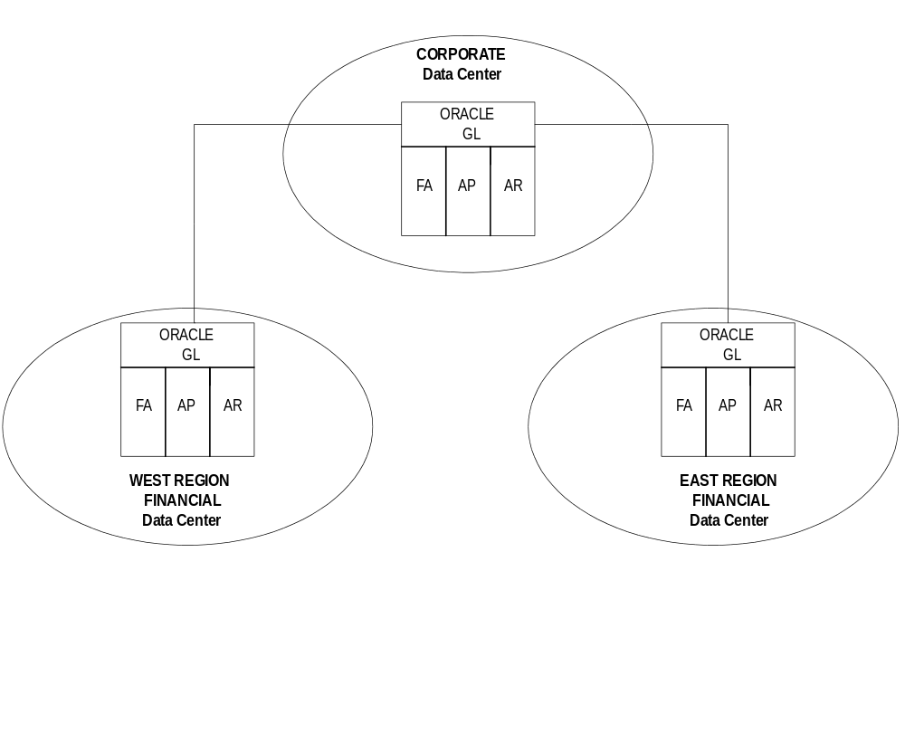

Open and Closed Issues for this Deliverable
Add open issues that you identify while writing or reviewing this document to the open issues section. As you resolve issues, move them to the closed issues section and keep the issue ID the same. Include an explanation of the resolution.
When this deliverable is complete, any open issues should be transferred to the project- or process-level Risk and Issue Log (PJM.CR.040) and managed using a project level Risk and Issue Form (PJM.CR.040). In addition, the open items should remain in the open issues section of this deliverable, but flagged in the resolution column as being transferred.

Open Issues

ID | Issue | Resolution | Responsibility | Target Date | Impact Date

Closed Issues

ID | Issue | Resolution | Responsibility | Target Date | Impact Date

