AIM
BR.060 Information Model
<Company Long Name>
<Subject>

Author: <Author>
Creation Date: May 5, 1999
Last Updated: June 2, 1999
Document Ref: <Document Reference Number>
Version: DRAFT 1A

Title, Subject, Last Updated Date, Reference Number, and Version are marked by a Word Bookmark so that they can be easily reproduced in the header and footer of documents. When you change any of these values, be careful not to accidentally delete the bookmark. You can make bookmarks visible by selecting Tools->Options…View and checking the Bookmarks option in the Show region.

Approvals:
<Approver 1>
<Approver 2>
To add additional approval lines, press [Tab] from the last cell in the table above.
You can delete any elements of this cover page that you do not need for your document. For example, Copy Number is only required if this is a controlled document and you need to track each copy that you distribute.
Copy Number _____

Document Control

Change Record
4
Date | Author | Version | Change Reference
5-May-99 | <Author> | Draft 1a | No Previous Document

Reviewers

Name | Position

Distribution

Copy No. | Name | Location
 | Library Master | Project Library
 |  | Project Manager
The copy numbers referenced above should be written into the Copy Number space on the cover of each distributed copy. If the document is not controlled, you can delete this table, the Note To Holders, and the Copy Number label from the cover page.

Note To Holders:
If you receive an electronic copy of this document and print it out, please write your name on the equivalent of the cover page, for document control purposes.
If you receive a hard copy of this document, please write your name on the front cover, for document control purposes.
Contents
Document Control
Information Flow Between Business Organizations
Cross-Business Organization Information Flow Diagrams
Information Flow Between Applications
Cross-Application Flows
Cross-Application Information Flow Diagrams
Information Flows Across Data Centers (Installations)
Cross-Data Center Information Flow Diagrams
Business Organizations
Security Policies and Requirements
Security Policies
Security Policies and Requirements
Organizational Information Access Analysis
Inter-Organizational Information Access Analysis
Open and Closed Issues for this Deliverable
Open Issues
Closed Issues

To update the table of contents, put the cursor anywhere in the table and press [F9]. To change the number of levels displayed, select the menu option Insert->Index and Tables, make sure the Table of Contents tab is active, and change the Number of Levels to a new value.

Information Flow Between Business Organizations
Specific rules to determine which cross-organization flows you include will depend on the scope and complexity of the implementation. If there are particularly complex areas of the business model that would benefit from the information flow treatment and help clarify the overall process, you should include them here. Each entry in the table describes an information flow between business organizations. If the flow includes the transfer of multiple business objects, you should document each object.
This section describes the information flows between key business organizations.
Selection of the specific cross-business organization flows was subject to the following rules:
- Information flows that cross business organizations in the supply-chain business process
- Information flows that cross business organizations in the order-to-fulfillment business process
- <Add any other criteria here>

Process | Source Business Organization | Destination Business Organization | Business Object Transferred | Information Medium | Event | Frequency | Projected Volume

Cross-Business Organization Information Flow Diagrams
Included below are a few very simple example diagrams. Replace with diagrams relevant to the business processes that are critical to your implementation.
Included are diagrams for the following cross-organizational business processes as information flows:
General Ledger Period Close
- Manufacturing and Distribution
- <Add any other business processes here>

General Ledger Period Close
The diagram below shows the information flows between the finance organizations for the period close process.

To edit the Visio diagram shown below, right-click on the diagram and select the edit option from the pop-up menu.

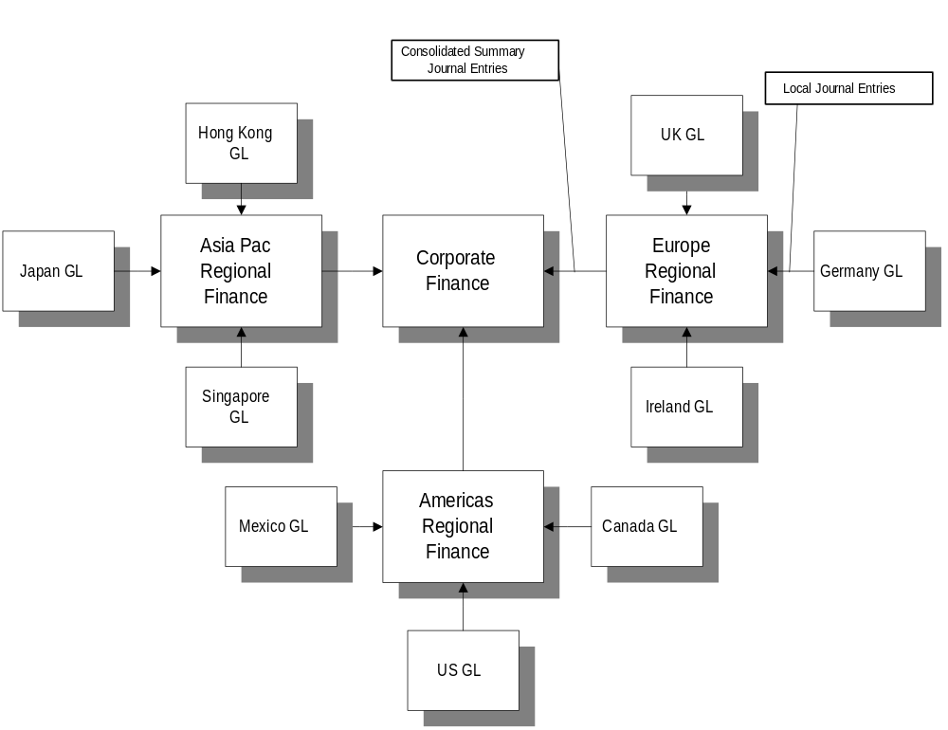

Manufacturing and Distribution
The diagram below shows the information flows between the supply chain organizations for the order fulfillment process.
To edit the Visio diagram shown below, right-click on the diagram and select the edit option from the pop-up menu.

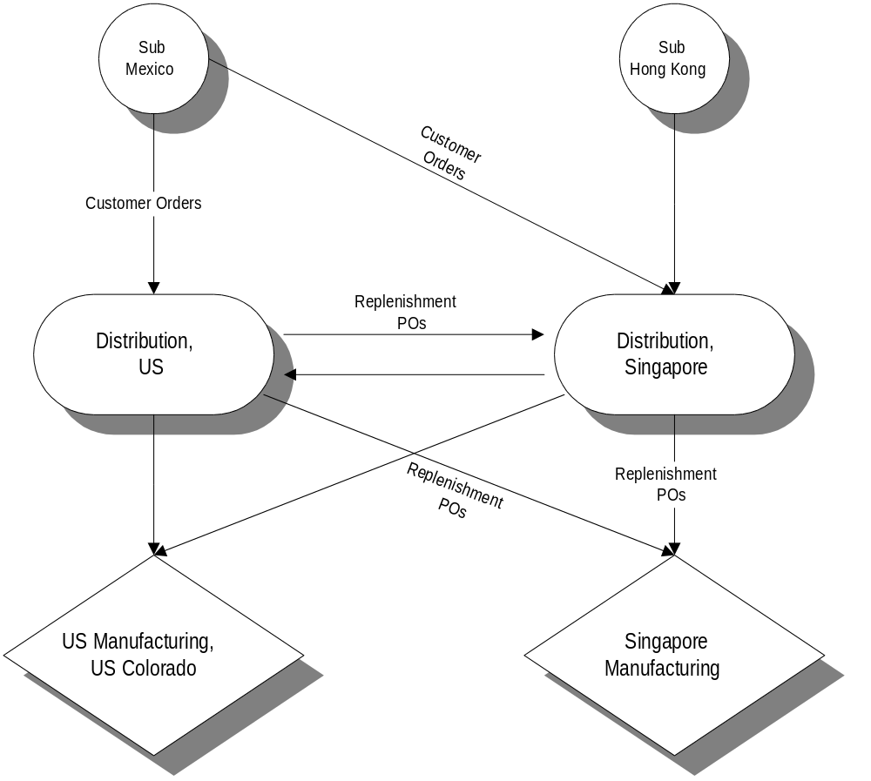
To edit the PowerPoint diagram shown below, right-click on the diagram and select the edit option from the pop-up menu.
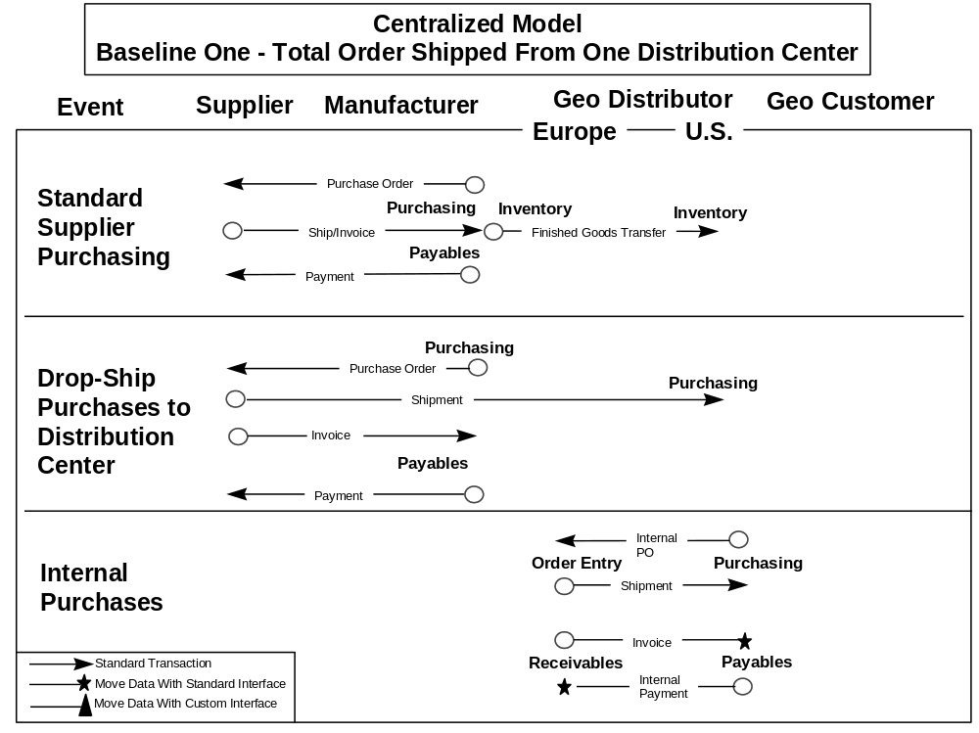

Information Flow Between Applications

Cross-Application Flows
This section is an important part of the requirements gathering for development of new system interfaces.
This section describes the information flows between different business applications.
Selection of the specific cross-business function flows was subject to the following rules:
- All information flows that flow across the external application integration points
- <Add any other criteria here>

Process | Source Application | Destination Application | Business Objects Transferred | Information Medium | Event | Frequency | Projected Volume

Cross-Application Information Flow Diagrams
To edit the Visio diagram shown below, right-click on the diagram and select the edit option from the pop-up menu.

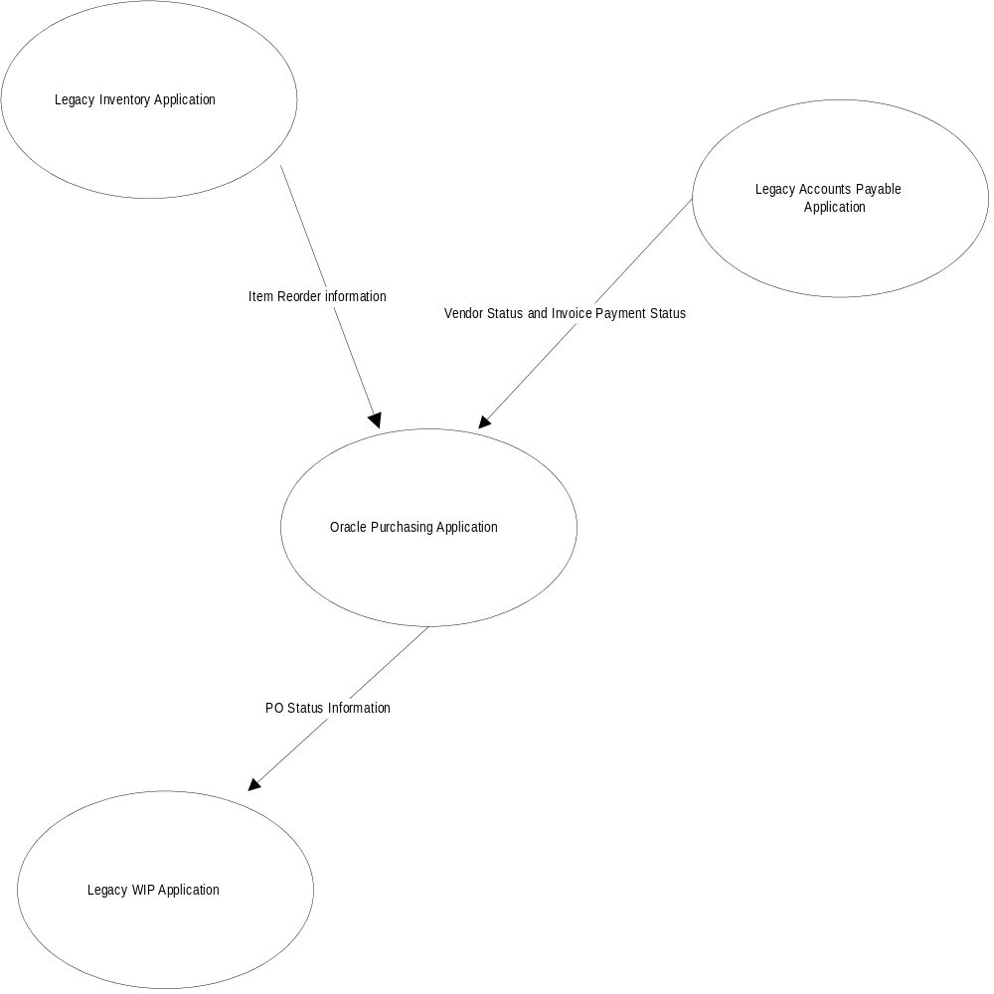

Information Flows Across Data Centers (Installations)
You will not need this section if the scope of the project only covers a single data center. You may have covered some of the flows here in other sections of this deliverable. If this is the case, you can refer back to flows in other sections.
This section describes the information flows between different applications installed in different data centers. Selection of the specific cross-data center flows was subject to the following rules:
- Information flows between installations of the same application in different data centers (flows between distributed databases)
- Information flows between installations of different applications in different data centers
- <Add other criteria here>

Process | Source Application | Destination Application | Business Objects Transferred | Information Medium | Event | Frequency | Projected Volume

Cross-Data Center Information Flow Diagrams
- To edit the PowerPoint diagram shown below right-click on the diagram and select the edit option from the pop-up menu.

Key High-Level Enterprise Information Flows
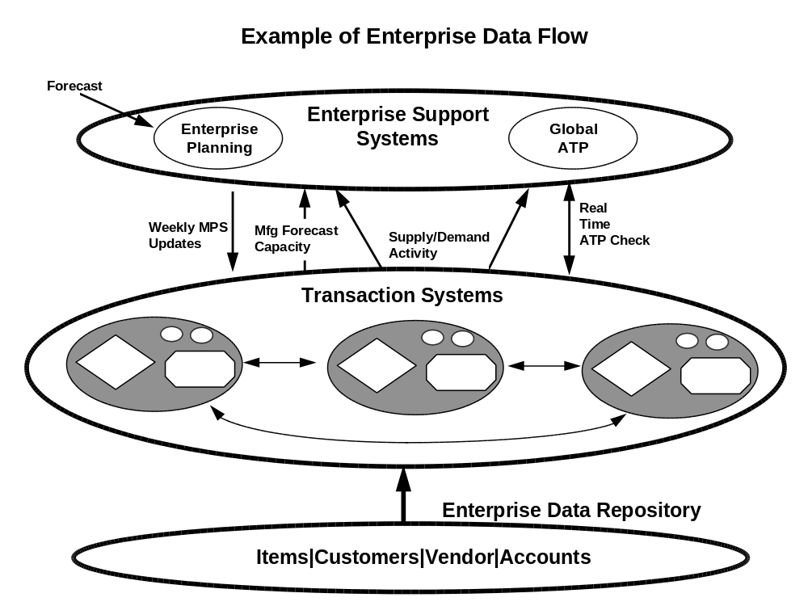

Business Organizations
The list below is the business organizations analyzed in this document.
Business Organization | Abbr. | Application Setup Parameter | Business Functions

Security Policies and Requirements

Security Policies
- If there are any security policies in effect, record them here. An example would be: All manufacturing staff must have read access to any data not created as part of their business unit, but must not be able to alter the information.
This section discusses the security policies that are in effect for the …

Security Policies and Requirements
- The table below shows example security requirements. Clear the table and enter the specific requirements that are relevant to your project
This section expands on the policies in the prior section to describe the detailed security requirements.

Business Function | Business Object | Requirement
General Ledger | Corporate journal information | Restrict read/transaction access to Corporate GL data to corporate finance users only.
 | Legal entity journal entries | Restrict read/transaction access to GL entries by legal entity.  Corporate finance users can read/transact any data.
 | Legal entity journal entries | Corporate finance users must be able to consolidate the journal entries for the individual legal entities for reporting purposes.
Accounts Payable | AP Vouchers | Restrict read/transaction access to AP Vouchers by revenue entity.  Corporate finance users can read/transact any data.
 | AP Checks | Restrict read/transaction access to AP Checks by revenue entity.  Corporate finance users can read/transact any data.
 | AP Banks | Restrict read/transaction access to AP Banks by revenue entity.  Corporate finance users can read/transact any data.
Fixed Assets | Assets | Restrict read/transaction access to Assets by revenue entity.  Corporate finance users can read/transact any data.

Organizational Information Access Analysis
This section describes the analysis of the requirements for the business organization's information access. It describes the ability of an organization to create, change, read, or delete information of any type.
The organization information access table summarizes this analysis. In the table, each cell represents the ability of the organization to Create, Read, Update, and Delete each of the business objects in the table. The table lists all the key business objects and shows how organizations access each one. Cells in the table can be empty, meaning the organization does not access the business object at all, or they can hold the initial letters of the following terms:
- Create: This means that the organization can create a business object of this type.
- Read: This means that the organization can read a business object of this type.
- Update: This means that the organization can update a business object of this type.
- Delete: This means that the organization can delete a business object of this type.
- The table does not fix the medium of the business object information, although if the medium is relational data it would correspond to rows in relational tables for the business objects.
If the requirements are standard across all organizations of the same type, you can replace the business organization name with organization type for clarity.

Business Object | Org 1 | Org 2 | Org 3 | Org 4 | Org 5 | Org 6 | Org 7
Chart of Accounts | CRUD | R |  |  | R | R | R
General Ledger | CRUD | CRUD
AP Checks | CRUD | CRUD
AP Vouchers | CRUD | CRUD
Customers | R | R |  |  | R | R | CRUD
Customer Credit Information | CRUD | CRUD |  |  | R | R | R
Sales Orders | R | R |  |  | R | R | CRUD
SO Shipments | R | R |  |  | CRUD | R | R
Invoices (Collections) | CRUD | CRUD |  |  |  | CRUD | R
Debit/Credit Memos | CRUD | CRUD |  |  |  | CRUD | R
AR Payment Receipts
Fixed Assets | CRUD | CRUD
Vendor Master | CRUD³ | CRUD |  |  | R
Purchase Requisitions | R | R |  |  | CRUD | CRUD | R
Purchase Orders | R | R |  |  | CRUD | CRUD | R
Purchase Receipts | R | R |  |  | CRUD | CRUD
Item Master | R | R |  |  | CRUD | R
Item Costs | CRUD | RU |  |  | R | R
Item Categories |  |  |  |  | CRUD | R
Subinventories (locations) |  |  |  |  | CRUD | R | R
Inventory Quantities | R | R |  |  | CRUD | RU | R
Inventory Transactions | R | R |  |  | CRUD | CRUD
Stock Locators |  |  |  |  | CRUD | R
Bills of Material | R | R |  |  | CRUD | R | R
Routings |  |  |  |  | CRUD | R
Engineering Change Orders | R | R |  |  | CRUD | R
Forecasts | R | R |  |  | RU | R | CRUD
MPS |  |  |  |  | CRUD | R | R
Material Plan |  |  |  |  | CRUD | CRUD
Discrete Jobs |  |  |  |  | CRUD | R
Repetitive Schedules |  |  |  |  | CRUD
Shopfloor Depts./Resources |  |  |  |  | CRUD

Inter-Organizational Information Access Analysis
This section provides more detail about information access requirements between organizations. Inter-Organization Information Access tables will include further detail.
Each key business object has a separate table that shows how a ”Consumer” organization can access a business object created by the ‘Creator’ organization.
- If there is only one filled-in row for a matrix, it signifies that only one organization creates a business object (for example, only one organization manages customers).
The business objects in this analysis are:
- Chart of Accounts
- Bill of Materials
- Sales Order

Chart of Accounts

Chart of Accounts | Consumer
Creator | Org 1 | Org 2 | Org 3 | Org 4
Org 1 | RUD | R | R | R
Org 2
Org 3
Org 4

Bill of Materials

BOM | Consumer
Creator | Org 1 | Org 2 | Org 3 | Org 4
Org 1 | RUD | R | R | R
Org 2 | R | RUD | R | R
Org 3 | R | R | RUD | R
Org 4 | R | R | R | RUD

Open and Closed Issues for this Deliverable
- Add open issues that you identify while writing or reviewing this document to the open issues section. As you resolve issues, move them to the closed issues section and keep the issue ID the same. Include an explanation of the resolution.
When this deliverable is complete, any open issues should be transferred to the project- or process-level Risk and Issue Log (PJM.CR.040) and managed using a project level Risk and Issue Form (PJM.CR.040). In addition, the open items should remain in the open issues section of this deliverable, but flagged in the resolution column as being transferred.

Open Issues

ID | Issue | Resolution | Responsibility | Target Date | Impact Date

Closed Issues
ID | Issue | Resolution | Responsibility | Target Date | Impact Date

