AIM
CV.010 Data Conversion Requirements and Strategy
<Company Long Name>
<Subject>

Author: <Author>
Creation Date: May 4, 1999
Last Updated: May 28, 1999
Document Ref: <Document Reference Number>
Version: DRAFT 1A

Title, Subject, Last Updated Date, Reference Number, and Version are marked by a Word Bookmark so that they can be easily reproduced in the header and footer of documents. When you change any of these values, be careful not to accidentally delete the bookmark. You can make bookmarks visible by selecting Tools->Options…View and checking the Bookmarks option in the Show region.

Approvals:
<Approver 1>
<Approver 2>
To add additional approval lines, press [Tab] from the last cell in the table above.
You can delete any elements of this cover page that you do not need for your document. For example, Copy Number is only required if this is a controlled document and you need to track each copy that you distribute.
Copy Number _____

Document Control

Change Record
5
Date | Author | Version | Change Reference
4-May-99 | <Author> | Draft 1a | No Previous Document

Reviewers

Name | Position

Distribution

Copy No. | Name | Location
 | Library Master | Project Library
 |  | Project Manager
The copy numbers referenced above should be written into the Copy Number space on the cover of each distributed copy. If the document is not controlled, you can delete this table, the Note To Holders, and the Copy Number label from the cover page.

Note To Holders:
If you receive an electronic copy of this document and print it out, please write your name on the equivalent of the cover page, for document control purposes.
If you receive a hard copy of this document, please write your name on the front cover, for document control purposes.
Contents
Document Control
Introduction
Purpose
Project Deliverables Audience
Benefits
Scope
Background
Applications
Platforms
Connectivity
Tools
Other Technologies
Objectives
Objectives
Critical Success Factors
Approach
Tasks and Deliverables
Key Inputs
Constraints and Assumptions
Schedule/Critical Milestones
Required Resources
Conversion Team Organization
Roles and Responsibilities
Conversion Resource Requirements
Conversion Strategy
Conversion Approach
Automated Tools
Conversion Process Flows
General Ledger Conversion Process Flow
Accounts Receivable Conversion Process Flow
Accounts Payable Conversion Process Flow
Inventory Conversion Process Flow
Bills of Material Conversion Process Flow
Work in Process Conversion Process Flow
MRP Conversion Process Flow
Engineering Conversion Process Flow
Purchasing Conversion Process Flow
Order Entry Conversion Process Flow
Project Standards
Century Date Compliance
Tool Standards
Deliverable Naming Standards
Data Clean-up Process
Data Clean-up
Key Data Translations
Testing Strategy
Acceptance Criteria
Delivery
Data Acceptance
Audit/Control
Issue Tracking Procedures
Issue Management Procedure
Issue Resolution
Version Control Procedures
Change Management
Quality Management
Conversion Requirements
Business Object Conversion Selection Criteria
Open and Closed Issues for this Deliverable
Open Issues
Closed Issues

To update the table of contents, put the cursor anywhere in the table and press [F9]. To change the number of levels displayed, select the menu option Insert->Index and Tables, make sure the Table of Contents tab is active, and change the Number of Levels to a new value.

Introduction

Purpose
This Data Conversion Requirements and Strategy document defines the requirements, scope, objectives, and strategy for the <Project Name> conversion effort.
The Data Conversion Requirements and Strategy document is used as follows:
- The primary use of this document is to record and communicate the data conversion scope, objectives, approach, and requirements.
- The conversion team uses this document to communicate the strategy for successfully converting the legacy data to the new Oracle system(s).
- The conversion team uses this document as a road map for performing the conversion. All members of the team should understand and follow the same strategy.
- The project manager uses this document to understand how the conversion team plans to perform the conversion, and how the conversion effort may impact the overall project.
Distribute and communicate the Data Conversion Requirements and Strategy to the:
- project manager from the implementation services provider
- client project manager, who should sign-off on the conversion requirements and strategy
- conversion team members
- other process leaders who are responsible for tasks that are prerequisites for conversion tasks, or whose tasks are dependent on output from conversion tasks
Use the following criteria to ensure the quality of this deliverable:
- Are the project scope and objectives clearly identified?
- Are specific critical success factors documented?
- Is the impact of each dependent task from other processes considered?
- Are the conversion requirements clearly defined, including all legacy applications and business objects? Do the definitions indicate the level of detail and history to be converted?
- Is a disposition path for every existing business object/data element clearly defined?
- Is the strategy understood by those on the distribution list for this deliverable?
- Are all assumptions, constraints, and risks that could impact the conversion stated, understood, and mitigated?

Project Deliverables Audience
Customize the list below to suit your situation.
The conversion activities involve interaction with the following groups:
- <Company Short Name> conversion and interfaces teams
- the project team members responsible for the following conversion prerequisites:
Design/Build Standards
Existing and proposed System Data Model
Database Extension Design
- those responsible for the technical architecture of the overall project conversion and interface capacity requirements
- those responsible for the system test and the systems integration test
- all <Company Short Name> pilot and roll out application and technology installation project teams
- project managers responsible for staffing the conversion and interface effort
- project managers responsible for training project resources

Benefits
By following the proven AIM conversion approach, the following benefits can be realized:
- faster data conversion through defined standards and procedures
- lower conversion cost leveraged from repetitive use of conversion programs
- centralized definition and maintenance of conversion practices, designs, and code
- minimized use of functional and technical resources to repetitively analyze, design, and deploy conversions
- minimized number of resources to support the conversion tasks

Scope
This section identifies included and excluded conversion project scope.

Background
Describe the background for the conversion by describing the aspects of the conversion effort listed below.
Delete or add project features as required.
Below is a discussion of the following project features:
- single or multi-site conversion implementation
- single or multi-phased conversion implementation
- single or multiple data sources
- common definition of key data elements across multiple sites
- unique project/legacy system features

Single or Multi-site Conversion Implementation

Single or Multi-phased Conversion Implementation

Single or Multiple Data Sources

Common Definition of Key Data Elements Across Multiple Sites

Common reference date:

Common document data:

Common transaction data:

Common historical data:

Unique Project/Legacy System Features

Applications
This project includes conversion of the following application modules to the defined Oracle Application modules:
Place an X in the Checkbox column for the Oracle applications that will store converted data from the legacy system.
Indicate with an X for each application whether you are converting documents, transactions, and/or historical data.
Add new Oracle Applications as required.
Oracle Application | Checkbox | Documents | Transactions | History
Financials
General Ledger
Payables
Purchasing
Fixed Assets
Distribution
Order Entry
Receivables
Inventory
Manufacturing
Bills of Material
Master Scheduling/MRP
Engineering
Capacity
Work in Process
HR/Payroll
Project Accounting
Sales and Marketing

The following data will be converted to a Data Warehouse:

The following legacy system applications will not be converted in this project to Oracle Applications:

Platforms

Legacy System
The legacy systems currently operate on the following platforms/environment:

Hardware/versions:

Operating system/versions:

Software/versions/module/manufacturer:

Oracle Applications Target System
The Oracle Applications will be running on the following platform/environment:

Connectivity
Delete or add to the list below as necessary.
The following data connectivity/transfer methods are available:

Transparent Gateways

Procedural Gateways

File Transfer Software
FTP and NDM are examples of file transfer software.

PC-Based Transfer Tools
Reflection and Rumba are examples of PC-based transfer tools.

ODBC Drivers

Tools
The following automated tools will be available to facilitate the conversion project:
Delete or add to the list as necessary.

Data Management Tools

Data Modeling Tools

Data Scrubbing Tools

Data Transformation Tools

Data Mapping Tools

Database Utilities

Other Technologies
The following is a list of third party software to be considered in the scope of this conversion project:

Objectives

Objectives
The key objectives of the conversion effort follow:
Add other key objectives as required.
- Convert legacy and other related enterprise data to the Oracle Application suite of products.

Critical Success Factors
Add additional critical success factors as needed. The critical success factors that are important to the success of the conversion project should not be limited to tasks within the conversion process. For example, it is imperative that the applications be configured and the production environment installed prior to conversion.
In addition to the critical success factors that have been identified for the overall Oracle implementation for <Company Short Name>, the following critical success factors are specific to this conversion:
- early conversion planning and coordination across all <Company Short Name> companies to maximize timely and cost-effective enterprise-wide conversion and migration development investments
- well defined technical architecture strategy, requirements, and application configurations that are agreed upon and stable
- participation of representatives from each conversion group as part of the project team helping to ensure consideration of enterprise-wide business and system interface points
- availability of planned Oracle application programmatic interfaces (APIs)
- early identification and completion of key data translations, clean-up, and transformations

Approach

Tasks and Deliverables
The major tasks and corresponding deliverables provided in this conversion project are:
Task | Description | Deliverable
Define Data Conversion Requirements and Strategy | Analyze and document the conversion scope, objectives, approach, requirements, and the strategy for how the conversion will be performed. | Data Conversion Requirements and Strategy
Define Conversion Standards | Document the standards that should be followed throughout the conversion effort. | Conversion Standards
Prepare Conversion Environment | Prepare the conversion environment for the development and testing of the conversion programs. | Conversion Environment
Perform Conversion Data Mapping | Map legacy data files and elements to the Oracle Application table(s) and columns. This map includes an explanation of business, translation, foreign key rules, and default settings. | Conversion Data Mapping
Define Manual Conversion Procedures | Define procedures for manually converting applicable business objects through Oracle Application forms. | Manual Conversion Procedures
Design Conversion Programs | Design how the conversion programs should be coded using conventional programming techniques or built using an automated conversion tool. | Conversion Program Designs
Prepare Conversion Test Plan | Specify test procedures to be followed for performing conversion unit, business object, and validation tests. | Conversion Test Plans
Develop Conversion Programs | Develop conversion programs based on the Conversion Program Design that have been coded or built using an automated conversion tool. | Conversion Programs
Perform Conversion Unit Tests | Test the performance of each of the individual conversion program modules. | Unit-Tested Conversion Programs
Perform Conversion Business Object Tests | Test how the converted data performs within the target application. | Business Object-Tested Conversion Programs
Perform Conversion Validation Tests | Test how the converted data performs within the entire suite of target applications. | Validation-Tested Conversion Programs
Install Conversion Programs | Install the conversion programs that have been coded and tested. If an automated conversion tool is being used, the tool should remain installed until the final conversion is performed | Installed Conversion Programs
Convert and Verify Data | Convert data that has been verified by the users before commencement of production operations. | Converted and Verified Data

Key Inputs
Key inputs to this conversion include:
Add additional key inputs as required.
- Statement of Work
- Documents outlining enterprise application and technology architecture strategy, requirements, and constraints
- Existing and required Business Data Flow
- Application and module configuration including code table definition, Oracle flexfield and descriptive flexfield definition, third-party and custom developed applications key field definitions, etc.
- Module Design Standards
- Module Build Standards
- Existing System Data Model
- Current Process Model
- Trained Users for testing
- Project Management Plan
- Project Workplan
- Project Quality Management Strategies, Standards, and Procedures

Constraints and Assumptions
The conversion effort must operate within the following limits and assumptions:
Add additional constraints and assumptions that are specific to your project situation.

Time Frames

Resource Availability

Schedule/Critical Milestones
Oracle and <Company Long Name> will review and approve each project milestone by using the standard acceptance criteria for each task deliverable produced.
In addition to the conversion deliverables, the following project milestones have been identified:
Add to the milestone list to reflect specific milestones in your project. Examples of critical milestones are application installation and configuration.
Milestone | Phase | Current Conversion Milestone Date | Actual Conversion Milestone Date
Application Installation | Operations Analysis | November 30, 1999 | TBD
Configure Applications | Solution Design | December 10, 1999 | TBD
Complete legacy data cleanup | Transition | March 31, 2000 | TBD

Required Resources
This conversion has the following resource requirements:
See the AIM Process and Task Reference chapter on the Conversion process for details on the responsibilities for the roles below.
- Project Manager
- Client Project Manager
- Business Analyst
- Application Specialist
- Technical Analyst for data mapping and design
- Developer
- IS Manager
- Client Staff Member
- Tester
- Database Administrator
- System Administrator
- User

Conversion Team Organization
The following are the criteria that were used to develop the structure of the conversion team:
Delete the sample criteria below if they do not make sense for your project, and replace with criteria that are specific to your project situation.
- conversion to be completed by <Provide a Date>, in time for Business System Testing
- the number of business objects to be converted
- skills required for conversion
- time estimate for conversion of each business object
- data reconciliation to be done by the users
Based on the above criteria, the conversion team can have one or more groups as shown below.
Insert an organization chart which shows the organization structure for the conversion team.
Adapt the sample conversion team structure provided to fit your specific needs. Use this structure along with the tasks, roles, and resource list to update the project workplan.
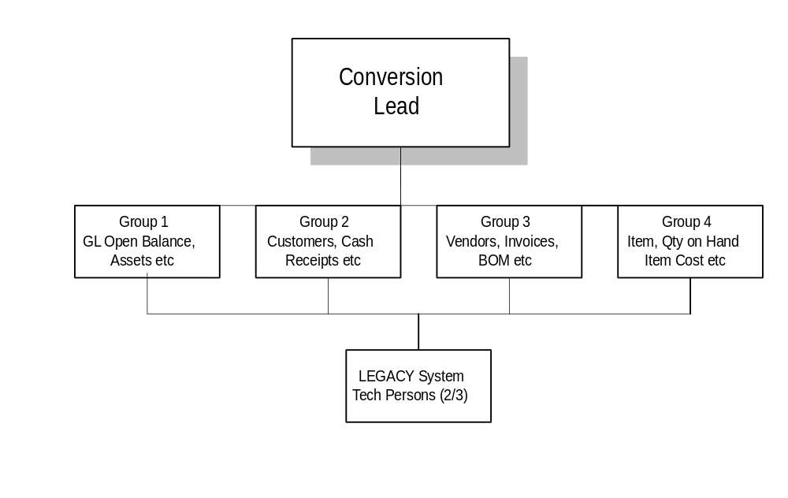

Conversion Group 1
This group will be responsible for the following tasks:

Conversion Group 2
This group will be responsible for the following tasks:

Conversion Group 3
This group will be responsible for the following tasks:

Conversion Group 4
This group will be responsible for the following tasks:

Roles and Responsibilities
The conversion project roles will be staffed by the individuals listed in the table below:
Fill in each of these roles for each conversion group. Depending on how the conversion team is structured, you may need to have multiple resources per role for a given conversion group.

Conversion Group # | Role | Oracle Team Member | Oracle Team Member Position | Client Team Member | Client Team Member Position
 | Business Analyst
 | Database Administrator
 | Client Staff Member
 | Developer
 | Technical Analyst
 | User
 | Tester
 | System Administrator
 | Applications Specialist

Conversion Resource Requirements
The following software and hardware requirements are considered components of this conversion effort:

Software
The application software used as part of this project includes:

Existing Legacy Environment (Source)

Planned Oracle Environment (Target)

Hardware Environment
The hardware and operating software used as part of this project include:

Existing Legacy Environment

Planned Oracle Environment

Network/File Transport

Existing File Transfer and Network Capabilities

Planned File Transfer and Network Capabilities

Experience/Training Requirements
The staff involved with this conversion must have the background, experience, and training in the following areas:
Task ID | Conversion Task | Background/Experience
CV.010 | Define Data Conversion Requirements and Strategy
CV.020 | Define Conversion Standards
CV.030 | Prepare Conversion Environment
CV.040 | Perform Conversion Data Mapping
CV.050 | Define Manual Conversion Procedures
CV.060 | Design Conversion Programs
CV.070 | Prepare Conversion Test Plans
CV.080 | Develop Conversion Programs
CV.090 | Perform Conversion Unit Tests
CV.100 | Perform Conversion Business Object Tests
CV.110 | Perform Conversion Validation Tests
CV.120 | Install Conversion Programs
CV.130 | Convert and Verify Data

Below is a list of skills that the current conversion project team does not fulfill:

Specialty Tools
The risks associated with the skills that the conversion team does not currently have can be mitigated through training, outside resources, or by using specialty tools. Below is a list with descriptions of the specialty tools proposed for use on this conversion project:
List any automated conversion tools which are going to be used to facilitate this conversion. In the description of the tool, explain the basis of the make or buy decision which instigated the purchase of each of the above tools.

Business Constraints
This conversion must comply with the following business constraints:

Hardware Availability

Budget Constraints

Legacy System Decommissioning

Technical Standards and Architecture
The project deliverables will be developed subject to:
- any governing <Company Short Name> technology platforms strategy and standards
- decisions made regarding the <Company Short Name> technical architecture plan
- architectural connectivity issues in linking local environments to the central or consolidation environment
- the Technical Architecture (TA) deliverables

Risks and Contingencies
Identified conversion risks include the following:
Describe any risks. The associated contingency plans for these risks should also be described. The risks listed below are examples.
Add or delete to the list as is appropriate for your specific conversion effort.
- incomplete definition of the conversion process
- lack of legacy resources to identify, document, and extract legacy data
- lack of tools to manage/manipulate data
- lack of understanding of project timelines and milestones
- poor data quality
- lack of understanding of required key data translation, clean-up, and transformation criteria
- lack of reliable mechanism for data transfer
The contingency plans that should be put in place for the above risks follow:

Project Metrics
Key metrics for this conversion project follow:
Below is a list of key metrics that affect the estimate and workplan of the conversion project. Refer to these metrics when adjusting the difficulty level for the conversion of each business object.
- number of platforms:
- number of conversion business objects to design and build:
- number of database tables (may not be known):
- number of conversion modules that can be reused:
- number of source applications to convert from:
- volume of data to be converted and/or migrated:
- complexity of the data to be converted and/or migrated:
- number of legacy data sources:
- amount of required data cleanup:
- number of data translations:

Conversion Strategy
This section provides a graphical description of the conversion approach that will be used to convert the legacy data to the Oracle Applications. An explanation of this strategy follows.
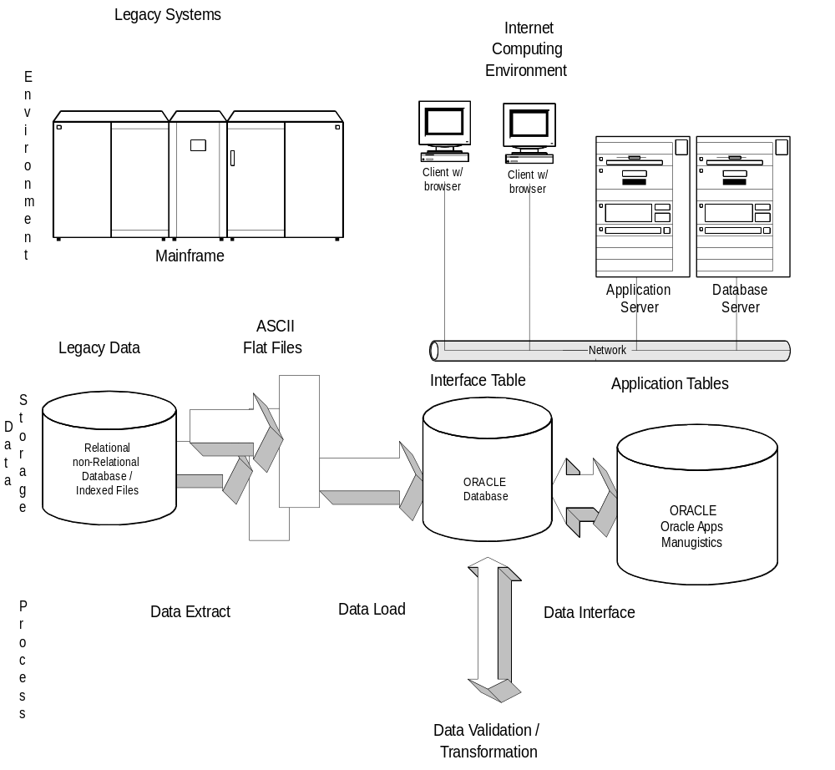

Conversion Approach

1. Conversion Data Mapping
The data mapping process provides detailed lists of the data sets and data elements that will need to be moved into the Oracle tables during the data conversion. During this process, some decisions will need to be made with regard to obtaining information needed by the target application that may not be present in the old system. Default settings, user input, and new data entries are some of the issues that must be addressed during this phase.
The output of this activity is data mapping tables that show what is needed for the Oracle target application processing to meet business operational requirements and where these data elements will come from. Based on this mapping, a design of the legacy data extract is defined.

2. Download Programs
These programs are used to extract the identified conversion data elements from the current systems in the form of an ASCII flat file. The tool that is used to accomplish this task is usually dependent on the abilities and training of the current system programmers . It is important to remember how the flat file will be structured (the order of the records as they are pulled) , type of delimitation used, number of records, etc. The flat files must match how the interim tables are set up. The output from a download program is an ASCII flat file as described in the next section.

3. ASCII Flat File
Most database or file systems output data in text form. A comma or space delimited, variable or fixed format data file from the existing system should be generated. If you cannot find a way to produce clean text data, try generating a report to disk, using a text editor to format your data.
One of the outputs of conversion data mapping is to identify the legacy data element data types and precision. After the conversion data mapping is complete, you should know if there are inconsistencies between the legacy data types and the requirements for the Oracle data types. If there are translations that need to take place, these translations can be performed on the legacy system prior to creating the extract or in an interface table. Also, if you are creating a fixed length extract file, you need to take into account the precision level of decimal numbers.

4. Upload Program
Once data has been put into an ASCII EBCDIC flat file and physically moved onto the same computer that has the Oracle RDBMS, the next step is to load the data into a relational database environment.
Programs must be written and run to move data, validate data, and insert/update standard values into default fields. Usually a single loader program is written for each data table being loaded.

5a. Description of Interface Table
The detailed technical description of any interface table that the data is placed into from the ASCII flat file is prepared. An interface table that mimics the production table into which the data will eventually be loaded into should be defined. This allows you to manipulate the data as needed before loading the legacy data into the production tables.

5b. Creation of Interface Table
Before loading the Oracle Application production tables, the legacy data should first be loaded into temporary or interface tables. The interface tables provide a location for you to manipulate and translate the data as needed before validating the data and loading the application production tables. These temporary interface tables need to be built before you run the loader script to populate these tables. The interface tables may be standard Oracle Application interface tables or may be custom interface tables.

6. Translation Programs
These scripts are developed to translate data from the existing system format into useful data for the Oracle target application. An example of this might be taking the date format that exists in the legacy system and converting it into an Oracle format. There may be several or no translation programs, depending on both the type of data coming across and the format of that data.

7. Interface Programs
The interface program scripts are used to populate the production database. The purpose of the interface programs is not only to move the data to the target tables but also to validate the data that would be validated by the form in the target application if the data was converted manually.

8. Application Production Table
This is the final production data table where the converted data resides. These tables are identified early on when doing the initial data mapping. These tables drive some of the translation programs that must ultimately ensure that 100% of the information that the target applications require is present in the final data structures.

9. Testing
This test plan has been integrated into the entire conversion process so that, even during the pre-conversion steps, some type of validation reports are generated from the legacy systems, to be compared later with the converted data.
The approach taken is to use as many standard reports as possible that are available in the legacy and target system for the final data validation. If no reports support the validation requirements, then custom scripts will need to be created for specific validation purposes.

10. Write and Perform Conversion Execution Plan
The conversion execution plan is the execution document that is to be followed when performing the actual conversion. This document is specifically tailored for the <Company Short Name> conversion.

Automated Tools
The following steps within the approach described above will be managed using the automated conversion tool described below:
There are several automated conversion and integration methods in addition to traditional coding available which should be considered. Among these tools are third party tools including screen scrubbers, data entry tools, ODBC interfaces, and Oracle gateways. See the Conversion chapter in the AIM Process and Task Reference for more detail.

Conversion Process Flows
When converting specific business objects for a given Oracle application there are business object prerequisites that must be followed. This section contains conversion process flows for the Oracle Applications you are converting that diagram these business object dependencies.
Use the sample conversion process flows below to document the business object dependencies for the Oracle Applications to which you are converting legacy data.
Delete any of the process flows that do not apply to your project.
Add process flows for additional applications by copying a sample conversion process flow, pasting it into the document, and modifying it as necessary.

General Ledger Conversion Process Flow
Double-click on the Visio diagram to edit the process flow.
Related application prerequisites show business objects from other Oracle Applications which must be converted or set up in the application before converting other business objects within the named Oracle application. Master data is non-transactional data which must be converted before the transactional data can be converted.
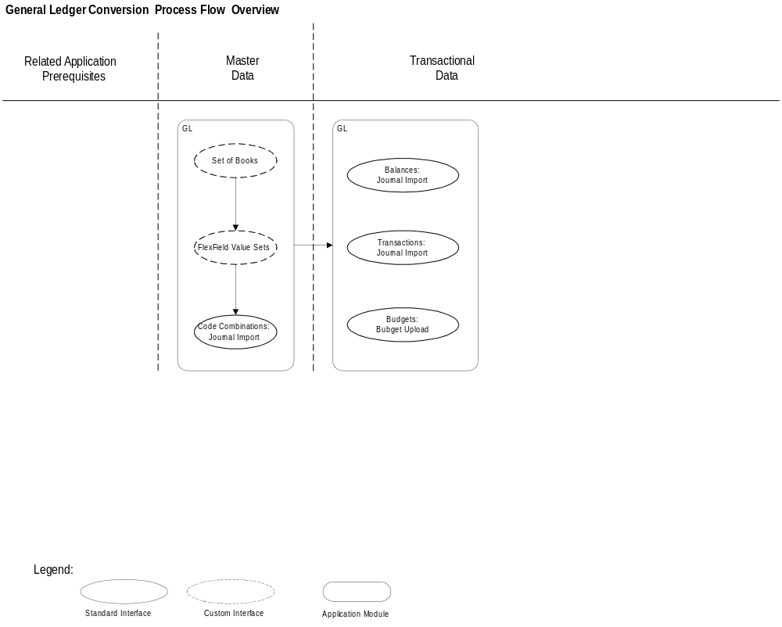

Accounts Receivable Conversion Process Flow
Double-click on the Visio diagram to edit the process flow.
Related application prerequisites show business objects from other Oracle Applications which must be converted or set up in the application before converting other business objects within the named Oracle application. Master data is non-transactional data which must be converted before the transactional data can be converted.
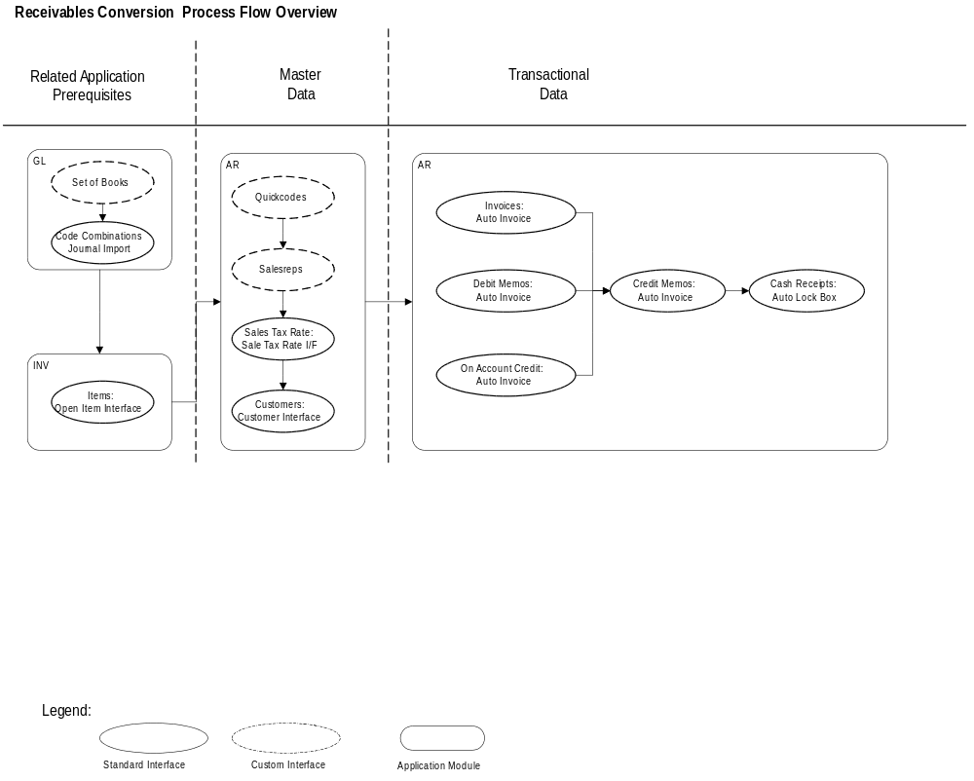

Accounts Payable Conversion Process Flow
Double-click on the Visio diagram to edit the process flow.
Related application prerequisites show business objects from other Oracle Applications which must be converted or set up in the application before converting other business objects within the named Oracle application. Master data is non-transactional data which must be converted before the transactional data can be converted.
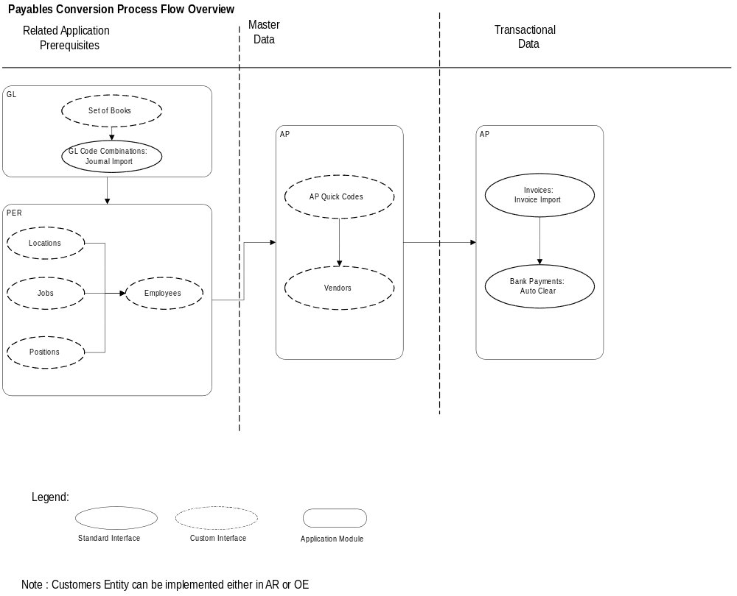

Inventory Conversion Process Flow
Double-click on the Visio diagram to edit the process flow.
Related application prerequisites show business objects from other Oracle Applications which must be converted or set up in the application before converting other business objects within the named Oracle application. Master data is non-transactional data which must be converted before the transactional data can be converted.
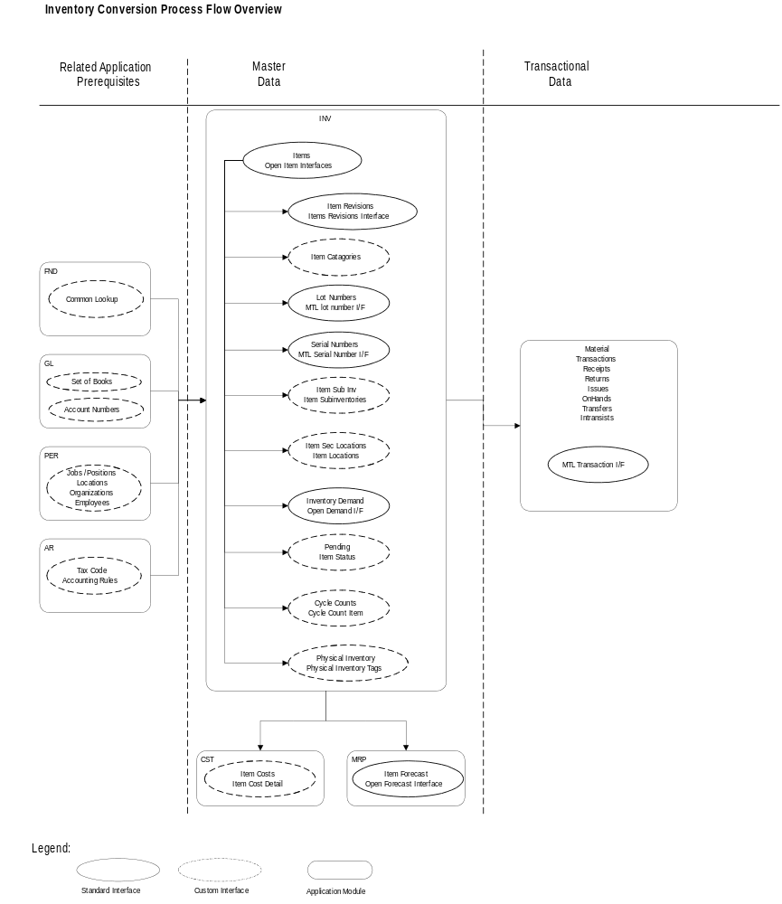

Bills of Material Conversion Process Flow
Double-click on the Visio diagram to edit the process flow.
Related application prerequisites show business objects from other Oracle Applications which must be converted or set up in the application before converting other business objects within the named Oracle application. Master data is non-transactional data which must be converted before the transactional data can be converted.
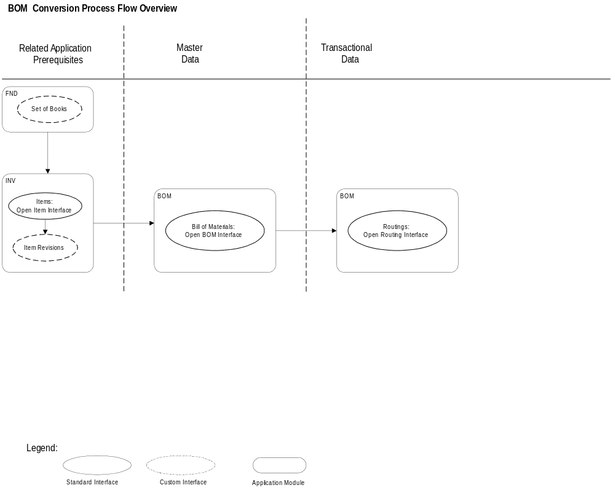

Work in Process Conversion Process Flow
Double-click on the Visio diagram to edit the process flow.
Related application prerequisites show business objects from other Oracle Applications which must be converted or set up in the application before converting other business objects within the named Oracle application. Master data is non-transactional data which must be converted before the transactional data can be converted.
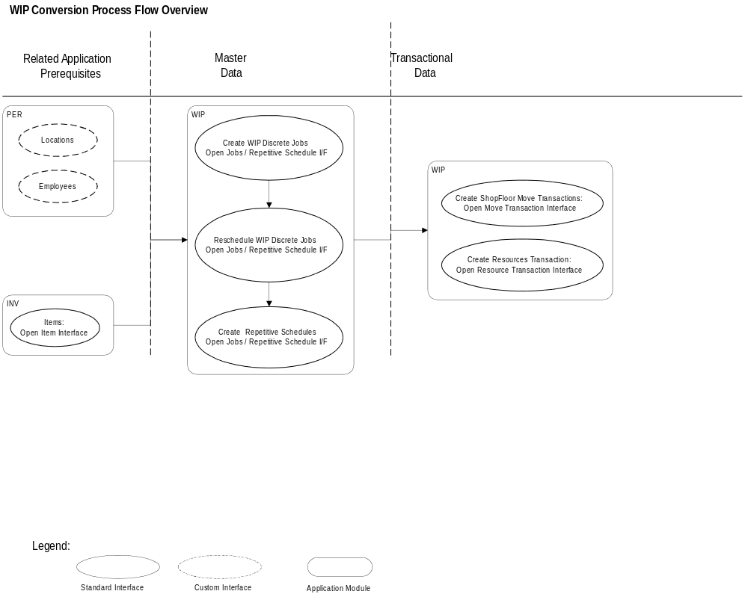

MRP Conversion Process Flow
Double-click on the Visio diagram to edit the process flow.
Related application prerequisites show business objects from other Oracle Applications which must be converted or set up in the application before converting other business objects within the named Oracle application. Master data is non-transactional data which must be converted before the transactional data can be converted.
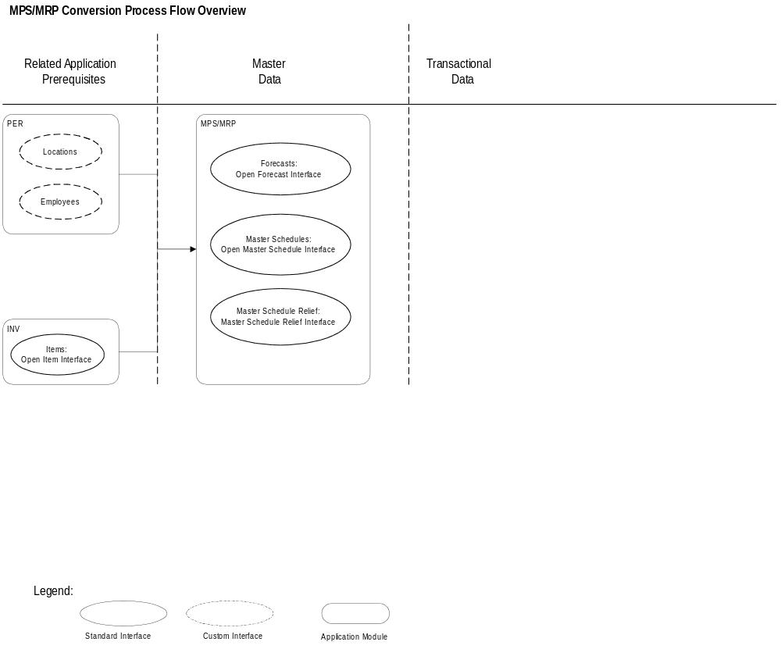

Engineering Conversion Process Flow
Double-click on the Visio diagram to edit the process flow.
Related application prerequisites show business objects from other Oracle Applications which must be converted or set up in the application before converting other business objects within the named Oracle application. Master data is non-transactional data which must be converted before the transactional data can be converted.
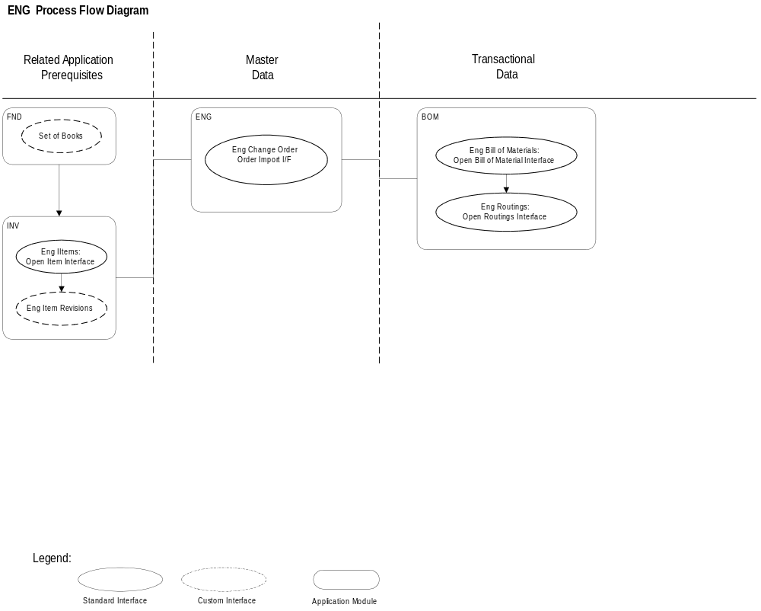

Purchasing Conversion Process Flow
Double-click on the Visio diagram to edit the process flow.
Related application prerequisites show business objects from other Oracle Applications which must be converted or set up in the application before converting other business objects within the named Oracle application. Master data is non-transactional data which must be converted before the transactional data can be converted.
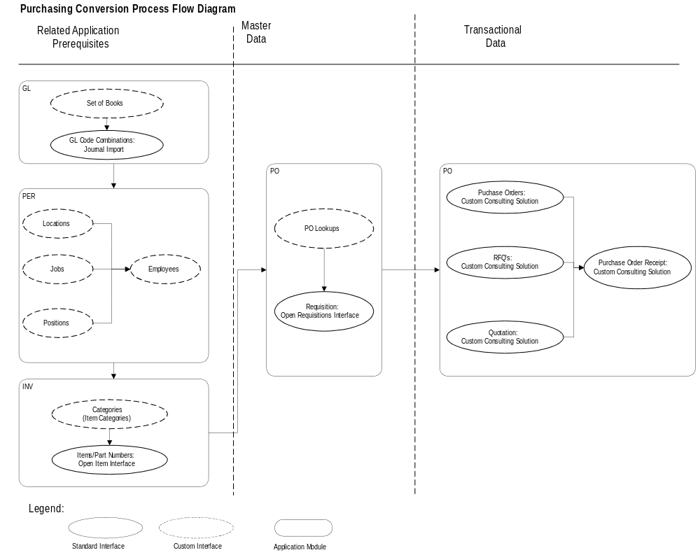

Order Entry Conversion Process Flow
Double-click on the Visio diagram to edit the process flow.
Related application prerequisites show business objects from other Oracle Applications which must be converted or set up in the application before converting other business objects within the named Oracle application. Master data is non-transactional data which must be converted before the transactional data can be converted.
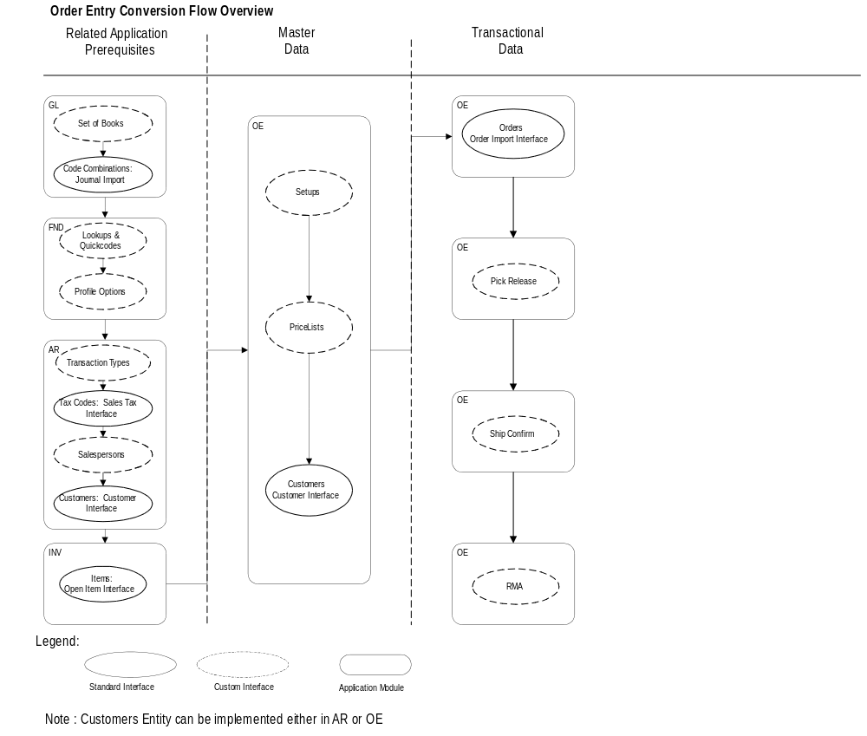

Project Standards

Century Date Compliance
In the past, two character date coding was an acceptable convention due to perceived costs associated with the additional disk and memory storage requirements of full four character date encoding. As the year 2000 approached, it became evident that a full four character coding scheme was more appropriate.
In the context of the Application Implementation Method (AIM), the convention Century Date or C/Date support rather than Year2000 or Y2K support is used. Coding for any future Century Date is now considered the modern business and technical convention.
Every applications implementation team needs to consider the impact of the century date on their implementation project. As part of the implementation effort, all customizations, legacy data conversions, and custom interfaces need to be reviewed for Century Date compliance.
Programmatically converted legacy data must be translated to the appropriate century date state before being uploaded to the production tables. Manually converted legacy data must be keyed into the data entry forms using 4 digits for the year, where supported.

Tool Standards
A list of tool standards specific to the conversion effort follows:
If the standards are the same as the overall AIM project standards, then refer the reader to the Quality Management Strategies, Standards, and Procedures deliverable (PJM.QM.010).

Application Tools

Conversion Tools

Source Control

Version Control

System Management Tools

Deliverable Naming Standards
The following table provides instructions on how to name files, programs, and other project deliverables.

Program Type | Format | Extension | Location/Directory | Example
Upload Module
Download Module
Interface Table Creation Module
Translation Module
Interface/Conversion Module
Word Documents
Other Project Deliverables

Data Clean-up Process

Data Clean-up
Specific business objects that are candidates for data clean-up include the following:
Examples of business objects which are traditional candidates for data clean-up are customers, vendors, and bills of materials.

The strategy for meeting the above data clean-up requirements is as follows:
For each of the business objects listed above note whether the clean-up will take place pre or post conversion and who will be responsible for the data clean-up of each of these business objects.

Key Data Translations
Strategic data that requires translation includes the following business objects:
Examples of candidates for key data translations are account numbers, categories, customer number, vendor number, and document number.

The strategy for meeting the above data translation requirements is as follows:

Testing Strategy
The agreed upon conversion deliverables should be approved by the client representatives who are responsible for the success of the conversion. In addition, three levels of conversion testing have been identified and described in the Prepare Conversion Test Plans deliverable (CV.070). The following criteria should be considered while performing business object and conversion validation testing:
At this point in the conversion process, the testing criteria do not need to be described at a detailed level.

Application | Business Object | Test Criteria
GL | Summary Balances | Record Counts
 |  | Hash Totals
 |  | Balances
 |  | Journal Debits and Credits

Acceptance Criteria
This conversion’s acceptance criteria will be measured by the completion and sign-off of key deliverables as specified in the Project Management Plan [PJM.CR.010, initial complete], produced in task PJM.CR.030. For some projects, these deliverables will be subjected to a quality assurance review.
Each deliverable in the conversion process will be reviewed and approved by the <Company Short Name> representative.
Additionally, each business object conversion may be subject to third-party audit requirements.

Delivery
All conversions will be deemed to be delivered following successful business system testing.

Data Acceptance
Conversion data acceptance criteria should include the following:
Describe the data acceptance criteria. Add to the list as necessary.
- transactability
- ability to reconcile financial information
- definition and acceptance of account level variances

Audit/Control
The audit and control requirements that need to be met are listed below:
Make sure you fully understand the outside auditors requirements for the data which is being converted from the legacy systems to the Oracle Applications.

Issue Tracking Procedures

Issue Management Procedure
All conversion issues will be tracked and managed as part of the overall project-level implementation process.

Issue Resolution
All conversion issues will be resolved using the project issue resolution process.

Version Control Procedures
All versions of instance information and conversion modules will be managed under version/source control. The version source control strategy being used by the overall project will be followed. Specific conversion version control standards are discussed in the deliverable Conversion Standards (CV.020).

Change Management
The scope and objectives of this conversion will be strictly controlled using the Oracle Project Management Method (PJM). A detailed discussion of change management is found in the Quality Management Strategies, Standards, and Procedures (PJM.QM.010). Change management should be adopted at the overall project level. Therefore, the conversion should use the same change management guidelines used by each of the other AIM processes.
The following change management procedures will be followed:
- identify scope definition change
- review the identified scope change with management
- analyze the impact of the scope change on the schedule and conversion project estimate
- review the scope change and obtain approval from overall project manager
- incorporate the scope change into the project workplans and budgets
Scope changes may be addressed and formalized for any of the reasons below:
- delayed delivery of legacy data extracts
- increased requirements for data-cleanup
- increased need for data translations between legacy data and target application data
- delayed receipt of application code
- delayed change in accounting flexfield structure and segment values

Quality Management
It is part of the Quality Management Strategies, Standards, and Procedures (PJM.QM.010) scope to determine the governing quality system that will be in effect for its deliverables and to define quality management procedures in detail to satisfy the requirements of the quality system.
At a minimum, an independent quality review will be provided to address two fundamentally different aspects of project activities:
- quality, completeness, and appropriateness of the project deliverables
- quality, completeness and appropriateness of project management, practices, and procedures
The review participants are expected to be designated by both <Company Short Name> and Oracle in accordance with the detailed quality procedures developed by the overall project.

Conversion Requirements
Complete the table below to document your client’s business requirements. Use the legend of codes provided at the bottom of the table. The table contains sample application and business object information for Oracle Applications. Delete and/or add information as needed.
If the Oracle application has an interface to assist in the conversion of a particular business object, then list the standard Oracle interface in column (8).
Some of the business objects may be listed for more than one application, because you may not install the entire suite of Oracle Applications. For example, if you’re implementing AP, PO, and INV, then delete the “items” business object from AP and PO. Items would then be listed only once as a business object for the Inventory application. The sequence to be converted is not applicable if you are only converting one application. However, if you are converting more than one application, then there are interdependencies between multiple applications that must be taken into consideration.
See the sample Conversion Process Flows in this deliverable for more information about the application business object dependencies. If for one application more than one business object has the same sequence number in the table below, then you can complete the conversion tasks for those business objects in parallel.
Columns (4) through (7) should be populated based on input from the company converting legacy data to the target Oracle Applications.
Disposition Type:
- M= Manual
- P= Programmatic
- A= Archival
Business Object Type:
- R= Reference
- D= Document
- T= Transaction
- H= Historical
- A= Aggregation/Roll-up
Business Ranking:
- M= Mandatory
- R= Preferred
- O= Optional
- W= Wish List

Indicate the disposition type, business object type, and business ranking based on any of the suggested criteria.
(1) | (2) | (3) | (4) | (5) | (6) | (7) | (8) | (9)
Application  Module | Sequence to be Converted | Business Object & Business Object Type | Business Ranking | Disposition Type | Data Volumes/  Number of Legacy Sources | Frequency:  One Time/  Periodic | Standard Oracle Open Interface | Comments/Open Issues
GL | 1 | Account Valid Values
 | 2 | Code Combinations |  |  |  |  | Journal Import
 | 3 | Journal Entries |  |  |  |  | Journal Import
 | 4 | Balances-: Summary |  |  |  |  | Journal import
 | 5 | Balances: Detail |  |  |  |  | Journal Import
 | 6 | Budgets |  |  |  |  | Budget Upload
PO | 1 | Employees/ Buyers
 | 2 | Vendors
 | 3 | Items |  |  |  |  | Open Item Interface
 | 4 | Purchase Agreements
 | 5 | Quotations
 | 6 | Requisitions |  |  |  |  | Requisitions Interface
 | 7 | Purchase Orders (Open)
 | 7 | Purchase Orders (Closed)
 | 8 | Receipts
AP | 1 | Employees
 | 2 | Bank Accounts
 | 2 | Vendors
 | 4 | Invoices (Open) |  |  |  |  | Invoice Import
 | 4 | Invoices (Closed) |  |  |  |  | Invoice Import
 | 5 | Payments
 | 5 | Prepayments
 | 6 | Notes
FA | 1 | Mass Additions |  |  |  |  | Mass Additions Interface
 | 2 | Production |  |  |  |  | Production Interface
 | 3 | Budgets |  |  |  |  | Budget Interface
AR | 1 | Salespersons
 | 1 | Tax Codes & Rates
 | 1 | Banks
 | 1 | Sales Tax Rates |  |  |  |  | Sales Tax Rate Interface
 | 1 | Exchange Rate Adjustments
 | 2 | Customers |  |  |  |  | Customer Interface
 | 3 | Invoices: Open |  |  |  |  | AutoInvoice
 | 3 | Invoices: Closed |  |  |  |  | AutoInvoice
 | 3 | Invoices: Partially paid |  |  |  |  | AutoInvoice
 | 3 | Commitments
 | 4 | Credit Memos |  |  |  |  | AutoInvoice
 | 4 | Debit Memos |  |  |  |  | AutoInvoice
 | 4 | On-Account Credit |  |  |  |  | AutoInvoice
 | 5 | Cash Receipts |  |  |  |  | AutoLockbox
 | 6 | Invoice Adjustments
OE | 1 | Items |  |  |  |  | Open Item Interface
 | 1 | Price Lists
 | 1 | Salespersons
 | 1 | Tax Locations and Rates
 | 2 | Customers |  |  |  |  | Customer Interface
 | 3 | Sales Orders (Open) |  |  |  |  | Order Import
 | 3 | Sales Orders (Closed) |  |  |  |  | Order Import
 | 4 | Sales Order Notes
 | 5 | Return Material Authorization
 | 6 | Pick Release
INV | 1 | Subinventories
 | 1 | Locators
 | 2 | Items |  |  |  |  | Open Item Interface
 | 3 | Inventory Receipts |  |  |  |  | Open Transactions Interface
 | 3 | Returns and Adjustments |  |  |  |  | Open Transactions Interface
 | 3 | Item Revisions
 | 3 | Item Replenishment |  |  |  |  | Open Replenishment Interface
 | 3 | Item Costs
 | 3 | Item Demand |  |  |  |  | Open Demand Interface
 | 3 | On-hand Quantities |  |  |  |  | Open Transaction Interface
BOM | 1 | Resources
 | 1 | Locations
 | 1 | Departments
 | 1 | Alternates
 | 2 | Bills of Material |  |  |  |  | Bill of Material Interface
 | 3 | Routings |  |  |  |  | Routings Interface
Master Scheduling/ MRP | 1 | Employees
 | 2 | Forecasts |  |  |  |  | Open Forecast Interface
 | 3 | Master Schedule Entries |  |  |  |  | Open Master Schedule Interface
 | 4 | Master Schedule Relief |  |  |  |  | Master Schedule Relief Interface
ENG | 1 | Employees
 | 2 | ECO Departments
 | 3 | Engineering Items |  |  |  |  | Open Item Interface
 | 4 | Eng. Item Revisions
 | 5 | Item Cross Reference
 | 6 | Engineering Change Notice
 | 7 | Eng. Item BOM |  |  |  |  | Bill of Material Interface
 | 8 | Eng. Routing |  |  |  |  | Routings Interface
Capacity | 1 | Bill of Resources
 | 2 | Bill of Resource Sets
WIP | 1 | Resources |  |  |  |  | Open Resource Transaction Interface
 | 2 | Material (Serial Numbers & Lot Numbers) |  |  |  |  | Material Transaction Interface/ Serial Number Interface and Lots Interface | If you are using serial number or lot number control then use the Serial Number and / or Lot Number Interface.
 | 2 | WIP Floor Transactions |  |  |  |  | Open Move Transactions Interface
 | 2 | WIP Material Transactions |  |  |  |  | Open Move Transactions Interface
 | 2 | WIP Completion Transactions |  |  |  |  | Open Move Transactions Interface
 | 3 | Discrete Jobs |  |  |  |  | Open Job and Repetitive Schedule Interface
 | 4 | Repetitive Schedules |  |  |  |  | Open Job and Repetitive Schedule Interface
Projects | 1 | Project Templates
 | 2 | Projects |  |  |  |  |  | Capital, Contract, and Indirect Projects
 | 3 | Tasks
 | 4 | Budgets |  |  |  |  |  | Cost and Revenue Budgets
 | 5 | Agreements
 | 6 | Funding
 | 7 | Expenditures
 | 8 | Revenue
 | 9 | Invoices
HR/Payroll | 1 | Locations
 | 2 | Organizations
 | 3 | Jobs
 | 4 | Grades
 | 5 | Positions
 | 6 | Employees
 | 7 | Positions
 | 8 | Pay Elements
 | 9 | Pay Elements History
 | 10 | Deductions
 | 11 | Deductions History
Oracle Sales & Marketing |  | Sales Force
 |  | Companies |  |  |  |  |  | Prospects and Customers
 |  | Company Contacts
 |  | Events
 |  | Event Facilities
 |  | Collateral |  |  |  |  |  | Product Literature
 |  | Advertisements
 |  | Sales Territories
 |  | Action Items
 |  | Marketing Programs
 |  | Mail or Call Scripts
 |  | Letters |  |  |  |  |  | Cover letters to send with product literature
 |  | Forecasts

Business Object Conversion Selection Criteria
Define the selection criteria for each of the business objects that are being converted as identified in the Conversion Requirements table in the previous component.
The selection criteria are:
- Historical/Active Periods
- Date Ranges
- Active/Obsolete
- Acquired/Dissolved/Sold-off
- Number of Periods
List the business objects that you are converting from column (3) in the table in the previous component. Then list the selection criteria for each business object.
Add rows to the table as needed.
Business Object | Selection Criteria
AP Invoices | Open (Unpaid) status only

Open and Closed Issues for this Deliverable
Add open issues that you identify while writing or reviewing this document to the open issues section. As you resolve issues, move them to the closed issues section and keep the issue ID the same. Include an explanation of the resolution.
When this deliverable is complete, any open issues should be transferred to the project- or process-level Risk and Issue Log (PJM.CR.040) and managed using a project level Risk and Issue Form (PJM.CR.040). In addition, the open items should remain in the open issues section of this deliverable, but flagged in the resolution column as being transferred.

Open Issues

ID |  | Issue | Resolution |  |  | Responsibility |  | Target Date |  | Impact Date

Closed Issues

ID | Issue | Resolution | Responsibility | Target Date | Impact Date

