AIM
MD.020 Application Extension Definition And Estimates
<Company Long Name>
<Subject>

Author: <Author>
Creation Date: April 23, 1999
Last Updated: June 17, 1999
Document Ref: <Document Reference Number>
Version: DRAFT 1A

Title, Subject, Last Updated Date, Reference Number, and Version are marked by a Word Bookmark so that they can be easily reproduced in the header and footer of documents. When you change any of these values, be careful not to accidentally delete the bookmark. You can make bookmarks visible by selecting Tools->Options…View and checking the Bookmarks option in the Show region.

Approvals:
<Approver 1>
<Approver 2>
To add additional approval lines, press [Tab] from the last cell in the table above.
You can delete any elements of this cover page that you do not need for your document. For example, Copy Number is only required if this is a controlled document and you need to track each copy that you distribute.
Copy Number _____

Document Control

Change Record
3
Date | Author | Version | Change Reference
23-Apr-99 | <Author> | Draft 1a | No Previous Document

Reviewers

Name | Position

Distribution

Copy No. | Name | Location
 | Library Master | Project Library
 |  | Project Manager
The copy numbers referenced above should be written into the Copy Number space on the cover of each distributed copy. If the document is not controlled, you can delete this table, the Note To Holders, and the Copy Number label from the cover page.

Note To Holders:
If you receive an electronic copy of this document and print it out, please write your name on the equivalent of the cover page, for document control purposes.
If you receive a hard copy of this document, please write your name on the front cover, for document control purposes.
Contents
Document Control
Introduction
Estimating Methodology
<Business Issue Name>
Requirement
Assumptions
Proposed Approach
Estimates
Recommended Staffing
Master Customization Worksheet
Open and Closed Issues for this Deliverable
Open Issues
Closed Issues

To update the table of contents, put the cursor anywhere in the table and press [F9]. To change the number of levels displayed, select the menu option Insert->Index and Tables, make sure the Table of Contents tab is active, and change the Number of Levels to a new value.

Introduction
This document summarizes the business requirements of <Company Long Name> that are not addressed by the Oracle Applications™ and recommends an approach to meeting each requirement. It serves as a confirmation that we understand the requirements and also documents the assumptions that are the basis of the work effort estimates provided.
Each business requirement includes a summary of specific requirements, a description of the functionality gap, assumptions, and the recommended approach to satisfy the stated requirements. The alternatives provided may include use of standard features, configuration options, database extensions (including descriptive flexfields and new tables), product customizations (new or modified forms, reports, and programs), and business process changes. Each proposed alternative includes a detailed estimate of effort required to implement the approach.

Estimating Methodology
Each proposed alternative includes a specific list of anticipated modules. These are classified as new or modified forms, reports, programs (which may include C programs, form user exits, PL/SQL™ procedures and packages, SQL*Plus® scripts, and Oracle database triggers), and database objects. Time estimates are calculated by assigning a difficulty rating to each module and applying standard estimating metrics. For the purposes of estimating, descriptive flexfields and zooms are classified as form modifications (Very Easy or Easy). Reports that use the Standard Report Submission (SRS) form use the metrics for a modified form as the estimate for SRS configuration.
The standard metrics are listed in the table below. All numbers are expressed in person-days.
 | For more information on the estimating metrics, see the <Project Name> Application Extension Strategy (MD.010).
The following table contains factors to use when estimating the level of effort for solutions not provided by the applications. Insert your own factors based on the resource skill sets available on your project.
The values in this table are duplicated in the estimating workbook below and will automatically be used when you select the type and rating values for each module identified for an application extension. Changes made to the factors in the table below should also be applied to the Lookups worksheet of the estimating workbook embedded in the Estimates section below.
Oracle® Corporation recommends that you evaluate these metrics in light of anticipated productivity factors for your internal staff or Consulting Services provider.

Module Type | Design |  |  |  | Build
 | VE | E | M | C |  | VE | E | M | C
Form - Mod | .25 | .75 | 1.5 | 2.5 |  | .5 | 1 | 2.5 | 5
Form - New | .5 | 1.5 | 3 | 5 |  | 1 | 2 | 5 | 10
Report - Mod | .25 | .5 | 1.25 | 2 |  | .5 | 1 | 2 | 3
Report - New | .5 | 1 | 2.5 | 4 |  | 1 | 2 | 4 | 6
Program | .5 | 2 | 3 | 6 |  | 1 | 3 | 6 | 10
Menu | .25 | .25 | .25 | .5 |  | .5 | .5 | .5 | 1
Tables | .25 | .25 | .5 | .5 |  | .25 | .5 | .75 | 1
These numbers represent base metrics that are used to derive the final numbers.
If the number, type, or complexity of modules required to satisfy a requirement change during analysis or design, the estimates will be modified accordingly. Likewise, after functional and technical designs are completed, the coding estimates may be revised after review with developers.
The estimating matrix includes a column for upgrade effort. It is up to the analyst to determine an appropriate estimate since it depends on the type of customization and the likelihood that the underlying application architecture will change. Application Object Library supported extensions such as descriptive flexfields and custom menus should not require any upgrade effort. Likewise, custom tables that have no (or minimal) relationship to standard tables and custom forms and reports against those tables will not require upgrading. Customized forms, reports, and programs that manipulate standard application tables will require specific analysis and possible modification. As a guideline for estimating purposes, 20% of the design and build efforts can be allocated for this effort. The existing Unit and Link Test scripts should be re-executed after an upgrade so the testing estimates are included in the total upgrade effort. All upgrade estimates should be reevaluated to reflect the actual design, build, and test times at the completion of the customization and when more is known about the next release.

<Business Issue Name>
Describe the business issue being addressed by the application extension. Provide details of the requirement below.

Requirement

Assumptions
The proposed alternative and estimated work effort is based on the following assumptions:

Proposed Approach
Attention: The recommendation and estimates below are based on limited analysis and do not constitute a design document. The estimates are not a firm commitment to perform any work and do not represent a maximum limit on the effort required to complete the proposed approach.
- Describe the proposed approach for meeting the business requirement.

Estimates
This estimate assumes Oracle Applications Release <Applications Release>. All numbers are person days for a skilled Oracle developer.
- Double-click on the worksheet below to generate your estimate. Select the button to the right of the Type and Rating columns to display a list of values. Choosing a Rating from the list also inserts base metrics in the Design, Build, and Upgrade columns. These values are formulas based on the values in the metrics table in the Introduction section. If you have altered the factors in the metrics table above, you should apply those same changes to the workbook by double-clicking on the worksheet, activating the Lookups tab and updating the factors in the Base Metrics section of that worksheet.
You can copy and paste the workbook below if you want to duplicate it in order to estimate multiple alternatives for satisfying the subject business issue. If you are altering the Base Metrics in the Lookups worksheet, you should make those updates before duplicating the workbook.
Insert rows for listing additional modules by clicking on the Insert Row Above button.

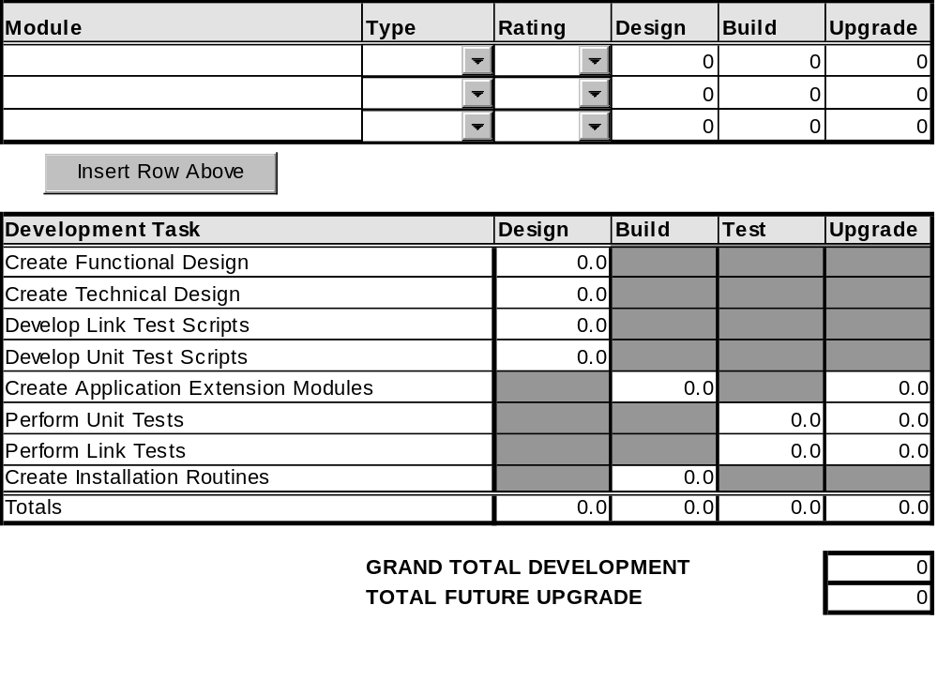
- The Future Upgrade total represents the time you should allocate when you need to upgrade the Applications to the next release. It is not part of the initial development effort.

Recommended Staffing
The table below represents the recommended maximum number of resources that can be assigned to each development task.

Development Task | Functional | Technical
Create Application Extensions Functional Design | 1
Create Application Extensions Technical Design |  | 1
Develop Link Test Script | 1
Develop Unit Test Script |  | 1
Create Application Extension Modules |  | 1
Perform Unit Test |  | 1
Perform Link Test | 2
Create Installation Routines |  | 1
- For most of the columns of this table, only enter values larger than one (1) if the customization includes several modules that developers could work on in parallel.

Master Customization Worksheet
- Double click on the table below to edit the Master Customization Worksheet in Microsoft Excel. This component is optional. You may wish to use it separately to track customizations, but not include it directly in an Application Extension Definition and Estimates deliverable.
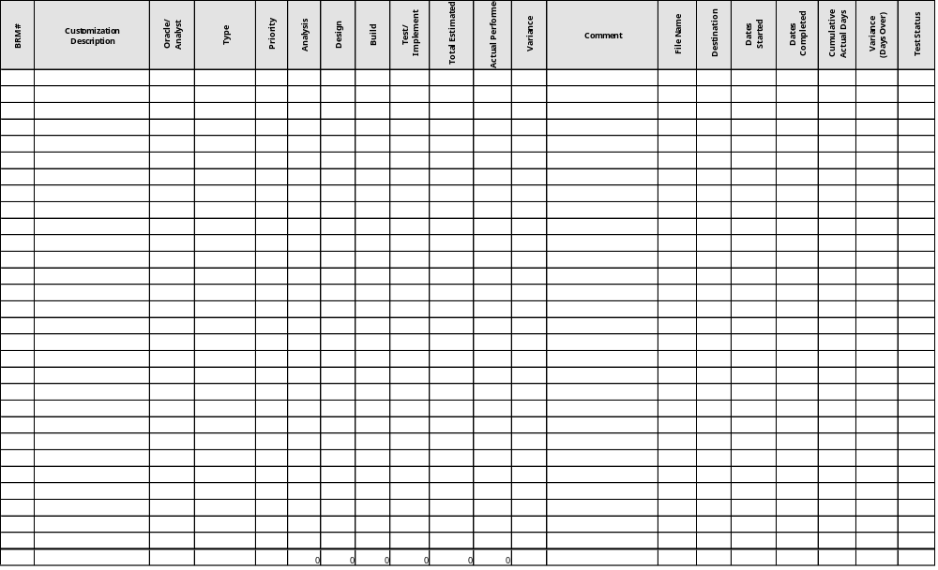

Open and Closed Issues for this Deliverable
- Add open issues that you identify while writing or reviewing this document to the open issues section. As you resolve issues, move them to the closed issues section and keep the issue ID the same. Include an explanation of the resolution.
When this deliverable is complete, any open issues should be transferred to the project- or process-level Risk and Issue Log (PJM.CR.040) and managed using a project level Risk and Issue Form (PJM.CR.040). In addition, the open items should remain in the open issues section of this deliverable, but flagged in the resolution column as being transferred.

Open Issues

ID | Issue | Resolution | Responsibility | Target Date | Impact Date

Closed Issues

ID | Issue | Resolution | Responsibility | Target Date | Impact Date

