AIM
PT.040 Performance Test Scripts
<Company Long Name>
<Subject>

Author: <Author>
Creation Date: May 18, 1999
Last Updated: June 21, 1999
Document Ref: <Document Reference Number>
Version: DRAFT 1A

Title, Subject, Last Updated Date, Reference Number, and Version are marked by a Word Bookmark so that they can be easily reproduced in the header and footer of documents. When you change any of these values, be careful not to accidentally delete the bookmark. You can make bookmarks visible by selecting Tools->Options…View and checking the Bookmarks option in the Show region.

Approvals:
<Approver 1>
<Approver 2>
To add additional approval lines, press [Tab] from the last cell in the table above.
You can delete any elements of this cover page that you do not need for your document. For example, Copy Number is only required if this is a controlled document and you need to track each copy that you distribute.
Copy Number _____

Document Control

Change Record
1
Date | Author | Version | Change Reference
18-May-99 | <Author> | Draft 1a | No Previous Document

Reviewers

Name | Position

Distribution

Copy No. | Name | Location
 | Library Master | Project Library
 |  | Project Manager
The copy numbers referenced above should be written into the Copy Number space on the cover of each distributed copy. If the document is not controlled, you can delete this table, the Note To Holders, and the Copy Number label from the cover page.

Note To Holders:
If you receive an electronic copy of this document and print it out, please write your name on the equivalent of the cover page, for document control purposes.
If you receive a hard copy of this document, please write your name on the front cover, for document control purposes.
Contents
Document Control
Introduction
Purpose
Test Scripts
Test Scenario 1 - <Performance Test Scenario Name>
Test Script Response Measurements
Test Scenario 1 - <Performance Test Scenario Name>
Assumptions
Open and Closed Issues for this Deliverable
Open Issues
Closed Issues

To update the table of contents, put the cursor anywhere in the table and press [F9]. To change the number of levels displayed, select the menu option Insert->Index and Tables, make sure the Table of Contents tab is active, and change the Number of Levels to a new value.

Introduction
Align this document with the Performance Test Scenarios and Performance Test Transaction Models. Use the <Subject> variable to describe the scope of tests covered in this document.

Purpose
The purpose of Performance Test Scripts is to describe the steps needed to execute the individual transactions included in the <Project Name> performance test.
The scenarios for the performance test are documented in the Performance Test Scenarios documents. The scenarios decomposed into separate test transaction models, each of which corresponds to the execution of the test scenario using a different set of test parameters. This deliverable takes the decomposed transaction models for <Subject> and breaks them down into a further level of detail, specifying the steps within each transaction that will make up a transaction model. The results of this break down is a series of test scripts for execution by the developer of the test transaction programs, or by the users involved in the performance test.

Test Scripts
This section includes decomposition of the performance test transactions into a sequence of transactions, inquiries and events in specific forms and reports of applications modules.
Carefully define the test scripts. Remember that test user roles should reflect real usage of the system. Take care not to introduce spurious actions; for example, unnecessary re-login to the system or re-launching a batch process multiple times.

Test Scenario 1 - <Performance Test Scenario Name>
Script Code: <Test Script Code>
Transaction Model(s) covered by this test: <Transaction Model Name>

Test Business Function | Process ID | Action | Application | Module | Seq.
Order Entry | OF1069.2 | Enter order header in Order zone (in booked state) | Oracle OE | Enter Orders | 1
 | OF1069.2 | Navigate to Additional Order Information region (next zone) |  | Enter Orders | 2
 | OF1069.2 | Enter further order header details |  | Enter Orders | 3

Order Entry Transaction Flow Diagram

- A useful (optional) technique is to diagram the test script flow. You can use the Process Modeling template that the Requirements Definition and Mapping teams use to diagram the actual business process or paste in diagrams from the Future Process Model.
- The diagram below is just a sample picture, not an editable Visio diagram.
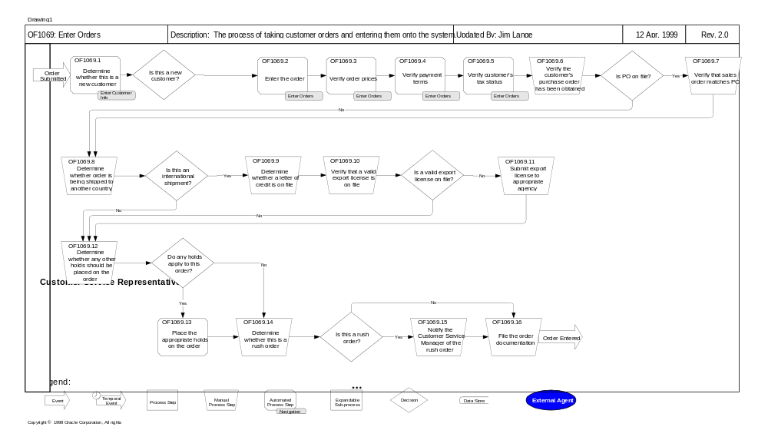

Test Script Response Measurements
This section details the measurement of performance test script responses. We capture these measurements during the course of the execution of the script. Measurements taken follow...

Test Scenario 1 - <Performance Test Scenario Name>
Script Code: <Test Script Code>
Transaction Model(s) covered by this test: <Transaction Model Name>

Test Business Function | Action | Measurement Code | Measurement
Order Entry | Select customer in order header of Enter Orders |  | Time to validate customer name from fully typed value
 | Commit order header in Enter Orders |  | Time to commit completed order header

Assumptions
<Describe the assumptions made in creating the test scripts or in defining the measurements to be made during the execution of the test script>

Open and Closed Issues for this Deliverable
- Add open issues that you identify while writing or reviewing this document to the open issues section. As you resolve issues, move them to the closed issues section and keep the issue ID the same. Include an explanation of the resolution.
When this deliverable is complete, any open issues should be transferred to the project- or process-level Risk and Issue Log (PJM.CR.040) and managed using a project level Risk and Issue Form (PJM.CR.040). In addition, the open items should remain in the open issues section of this deliverable, but flagged in the resolution column as being transferred.

Open Issues

ID | Issue | Resolution | Responsibility | Target Date | Impact Date

Closed Issues

ID | Issue | Resolution | Responsibility | Target Date | Impact Date

