AIM
PT.130 Performance Test Report
<Company Long Name>
<Subject>

Author: <Author>
Creation Date: May 21, 1999
Last Updated: May 26, 1999
Document Ref: <Document Reference Number>
Version: DRAFT 1A

Title, Subject, Last Updated Date, Reference Number, and Version are marked by a Word Bookmark so that they can be easily reproduced in the header and footer of documents. When you change any of these values, be careful not to accidentally delete the bookmark. You can make bookmarks visible by selecting Tools->Options…View and checking the Bookmarks option in the Show region.

Approvals:
<Approver 1>
<Approver 2>
To add additional approval lines, press [Tab] from the last cell in the table above.
You can delete any elements of this cover page that you do not need for your document. For example, Copy Number is only required if this is a controlled document and you need to track each copy that you distribute.
Copy Number _____

Document Control

Change Record
1
Date | Author | Version | Change Reference
21-May-99 | <Author> | Draft 1a | No Previous Document

Reviewers

Name | Position

Distribution

Copy No. | Name | Location
 | Library Master | Project Library
 |  | Project Manager
The copy numbers referenced above should be written into the Copy Number space on the cover of each distributed copy. If the document is not controlled, you can delete this table, the Note To Holders, and the Copy Number label from the cover page.

Note To Holders:
If you receive an electronic copy of this document and print it out, please write your name on the equivalent of the cover page, for document control purposes.
If you receive a hard copy of this document, please write your name on the front cover, for document control purposes.
Contents
Document Control
Executive Summary
Summary of Test Results
Conclusions and Recommendations
Project Scope, Objectives, and Approach
Scope
Objectives
Approach
Performance Test Strategy
Methodology
Automated Testing Tools
Test Execution
Test Models
Test Scenarios
Transaction Models
Test Scripts
Test Database
Database Population Strategy
Data Volumes
System Architecture and Configuration
Technical Architecture
Hardware, O/S and Network Configuration
Database Configuration
Application Configuration
Assumptions
Business Model
Application Functionality and Configuration
Technical Architecture
Risks
Test Results
Summary
Performance Measurements
Issues Identified and Resolution
Application Processing
Patches Applied
Conclusions and Recommendations
Conclusions
Recommendations
Appendix A: Glossary
Open and Closed Issues for this Deliverable
Open Issues
Closed Issues

To update the table of contents, put the cursor anywhere in the table and press [F9]. To change the number of levels displayed, select the menu option Insert->Index and Tables, make sure the Table of Contents tab is active, and change the Number of Levels to a new value.

Executive Summary
Much of this document summarizes information documented in other Performance Testing deliverables. You may wish to replace the boilerplate below with the appropriate content from the source deliverables.
Oracle Applications™ is a suite of advanced, open systems, application products that <Company Short Name> has implemented to manage parts of its enterprise business information. These products use the Oracle Relational DBMS technology to store data and their design provides comprehensive and complex functionality.
Execution of a performance test project took place between the dates of <Test Project Start Date> and <Test Project End Date>. Performance testing assists the Oracle Applications implemented at <Company Short Name> to perform the business processing within an acceptable time frame. Design of this test took into consideration the expected performance of the applications when processing in a business environment similar to <Company Short Name>‘s live production systems. This report describes the method and results of the Performance Test performed at <Company Short Name>.

Summary of Test Results
The main results obtained from the test were:

Conclusions and Recommendations
The conclusions drawn from the test results are:

In the light of these results, the leader of the performance test team makes following recommendations.

Project Scope, Objectives, and Approach

Scope
The Performance Test conducted for <Company Long Name> included the following Oracle Applications:
- <Application 1>
- <Application 2>

The business processes represented in the test were:
- <Process 1>
- <Process 2>

Objectives
The purpose of the Performance Test was to …

Target Performance Metrics
The target metrics for the performance test were as follows:
Performance Measurement | Type of Measurement | Target Metric | Current Metric | Description

Approach
In order to prepare a detailed test plan and testing approach, the performance test team has prepared an analysis that breaks out processing loads and identifies tangible measurements to gauge system performance.
Selection of transaction flows included interviews with <Company Short Name> business analysts and IS staff. The intention was to model potential peak load periods, thereby ensuring acceptable performance during critical processing time frames. Each of these special peak load processing periods, termed performance test scenarios, will have its own characteristic relative mix of online and batch usage.
The precise specification of mixes for online and batch transactions exist as particular transaction models for each scenario. Each transaction model has very precise numbers of simulated test users and sessions, and each test user also has a precisely defined rate at which to perform transactions.
The analysis also provides information about the size of the test servers necessary to mimic the production environment. Accurate server sizing relative to the live production servers is essential if the performance results are to be a fair reflection of the system response in the production environment.

Performance Test Strategy

Methodology
The method chosen for this subproject adheres to the Performance Testing process within Oracle’s Application Implementation Method.
The AIM Performance Testing process defines the following tasks and deliverables.

ID | AIM Phase | Task Name | Deliverable | Description
PT.010 | Definition | Define Performance Testing Strategy | Performance Testing Strategy
PT.020 | Operations Analysis | Identify Performance Test Scenarios | Performance Test Scenarios
PT.030 | Operations Analysis | Identify Performance Test Transaction Models | Performance Test Transaction Models
PT.040 | Solution Design | Create Performance Test Scripts | Performance Test Scripts
PT.050 | Solution Design | Design Performance Test Transaction Programs | Performance Test Transaction Program Designs
PT.060 | Solution Design | Design Performance Test Data | Performance Test Data Design
PT.070 | Solution Design | Design Test Database Load Programs | Performance Test Database Load Program Designs
PT.080 | Build | Create Performance Test Transaction Programs | Performance Test Transaction Programs
PT.090 | Build | Create Test Database Load Programs | Performance Test Database Load Programs
PT.100 | Build | Construct Performance Test Database | Performance Test Database
PT.110 | Build | Prepare Performance Test Environment | Performance Test Environment
PT.120 | Build | Execute Performance Test | Performance Test Results
PT.130 | Build | Create Performance Test Report | Performance Test Report

Automated Testing Tools
<Describe the selection and use of testing tools here>

Test Execution
<Describe test execution methods here>

Test Models

Test Scenarios
Each test scenario consists of a number of active business functions. The business functions assumed to be active in the test scenario are the Test Business Functions. Business Function Roles perform these Test Business Functions.

Test Scenario 1 - <Performance Test Scenario Name>
This scenario corresponds to a system processing situation…<enter description of situation here>
The composition of this scenario was:

Test Business Function | Function Type | Business Function Role | Current # of Users | # of Users as of <Business Metrics Date>
Order Entry | Online | Order Administrator | 53 | 70

with the following processing metrics:

Test Business Function | Business Metric | # of Users | Rate | Comments
Order Entry | 1400 new orders in 5 hours | 70 | 1 order per user per 15 min | Assuming 10% growth in sales orders

Transaction Models
Each test scenario consists of a series of transactions corresponding to the business functions and user roles identified in the test scenarios.
<Enter the detailed transaction model information here if appropriate>

Test Scripts
We defined test user roles in order to process the transactions of each specified scenario. Each test user role associates to a simulated number of users in a test cycle. Thus, you may think of a test user role as a conceptual application user process flow. A real system user may map onto one or more test user roles.
To implement the process flow for each test user role, transactions associated with the flow decompose into one or more test scripts.

Test Database

Database Population Strategy
Describe sources for data resident during the tests. Describe volumes of key application tables (e.g. balances, code combinations). Indicate if the test data was from a generation, or conversion from an existing system.

Data Volumes
In deciding the volume of data to use in the test database it is necessary to take into account purge/archive cycles for the different application data. Since these cycles may differ, the historical volume of data may vary between different data entity tables at any given point in time. The figures below represent the actual volumes of data used in the test database. These figures reflect the worst possible processing situation (highest volume in the database) with the purge/archive cycles that <Company Short Name> has specified.

Business Object | Transaction Rate (Objects/month) | Historical Volume (months) | Total Data Volume (Objects)

System Architecture and Configuration
This section describes the system architecture and configurations implemented for the performance test. It includes detailed specifications for the technical infrastructure of the test, that is, hardware, operating system and network components, as well as the application configuration.

Technical Architecture
Specifications for the technical architectures included in testing appear below.

Configuration 1 - Central Host

If you tested more than one technical architecture configuration, include the others here.

Hardware, O/S and Network Configuration
This section discusses the operating system configuration including the O/S version and key parameters. If parallel server is being tested, describe the platform-specific software that manages the distributed lock manager.

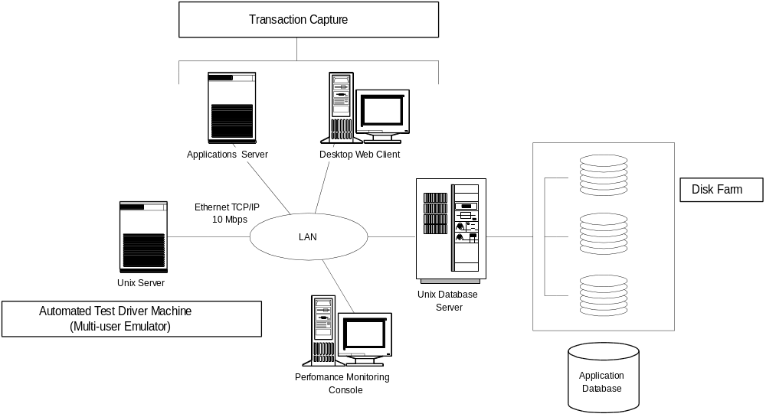

Database Configuration

Overview
Give overview the database configuration(s) tested. Examples include database instances, parallel server, etc.

ORACLE ID Configuration
Describe ORACLE ID configuration, interconnection, and mapping to user responsibilities. Discuss any customizations to the standard AutoInstall configuration.

Instance | ORACLE ID | Responsibility
PERFTEST | APPLSYS | System Administrator
 | GL | GL Super User
 |  | GL Clerk

Init.ora Parameters
Describe key init.ora parameters used and explain rationale.

Instance | Parameter Name | Value
PERFTEST | DB_BLOCK_BUFFERS
 | SHARED_POOL_SIZE

Database Object Distribution

Tables
Describe table sizes and the distribution of tables and tablespaces for the RDBMS instance(s) and disk drives. If using table striping, discuss which tables were subject to stripping and the granularity of the striping.

Instance | Table Name | Tablespace | Table Size | Disk Drive

Indexes
Instance | Index Name | Tablespace | Index Size | Disk Drive

Application Configuration

Key Set-Up Parameters

Application Object Library

Describe key configuration parameters. Examples include concurrent managers, maximum number of requests, responsibilities, audit trail, alert and autoinstall issues.
If your project has concurrent manager configured across multiple nodes, e.g. in a parallel server configuration, discuss which managers run on which nodes.

Standard Options Used
Describe which standard application features used or omitted from the tests, and any relevant rationale.

Custom Options Used
Describe any custom components or options used, how they integrated into the packaged applications, rationale for using them, and the impact on the test (if any).

Assumptions
This component is an integrated list of all of the assumptions made in setting up the tests.
Describe key assumptions about application users, historical data on line, processing volumes etc.

Business Model
This covers business volume metrics and processes
<Enter assumptions about the future business model here>

Application Functionality and Configuration
<Enter assumptions about the use application functionality and configuration here>
Example: Test Scenarios 1 and 2 concern themselves, in part, with key components of the overall order-to-fulfillment process. In defining these test processes, the assumption will be made that the BOMs will be managed using an PTO model in Oracle and will not use the ATO functionality

Technical Architecture
<Enter assumptions about the future technical architecture here>

Risks
The text here is a sample discussion of the risks in a performance test project.
Performance Test models used are artificial constructs since it is impossible to exactly simulate all the complex interactions and processing that takes place in a production ERP system. There are inherent risks in the interpretation of the results from a test that only includes a small subset of the processing that actually occurs in a particular situation. The limited range of transactions and business processes included in the scenarios may not sample all processes currently recognized to create a large performance overhead. Nor can the test include processes subsequently found to be of sufficient concern to warrant their inclusion in such a test.
Resource and time limitations mean inclusion of only a small number of scenarios in the testing. These scenarios provide coverage to at least some of the concerns of the finance, supply and demand teams. This does not represent a complete list of situations in which the combined processing of the separate users and batch processes create an usual load on the hardware. The project team recognizes that there other scenarios worthy of test, given sufficient resource and time.

Test Results
Describe the test results for each application tested in the project. Include failures, successes, timings, conclusions, and potential areas for future investigation.

Summary
<Summarize the test results>

Performance Measurements
This section should describe measurements taken during the testing process.
This section lists the test performance measurements taken during each scenario. The measurements are of two general types; the first involve measuring response times for particular events that occur during the transaction processing of a scenario. An example is the time taken for a navigation event, saving changes to the database or displaying a list of values. The other type involves making measurements about gross system performance such as CPU usage or network load. When a measurement does not associate with a particular system business event, the transaction column is blank.

Scenario | Transaction | Meas. Code | Measurement
1 | Display List of Customers in Enter Customer Form | A-LOV-01 | Time for list to appear after keystroke to display list
 |  | A-CPU-01 | CPU % Usage

Issues Identified and Resolution
Indicate key issues found during testing, changes in scope, software or hardware problems (reference the site log if necessary).

Application Processing
Describe results of tests, and any changes made based upon intermediate findings. Indicate performance improvements or degradation, their causes and remedies.

Patches Applied
Indicate any patches that required during testing.

No. | Type | Patch Reference | Bug Number | Impact to Performance Test | Date Executed |  | Resp.

Conclusions and Recommendations

Conclusions
<Enter the conclusions drawn from the test results here>

Recommendations
<Enter the recommendations arising from the test here>

Appendix A: Glossary

Benchmark Test
A test that measures the limiting performance metrics for a selected configuration and prescribed set of application test functions, as one or more test parameters will vary towards some limiting value. Is usually concerned with testing a small number of special transactions in a highly tuned environment, rather than simulating the complex business processing of an enterprise in live production. In the case of a published benchmark, an impartial external agency (such as TPC benchmarks) prescribes the test transactions.

Performance Test
A test which measures performance metrics for a hardware/software configuration that is processing a set of application test functions subject to a single set of test parameters. Usually the design of the test is to mimic a particular production processing environment. It differs from a benchmark in that a benchmark is less likely to consider simulating a production environment.

Performance Test Scenario
A point-in-time sample of the processing environment to be tested. Each scenario will include, users working in multiple applications, with on-line and/or batch processing being performed.

Test Cycle
An instance of a test transaction model with a specific set of test parameters or a specific hardware configuration. For example, by varying the number of simulated users in multiple cycles, it is possible to determine the capacity of the configuration under test.

Test Parameters
Test parameters are the set of test variables that may alter during a series of test cycles, possibly for benchmarking purposes. Test parameters can change without altering the hardware/software configuration or the mix of transactions that comprise the overall application test functions. Examples are the total number of users being simulated in the test or the number of CPU slots utilized in a server.

Test Scenario
A description of the processing situations (point-in-time processing snapshots) in the future production system where there will be critical performance requirements. These performance test scenarios form the basis of models of the system transactions that make up the test.

Test Script
A program created to execute all or part of a specific Test User Role. If the test user role models a real application process flow in a test scenario, a component test script will cause the execution of transactions for a realistic process flow.

Test User Role
A set of transactions associated with a defined group of application users in the Performance Test. A test user role may include a set of transactions that attempt to model a “real” application user process active during a test scenario. In some cases, a test user role facilitates segregation of the total active process flows, using a heuristic transaction grouping scheme. Transaction(s) process for each test user role through the execution of one or more unique test scripts.

Transaction Model
A specific mix of transactions for a particular test scenario. Each test scenario is supported by one or more transaction models.

Open and Closed Issues for this Deliverable
Add open issues that you identify while writing or reviewing this document to the open issues section. As you resolve issues, move them to the closed issues section and keep the issue ID the same. Include an explanation of the resolution.
When this deliverable is complete, any open issues should be transferred to the project- or process-level Risk and Issue Log (PJM.CR.040) and managed using a project level Risk and Issue Form (PJM.CR.040). In addition, the open items should remain in the open issues section of this deliverable, but flagged in the resolution column as being transferred.

Open Issues

ID | Issue | Resolution | Responsibility | Target Date | Impact Date

Closed Issues

ID | Issue | Resolution | Responsibility | Target Date | Impact Date

