AIM
RD.010 Financial And Operating Structure
<Company Long Name>
<Subject>

Author: <Author>
Creation Date: February 12, 1999
Last Updated: May 17, 1999
Document Ref: <Document Reference Number>
Version: DRAFT 1A

Title, Subject, Last Updated Date, Reference Number, and Version are marked by a Word Bookmark so that they can be easily reproduced in the header and footer of documents. When you change any of these values, be careful not to accidentally delete the bookmark. You can make bookmarks visible by selecting Tools->Options…View and checking the Bookmarks option in the Show region.

Approvals:
<Approver 1>
<Approver 2>
To add additional approval lines, press [Tab] from the last cell in the table above.
You can delete any elements of this cover page that you do not need for your document. For example, Copy Number is only required if this is a controlled document and you need to track each copy that you distribute.
Copy Number _____

Document Control

Change Record
1
Date | Author | Version | Change Reference
12-Feb-99 | <Author> | Draft 1a | No Previous Document

Reviewers

Name | Position

Distribution

Copy No. | Name | Location
 | Library Master | Project Library
 |  | Project Manager
The copy numbers referenced above should be written into the Copy Number space on the cover of each distributed copy. If the document is not controlled, you can delete this table, the Note To Holders, and the Copy Number label from the cover page.

Note To Holders:
If you receive an electronic copy of this document and print it out, please write your name on the equivalent of the cover page, for document control purposes.
If you receive a hard copy of this document, please write your name on the front cover, for document control purposes.
Contents
Document Control
Introduction
Organization Legal Entity Structure Chart
Business Organization Listing and Overview
Business Organization Overview
Business Organization Listing
Financial Operating Environment
Financial and Management Reporting Environment
Open and Closed Issues for this Deliverable
Open Issues
Closed Issues

To update the table of contents, put the cursor anywhere in the table and press [F9]. To change the number of levels displayed, select the menu option Insert->Index and Tables, make sure the Table of Contents tab is active, and change the Number of Levels to a new value.

Introduction
This document describes the financial and operating structure of <Company Long Name>.
Briefly introduce the business, state its purpose and describe how the present organization structure helps it achieve its business purpose.

Organization Legal Entity Structure Chart
The diagram below shows the main legal entities in the <Company Short Name> hierarchy. The hierarchy does not purpost to show all legal entities; for example, it does not include the intercompany elimination or suspense entities.
This chart shows examples of two types of consolidation: one is the consolidation of three entities “sets of books” into a parent consolidated set of books; the second is the rollup of divisional activity of several locations into a consolidated divisional total. .
Construct a picture of how your company’s organizations are structured; this should portray a clear picture of how the different operating units are structured and consolidated. Double click on the diagram to directly update the chart using Visio.
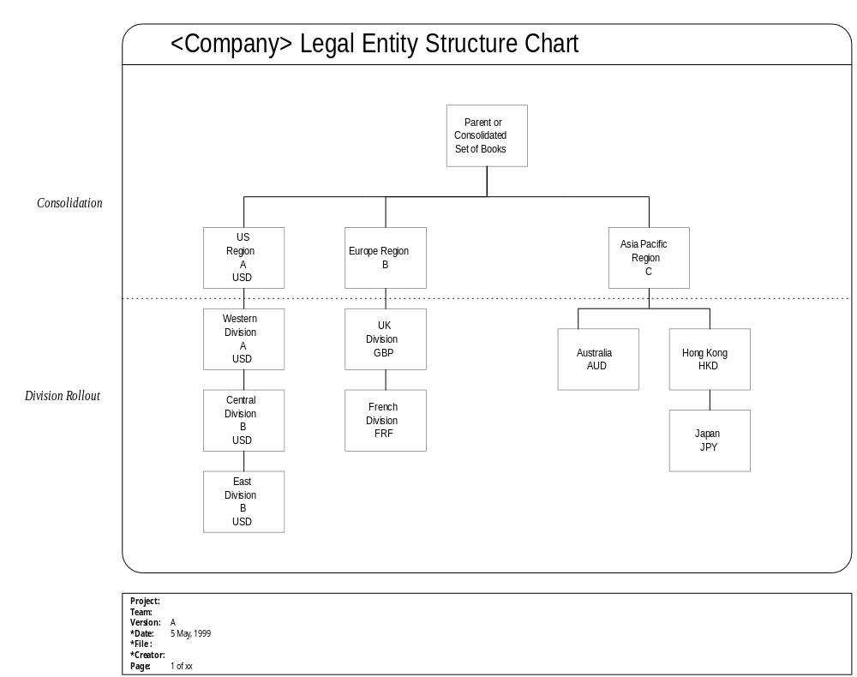

Business Organization Listing and Overview
Provide a brief description of each of the organizations that will be covered by the application functionality. This description should cover the major business functions conducted within that organization.

Business Organization Overview

<Organization 1>

<Organization 2>

<Organization 3>

Business Organization Listing
The following table lists the business organizations that collectively will need to be covered by the enterprise model; it shows their locations, types and primary functions. This listing is used later to map out the information flow model and information access requirements.
Example information is provided; please replace it with the specific information for your enterprise’s organizations. The following information should be provided:
Organization: Name of Organization
Abbr. or Code: 3-character code which uniquely identifies the organization
Address/Location: Supply the full address of the location.
Organization Type: Main purpose or function of the organization
Primary Functions: Type of business functions occurring at the location
Descriptions /Comments: Additional description/comments that further explain the nature of this location

Organization | Abbr or Code | Location | Organization Type | Primary Functions | Description/Comments
Company HQ | CHQ | 1376 Mission Street  San Francisco, CA. 97333 | Finance | Corporate Finance | Corporate Headquarters
US Operations | USO | 7631 Third Ave.  New York, NY  11111 | Manufacturing | Engineering; Production
Worldwide Production Planning | WPP |  | Logistics | Planning | Central planning group
US Sales | USS |  | Sales | Sales
US Repair Center | USR |  | Repair | Customer Service
US Finance | USF |  | Finance | Local Expense Finance /  Revenue Entity Finance

Financial Operating Environment
Within this part of the Financial and Operating Structure, the financial structure of the Corporation is developed in more detail. The operating environment of a business organization is defined by the combination of Chart of Accounts, Functional Currency, Accounting Calendar and Legal Entity that is relevant for the General Ledger entries created for the organization when it is performing a particular function on its own behalf, or behalf of another organization.
The first three columns simply duplicate the information supplied in the Business Organization Listing. The other columns are as follows:
Functional Currency: the principle currency used to record business transactions and maintain accounting data
Chart of Accounts: The General Ledger set of books that this organization will be consolidated into
Accounting Calendar: Identify which fiscal calendar the location will use

Organization | Organization Type | Function | Functional Currency | Chart of Accounts | Accounting Calendar
Company HQ
US Operations | Finance | Corporate Finance | USD | Corporate | Corporate
Worldwide Production Planning | Manufacturing | Engineering; Production | USD | Corporate | Corporate
US Sales | Logistics | Planning | USD | Corporate | Corporate
US Repair Center | Sales | Sales | USD | Corporate | Corporate
US Finance | Repair | Customer Service | USD | Corporate | Corporate
 | Finance | Local Expense Finance /  Revenue Entity Finance | USD | Corporate | Corporate

Financial and Management Reporting Environment
Identify the planned financial and management reporting requirements for each location.

Location | Organization Type | Financial Reporting | Management Reporting Revenue Center | Management Reporting Cost Center | Management Reporting Profit Center | Management Reporting  Investment Center
Cincinnati, OH | Logistics
Louisville, KY | Manufacturing/ Logistics |  |  |  | Yes
Wilmington, NC | Manufacturing
Shrewsbury Specialty Storage | Manufacturing/ Logistics
US Repair Center | Repair |  | Yes
Europe Repair Center | Customer Service |  |  | Yes
Corporate Office | Financial | Yes

Open and Closed Issues for this Deliverable
Add open issues that you identify while writing or reviewing this document to the open issues section. As you resolve issues, move them to the Closed Issues section and keep the issue ID the same. Include an explanation of the resolution.
When this deliverable is complete, any open issues should be transferred to the project- or process-level Risk and Issue Log and managed using a project level Risk and Issue Form. In addition, the open items should remain in the Open Issues section of this deliverable, but flagged in the Resolution column as being transferred.

Open Issues
ID | Issue | Resolution | Responsibility | Target Date | Impact Date

Closed Issues
ID | Issue | Resolution | Responsibility | Target Date | Impact Date

