AIM
TA.030 Preliminary Conceptual Architecture
<Company Long Name>
<Subject>

Author: <Author>
Creation Date: May 27, 1999
Last Updated: June 10, 1999
Document Ref: <Document Reference Number>
Version: DRAFT 1A

Title, Subject, Last Updated Date, Reference Number, and Version are marked by a Word Bookmark so that they can be easily reproduced in the header and footer of documents. When you change any of these values, be careful not to accidentally delete the bookmark. You can make bookmarks visible by selecting Tools->Options…View and checking the Bookmarks option in the Show region.

Approvals:
<Approver 1>
<Approver 2>
To add additional approval lines, press [Tab] from the last cell in the table above.
You can delete any elements of this cover page that you do not need for your document. For example, Copy Number is only required if this is a controlled document and you need to track each copy that you distribute.
Copy Number _____

Document Control

Change Record
1
Date | Author | Version | Change Reference
27-May-99 | <Author> | Draft 1a | No Previous Document

Reviewers

Name | Position

Distribution

Copy No. | Name | Location
 | Library Master | Project Library
 |  | Project Manager
The copy numbers referenced above should be written into the Copy Number space on the cover of each distributed copy. If the document is not controlled, you can delete this table, the Note To Holders, and the Copy Number label from the cover page.

Note To Holders:
If you receive an electronic copy of this document and print it out, please write your name on the equivalent of the cover page, for document control purposes.
If you receive a hard copy of this document, please write your name on the front cover, for document control purposes.
Contents
Document Control
Introduction
Purpose
Sources
Business Operations
Key Business Organizations and Functions
Financial Structure
Major Business Processes
Data Center and Hosting Facility Operations
Data Center/Hosting Facility - <Data Center Name/Location>
Business Information Model
Information Flows
Information Access
Key Applications
Existing Applications Retained
Replacement Applications
Conceptual Architecture
Analysis of Architecture Model
Project Environment Architecture
Server Environments
Server Capacity Requirements
Client Environments
Open and Closed Issues for this Deliverable
Open Issues
Closed Issues

To update the table of contents, put the cursor anywhere in the table and press [F9]. To change the number of levels displayed, select the menu option Insert->Index and Tables, make sure the Table of Contents tab is active, and change the Number of Levels to a new value.

Introduction
This deliverable is first created in the Develop Preliminary Conceptual Architecture (TA.030), the later revised in the task Revise Conceptual Architecture (TA.070). The deliverable name then becomes Conceptual Architecture (TA.070).

Purpose
The purpose of this document is to provide a reference at any time for resources working on the Application and Technical Architecture of the <Project Name>. This document is used to circulate for feedback and support of the entire project team to proposed conceptual approaches to resolving architecture requirements.
This document is also the source for current application and technical architecture information for project team members in processes with a dependency on the high level architecture model for <Company Short Name>’s future information systems.
This document describes:
- high level business operations requirements for the future architecture
- data center operations requirements for the future architecture
- high level conceptual view of each of the integrated application and technical architecture models for the business
- conceptual approaches to resolving architecture requirements as defined in the Architecture Requirements and Strategy document
- advantages and disadvantages of each conceptual architecture model
- preferred architecture model out of the candidate architectures
The Conceptual Architecture is a critical milestone in the development of security, reporting, application, database and application server, and network architectures.

Sources
This Conceptual Architecture document was prepared with input from the following sources:
- Project Management Plan [PJM.CR.010, initial complete], produced in task PJM.CR.030, for the <Project Name>
- Architecture Requirements and Strategy (TA.010) for the <Project Name>
Add other sources.

Business Operations
This information can be copied from the Project Management Plan (PJM.CR.010), or in some cases the Architecture Requirements and Strategy (TA.010) deliverable.
Review these deliverables and ensure that the list of requirements being addressed is the same list that is presented in these documents. If you discover and validate additional requirements, be sure to update the Architecture Requirements and Strategy deliverable (TA.010).
<Company Long Name> is a:
State the business that the company engages in.
State the approximate revenue of the business.
Describe the high-level business structure.

Key Business Organizations and Functions
Describe the:
key business organizations and business functions
structure of business functions - centralized or decentralized
products sold, distributed or manufactured at each site
business services provided by each site

Business Organization | Site | Business Functions | Business Organizations Serviced | Comments

The following diagram represents the geographical distribution of business operations:
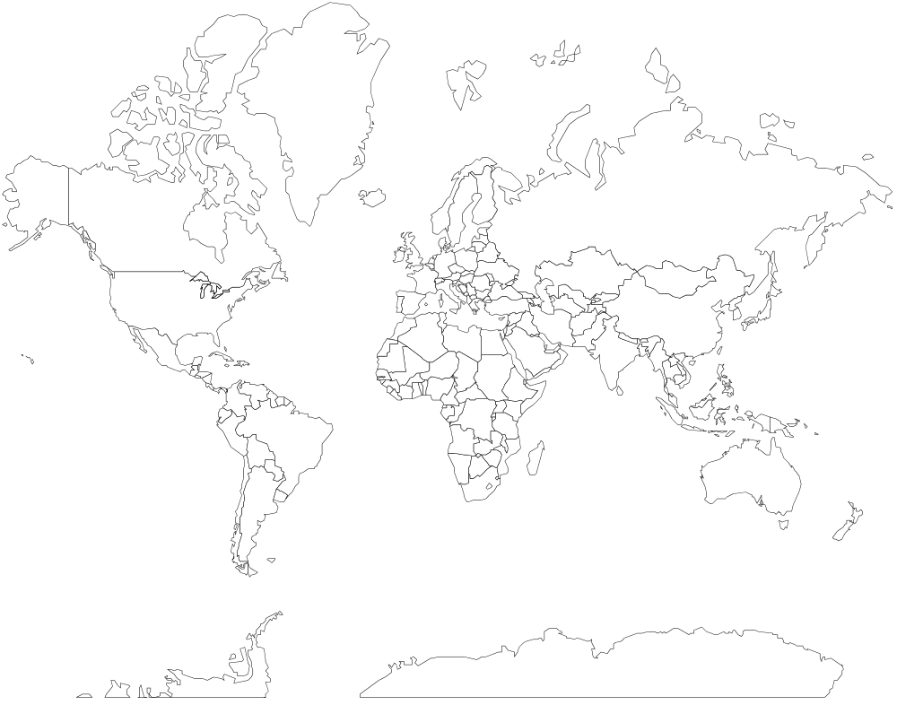

Financial Structure

Chart of Accounts
Describe the future chart of accounts.

Revenue Recognition
Describe which sites, functions, and organizations recognize revenue.

Corporate Finance
Describe where the corporate finance functions are performed.

Subledgers and Local General Ledgers
Describe the sites and organizations where subledgers and local general ledgers are maintained. Explain if the subledger processing is centralized or decentralized in nature.

Consolidation Approach
Describe how the corporate finance group approaches financial consolidation today, and describe conceptually how it will be handled with the new system.

Intercompany Settlements
Describe how the organization approaches settlement of intercompany transactions today, and describe conceptually how it will be handled with the new system.

Major Business Processes
The following are the key business processes that will significantly affect the application architecture:
This list of high-level business processes is a sample. Include the processes relevant to your project.

- Sales and Market Management |  | - Product Development
- Order Fulfillment |  | - Financial Management
- Post Sales Service |  | - Human Resource Management
- Procurement |  | - Enterprise Management
- Operations |  | - Quality Management
- Materials Management |  | - Information Technology Management
- Planning and Forecasting

Describe the high level processes that you listed above and how they map to the business structure and functions.

Sales and Market Management

Order Fulfillment

Data Center and Hosting Facility Operations
Data centers and hosting facilities which support <Company Short Name>'s information needs are located in the following cities and countries:
Update this table with your specific information. The information provide in this table is an example only.
Location | Serves Business Organizations | Company Owned or Managed
Istanbul, Turkey | All in Europe, Middle East | Hosted Facility by Inkora Facilities Plc. (Istanbul, Turkey)

The following diagram represents the geographical distribution of the data centers:
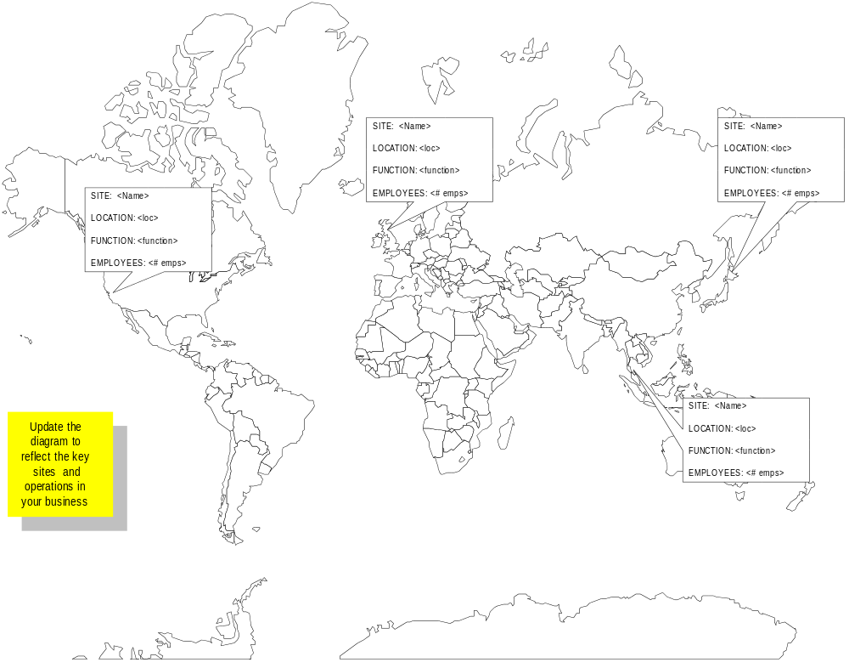

Data Center/Hosting Facility - <Data Center Name/Location>
Repeat this section for each data center or hosting facility in use.

Current Operations
Describe the operations this data center performs, the systems or applications the data center supports, and the business functions and organizations for which it performs the operations.

Planned Operations
Describe the operations this data center may perform in the new systems environment. Include the systems or applications the data center may support and the business functions and organizations for which it would perform the operations.

Business Information Model

Information Flows
The information model describes the information flows that result from the key business processes executed in the corporation. The information flows documented here are associated with the following business processes:
Incorporate information from the Information Model (BR.060) if it exists and has content at this point in the project. However, it may not exist at this time, and you should try to work with the business analysts to start defining the information flows.

- <Process Name>
- <Process Name>
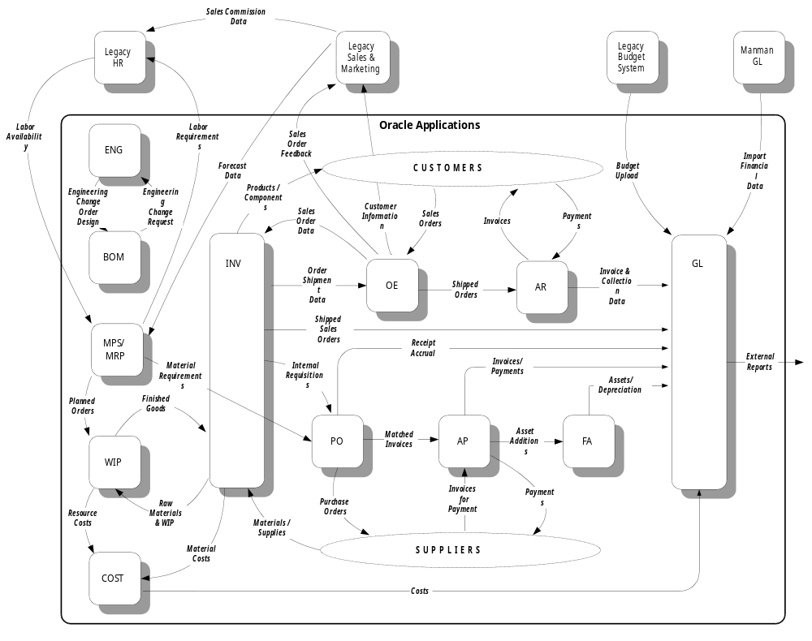

Information Access
Incorporate information from the Information Model (BR.060) if it exists and has content at this point in the project. However, it may not exist at this time, and you should try to work with the business analysts to start defining the information access requirements.
The information model describes the access to information that business units need in order to execute the business process steps in which they provide services without compromising the integrity and security of the enterprise information as a whole.
Information access is concerned with:
- information (data) partitioning to provide security and maintain integrity
- information (data) aggregation, consolidation, and summation to provide appropriate reporting views of the state of the business

Information Security
Describe the general information security needs of the business with reference to organizations, business functions, and groups of users.

Ownership of Reference (Master) Data Objects
The following sets of (reference) master data objects are important for the business:
Add the sets of master data objects that are relevant to the business.

- Chart of Accounts
- Part Master
- Vendor Master
- Customer Master
The security and ownership policies and requirements relevant to the creation, change, or deletion of these master data objects are:
- <Security and Ownership Policies>

Information Aggregation, Consolidation, and Summation
Describe the information summation and consolidation needs for reporting and analysis purposes.

Key Applications
This section describes the major or key applications that will be part of the future architecture.

Existing Applications Retained
The following key applications will be retained in the future architecture:

Application - <Application Name>
Repeat this section for each application that is being retained.
Describe the basic functions and architecture of the application.

Replacement Applications
The following key replacement applications will be added in the future architecture:

Application - <Replacement Application Name>
Repeat this section for each application that is being added to the architecture.
Describe the basic functions and architecture of the application.

Conceptual Architecture
Following is a summary of the architecture conceptual approaches to requirements defined in the Architecture Requirements and Strategy (TA.010).

Information Systems Organization
Enter conceptual approach to meet requirements here if relevant, or specify "none".

Application Deployment
Enter conceptual approach to meet requirements here if relevant, or specify "none".

Applications Architecture
Enter conceptual approach to meet requirements here if relevant, or specify "none".

User Desktop and User Interfaces
Enter conceptual approach to meet requirements here if relevant, or specify "none".

Foreign Currency and National Language Support
Enter conceptual approach to meet requirements here if relevant, or specify "none".

Data and System Security
Enter conceptual approach to meet requirements here if relevant, or specify "none".

Reporting Systems
Enter conceptual approach to meet requirements here if relevant, or specify "none".

Business Intelligence Systems
Enter conceptual approach to meet requirements here if relevant, or specify "none".

Strategic Enterprise Management (SEM) Systems
Enter conceptual approach to meet requirements here if relevant, or specify "none".

Workflow Automation
Enter conceptual approach to meet requirements here if relevant, or specify "none".

eCommerce and Internet Based Functions
Enter conceptual approach to meet requirements here if relevant, or specify "none".

Authentication Services
Enter conceptual approach to meet requirements here if relevant, or specify "none".

Telephony/Call Center Automation Systems
Enter conceptual approach to meet requirements here if relevant, or specify "none".

System Availability
Enter conceptual approach to meet requirements here if relevant, or specify "none".

Technical Architecture and Enabling Technology
Enter conceptual approach to meet requirements here if relevant, or specify "none".

Platform and Networks
Enter conceptual approach to meet requirements here if relevant, or specify "none".

Mobile Computing Support
Enter conceptual approach to meet requirements here if relevant, or specify "none".

Specialized Printing Systems
Enter conceptual approach to meet requirements here if relevant, or specify "none".

Custom Development
Enter conceptual approach to meet requirements here if relevant, or specify "none".

Interface Requirements
Enter conceptual approach to meet requirements here if relevant, or specify "none".

Integration with Other Information Systems
Enter conceptual approach to meet requirements here if relevant, or specify "none".

Approximate System Capacity
Describe the system capacity requirements for the technical architecture.

Analysis of Architecture Model

Business Advantages
The perceived advantages of this conceptual architecture option are:

Business Disadvantages
The perceived disadvantages of this conceptual architecture are:

Major Custom Extensions or Modifications Needed
To support this conceptual architecture, the following custom extensions or modifications are likely to be needed:

Risks
Describe the risks in this architecture model.

Project Environment Architecture
This section describes the architecture for the <Project Name> project environments.
<Project Name> will initially use a single series of servers for training, mapping, and development environments. The specific Oracle Applications environments required are:
- Seed Data
- Demo
- Development
- Test
- Production

Server Environments
This diagram illustrates the database environments installed on the project server. Boxes that resemble buildings with a roof represent an application environment—shared executable code and environment variables that identify application directories. Multiple databases may share the same environment for executables, concurrent log and output files, and so on. The database names correlate to the database instance names (ORACLE_SID).

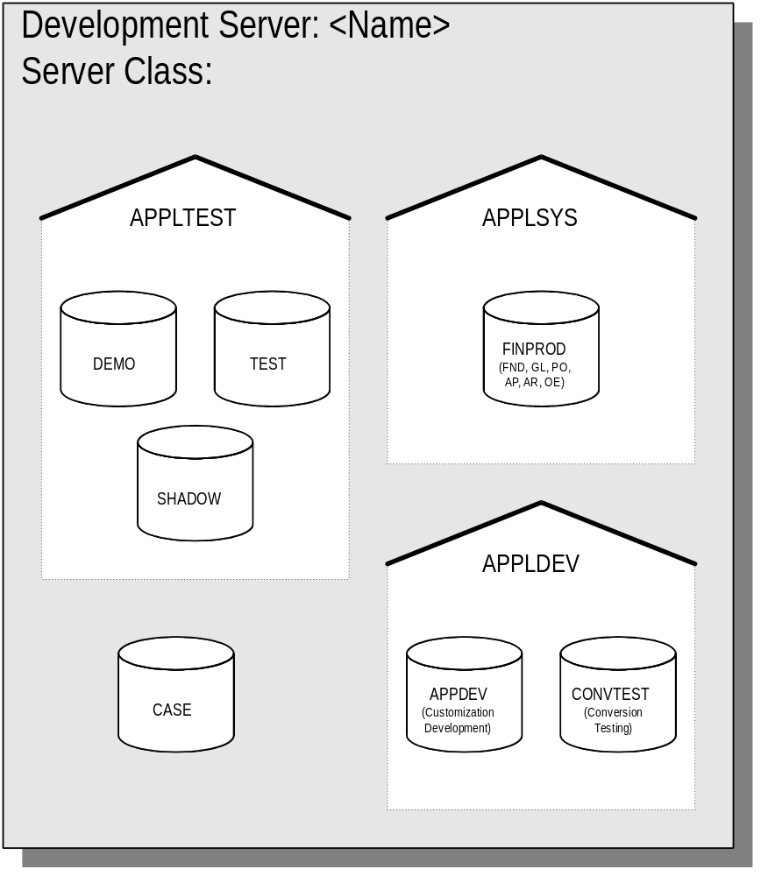

Application Extensions and Modifications
Describe how the architecture will accommodate design and build of extensions and modifications.

Server Capacity Requirements
Complete the summary worksheet provided based on what you know about the environment. This is merely a summary of estimates. Future adjustments will be made when more information is available.

Server Processing Capacity
Describe the database server sizing for project team usage of CPUs and RAM.

Server Disk Capacity
Preliminary server sizing has been performed for the project servers using the Oracle Applications Sizing Spreadsheet. The results are summarized below with additional requirements for operating system and software tools. Note that these are servers to support the development of the production environments. The production environments are sized elsewhere.
The forms server and the database server are segregated for each environment. Modified source code and application setup data will affect the purity of environments unless segregated.
If you are combining servers on a single platform, do not double count for the same space requirements. Use the DNS name to indicate what platform the server will be running on.
Component | Con- current Processing Server (MB) | Admin Server (MB) | TRAIN  Forms Server (MB) | MAP  Forms Server (MB) | DEV  Forms Server (MB) | TRAIN Database Server (MB) | MAP Database Server (MB) | DEV Database Server (MB)
DNS Name
Operating System | 0 | 0 | 0 | 0 | 0 | 0 | 0 | 0
Swap Space | 0 | 0 | 0 | 0 | 0 | 0 | 0 | 0
User Directories | 0 | 0 | 0 | 0 | 0 | 0 | 0 | 0
Documentation Repository | 0 | 0 | 0 | 0 | 0 | 0 | 0 | 0
Oracle Executables | 0 | 0 | 0 | 0 | 0 | 0 | 0 | 0
Application Executables | 0 | 0 | 0 | 0 | 0 | 0 | 0 | 0
SYSTEM Tablespaces | n/a | n/a | n/a | n/a | n/a | 0 | 0 | 0
Rollback Segments | n/a | n/a | n/a | n/a | n/a | 0 | 0 | 0
Archiving files | n/a | n/a | n/a | n/a | n/a | 0 | 0 | 0
Temp Space | 0 | 0 | 0 | 0 | 0 | 0 | 0 | 0
Total Applications Data | n/a | n/a | n/a | n/a | n/a | 0 | 0 | 0
Total Applications Indexes | n/a | n/a | n/a | n/a | n/a | 0 | 0 | 0
Oracle Documentation Files | 0 | 0 | 0 | 0 | 0 | 0 | 0 | 0
Space for Export files | n/a | 0 | n/a | n/a | n/a | 0 | 0 | 0
Log files | 0 | 0 | 0 | 0 | 0 | 0 | 0 | 0
Output files | 0 | 0 | 0 | 0 | 0 | 0 | 0 | 0
TOTAL DISK SPACE | 0 | 0 | 0 | 0 | 0 | 0 | 0 | 0

Client Environments
Describe the client-side architecture for the project environments.

Open and Closed Issues for this Deliverable
Add open issues that you identify while writing or reviewing this document to the open issues section. As you resolve issues, move them to the closed issues section and keep the issue ID the same. Include an explanation of the resolution.
When this deliverable is complete, any open issues should be transferred to the project- or process-level Risk and Issue Log (PJM.CR.040) and managed using a project level Risk and Issue Form (PJM.CR.040). In addition, the open items should remain in the open issues section of this deliverable, but flagged in the resolution column as being transferred.

Open Issues

ID | Issue | Resolution | Responsibility | Target Date | Impact Date

Closed Issues

ID | Issue | Resolution | Responsibility | Target Date | Impact Date

