AIM
TA.040 Application Architecture
<Company Long Name>
<Subject>

Author: <Author>
Creation Date: June 1, 1999
Last Updated: June 10, 1999
Document Ref: <Document Reference Number>
Version: DRAFT 1A

Title, Subject, Last Updated Date, Reference Number, and Version are marked by a Word Bookmark so that they can be easily reproduced in the header and footer of documents. When you change any of these values, be careful not to accidentally delete the bookmark. You can make bookmarks visible by selecting Tools->Options…View and checking the Bookmarks option in the Show region.

Approvals:
<Approver 1>
<Approver 2>
To add additional approval lines, press [Tab] from the last cell in the table above.
You can delete any elements of this cover page that you do not need for your document. For example, Copy Number is only required if this is a controlled document and you need to track each copy that you distribute.
Copy Number _____

Document Control

Change Record
3
Date | Author | Version | Change Reference
1-Jun-99 | <Author> | Draft 1a | No Previous Document

Reviewers

Name | Position

Distribution

Copy No. | Name | Location
 | Library Master | Project Library
 |  | Project Manager
The copy numbers referenced above should be written into the Copy Number space on the cover of each distributed copy. If the document is not controlled, you can delete this table, the Note To Holders, and the Copy Number label from the cover page.

Note To Holders:
If you receive an electronic copy of this document and print it out, please write your name on the equivalent of the cover page, for document control purposes.
If you receive a hard copy of this document, please write your name on the front cover, for document control purposes.
Contents
Document Control
Introduction
Purpose
Scope
Integrated Application Business Architecture
Sets of Books
Inventory Organizations
Human Resources Business Groups and Organizations
Integrated Application Functional Architecture
Open and Closed Issues for this Deliverable
Open Issues
Closed Issues

To update the table of contents, put the cursor anywhere in the table and press [F9]. To change the number of levels displayed, select the menu option Insert->Index and Tables, make sure the Table of Contents tab is active, and change the Number of Levels to a new value.

Introduction

Purpose
The purpose of the Application Architecture document is to describe the application architecture elements that affect subsequent set up of the applications. This deliverable is used to assist in the revision of conceptual architecture and the development of application setups. It includes:
- definition of the tiered architecture that will be used
- standards used for describing the physical architecture
- definition of key application structures such as organizational roll-ups and relationships
- definitions of key application structures to support organization views for access to data, financial and fiscal authorities, and inventory and revenue accounting organization

Scope
The <Project Name> project Application Architecture provides services to support the following key business functions:
Customize this list to indicate the scope of the users of the new architecture.
Define business functions at a very high-level, as these are described in the project at a detailed level elsewhere.
Business Organization | Geography | Business Functions
Universal Holdings | HQ, Ralston | Finance, Purchasing, Consolidated reporting
Universal Lock | Salzburg, Aus., Hamburg, Gr., | Finance, Purchasing, Discrete Manufacturing
Universal Security | Toronto, Can. | Finance, Call Center

Integrated Application Business Architecture
The following diagram shows the business architecture for the integrated finance, distribution, and manufacturing operations of <Company Short Name> when implemented in Oracle Applications.
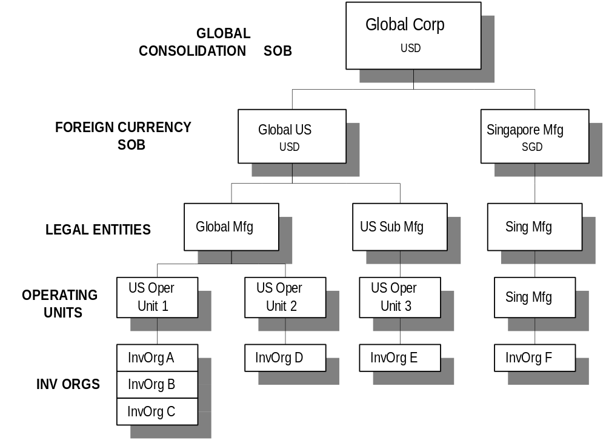

Key Points of the Business Architecture
Enter key elements of business architecture.

Oracle Multi-Org configuration
This area relates to the configuration of Oracle’s multi-org capabilities. It is critically important that a great deal of care and experience contribute to this aspect of the architecture design.
If you require additional information on architecting multi-org for your enterprise, please contact Oracle Worldwide Support or an experienced Oracle implementation consulting resource.
Oracle’s multi-org capability will be configured as follows:
Enter configuration information.

Sets of Books
The most important setup parameter within Oracle General Ledger and other applications that process financial transactions in some way is the Set of Books. This setup parameter is defined as the combination of :
- Chart of Accounts structure
- Functional Currency
- Accounting Calendar
The financial and operating structure information gathered during the Business Requirements Definition process and information about <Company Short Name>‘s business processes is analyzed to map out the Sets of Books needed. The following table maps the organizations in <Company Short Name>‘s business to the sets of books within which they will process financial transactions.
Organization | Function | Functional Currency | Chart of Accounts | Accounting Calendar | Set of Books
Universal
Universal | Corporate Finance | USD | Corp | Corp | Corp

Sets of Books Listing
The following table lists the distinct sets of books needed to support the financial organizations in <Company Short Name>’s business.
Set of Books | Abbr or Code | Type | Functional Currency | Chart of Accounts | Accounting Calendar
Universal Cons | CCONS | Consolidation | USD | Corp | Corp

GL Sets of Books Structure
The structure of the General Ledger sets of books is shown below. The intermediate consolidation books are also shown.
The key points about the structure are:

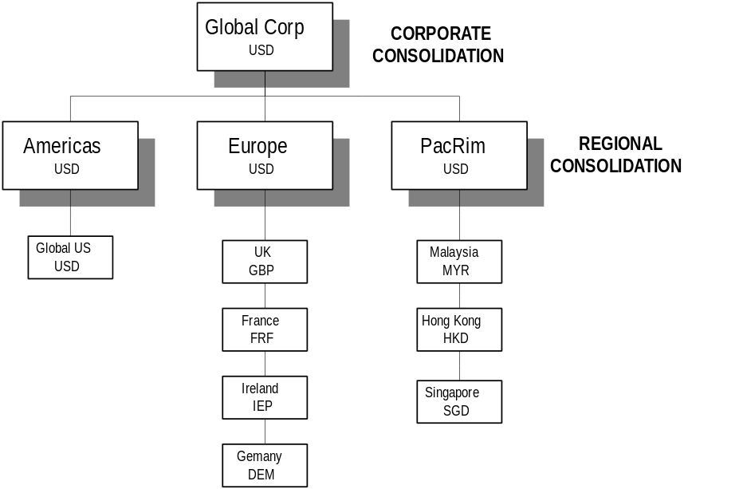

Inventory Organizations
The key architecture parameter that affects the Oracle Manufacturing Applications is the inventory organization. When you enter transactions or query data in these applications, you need to do so from within a particular inventory organization. In general terms, an inventory organization can be thought of as a plant, warehouse, or distribution center, but there are various complex factors you need to consider when specifying the business needs of the individual organization.

Inventory Organization Listing
The following table lists the distinct Oracle Inventory Organizations needed to support the manufacturing and distribution organizations in <Company Short Name>’s business.
Inventory Organization | Abbr or Code | Type | Set of Books | Description
Global Engineering | GBLENG | Item Master | Global US | Centralized Engineering and Item Master
North American Mfg | NAM | Manufacturing | Global US
North American Repair | NAR | Repair | Global US

Inventory Organization Structure
The structure and relationship between the inventory organizations is shown below. The key points about the structure are:

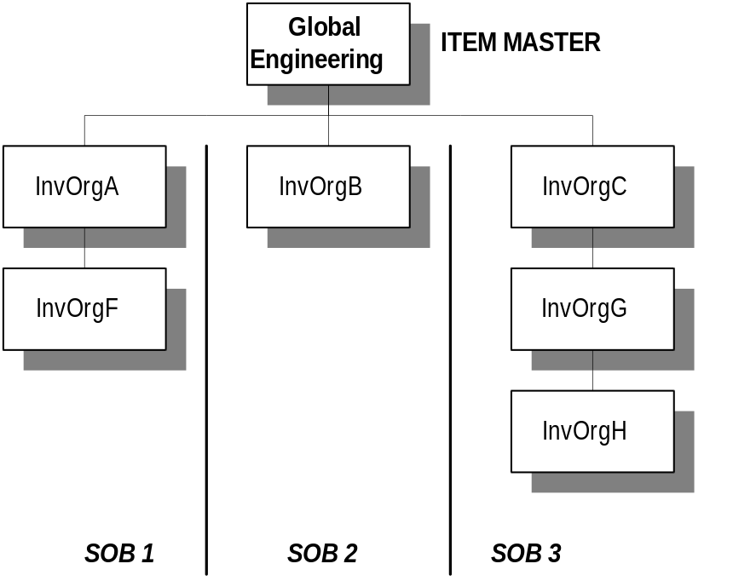

Human Resources Business Groups and Organizations
The key architecture parameters that affect the Human Resources Applications are the business group and HR organizations.

HR Business Group and Organization Listing
The following table lists the distinct Oracle Business Group and HR Organizations needed to support the human resources operations in <Company Short Name>’s business.

HR Organization | Abbr or Code | Type | Business Group | Description
Universal Holdings | Universal | Business Group | Universal Holdings | Highest level corporate HR organization contains all HR data
Western Region | West (313) | HR Organization | Universal Holdings | Western Region operations
Eastern Region | East (311) | HR Organization | Universal Holdings | Eastern Region operations

HR Organization Structure
The following hierarchy shows the Oracle HRMS structure of the HR organizations in <Company Short Name>. The key points of the structure are:

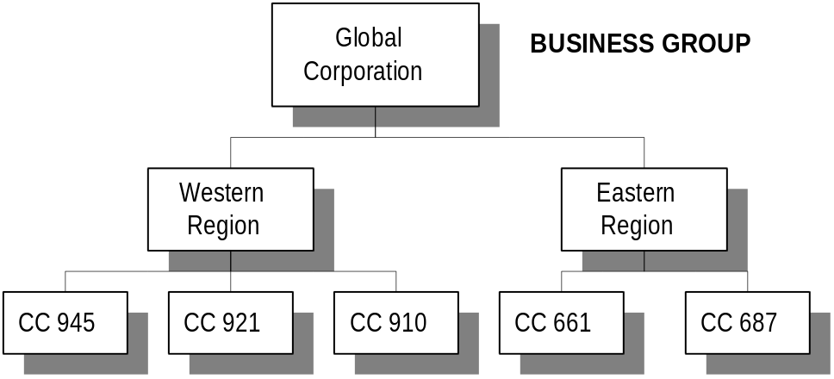

Integrated Application Functional Architecture
The following diagram shows the functional architecture for the integrated finance, distribution, and manufacturing operations of <Company Short Name> when implemented in Oracle Applications. The functional architecture uses the business architecture shown below and develops it to show how the critical architecture parameters relate to the individual business functions which correlate to Oracle Application modules.
The key points of the functional architecture are:

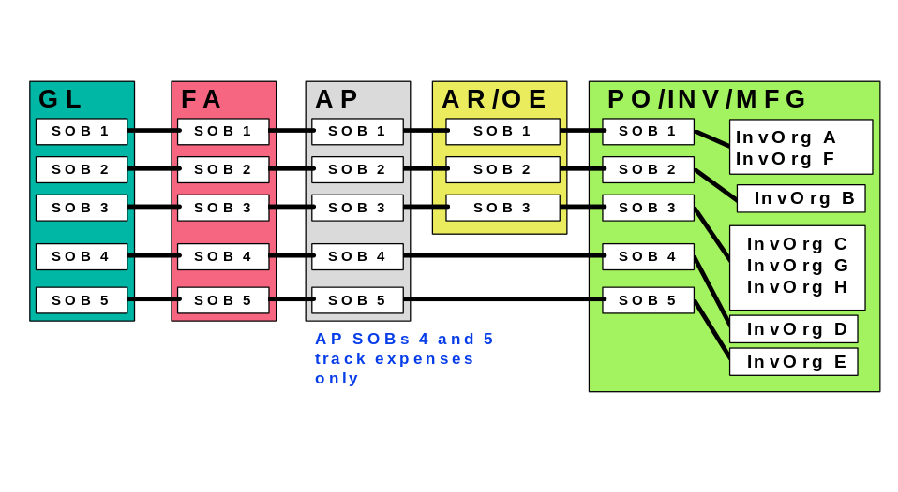

Open and Closed Issues for this Deliverable
Add open issues that you identify while writing or reviewing this document to the open issues section. As you resolve issues, move them to the closed issues section and keep the issue ID the same. Include an explanation of the resolution.
When this deliverable is complete, any open issues should be transferred to the project- or process-level Risk and Issue Log (PJM.CR.040) and managed using a project level Risk and Issue Form (PJM.CR.040). In addition, the open items should remain in the open issues section of this deliverable, but flagged in the resolution column as being transferred.

Open Issues

ID | Issue | Resolution | Responsibility | Target Date | Impact Date

Closed Issues

ID | Issue | Resolution | Responsibility | Target Date | Impact Date

