AIM
TA.090 Application and Database Server Architecture
<Company Long Name>
<Subject>

Author: <Author>
Creation Date: May 27, 1999
Last Updated: June 10, 1999
Document Ref: <Document Reference Number>
Version: DRAFT 1A

Title, Subject, Last Updated Date, Reference Number, and Version are marked by a Word Bookmark so that they can be easily reproduced in the header and footer of documents. When you change any of these values, be careful not to accidentally delete the bookmark. You can make bookmarks visible by selecting Tools->Options…View and checking the Bookmarks option in the Show region.

Approvals:
<Approver 1>
<Approver 2>
To add additional approval lines, press [Tab] from the last cell in the table above.
You can delete any elements of this cover page that you do not need for your document. For example, Copy Number is only required if this is a controlled document and you need to track each copy that you distribute.
Copy Number _____

Document Control

Change Record
1
Date | Author | Version | Change Reference
27-May-99 | <Author> | Draft 1a | No Previous Document

Reviewers

Name | Position

Distribution

Copy No. | Name | Location
 | Library Master | Project Library
 |  | Project Manager
The copy numbers referenced above should be written into the Copy Number space on the cover of each distributed copy. If the document is not controlled, you can delete this table, the Note To Holders, and the Copy Number label from the cover page.

Note To Holders:
If you receive an electronic copy of this document and print it out, please write your name on the equivalent of the cover page, for document control purposes.
If you receive a hard copy of this document, please write your name on the front cover, for document control purposes.
Contents
Document Control
Introduction
Purpose
Scope
Database and Applications Server Architecture Summary
Description
Production Environment
Test Environment
Data Center/Hosting Facility - Corporate
Environment Hosting
Sharing of Environments
Database Tier
Application Tier
Desktop Client Tier
Deployment Site - Corporate
Open and Closed Issues for this Deliverable
Open Issues
Closed Issues

To update the table of contents, put the cursor anywhere in the table and press [F9]. To change the number of levels displayed, select the menu option Insert->Index and Tables, make sure the Table of Contents tab is active, and change the Number of Levels to a new value.

Introduction

Purpose
The purpose of the Application and Database Server Architecture document is to describe the application installations, application server, and database server instances needed to support the business and data processing the new system will perform. It includes:
- definition of the tiered architecture that will be used
- standards used for describing the physical architecture
- strategy for designing the physical database including major operational factors, use of striping and disk arrays (RAID), efficient utilization of disk space ,and facilitation of database administration tasks
- specification of fundamental database parameters
- mapping of the logical database objects to tablespaces and physical datafiles
- estimation of the I/O throughput requirements

Scope
The <Project Name> project Application and Database Server Architecture provides services to support the following key business functions:
Customize this list to indicate the scope of the users of the new architecture.
Define business functions at a very high-level, as these are described in the project a detailed level elsewhere.
Business Organization | Geography | Business Functions
Universal Holdings | HQ, Ralston | Finance, Purchasing, Consolidated reporting
Universal Lock | Salzburg, Aus., Hamburg, Ger., | Finance, Purchasing, Discrete Manufacturing
Universal Security | Toronto, Can. | Finance, Call Center

Database and Applications Server Architecture Summary

Description
Within each data center or hosting facility, there may be a number of Application Server instances and database server instances.
The distribution of application and database servers is based on a number of factors including network bandwidth between users and the primary data center or hosting facility. In many cases, the central data center will house the corporate data server, and a series of remote data centers or hosting facilities will host application servers.
 | Suggestion: Placing application servers in closer proximity to clusters of user web-clients may be advantageous, depending on available network capacity on the corporate wide-area-network.

Production Environment
The characteristics of the architecture are:
Update the diagram below to be an exact statement of the architecture planned. It is not necessary to draw in the network, as this is implied.
Diagram all environments that you will be supporting after go-live such as test, development, production, and training.
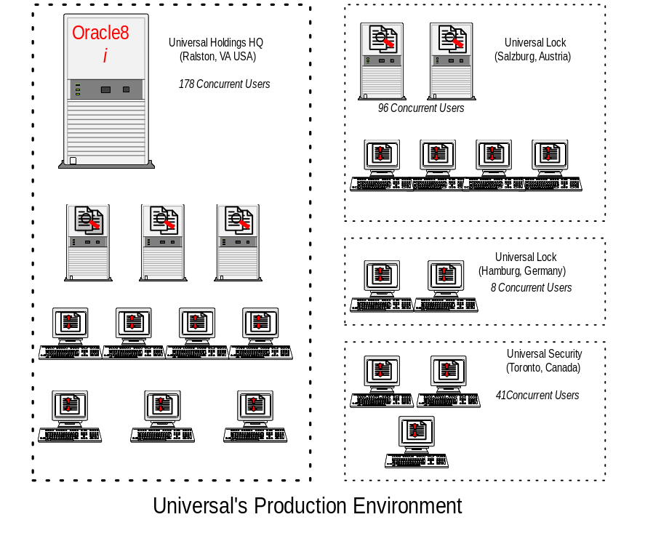

Test Environment
The characteristics of the architecture are:
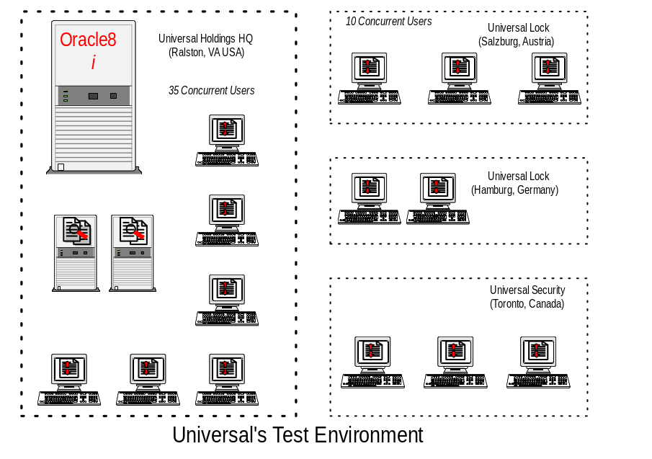

Data Center/Hosting Facility - Corporate
Repeat this section for each Data Center/Hosting facility used to host Database and/or Application Tiers of the architecture.
Alter the qualifier Corporate to an appropriate designation for this Data Center/Hosting Facility.

Environment Hosting
Update this section to reflect the nature of the facilities management arrangement. For example, the corporate data center may be hosted or facility managed by an outside party.
This Data Center/Hosting Facility is owned, managed and controlled by <Company Long Name>. This data center is located at: <Data Center Location>.
Update the checklist below to indicate what other activities are hosted at this Data Center/Hosting facility. Suggest using an "x" or "✓" character. Update list as required.

Sharing of Environments
The environments supported by this Data Center/Hosting Facility are:
- Production - Corporate
- Business Systems Testing
- User Learning (Training)

Database Tier
The database tier holds all data and data-intensive programs, and processes all SQL requests for data. The database tier includes the Oracle database server, the administration server, and the concurrent processing server. The concurrent processing server executes traditional batch processing tasks such as transactional interfaces and reports. By definition, platforms in this tier do not communicate directly with applications users but rather with machines on the application tier that mediate these communications or with other servers on the database tier.

Database Servers
The database server contains the transactional and schema data associated with the Oracle Applications. The platform that supports this server contains two sets of objects. One set is the necessary files that support a running database server, and the other set is a series of database files that contain the actual database data.
Suggestion: One platform may support more than one database instance such as PROD (production) and TEST. One set of database files (executables) may support more than one database instances. There may some restrictions depending on the operating and Oracle database server releases that you are running.
The following Oracle database server instances will be established to support the data conversion activities of the project:
Update the table below to reflect your planned database server use at this data center or hosting facility.
Oracle Database Instance | Platform / DNS | Platform  O/S | Server Release | Function
CONV | Compaq Proliant 640  (trn1) | Windows 3000 Server | Oracle 9.5i | Application Conversion Environment

Naming Standards
This section describes the naming standards that will be used for objects and files relevant to the database architecture:
Object | Naming Standard
File System Mount Points | Standard: ‘/u[01-99]/’  Example: ‘/u03/’
Oracle File Categories | Standard: ‘ ‘’  Example: ‘ ‘
Database Files | Standard: ‘’  Example: ‘’
Tablespaces | Standard: ‘’  Example: ‘’
Mount Points | Standard: ‘’  Example: ‘’

Oracle Database Instance - <ORACLE_SID>
Repeat this entire section for each Oracle SID that exists in the architecture.

Key init.ora Parameter Listing
The following table documents the values of other key database init.ora parameters:
Parameter Name | Parameter Value | Description
_undo_optimizer_changes | TRUE

Additional Database Server Configuration Details
Below are additional configuration details for the database server:
Parameter | Value
What is the platform DNS name | CONV
What Type of Hardware Platform and OS is being used | Sun Solaris 9.5
Oracle Block Size
Net8 Listener Port | 1521
Net8 Report Procedure Call (RPC) Server Port | 1522
Character Set used for database creation | WE8ISO8859P1
Location of Oracle Home Directory | /u01/app/oracle/product/905
Location of Oracle Base Directory | /u01/app/oracle
Is the Optimal Flexible Architecture Standard Being Used | Yes

Tablespace Partitioning
This section describes the basic partitioning of the tablespaces within the production database instances. The partitioning is designed to satisfy <Company Short Name>’s database architecture strategy.
Update the following table with your specific tablespaces and requirements. These are only examples.
Segment Type | Tablespace | Comments
System
Temporary
Rollback
Tools
Misc User
Data
Index

Tablespace Storage Parameters
The following table shows the tablespaces for this Oracle Applications database instance:
Update the following table with your specific tablespaces and requirements. These are only examples.
 |  |  |  | Storage Parameters |  |  |  |  |  | Number of | File Systems
Tablespace | Size  (MB) |  | init |  | nxt | pct | min | max | Datafiles |  | /u1 | /u2 | /u3 | /u4 | /u5
Redo Logs
SYSTEM
RBS
TEMP
USERS
Totals | 0 |  |  |  |  |  |  |  | 0 |  | 0 | 0 | 0 | 0 | 0

Tablespace File Mapping
This section describes the mapping of the tablespace structures onto physical storage files.
Update the following table with your specific tablespaces and requirements. These are only examples. Consider using Oracle’s OFA standards.
Tablespace | Size (MB) | File System | Directory | Datafile
RSEGS | 105 | sd7h | /ora2/ORACLE/proddb | prod_rseg1.dbf
AOLTAB | 105 | sd4g | /ora3/ORACLE/proddb | prod_aoltab1.dbf
ARTAB | 210 | sd4g | /ora3/ORACLE/proddb | prod_artab1.dbf
GLTAB | 262 | sd4g | /ora3/ORACLE/proddb | prod_gltab1.dbf
POIND | 157 | sd4g | /ora3/ORACLE/proddb | prod_poind1.dbf
SHAREIND | 52 | sd4g | /ora3/ORACLE/proddb | prod_sharedind1.dbf
AOLIND | 52 | sd5g | /ora4/ORACLE/proddb | prod_aolind1.dbf

Administrative Servers
The administration server is the machine from which you maintain the data in your Oracle Applications database. There are three types of operations you will carry out here, each using a different program:

Installing and Upgrading the Database
This process is only performed when installing a new release, or upgrading to a new minor or major release.

Applying Applications Database Updates
Most maintenance patches will consist of new files and scripts that update database objects.

Maintaining the Applications Data
Some features, such as MultiLingual Support and Multiple Reporting Currencies, require regular maintenance to ensure updates are propagated to the additional schemas used by these features
Suggestion: The administration server is the most infrequently used, compared to other servers in the Applications multi-tier environment, and it has the smallest computing requirements. You therefore should not need to have more than one administration server for your installation.
The following Administration Servers will be established to support the data conversion activities of the project:
Update the table below to reflect your planned administrative server use at this data center or hosting facility.

Oracle Database Instance | Platform / DNS | Platform  O/S | Server Release | Function
CONV | Sun E-950 (prod1) | Solaris 5.2 | Oracle 9.5i | Applications Conversions Environment

Concurrent Processing Servers
Most interaction with applications data occur through Applications forms. However, there are also reporting programs that periodically need to be run. These programs may contain a very large number of computations. To ensure that they do not interfere with interactive operations, they can be configured to run on a separate machine called the concurrent processing server.
Processes that run on the concurrent processing server are called concurrent programs, and they operate in the background while users continue to work on other tasks. These programs are typically executables written in C or reports written using Oracle Reports.
A request to run a concurrent program is submitted through applications forms, which insert the request into a database table. When the table is read by a monitoring process, the request is assigned to one of several concurrent managers (also referred to as workers) running on the concurrent processing server. The concurrent manager processes the request (which may involve calling another program, for example, or running Oracle Reports), and generates log and output files, which are stored on the concurrent processing server.
 | Additional Information: For an overview of Concurrent Processing, see Oracle Applications Systems Administrator’s Guide.

Suggestion: More than one server (one per platform) may be configured to provide parallel concurrent processing. Parallel concurrent processing allows you to run concurrent managers on multiple servers in your database tier. This distributes the processing load and provides fault tolerance in case one or more servers fail.

The following Concurrent Processing Servers will be established to support the data conversion activities of the project:
Update the table below to reflect your planned administrative server use at this data center or hosting facility.

Oracle Database Instance | Platform / DNS | Platform  O/S | Server Release | Function
CONVE | Sun E-950 (prod1) | Solaris 5.2 | Oracle 9.5i | Applications Conversion Environment

<Platform Name>
Repeat this section for each platform used to support the database tier in your architecture.

Platform Configuration
Describe in detail the configuration of this platform.

Disk Device Map
The worksheet below documents the disk device map on the hardware platform designated as <Platform Name>.
Device | File System | Available Space
C0S0S0 | /u1 | 4,354 | MB
C0S0S1 | /u2 | 654 | MB
 |  |  | MB
 |  |  | MB
 |  |  | MB
 |  |  | MB
 |  |  | MB
 |  |  | MB
 |  |  | MB

I/O Subsystem Configuration
Describe the configuration of the I/O subsystem for this platform.

Application Tier
The application servers form the middle tier between the desktop clients and database servers. They provide load balancing, business logic, and other functionality.
Attention: In installations that use multiple application servers, only one needs to run the Oracle Web Application Server software.

Forms Servers
The forms server is a specific type of application server that hosts the Oracle Forms Server engine. The Oracle Forms Server is an Oracle Developer component that mediates between the desktop client and the Oracle database server, displaying client screens and causing changes in the database records based on user actions. Data is cached on the forms server and provided to the client as needed, such as when scrolling through multiple order lines. The forms server exchanges messages with the desktop client across a standard TCP/IP network connection.
Suggestion: Load balancing among forms servers provides automatic load balancing among multiple application servers. In a load-balancing configuration, a single coordinator called the Metrics Server is on one application server. Metrics Clients located on the other application servers periodically send load information to the Metrics Server so it can determine which has the lightest load. When a client issues a request to download the Forms client applet, the Metrics Server provides the name of the least-loaded host for the applet to connect to.
Update the table below to reflect your planned Forms server use at this data center or hosting facility.
The following Oracle Web Application (Forms) Server instances will be established to support the data conversion activities of the project:
Platform / DNS | Platform  O/S | Server Release | Metric | Forms Port | Forms Server Port | Function
Sun E-950 (was1) | Solaris 5.2 | 2.5 | Server | 8000 | 9000 | Applications Server, Load Management Machine (Production)
Sun E-950  (was2) | Solaris 5.2 | 2.5 | Client | 8000 | 9000 | Applications Server (Production)
Sun E-950  (was3) | Solaris 5.2 | 2.5 | Client | 8000 | 9000 | Applications Server (Production)

Attention: Automatic failover capabilities are inherent in this load-balancing system. If an application server becomes unavailable for any reason, the Metrics Server ceases to route requests to the server until it comes back online. While the application server is offline, requests are routed to one of the other application servers.

Oracle Applications File System
The Oracle Applications File system contains all of the forms and executables that execute of the applications tier of the architecture.

Owner of the File System
The owner of the Oracle Applications File System is: <Userid> (Example: applmgr)

Additional Forms Server Configuration Details
Below are additional configuration details for the Forms Server:
- New Cartridge Configuration Settings
Parameter | Value
Cartridge Name: | <Oracle SID>
Object Path: | $ORACLE_HOME/lib/f65webc.so
Entry Point: | form_entry
- Virtual Paths
Parameter | Value
/Oracle SID | $ORACLE_HOME/lib
Name of DAD to be used: | <Oracle SID>
Protect PL/SQL Agent: | TRUE
Authorized Ports: | <Web Listener Port>
- Cartridge Configuration Screen Values
Parameter | Value
baseHTML | $OA_HTML/afsampled.htm
serverPort | <Forms Port>
userid | APPS/APPS@${ORACLE_SID}
fndnam | APPS

Web Servers
The web server is another type of application server, which runs an HTTP listener. The HTTP listener (also called a web listener) is a component of an HTTP server, such as Microsoft Internet Information Server, or Netscape Enterprise Server. This listener accepts incoming HTTP requests (or URLs) from desktop clients, through the web browser or appletviewer. These requests are either immediately processed, for example, by returning an HTML document, or they are passed on to the Oracle Web Application Server, which also resides on the same platform.
The following web servers will be established to support the data conversion activities of the project:
- Update the table below to reflect your planned web server use at this data center or hosting facility.

Server  Name | Platform / DNS | Platform  O/S | Server Release | UDP Port | Admin Port | Function
CONV | Sun E-950 (prod1) | Solaris 5.2 | 5.4 | 2649 | 8888 | Applications Conversion Environment

Additional Web Server Configuration Details
Below are additional configuration details for the web server:

Virtual Directories
File System | Directory Flag | Virtual Path
$APPLTMP | NR | /OA_TEMP/
$APPL_TOP/doc/doc/ | NR | /OA_DOC/
$APPL_TOP/html/html/ | NR | /OA_HTML/
$APPL_TOP/html/html/bin/ | CN | /OA_HTML/bin/
$ORACLE_HOME/forms65/java/ | NR | /OA_JAVA/
$ORACLE_HOME/forms65/java/oracle/apps/media/ | NR | /OA_MEDIA/

Java Cartridge Path
Virtual Path | Application | Physical Path
/OA_JAVA_SERV | JAVA | $ORACLE_HOME/forms65/java

DAD Settings
Parameter | Value
DAD Name: | <Oracle SID>
Database User: | APPS
Identified by: | APPS
Database User Password: | APPS
ORACLE HOME: | $ORACLE_HOME
Net8 Service: | <Oracle SID>
NLS Language: | American

PL/SQL Cartridge Settings
Parameter | Value
Name of PL/SQL Agent: | <Oracle SID>
Name of DAD to be used: | <Oracle SID>
Protect PL/SQL Agent: | TRUE
Authorized Ports: | <Web Listener Port>

PL/SQL Virtual Path
Virtual Path | Application | Physical Path
/<Oracle SID>/plsql | PLSQL | $ORACLE_HOME/ows/6.0/bin

<Platform Name>
- Describe in detail the configuration of this platform.
- Repeat this section for each platform used to support the application tier in your architecture.

Disk Device Map
The worksheet below documents the disk device map on the hardware platform designated as <Platform Name>.
Device | File System | Available Space
C0S0S0 | /u1 | 4,354 | MB
C0S0S1 | /u2 | 654 | MB
 |  |  | MB
 |  |  | MB
 |  |  | MB
 |  |  | MB
 |  |  | MB
 |  |  | MB
 |  |  | MB

I/O Subsystem Configuration
- Describe the configuration of the I/O subsystem for this platform.

Desktop Client Tier
The desktop client runs a Java applet using a Java-enabled web browser or appletviewer. The applet sends user requests to the forms server and handles such responses as screen updates, pop-up lists, graphical widgets, and cursor movement. It can display any Oracle Applications screen and supports field-level validation, multiple coordinated windows, and data entry aids like lists of values. A web browser or appletviewer manages the downloading and storage of the Forms client applet on each user’s desktop. They also supply the Java Virtual Machine (JVM) that runs the Forms client applet.
 | Security: Security features ensure that the Forms server only accepts connections from "certified" Forms clients bearing the Oracle Applications signature. For additional security, all communication between the Forms client applet and Forms server is encrypted using the RSA RC4 40-bit standard form of encryption.

Deployment Site - Corporate
- Repeat this section for each site where the client tier is deployed.
Alter the designation "Corporate" to reflect the actual common name for each particular deployment site, for example "Rome".

Application and Database Tier Servers Supporting this Deployment Site
The table below identifies the Application Tier servers that the clients at this site will connect to.

Database Tier:
Oracle Database Instance | Platform / DNS | Platform  O/S | Server Release | Function
PROD | Sun E-950 (prod1) | Solaris 5.2 | Oracle 9.5i | Applications Production Environment

Applications Tier:
Platform / DNS | Platform  O/S | Server Release | Metric | Forms Port | Forms Server Port | Function
Sun E-950 (was1) | Solaris 5.2 | 2.5 | Server | 8000 | 9000 | Applications Server, Load Management Machine (Production)
Sun E-950  (was2) | Solaris 5.2 | 2.5 | Client | 8000 | 9000 | Applications Server (Production)
Sun E-950  (was3) | Solaris 5.2 | 2.5 | Client | 8000 | 9000 | Applications Server (Production)

Web Browsers
Below are the web browsers that will be supported by the project during deployment:
- List Browsers: Name, OS, Version.

Web Appliances
Web appliances are devices that are capable of supporting the presentation and execution of a Java applet. These may be single purpose devices or mobile devices. Below are the web appliances that will be supported by the project during deployment:
- List web appliances: Name, Manufacturer, Model Number.

Applet Viewers
Applet views are run time environments that run on an operating system and present and execute Java applets. Below are the applet viewers that will be supported by the project during deployment:
- List applet viewer: Name, OS, Version.

Open and Closed Issues for this Deliverable
- Add open issues that you identify while writing or reviewing this document to the open issues section. As you resolve issues, move them to the closed issues section and keep the issue ID the same. Include an explanation of the resolution.
When this deliverable is complete, any open issues should be transferred to the project- or process-level Risk and Issue Log (PJM.CR.040) and managed using a project level Risk and Issue Form (PJM.CR.040). In addition, the open items should remain in the open issues section of this deliverable, but flagged in the resolution column as being transferred.

Open Issues

ID | Issue | Resolution | Responsibility | Target Date | Impact Date

Closed Issues

ID | Issue | Resolution | Responsibility | Target Date | Impact Date

