AIM
TA.120 Platform and Network Architecture
<Company Long Name>
<Subject>

Author: <Author>
Creation Date: May 28, 1999
Last Updated: June 10, 1999
Document Ref: <Document Reference Number>
Version: DRAFT 1A

Title, Subject, Last Updated Date, Reference Number, and Version are marked by a Word Bookmark so that they can be easily reproduced in the header and footer of documents. When you change any of these values, be careful not to accidentally delete the bookmark. You can make bookmarks visible by selecting Tools->Options…View and checking the Bookmarks option in the Show region.

Approvals:
<Approver 1>
<Approver 2>
To add additional approval lines, press [Tab] from the last cell in the table above.
You can delete any elements of this cover page that you do not need for your document. For example, Copy Number is only required if this is a controlled document and you need to track each copy that you distribute.
Copy Number _____

Document Control

Change Record
1
Date | Author | Version | Change Reference
28-May-99 | <Author> | Draft 1a | No Previous Document

Reviewers

Name | Position

Distribution

Copy No. | Name | Location
 | Library Master | Project Library
 |  | Project Manager
The copy numbers referenced above should be written into the Copy Number space on the cover of each distributed copy. If the document is not controlled, you can delete this table, the Note To Holders, and the Copy Number label from the cover page.

Note To Holders:
If you receive an electronic copy of this document and print it out, please write your name on the equivalent of the cover page, for document control purposes.
If you receive a hard copy of this document, please write your name on the front cover, for document control purposes.
Contents
Document Control
Introduction
Purpose
Scope
Platform and Network Standards
Platform Standards
Network Standards
Enterprise Platform and Network Architecture
Technical Configuration
Platform Deployment
Network Connections
Platform and Network Architecture for <Data Center/Hosting Facility Name>
Technical Configuration
Database/Application Tier
Data Center Network Configuration
Client Desktop Tier for <Deployment Site Name>
Open and Closed Issues for this Deliverable
Open Issues
Closed Issues

To update the table of contents, put the cursor anywhere in the table and press [F9]. To change the number of levels displayed, select the menu option Insert->Index and Tables, make sure the Table of Contents tab is active, and change the Number of Levels to a new value.

Introduction

Purpose
The purpose of the Platform and Network Architecture document is to describe the physical platform and network configuration to support the final Platform and Network architecture. You map the physical application and database server architecture onto specific computing platforms included in the scope of the <Project Name> Application and Technical Architecture process.

Scope
The <Project Name> platform and network architecture work covers the following topics:

Platform and Network Standards
Depending on how much work on this was done in the Architecture Requirements and Strategy (TA.010) deliverable, may only need to copy or reference work done previously in this section.

Platform Standards
This section describes the standards that the <Project Name> project platforms should meet.
These standards were arrived at by:
Describe the process used for creating Platform Standards.
The platforms standards cover the following components and hardware types:
Modify as appropriate to your project.

- hardware platform servers
- Internet/web servers
- data storage media
- networking devices
- networking protocols
The standards for platform servers are summarized in the following table:
Platform Server Class | Hardware Standard | Vendor | Operating System | Platform Resources | Comments
Database Server
Concurrent Management
Administration
Web
Forms
Printing

Network Standards
This section describes the standards that the <Project Name> project networks should conform to.
These standards were arrived at by:
Describe the process used for creating Network Standards.

The network standards cover the following network components:
- Wiring
- Protocols
- Routers
- Bridges
- Modems
The following are some sample standards. Replace with the standards for your business.

Wiring
The standards for network wiring are summarized in the following table:
Application/ Circuit Type | Network Standard | Network Speed | Cable Type | Comments
LAN | Ethernet | 10Mb/sec, 100 Mb/sec, Gigabit | UTP, STP, Coaxial | 10BaseT, 100BaseT, 10Base2, 10Base5, Gigabit Ethernet
LAN | Token Ring | 4Mb/sec, 16Mb/sec | UTP, STP | IBM “standard”
LAN | Arcnet | 2.5Mb/sec | UTP | Non-IEEE standard
LAN | LocalTalk | 232Kb/sec | UTP | Apple Computer’s Peer-to-Peer networking “standard” running Apple’s AppleTalk protocol
LAN | EtherTalk | 10Mb/sec, 100Mb/sec, Gigabit | UTP | Apple Computer’s Implementation of AppleTalk over Ethernet. EtherTalk can support both AppleTalk as well as standard Ethernet hosted protocols
LAN | FireWire | 400Mb/sec | FireWire Cable | Supported by Apple, and other hardware manufactures. Often used in high-bandwidth multimedia applications. Hot-pluggable. Greater than a 600 device limit. Self-Configuring.
LAN, Device Bus | Universal Serial Bus | 12/Mb/sec | UTP/USB | Used for device bus. May also be used for rudimentary file transfer. Hot-pluggable. 127 device limit.
LAN | FDDI/CDDI | 100Mb/sec | Fiber Optic, Copper | Common “Backbone” use

Note: Kb/sec = kilobits per second, Mb/sec = megabits per second, UTP = Unshielded Twisted Pair, STP = Shielded Twisted Pair, XXBaseT = Twisted Pair cabling solution, 10Base2 = Thin Coaxial cabling solution, 10Base 5 = Thick Coaxial cabling solution
The following are some sample standards. Replace with the standards for your project.

LAN Transport and Protocols
The standards for LAN transport and protocols are summarized in the following table:
Network/Host Operating System/Environment | “Native” Network/Transport Protocols | Application/Circuit Type | Comments
Novell NetWare | IPX/SPX
IBM LAN Server | NETBEUI
Windows/NT | NETBEUI, TCP/IP, IPX/SPX
DEC Pathworks | DECnet, NETBEUI
IBM Mainframe | SNA
Apple MacOS, MacOS-X Server and Client Edition | AppleTalk, IPX/.SPX, TCP/IP, NETBEUI (with MacOS-X Server)

WAN Transport and Protocols
The standards for WAN transport and protocols are summarized in the following table:
WAN protocol standard | Bandwidth | Application/Circuit Type | Comments
Frame Relay | T1- 1.54 Mbps | Point-to-Point
ISDN | 128 Kbps
ATM | T1-T3
PPP |  |  | On-Demand Dial or fixed

Enterprise Platform and Network Architecture

Technical Configuration
Describe the salient features of the overall enterprise technical configuration here.
If the architecture is primarily or totally based on the 3-tier Web-Client/Server architecture of Oracle Applications, then mention that here.
Explain the transaction, reporting and data warehousing systems, how they are linked, and who uses them.
Diagrams are an effective way to present information in architecture work, so use them wherever possible to reduce the need for lengthy description.
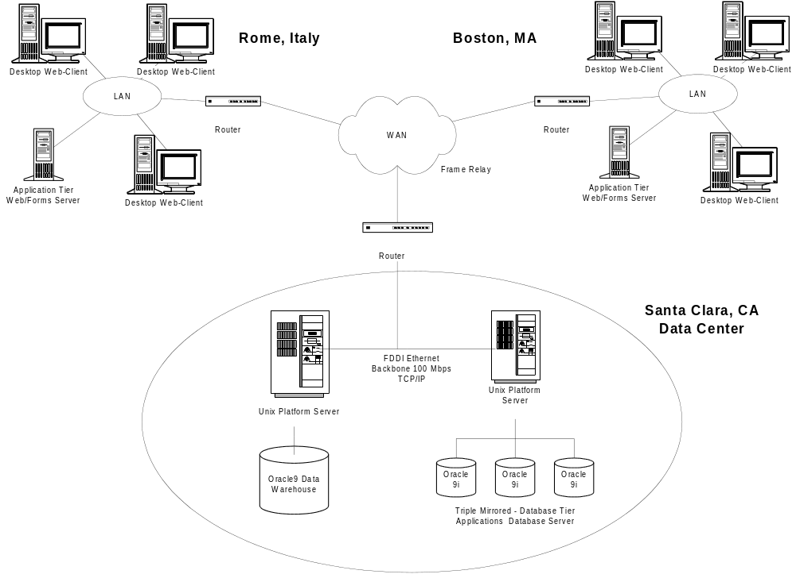

Client Desktop Environment
If there are enterprise-wide standard architecture strategies and configurations for the desktop clients and application client file servers, mention them here, or else reserve the discussion for the data centers.
Clients will be primarily PCs running Microsoft Windows located at the work sites.

Platform Deployment

Servers
The main database servers will be located at: <Location>.
The configuration of each server is detailed below.
Server | Model | Number of CPUs | Disk Space | Disk Controller | Total RAM | Backup Media

Network Connections
The Enterprise Network Architecture of <Company Short Name>‘s network is of the <Network Type> type.
Describe Network Topology.
Characterize main network connections - protocol, bandwidth, latency, # of routers or bridges and so on.
Describe the salient features of the enterprise network architecture. Focus on the most important network connections that link data centers or major offices.
Site 1 | Site 2 | Network Type | Protocol | Band width | Latency | Network Hops | Comments

Platform and Network Architecture for <Data Center/Hosting Facility Name>
Repeat this section for each Data Center/Hosting Facility in the architecture.

Technical Configuration
Describe the salient features of the data center technical configuration here.
Diagrams are an effective way to present information in architecture work so use them wherever possible to reduce the need for lengthy description.
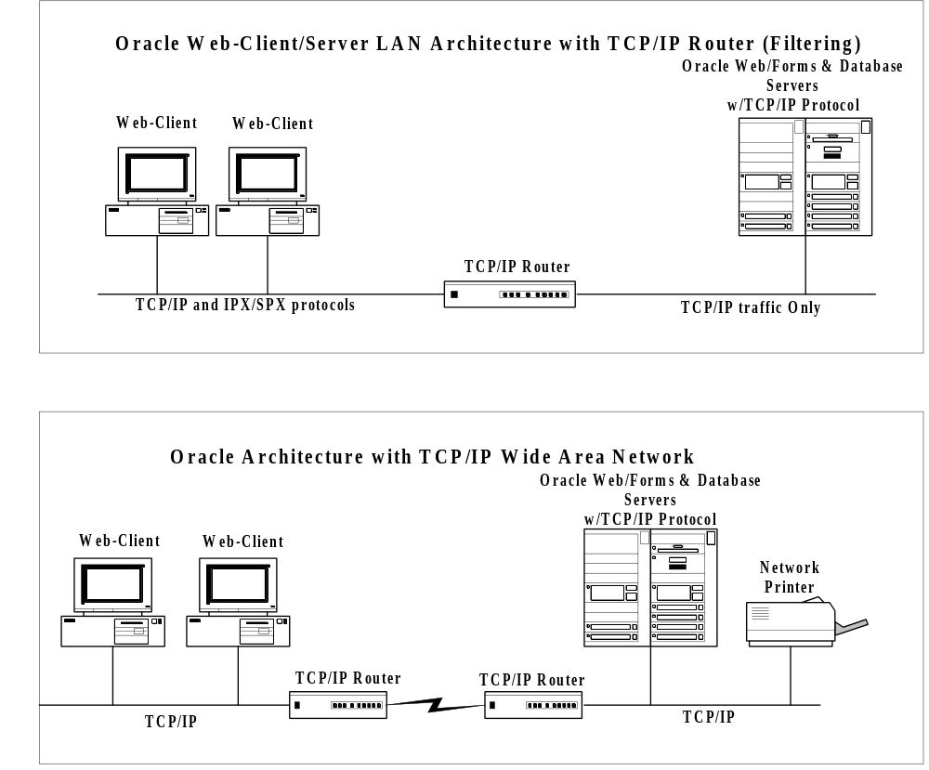

Database/Application Tier

Server Mapping
This section describes the servers that support each application.
Application Type | Application Environment | Platform Type | Platform DNS Name | O/S Version | Facility
Database | PROD | Sun E-1250 | PROD1 | Solaris 7.5 | Corporate
Concurrent | PROD | Sun E-1250 | PROD1 | Solaris 7.5 | Corporate
Administration | PROD | Sun E-1250 | PROD1 | Solaris 7.5 | Corporate
Web | PROD | Compaq Proliant 2300 | PRODW1 | NT3000 | Corporate
Web | PROD | Compaq Proliant 2300 | PRODW2 | NT3000 | Corporate
Web | PROD | Compaq Proliant 2300 | PRODW3 | NT3000 | Corporate
Forms | PROD | Compaq Proliant 2300 | PRODW1 | NT3000 | Corporate
Forms | PROD | Compaq Proliant 2300 | PRODW2 | NT3000 | Corporate
Forms | PROD | Compaq Proliant 2300 | PRODW3 | NT3000 | Corporate

Include only the new data servers or both existing and new servers depending on the use of this deliverable. Data servers could be for OLTP systems, reporting systems, standby servers, and data warehouses.

Platform Server Configuration
The configuration of each platform is detailed below.
Server | Model | No. of CPUs | Disk Space | Disk Controller | Total RAM | Backup Media
PROD1 | Sun E-1250 | 8 | 32GB | 4-Ch/SCSI | 4GB | 12GB DLT
PRODW1 | Compaq Proliant | 4 | 12GB | 2-Ch/SCSI | 2GB | 12GB DLT
PRODW2 | Compaq Proliant | 4 | 12GB | 2-Ch/SCSI | 2GB | 12GB DLT
PRODW3 | Compaq Proliant | 4 | 12GB | 2-Ch/SCSI | 2GB | 12GB DLT

Data Center Network Configuration

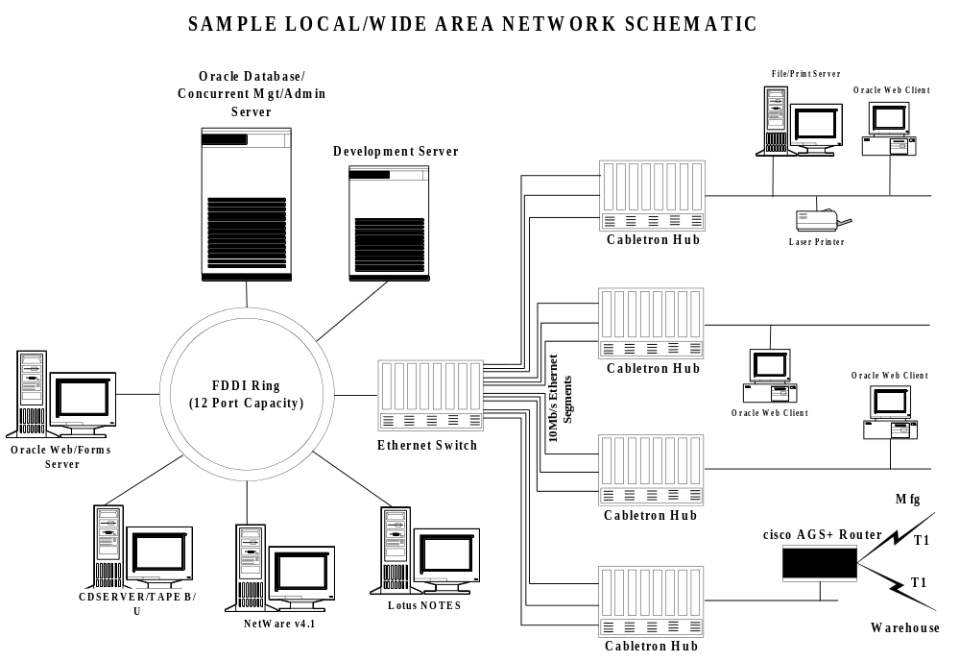

Network Specifications
Description of basic network architecture and topology.
Site 1 | Site 2 | Network Type | Protocol | Band width | Latency | Network Hops | Comments

Client Desktop Tier for <Deployment Site Name>
Repeat this section for each deployment site for the Client Desktop Tier in the architecture

Client Desktop Environment
Describe the architecture of the client desktop environment, including desktop client. The text here is an example.
Clients will be primarily PCs running Microsoft Windows located at the work sites. The diagram above illustrates the locations of all components. These systems will be running Netscape Communicator version 9.5 and will be configured with 48MB of RAM and 35 MB of available disk space. They will be connected to the corporate LAN/WAN at 10MBS.

Printer Deployment
The printers that will be used for the production system report printing are of the types:

The specifications of the printers are:

The printer deployment strategy is:
Describe how the printers will be distributed and what the minimum size is for unit of the business to get its own printer, for example, a printer on every floor of a building.

Peripheral Devices
The types of peripheral devices that are part of <Company Short Name>‘s <Project Name> technical architecture are:
- Modems

The impact of the peripheral devices on the technical architecture is:

Open and Closed Issues for this Deliverable
Add open issues that you identify while writing or reviewing this document to the open issues section. As you resolve issues, move them to the closed issues section and keep the issue ID the same. Include an explanation of the resolution.
When this deliverable is complete, any open issues should be transferred to the project- or process-level Risk and Issue Log (PJM.CR.040) and managed using a project level Risk and Issue Form (PJM.CR.040). In addition, the open items should remain in the open issues section of this deliverable, but flagged in the resolution column as being transferred.

Open Issues

ID | Issue | Resolution | Responsibility | Target Date | Impact Date

Closed Issues

ID | Issue | Resolution | Responsibility | Target Date | Impact Date

