PJM
RM.040 Physical Resource Plan
<Company Long Name>
<Subject>

Author: <Author>
Creation Date: March 5, 1999
Last Updated: September 14, 1999
Document Ref: <Document Reference Number>
Version: DRAFT 1A

Title, Subject, Last Updated Date, Reference Number, and Version are marked by a Word Bookmark so that they can be easily reproduced in the header and footer of documents. When you change any of these values, be careful not to accidentally delete the bookmark. You can make bookmarks visible by selecting Tools->Options…View and checking the Bookmarks option in the Show region.

Approvals:
<Approver 1>
<Approver 2>
To add additional approval lines, Press [Tab] from the last cell in the table above.
You can delete any elements of this cover page that you do not need for your document. For example, Copy Number is only required if this is a controlled document and you need to track each copy that you distribute.
Copy Number _____

Document Control

Change Record
5
Date | Author | Version | Change Reference
5-Mar-99 | <Author> | Draft 1a | No Previous Document

Reviewers

Name | Position

Distribution

Copy No. | Name | Location
 | Library Master | Project Library
 |  | Project Manager
The copy numbers referenced above should be written into the Copy Number space on the cover of each distributed copy. If the document is not controlled, you can delete this table and the Copy Number label from the cover page.

Note To Holders:
If you receive an electronic copy of this document and print it out, please write your name on the equivalent of the cover page, for document control purposes.
If you receive a hard copy of this document, please write your name on the front cover, for document control purposes.
Contents
Document Control
Change Record
Reviewers
Distribution
Introduction
Environment Requirements
Support Tools Required
Application/Development Environments
High-level Database Topology
Sizing Summary
Instance Synchronization Approach
Legacy Systems and Support
Infrastructure Plan
Physical Resources
Planned Changes to Resources
Test and Porting Environments
Network Setup
System Administration
Procurement Plan
Hardware Support Policy
Service Definition
Services
Areas of Responsibility
Availability and Notification Periods
Reporting Arrangements
Client Responsibilities
Client Responsibilities
Computer Access and Security
Site Access
Procedures
Service Loss Procedure
Service Incident Procedure
Service Change Procedure

To update the table of contents, put the cursor anywhere in the table and press [F9]. To change the number of levels displayed, select the menu option Insert->Index and Tables, make sure the Table of Contents tab is active, and change the Number of Levels to a new value.

Introduction
This document summarizes the hardware and software required by <Project Name> at <Company Long Name>. It describes systems needed by the project team to carry out project activities, but does not attempt to define the technical architecture of the production system. This document serves as a planning document during the initial stages of the project to ensure that the required environment is in place as each stage of the project commences.
This document will be succeeded by the following additional documents that will describe related requirements in more detail:
Adjust these titles to support your project deliverables. Tables and lists in this template are generally applicable to AIM and will need adjustment for CDM.

- Project Infrastructure
- Application Sizing spreadsheets
- Installation planning worksheets
- Application Architecture (high-level and detail)
- Technical Architecture (high-level and detail)
- Backup and Recovery Plan
- Design and Development Standards

Environment Requirements
Special computer hardware and software is required to support <Project Phase> of the <Company Short Name> project <Project Name>. At a minimum, this includes

Support Tools Required
The table below summarizes the tool requirements of significant tasks throughout the project:
Milestone Task | Applications | Word Processing | Diagram-ming | CASE Tools | Source Control
Assess Current Business |  | ✓ | ✓ | ✓
Define Future Business | ✓ | ✓ | ✓ | ✓
Propose Technical Architecture |  | ✓ | ✓
Train Project Team | ✓ | ✓
Map Business Requirements | ✓ | ✓
Define Business Solution | ✓ | ✓ | ✓ | ✓
Design Custom Modules | ✓ | ✓ | ✓ | ✓ | ✓
Design Technical Architecture | ✓ | ✓ | ✓
Construct Programs | ✓ | ✓ |  | ✓ | ✓
Perform Business System Test | ✓ | ✓ |  |  | ✓
Convert Data | ✓ | ✓ |  | ✓ | ✓
Train Users | ✓
Implement Production Environment | ✓ | ✓ |  |  | ✓
Accept System | ✓ | ✓
Commence Production | ✓
Support Production System | ✓ | ✓ |  |  | ✓
Monitor Performance | ✓ | ✓ | ✓
Refine System | ✓ | ✓ | ✓ | ✓ | ✓
Modify the check marks (using cut/paste) to represent YOUR project. You can add columns for additional requirements.
The software selected for each of the above is as follows:
Applications Oracle Cooperative Applications
Word Processing Microsoft Word for Windows
Diagramming Visio
Microsoft Powerpoint
Oracle Designer
(Tool dependent on type of diagram)
Design Tools Oracle Designer
Configuration Management <Configuration Mgmt System>

Application/Development Environments
The table below summarizes the application/development environments required to support the project team during the project:

Milestone Task | Demo Database  DEMO | Test Install  TEST | Develop-ment  APPDEV | Conversion  CONVTEST | Production  FINPROD  MFGPROD
Assess Current Business
Define Future Business | ✓
Propose Technical Architecture
Train Project Team | ✓
Map Business Requirements |  | ✓
Define Business Solution |  | ✓
Design Custom Modules |  | ✓ | ✓
Design Technical Architecture |  | ✓
Construct Programs |  |  | ✓ | ✓
Perform Business System Test |  | ✓ | ✓ | ✓
Perform Performance Assurance Test |  |  |  |  | ✓
Convert Data |  |  | ✓ | ✓ | ✓
Train Users |  | ✓
Implement Production Environment |  |  |  |  | ✓
Accept System |  |  |  |  | ✓
Commence Production |  |  |  |  | ✓
Support Production System |  | ✓ | ✓ |  | ✓
Monitor Performance |  |  |  |  | ✓
Refine System |  | ✓ | ✓ |  | ✓

High-level Database Topology
<Company Short Name> will initially have a single system for training, mapping, and development tasks. A second production system will be installed after detailed requirements analysis. The planned location of the various project databases on each system is shown below.

Diagram Conventions
In the diagram below, each server is represented by a shaded box that represents the physical machine. Databases on the machine are represented with the familiar drum symbol:
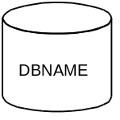
DBNAME is the name of the database instance (referenced by the environment variable ORACLE_SID). Databases that share the same set of application executables are grouped together within a box that resembles a building:
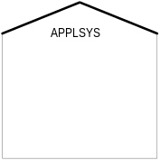
The name at the top identifies the application environment file that sets the environment variables to product directories (i.e., APPLSYS.env). Each application environment may be a different version of applications. This allows us to test and migrate customizations to the next release of applications while the users continue to run against the prior version.
Databases that are independent of applications are not contained within an environment box (in this example, CASE).
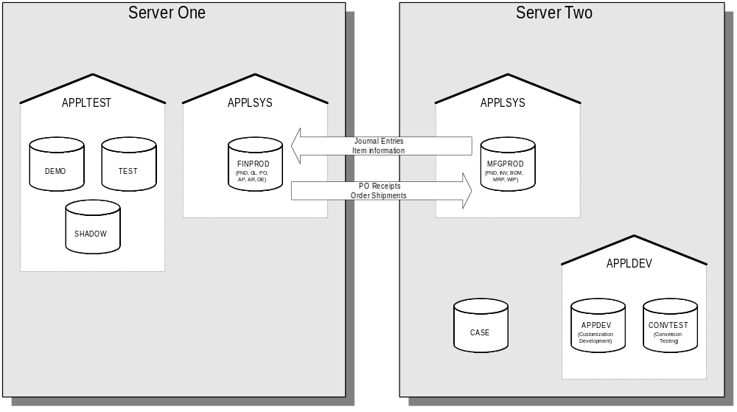
Double-click picture above to edit drawing.
(This diagram is also included in the Scope, Objectives, and Terminology document.)
Change Server One and Server Two to the actual names of your servers.

Sizing Summary
Preliminary database sizing has been performed for the project databases using the Oracle Applications Sizing Spreadsheet. The results are summarized below with additional requirements for operating system and software tools.

Component | Server One (Mb) | Server Two (Mb)
Operating System | 0 | 0
Swap Space | 0 | 0
User Directories | 0 | 0
Documentation Repository | 0 | 0
Oracle Executables | 0 | 0
Application Executables | 0 | 0
SYSTEM Tablespaces | 0 | 0
Rollback Segments | 0 | 0
Archiving Files | 0 | 0
Temp Space | 0 | 0
Total Applications Data | 0 | 0
Total Applications Indexes | 0 | 0
CASE database | 0 | 0
Oracle Bookviewer Files | 0 | 0
Space for Export files | 0 | 0
 | 0 | 0
TOTAL DISK SPACE | 0 | 0

Instance Synchronization Approach
Clients will want to use their own data to work with as soon as possible. The consultant will find that each time the client sets up a new instance of the database, he will assume that this will be his production database. These new databases soon become overrun with test data and cannot be used as production. Managing these pre-production databases has to be dealt with by system administrators and users, as they roll good information from one pre-production environment to the next.
Since separate instances will be set up for training, mapping, development, testing, and production, a mechanism is required to migrate setups established during mapping to the subsequent environments. This process is referred to as instance synchronization.
The first two Applications Instances are the demo database (DEMO) and a test instance (TEST). The first contains setup data that is seeded from Oracle. The second will be used during mapping to prototype business solutions and make configuration decisions. Therefore, neither of these environments is suitable as the source of setup information.

Target Live Setup
To support instance synchronization, a third instance (SHADOW) will be established to hold the target live setup (TLS). When configuration decisions are finalized, the project team will perform the required configuration in the SHADOW environment. At the end of the Solution Design stage, this environment will contain all the setup information required for the Business Systems Test, Performance Assurance Testing, End-User Training, and Production environments. Refinements to the target live setup may be made as the result of each of these activities.
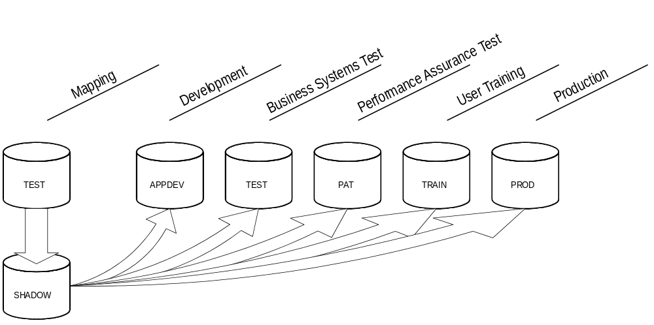

Legacy Systems and Support
It may be that the client wants to run some applications on legacy system and have a partial or phased implementation of Oracle applications.
<Company Short Name> currently has the following internal systems running on various hardware platforms:
Application | Purpose | System Name | Hardware Type | Operating System | Database Type | Retain?
Acme GL | General Ledger | ALPHA1 | IBM 4341 | MVS | DB2 | No
Systems with “Yes” in the Retain? column will be retained after the project. Interfaces between these systems and the Oracle Software will be required. The specific interfaces will be defined in the Application Architecture document (created during Analysis and Design stages).

Infrastructure Plan
Describe here the physical resources to implement the environment requirements, together with planned changes to the infrastructure during the life of the project

Physical Resources

Planned Changes to Resources

Test and Porting Environments

Network Setup

System Administration

Procurement Plan
New hardware and software to support the project will be procured according to the following schedule:
Vendor | Model/ Package | Description | Purpose | Scheduled Delivery | Delivered?
Sequent | S99-001 | 32 Processor Sequent Symmetry | Training |  | Yes
 |  |  | Evaluation |  | No
 |  |  | Production
Procurement will be made using the client/Oracle purchasing arrangments.

Hardware Support Policy
Define here the policy for hardware support for the project. This may be a delegated responsibility to either client staff or a sub contractor or may be performed in part by the project team, eg backups.
The hardware support policy for this project is:

Service Definition

Services

Areas of Responsibility

Availability and Notification Periods

Reporting Arrangements

Client Responsibilities

Client Responsibilities

Computer Access and Security

Site Access

Procedures
The following examples may be appropriate for your assignment, but other procedures you will use may be relevant.

Service Loss Procedure

Service Incident Procedure

Service Change Procedure
Define here project specific arrangements or refer out to other documents

