# Workshop: Pet Care

You are assigned to implement a **Web application** (SPA) using JavaScript. The application should dynamically display content, based on user interaction, and support user-profiles and CRUD operations, using a REST service.

## Pet Care – Overview

*You will receive running* ***SPA - Pet Care****. The app* ***allows******visitors*** *to* ***view******different******pets****, including* ***name****,* ***breed*** *and* ***age****. Users can* ***register*** *and* ***log in*** *with an* ***email*** *and* ***password****, allowing them to create their pet* ***postcard****. Pet creators can also* ***edit*** *or* ***delete*** *their* ***posts*** *at any time.*

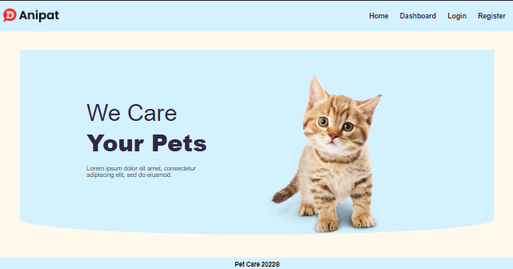

## Start the Application

First you must **install all dependencies** included in the **package.json** file by typing **npm install** in a **terminal**.

|  |
| --- |
| **npm install** |

Then you must **serve** the app by typing **npm start** in a **terminal**.

|  |
| --- |
| **npm start** |

After that **Pet** **Care** could be accessed on [http://localhost:3000](http://localhost:3000/) URL.

To work with **Observables**, we need to use the **RxJS** **library.**

|  |
| --- |
| npm install rxjs |

## Rewrite Async/Await Functions

The **application** works with **async/await functions**, your task is to **rewrite** the **async/await functions** into functions, which use **observables**.

### Example – LoginUser Function

Here is how you can **rewrite** the **loginUser** function as an **Observable** using **RxJS.**

In this code, we use the **from** operator to **create** an **Observable** from the result of the **fetch** call. We then use the **map** operator to check if the **response** is **OK** and **throw** an **error** if it's **not**. Finally, we **return** the **Observable** with the **transformed** **response**.

### Example – Login Function

Here's how you can **rewrite** the **login** **function** as an **Observable** using **RxJS**.

In the above code, we **import** the **fromEvent**, **map**, **switchMap**, and **throwError** **operators** from **RxJS**. We then define the **login** **function**, which takes an e **event** **parameter**. Inside the function, we extract the **email** and **password** values from the **form** **data**.

In the above code, we use the **fromEvent** operator from **RxJS** to convert the form **submission** **event** to an **observable**. We then use the **switchMap** operator to **switch** to the **loginUser** **observable** when the **form** is **submitted**. We also use the **catchError** **operator** to **catch** any **errors** that occur **during** the **login** **process**.