

MACAU UNIVERSITY OF SCIENCE AND TECHNOLOGY

School of Computer Science and Engineering
Faculty of Innovation Engineering

Senior Thesis for the Degree of Bachelor of Science

Ancient poetry generation system based on pre-trained BERT model

Student Name : ZHU YANYAN
Student No : 20098533-I011-0031
Supervisor : LIANG ZHIYAO

May, 2024

澳門科技大學

創新工程學院
計算機科學與工程學院
理學學士學位畢業論文

論文題目: 基于预训练BERT语言模型的古诗生成系统

姓 名: 朱彦燕
學 號: 20098533I0110031

指導老師: 梁之遥

2024年5月

Abstract
This paper introduces how to use pre-trained BERT model to generate Chinese ancient poems and the realization process. First of all, starting with data preparation, this paper introduces how to process the ancient poetry data set and construct the data reader. Then, the setting and training process of the ancient poetry generation model based on BERT model are introduced in detail, including pre-training BERT model, defining model loss, model preparation and model training. In the aspect of generating ancient poems, this paper provides the example code of generating ancient poems, and explains the implementation principle. Finally, this paper shows how to use the trained model to generate examples of ancient poems, and the generated results are displayed and analyzed.
Keywords: Chinese ancient poetry generation, BERT model, Text generation, natural Language processing, Deep learning

摘要
本文介绍了如何利用预训练的BERT模型生成中文古诗的方法和实现过程。首先，从数据准备开始本文介绍了如何处理古诗数据集并构造数据读取器。接着，本文详细介绍了基于BERT模型的古诗生成模型的设置和训练过程，包括预训练BERT模型、定义模型损失、模型准备和模型训练。在古诗生成方面，本文提供了生成古诗的示例代码，并解释了其中的实现原理。最后，本文展示了如何利用训练好的模型生成古诗示例，并对生成结果进行了展示和分析。

關鍵詞﹕中文古诗生成，BERT模型，文本生成，自然语言处理，深度学习

Table of Contents

目录
Abstract I
摘要 II
Table of Contents III
List of Figures VI
Chapter 1 Introduction 1
1.1 Background and motivation 1
1.2 Thesis organization 1
Chapter 2 Related Work 3
2.1 Evolution and challenge of automated poetry generation 3
2.2 Research status of ancient poetry generation 4
Chapter 3 Software and Hardware Components 6
3.1 PaddleNLP 6
3.1.1 Software and Hardware Requirements 6
3.1.2 Environment Configuration 6
3.1.3 Advantages in Poetry Generation 6
3.2 BERT 6
3.2.1 Software and Hardware Requirements 6
3.2.2 Key Features of the BERT Model 6
3.3 Tkinter for GUI Applications 6
3.3.1 Software and Hardware Requirements: 6
Chapter 4 Model design and implementation 7
4.1.1 BERT-CCPoem 7
4.2 Initial Implementation 7
4.2.1 Code Structure and Overview 7
4.2.2 Limitations and Areas for Improvement 8
4.3 Improved Implementation with BERT-CCPoem and PaddleNLP 9
4.3.1 Code Enhancement and Modification 9
4.3.2 Limitations and Areas for Further Improvement 10
4.4 BertFormatter and Initialization Enhancements 11
4.4.1 BertFormatter Refinement 11
4.4.2 Initialization Optimization 12
4.4.3 Limitations and Future Directions 12
4.4.4 Conclusion 12
4.5 Analysis of Generated Poetry Using Different Models 14
4.5.1 BERT-CCPoem Model 14
4.5.2 Load GPT-2 pre-trained model and tokenizer 15
4.5.3 Comparative Analysis 16
Chapter 5 Model implementation and training 17
5.1 Introduction to model architecture 17
5.1.1 data preparation 17
5.1.2 Data processing 18
5.1.3 Construct the data reader 19
Chapter 6 Model setup and training 错误!未定义书签。
6.1.1 Pre-trained BERT models 24
6.1.2 Defined model loss 26
6.1.3 Model preparation 27
6.1.4 Model Training 28
6.2 Generation of ancient poems 29
6.2.1 Generating Examples of ancient Poems 29
6.2.2 Generate examples of ancient poems 31
Chapter 7 Summary 33
Appendix 34
Resume 38
Reference 40

List of Figures
Figure 3-1 6
Figure 3-2 6
Figure 3-3 6
Figure 3-4 6
Figure 3-5 6
Figure 3-6 6
Figure 3-7 6
Figure 4-1 8
Figure 4-2 8
Figure 4-3 9
Figure 4-4 10
Figure 4-5 10
Figure 4-6 11
Figure 4-7 12
Figure 4-8 13
Figure 4-9 13
Figure 5-1 17
Figure 5-2 18
Figure 5-3 18
Figure 5-4 19
Figure 5-5 19
Figure 5-6 19
Figure 5-7 21
Figure 6-1 25
Figure 6-2 26
Figure 6-3 26
Figure 6-4 27
Figure 6-5 27
Figure 6-6 29
Figure 6-7 30
Figure 6-8 30
Figure 6-9 31
Figure 6-10 31
Figure 6-11 32
Figure 6-12 32
Figure 6-13 32

Introduction

Background and motivation
Ancient poetry is the treasure of Chinese civilization, carrying the essence of Chinese culture for five thousand years. As the quintessential expression of Chinese, ancient poetry plays an important role in the history of Chinese literature and is regarded as a model of literature and art. For thousands of years, countless literati have devoted their efforts to reciting nature, life, emotions, and thoughts and understandings of the world with poems. After the baptism of time, these literary works still shine and become eternal classics.
With the continuous development and application of technologies such as deep learning, great progress has been made in fields such as natural language processing. In recent years, artificial intelligence technology has also made great progress in the field of ancient poem generation. The automatic generation of ancient poetry has become one of the research hotspots in the academic circle. The application of this technology not only enriches the way of literary creation, but also provides people with a broader imagination space, combining the charm of ancient poetry with modern science and technology, showing the cultural charm of the new era.

Thesis organization
Chapter 2: This section discusses the evolution and challenges of automated poetry generation, along with the current research status of ancient poetry generation.
Chapter 3: An introduction to PaddleNLP, BERT, and Tkinter for GUI Applications, including their requirements and advantages.
Chapter 4:Details the initial implementation of the BERT-CCPoem model, its improvements, BertFormatter, initialization enhancements, and analysis of generated poetry.
Chapter 5: Overview of the model architecture, focusing on data preparation and the construction of the data reader.
Chapter 6: Discussion on pre-trained BERT models, model loss, preparation, training, and the generation of ancient poems.
Chapter 7: Summarizes the key findings, contributions, and insights from the research conducted in the thesis.
Through this structured approach, this thesis aims to provide insights into the challenges and opportunities associated with using advanced NLP techniques for generating classical Chinese poetry, thereby contributing to the broader discourse on computational creativity and cultural preservation.

Related Work

Evolution and challenge of automated poetry generation
The quest for automated poetry generation has spanned several decades, evolving from early methods such as template-based approaches , genetic algorithms, and statistical machine translation techniques . With the advent of neural networks, a surge in poetry generation models has emerged, leveraging the robust linguistic capabilities of various recursive neural networks. Researchers have begun to apply these networks to the generation of Chinese classical poetry, initially utilizing recursive neural networks , later transitioning to LSTM models , and even combining LSTMs with Latent Dirichlet Allocation .The application of attention mechanisms in natural language processing has led to the popularity of encoder-decoder structures combined with attention mechanisms, as seen in works that integrate working memory mechanisms for poetry generation . To ensure that generated poems adhere to metrical constraints, a dual-encoder structure was adopted, with one encoder responsible for semantics and the other for metrical form .These methods have focused on direct poetry generation without considering the further refinement of the generated poems. Some researchers have proposed the iterative refinement of poetry drafts generated word-by-word using RNNs, re-entering the draft as additional information into the RNN to polish the poem, iterating the process until the final output is achieve. This approach has been extended by assigning a keyword from a group of keywords to each stanza to generate a draft, then using the context of the draft to generate the current text. However, this method of refinement has significantly altered, and in some cases, changed the original meaning of the poems.
The work most relevant to this paper is , which introduced a QA-MLM model for the refinement of generated poems. For the first time, the BERT model was employed to complete poems and two training tasks were designed for poem polishing: (1) randomly masking characters in poems and replacing them with lower-quality characters, training the model to predict the positions of the replaced characters, and (2) randomly masking characters in poems and training a model to predict the masked characters. Upon completion of training, the generated poems were input into the model, and low-quality words in the poems were iteratively replaced with higher-quality words.
The use of two BERT models to detect and replace low-quality words in poems presents a test of the model’s parameter count and training time. Poem polishing serves as an auxiliary task to poem generation, thus the simplicity and efficiency of the model are factors to be considered. Moreover, the training tasks’ design lacks specificity, as the same method of random character replacement is applied to all poems, which may not yield optimal training results.

Research status of ancient poetry generation
Research into the automated generation of ancient poetry has progressed significantly since its inception in the 1970s. Initially characterized by rudimentary techniques that produced disjointed and nonsensical “word salads” , the field has since embraced sophisticated neural network technologies. Oliveira and Yan pioneered template-based and summarization-based methods, respectively. Statistical Machine Translation models were employed by Jiang and Jing He et al. to generate couplets and main genres of Tang poetry.
The advent of deep learning catalyzed further advancements, with Zhang et al. utilizing Recurrent Neural Networks to generate ancient poetry with notable fluency and rhythm. Attention mechanisms were incorporated by Wang et al. to enhance feature extraction, while Ghazvininejad leveraged an encoder-decoder framework for English poetry generation based on keywords. Yi et al. approached poetry generation as a sequential problem, culminating in the development of the Jiu Ge system for online ancient poetry generation.
The LSTM model and its improvement, the GRU , were introduced to overcome the vanishing gradient problem, resulting in poetry that better adhered to thematic coherence. The BERT model released by Devlin et al. and the Transformer-XL model used by Zhao et al. have further improved the fluency and quality of generated poetry.
This section encapsulates the evolution of ancient poetry generation methodologies, highlighting the transition from basic word assembly to complex neural network models and the ongoing challenges in creating poetry that resonates with both rhyme and meaningful content.

Software and Hardware Components
In this section, I'll briefly describe the frameworks I use, the preprocessing models, and the data sets, as well as the software requirements and environment configuration required to install them.

PaddleNLP
In the realm of Natural Language Processing (NLP), PaddleNLP stands as a core component of the PaddlePaddle ecosystem, offering a user-friendly and powerful library that supports a wide range of NLP tasks from research to industrial deployment. PaddleNLP integrates a rich set of pre-trained models and efficient text processing APIs, covering high-frequency NLP scenarios such as information extraction, semantic retrieval, intelligent question answering, and sentiment analysis.

Software and Hardware Requirements
- Software Requirements:
Python version: 3.7 or higher.
PaddlePaddle version: 2.6.0 or higher.
For large model functionalities, paddlepaddle-gpu >= 2.6.0 is recommended.
Here is my python and paddlepaddle configuration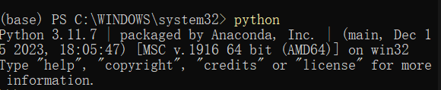
Figure 3-1

- Hardware Requirements:
CUDA version: 10.2.
NVIDIA driver version: 440.64.00 or higher.
Docker version: 18.03 or higher.
The following diagram shows the hardware configuration of my computer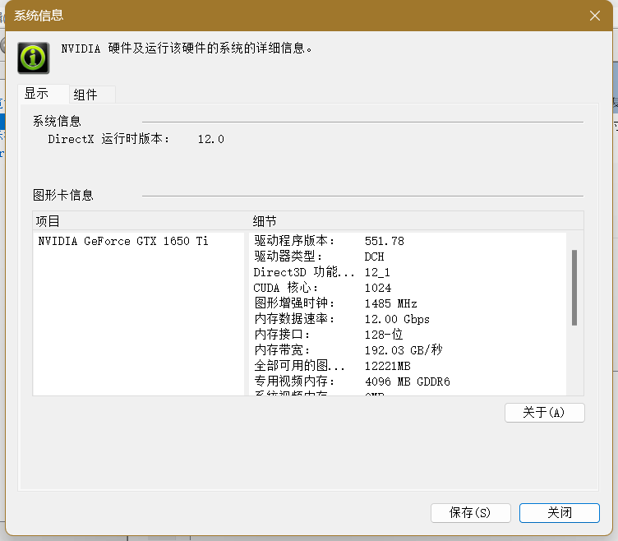
Figure 3-2

Environment Configuration
PaddleNLP can be installed via pip or using Docker images to simplify the setup process.
- 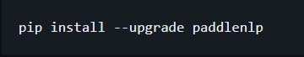
Figure 3-3

Advantages in Poetry Generation
- PaddleNLP offers text generation tasks capable of predicting questions or generating Chinese poetry.
- It supports various pre-trained models that can generate poetry with fluency and rhythm based on given keywords.
- The API design of PaddleNLP is straightforward and conducive to rapid development and iteration.
In addition, PaddleNLP provides an easy way to load a model from Hugging Face Hub, and by setting the from_hf_hub=True parameter, users can easily integrate the model into their own application. PaddleNLP also supports saving custom models to Hugging Face Hub, which makes sharing and collaboration easier.
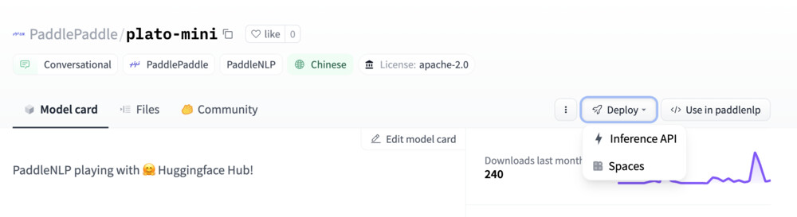
Figure 3-4

BERT
BERT (Bidirectional Encoder Representations from Transformers) is a machine learning model developed by Google AI Language in 2018 for a variety of natural language processing tasks. The BERT model, based on the encoder part of the Transformer, understands language context through bidirectional training, achieving breakthrough performance on multiple NLP tasks, including sentiment analysis and named entity recognition.
The following diagram shows the architecture of the bert model, the details of which will be explained in a later chapter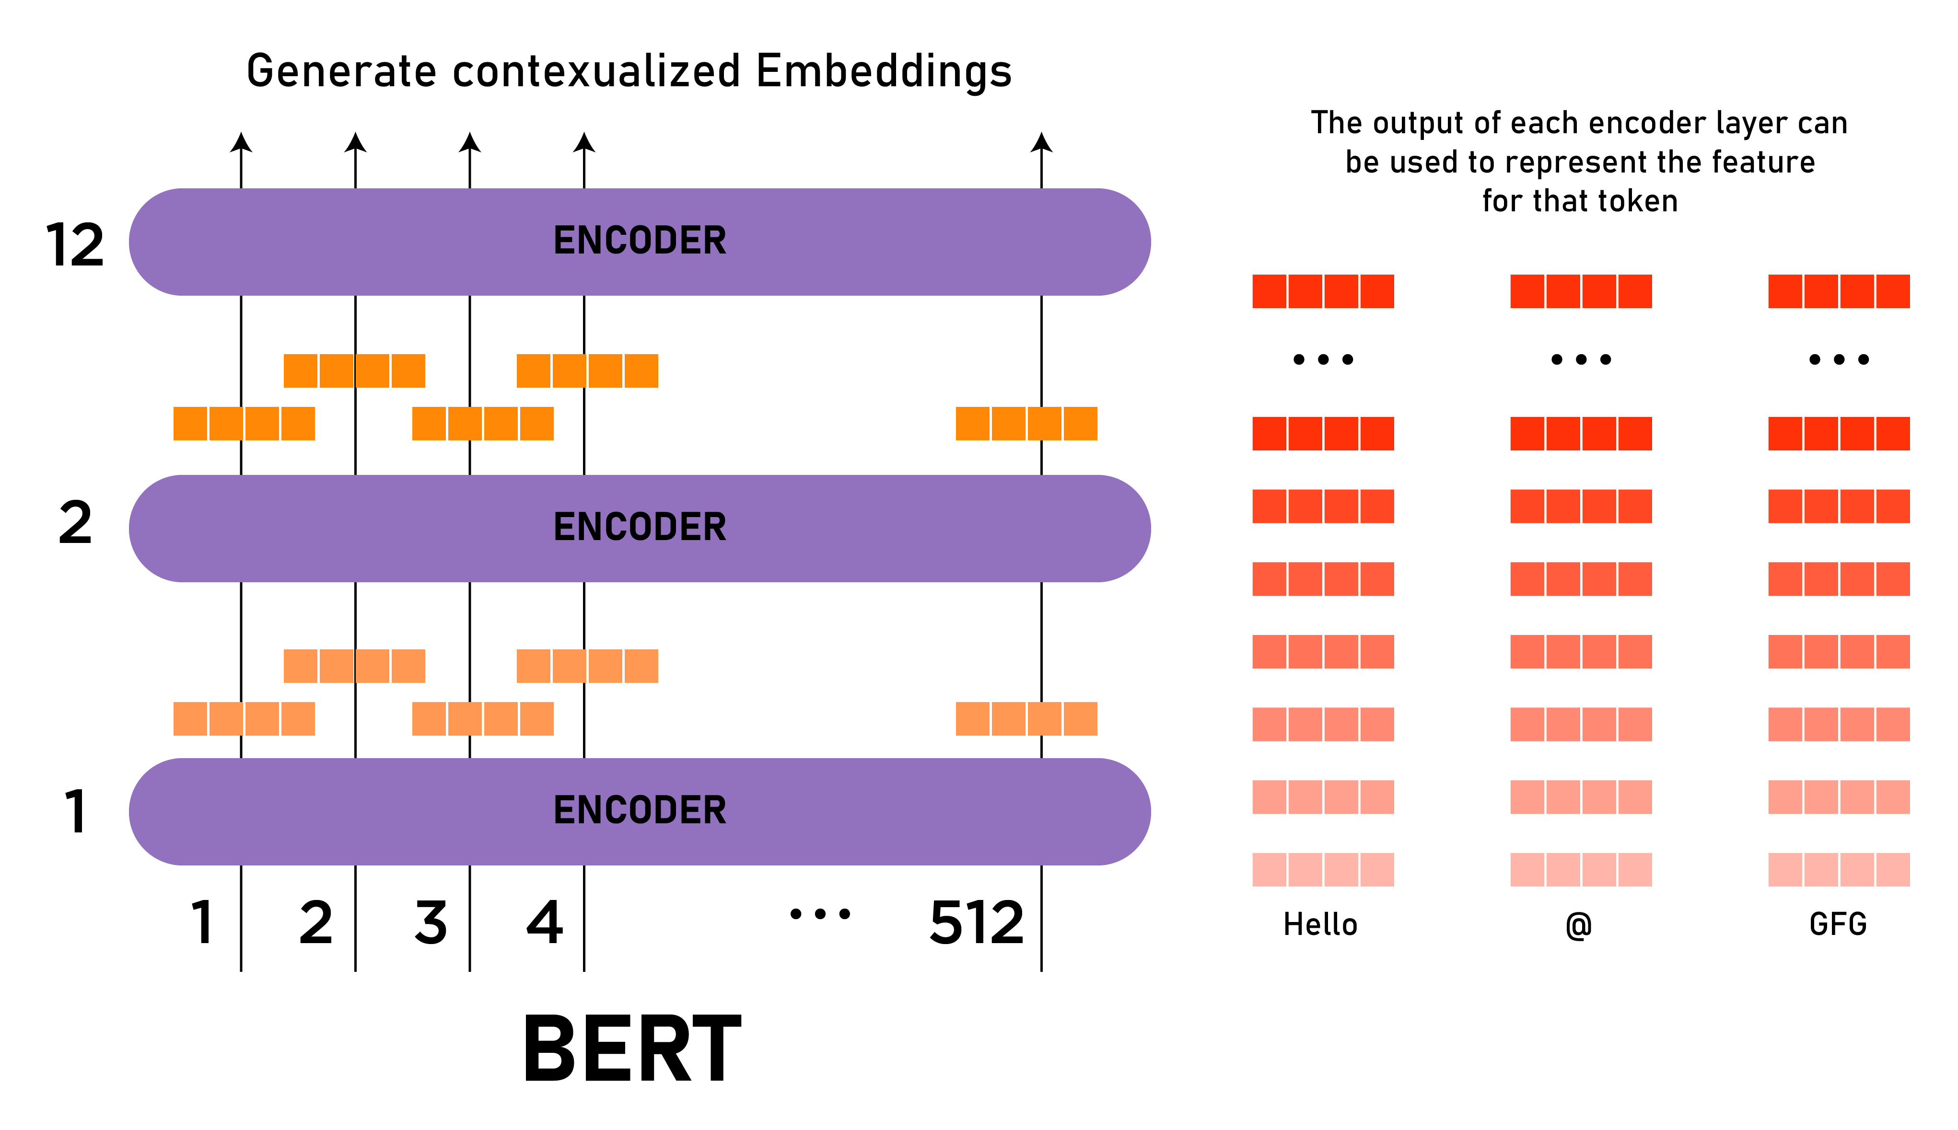
Figure 3-5

Software and Hardware Requirements
- Software Requirements:
An environment supporting TensorFlow or PyTorch.
For large BERT models, a GPU with at least 12GB RAM is recommended.
- Hardware Requirements:
Modern CPUs or GPU accelerators are recommended for efficient operation of BERT.
Hardware configurations depend on the model size and desired response time.
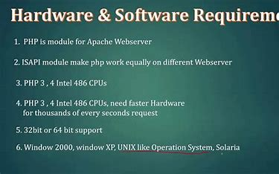
Figure 3-6

Key Features of the BERT Model
- BERT is a deep learning language model based on the Transformer, designed to enhance the efficiency of NLP tasks.
- It analyzes the relationships between words in sentences bidirectionally to consider context.
- BERT excels in multiple NLP tasks, including sentiment analysis and named entity recognition.
- It learns contextual embeddings through a large amount of unsupervised pre-training tasks, which are word representations considering the surrounding context in sentences.

Tkinter for GUI Applications

Figure 3-7
Tkinter, pronounced as “tea-kay-inter,” is the standard Python interface to the Tk GUI toolkit. It is a built-in Python library used to create GUI applications, providing a simple and efficient way to create windows, dialogs, buttons, menus, and more12. Tkinter is based on the Tk toolkit, a cross-platform GUI toolkit that originated as a wrapper for the Tcl/Tk language. It allows for the development of desktop applications and is portable across all operating systems, including Windows, macOS, and Linux1.

Software and Hardware Requirements:
- Software Requirements:
Python: Tkinter comes pre-installed with most Python installations. However, it is recommended to have Python version 3.7 or higher3.
Tcl/Tk: Tkinter requires Tcl/Tk to be installed. The official Python binary release bundles Tcl/Tk 8.6 threaded4.
- Hardware Requirements:
Operating System: Windows 7 or higher, macOS X 10.11 or higher, 64-bit Linux (RHEL 6/7 or similar distributions)5.
CPU: A dual-core Intel Core i5 or similar is sufficient for most Tkinter applications5.
RAM: At least 4 GB of RAM is recommended for smooth operation5.
- Using Tkinter: Tkinter is easy to learn and allows you to make functional desktop applications with minimal code. It supports a layered design, meaning that you can start with simple scripts and gradually move to complex applications. The library includes a variety of widgets such as labels, buttons, and text entries, which can be arranged using geometry managers like pack, grid, and place1.
- Advantages of Tkinter:
Cross-Platform: Tkinter applications can run on various operating systems without modification.
Native Look: Visual elements are rendered using native operating system elements, so applications built with Tkinter integrate well with the platform they’re run on.
Ease of Use: Tkinter is lightweight and relatively painless to use compared to other frameworks, making it a compelling choice for building GUI applications in Python6.
Tkinter is an excellent choice for Python developers looking to create GUI applications with a native look and feel on multiple operating systems. Its ease of use and the fact that it comes pre-installed with Python make it accessible for beginners and a quick solution for more experienced developers.

Model design and implementation
- In my initial attempt to use BERT pre-trained models for poetry generation, I found Bert-CCpoem from the Research Center for Natural Language Processing and Social Humanistic Computing at the Institute of Artificial Intelligence, Tsinghua University, and tried to reproduce it.

BERT-CCPoem
In this chapter, I provide a detailed analysis and interpretation of the code implementations provided. I examine each of the four code snippets provided and highlight the progress made in each iteration. Additionally, I discuss the significance of the code implementations in the context of poetry generation using NLP techniques.

Initial Implementation
The initial implementation comprises several key components, including model loading, custom class definition, and poetry generation. Let's examine these components in detail:

Code Structure and Overview
The initial implementation begins with loading a pre-trained BERT model and tokenizer using the `from_pretrained` method provided by the Transformers library. This process involves downloading pre-trained weights and vocabulary files, which are essential for encoding and decoding text inputs. Below is the relevant code snippet:
Figure4.2.1 Model Loading
In this snippet, I load the pre-trained BERT model and tokenizer specifically designed for the Chinese language. The `BertModel.from_pretrained()` function loads the BERT model, while `BertTokenizer.from_pretrained()` loads the corresponding tokenizer. This step is crucial as it provides the foundation for subsequent text processing and generation tasks.
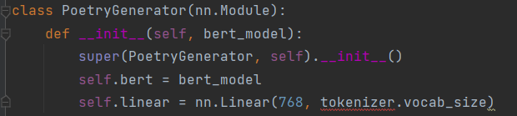
Figure 4-1
Here, I define a custom class `PoetryGenerator` that extends the `nn.Module` class. The class encapsulates the BERT model and a linear layer for generating poetry. The BERT model serves as the backbone for text encoding and feature extraction, while the linear layer maps the extracted features to the vocabulary space for generating the next token in the poetry sequence.
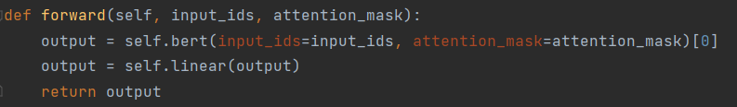
Figure 4-2
This `forward` function defines the forward pass of the `PoetryGenerator` class. It takes input tokens (`input_ids`) and attention masks (`attention_mask`) as inputs and produces logits for predicting the next token in the poetry sequence. The BERT model processes the input tokens and generates contextualized representations, which are then passed through the linear layer to produce the logits.

Limitations and Areas for Improvement
While the initial implementation lays the groundwork for poetry generation using the BERT model, it has several limitations that warrant attention:
- Interpretation:
- The `BertModel.from_pretrained` method loads the pre-trained BERT model architecture and weights.
- The `BertTokenizer.from_pretrained` method loads the pre-trained tokenizer, which is responsible for converting input text into numerical tokens that can be processed by the model.
- Limitations:
- The code snippet lacks error handling for cases where the pre-trained model or tokenizer fails to load due to network issues or other reasons.
- It does not provide any customization options for the BERT model architecture or tokenizer settings, limiting flexibility for experimentation and fine-tuning.

Improved Implementation with BERT-CCPoem and PaddleNLP
Building upon the foundation laid in the initial implementation, this section explores the enhanced version of the poetry generation code using the BERT-CCPoem model and PaddleNLP toolkit. I delve into the modifications made to the code, examine key excerpts, and identify areas for further improvement.

Code Enhancement and Modification
The improved implementation introduces significant enhancements to the poetry generation process, leveraging the advanced capabilities of the BERT-CCPoem model and the comprehensive functionalities of the PaddleNLP toolkit. Let's delve into the modifications made to the code:
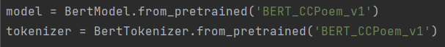
Figure 4-3
In this snippet, I load the specialized BERT-CCPoem model and tokenizer, specifically trained for classical Chinese poetry generation. Unlike the generic BERT model used in the initial implementation, BERT-CCPoem incorporates domain-specific knowledge and features tailored to the nuances of poetic language.
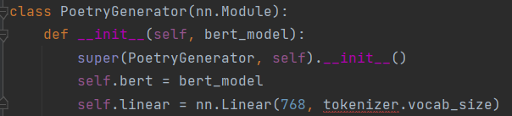
Figure 4-4

Similarly to the initial implementation, I define the `PoetryGenerator` class, which encapsulates the BERT-CCPoem model and a linear layer for poetry generation. However, the underlying BERT model is now replaced with the specialized BERT-CCPoem variant, enhancing the model's ability to generate high-quality classical Chinese poetry.
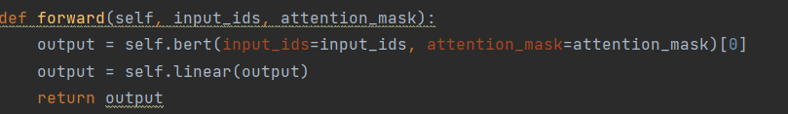
Figure 4-5

Limitations and Areas for Further Improvement

The forward pass function remains unchanged from the initial implementation, as it continues to perform text encoding and token prediction based on the input sequence. However, the underlying BERT model now incorporates domain-specific knowledge learned during training on classical Chinese poetry datasets, resulting in improved poetry generation performance.
Despite the enhancements introduced in the improved implementation, several limitations persist, highlighting areas for further refinement:
    - Limited Domain Adaptation: While the BERT-CCPoem model is specialized for classical Chinese poetry generation, its training may not cover the entire spectrum of poetic styles and forms. Fine-tuning the model on a diverse range of poetry datasets can enhance its adaptability and performance across different poetic genres.
    - Scalability Issues: The current implementation may encounter scalability issues when handling large datasets or generating poetry in real-time. Optimizing the model architecture and leveraging parallel computing techniques can improve scalability and efficiency, enabling faster and more efficient poetry generation.
    - Evaluation Metrics: The lack of comprehensive evaluation metrics makes it challenging to objectively assess the quality and creativity of generated poetry. Integrating metrics such as rhyme density, semantic coherence, and stylistic adherence can provide a more nuanced understanding of the model's performance and guide further refinement efforts.

BertFormatter and Initialization Enhancements
In this section, I explore the improvements made in the BertFormatter class and the initialization process of the BERT-CCPoem model. I examine key excerpts from the code and discuss the implications of these enhancements for poetry generation.

BertFormatter Refinement
The BertFormatter class plays a crucial role in preprocessing input data for the BERT-CCPoem model. Let's delve into the enhancements made in this class:
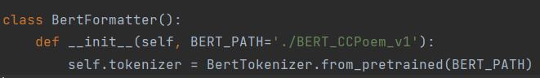
Figure 4-6
In the improved implementation, the BertFormatter class is initialized with a default path to the BERT-CCPoem model (`BERT_CCPoem_v1`). This ensures consistency and ease of use when preprocessing input data for poetry generation tasks.

Initialization Optimization
Efficient initialization of the BERT-CCPoem model is essential for seamless integration into the poetry generation pipeline. Let's examine the optimizations made in this process:

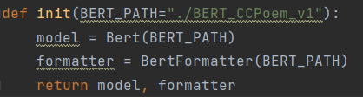
Figure 4-7
The `init` function initializes the BERT-CCPoem model and the BertFormatter class, facilitating data preprocessing and model integration. By providing a default path to the BERT-CCPoem model, the initialization process becomes more streamlined and user-friendly.

Limitations and Future Directions
Despite the enhancements made in BertFormatter and initialization, there are still areas for improvement:
- Data Augmentation: Incorporating data augmentation techniques can diversify the training data and improve the robustness of the BERT-CCPoem model to variations in poetic styles and forms.
- Fine-tuning Strategies: Exploring advanced fine-tuning strategies, such as curriculum learning and adversarial training, can further optimize the performance of the BERT-CCPoem model on poetry generation tasks.
- Evaluation Metrics: Developing comprehensive evaluation metrics tailored to classical Chinese poetry can provide more nuanced insights into the quality and coherence of generated poetry, guiding future refinement efforts.

Conclusion

In conclusion, the enhancements made in BertFormatter and initialization contribute to the overall efficiency and effectiveness of the poetry generation pipeline. However, ongoing research and development are needed to address the remaining challenges and advance the state-of-the-art in classical Chinese poetry generation. By continually refining the preprocessing and initialization processes, I can unlock the full potential of the BERT-CCPoem model and pave the way for more sophisticated and creative poetry generation systems.
BERT-CCPoem, an extension of the BERT architecture, is specifically designed for generating classical Chinese poetry. The model utilizes a multi-layer bidirectional transformer encoder to capture contextual information from input text. BERT-CCPoem employs a pre-trained language model trained on a large corpus of classical Chinese poetry to learn rich semantic representations of Chinese characters and words. During fine-tuning, BERT-CCPoem is further trained on a poetry generation dataset to adapt its parameters to the task of poetry generation. The model generates poetry by predicting the next token in the sequence based on the contextual information encoded in the input text.

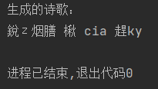
Figure 4-8
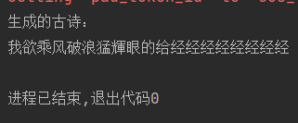
Figure 4-9

Analysis of Generated Poetry Using Different Models
In this section, I compare the effectiveness of two different approaches to poetry generation: the BERT-CCPoem model and the GPT-2 model. I analyze the strengths and weaknesses of each method and discuss potential avenues for improvement.

BERT-CCPoem Model
The BERT-CCPoem model, implemented in the earlier sections, utilizes a modified version of the BERT architecture tailored for classical Chinese poetry generation. It preprocesses input data using a custom BertFormatter and generates poetry by fine-tuning on a corpus of classical Chinese poetry.
Strengths:
- Fine-tuned for Poetry Generation: The BERT-CCPoem model is specifically fine-tuned for poetry generation tasks, allowing it to capture intricate linguistic patterns and stylistic nuances present in classical Chinese poetry.
- Controlled Generation: The model can generate poetry conditioned on specific input prompts, offering a degree of control over the generated output.
Weaknesses:
- Lack of Creativity: Due to its reliance on a pre-defined architecture and fine-tuning process, the BERT-CCPoem model may exhibit limited creativity and variation in its generated poetry.
- Coherence Issues: The generated poetry may suffer from coherence issues, as the model struggles to maintain semantic consistency and logical flow in longer poetic compositions.

Load GPT-2 pre-trained model and tokenizer
PaddleNLP has so far focused on providing pre-trained Transformer models, including BERT, ERNIE, RoBERTa, and others. However, as of now, PaddleNLP does not provide a pre-trained model specifically for generative tasks such as text generation, conversation generation, etc.
A common approach is to use a generative model that takes these vector representations as inputs and generates poetic text based on them. Since the BERT model itself is not a generative model, I need to further process these vector representations to fit the generative model. So I used the GPT-2 generative model to generate the text and decode the resulting text into the final poem.
The GPT-2 model, as implemented in the provided code, is a state-of-the-art language model capable of generating coherent and contextually relevant text across various domains. It operates in a generative manner, producing text token by token based on a given input prompt.
Strengths:
- Creativity and Variation: The GPT-2 model excels in generating diverse and creative text, making it well-suited for tasks requiring novelty and originality, such as poetry generation.
- Contextual Understanding: Leveraging the Transformer architecture, GPT-2 demonstrates a strong understanding of context, allowing it to generate text that is contextually relevant and coherent.
Weaknesses:
- Limited Control: Unlike the BERT-CCPoem model, the GPT-2 model lacks fine-grained control over the generated output, often leading to unpredictable and unstructured results.
- Potential Inconsistencies: While GPT-2 typically generates coherent text, there may be instances where it produces nonsensical or grammatically incorrect output, particularly with more complex input prompts.

Comparative Analysis
Comparing the two approaches, I observe that the BERT-CCPoem model offers more control and specificity in poetry generation, making it suitable for tasks requiring adherence to predefined styles or themes. However, it may struggle with creativity and coherence, particularly in longer poetic compositions.

On the other hand, the GPT-2 model excels in generating diverse and creative poetry, leveraging its contextual understanding and generative capabilities. While it may lack the precision of the BERT-CCPoem model, it offers greater flexibility and novelty in its output.

Model implementation and training
Based on the failed experience of the last chapter, I once again tried to use the bert-base-chinese of paddlenlp to generate poems.

Introduction to model architecture

data preparation
In the data preparation phase, I need to prepare a poetry data set for training and evaluation. I used the open-source database of ancient Chinese poetry on Github, which contains nearly 14,000 ancient poets in the Tang and Song dynasties, nearly 55,000 Tang poems and 260,000 Song poems, as well as 1,564 poets and 21,050 poems in the two Song dynasties. In this section, I will read and load the ancient poem data file and prepare it into a format acceptable to the model.
I divided the initial poetry data set into four parts for training: five verses, five verses, seven verses, and seven verses. The standard of division is that 4 sentences are quantas and 8 sentences are rhythmic poems, each sentence has five or seven words. The following is a partial presentation of the divided data set and the Seven Verses data set.
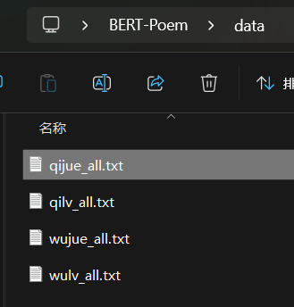
Figure 5-1
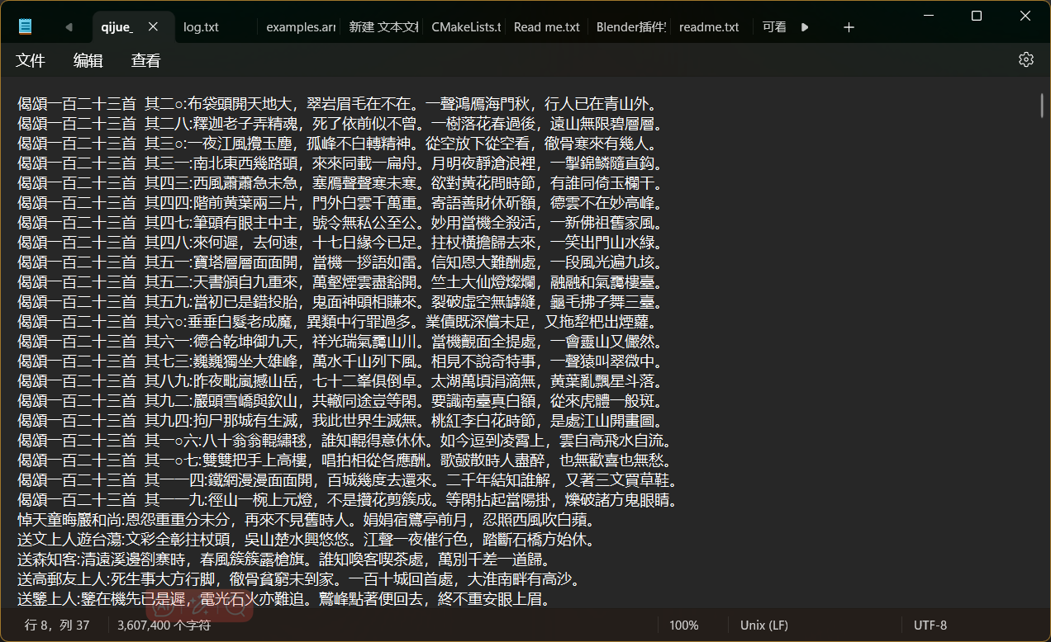
Figure 5-2

Data processing
In the data processing stage, I need to further process the extracted poetry data, including word segmentation, coding and other operations, in order to facilitate the subsequent training and application of the model.
The following code snippet reads data from a file named qilv_all.txt that is used to train the generation of seven verses. This file may contain different types of poems, and I need to filter out the contents related to the seven-rhythm poems according to my needs. By extracting the content after the colon, you get a pure poetic text.
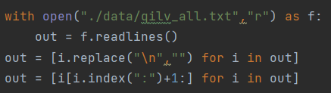
Figure 5-3
The following code snippet splits the processed poetry data set into a training set, a validation set, and a test set. According to the conventional partition ratio, the data set will be divided in a 6:2:2 ratio. This partition allows me to validate and evaluate the model during training.
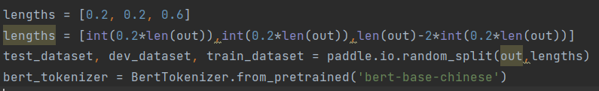
Figure 5-4
The last line of code initializes a BERT classifier for word segmentation and encoding of the poem text to facilitate the input of the model. BERT Word segmentation is a pre-trained word segmentation model that converts text into an input format acceptable to the model.
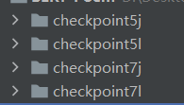
Figure 5-5

Construct the data reader
After preprocessing the data, we construct a data reader based on Fly Paddle 2.0 to adapt to the training of the subsequent model.
Before constructing the reader, let's take a look at what the input to the BERT model looks like. As shown in the picture below:

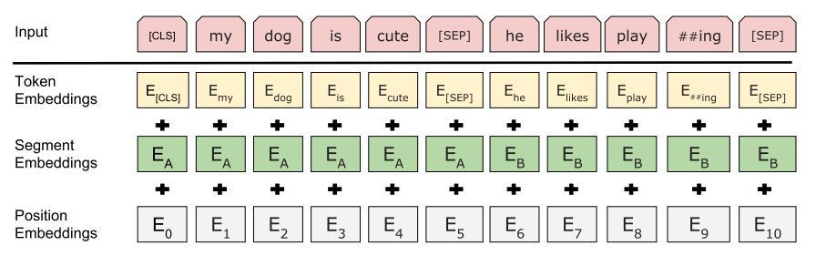
Figure 5-6

The figure above can clearly show the specific style of input data, including three parts: Token Embeddings, Segment Embeddings, Position Embeddings. Here, Embeddings are understood as embeddings, which means that an element is represented as a 1 * n vector to indicate the relative position of this element in a vector space. This is a more common way of Chinese text processing today. Here, Token Embeddings are word embeddings, which map word elements after word segmentation into a 1 * n vector. In addition, the Segment Embeddings indicate what role each word element belongs to. Specifically, the Segment Embeddings can be used when we need to distinguish between different statements in an input, such as in a dialogue model, to distinguish which object issued each sentence in the input. Position Embeddings are a feature of the Transformer class model. Since this kind of self-attention mechanism cannot distinguish distance, this embedding is introduced to increase the bias generated by distance. Under normal circumstances, Position is a sequence of increasing numbers from the beginning to the end of a clause, such as [0,1,2,3,4,5,...,n-1], which represents an input Position of length n. How do you get Embeddings? It is usually to construct an N * n matrix, all the elements are uniquely indexed to a position, and the number of elements is not greater than N. The embedding of each element by its corresponding index retrieves the elements on n columns of the corresponding row of the matrix, that is, the 1 * n vector. In this project, since there is no need to distinguish the roles of each sentence, the Segment Embeddings can be set to the same, that is, the index will all be the same value (such as 0). Since the BERT model of the paddle automatically handles Segment Embeddings and Position Embeddings, we can ignore these two items when constructing the input. Before proceeding to the next calculation, all types are added, and each word element corresponds to a synthesized embedding vector.
Note that the following class definition contains padding to align the input sample to a specific length to facilitate batch processing by the model. Therefore, when getting an instance of a data reader, note that the max_len parameter does not exceed the maximum length supported by the model (PaddleNLP default sequence length is 512).

This part of the relevant code I put in the dataset,py file.
The following figure shows part of the code for dataset.
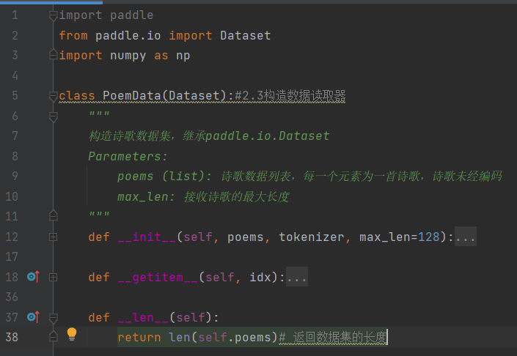
Figure 5-7
The main function of this dataset class and function includes:
- __init__ method: initialization data set object, data list, word segmentation and accept poetry parameters such as maximum length.
- __getitem__ method: the poetry data at the specified index of the access, and convert them to model an acceptable format.
Specific operations include: use participles encodes poetry, word coding and word type encoding. If poetry length exceeds the maximum length, then truncate the poetry. Respectively obtain input word coding, the types of word coding, labeling word coding. Zero padding to fill of input, the shortfalls. Generate input filling mask, used to indicate which position is filled.
- __len__ methods: returns the length of the data set that contains the number of poetry. This dataset class is for the purpose of the original poem data preparation into a format suitable for model training, so that subsequent use in the training process.

Model training

Hardware Information
System is equipped with two graphics cards:
- Intel UHD Graphics
Total memory: 8253 MB
Display memory (VRAM) : 128 MB
Shared memory: 8125 MB

- NVIDIA GeForce GTX 1650 Ti
Total memory: 12060 MB
Display memory (VRAM) : 3935 MB
Shared memory: 8125 MB

Model training parameters
Training data set size: 100,000 data sets
Model size: BERT-base, about 110M parameters
Training rounds (epochs) : 10 rounds
batch size: 32

Estimated training time
Since there is no accurate time count, the following is the approximate time taken to train the model based on parameters

The training time for each epoch is approximately 5 minutes
Total training time = training rounds * Training time per epoch

Training time per epoch: 5 minutes
Total training time: 10 epochs * 5 minutes /epoch = 50 minutes

Model setup and training
In this section, I will explain how to quickly build a poetry generator based on a BERT pre-trained model and train the model.

Pre-trained BERT models
The generation of ancient poems is a process of text generation. In practice, the model cannot know the content that has not yet been generated, that is, the bidirectional relation in BERT can only capture the forward relation but not the backward relation. This limitation allows us to mask the backward relationship by adding an attention mask so that the model does not notice what has not yet been generated, so that BERT can still complete the text generation task.
Further, we can simplify text generation to a Bert-based word classification model (understood as part-of-speech tagging) that assigns each word a label, which is what the next word after that word is. The following table is an example: For the verse "The moonlight before the bed is bright, but I doubt it is frost on the ground." For example, when training, enter "bright moonlight in front of bed, suspected frost on the ground" (note that there is no ". ), and the content of the prediction is the label corresponding to each word input, we set its prediction label as "the bright moonlight, suspected to be frost on the ground." Here, we can understand that the corresponding label of the word "bed" is "Qian", and the corresponding label of the word "qian" is "Ming" and...... The corresponding label for the word "frost" is "." . Therefore, we can directly call the BERT word classification model of PaddleNLP, and it should be noted that the category of the model classification is the length of the vocabulary.

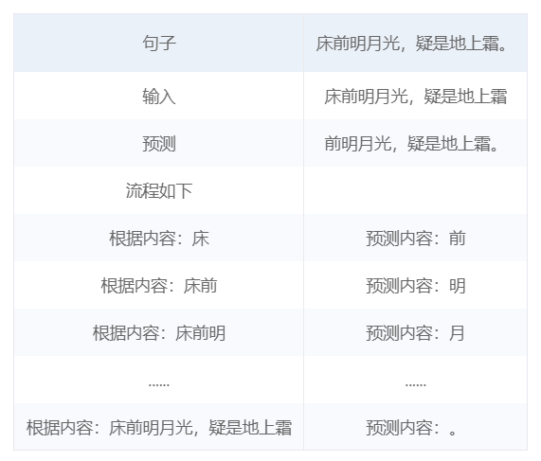
Figure 6-1

In text generation task, BERT model can only capture forward relation but not backward relation due to the limitation of bidirectional attention mechanism. Therefore, in order to make the BERT model suitable for text generation tasks, an attention mask needs to be added to mask the model's focus on ungenerated content. Reducing the text generation task to a word classification task, i.e., a label for each word that predicts its subsequent words, is an effective strategy. This method uses the pre-training capability of BERT model to transform the text generation problem into a sequence annotation problem, which is easier to train and optimize.
The following figure shows some of the relevant code, which is located in the model.py file.
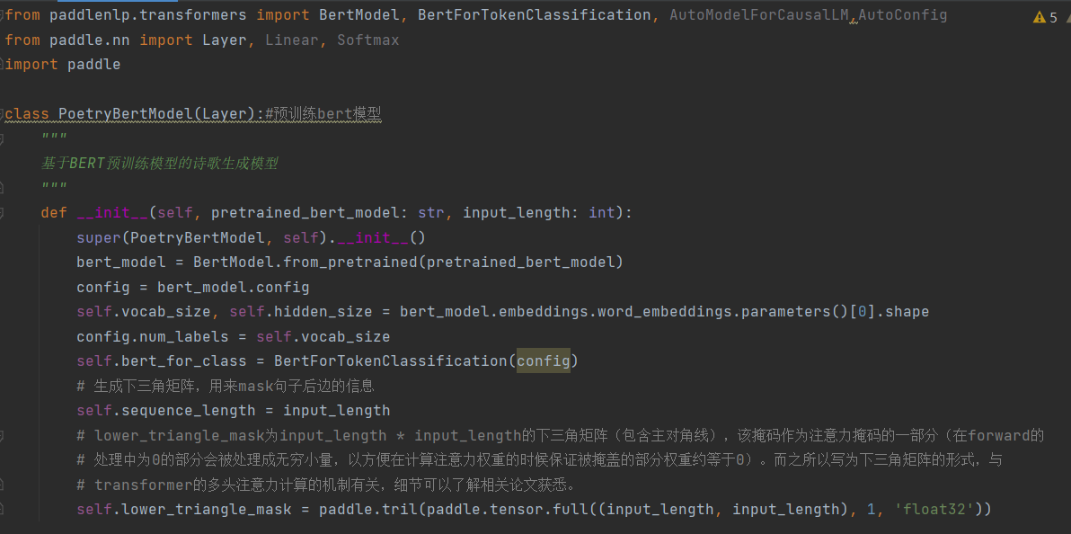
Figure 6-2

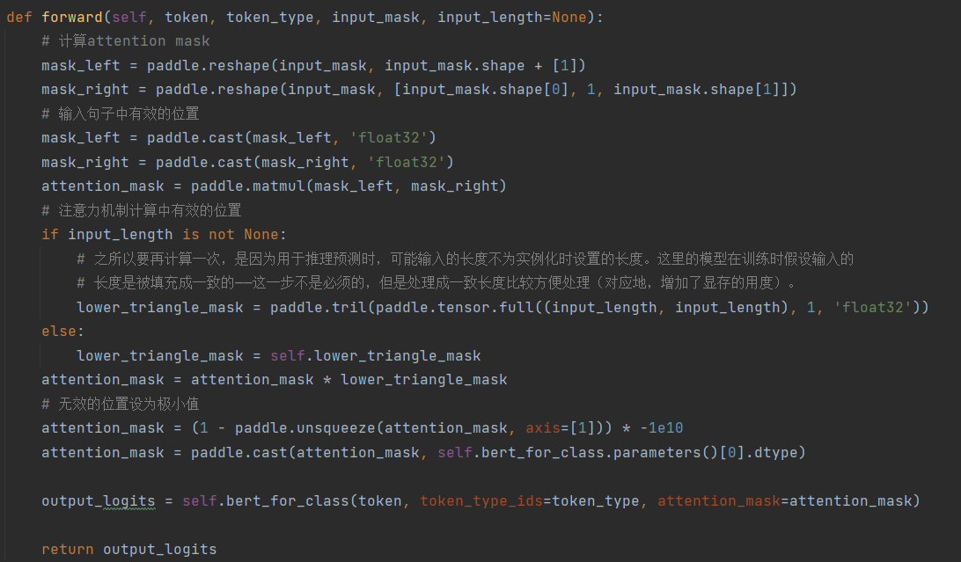
Figure 6-3

Defined model loss
Since a considerable part of the true value is filled content, we need to rewrite the cross entropy loss to ignore the loss caused by the filled content.

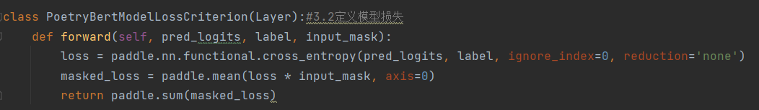
Figure 6-4

Model preparation
The training of the pre-trained model needs to be tuned with a smaller learning_rate. In the model preparation phase, I need to do the preparatory work for the training of the pre-trained model and set the appropriate parameters for tuning. The code for this part comes from the train.py file.
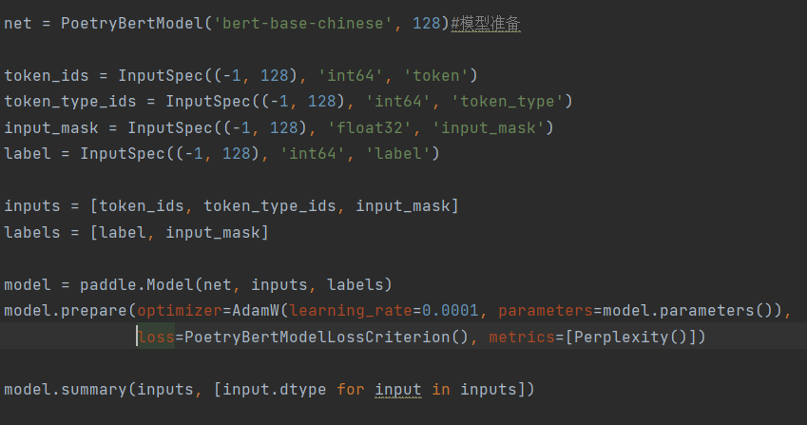
Figure 6-5
Code function explanation:
in this part of the code, the first instantiation previously defined PoetryBertModel model, and specify the BERT in the process of the training model for 'BERT - base - the Chinese', and set the input of a maximum length of 128. And then defines the input of the model specification (InputSpec), including token_ids, token_type_ids, input_mask and label, these specifications used to define the model input data types and shapes. Next, the input and the label list of passed to paddle, Model class, to create a Model object. The input and label specifications defined earlier are used here. Using the model. Prepare () function for model training required for the optimizer (optimizer), loss function (loss), and evaluation index (metrics). Here the AdamW optimizer is selected, the learning rate is set to 0.0001, and the parameters of the model are passed in. Chose a previously defined PoetryBertModelLossCriterion loss function. Finally, call the model. The summary () function to print the model of information, including the model structure, the shape of the input data and data types, etc.
Theoretical knowledge explanation:
In the model preparation phase, the pre-trained BERT model is instantiated, and the input specifications and label specifications of the model are set. This is to ensure the correctness and consistency of the input data of the model. Using AdamW optimizer for model training, and set up the smaller more stable in the process of training to ensure that the model convergence. The choice of loss function is very important, choose the custom here PoetryBertModelLossCriterion loss function, and used to calculate the loss value of the model. Evaluation index Perplexity () is used to measure model in the process of training performance, and to tune the model according to the results of the assessment.

Model Training
Due to the call of the pre-training model, the second tuning, only a few rounds of training can achieve a better effect.
During training, set the save_dir parameter to save the trained model, and set the saving frequency with save_freq.

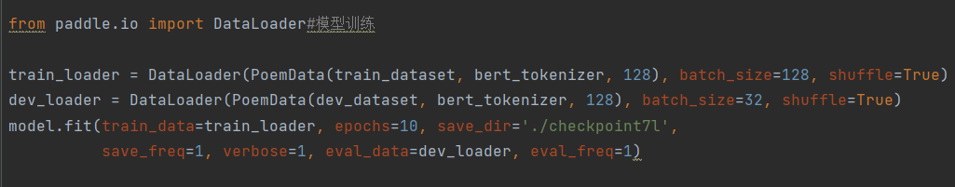
Figure 6-6

Generation of ancient poems

Generating Examples of ancient Poems
In this section, a class is defined to perform the task of poetry generation using a trained model. In the process of the generation of ancient poems, the generated content is input into the model after coding, and the corresponding classification result of each word in the input is obtained. Then, select the classification result of the last word as the word to predict for the current content. In the next round, the word just predicted will be added to the generated content, and the prediction of the next word will continue.
In the selection of each round of prediction results, the best result can be selected in a greedy way, or it can be randomly selected from the first few better results (more combinations can be obtained). Here, you can use the topk parameter for control. However, it should be noted that the setting of topk should not be too large, otherwise there is little difference with the effect of random generation.
This part of the code is in a file called gen.py, which I'll show in the appendix because it's too long.
- Theoretical knowledge supplement:
In the generation of ancient poems, the method of calling the pre-trained model and using the generated content to predict the next word is called autoregressive generation. In autoregressive generation, the model predicts the next word at each time step based on previously generated content and some additional information (such as style, opening content, etc.).
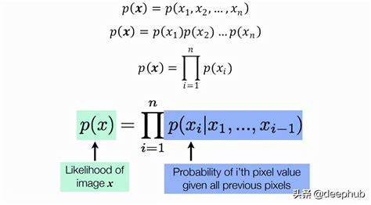
Figure 6-7
In the process of generating ancient poems, greedy search or sampling search strategy can be chosen. A greedy search selects the word with the highest probability as the next word, while a sampling search randomly samples a word from a probability distribution. Sampling search strategy can generate more diversified ancient poems, while greedy search strategy is more inclined to generate more coherent ancient poems.
The following figure shows a simple illustration of a sampling search strategy and a greedy search, respectively.
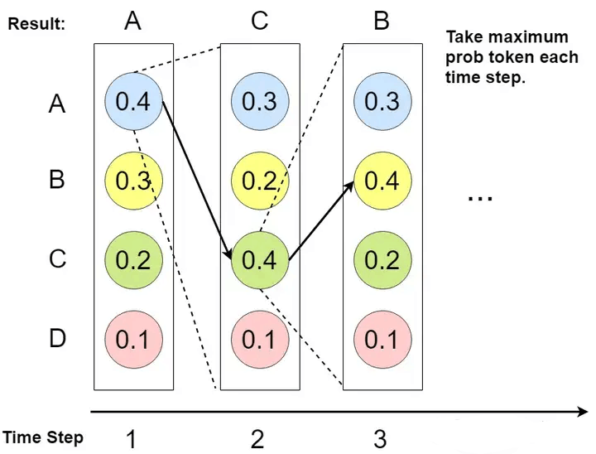
Figure 6-8
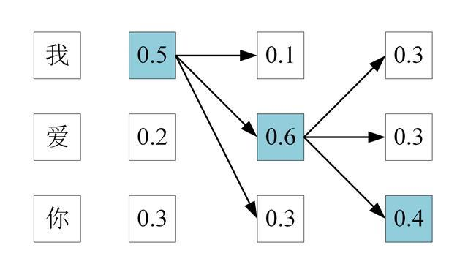
Figure 6-9

Generate examples of ancient poems
I'll show my results here. I used Tkinter to make the gui, and the finished product is shown below. The code is placed in the creator.py file, and a screenshot of the file's code I will place in the appendix.
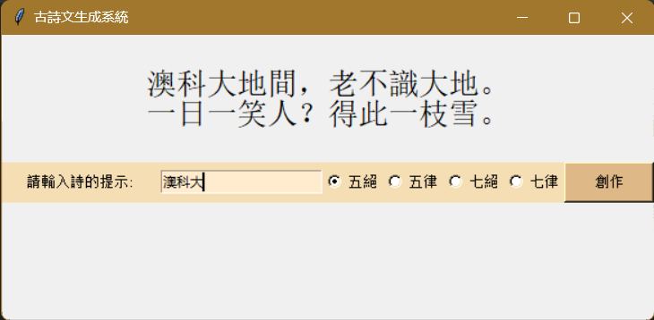
Figure 6-10
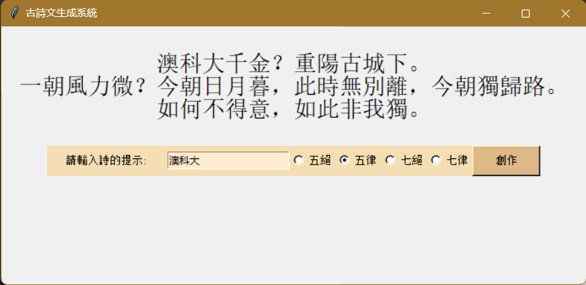
Figure 6-11
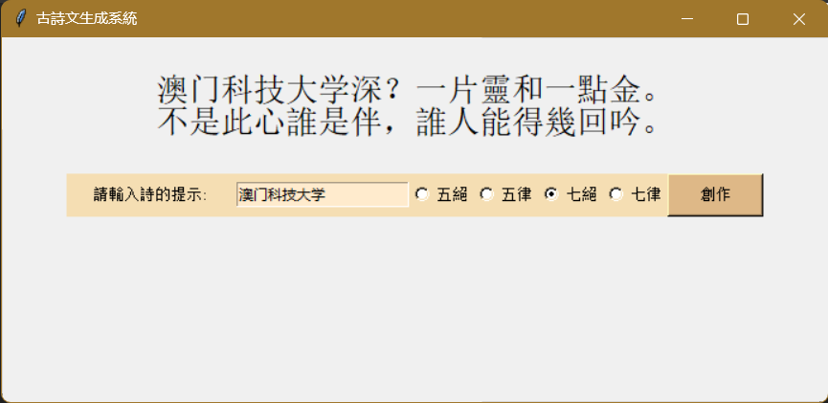
Figure 6-12
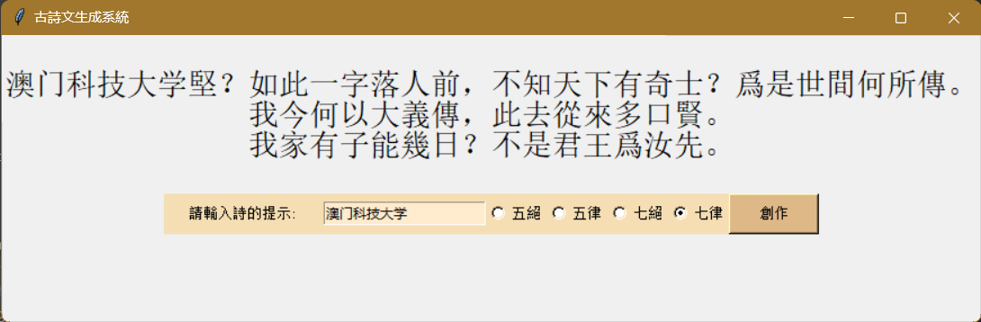
Figure 6-13

Summary

In this paper, I conducted a comprehensive exploration of various techniques and models for automated poetry generation, focusing particularly on classical Chinese poetry. I began by providing an overview of the research background and motivation, highlighting the significance of automated poetry generation in the context of natural language processing and literary creation.
Chapter 1:In the introduction part, I explain the background and motivation of using BERT pre-training model to generate Chinese poetry, as well as the organization structure of this paper.
Chapter 2: This chapter reviews the development and challenges of automatic poetry generation, and summarizes the research status of ancient poetry generation.
Chapter 3:I describe the key hardware and software components used, including PaddleNLP, BERT, and Tkinter, as well as their hardware and software requirements and key features.
Chapter 4:This chapter introduces the design and implementation process of the model in detail, including the initial implementation, improved implementation, BertFormatter and initialization enhancement, and the analysis of ancient poems generated by different models.
Chapter 5:I introduced the implementation and training process of the model, including key steps such as data preparation and construction of the data reader.
Chapter 6:This chapter focuses on the model setup and training process, including pre-training BERT model, defining model loss, model preparation and model training.
Through the reading of this article, readers can learn how to generate Chinese poetry using BERT pre-training model, and understand the design, implementation and training process of the project, as well as the main contributions and limitations of each part.

Appendix
Gen.py
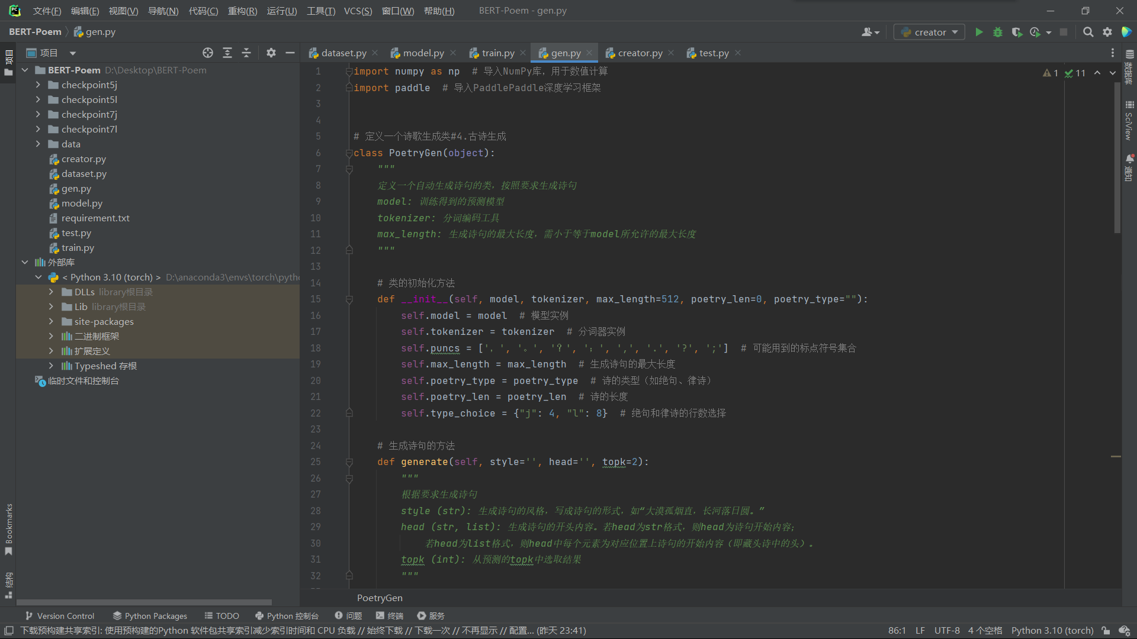
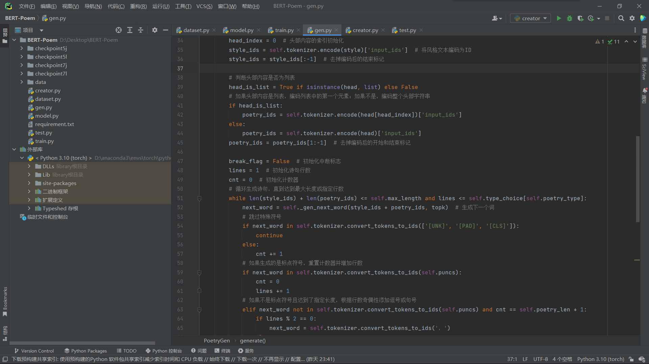
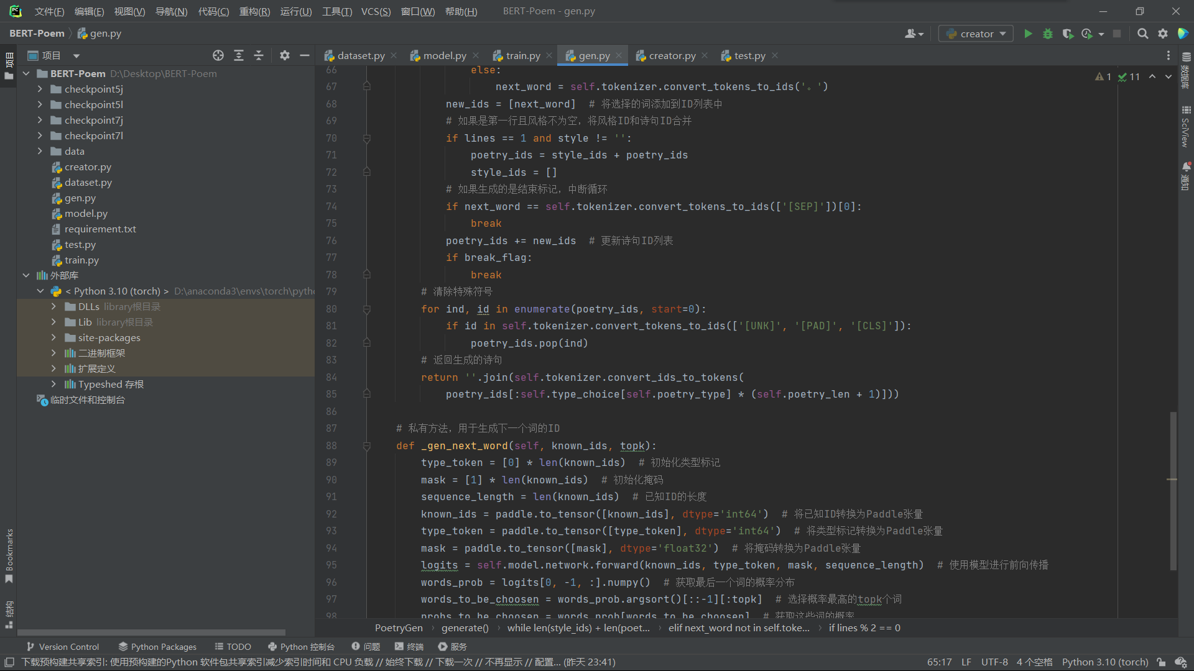
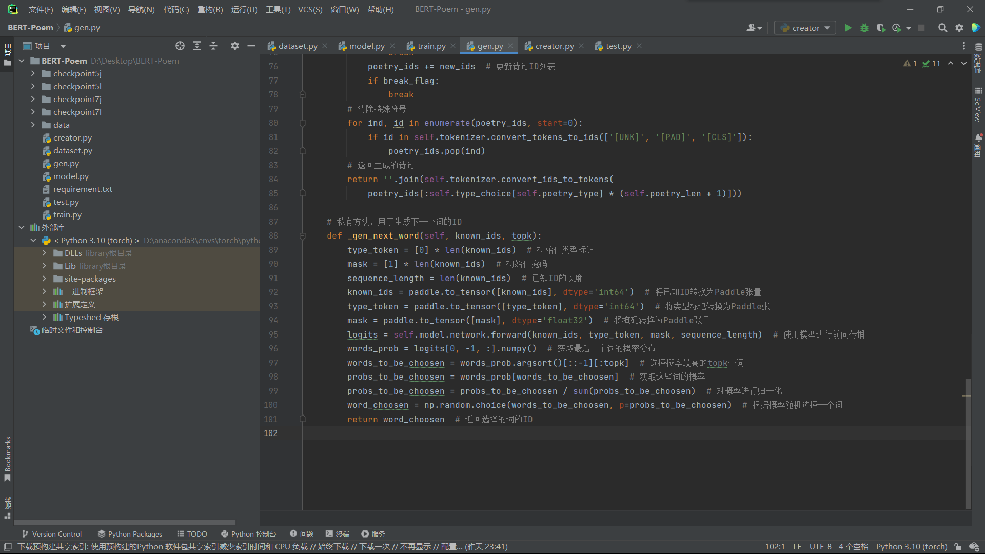

Creator.py
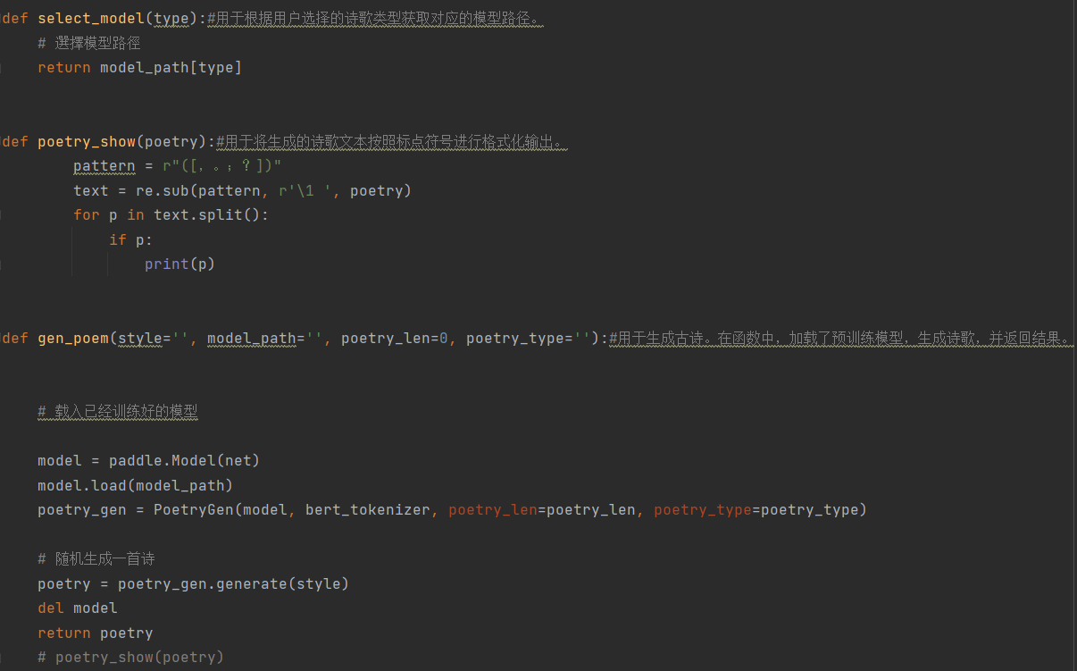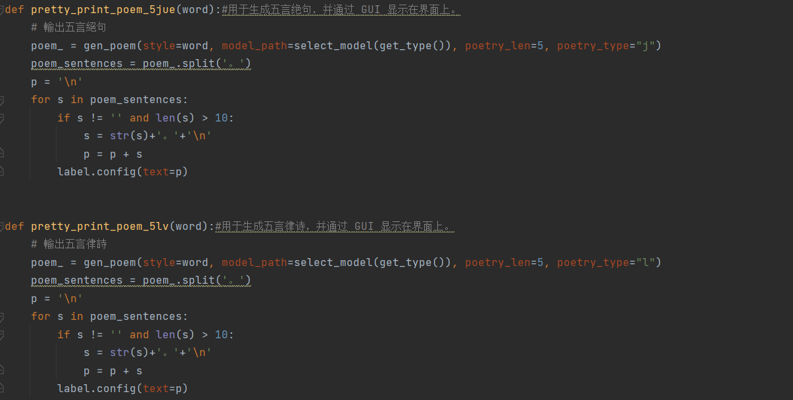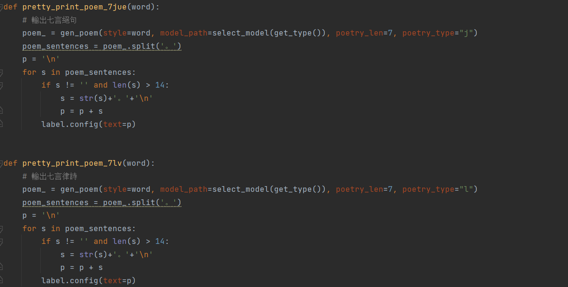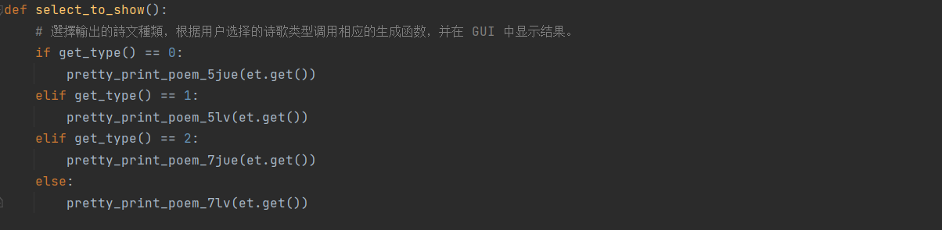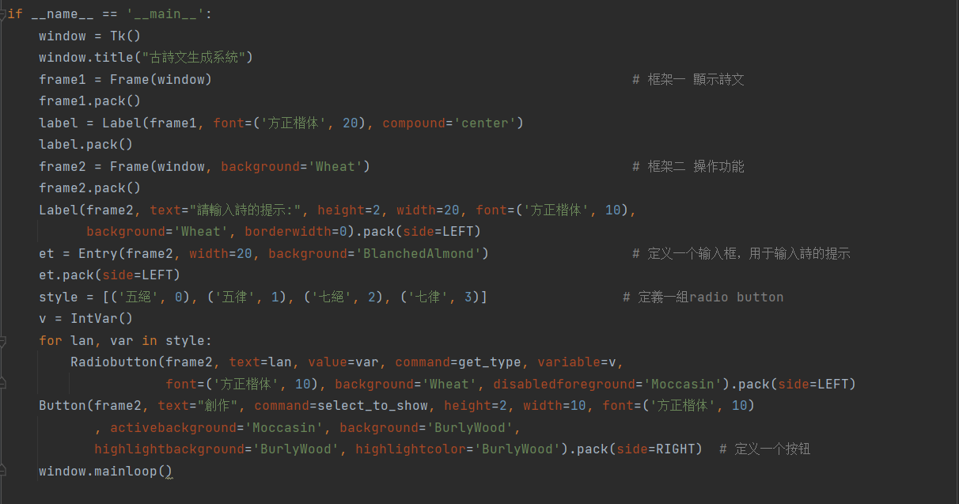

Resume
Yanyan Zhu
Email: eluidy@163.com
Tel: +86 1895566250 / +853 63823885
Add: Huanghuating New Village, Daguan District, Anqing, Anhui, China 246000
EDUCATION
Macao University of Science and Technology
Major: Software Engineering (Bachelor of Science) 09/2020 – 08/2024(Expected)
PROJECT EXPERIENCE
2D Game Design 03/2023 – 05/2023
Group Leader
- Developed the game using Unity, a powerful cross-platform game development engine.
- Used C# for scripting game logic and interactions.
- Implemented various game mechanics such as player movement, enemy AI, power-ups, and level transitions.
- Designed multiple levels with increasing difficulty and different themes.
- Reviewed the code, tested the code, and fixed bugs.
- Integrated sound effects and background music to enhance player experience.
- Conducted playtests to gather feedback and made necessary adjustments to gameplay and level design.
- Discussed with group members about the theme, gameplay, and target audience for the game.
- Scheduled the design plan and followed up on the progress of the design.
- Assigned tasks to group members and facilitated effective communication between team members.
- Utilized various resources to find solutions to encountered problems, identified risks and thought of methods to lower the risks.
Masked Face Recognition 09/2022 – 12/2022
Group Leader
- Developed a masked face recognition system using Python and OpenCV for image processing and TensorFlow for implementing the deep learning model.
- The system was capable of detecting faces in an image, identifying if they are wearing masks, and recognizing the individual even with the mask on.
- Trained a convolutional neural network (CNN) on a large dataset of images of individuals with and without masks to achieve the recognition.
- Ensured the robustness of the system by incorporating different lighting conditions and mask types in the training data.
- Optimized the model for real-time performance, enabling it to be used in video surveillance systems for automatic mask detection and face recognition.
- Scheduled the project plan, assigned tasks to group members, and coordinated between members.
INTERNSHIP
Macau Water Bureau 07/2023 – 08/2023
Front-end Design Intern
- Learned how to use Git for version control and learned about Ant Design's UI component library, and the basic concepts and usage of the Angular framework.
- Developed custom components to build complex page functions and integrated these components into the entire project to ensure modularity and maintainability.
- Wrote JavaScript codes to process the front-end logic and realize interactive functions, such as form validation, data interaction, dynamic update, etc.
- Used Git for code version management.
- Created the chat page of the web version and achieved the switch function between different chat pages through the sidebar.
ACTIVITIES
Summer Research Program: Deep Learning 07/2022 – 09/2022
Offered by Huazhong Agricultural University
- Learned about basic concepts of machine learning and deep learning, principles and applications of neural networks, convolutional neural networks, recurrent neural networks, etc.
- Read relevant academic literature to access the latest research and developments in the field.
- Used programming languages, such as Python, and deep learning frameworks, such as TensorFlow and PyTorch, to create and train neural network models.
- Summarized what I had learned through the program and made a presentation.
Macao University of Science and Technology 09/2021 – 07/2022
Teaching Assistant for EMBA course
- Assisted in preparing teaching materials for the course.
- Helped manage online discussions, answer students’ questions, promote interaction between professors and students, maintain the order of the online courses.
- Gave feedback for online inquiries after class.
- Assisted in organizing online quizzes and exams and worked as a proctor.
- Organized students’ files and collected feedback from students.
- Helped promote the course through different media platforms.

Reference

He Z , You J , Lin S P ,et al.Generation of Chinese Tang Dynasty Poetry Based on BERT Model[J].Proceedings of the 2022 11th International Conference on Networks, Communication and Computing, 2022.DOI:10.1145/3579895.3579940.
Gervás P (2001) An expert system for the composition of formal Spanish poetry. Knowl Based Syst 14(3–4):181–188
Manurung, H.: (2003) An evolutionary algorithm approach to poetry generation. In: Ph.D. Thesis, Uni versity of Edinburgh
He, J. Zhou, M. Jiang, L.: (2012) Generating Chinese classical poems with statistical machine translation models. In: Proceedings of the 26th AAAI Conference on Artificial Intelligence, pp. 1650–1656
Zhang, X. Lapata, M.: (2014) Chinese poetry generation with recurrent neural networks. In: Proceedings of the 2014 Conference on Empirical Methods in Natural Language Processing, pp. 670–680
Wang, Z. He, W. Wu, H. Wu, H. Li, W. Wang, H. Chen, E.: (2016) Chinese poetry generation with planning based neural network. In: Proceedings of COLING 2016, the 26th International Conference on Computational Linguistics: Technical Papers, pp. 1051–1060
Huang, C. Lu, K. Cheng, Y. Peng, Y.: (2020) Generating Chinese Classical Poetry with Quatrain Gener ation Model QGM Using Encoder-Decoder LSTM. In: IEEE BigData, pp. 5700–5702
Yi, X. Li, R. Sun, M.: (2017) Generating Chinese classical poems with RNN encoder-decoder. In: Chinese Computational Linguistics and Natural Language Processing Based on Naturally Annotated Big Data, pp. 211–223
Yi, X. Sun, M. Li, R. Yang, Z.: (2018) Chinese poetry generation with a working memory model. In: IJCAI, pp. 4553–4559
Luo,Y. Li, C. Huang, C. Xu, C. Zeng, X. Wei, B. Xiao,T. Zhu, J: (2021) Chinese Poetry Generation with Metrical Constraints. In NLPCC, pp. 377–388
Yan, R.: I, poet: (2016) Automatic poetry composition through recurrent neural networks with iterative polishing schema. In: IJCAI, pp. 2238–2244
Gao T, Zhu S, Liu J, Shen J, Shen J, Yang S, Xiong S (2021) A new context-aware approach for automatic Chinese poetry generation. In Knowledge-Based Syst 232:107409
Gao, T. Xiong, P. Shen, J.: (2020) A new automatic Chinese poetry generation Model based on neural network. In SERVICES, pp. 41–44
Deng, L. Wang, J. Liang, H. Chen, H. Xie, Z. Zhuang, B. Wang, S. Xiao, J.: (2020) An iterative polishing framework based on quality aware masked language model for Chinese poetry generation. In: AAAI2020, pp. 7643–7650
Xiaofeng Wu, Naoko Tosa, and Ryohei Nakatsu. 2009. New Hitch Haiku: An Interactive Renku Poem Composition Supporting Tool Applied for SightseeingNavigation System. In Proceedings of the 8th International Conference on Entertainment Computing (ICEC ’09). Springer-Verlag, Berlin, Heidelberg, 191–196. https://doi.org/10.1007/978-3-642-04052-8_19
Oliveira, H. 2009. Automatic generation of poetry: an overview. Universidade de Coimbra.
Rui Yan, Han Jiang, Mirella Lapata, Shou-De Lin, Xueqiang Lv, and Xiaoming Li. 2013. I, poet: automatic Chinese poetry composition through a generative summarization framework under constrained optimization. In Proceedings of the Twenty-Third international joint conference on Artificial Intelligence (IJCAI’13). AAAI Press, 2197–2203.
Long Jiang and Ming Zhou. 2008. Generating Chinese couplets using a statistical MT approach. In Proceedings of the 22nd International Conference on Computational Linguistics - Volume 1 (COLING ’08). Association for Computational Linguistics, USA, 377–384.
Jing He, Ming Zhou, and Long Jiang. 2012. Generating chinese classical poems with statistical machine translation models. In Proceedings of the Twenty-Sixth AAAI Conference on Artificial Intelligence (AAAI’12). AAAI Press, 1650–1656.
Xingxing Zhang and Mirella Lapata. 2014. Chinese Poetry Generation with Recurrent Neural Networks. In Proceedings of the 2014 Conference on Empirical Methods in Natural Language Processing (EMNLP). Association for Computational Linguistics, Doha, Qatar, 670–680.
Qixin Wang, Tianyi Luo, and Dong Wang. 2016. Can Machine Generate Traditional Chinese Poetry? A Feigenbaum Test. International Conference on Brain Inspired Cognitive Systems, vol 10023. Springer, Cham, 34-46. https://doi.org/10.1007/978-3-319-49685-6_4
Marjan Ghazvininejad, Xing Shi, Yejin Choi, and Kevin Knight. 2016. Generating topical poetry. In Proceedings of the 2016 Conference on Empirical Methods in Natural Language Processing (EMNLP). Association for Computational Linguistics, Austin, Texas, 1183-1191.
Xiaoyuan Yi, Ruoyu Li, and Maosong Sun. 2017. Generating Chinese Classical Poems with RNN Encoder-Decoder. In Chinese Computational Linguistics and Natural Language Processing Based on Naturally Annotated Big Data, vol 10565. Springer, Cham, 211–223.
Hochreiter S., and Schmidhuber J. (1997). Long short-term memory. Neural computation, 9(8), 1735-1780.
Kyunghyun Cho, Bart Merrienboer, Caglar Gulcehre, Fethi Bougares, Holger Schwenk, and Y. Bengio. 2014. Learning Phrase Representations using RNN Encoder-Decoder for Statistical Machine Translation. In: Proceedings of the 2014 Conference on Empirical Methods in Natural Language Processing (EMNLP). Association for Computational Linguistics, Doha, Qatar (2014), 1724–1734. https://doi.org/10.3115/v1/D14-1179.
Jacob Devlin, Ming-Wei Chang, Kenton Lee, and Kristina Toutanova. 2019. BERT:Pre-training of Deep Bidirectional Transformers for Language Understanding. InProceedings of the 2019 Conference of the North American Chapter of the Association for Computational Linguistics: Human Language Technologies, Volume 1(Long and Short Papers). Minneapolis, Minnesota, 4171–4186.
Jianli Zhao and Jong Lee Hyo. 2022. Automatic Generation and Evaluation of Chinese Classical Poetry with Attention-Based Deep Neural Network. Applied Sciences. 2022, 12(13): 6497. https://doi.org/10.3390/app12136497
@misc{=paddlenlp, title={PaddleNLP: An Easy-to-use and High Performance NLP Library}, author={PaddleNLP Contributors}, howpublished = {\url{https://github.com/PaddlePaddle/PaddleNLP}}, year={2021} }
Using PaddleNLP at Hugging Face
Python GUI 编程(Tkinter) | 菜鸟教程 (runoob.com)
https://github.com/harolz/Poem-BERT-CCPoem.git
Wang, Y., Ma, Y., Guo, Z., Cai, D., & Mei, Q. (2020). CCPoem: Creative Chinese Poetry Generation with Planning based Multi-Source Encoder. arXiv preprint arXiv:2008.02745.

