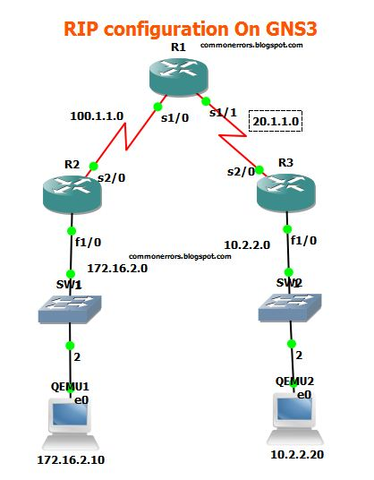

RIP routing protocol have simple configuration, you need a just network command to advertised the connected networks.

**Configuration for R1:**

R1#conf t

R1(config)#int s1/0

R1(config-if)#ip add 100.1.1.2 255.255.255.0

R1(config-if)#no shut

R1(config-if)#int s1/1

R1(config-if)#ip address 20.1.1.1 255.255.255.0

R1(config-if)#no shut

R1(config-if)#exit

**RIP Configuration Commands for R1:**

R1(config)#router rip

R1(config-router)#version 2

R1(config-router)#network 20.1.1.0

R1(config-router)#network 100.1.1.0

R1#copy run start

**Configuration for R2:**

R2#config t

R2(config)#int f1/0

R2(config-if)#ip address 172.16.2.1 255.255.255.0

R2(config-if)#no shut

R2(config-if)#int s2/0  ******

R2(config-if)#ip address 100.1.1.1 255.255.255.0

R2(config-if)#no shut

R2(config-if)#exit

R2(config)#router rip

R2(config-router)#version 2

R2(config-router)#network 172.16.2.0 ********

R2(config-router)#network 100.1.1.0

R2#copy run start

**Configuration for R3:**

R3(config)#int s2/0

R3(config-if)#ip add 20.1.1.2 255.255.255.0

R3(config-if)#int f1/0

R3(config-if)#ip add 10.2.2.1 255.255.255.0

R3(config-if)#no shut

R3(config-if)#ex

R3(config)#router rip

R3(config-router)#ver 2

R3(config-router)#network 10.2.2.0

R3(config-router)#network 20.1.1.0

R3#copy run start

RIP Verification Commands:

“Show ip route” command should display all RIP networks and end to end ping should be successful.

