**Lab -2**

**Topic: Implementing Random Agent in Tic-Tact-Toe and Chess Game**

In this lab, we will learn to implement Tic-Tac-Toe game and the Chess game. In this lab we will consider computer working as a random agent, i.e., at each step it generates a random action

Q1. Implement Tic-Tac -Toe game with as a random agent.

1. Initial the board
2. Take input from the user
3. Update the board
4. Check the if the game is over or not
5. If the game is over stop, Otherwise, repeat the step from (b-e)

**Solution:** **tic-tac-toe-random-choice.html**

Q 2. Make a simple chess game where the computer with play with its own and it will take a random action at each step.

Note: you can read the link at the following location for more information:

<https://readthedocs.org/projects/python-chess/downloads/pdf/stable/>

a. Import python chess library and show the initial board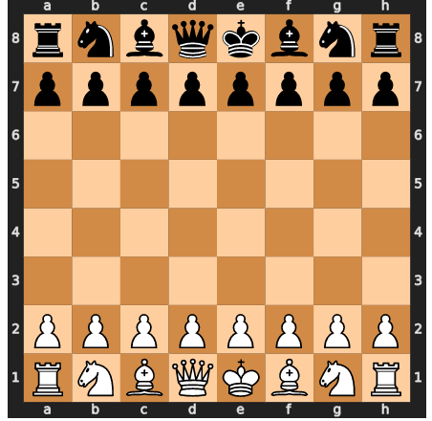

b. Print all the legal moves

c. Move any white or black solider to one location forward

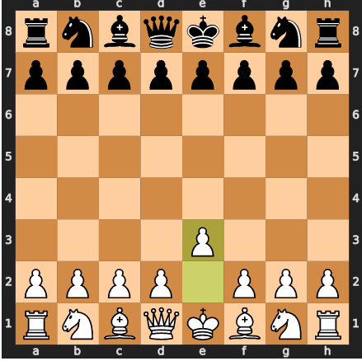

1. Make two random player on computer (no human) to play chess

**Solution : Programming a Chess Player.html** (section 1 to 1.5)

**References:**

**Tic-Tac-Toe:** [**https://medium.com/byte-tales/the-classic-tic-tac-toe-game-in-python-3-1427c68b8874**](https://medium.com/byte-tales/the-classic-tic-tac-toe-game-in-python-3-1427c68b8874)

**Chess:** [| Chess game in python (4 lines ) | | AK | - YouTube](https://www.youtube.com/watch?v=l6ex08F92F0)