This calculator is implemented by visual studio 2015 in two ways.

1. Console pricer. Please change the option parameter in main.cpp
2. GUI pricer with Qt. This project must be compiled with Qt library. The GUI looks like this way:

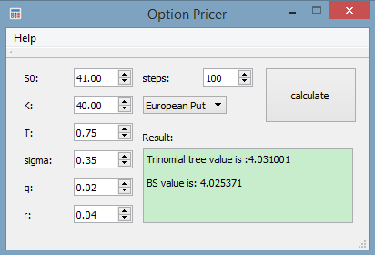

The executables are built with 32 bit and are stored in Run folder. It should be able to run in both 32bit and 64bit windows machines. And it has been tested in Windows 8.1 64 bit and Windows 10 64 bit.

If you cannot run the GUI program, please use the console program. If you are using Mac or Linux, please use g++ or other tools with the console program.

The tree pricer files are located at common_files folder.