**HACKATHON-3**

**API INTEGRATION & DATA MIGRATION**

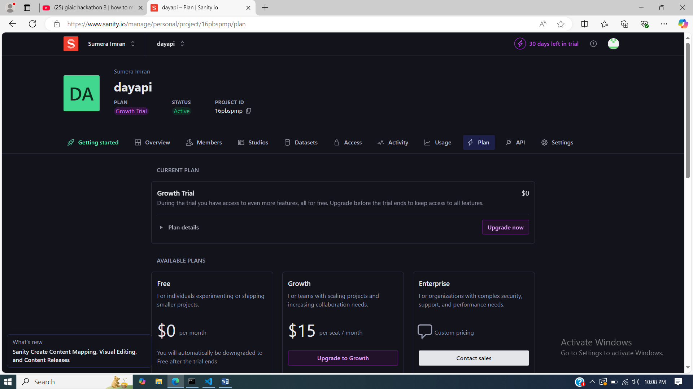

**SANITY INSTALLATION**

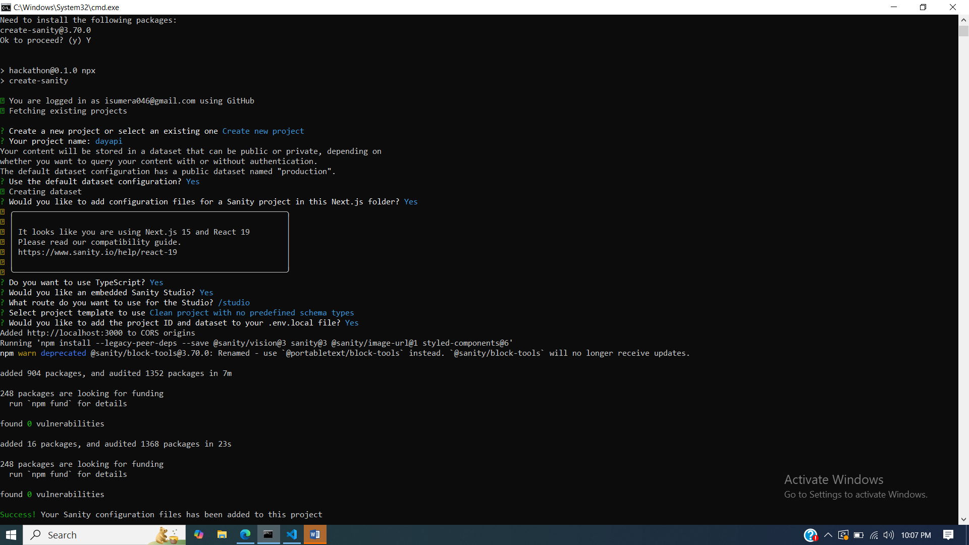

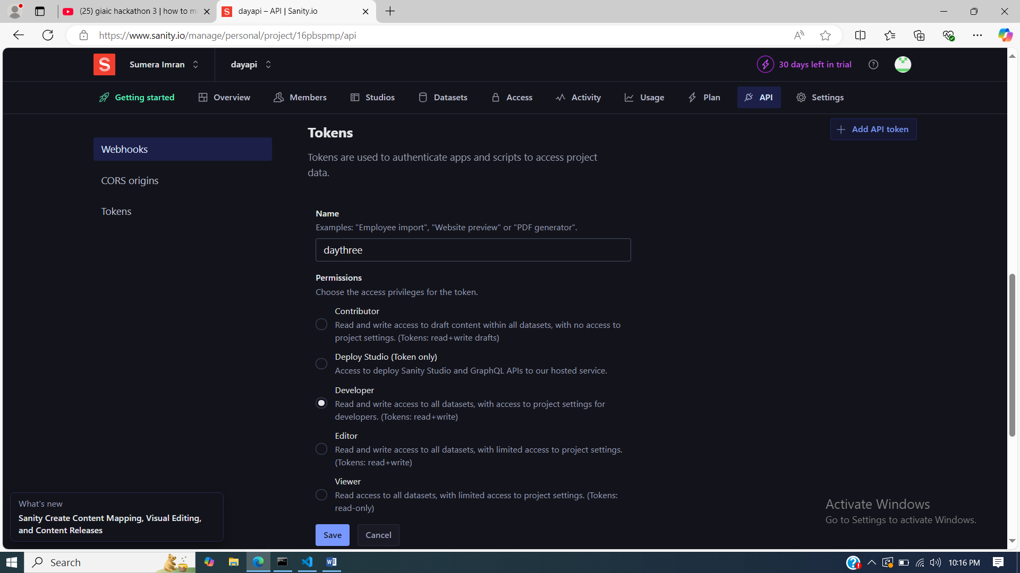

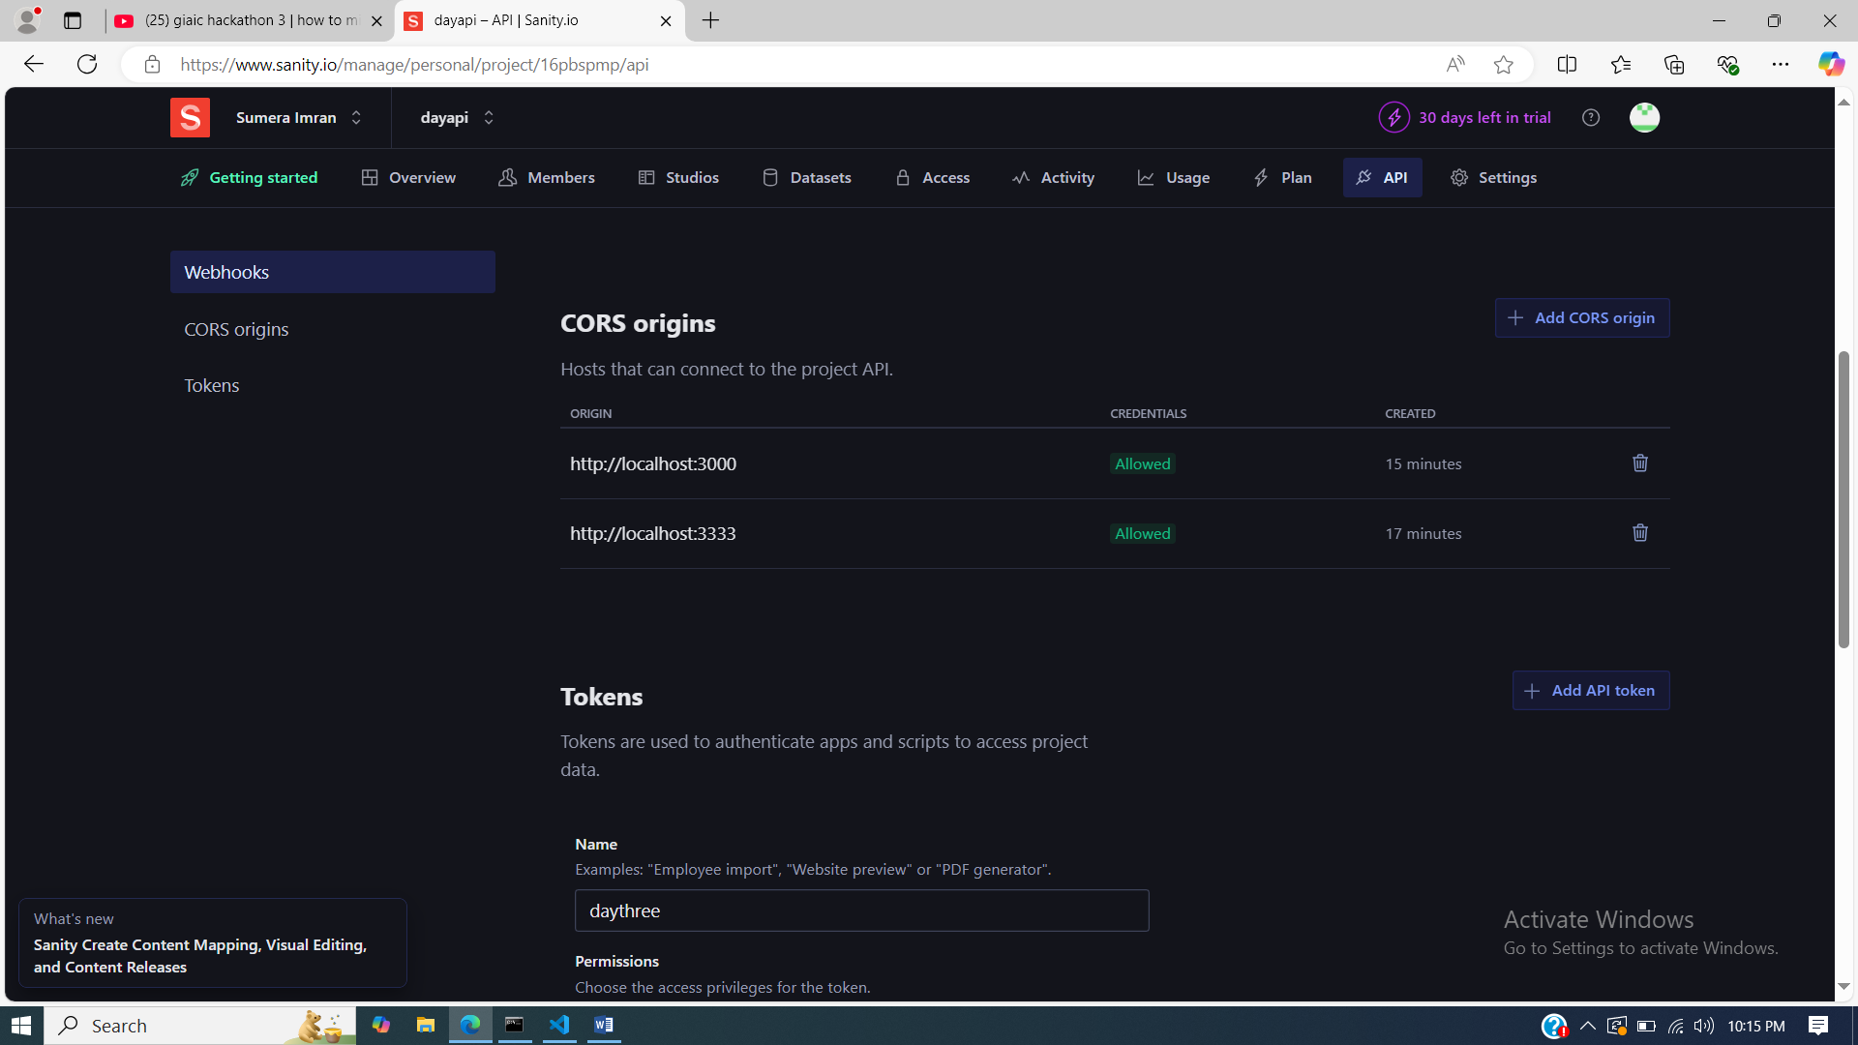

**TOKEN**

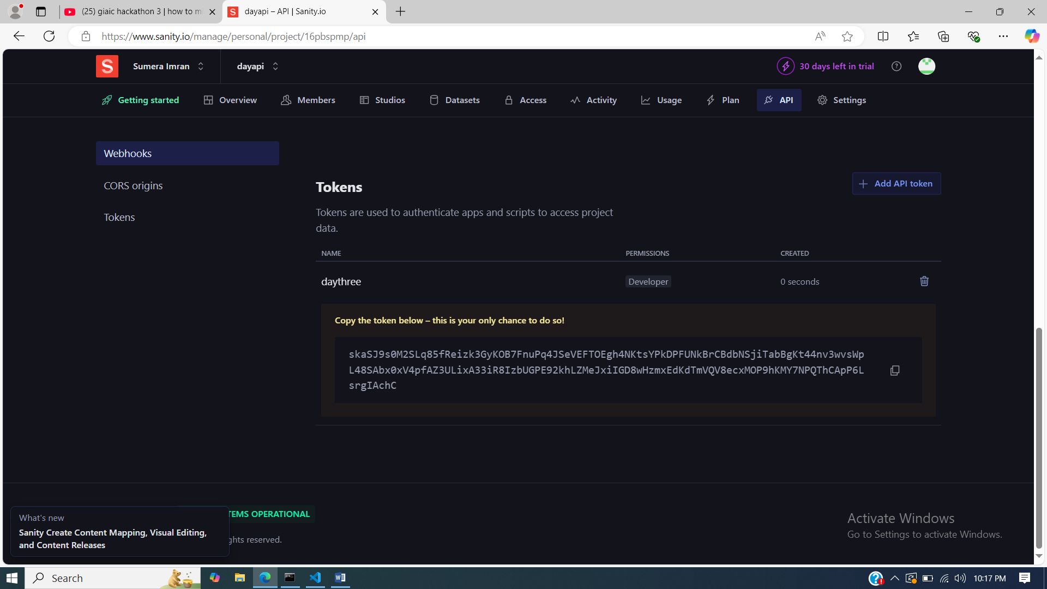

**PRODUCT**

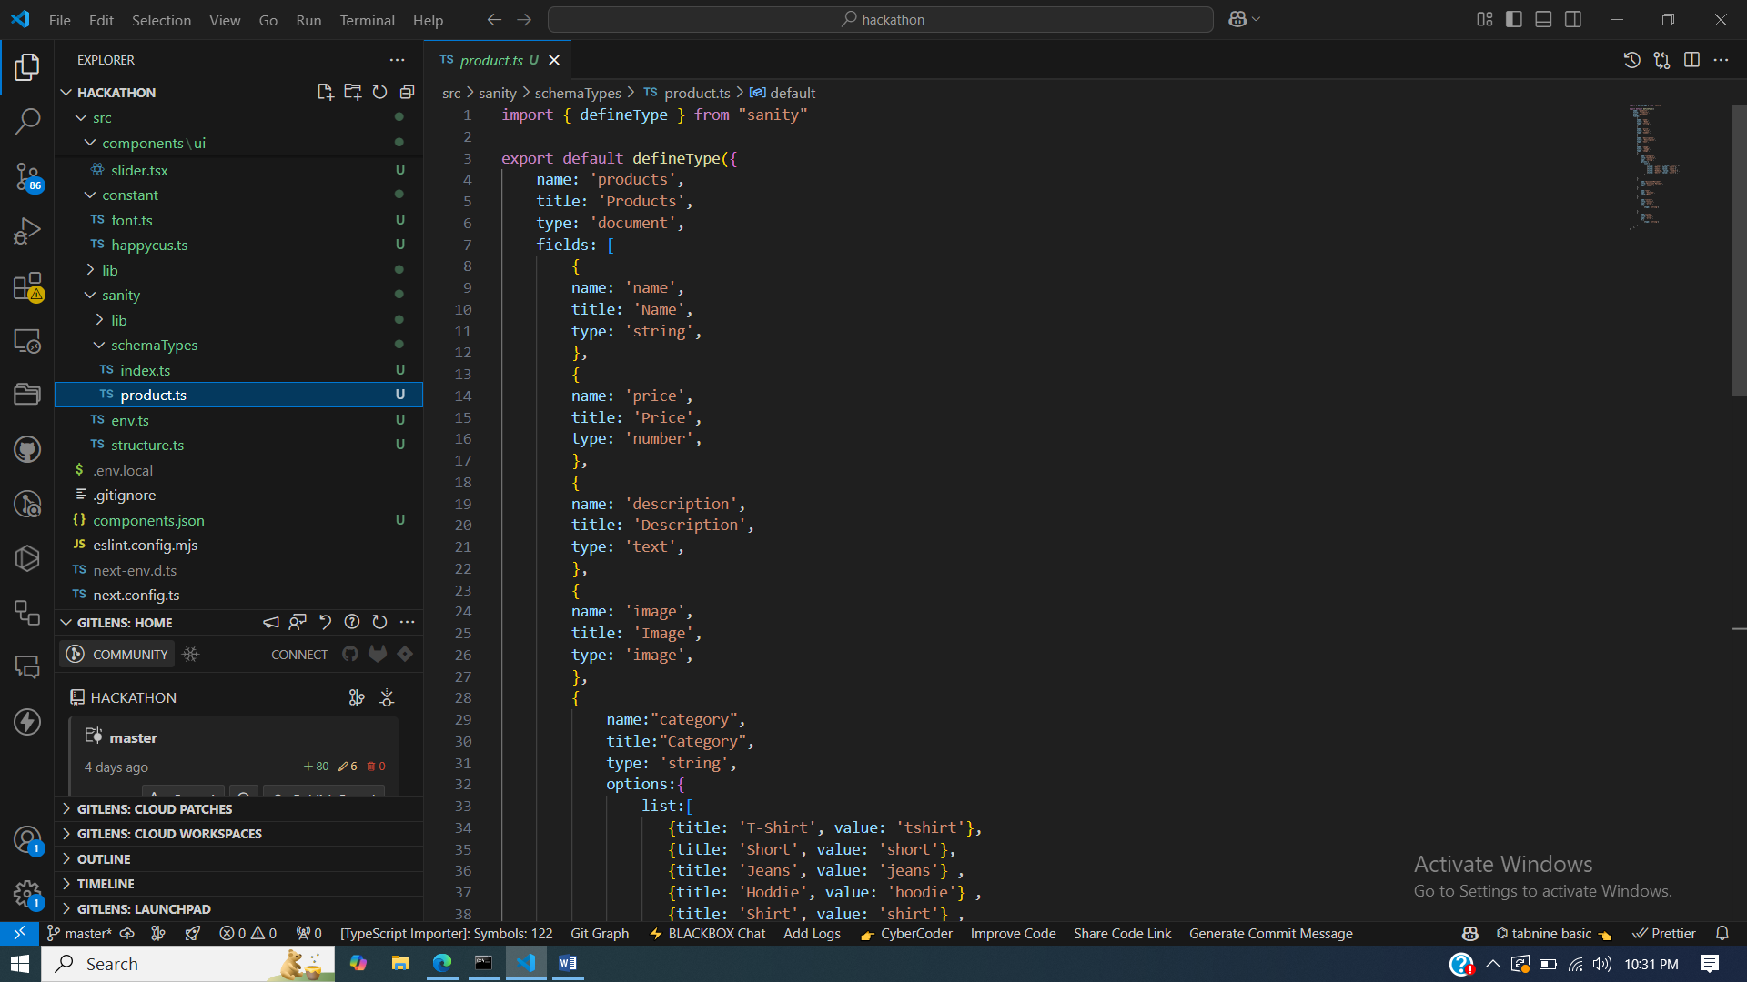v

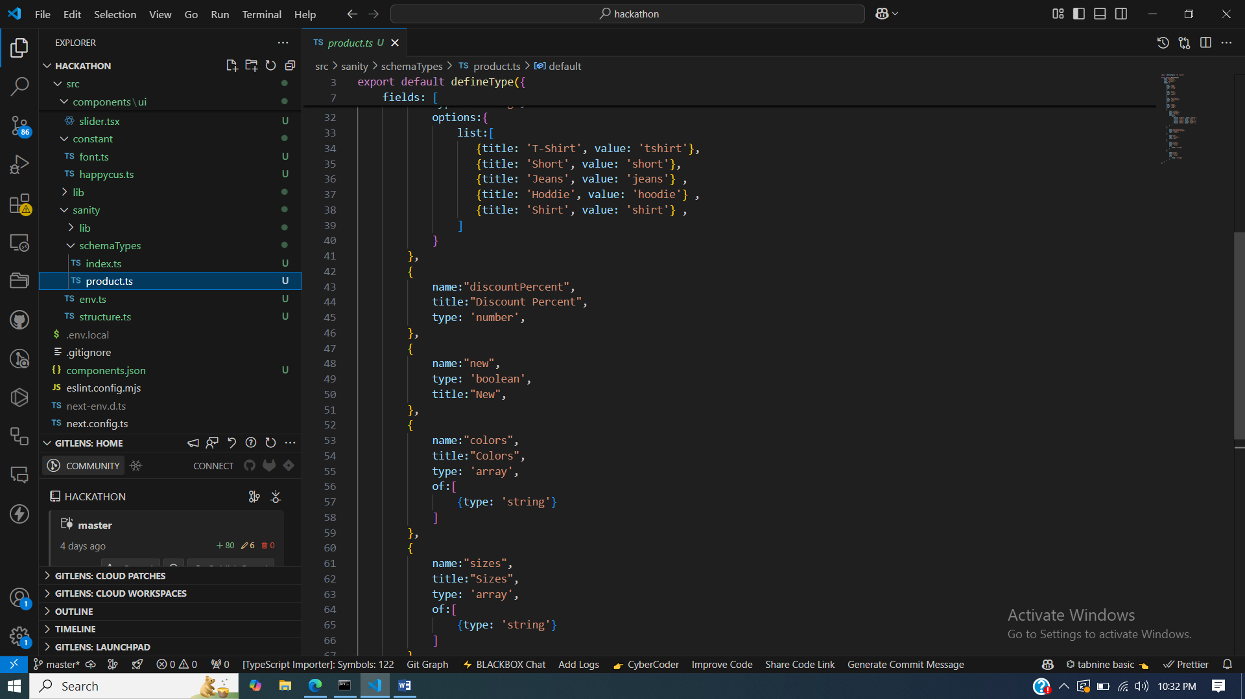

**API Integration and Migration for a Clothing Website**

**Overview**

API integration and migration for a clothing website involves incorporating external services to enhance functionality and ensure seamless data transfer between old and new systems. This process can include integrating payment gateways, shipping providers, inventory management tools, or migrating to a more robust backend system. Below is a step-by-step guide to approach this process effectively.

**1. Assessment and Planning**

**a. Identify Business Requirements**

* List all functionalities needed for the clothing website.
  + Inventory synchronization
  + Payment processing
  + User authentication
  + Order management
  + Product catalog updates
* Define KPIs (e.g., faster load times, error reduction).

**b. Audit Existing Systems**

* Evaluate the current system’s architecture.
* Note any custom integrations or proprietary data formats.

**c. Select APIs and Tools**

* Choose APIs that meet your requirements:
  + **Payment Gateways:** Stripe, PayPal, Razorpay
  + **Shipping Services:** Shippo, FedEx, DHL APIs
  + **Inventory Management:** TradeGecko, Skubana
* Ensure compatibility with your tech stack.

**2. API Integration**

**a. Authentication Setup**

* Use OAuth 2.0, API keys, or token-based authentication depending on the API.
* Secure sensitive data using encryption and environment variables.

**b. API Configuration**

* Set up endpoints for key functionalities:
  + **GET** requests for fetching product details, inventory, and orders.
  + **POST** requests for creating new orders or adding products.
* Implement rate-limiting to prevent overloading.

**c. Error Handling and Logging**

* Implement retry mechanisms for failed requests.
* Log all API calls for debugging and analysis.

**d. Frontend Integration**

* Use AJAX, Axios, or Fetch API for real-time data updates.
* Ensure responsiveness and seamless UI/UX design.

**3. Data Migration**

**a. Data Mapping and Cleaning**

* Map data fields from the old system to the new one.
* Remove redundant or outdated information.

**b. Export and Import**

* Use CSV, JSON, or XML formats for data transfer.
* Automate the process with scripts or tools like AWS Data Pipeline or Talend.

**c. Validation**

* Verify data integrity post-migration:
  + Check product details.
  + Confirm order histories.

**4. Testing and Deployment**

**a. Testing**

* **Functional Testing:** Ensure each API endpoint performs as expected.
* **Load Testing:** Simulate high traffic to test system resilience.
* **Security Testing:** Verify that sensitive information is secure.

**b. Staging Environment**

* Test integrations in a staging environment before deploying to production.
* Gather feedback from key stakeholders.

**c. Deployment**

* Schedule the migration during off-peak hours.
* Monitor the system for anomalies immediately after deployment.

**5. Post-Migration Maintenance**

**a. Monitoring**

* Use tools like New Relic or DataDog to monitor API performance.

**b. Updates**

* Stay updated with changes to API versions and deprecations.
* Regularly review and optimize integration for performance.

**c. User Feedback**

* Collect feedback from end-users to identify any usability issues.
* Implement changes to improve user experience.

**Conclusion**

API integration and migration for a clothing website can significantly enhance performance, scalability, and user experience. Proper planning, robust implementation, and thorough testing are essential to ensure a smooth transition and long-term success.

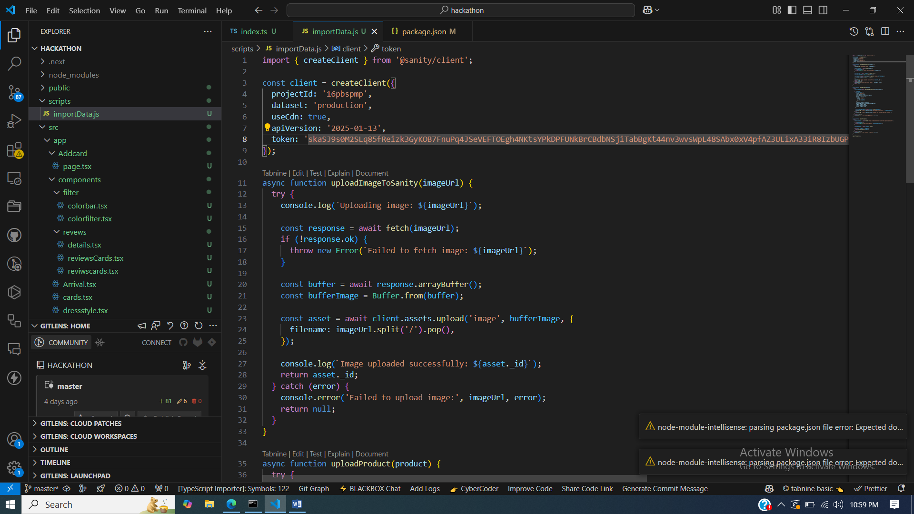

**SANITY PRODUCTS**

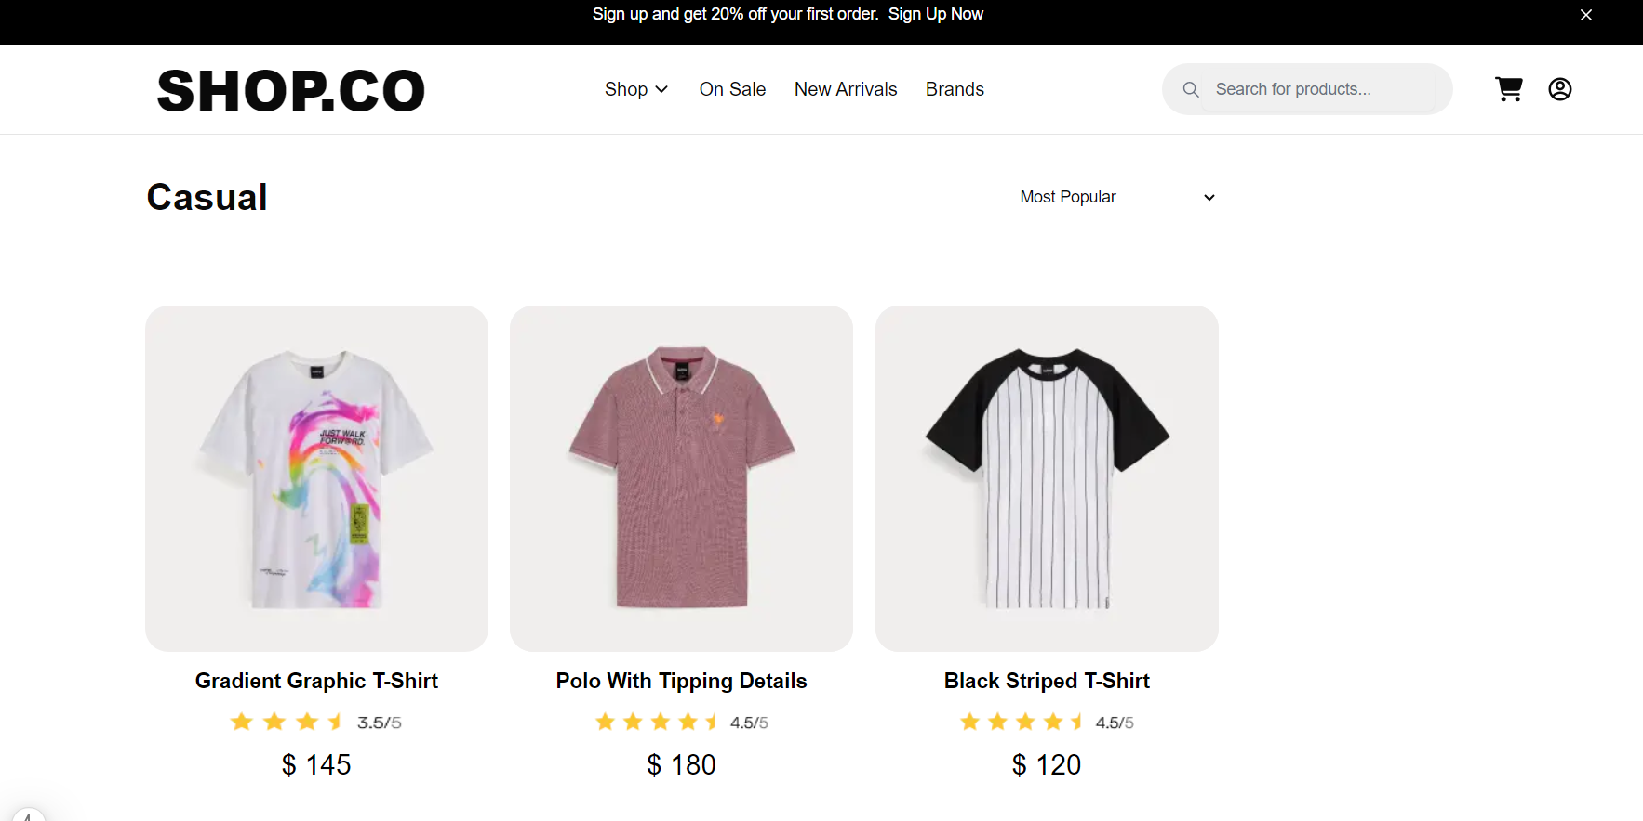

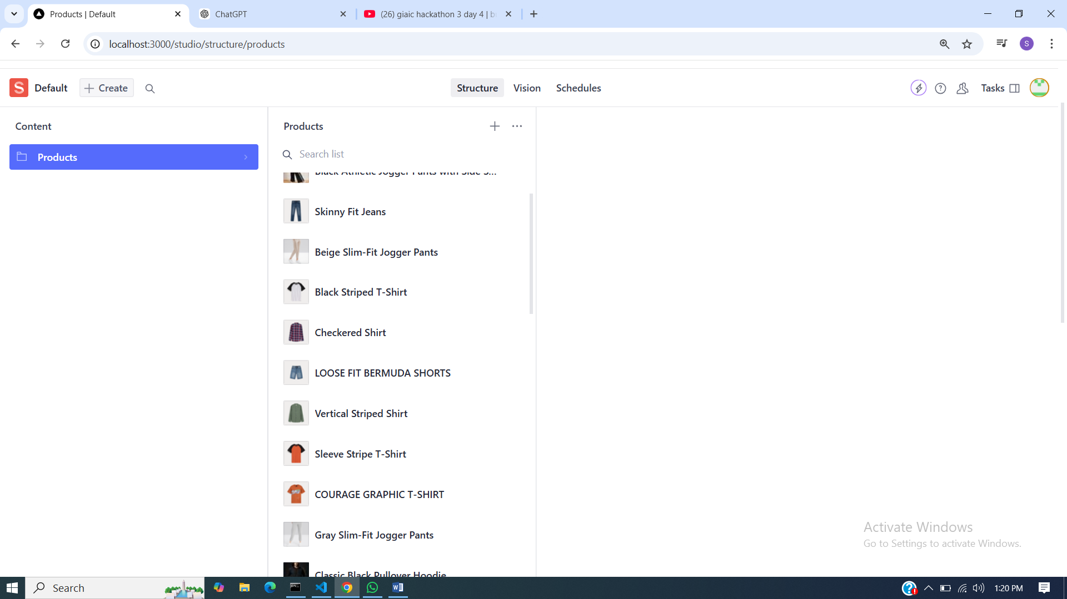

**IMPORTDATA.JS**

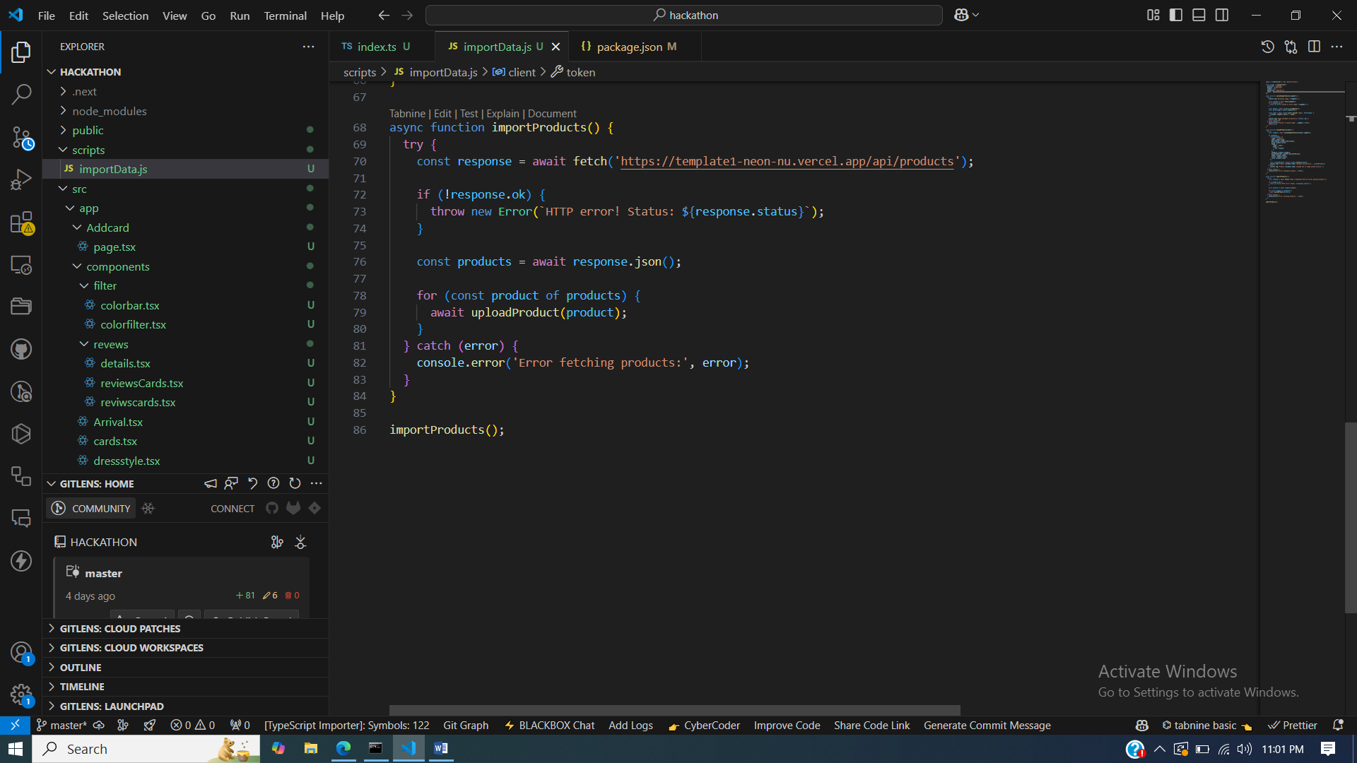

**PACKAGE.JSON**

