**STEP:3 API STATUS**

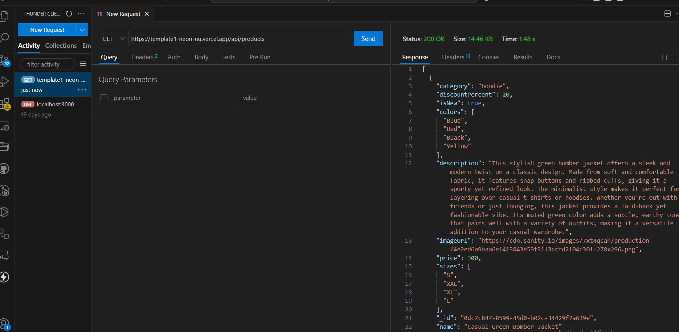



**STEP:4 PERFORMANCE OPTIMIZATION**

**npm install –g lighthouse**

**lighthouse** [**http://localhost:3000**](http://localhost:3000) **–view**

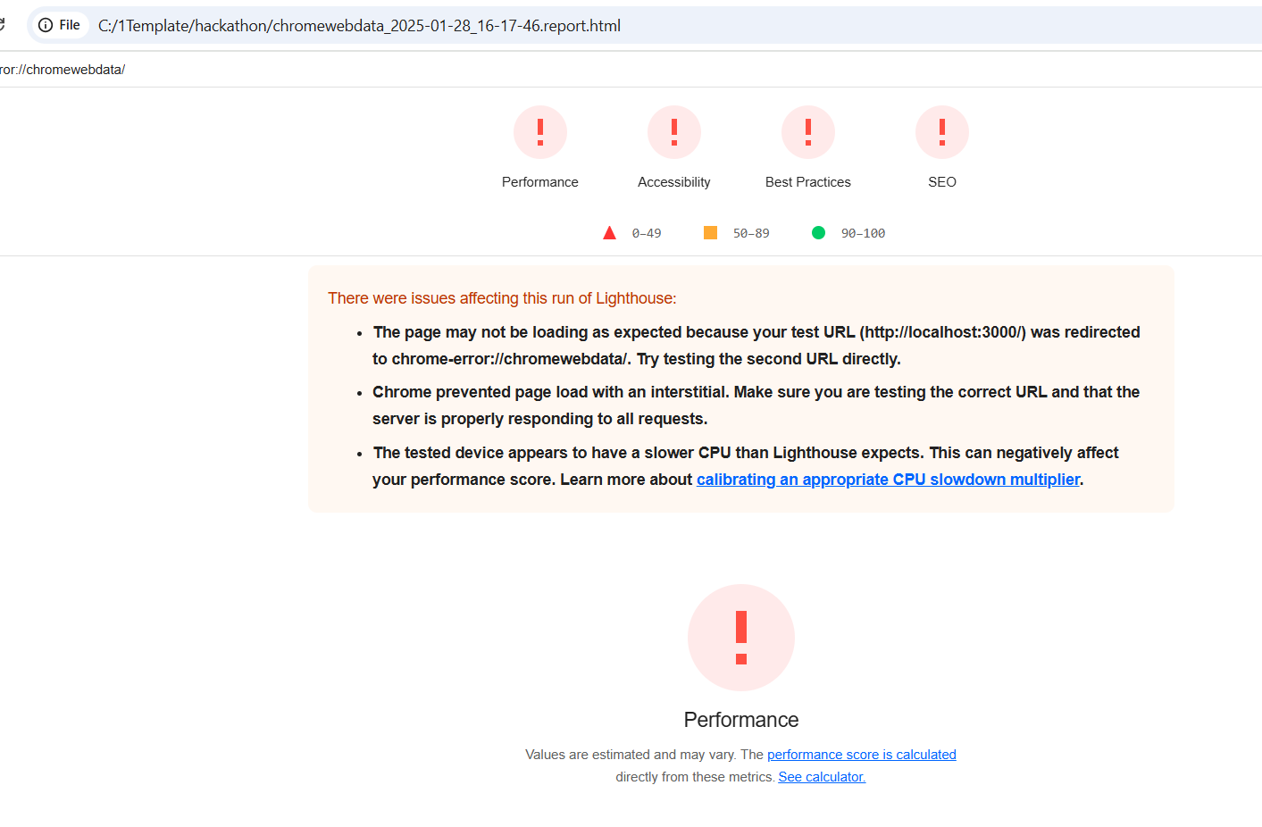

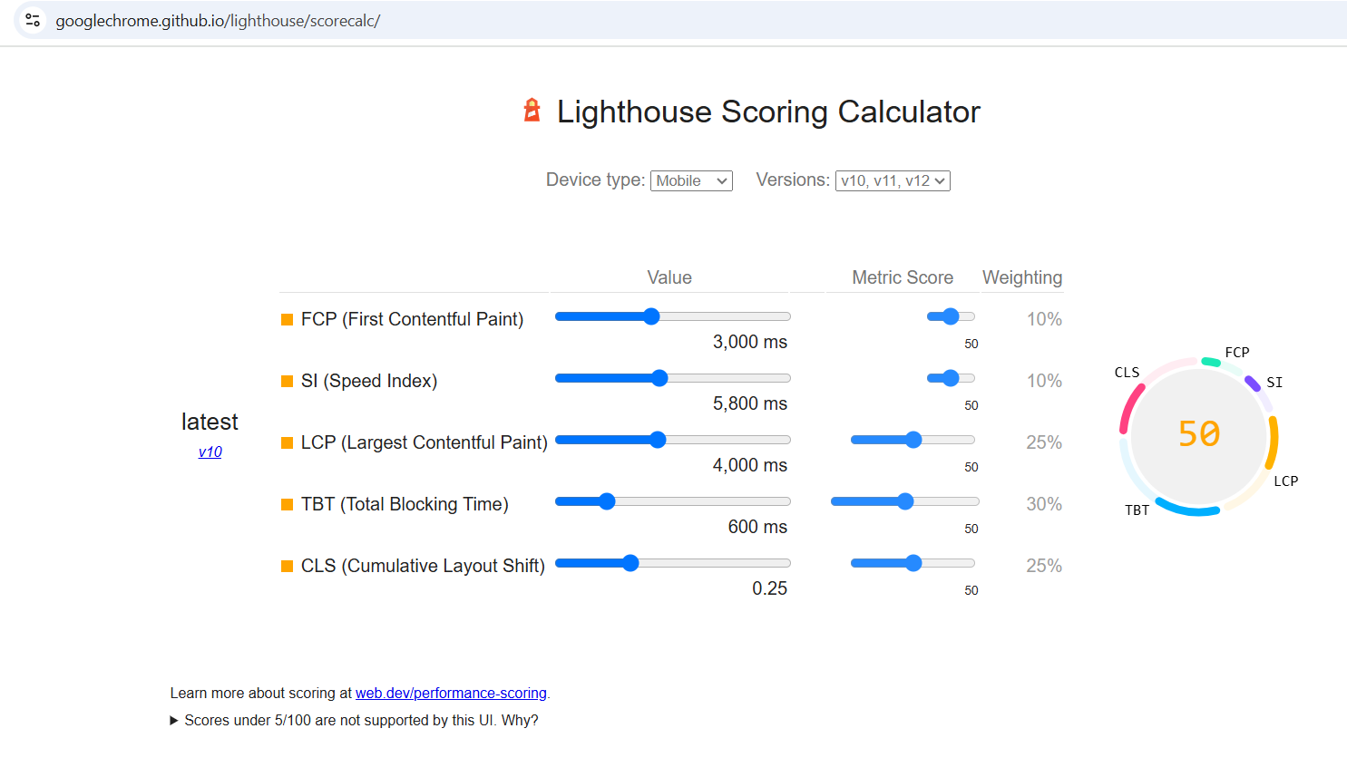

**DEVELOPER RESOURCES**

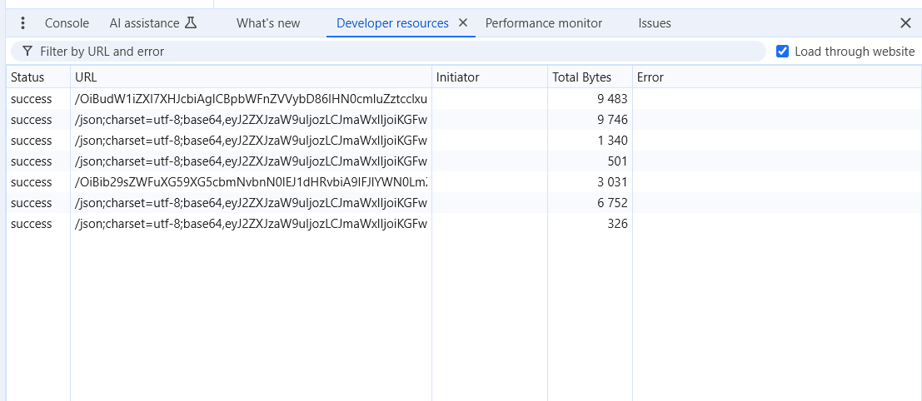

**PERFORMANCE MONITOR**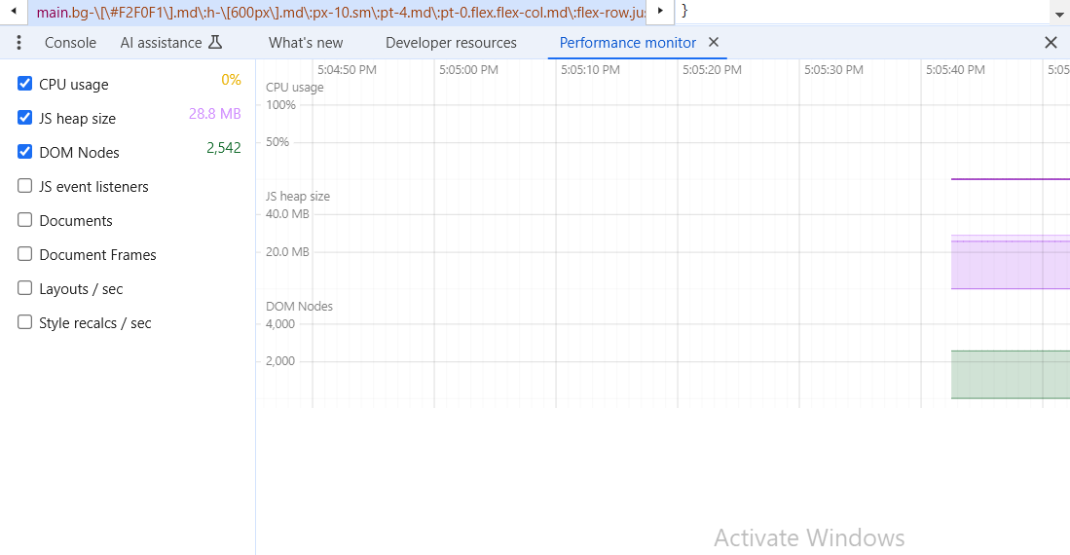

**SECURITY**

