fcc_logo

**Federal Communications Commission**

**445 12th Street, SW**

**Washington, DC 20554**

**FCC White Paper**

The Mobile Broadband

Spectrum Challenge:

International Comparisons

**Wireless Telecommunications Bureau**

**Office of Engineering & Technology**

**February 26, 2013**

# introduction

The mobile wireless landscape is undergoing a transformation, as mobile broadband networks are emerging not only as the foundation for communications services in the twenty-first century, but also as the infrastructure supporting economic growth and innovation in wide-ranging, consumer-focused areas such as health care, public safety, education, and social welfare. Ensuring that sufficient spectrum is available to satisfy the growing demand for mobile broadband services is a global challenge: global mobile data traffic is anticipated to grow eighteen-fold between 2011 and 2016.[[1]](#footnote-2) In this white paper, we provide information on how the United States and certain other countries are responding to this challenge, in terms of making both licensed and unlicensed spectrum available for mobile broadband services. The white paper is divided into two parts: we first discuss the availability of licensed mobile broadband spectrum and then examine opportunities for using unlicensed spectrum.

Table 1 below summarizes the results of our analyses of licensed and unlicensed spectrum in various parts of the world:

**Table 1: Summary of Licensed and Unlicensed Spectrum Available for Mobile Broadband**

**(in megahertz)**

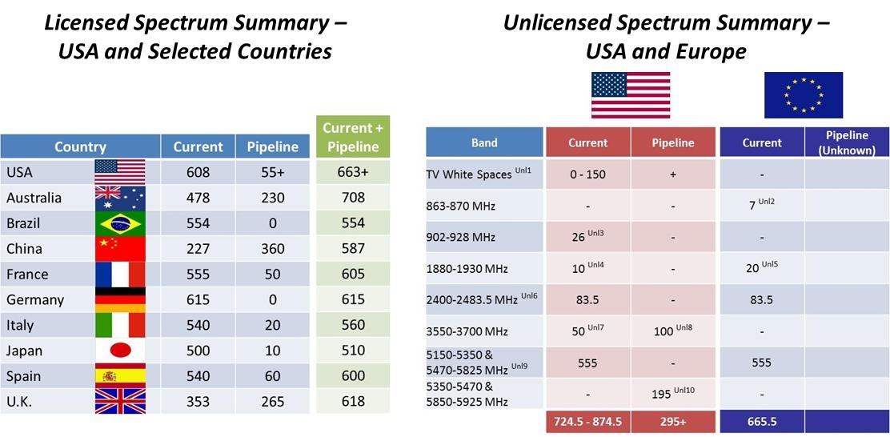

***Note****: US pipeline numbers do not include the significant amount of spectrum that will be made available for mobile broadband from incentive auctions and federal repurposing.*

***Note****: Includes “licensed-light” spectrum.*

# Licensed spectrum resources

In this section, we discuss the status of spectrum available for mobile broadband services for selected countries[[2]](#footnote-3) and the United States. We limit our analysis in this section to licensed spectrum below 2.7 GHz, because these are the frequency bands that, at present, are primarily used for the provision of mobile broadband services around the world.[[3]](#footnote-4) For purposes of this section, we distinguish between mobile spectrum bands by placing them into one of two categories: (1) “currently available” or (2) “in the pipeline.” We consider spectrum to be “currently available” if providers have legal authority to build networks and provide voice and/or mobile broadband service. This includes spectrum that is currently being used to provide such service, as well as spectrum where providers have not yet built out their networks, and encumbered spectrum where providers have the authority to clear the spectrum. We consider spectrum to be “in the pipeline” if it is not currently available for commercial services but the relevant government has plans to make this spectrum available to providers within the next three years. “Pipeline” spectrum includes encumbered spectrum where providers lack the authority to clear the spectrum but the relevant government has plans to make the spectrum available for commercial services, through clearing or sharing, within the next three years.

For the most part, the spectrum bands commonly used for mobile broadband services around the world are based on two sets of “standard” bands that are used in the United States or Europe, with some exceptions (such as the use of the 1.5 GHz band in Japan).[[4]](#footnote-5) By using the same standard bands that are used throughout the world, countries can take advantage of economies of scale in designing and deploying network and consumer equipment. While the standard mobile spectrum bands used in Europe do not correspond exactly with the standard mobile spectrum bands used in the United States, the largest and most commonly deployed bands are comparable in terms of general frequency range, timing, and technology, as shown below (see Table 2). The total available spectrum in these standard mobile spectrum bands is also roughly equal for Europe and the United States.

**Table 2: EU and US – The Most Commonly Deployed**

**Mobile Broadband Spectrum Bands**

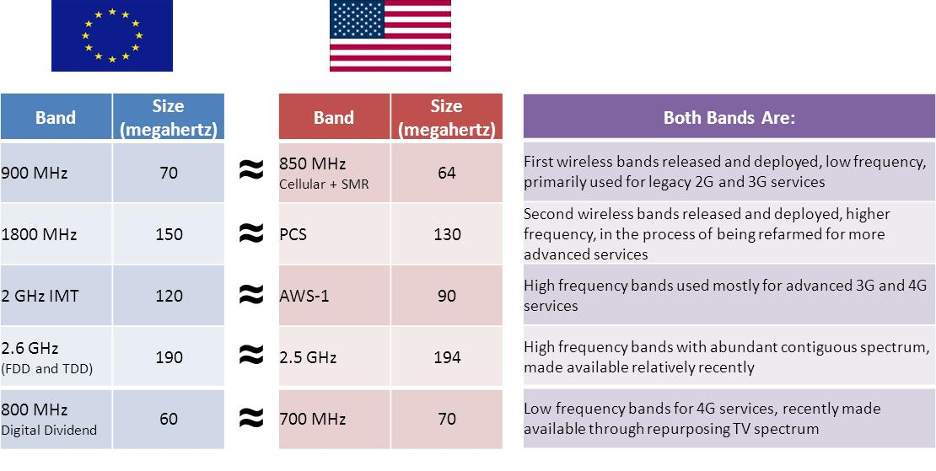

***Note****: This table represents only the most commonly deployed bands in the EU and US as of the date of this paper. Thus, it does not include the AWS-4 and WCS bands recently made available in the US, which are not yet deployed and generally do not have a comparable counterpart in Europe.*

Figure 1, below, provides another perspective on the most commonly deployed US and European allocations by showing those mobile spectrum allocations by frequency band (under 1 GHz, between 1 and 2 GHz, and between 2 and 3 GHz). While there is significant overlap, the allocations are not identical.

**Figure 1: EU and US – The Most Commonly Deployed**

**Mobile Broadband Spectrum Bands**

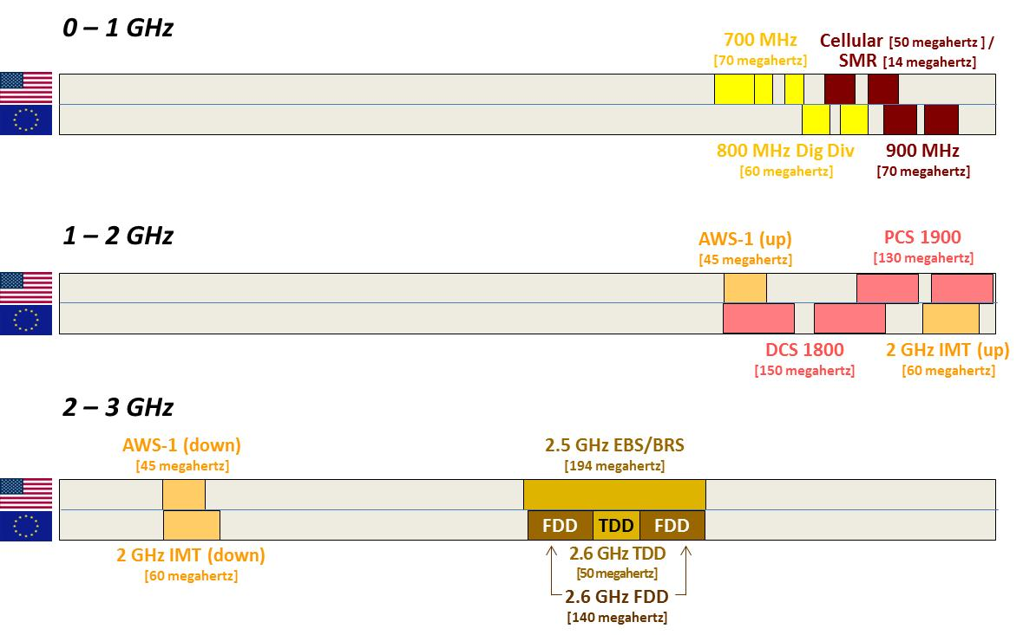

***Note****: This figure represents only the most commonly deployed bands in the EU and US as of the date of this paper. Thus, it does not include the AWS-4 and WCS bands recently made available in the US, which are not yet deployed and generally do not have a comparable counterpart in Europe.*

In the tables below, for the United States and certain other countries, we break down the amount of licensed mobile broadband spectrum that is currently available and in the pipeline by frequency band. The text and endnotes also identify spectrum that is potentially available in the future for licensed mobile broadband.

**Table 3: Mobile Broadband Spectrum in the United States as of February 2013**

**(in megahertz)**

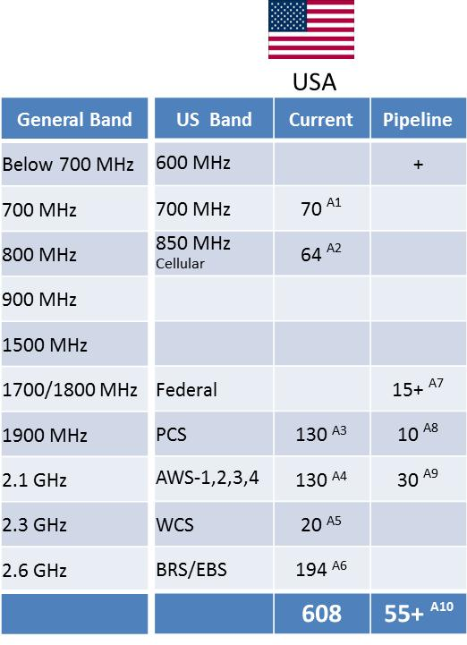

As represented by the “+” signs, the United States has several initiatives underway to free up more spectrum than shown above, including work with federal agencies and the National Telecommunications and Information Administration (NTIA) to free and/or share significant amounts of federal spectrum. The Federal Communications Commission has begun the process to implement incentive auctions for television broadcast spectrum in the 600 MHz range in order to free up significant additional spectrum for mobile use. Because of the difficulty of predicting the precise amount of spectrum that will be made available through each of these efforts, we have chosen not to include a specific estimate for this spectrum in the table above.

**Table 4a: Mobile Broadband Spectrum in Certain EU Countries as of October 2012**

**(in megahertz)**

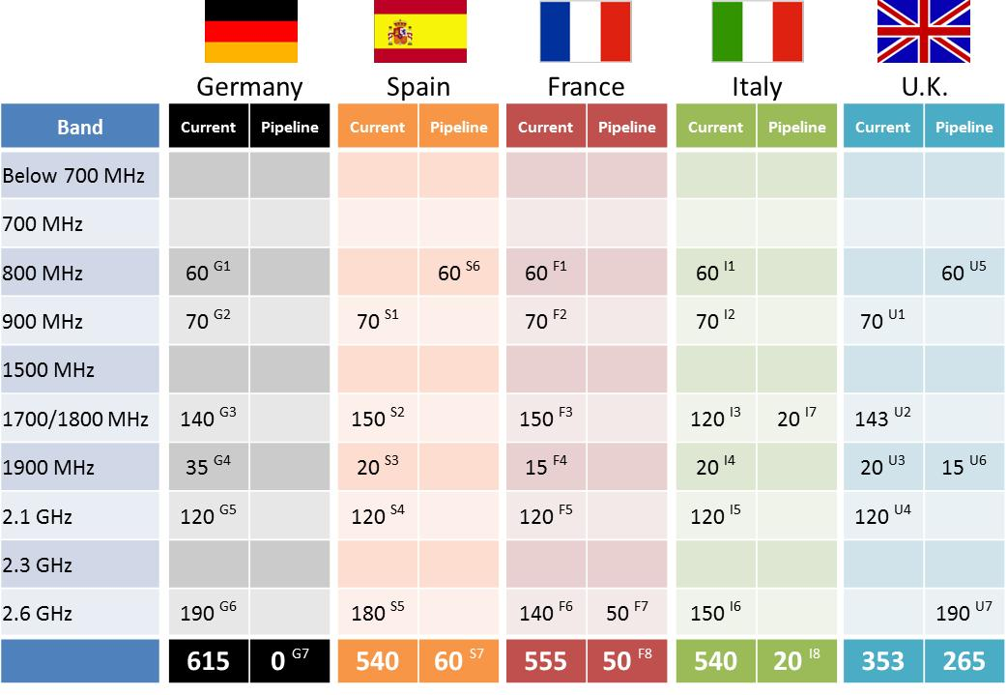

Europe is in the preliminary stages of considering a second digital dividend that could create another large band of low frequency spectrum on the order of 50 to 70 megahertz. This is a long-term effort, however, and this spectrum is not yet available as “pipeline” spectrum.

**Table 4b: Mobile Broadband Spectrum in Certain Other Countries**

**as of October 2012 (in megahertz)**

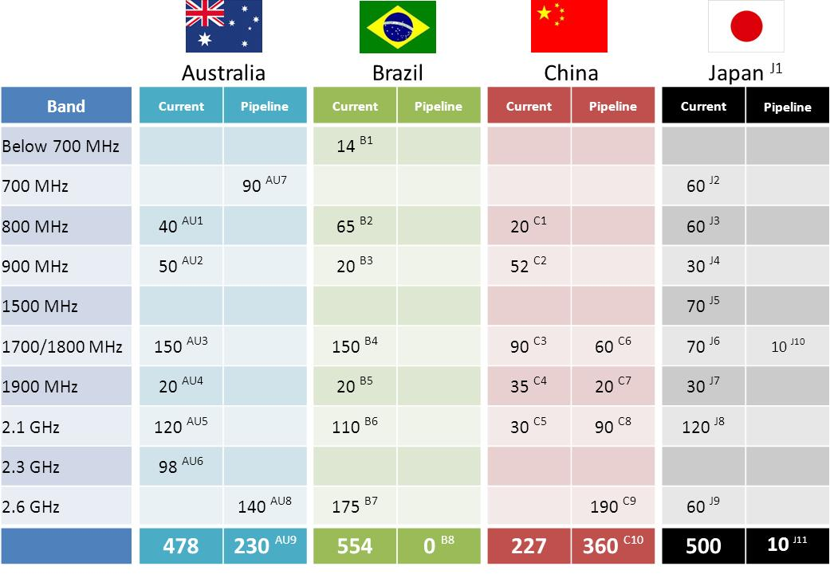

For many countries, the combined total for the amount of mobile broadband spectrum that is currently available and in the pipeline is fairly constant, largely due to common usage of the same standard bands (see Table 5).

**Table 5: Summary of Total Available Licensed Spectrum Available for Mobile Broadband (in megahertz)**

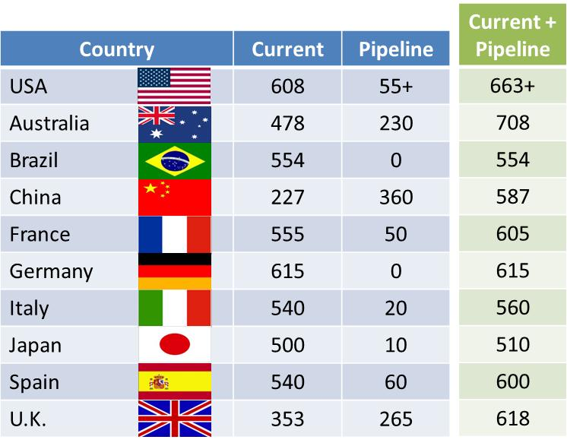

***Note****: US pipeline numbers do not include the significant amount of spectrum that will be made available for mobile broadband from incentive auctions and federal repurposing.*

# UNLicensed spectrum resources

The United States has pursued innovative spectrum access models that allow entry into bands that had previously been viewed as encumbered or otherwise unsuitable for development. As described in greater detail below, and in the accompanying charts, the United States has utilized different approaches to make spectrum available for mobile broadband use on a non-exclusive basis. We identify well over 700 megahertz of spectrum that is available in the United States for mobile broadband use on a nonexclusive basis, as well as an additional 345 megahertz that is either in the pipeline or has the potential to be used in such a manner.

Under the traditional unlicensed approach, the Commission has required no specific device or user authorization, either through registration or grant of a license. Technologies such as Wi-Fi, Bluetooth, and Zigbee – spawned by US leadership – have thrived under this model. Widely deployed, devices that use these standards have proven to be popular with consumers and are broadly supported and used by industry. Such devices have turned frequency bands that were formerly considered to be of relatively limited value (due to potential interference from microwave ovens and industrial equipment that uses high power RF energy to perform various functions) into important broadband networking platforms.

In other instances, new and innovative technologies have provided the means to expand unlicensed spectrum use. For example, as a result of the Commission’s recent white spaces proceeding, we permit operation in the TV bands without a specific license, providing spectrum access by means of a database and the use of cognitive radio technologies.[[5]](#footnote-6) The prospect of using such advanced technologies has also served as a potential basis for sharing of other parts of the spectrum, including spectrum used by the federal government. Although this has obvious potential benefits for increased access to spectrum in the United States, it is likely that other parts of the world will consider similar approaches to facilitate growth and innovation in unlicensed devices.

An additional approach used in some Commission-regulated services involves “blanket licensing,” under which users must comply with specific service rules but do not have to obtain individual station licenses. For example, in the 3650 MHz band, the Commission implemented a licensed model that employs non-exclusive licenses.[[6]](#footnote-7) The Commission just recently proposed to make additional spectrum available at 3550-3650 MHz on a “licensed-light” basis, shared with existing federal services. For purposes of this paper, we are treating such licensed-light spectrum bands as unlicensed because they are open to anyone, and typically a service provider obtains a license through a simple, non-exclusive process.

Also for purposes of this paper, we have not accounted for unlicensed spectrum that is available for general use but may not be particularly well suited for mobile broadband purposes and instead is used for applications such as remote control, RFID, and wireless sensors. We also have not accounted for spectrum that is available above the 5 GHz region, such as the band at 57–64 GHz. This band can be used for fixed broadband applications but typically only over very short distances. While this spectrum may ultimately be deployed for Wi-Fi applications, it has not been used for mobile applications thus far. Nor have we accounted for spectrum available for ultra-wideband operations because these devices have not been deployed in any significant numbers.

Although US efforts to make non-exclusive spectrum bands available for mobile broadband use are well documented, it is somewhat difficult to compare this record with other countries. First, unlike high-power radio services that have the potential to cause interference across international borders and therefore are the focus of international organizations such as the International Telecommunication Union (ITU), unlicensed operations typically use relatively low power and spectrum availability is not generally considered by international organizations. Additionally, while nearly all spectrum can be used for unlicensed devices, not all bands are suitable for mobile broadband – either because of technical characteristics of various parts of the spectrum or restrictions necessary to protect incumbent services against harmful interference. Also, many countries do not publish lists of unlicensed bands or require registration or licensing of all spectrum users.

The 2.4 and 5 GHz bands – popularized by Wi-Fi applications – are widely available in many countries, although the exact amount of available spectrum varies by jurisdiction. These bands are especially well suited for near-ubiquitous worldwide deployment given their primary allocation by the ITU for industrial, scientific and medical equipment; the presence of strong international standards and trade groups such as the IEEE and the Wi-Fi Alliance; and the production of vast amounts of low-cost popular consumer devices.

Beyond those bands, comparisons can only be general at best. What is clear from past experience is that unlicensed technologies can become especially popular when they can achieve economies of scale. The United States has supported innovation in the development of unlicensed devices, and has in turn made spectrum available to support such devices. We recognize that other jurisdictions may not yet have realized some of these unlicensed spectrum opportunities. For example, while the Commission has already acted to permit new unlicensed uses of television broadcast spectrum, most other countries are only just beginning to consider similar action. The actions of the United States may serve as a practical model for these countries as they work to adopt new and expanded schemes to provide for unlicensed broadband use.

In the following table, we have documented those bands that the United States has made available for unlicensed use and that can support mobile broadband applications. To the extent that information is available, we have also made comparisons with European bands.

**Table 6: Amount of Spectrum Below 6 GHz Available for Unlicensed Broadband Use**

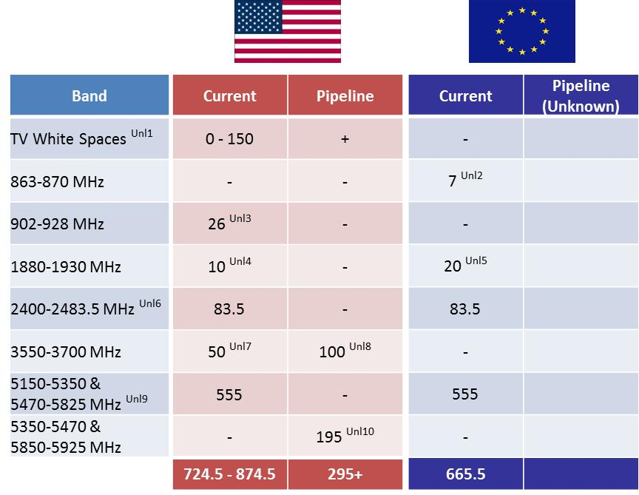

The TV white spaces are currently estimated as 0 to 150 megahertz because the amount of available spectrum varies by location. The “+” sign in the pipeline column indicates that the Commission has proposed to make a substantial amount of spectrum available for unlicensed use in its recent proposal to provide for incentive auctions as discussed above, including a significant portion that would be available on a nationwide basis for the first time.

The row for the 5350-5470 MHz and 5850-5925 MHz bands represents the Commission’s recently initiated proceeding to make up to 195 megahertz available for unlicensed devices.  These bands are currently under study by the NTIA to determine whether unlicensed devices may share this spectrum with existing federal services. This additional spectrum would provide for the next generation of Wi-Fi that offers higher data speeds and greater capacity that can help reduce congestion at major Wi-Fi hubs such as airports and convention centers.

# CONCLUSION

The need for spectrum to accommodate increasing mobile broadband demands is a challenge confronting countries worldwide. As discussed above, the United States is taking a multipronged approach to ensure that sufficient spectrum – both licensed and unlicensed – is available to fuel the nation’s wireless broadband networks. Likewise, we recognize that worldwide efforts are underway to meet mobile broadband spectrum needs. In this regard, given the dynamic nature of the wireless landscape, the information in this white paper is subject to change. This white paper is based on a review of publicly available information. We welcome the submission of updated or additional data for future revisions. Interested parties may submit comments to *intlspectrumpaper@fcc.gov*.

**ENDNOTES**

**SECTION II: LICENSED SPECTRUM RESOURCES – TABLES 3, 4a, 4b**

United States

A1. 698-716 & 728-746 MHz FDD, 716-728 MHz unpaired, and 776-787 & 746-755 FDD: Auctioned in 2000, 2001, and 2008. This is the first large-scale, low-band LTE deployment in the world with the most LTE subscribers worldwide.

A2. 824-849 & 869-894 MHz FDD (cellular band) and 817-824 & 862-869 MHz (Enhanced Specialized Mobile Radio Service (ESMR) Band):  The cellular band is the first band available for mobile use in the US and supports both 2G and 3G technologies.  ESMR is being rebanded to solve interference issues and currently supports 2G iDEN and 2.5G CDMA technologies.  In the future, both bands may be refarmed to support 4G services.

A3. 1850-1910 & 1930-1990 MHz (Personal Communications Service (PCS) Band) and 1910-1915 & 1990-1995 MHz (G Block): This is the second band available for mobile use in the US; supports 2G, 3G, and 4G services.

A4. 1710-1755 & 2110-2155 MHz (Advanced Wireless Service (AWS)-1) and 2000-2020 & 2180-2200 (AWS-4): AWS-1 was auctioned in 2006, supports 3G and 4G services, and is viewed by many to be prime LTE capacity spectrum. AWS-4 is recently liberalized Mobile Satellite Service (MSS) spectrum. Per the technical rules, the lowest 5 megahertz of the AWS-4 uplink is restricted to low power. *See AWS-4 Report and Order*, FCC 12-151 (released December 17, 2012).

A5. 2305-2315 & 2350-2360 MHz (Wireless Communications Service (WCS) Band): AT&T is the largest holder of this spectrum.  The technical rule changes adopted by the Commission in October 2012 enable 20 megahertz to be used for mobile broadband.

A6. 2496-2690 MHz: Majority of band is used currently for WiMAX but transition to TD-LTE is planned, and there are some limitations on the usability of this spectrum in specific geographies. In part because of these limitations, in its past review of transactions the Commission has not considered Educational Broadband Service (EBS) spectrum made available for mobile broadband service through leasing, but has focused on 55.5 megahertz of Broadband Radio Service (BRS) spectrum. *See Sprint-Clearwire Order,* FCC 08-259, paras. 61-74 (2008).

A7. 15 megahertz of 1675-1710 MHz: The FCC is required by statute to auction 15 megahertz in this band plus another 15 megahertz (that is to be determined) by February 2015. *See Spectrum Act*, §§ 6401(a)(2)-(3), 6401(b)(1). Since the latter 15 megahertz is not yet identified, it is not represented in this table. The “+” is intended to indicate that the FCC and NTIA are currently working to free and/or share significant amounts of federal spectrum.

A8. 1915-1920 & 1995-2000 MHz (AWS-2 H Block): This spectrum serves as a natural extension of the current PCS band and the FCC recently proposed to auction this block in 2013. *See H Block NPRM* , FCC 12-152 (released December 17, 2012).

A9. Includes 2020-2025 & 2175-2180 MHz (AWS-2 J Block) and currently unpaired 2155-2175 MHz (AWS-3):  Ongoing proceedings and work with NTIA will make AWS-2 and AWS-3 spectrum available for mobile broadband in the next 2-3 years.

A10. In addition to ongoing efforts to free and/or share large amounts of federal spectrum and the 600 MHz incentive auction proceeding mentioned in text on page 5, an additional 10 megahertz of WCS is available for fixed broadband now and may be used for supplemental mobile downlinks in the future (i.e., 2315-2320 & 2345-2350 MHz). *See* *WCS Reconsideration Order*, FCC 12-130 (released October 17, 2012).

Germany

G1. 832-862 & 791-821 MHz: Germany auctioned Digital Dividend spectrum in May 2010

G2. 880-915 & 925-960 MHz: First band available for mobile use; legacy GSM is predominant use but is being refarmed for 3G.

G3. 1710-1780 & 1805-1875 MHz: Germany now uses all but the upper 5+5 megahertz of the second band available for mobile. The May 2010 auction included 50 megahertz of this band: 15+15 megahertz that had been recently cleared and two 5+5 megahertz blocks that an operator had previously traded for 900 MHz expansion spectrum.

G4. Unpaired 1900-1920 MHz and unpaired 2010-2015 MHz: Neither band is deployed in Germany; the 2010-2015 MHz band was sold to a single bidder at the reserve price in the May 2010 auction.

G5. 1920-1980 & 2110-2170 MHz: Six bidders won 10+10 megahertz in Germany’s 3G auction in 2000, but two later defaulted. Thus, the May 2010 auction included the re-auction of this 40 megahertz.

G6. 2500-2570 & 2620-2690 MHz FDD and 2570-2620 MHz TDD: Auctioned in May 2010.

G7. Although our table shows that Germany has no pipeline spectrum, 1780-1785 & 1875-1880 MHz may potentially become available. Germany has not allocated this last part of the 1800 MHz band for broadband, but it is possible that it may be cleared, allocated, and deployed in the future.

Spain

S1. 880-915 & 925-960 MHz: First band available for mobile use; legacy GSM is predominant use but recent auctions in July and October 2011 included the re-auction of two expiring 5+5 megahertz GSM licenses for licenses that include flexible use rights.

S2. 1710-1785 & 1805-1880 MHz: Second band available for mobile use in Spain; still used for GSM

S3. Unpaired 1900-1920 MHz: Not deployed in Spain.

S4. 1920-1980 & 2110-2170 MHz: Used for 3G (UMTS/HSPA).

S5. 2500-2570 & 2620-2690 MHz FDD and 2575-2615 MHz TDD: Auctioned in July 2011, but 50 megahertz of TDD spectrum received no bids. The re-auction in October 2011 included only 40 megahertz of TDD spectrum, which was successfully sold to two nationwide operators and several regional licensees. Our assumption is that the remaining 10 megahertz will be used as guard band between TDD and FDD services.

S6. 832-862 & 791-821 MHz: Spain successfully auctioned Digital Dividend spectrum in July 2011, but it is not available for deployment until the end of 2014 due to incumbent users.

S7. In addition to the 60 megahertz at 800 MHz, unpaired 2010-2025 MHz may potentially become available in Spain. This spectrum has lain fallow in several European countries for years, including Spain. The EEC is currently trying to determine the best use for the band with the intent of harmonizing the spectrum throughout Europe. As this is an ongoing process with an uncertain end, this spectrum is not listed as “pipeline.”

France

F1. 832-862 & 791-821 MHz: France auctioned Digital Dividend spectrum in December 2011

F2. 880-915 & 925-960 MHz: First band available for mobile use; legacy GSM is predominant use but rebanding effort is ongoing, scheduled to complete January 2013.

F3. 1710-1785 & 1805-1880: Second band available for mobile in France; still used for GSM.

F4. Unpaired 1900-1920 but excluding 1905-1910 MHz: Not deployed in France.

F5. 1920-1980 & 2110-2170 MHz: Used for 3G (UMTS/HSPA).

F6. 2500-2570 & 2620-2690 MHz FDD: Auctioned in September 2011.

F7. Unpaired 2570-2620 MHz: France’s plan for the TDD spectrum in this band is unclear, but we have assumed action is imminent.

F8. In addition to the 50 megahertz at 2.6 GHz, unpaired 1905-1910 MHz and unpaired 2010-2025 MHz may potentially become available in France. France’s plans for the 5 megahertz in 1900-1920 are unclear, and as described in S7, Europe is in the process of determining the best use for the 2010-2025 MHz band.

Italy

I1. 832-862 & 791-821 MHz: Italy auctioned Digital Dividend spectrum in September 2011, and our understanding is that this spectrum became available for mobile broadband on January 1, 2013.

I2. 880-915 & 925-960 MHz: First band available for mobile use; legacy GSM is predominant use but is being refarmed and rationalized for 3G. Refarming will also create a 5+5 megahertz block for a fourth operator in the band. Scheduled completion is November 2013.

I3. 1725-1785 & 1820-1880 MHz: The September 2011 auction included 30 megahertz of previously unused spectrum in this band. Minor rationalization was needed to ensure contiguity of spectrum holdings.

I4. Unpaired 1900-1920 MHz: Not deployed in Italy.

I5. 1920-1980 & 2110-2170 MHz: Used for 3G (UMTS/HSPA).

I6. 2510-2570 & 2630-2690 MHz FDD band and 2570-2600 MHz TDD band: Auctioned in September 2011.

I7. H3G (3 Italia) qualified for an option to obtain an additional 10+10 megahertz of 1800 MHz spectrum (1715-1725 & 1810-1820 MHz). They have until early 2013 to exercise the option.

I8. In addition to the 20 megahertz at 1800 MHz, several additional bands may potentially become available in Italy: 1710-1715 & 1805-1810 MHz is used by the Ministry of Defense, but there is potential to clear this block for mobile broadband in the future. Unpaired 2010-2025 MHz was offered in the September 2011 auction but received no bids. As described in S7, this band is part of a broad European ongoing proceeding. Lastly, 2500-2510 & 2620-2630 MHz in the 2.6 GHz FDD allocation and 2600-2620 MHz in the TDD allocation have been reserved for the Ministry of Defense. We assume there is the potential, however, for these blocks to be cleared in the future.

U.K.

U1. 880-915 & 925-960 MHz: Used for legacy GSM and UMTS/HSPA.

U2. 1710-1781.7 & 1805-1876.7: Used for GSM, UMTS and recently one operator announced plans to launch LTE. The upper 3.3+3.3 megahertz (aka the DECT guard band) was auctioned in 2006 to 12 licensees for low power use, but so far has not been deployed. We have assumed that this part of the band will not become available for full power mobile broadband use.

U3. Unpaired 1900-1920 MHz: Not deployed in the UK.

U4. 1920-1980 & 2110-2170 MHz: Used for 3G (UMTS/HSPA).

U5. 832-862 & 791-821 MHz: On February 20, 2013, Ofcom announced the winners in an auction for this spectrum and the 2.6 GHz spectrum. Once licensing is complete, this spectrum will be currently available for provision of mobile broadband.

U6. Unpaired 2010-2025 MHz: This was used on a temporary basis during the 2012 London Olympic Games and Ofcom announced plans to auction it after the games. Since the UK has made more progress with this band than most other countries, we have characterized here as “pipeline.”

U7. 2500-2570 & 2620-2690 MHz FDD and Unpaired 2570-2620 MHz TDD: On February 20, 2013, Ofcom announced the winners in an auction for this spectrum and the 800 MHz spectrum. Once licensing is complete, this spectrum will be currently available for provision of mobile broadband.

Australia

AU1. 825-845 & 870-890 MHz: Aligns with the US cellular band. Used for UMTS/HSPA.

AU2. 890-915 & 935-960 MHz: Aligns with European GSM band. Used for both 2G GSM and 3G UMTS/HSPA services.

AU3. 1710-1785 & 1805-1880 MHz: Full 150 megahertz is not available nationwide, only in Adelaide, Brisbane, Melbourne, Perth and Sydney. 90 megahertz (1710-1755 & 1805-1850 MHz) is available in the next five largest population centers, and 30 megahertz (1710-1725 & 1805-1820 MHz) is available elsewhere.

AU4. Unpaired 1900-1920: Spectrum licensed in capital cities only. As in Europe, there is little demand for this band and ACMA removed the buildout requirements.

AU5. 1920-1980 & 2110-2170 MHz: European IMT band used for 3G. Full 120 megahertz is available only in Melbourne and Sydney. 110 megahertz (all except 1930-1935 & 2120-2125 MHz) is available in Adelaide, Brisbane and Perth; and 90 megahertz (1935-1980 & 2125-2170 MHz) is available in Canberra, Darwin and Hobart. In the rest of the country, 40 megahertz (1960-1980 & 2150-2170 MHz) is available.

AU6. Unpaired 2302-2400 MHz: Used for TDD.

AU7. 703-748 & 758-803 MHz: Australia was among the first countries to commit to the APT band plan for 700 MHz. An auction is planned for early 2013.

AU8. 2500-2570 & 2620-2680 MHz: The FDD portion of the European 2.6 GHz band will also be auctioned in early 2013.

AU9. In addition to the 230 megahertz shown in the table, several other bands may potentially become available in Australia: All or part of 805-825 & 850-870 MHz is being considered by ACMA via consultation to be converted to mobile broadband expansion spectrum. In addition, Australia is watching progress of the unpaired 2010-2025 MHz band in the rest of the world but is also considering it for Electronic News Gathering in urban areas. Finally, the unpaired 2570-2620 MHz band is currently used for ENG, but Australia has proposed designating the 2.5 GHz mid-band gap for spectrum licensing and is in the process of determining whether this is in public interest.

Brazil

B1. 451-458 & 461-468 MHz: Brazil’s recent auction of 2.5 GHz spectrum included this band for the purpose of expanding wireless voice and data services to Brazil’s rural population of 30M. The band received no bids, but the auction included a provision that allocated the full band to winners of 2.5 GHz in different geographic areas. The band has extensive coverage obligations and standardization of the band for LTE was recently initiated in 3GPP.

B2. 824-849 & 869-894 MHz and 806-813.5 & 851-858.5 MHz: Brazil follows the US cellular plan and also uses part of the SMR band for commercial services.

B3. 898.5-901 & 943.5-946 MHz and 907.5-915 & 952.5-960 MHz: Brazil uses part of the European 900 MHz band as “extension bands” and blocks of 900 MHz are co-licensed with 1800 MHz licenses (*i.e*., the “D” and “E” blocks). The band is currently used for GSM.

B4. 1710-1785 & 1805-1880 MHz: Brazil uses the entire European 1800 MHz band for both 2G GSM and 3G UMTS/HSPA services.

B5. Unpaired 1885-1895 MHz and paired 1895-1900 & 1975-1980: We have characterized this spectrum as “current” despite lack of evidence that it is auctioned and/or used. The unpaired band is shown in Anatel documents as “extension” TDD spectrum, and the paired portion is Brazil’s “L” block that aligns with the US PCS band. However, there are potential interference issues in both segments given the TDD/FDD adjacency at 1895 MHz and the uplink/ downlink adjacency at 1975 MHz, so practical use of these bands is questionable.

B6. 1920-1975 & 2110-2165 MHz: Brazil uses all but 5+5 megahertz of the European 3G IMT band for UMTS/HSPA service.

B7. 2500-2570 & 2620-2690 MHz FDD and unpaired 2585-2620 MHz TDD:  Anatel completed an auction of these frequencies in June 2012.  While most of the FDD licenses are nationwide (*i.e*., 60+60 megahertz of the 70+70 megahertz total FDD are nationwide licenses), the TDD licenses were offered regionally, presumably because this part of the band is heavily encumbered by MMDS and government use.  Because of these encumbrances, TDD licenses in major cities generally excluded the major population centers.  Thus the TDD “U” block licenses that sold cover only about 11% of the population.  Regardless, the 35 megahertz “U” block is considered “current” spectrum in Brazil for our purposes.  Similarly, the 10+10 megahertz FDD “P” block (2500-2510 & 2620-2630 MHz) was offered regionally and the licenses that sold cover about 30% of the population. Again, for our purposes we consider the “P” block “current” spectrum.

B8. Although we have listed no “pipeline” spectrum for Brazil, there are several bands that may potentially become available: For example, Brazil’s DTV transition is not scheduled to be completed until June 2016, so 703-748 & 758-803 MHz should become available just outside the three-year window we defined for “pipeline” spectrum. We expect that Brazil will adopt the APT band plan for FDD at 700 MHz. Also, 901-907.5 & 946-952.5 represents a gap in Brazil’s 900 MHz band and it is possible that Anatel will eventually clear this gap. If it is not cleared, broadband deployments in this band will be very limited in the future. Lastly, we note the unpaired 2570-2585 MHz band, which received no bids in the June 2012 auction where it was offered as a TDD “T” block license but only in combination with the adjacent “U” block. As stated above, the band is heavily encumbered with incumbent users, but it is possible that this block will eventually be cleared and/or successfully re-auctioned.

China

C1. 825-835 & 870-880 MHz: Aligns with the US cellular band. Used for CDMA.

C2. 889-915 & 934-960 MHz: Aligns with the European 900 MHz band. Used for GSM.

C3. 1710-1755 & 1805-1850: Aligns with the European 1800 MHz band. Used for GSM.

C4. Unpaired 1880-1900 MHz and unpaired 2010-2025 MHz: Both are TDD bands used by the same operator for TD-SCDMA services.

C5. 1940-1955 & 2130-2145 MHz: Aligns with the European 2.1 GHz IMT band. Used for 3G (UMTS/HSPA).

C6. 1755-1785 & 1850-1880 MHz: This is the remainder of the European 1800 MHz band that MIIT plans to make available soon.

C7. Unpaired 1900-1920 MHz: So far this part of the TDD band is not used in China, but use is planned.

C8. 1920-1940 & 2210-2130 MHz and 1955-1980 & 2145-2170 MHz: This is the remainder of the European 2.1 GHz IMT band that MIIT plans to make available soon.

C9. Unpaired 2500-2690 MHz: 50 megahertz of this band is currently used for a multi-city trial of TD-LTE technology (2570-2620 MHz), but the service has not yet been offered commercially. Conversion of this network to commercial use is imminent. With respect to the remainder of the band (2500-2570 & 2620-2690 MHz), MIIT recently announced plans to use this spectrum for TDD.

C10. In addition to the 360 megahertz shown in the table, unpaired 703-803 MHz may also potentially become available in China. China’s DTV transition is several years away, but when the spectrum is cleared, most anticipate that the band will be used for TDD rather than FDD services. Also, unpaired 2320-2370 MHz is used for TD-SCDMA, but in most areas use is restricted to indoors due to interference to/from radar, so we do not consider this spectrum currently available for mobile broadband. Finally, TDD use is planned for the remainder of the 2.3 GHz band (2300-2320 MHz and 2370-2400 MHz), but it has not yet been allotted in China and is likely to be subject to the same indoor restriction as the unpaired TD-SCDMA. Therefore, we do not consider this as pipeline spectrum.

Japan

J1. Japan’s spectrum management is fundamentally different from other countries considered in this analysis. MIC allocates spectrum to specific uses, finalizes rules and parameters through a lengthy public consultation process, and then assigns it to qualified companies. In this context, our definition of “current” is spectrum that MIC has previously assigned to providers of mobile broadband services, and our definition of “pipeline” is spectrum that MIC has allocated to mobile broadband, finalized the rules and parameters, and publicly announced imminent assignment.

J2. 718-748 & 773-803 allocated by MIC in June 2012 to three operators. This is the upper 30+30 megahertz of the APT 700 MHz band plan.

J3. 815-845 & 860-890 MHz: These are two 15+15 megahertz bands that are unique to Japan, although there is some overlap with the US cellular band.

J4. 900-915 & 945-960 MHz: This overlaps with the European 900 MHz band. Japan cannot use the entire band because their 800 MHz band overlaps.

J5. 1427.9-1462.9 & 1475.9-1510.9 MHz: This band is unique to Japan. For 3GPP technologies, it is actually two overlapping band classes. Use of the upper 6.55+6.55 megahertz is restricted in some areas until March 2014.

J6. 1749.9-1784.9 & 1844.9-1879.9: This is the upper 35+35 megahertz of the European 1800 MHz band.

J7. Unpaired 1884.5-1915.7 MHz: Used in Japan for the Personal Handy-phone System (PHS), a TDD cordless phone system for urban areas. PHS supports handovers but has limited mobility because it is low power and cells are very small. Vehicle speeds are not supported and thus it is not equivalent to other mobile broadband technologies and bands that are listed here. Regardless, we include it as “current” spectrum.

J8. 1920-1980 & 2110-2170 MHz: The European 3G band is also used in Japan for 3G (UMTS/HSPA and CDMA). The operator in the lower part of the band has uplink constraints due to the need to protect the PHS system.

J9. Unpaired 2545-2575 MHz and unpaired 2595-2625 MHz: These two TDD allocations support TD-LTE (formerly XGP) and mobile WiMAX, respectively.

J10. We understand that 1744.9-1749.9 & 1839.9-1844.9 was to be released in 2012 after October. It was expected to go to the operator that holds the adjacent 15+15 megahertz. Some standards changes will be required in 3GPP to allow an LTE deployment.

J11. In addition to the 10 megahertz shown in the table as pipeline spectrum, additional spectrum may also potentially become available in Japan: The unpaired 2010-2025 MHz band is spectrum that was returned to the regulator when IPMobile went bankrupt in late 2007. MIC has taken no action on the band since. Also, MIC has plans to release an additional 30 megahertz in the 2.5 GHz band, specifically 2625-2655 MHz. But in the consultation process most companies recommended a 5 megahertz guard band at both ends, so the actual allocation may be just 20 megahertz. Since MIC has not yet decided on this, we have not yet characterized this possibility as “pipeline” per our definition above. Also, several other bands in Japan include spectrum that has been allocated to cellular or mobile broadband use, but a consultation process has not yet been initiated. See [WIK Report - [http://ec.europa.eu/information\_society/policy/ecomm/radio\_spectrum/\_document\_storage/studies/inventory\_2012/cion\_spectrum\_inventory\_final\_report.pdf](https://webmail.fcc.gov/owa/redir.aspx?C=716f251e65e84f849acf0890658c6255&URL=http%3a%2f%2fec.europa.eu%2finformation_society%2fpolicy%2fecomm%2fradio_spectrum%2f_document_storage%2fstudies%2finventory_2012%2fcion_spectrum_inventory_final_report.pdf) ] and [MIC Action Plan Sept 2011 - <http://www.tele.soumu.go.jp/resource/e/freq/process/actionplan.pdf> ]

**SECTION III: UNLICENSED SPECTRUM RESOURCES – TABLE 6**

Unl1. The amount of spectrum available to TV Band devices varies by location. While at least 6 megahertz is available throughout most of the United States, there are a few locations where there is no spectrum available, particularly considering that provisions to protect wireless microphones at major venues during events could preclude the availability of white space at those locations for periods of time. 47 C.F.R. Part 15, Subpart H. Generally 54-60, 76-88, 174-216, 470-608, and 614-698 MHz.

Unl2. S*ee* CEPT Recommendation ERC/REC 70-03 (Annex 1).

Unl3. The 902-928 MHz band is designated for industrial, scientific, and medical (ISM) applications in North and South America (ITU Region 2). 47 C.F.R. §§ 2.106 international footnote 5.150, 15.245, 15.247, 15.249.

Unl4. Unlicensed Personal Communications Service (PCS) devices, including Digital Enhanced Cordless Telecommunications (DECT) equipment in the US and other countries in Region 2, operate in the1920-1930 MHz band. 47 C.F.R. Part 15, Subpart D.

Unl5. Digital Enhanced Cordless Telecommunications (DECT), a voice and multimedia cordless communication standard, may be utilized in the 1880-1900 MHz band in Europe, in the 1900-1920 MHz band in China, in the 1910-1930 MHz band in Latin America, and in the 1920-1930 MHz band in the US and Canada; see Recommendation ITU‑R M.1457.

Unl6. The 2400-2500 MHz band is designated for ISM applications in all ITU Regions (global) and this band is widely used for unlicensed devices. 47 C.F.R. §§ 15.247, 15.249. In the EU, unspecified Short Range Devices (SRDs) and Wideband Data Transmission Systems may operate in the 2400-2483.5 MHz band. *See* CEPT Recommendation ERC/REC 70-03 (Annexes 1 and 3).

Unl7. The 3650-3700 MHz band is licensed on the basis of non-exclusive nationwide licenses, which serve as a prerequisite for registering individual fixed and base stations. A licensee cannot operate a fixed or base station before registering it. This licensing method has been referred to as “licensed-light.” 47 C.F.R. Part 90, Subpart Z. WiMAX Worldwide Interoperability for Microwave Access) devices operate in the 2496-2690 MHz and 3650-3700 MHz bands in the US and in the 2300-2400 MHz band in Asia (3.3 GHz and 3.5 GHz are also used).

Unl8. The 3550-3650 MHz band was identified by NTIA for shared federal and non-federal use in the 2010 Fast Track Report. The PCAST Report suggests that microcell and femtocell technology and Wi-Fi could be used to share the band with incumbent users on a “licensed-light” basis. In December 2012 the Commission issued a Notice of Proposed Rulemaking to explore this approach. See GN Docket No. 12-354.

Unl9. The 5150-5350 MHz and 5470-5725 MHz bands are allocated to the “mobile except aeronautical mobile service” on a primary basis in all ITU Regions, and international footnote 5.446A states that use of these allocations must be in accordance with ITU Resolution 229. This resolution states that these allocations are for the implementation of Wireless Access Systems (WAS), including Radio Local Area Networks (RLANs). In the US, the WAS allocations were implemented under the name Unlicensed National Information Infrastructure (U-NII) devices. U‑NII devices may also operate in the 5725-5825 MHz band. 47 C.F.R. Part 15, Subpart E. Also, the 5725-5875 MHz band is designated for ISM applications in all ITU Regions. 47 C.F.R. Part 15, Subpart E and §§ 15.247, 15.249. In the EU, non-specific SRDs may operate in the 5725-5875 MHz band with 25 mW EIRP. *See* CEPT Recommendation ERC/REC 70‑03 (Annex 1).

Unl10. The FCC has proposed to make the 5350 – 5470 MHz and 5850 – 5925 MHz bands available for unlicensed use subject to the results of further technical studies. See Notice of Proposed Rule Making in ET Docket No. 13-49 adopted on February 20, 2013, available at http://www.fcc.gov/document/5-ghz-unlicensed-spectrum-unii.

**MAJOR SOURCES – FOR FURTHER READING**

* *ECO Report 03: The Licensing of 'Mobile Bands' in CEPT*, European Communications Office(October 22, 2012), <http://www.cept.org/eco/deliverables/eco-reports>.
* *APT Report on Information of Mobile Operators’ Frequencies, Technologies and License Durations in Asia Pacific Countries [http://www.apt.int/sites/default/files/APT-AWF-REP-15\_APT\_Report\_on\_Mobile\_Band\_Usage.doc ]*
* *Towards 2020 –Future Spectrum Requirements for Mobile Broadband*, Australian Communications and Media Authority (May 2011), http://www.acma.gov.au/webwr/\_assets/main/lib312084/ifc13\_2011\_toward\_2020-future\_spectrum\_requirements.pdf.
* For the Table of Frequency Allocations for the United States, *see* 47 C.F.R. § 2.106. For the ISM bands, *see* 47 C.F.R. § 2.106 international n.5.150.
* For Part 15–Radio Frequency Devices operating in the United States, *see* 47 C.F.R. §§ 15.1-.717. In particular, *see* 47 C.F.R. §§ 15.245, 15.247, 15.249, 15.301-.407, 15.701-.717; *see also* 47 C.F.R. § 90.1301-.1337.
* For Short Range Devices operating in CEPT administrations, *see* *ERC Recommendation 70-03, Relating to the Use of Short Range Devices (SRD*), CEPT Electronic Communications Committee (Oct.9, 2012), http://www.erodocdb.dk/Docs/doc98/official/pdf/REC7003E.PDF.
* For DECT phones, *see Recommendation ITU-R M.1457-10, Detailed specifications of the terrestrial radio interfaces of International Mobile Telecommunications-2000,* International Telecommunications Union, 785-801 (June 2011), http://www.itu.int/dms\_pubrec/itu-r/rec/m/R-REC-M.1457-10-201106-I!!PDF-E.pdf; Digital Enhanced Cordless Telecommunications, Wikipedia, http://en.wikipedia.org/wiki/Digital\_Enhanced\_Cordless\_Telecommunications.
* For the PCAST Report, *see* Executive Office of the President, President’s Council of Advisors on Science and Technology, Realizing the Full Potential of Government-Held Spectrum to Spur Economic Growth (2012), *available at* http://www.whitehouse.gov/administration/eop/ostp/pcast/docsreports.

1. *See* Cisco White Paper, Cisco Visual Networking Index: Global Mobile Data Traffic Forecast Update, 2011-2016, Executive Summary, February 14, 2012, available at http://www.cisco.com/en/US/solutions/collateral/ns341/ns525/ns537/ns705/ns827/white\_paper\_c11-520862.html (last visited Jan. 10, 2013). [↑](#footnote-ref-2)
2. The countries selected for this initial analysis were based in part on data availability. Future updates of this paper may also include countries such as Canada, Mexico, South Korea, Singapore, and India. [↑](#footnote-ref-3)
3. We will modify our analysis in the event the predominant use of licensed spectrum between 2.7 and 3.7 GHz changes. We note that there are instances where licensed spectrum above 2.7 GHz is authorized for mobile use – for example, 3.5 GHz spectrum is authorized for mobile use in European countries, and Japan plans to make the 3400-3600 MHz band available for mobile broadband. Furthermore, the National Broadband Plan includes licensed spectrum up to 3.7 GHz as part of its recommendation that an additional 300 megahertz of spectrum be made available by 2015 for mobile use in the United States. *See* Connecting America: The National Broadband Plan, Recommendation 5.8 (Mar. 16, 2010). We note, however, that while spectrum between 2.7 and 3.7 GHz is capable of supporting and/or augmenting mobile services today, and even higher frequencies can be used to augment mobile services, this spectrum currently provides more limited mobility than lower frequency spectrum. In addition, spectrum above 2.7 GHz – both licensed and unlicensed – is not now used for mobile use, but to augment and offload mobile networks – for example mobile network providers can deploy Wi-Fi hotspots that use 5 GHz unlicensed spectrum. Thus, we discuss spectrum bands above 2.7 GHz in the Unlicensed Spectrum Resources section below. As technical advances that further blur the line between full mobility and hotspot coverage are developed and deployed, we may modify our analysis to recognize this. [↑](#footnote-ref-4)
4. With respect to other countries, most countries in Asia and Latin America use a combination of US and European bands for mobile services, while the Middle East and Africa generally follow the European standard bands, with a few exceptions. [↑](#footnote-ref-5)
5. *See, e.g.,* Office of Engineering and Technology Invites Proposals from Entities Seeking To Be Designated TV Band Device Database Managers, ET Docket No. 04-186, *Public Notice*, 24 FCC Rcd 14136 (2009). [↑](#footnote-ref-6)
6. *See, e.g.,* Wireless Telecommunications Bureau Announces Start Date for Licensing and Registration Process for the 3650-3700 MHz Band, ET Docket No. 04-151; WT Docket No. 05-96, *Public Notice*, 22 FCC Rcd 19802 (2007). [↑](#footnote-ref-7)