 # move_to_element() 鼠标悬停

from selenium import webdriver

from selenium.webdriver.common.action_chains import ActionChains

driver = webdriver.Chrome()

driver.get("http://www.bjomick.cn/zhuanye/xbhp/?PC_BD/TYHB/&e_keywordid=69545129021")

driver.maximize_window()

ele=driver.find_element_by_xpath("//span[contains(text(),'popular courses')]")

ActionChains(driver).move_to_element(ele).perform()

#document.querySelector("#index > div.nav-compent > div > ul > li.item.header-nav > ul > li:nth-child(1) > a > div.nav_title > div")

sub_ele = driver.find_element_by_partial_link_text('2个半月').click()

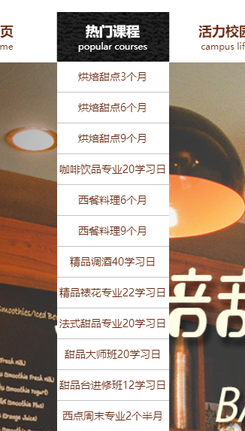

from selenium import webdriver

from selenium.webdriver.common.action_chains import ActionChains

import time

driver = webdriver.Chrome()

driver.maximize_window()

driver.get("https://www.baidu.com/")

time.sleep(2)

ele=driver.find_element_by_link_text("设置")

print(ele.text)

ActionChains(driver).move_to_element(ele).perform()

driver.find_element_by_link_text("搜索设置").click()

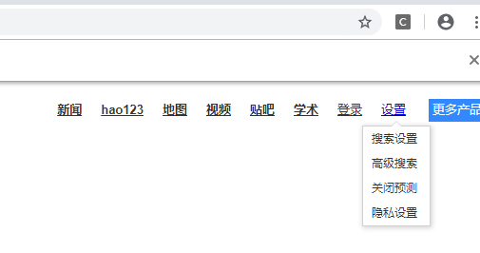

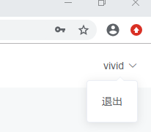

#定位鼠标移动到一个元素上//*[@id="app"]/div/div[2]/div[1]/div/span

# ele_span=self.driver.find_element_by_xpath('//*[@class=" el-dropdown-selfdefine"]').text

# print(ele_span)

# uname_click=self.driver.find_element_by_xpath('//*[@class=" el-dropdown-selfdefine"]')

# ActionChains(self.driver).move_to_element(uname_click).perform()

# text_logout =self.driver.find_element_by_xpath('//div[@class="header-btn el-dropdown"]/ul/li[@class="el-dropdown-menu__item"]').text

# print(text_logout)

js='document.querySelector(".el-popper > li").click()'

self.driver.execute_script(js)