Admin Dashboard & Analytics System Proposal
Objective:
Create an advanced Admin Dashboard & Analytics System that provides complete visibility into operations, revenue, performance, and user behavior for a house-help booking platform.
DESCRIPTION:
The Admin Dashboard & Analytics System is a centralized platform that provides complete visibility into bookings, revenue, users, and helper performance for the house-help service. It enables real-time monitoring, analytics, complaint management, and smart insights to improve operational efficiency. With advanced features like performance tracking, demand forecasting, and automated reports, the system helps business owners make data-driven decisions and scale effectively.

1. Core Features (Given Requirements)
- Total Bookings Overview
- Revenue Tracking
- Active Users & Helpers Monitoring
- Cancellation Reports
- Feedback Analytics
- Complaint Management System

2. Proposed New & Innovative Ideas:
- Real-time 15-minute Response Tracking Dashboard
- AI-based Demand Prediction (Peak time forecasting)
- Smart Auto-Assignment Monitoring Panel
- Helper Performance Scorecard (completion rate, punctuality, ratings)
- Fraud Detection Alerts (multiple cancellations, fake accounts)
- Revenue Breakdown by City/Area/Service Type
- Customer Retention Analytics
- Heatmap Visualization for Booking Density
- Automated Weekly/Monthly Report Generator (PDF export)
- Role-Based Access Control (Super Admin / Manager / Support Team)
- Premium with early access
- One time booking (For emergency)
- Real time helper tracker
- OTP verification
- Dynamic pricing

3. System Architecture Overview
FRONTEND(ADMIN DASHBOARD) :
- We will built the main dashboard using React.js
- Style our web page using Tailwind CSS
- Deploy our website using Vercel
BACKEND(SERVER / API) :
- Built using Node.js (Backend Server) + Express.js (Lightweight Framework)
- Handles authentication, bookings, analytics logic
- These tasks will be hosted on render on Render (Push code on Github deploys automatically )
DATABASES :
We will be using MongoDB Atlas which will be holding our entities and attributes like;
- Users
- Helpers
- Bookings
- Payments
- Feedback
- Complaints
FOR AUTHENTICATION AND SECURITY PURPOSES :
The system uses secure email-password login. Passwords are encrypted, and JWT tokens are used to verify and protect admin access.
- JWT (JSON Web Tokens) :- Mainly used for authentication
- Password hashing using bcrypt (library used to securely hash passwords before storing them in a database.)
- Environment variables for security

CONNECTIONS/WORKING :
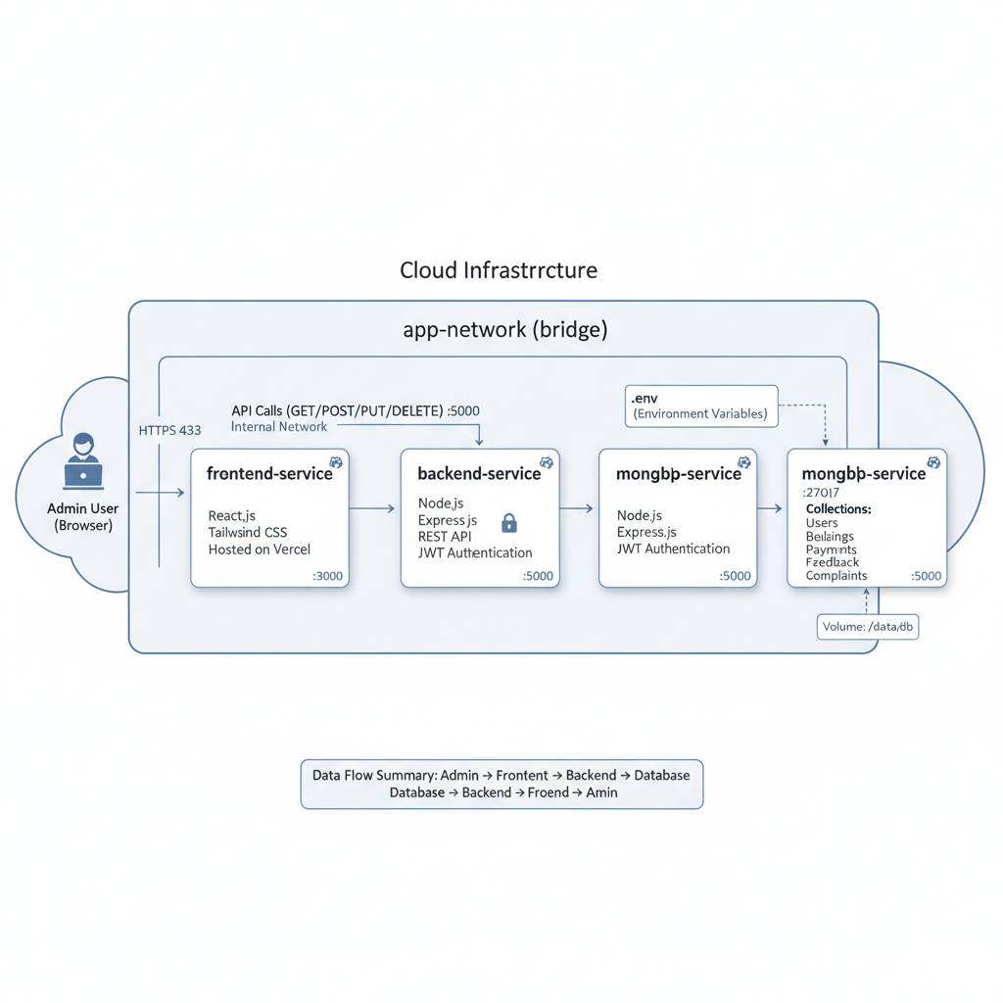

4. Waterfall Model :
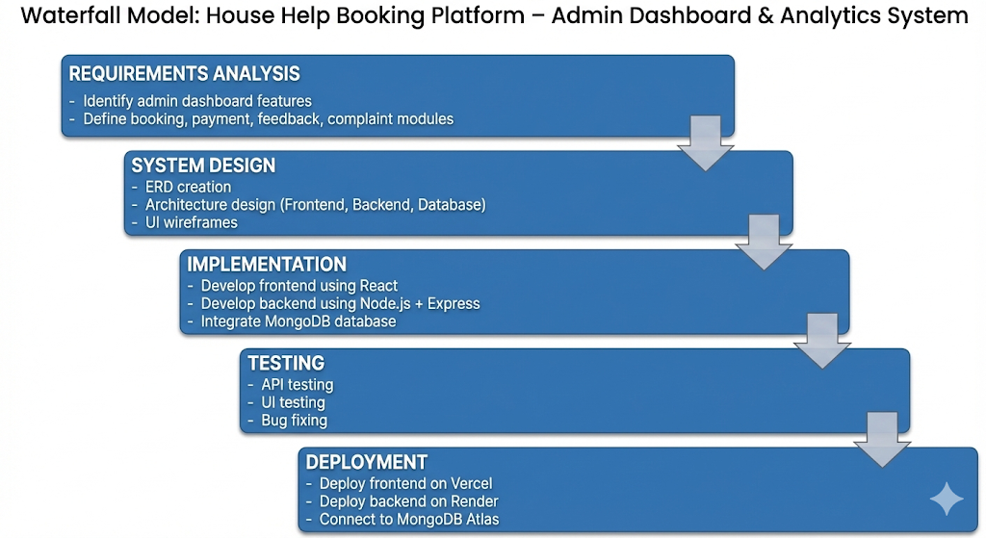

5. Deployment Plan
- First, we develop and test the frontend and backend locally on our system to make sure everything works smoothly.
- Once the core features are ready, we connect the backend to a cloud database (MongoDB Atlas free tier).
- After testing locally, we push the complete project to GitHub for version control and collaboration.
- The frontend is then deployed on Vercel, which provides fast and free hosting.
- The backend server is deployed on Render, allowing the API to run online.
- Environment variables such as database URLs and JWT secrets are securely configured.
- Finally, we test the live application to ensure all features — bookings, analytics, complaints, and reports — work correctly in production.

6. Future Scalability Plan
As the platform grows, the system can be upgraded to handle more users and data efficiently. We can shift to a microservices architecture for better performance, integrate secure payment gateways, and introduce a mobile admin app for easier access. Advanced AI features like smart demand prediction and fraud detection can also be added to improve reliability and user trust.

