**Tests ReArm – file and details for EEG analysis**

ReArm testing session:

* Reaching task => file finishing with **‘_r’**
* Circular steering task => file finishing with ‘**_c’**
* Lady Bug on the Armeo => file finishing with ‘**_a’**

Population:

* Patients => files beginning with ‘C1PXX or C2PXX’
* Healthy Young => files beginning with ‘XXX’
* Healthy Old => files beginning with ‘2XX’

*With X = number*

Output:

* XDF file / task
* With all the data stream inside

Stream details:

* NIC-Markers (EEG markers)
* NIC-Accelerometer (data from the accelerometer located on the EEG device)
* NIC-Quality (Quality markers from the EEG)
* **NIC-EEG (EEG data)**
* Oxysoft (fNIRS data)
* Oxysoft Event (fNIRS markers)
* EuroMov-Mocap-Kinect (motion capture data from the Kinect)
* EuroMov-Markers-Kinect (markers from the Kinect)
* Mouse (data from the circular task)
* **MouseToNIC (markers from the circular task software)**

Data to use for EEG analysis:

* Data from the EEG-NIC software: stream NIC-EEG

Markers/events to use:

* Markers of the task: MouseToNIC:
  + 111 = beginning of the task
  + 100 = beginning of rest period

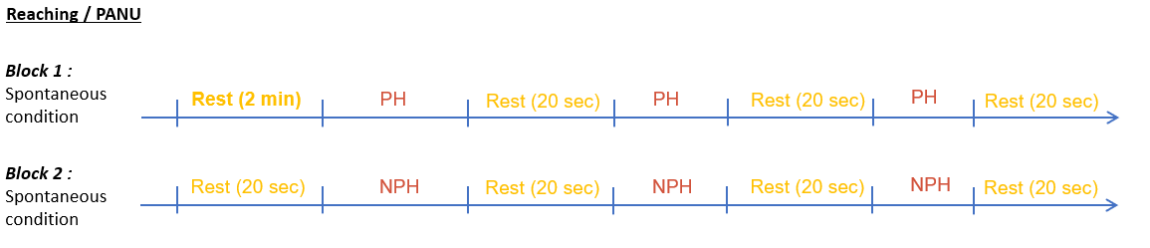Details of the reaching task:

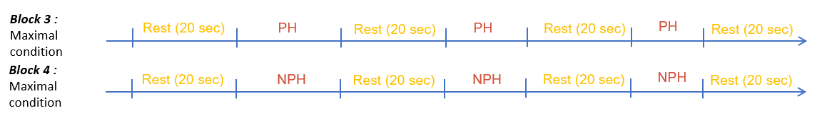

*PH = paretic hand for patients and left hand for healthy*

*NPH = non paretic hand for patients and right hand for healthy*

*Spontaneous condition = free movement*

*Maximal condition= trunk constrained movement*

*Rest period = 20 sec*

*Task period = 20 sec*

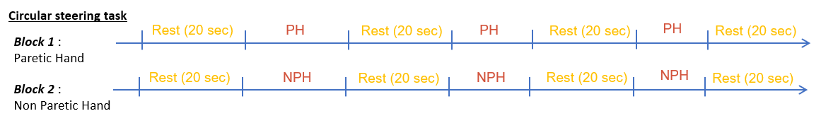Detail of the circular steering task:

*PH = paretic hand for patients and left hand for healthy*

*NPH = non paretic hand for patients and right hand for healthy*

*Rest period = 20 sec*

*Task period = 20 sec*

Bibliography:

* *Muller, C.O., Muthalib, M., Mottet, D. et al. Recovering arm function in chronic stroke patients using combined anodal HD-tDCS and virtual reality therapy (ReArm): a study protocol for a randomized controlled trial. Trials 22, 747 (2021).* [*https://doi.org/10.1186/s13063-021-05689-5*](https://doi.org/10.1186/s13063-021-05689-5)