# Web App Design with React Final Project

**Points possible:** 70

|  |  |  |
| --- | --- | --- |
| Category | Criteria | % of Grade |
| Functionality | Does the code work? | 25 |
| Organization | Is the code clean and organized? Proper use of white space, syntax, and consistency are utilized. Names and comments are concise and clear. | 25 |
| Creativity | Student solved the problems presented in the assignment using creativity and out of the box thinking. | 25 |
| Completeness | All requirements of the assignment are complete. | 25 |

**Instructions:** In VS Code, or an IDE of your choice, write the code that accomplishes the objectives listed below. Ensure that the code compiles and runs as directed. Take screenshots of the code and of the running program (make sure to get screenshots of all required functionality) and paste them in this document where instructed below. Create a new repository on GitHub for this week’s assignments and push this document, with your JavaScript project code, to the repository. Add the URL for this week’s repository to this document where instructed and submit this document to your instructor when complete.

**Coding Steps:**

1. Using an online API of your choice, or multiple APIs (or if no API can be found, using an array for in-memory storage is okay as well), create a React project of your choice. You will be working on this for the next three weeks.
2. Project must meet the following criteria:
   1. Use React Router and have at least 3 pages
   2. Use React Bootstrap or an alternative styling library
   3. Contain at least 10 components
   4. Allow for all CRUD operations

**Screenshots of Code:**

Index.js:

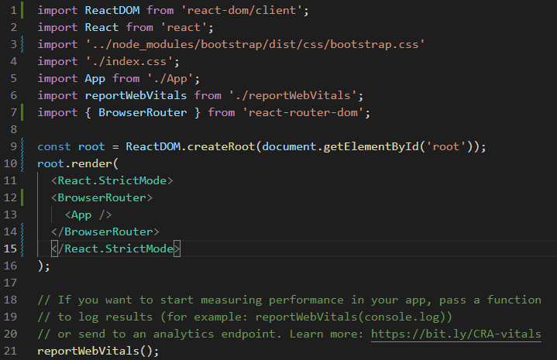

App.js:

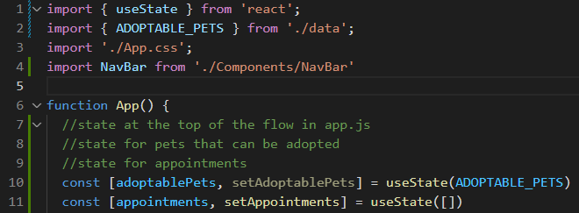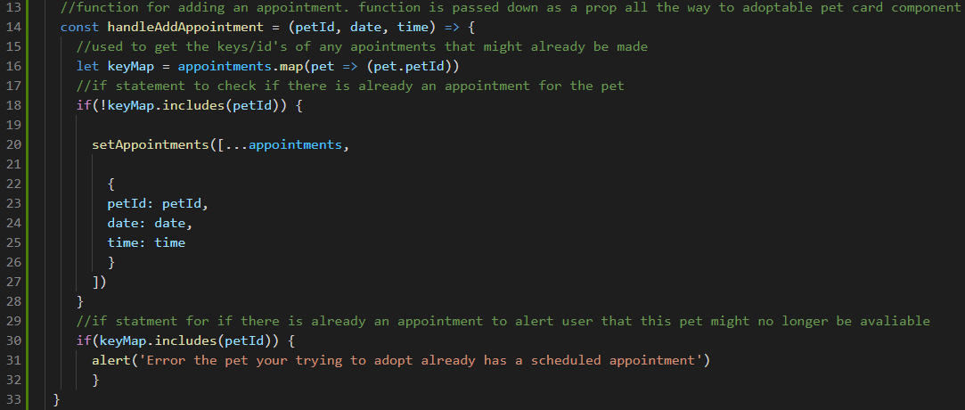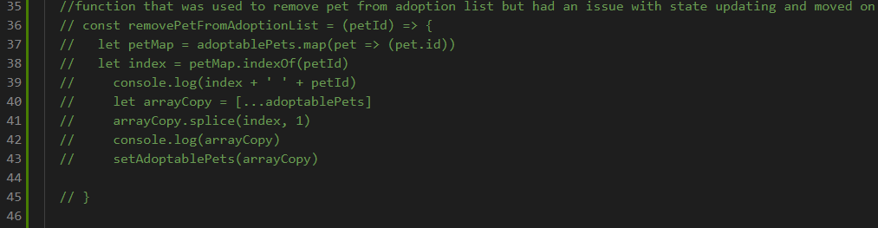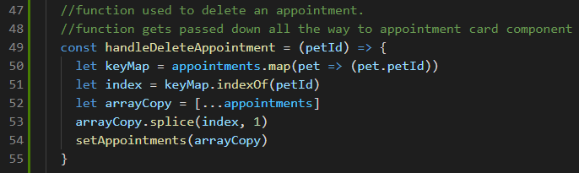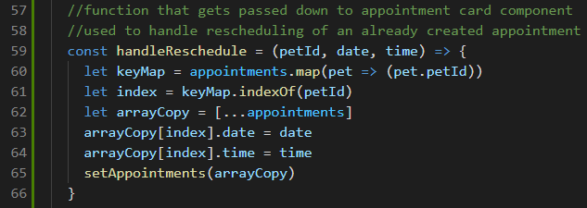

NavBar.js:

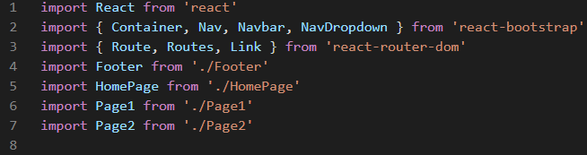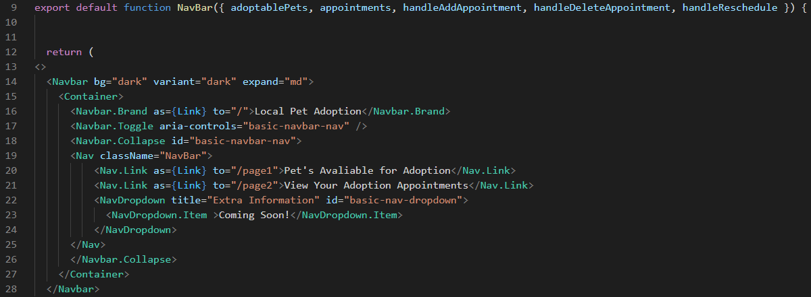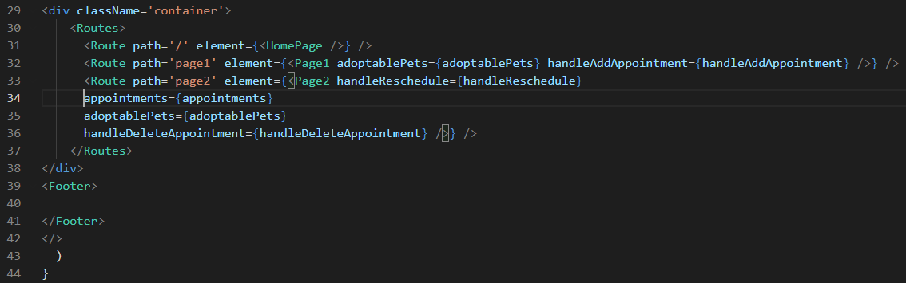

HomePage.js:

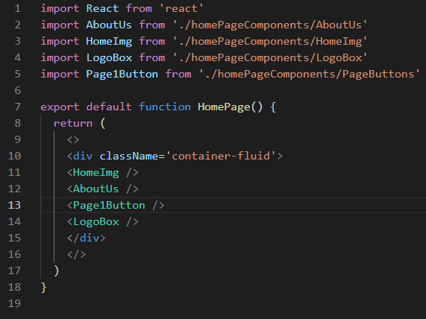

Page1.js:

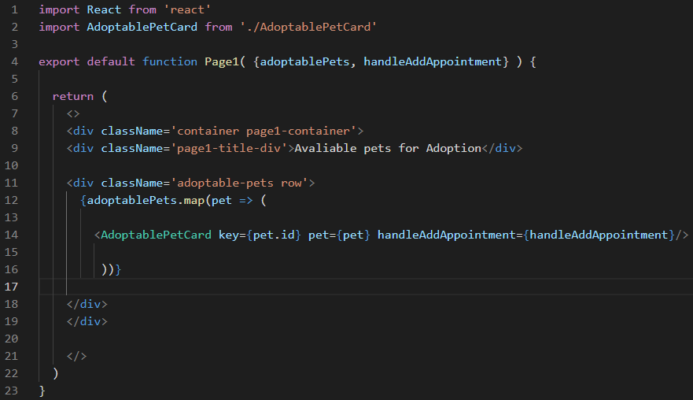

Page2.js:

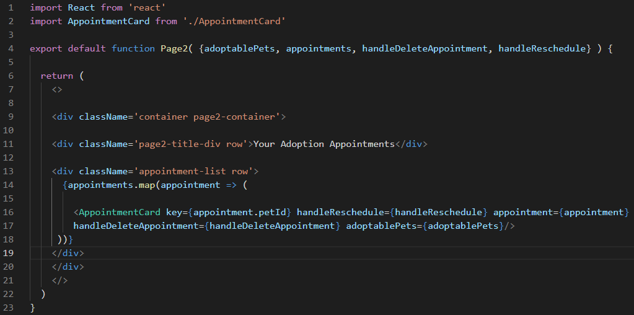

AdoptablePetCard.js:

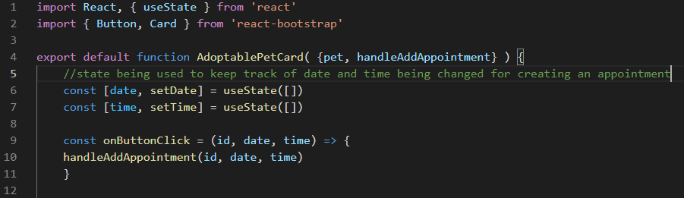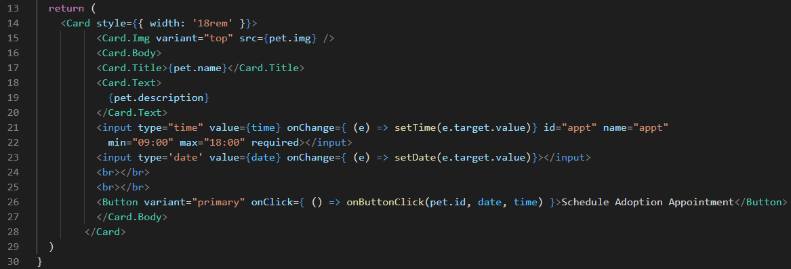

AppointmentCard.js:

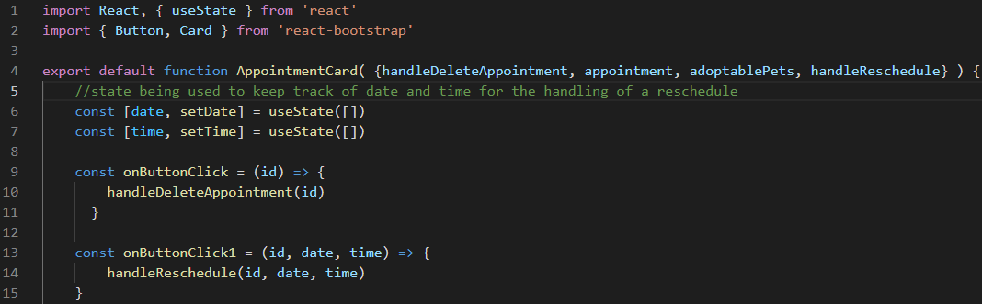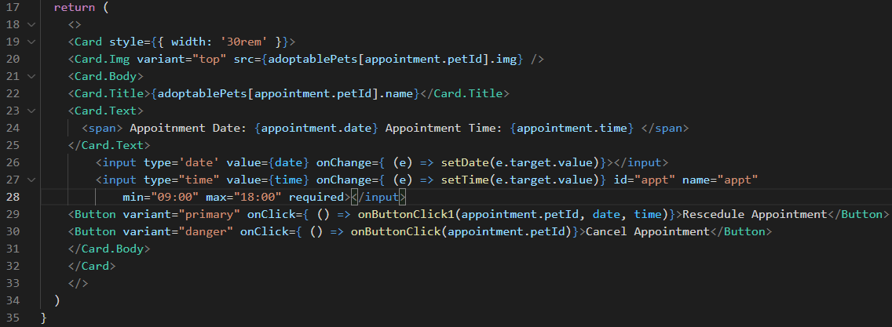

Footer.js:

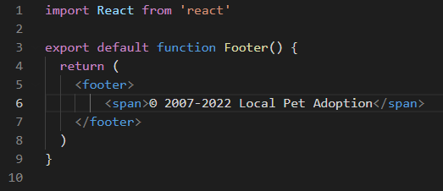

AboutUs.js:

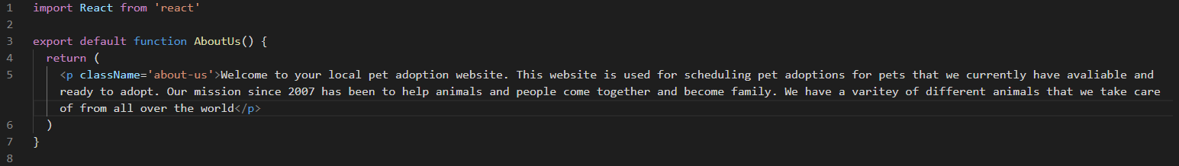

HomeImg.js:

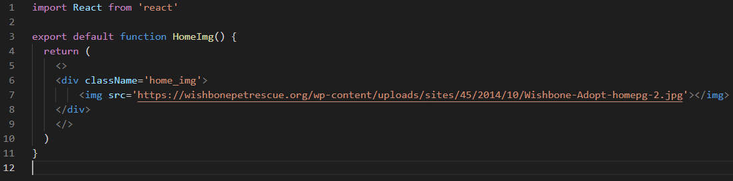

LogoBox.js:

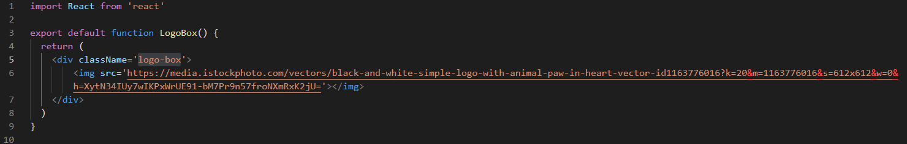

PageButtons.js:

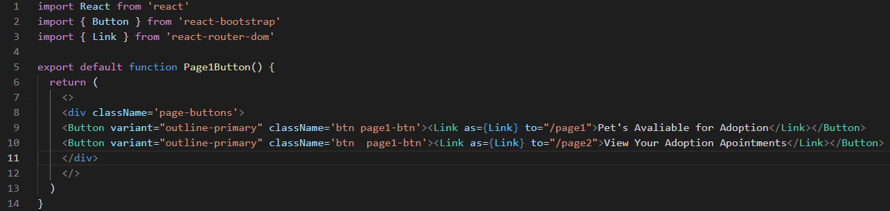

App.css:

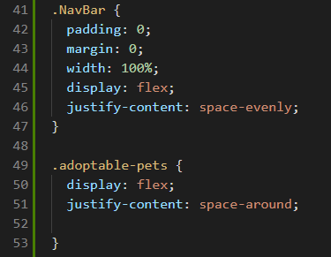

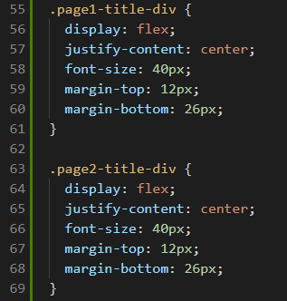

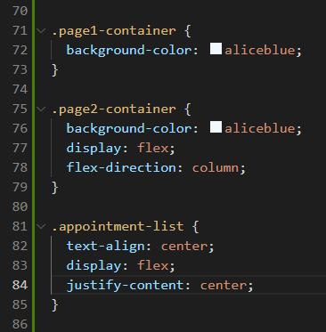

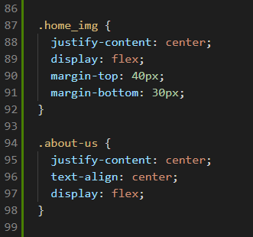

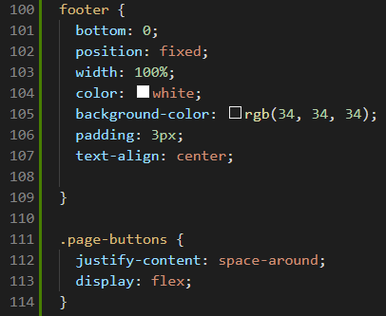

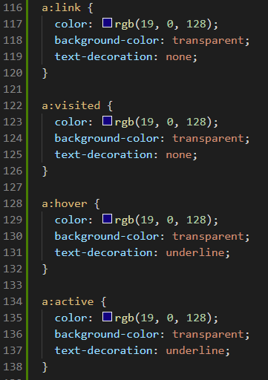

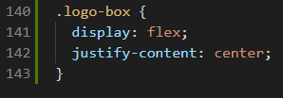

Data.js:

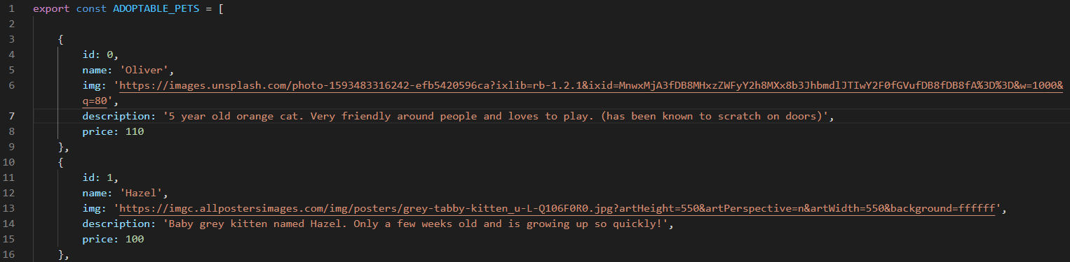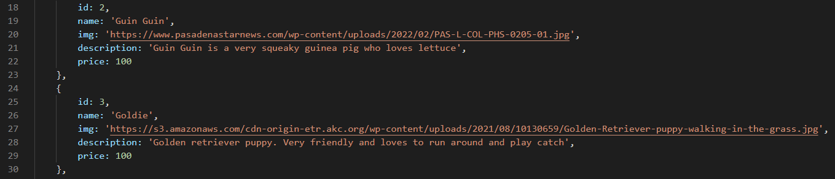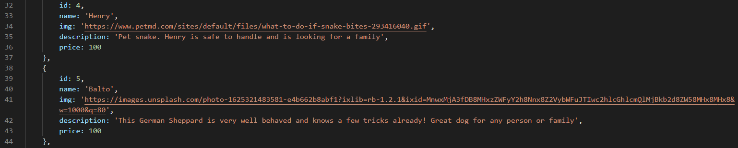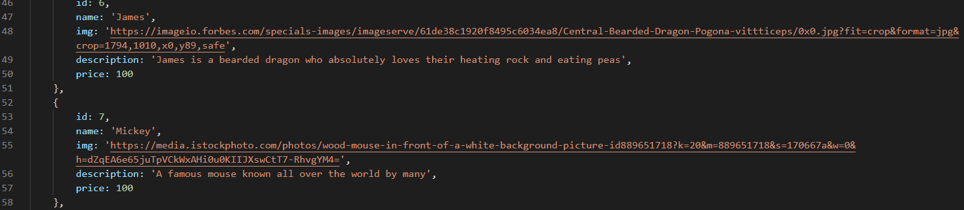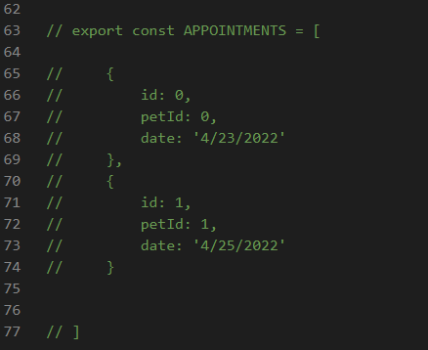

**Screenshots of Running Application:**

Homepage:

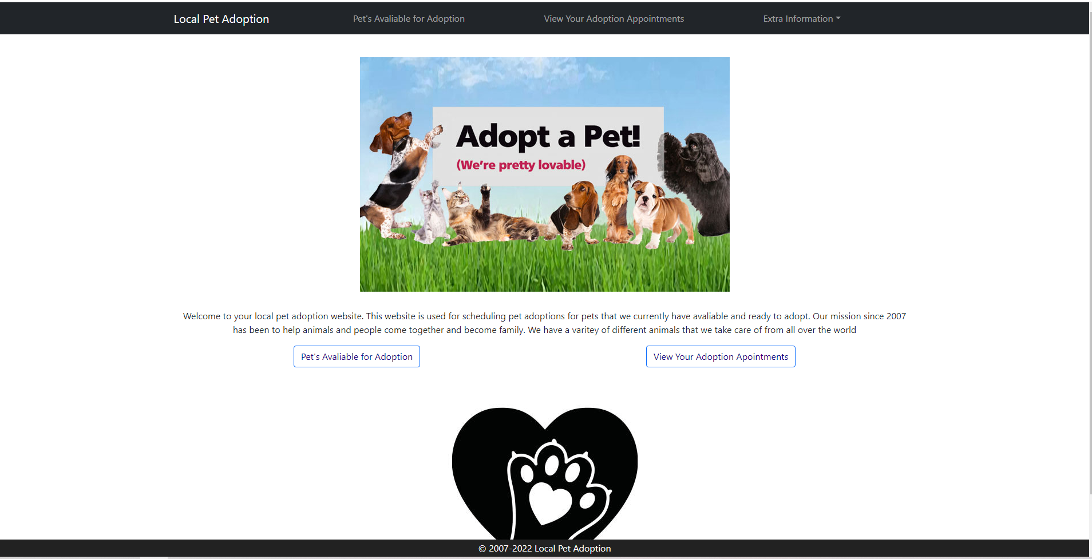

Page1/Avaliable pets page:

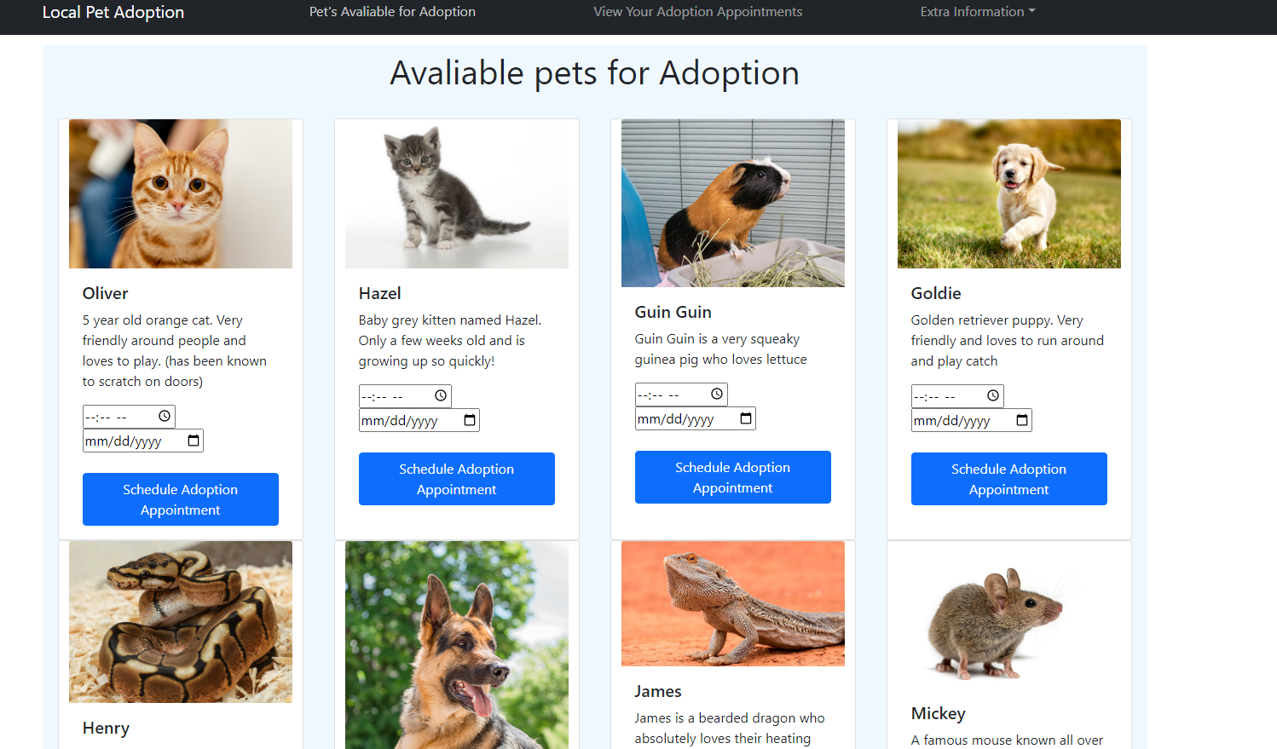

Appointment Page:

Without any appointments:



Guin guin has an appointment:

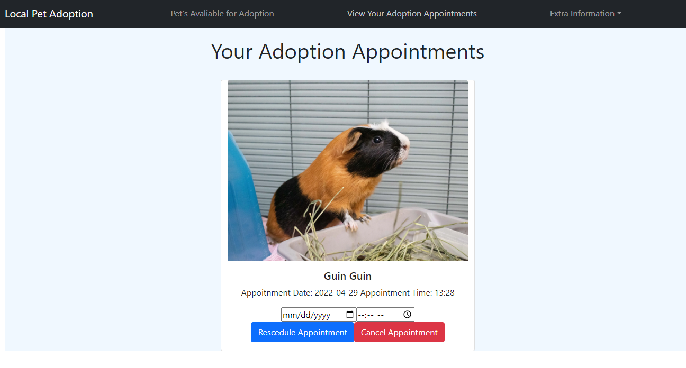

2 pets being adopted:

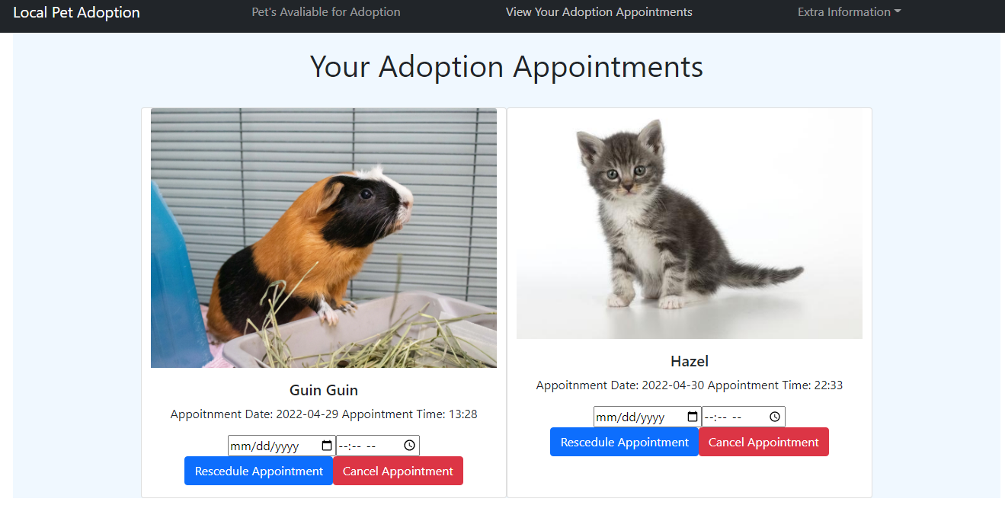

Closer look:

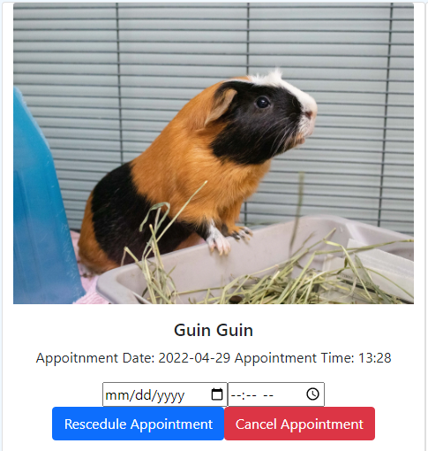

Changing the adoption appointment:

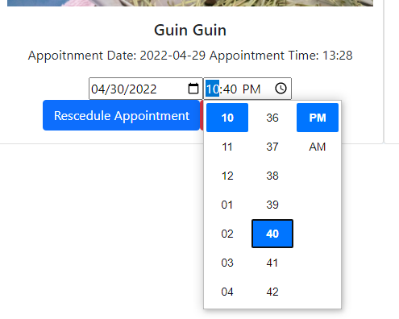

After the reschedule with the above input:

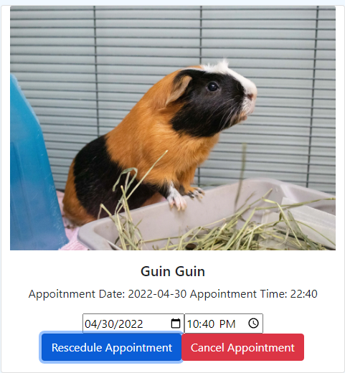



Both appointments canceled^

**URL to GitHub Repository:**

[**https://github.com/iwokeupinadream/ReactFinalProject**](https://github.com/iwokeupinadream/ReactFinalProject)