# Front End Technologies Week 6 Coding Assignment

**Points possible:** 70

|  |  |  |
| --- | --- | --- |
| Category | Criteria | % of Grade |
| Functionality | Does the code work? | 25 |
| Organization | Is the code clean and organized? Proper use of white space, syntax, and consistency are utilized. Names and comments are concise and clear. | 25 |
| Creativity | Student solved the problems presented in the assignment using creativity and out of the box thinking. | 25 |
| Completeness | All requirements of the assignment are complete. | 25 |

**Instructions:** In VS Code, or an IDE of your choice, write the code that accomplishes the objectives listed below. Ensure that the code compiles and runs as directed. Take screenshots of the code and of the running program (make sure to get screenshots of all required functionality) and paste them in this document where instructed below. Create a new repository on GitHub for this week’s assignments and push this document, with your JavaScript project code, to the repository. Add the URL for this week’s repository to this document where instructed and submit this document to your instructor when complete.

**Coding Steps:**

1. As a team, create a full CRUD application of your choice. If you can use an existing API, use AJAX to interact with it. However, you do not have to use an API. If you do not use an API, store the entities you will create, read, update, and delete in an array.
   1. Application should have at least 1 entity per team member
   2. Use a form to add new entities
   3. Build a way for users to update or delete entities
   4. Use Bootstrap and CSS to style your project

**Screenshots of Code:**

HTML:

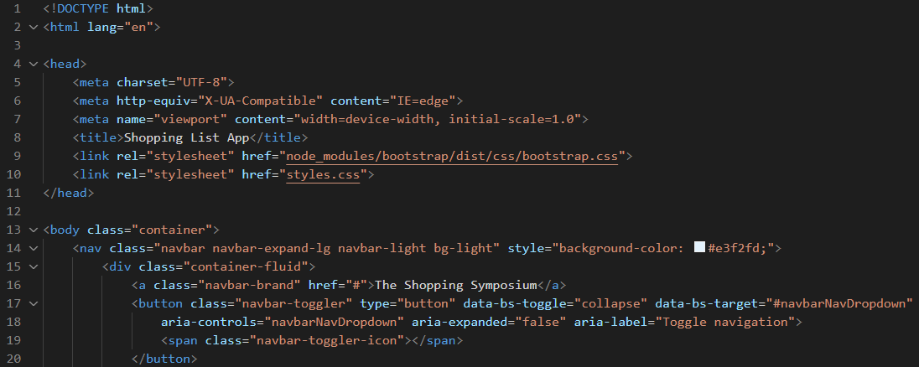Nav bar done by Joshua ^

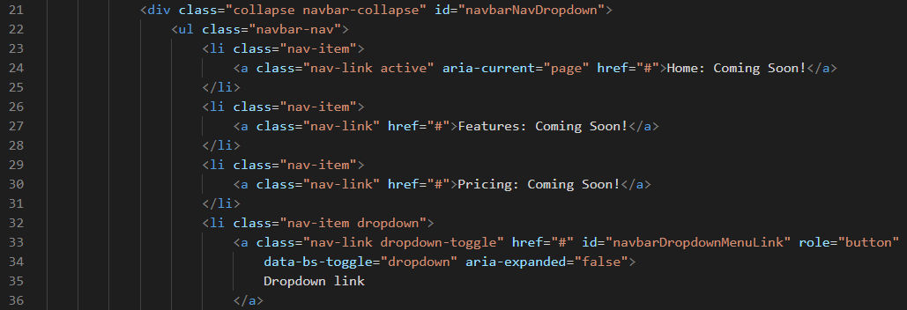More of navbar done by Joshua

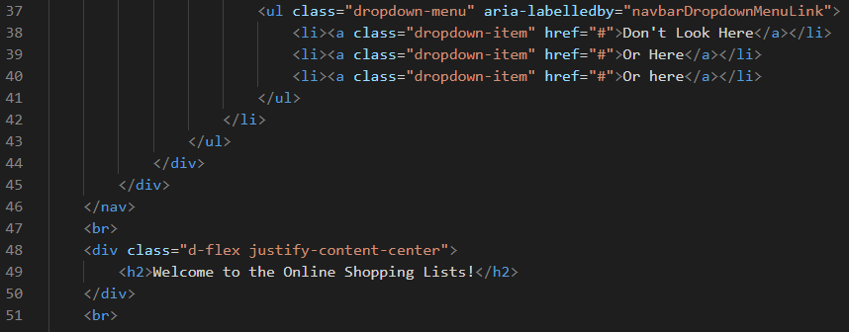More of nav bar done by Joshua

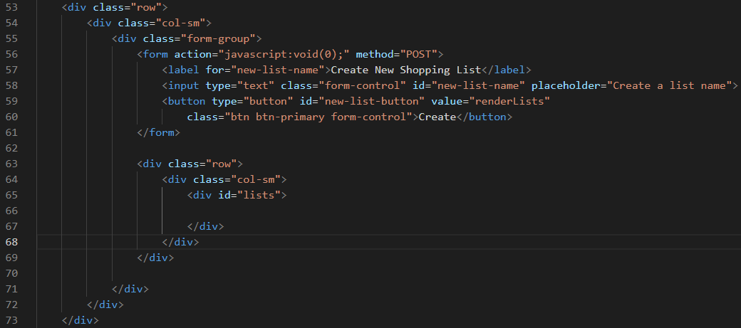Setting up the button and input for creating a new shopping list done by me

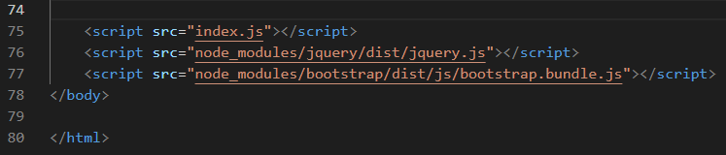

Javascript:

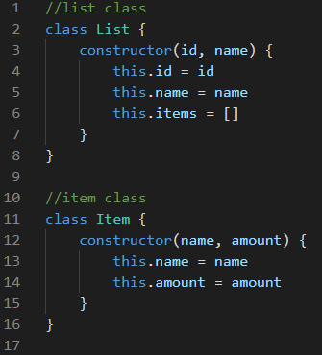

Class for items and for lists created by me

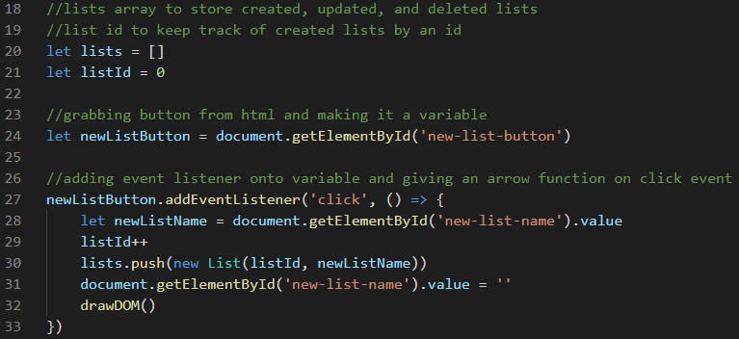Created by me

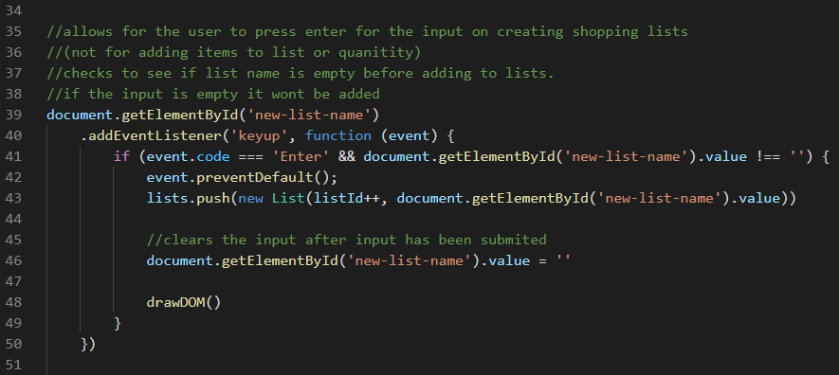Implemented/ created by me. Found out how to get it to accept enter and made it so you can not create a list that has no name upon pressing enter. You can create a list without a title by clicking

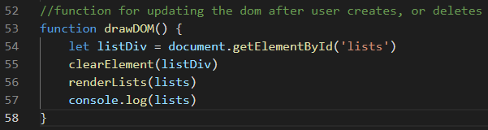Joshua and I both worked on figuring out our drawDOM function but was created by me

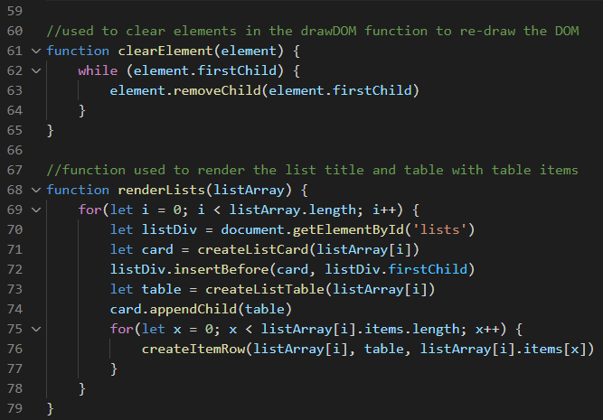RenderLists function was created by me but had a bug that joshua was able to fix

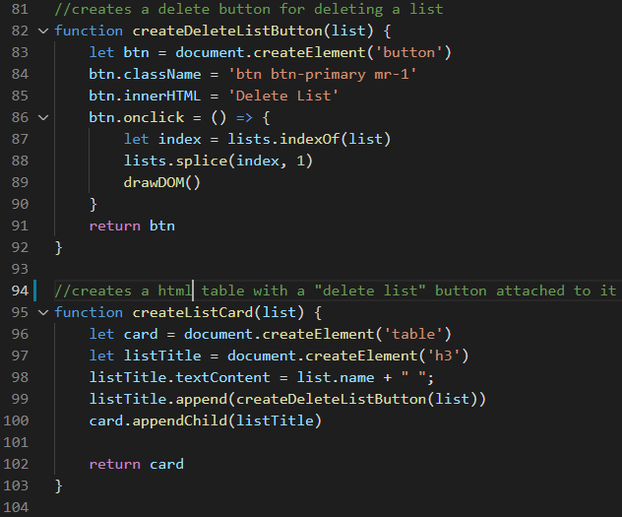CreateListCard function created by me. Creates a table but we were trying to do it without a table when we were trying to write this version of our project so that’s why there is a variable called card

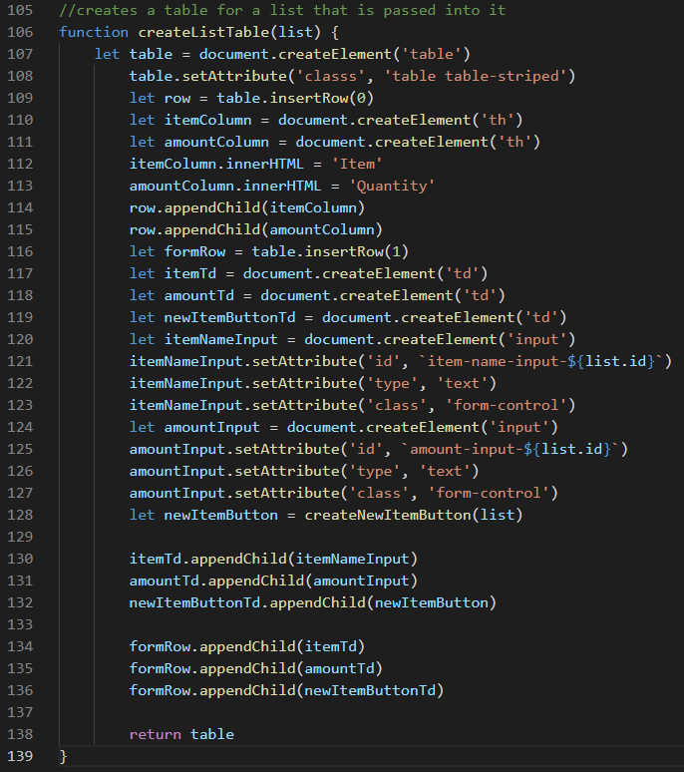Function for creating a table element out of a list implemented by me. We really wanted to try and slim this one down and simplify it but were not able to

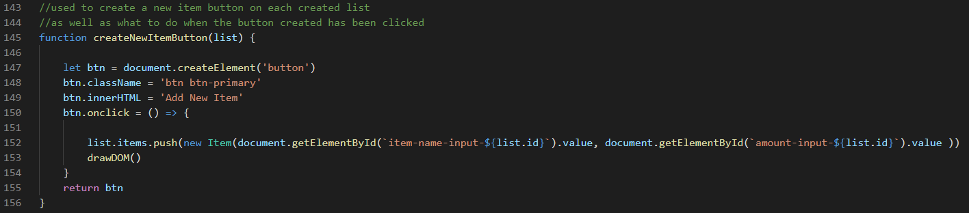Creating a button that gets attached to the table implemented by me

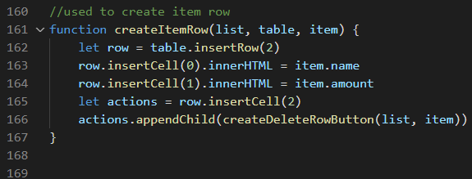Used to create item row implemented by me

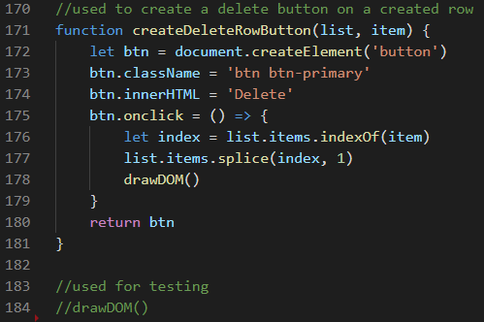

Implemented by me but fixed by Joshua

Css: (all of it done by joshua)

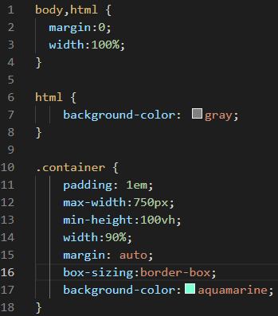

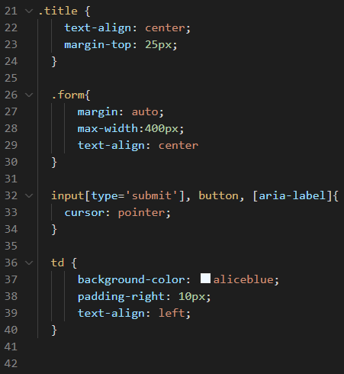

**Screenshots of Running Application:**

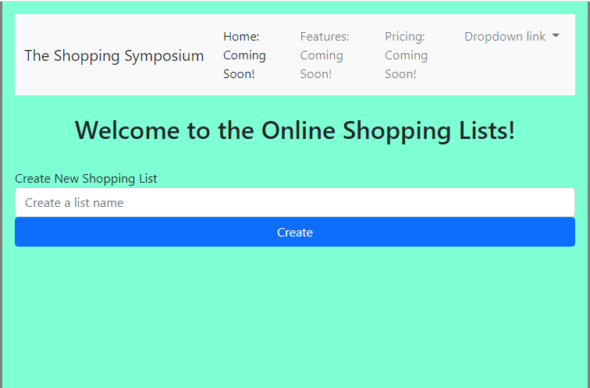

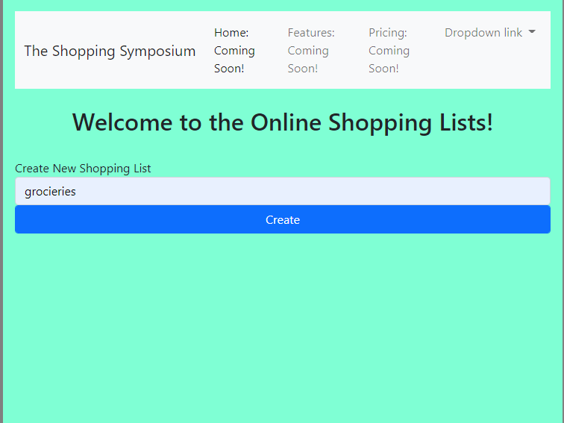

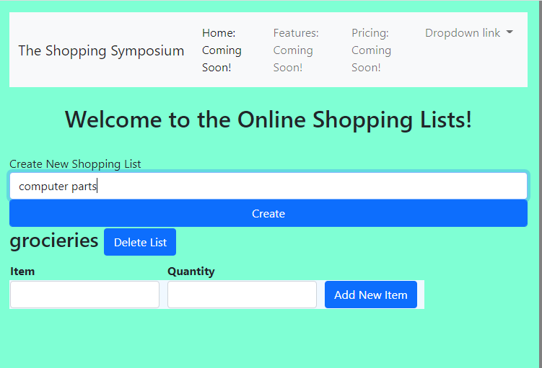

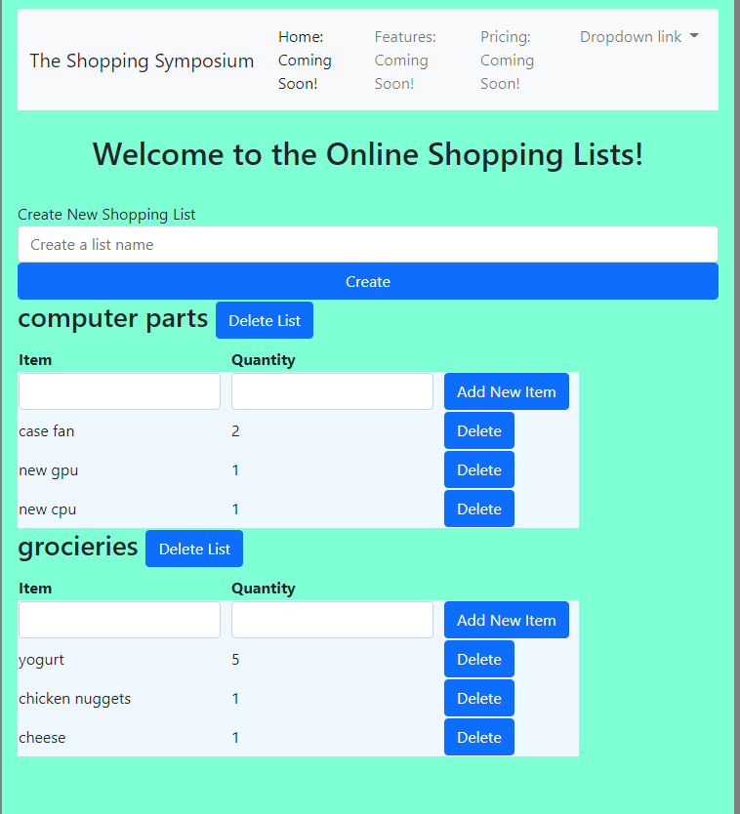

**URL to GitHub Repository:**

[**https://github.com/iwokeupinadream/week6FET_FinalProject**](https://github.com/iwokeupinadream/week6FET_FinalProject)