1. Tell us about a technical book or article you read recently, why you liked it, and why I should read it.
   1. Something for a good morning

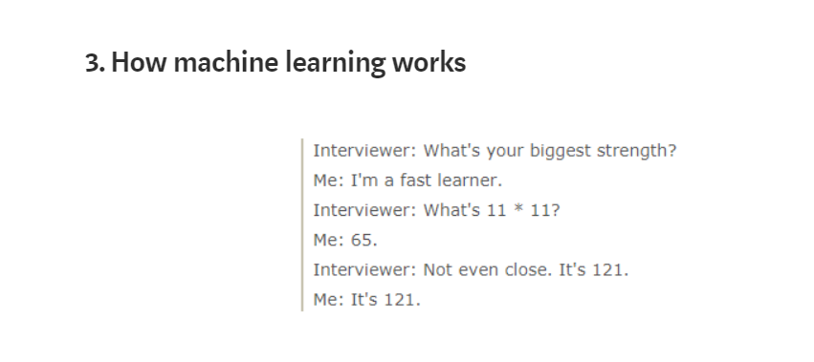

* 1. Migrate to java 9

<https://blog.joda.org/2018/09/from-java-8-to-java-11.html>

* 1. WebSphere

<https://www.reddit.com/r/programming/comments/7zb7jt/ibm_java_cto_devs_shouldnt_have_to_learn_docker/>

The above articles are referring to the type of job I’m doing, and may impact any future decisions around architecture.

If they are relevant to you, you should answer by yourself.

1. What’s your proudest achievement? This can be a personal project or something you’ve worked on professionally. Just a short paragraph is fine, but we would love to know why you’re proud of it.

In one of my previous jobs,

At some stage company decided to segregate jobs. They took away Tibco guy from our team.

Tibco guys became available on American side only.

With time Zone difference, only 3 Tibco guys available, communication problems have started.

There was a project coming, to integrate our Terminal configuration with terminal provider (3rd party/external company).

Tibco should have been the integrator.

Knowing about all the political problems, we definitely wouldn’t meet deadline. We started to look for any other solution.

Initially we tried with Spring Integration, as we already had the knowledge.

But very quickly we moved into Camel, it was fully integrated with Spring, easy to traverse in DSL and testing out of the box.

WebSphere server was the only one machine we could get in reasonable time frame.

I made the decision about architecture solution, to deliver the project as a new web application.

I took the first task to build the structure of the new application for this and any future projects.

On top or the structure, I created a first business route with correct initialization, transport, notifications and error-handling routes.

Then colleagues started joining with another project related routes, with me teaching and helping to reuse the structure, and verify all error path options.

When project was ready, company noticed it is working and it can be easily extended.

They accepted Camel and started designing for it, while before Tibco was the only option.

What made me happy, is the decision. Even within all the obstacles I managed to create brand new application with suitable technology inside and get that up to production.

I can see the application is working in production and somebody is using that.