MARKET & STRATEGY REPORT
Nickel Bronze Alloys
Nickel-Aluminium Bronze & C99500 family: composition, demand, pricing (LME, INR), competition and recommendations for Bajaj Alloys
Prepared for: Bajaj Alloys
Date: 4 October 2026
Price basis: LME 3-month Cu US$14,258/t, Ni US$15,626/t; USD/INR 96.3
Note: Market sizes, growth rates, competitor scores and conversion premiums are indicative analyst estimates for planning, not audited data. Compositions are nominal and should be verified against the applicable ASTM/customer specification before commercial use.

1. Executive Summary
Nickel bronzes are copper-based casting alloys in which nickel (with aluminium, iron and manganese) delivers high strength, outstanding seawater and cavitation resistance and good wear behaviour. The family spans nickel-aluminium bronzes (NAB: C95400, C95500, C95510, C95800), the lower-aluminium nickel-iron bronzes C99400 / C99500 and the copper-nickel C96400. C99500 is the focus alloy for this study.

₹1,442–1,736  Indicative alloy price per kg | ~5.8%  Indicative demand CAGR 2025–32 | ~32%  Share of demand from marine | ~₹1,505  Nickel at LME, per kg | ~₹1,373  Copper at LME, per kg

Key takeaways
- Raw-material led pricing: Copper and nickel together make up roughly 85–95% of metal value in every alloy here, so alloy prices track LME closely. Each 10% move in LME nickel shifts C99500 by about ₹7/kg and C96400 by about ₹45/kg.
- Demand is anchored in marine, offshore and flow control, with defence indigenisation, port expansion (Sagarmala) and hydro/power the fastest-growing Indian pockets.
- C99500 sits in a defensible middle niche: higher nickel/iron strength than C99400, cheaper than NAB heat-treated grades and easy to cast, which suits pump, valve and bushing castings for Indian OEMs.
- Recommendation: launch a focused C99500 + C95800 + C95500 portfolio, lock in metal-price-linked contracts, invest in spectrometer and heat-treatment capability and target marine, defence and pump OEM customers (Section 9).

Contents
- 1. Executive summary
- 2. Alloy family & composition
- 3. Market demand & growth
- 4. Applications by sector
- 5. Pricing – LME-linked, in INR
- 6. Competitive landscape
- 7. Comparative analysis of the family
- 8. SWOT, PESTLE & Porter's Five Forces
- 9. Recommendations for Bajaj Alloys

2. Alloy Family & Composition
The table lists the principal nickel bronze grades (UNS designations) with nominal composition. Copper is shown as the balance. Values are indicative mid-range figures rather than specification limits.
UNS | Cu | Ni | Al | Fe | Mn | Si | Zn | Type / note
C95400 | 84 | 1 | 10.5 | 4 | 0.5 | – | – | NAB, general-purpose
C95500 | 79.9 | 4.3 | 10.8 | 4 | 1 | – | – | NAB, heat-treatable
C95510 | 80.2 | 5 | 10 | 3 | 1.5 | 0.3 | – | NAB, high-Ni, low-Si
C95800 | 81.2 | 4.5 | 9 | 4 | 1.2 | 0.1 | – | NAB, marine standard
C99400 | 92.8 | 2 | 1.2 | 2 | – | 1 | 1 | Ni-Fe bronze, low Al
C99500 | 88.3 | 4.5 | 1.2 | 4 | – | 1 | 1 | Ni-Fe-Al-Si bronze (focus)
C96400 | 68.1 | 30 | – | 0.9 | 1 | – | – | Cu-30Ni, seawater

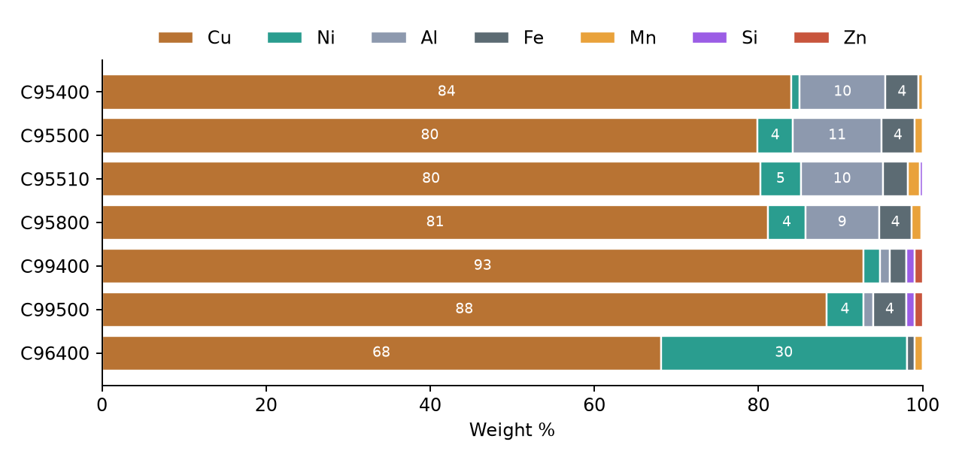
Figure 1: Nominal composition of nickel bronze grades (wt%)
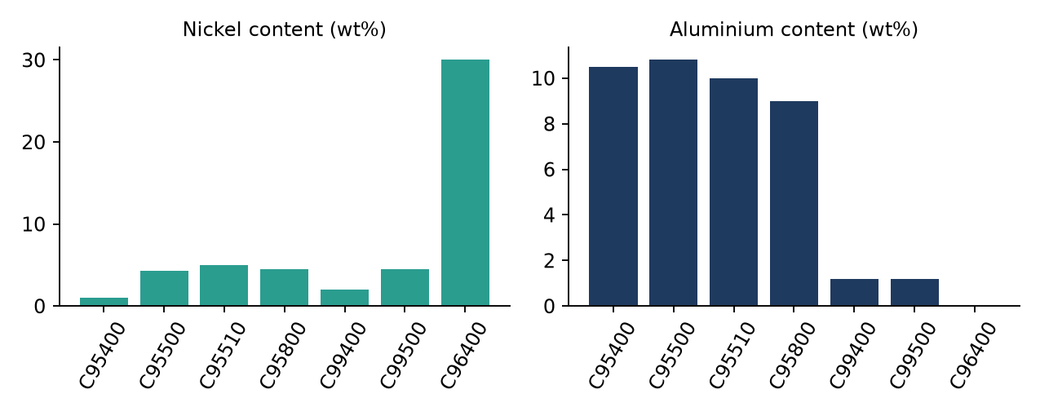
Figure 2: Nickel and aluminium content by grade
Reading the chart: the NAB grades carry 9–11% aluminium that forms a hard kappa phase, the source of high strength and cavitation resistance. C99400/C99500 trade much of that aluminium for nickel, iron and silicon, giving moderate strength with simpler melting and casting. C96400 is a different route: 30% nickel gives superior seawater corrosion resistance at a higher metal cost.

3. Market Demand & Growth
Demand for copper-nickel and nickel-aluminium bronze castings is tied to capital-goods cycles: shipbuilding and ship repair, offshore oil & gas, desalination, power and defence. Indicative planning assumptions are shown below.
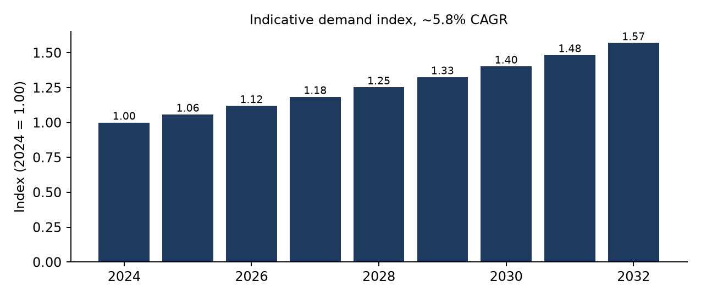
Figure 3: Indicative global demand index (2024 = 1.00)
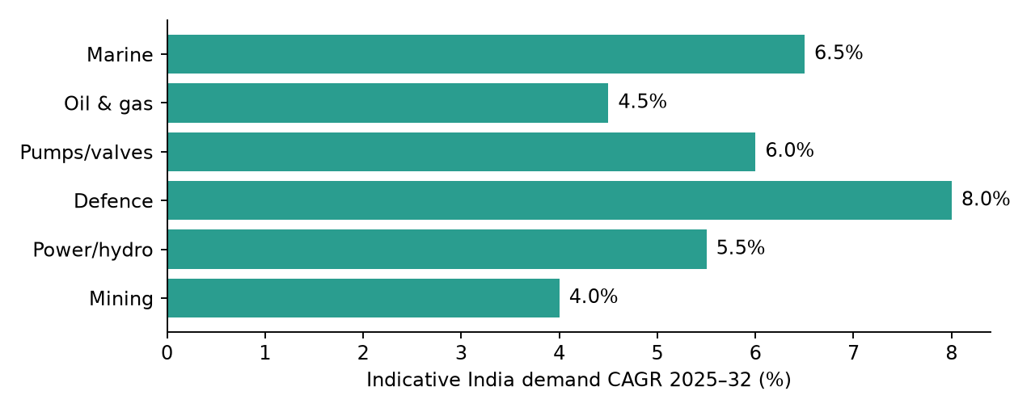
Figure 4: Indicative India demand growth by end-use sector

Demand drivers
- Shipbuilding & naval programmes: Indian shipbuilding incentives, indigenous warship builds and the National Maritime vision drive propellers, shafts bearings and seawater pumps.
- Energy infrastructure: offshore platforms, hydro turbines and desalination plants specify NAB for erosion and cavitation resistance.
- Import substitution: OEMs seek local sources for castings now imported at long lead times.

Constraints
- Price volatility of LME copper and nickel; lengthy qualification cycles (classification societies, defence approvals); competition from stainless/duplex steels and polymer bearings in cost-driven uses.

4. Applications by Sector
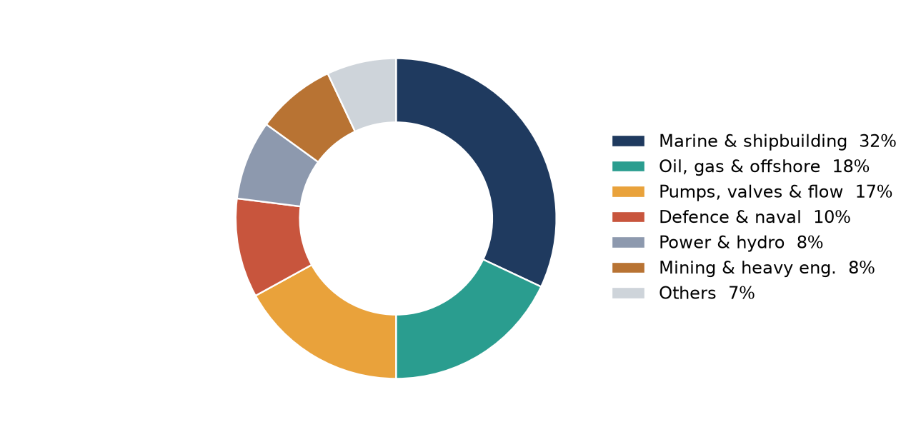
Figure 5: Indicative end-use split of nickel bronze demand
Sector | Typical components | Preferred grades
Marine & shipbuilding | Propellers, hubs, rudder fittings, seawater pump casings, bearings | C95800, C95500, C95400
Oil, gas & offshore | Valve bodies, wear rings, subsea connectors, fire-water pumps | C95500, C95800, C95510
Pumps, valves & flow | Impellers, volutes, gate/ball valve parts, bushes | C95400, C95800, C99500
Defence & naval | Submarine/ship fittings, non-magnetic parts, gears | C95800, C95510
Power & hydro | Turbine runners, guide-vane bushings, heat-exchanger parts | C95500, C95400
Mining & heavy engineering | Wear plates, gear blanks, slide bearings | C95400, C99400, C99500
Desalination & water | Pump parts, tubesheets, condenser components | C96400, C95800
Aerospace & tooling | Landing-gear bushes, forming dies | C95510, C95500

Insight: marine and offshore together account for roughly half of demand, so classification-society approvals (IRClass, DNV, LR, ABS) are the gate to the largest segment.

5. Pricing – LME-Linked, in INR
Method: alloy price = Σ (element weight % × LME price) × (1 + conversion premium) × USD/INR. Premiums (18–25%) cover melting loss, alloying, casting yield, testing and margin and are assumptions. Aluminium, iron, manganese, silicon and zinc are priced at assumed reference levels.
Input metal | LME / reference (US$/t) | ₹ per kg | Source
Copper | 14,258 | 1,373 | LME 3M close, 4 Oct 2026
Nickel | 15,626 | 1,505 | LME 3M close, 4 Oct 2026
Aluminium | 2,900 | 279 | Assumed reference
Iron | 700 | 67 | Assumed reference
Manganese | 2,000 | 193 | Assumed reference
Zinc | 3,000 | 289 | Assumed reference
Silicon | 2,500 | 241 | Assumed reference

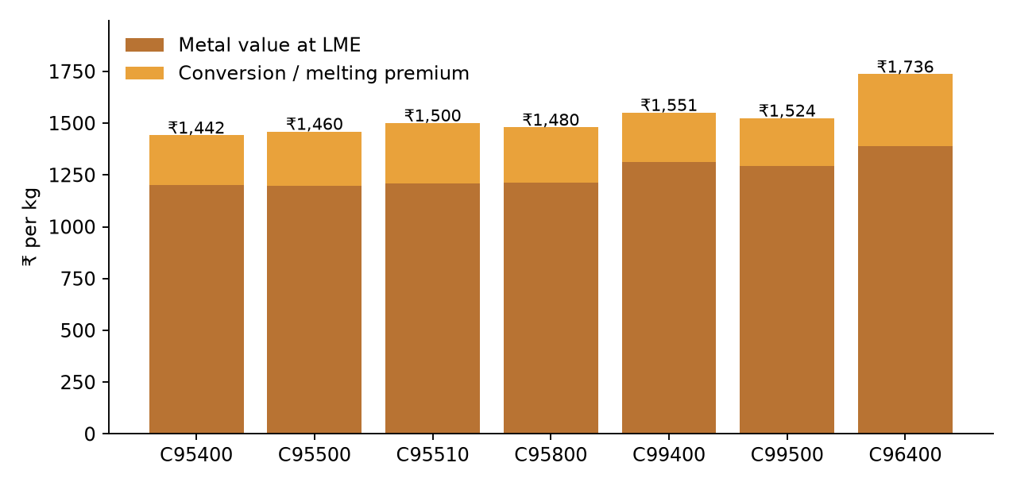
Figure 6: Indicative ingot / casting-alloy price (₹/kg) – metal value plus conversion premium
UNS | Metal value ₹/kg | Premium | Indicative price ₹/kg | Price ₹ lakh / tonne
C95400 | 1,201 | 20% | ₹1,442 | 14.42
C95500 | 1,197 | 22% | ₹1,460 | 14.60
C95510 | 1,210 | 24% | ₹1,500 | 15.00
C95800 | 1,213 | 22% | ₹1,480 | 14.80
C99400 | 1,314 | 18% | ₹1,551 | 15.51
C99500 | 1,292 | 18% | ₹1,524 | 15.24
C96400 | 1,389 | 25% | ₹1,736 | 17.36

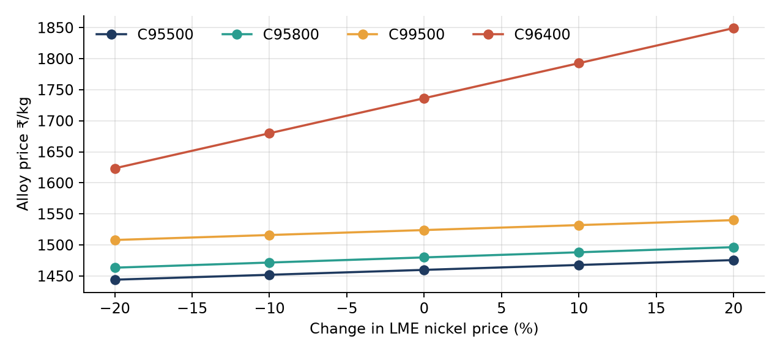
Figure 7: Sensitivity of alloy price to ±20% change in LME nickel
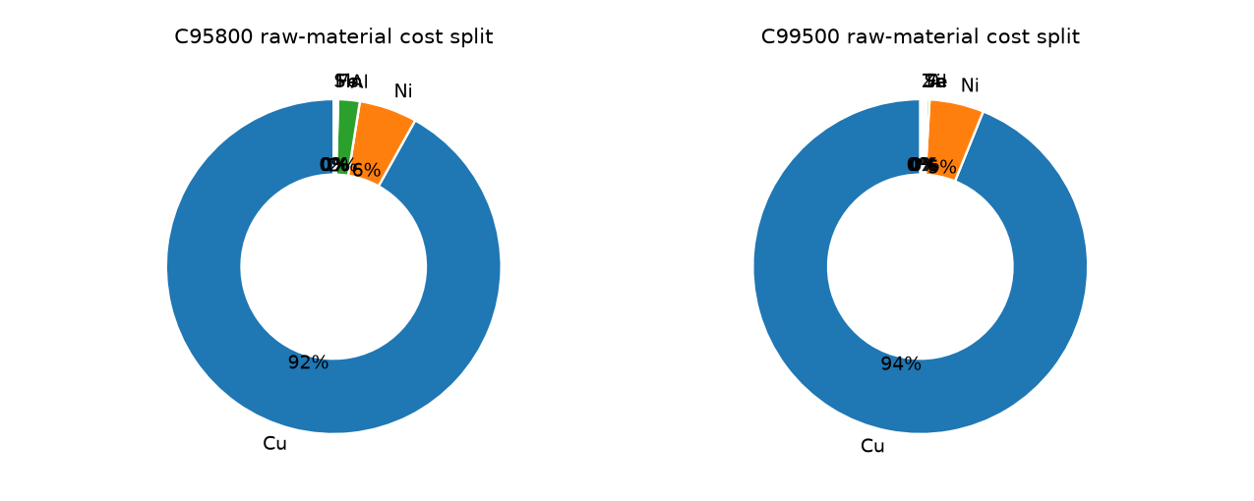
Figure 8: Raw-material cost split – C95800 vs C99500
Observation: copper carries the majority of cost in C99500, whereas C95800 benefits from low-cost aluminium and iron. C96400, with 30% nickel, is the most nickel-sensitive. Bajaj should quote with a published LME-linked formula (metal + fixed conversion) and hedge or back-to-back its metal purchase to protect margins.
Sources: LME 3-month closing prices (Cu US$14,258.50/t; Ni US$15,626/t) and USD/INR ~96.3 as reported on 4 Oct 2026 from lme.com, tradingeconomics.com and market data aggregators. Prices exclude GST, freight and premiums over LME.

6. Competitive Landscape
The market is a mix of global specialists with certified, broad ranges and a fragmented set of regional Indian foundries competing on price and delivery. Scores below (1–5) are a qualitative author assessment to frame positioning, not measured data.
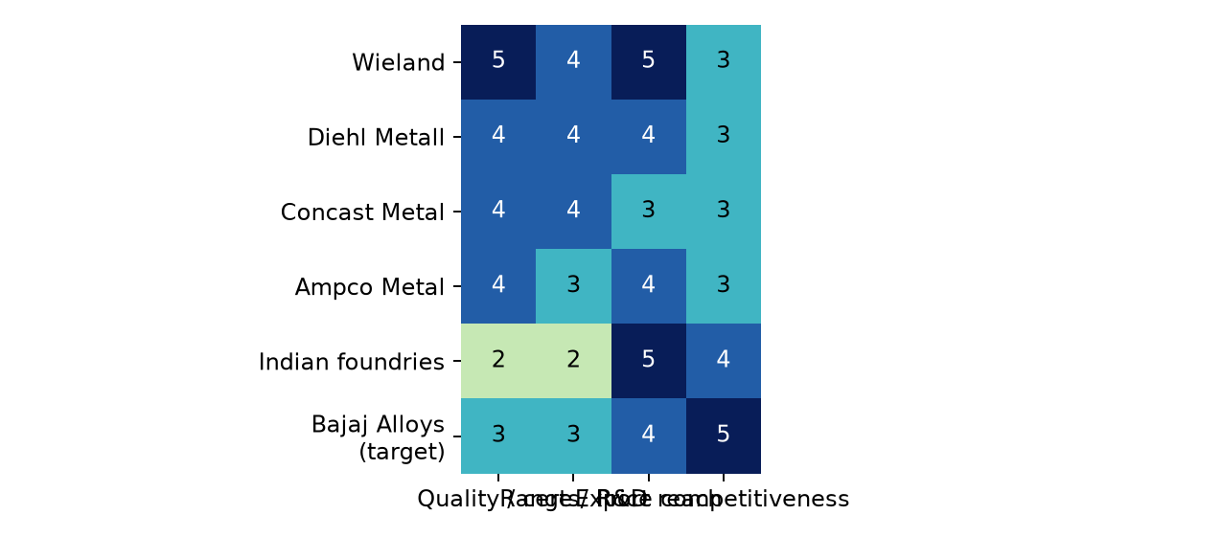
Figure 9: Competitor positioning heat-map (qualitative)
Player type | Examples | Competitive stance
Global specialists | Wieland, Diehl Metall, Aurubis | Broad range, strong R&D, premium pricing, global approvals
Casting specialists | Concast Metal Products, Ampco Metal | Deep foundry know-how, large NAB propeller / heavy-section capability
Indian foundries | Regional and unorganised foundries | Low price, short lead times, inconsistent chemistry / certification
Importers / traders | Stockists of imported ingot and castings | Fill gaps; exposed to FX and long lead times
Substitutes | Duplex & super-duplex steel, titanium, polymer bearings | Win on cost or weight in specific applications

Bajaj Alloys’ edge: scrap-based copper-alloy sourcing know-how, domestic cost base and agility. Gaps to close: international certifications, NAB heat-treatment capability and brand recognition with marine and defence buyers.

7. Comparative Analysis of the Alloy Family
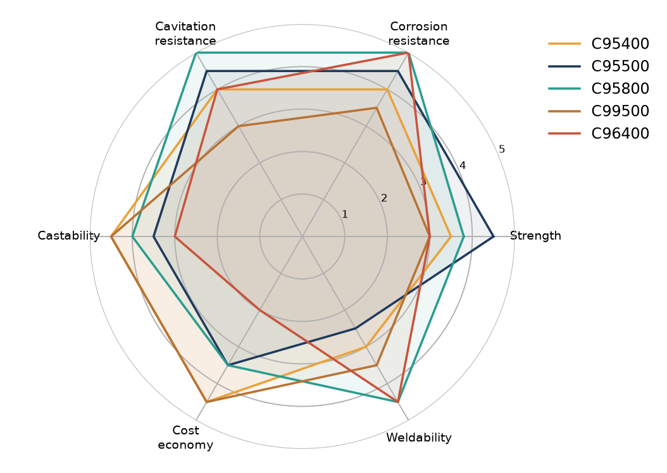
Figure 10: Relative performance profile (5 = best; indicative)
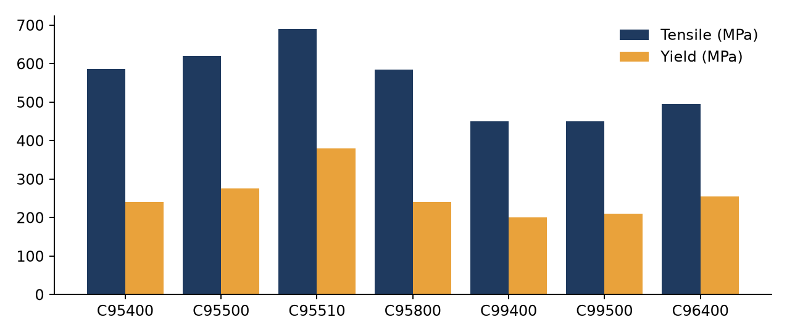
Figure 11: Typical as-cast tensile and yield strength (MPa, approximate)
UNS | Tensile / yield (MPa) | Price ₹/kg | Strengths | Limitations
C95400 | 586 / 241 | 1,442 | Good strength, wear and corrosion; economical NAB | Lower strength than C95500; limited weldability
C95500 | 620 / 275 | 1,460 | Highest strength NAB, heat-treatable to ~760 MPa | Harder to weld and machine
C95510 | 690 / 380 | 1,500 | High strength with better corrosion resistance | Higher cost; fewer suppliers
C95800 | 585 / 241 | 1,480 | Marine benchmark; weldable; cavitation resistant | Needs tight Fe/Mn/Al control
C99400 | 450 / 210 | 1,551 | Easy casting, good conductivity/corrosion | Modest strength; limited approvals
C99500 | 450 / 210 | 1,524 | Value grade, good castability & wear | Lower strength than NAB; seawater duty moderate
C96400 | 495 / 255 | 1,736 | Best seawater corrosion & biofouling resistance | Highest cost; nickel-sensitive

Bottom line: C95500 delivers the highest strength (and responds to heat treatment) at a modest price premium over C95400; C95800 is the benchmark for seawater duty and weldability; C99500 is the best-value, easily cast entry grade and a logical volume product for Bajaj.

8. SWOT, PESTLE and Porter’s Five Forces

SWOT – Bajaj Alloys in nickel bronzes
Strengths  • Copper-alloy melting and scrap sourcing expertise  • Domestic cost base and fast response  • Flexibility on batch sizes | Weaknesses  • Limited certifications for marine/defence  • Metal-price exposure on working capital  • Brand recognition vs global players
Opportunities  • Import substitution in pumps, valves, naval  • Port, shipbuilding and hydro capex  • Value-added machined / heat-treated castings | Threats  • LME volatility and INR depreciation  • Low-cost unorganised foundries  • Substitutes: duplex steels, polymers

PESTLE
Factor | Impact on nickel bronze business
Political | Make-in-India, defence indigenisation and shipbuilding incentives support domestic castings.
Economic | INR near 96/USD raises landed metal cost; copper and nickel cycles drive working capital.
Social | Skilled foundry labour shortage; workplace safety expectations rising.
Technological | Spectrometry, simulation-led casting design, heat-treatment control improve yield and quality.
Legal | BIS/ASTM standards, classification-society approvals, scrap import rules and GST on metals.
Environmental | Emission norms for foundries, recycling and low-carbon copper are becoming tender criteria.

Porter’s Five Forces
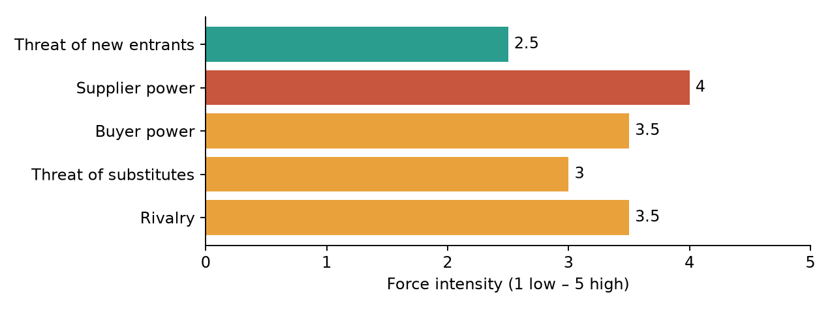
Figure 12: Industry force intensity (qualitative assessment)
Force | Assessment
Threat of new entrants (Low–Mod.) | Capital, approvals and metallurgical know-how are barriers; small foundries can still enter low-spec segments.
Supplier power (High) | Copper and nickel are LME-priced; scrap availability and quality vary; limited ability to negotiate.
Buyer power (Mod.–High) | OEMs and shipyards are concentrated and demand certification and price-formula contracts.
Threat of substitutes (Moderate) | Duplex steel, titanium and polymers in selected uses; nickel bronze keeps cavitation/wear advantage.
Rivalry (Mod.–High) | Global specialists on quality, Indian foundries on price.

9. Recommendations for Bajaj Alloys
Strategy in one line: become India’s dependable, certified, LME-linked supplier of C99500 and the core NAB grades (C95500 / C95800) to marine, defence and pump OEMs.

# | Recommendation | Actions
1 | Focused portfolio | Lead with C99500 (volume, value-for-money); add C95800 and C95500 for marine/offshore; pilot C95510 and C99400 on demand.
2 | Metal-linked pricing | Quote LME Cu/Ni + fixed conversion; hedge or back-to-back metal purchases; review INR/USD weekly.
3 | Quality & certification | Invest in optical emission spectrometer, mechanical lab and heat treatment; pursue IRClass/DNV/LR approvals and ISO 9001.
4 | Target customers | Pump and valve OEMs, shipyards and ship-repair, naval/defence PSUs, hydro/power OEMs, desalination EPCs.
5 | Sourcing & recycling | Secure clean copper-nickel scrap streams; segregate and certify scrap to reduce cost versus primary metal.
6 | Value addition | Offer machined and heat-treated castings and stock programmes to shorten OEM lead times.
7 | Risk management | Diversify nickel suppliers, maintain inventory policy, track substitutes and customer concentration.

90-day / 12-month roadmap
- 0–90 days: finalise grade specs and price formula, sample C99500 / C95800 heats, start certification process, identify 15–20 target OEMs.
- 3–12 months: commission lab and heat-treatment upgrades, secure first marine / defence approvals, sign 3–5 formula-priced supply contracts.
- 12+ months: scale NAB range, enter export enquiries from Gulf and South-East Asia shipyards.

Disclaimer: Prices, market sizing, growth rates and competitor scores are indicative and prepared for strategic discussion. Validate compositions and properties against ASTM B148 / B584 and customer drawings; refresh LME and FX inputs before quoting.

