CAST COPPER ALLOYS | REPORT 2 OF 2 | EXPANDED EDITION

C97600 and C99700 Application Atlas
Where the two alloys are used, which valve and pump sub-components they suit, what else can be made from them, what each part is worth in metal, what could replace them and what could go wrong.
Expanded edition, 17 October 2026. Metal prices are LME cash settlement of 16 Oct 2026 at INR 96.5/US$. Part pictures are drawn schematics, not photographs.

Executive summary
Measure | Value
Products, assemblies and sub-components catalogued | 102 (up from 44)
Sectors covered | 14 (up from 8)
Valve families assessed / valve sub-components | 16 / 14
Pump families assessed / pump sub-components | 11 / 16
Entries for C97600 / C99700 / either | 53 / 42 / 7
Listed by a supplier or data sheet / patent context / inferred | 18 / 5 / 79
Metal value, C97600 | INR 1,436 per kg
Metal value, C99700 (Mn at an assumed US$2,000/t) | INR 999 per kg (INR 974 excl. Mn)
C99700 metal saving against C97600 | 30% per kg; more per part because it is 9% less dense
India valves market, 2025 to 2034 (IMARC) | US$2.77 bn to US$4.77 bn, 6.05% a year
India pumps market, 2025 to 2034 (IMARC) | US$7.2 bn to US$8.8 bn, 2.17% a year
Table 1. Headline numbers
- Valves and pumps are where the two alloys compete head-on. Both data sheets name them. The deeper split is by sub-component: C97600 wins where corrosion and hygiene decide (seat rings, seal glands, sea-water and dairy bodies); C99700 wins where strength and sliding decide (stem nuts, wear rings, shaft sleeves, lobe rotors, gear-pump gears).
- Sub-components are the real product list. A DN50 globe valve carries about 4 kg of castings across 11 parts; a 3 kW end-suction pump carries about 11.5 kg across 10 copper-alloy parts. The body or casing is over half the metal in each.
- C99700 is roughly a third cheaper in metal. INR 999 against INR 1,436 per kg. Copper is 64% of C97600's metal value; nickel and tin add most of the rest.
- Lead rules are the hard ceiling. Neither grade meets the US 0.25% weighted-average lead limit for drinking-water parts, and stainless steel holds 55% of the hygienic pump and valve market. Growth is in non-potable valves, fire protection, marine, wear parts and hardware.
- Fourteen sectors, 102 entries. New sectors in this edition: beverage and dispensing, fire protection, agricultural equipment, instrumentation and metering, locks and security, and India's 'German silver' decorative market.
- Evidence is still thin. Only 18 entries are named by a supplier or data sheet; 79 are engineering inference and are tagged so. Use the inferred list to plan supplier and customer enquiries, not as a confirmed order book.
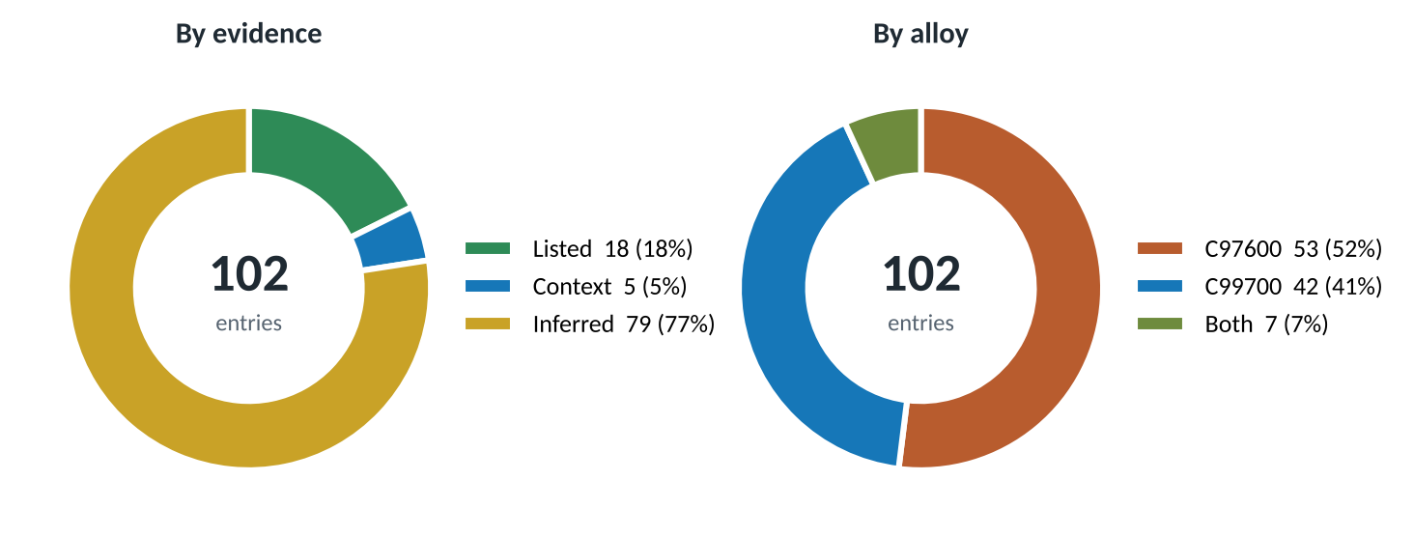
Figure 1. The catalogue by evidence strength and by alloy
Contents
1. How to read this report
2. The two alloys in numbers
3. Market context
4. Valves: deep dive
5. Pumps: deep dive
6. Failure modes and design checks
7. Standards and testing
8. Application landscape
9. Sector deep dives (12 sectors)
10. Selection guide
11. What a part costs in metal
12. What could replace them
13. Risks and outlook
14. Opportunity map for a foundry
15. From casting to finished part
16. Manufacturing methods used
Glossary and sources

1. How to read this report
Every catalogue entry carries one of three evidence tags. Scores elsewhere in the report (fit, exposure, attractiveness) are judgement on a 1 to 5 scale, drawn from composition, published properties and common practice; they are labelled wherever they appear.
Tag | Meaning | Count
Listed | A supplier page or data sheet names the use | 18
Context | A patent or related document supports the use | 5
Inferred | Engineering inference from the alloy's properties; check before relying on it | 79
Table 2. Evidence tags
Convention | Used for
Fit score 1 to 5 | How well an alloy suits a valve family, pump family or sub-component (5 = strong)
Exposure score 1 to 5 | How exposed an alloy is to a failure mode (5 = high)
Metal value | LME value of the metals in the alloy; excludes melting loss, casting, machining, margin and tax
Part masses | Assumed for illustration from typical bronze valve and small-pump practice; replace with drawing weights
Alloy colours | Copper-orange = C97600, blue = C99700, green = either alloy, grey = another material
Table 3. Scoring and display conventions
Use sources: Concast, Metaltek and Aviva Metals for C97600; the ICAST ASTM B176 data sheet and US patent 6,149,739 for C99700. Piano keys are listed by one C97600 supplier but keys are normally wrought nickel silver, so treat that item with care.

2. The two alloys in numbers
Composition drives use. Nickel (19-21.5%) and lead (3-5%) define C97600, a leaded nickel bronze often called 20% nickel silver or 'dairy metal'. Manganese (11-15%), zinc (19-25%) and nickel (4-6%) together define C99700, a white manganese brass that looks similar for far less nickel.
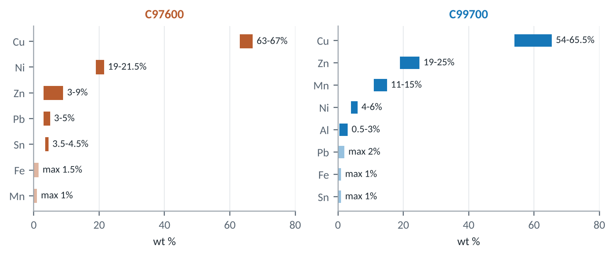
Figure 2. Specified composition ranges (pale bars are maximum-only limits)
Property | C97600 | C99700 | Source
Tensile strength, MPa | 276 min (40 ksi) | 380 typ. (55 ksi) | Concast B505; MakeItFrom
Yield strength, MPa | 138 min (20 ksi) | 170 typ. (25 ksi) | Concast B505; MakeItFrom
Elongation, % | 10 min | 25 typ. | Concast B505; MakeItFrom
Brinell hardness | 80 typ. | Not found | Concast
Density, g/cm3 | 8.9 | 8.1 | Concast; MakeItFrom
Melting range, deg C | 1108-1143 | 880-900 | Concast; MakeItFrom
Freezing range, deg C | 35 | 20 | Derived from melting range
Electrical conductivity, % IACS | 5 | 3 | Concast; MakeItFrom
Thermal conductivity, W/m.K | 22.6 | Not found | Concast
Machinability rating (C36000 = 100) | 70 | Not found | Concast
Elastic modulus, GPa | Not found | 120 | MakeItFrom
Embodied carbon, kg CO2/kg | Not found | 3.3 | MakeItFrom
Main specification | ASTM B505 (also listed in B584/B271; verify) | ASTM B176 die castings | Concast; ICAST
Table 4. Mechanical and physical properties
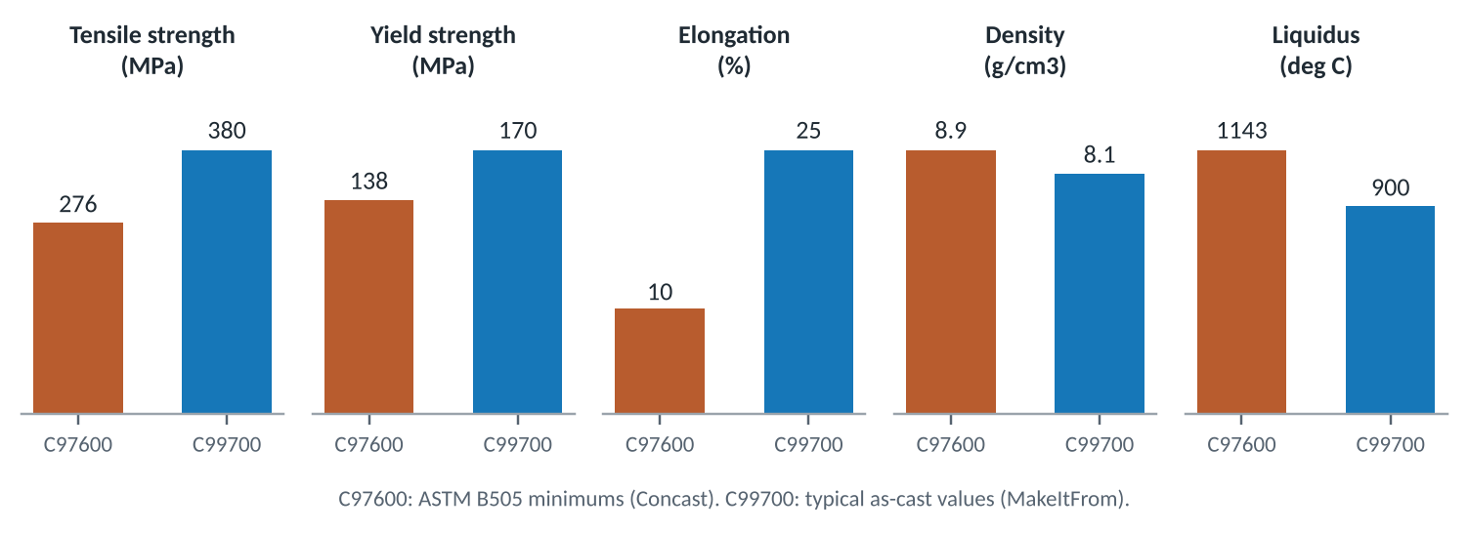
Figure 3. Published property values side by side
What the numbers mean for valves and pumps
- Strength: C99700's typical tensile strength (380 MPa) is about 38% above C97600's specified minimum (276 MPa). Compare like with like before thinning a wall: one is a typical value, the other a guaranteed minimum.
- Ductility: 25% elongation for C99700 against a 10% minimum for C97600 means C99700 tolerates impact and over-tightening of threaded parts better.
- Density: C99700 is 9% lighter, so the same casting weighs less and the per-part metal saving is larger than the per-kg saving.
- Pouring: C99700 melts about 240 deg C lower and freezes over a narrower range (20 against 35 deg C). That suits die casting (ASTM B176) and gives fewer scattered pores, but needs good feeding to avoid concentrated shrinkage.
- Machinability: C97600 rates 70 against free-cutting brass at 100, helped by its 3-5% lead. No rating was found for C99700; its lower lead suggests somewhat harder cutting.
- Conductivity: both are poor electrical conductors (3-5% IACS), so neither is an electrical alloy.
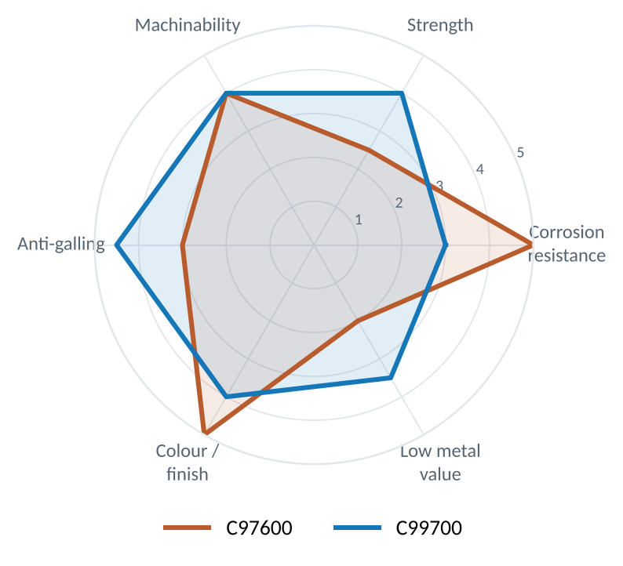
Figure 4. Relative strengths on six properties (judgement scores, 1 low to 5 high)

3. Market context
No source sizes the market for these two grades. The useful numbers are for the equipment they go into. Valves and pumps in India alone are worth about US$10 billion a year, and the hygienic segment where copper alloys once led is growing faster than pumps overall.
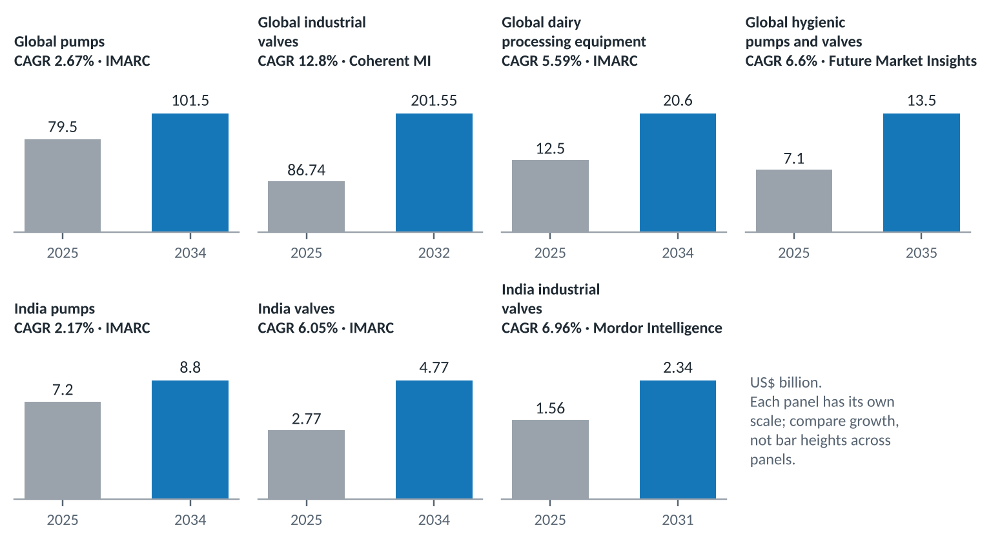
Figure 5. Market size now and forecast for the equipment that uses these alloys
Market | Base | Forecast | CAGR | Source
Global pumps | US$79.5 bn (2025) | US$101.5 bn (2034) | 2.67% | IMARC
Global industrial valves | US$86.74 bn (2025) | US$201.55 bn (2032) | 12.8% | Coherent MI
Global dairy processing equipment | US$12.5 bn (2025) | US$20.6 bn (2034) | 5.59% | IMARC
Global hygienic pumps and valves | US$7.1 bn (2025) | US$13.5 bn (2035) | 6.6% | Future Market Insights
India pumps | US$7.2 bn (2025) | US$8.8 bn (2034) | 2.17% | IMARC
India valves | US$2.77 bn (2025) | US$4.77 bn (2034) | 6.05% | IMARC
India industrial valves | US$1.56 bn (2025) | US$2.34 bn (2031) | 6.96% | Mordor Intelligence
Table 5. Equipment markets (forecasts as published; the 12.8% global valve CAGR is an outlier against other forecasts)
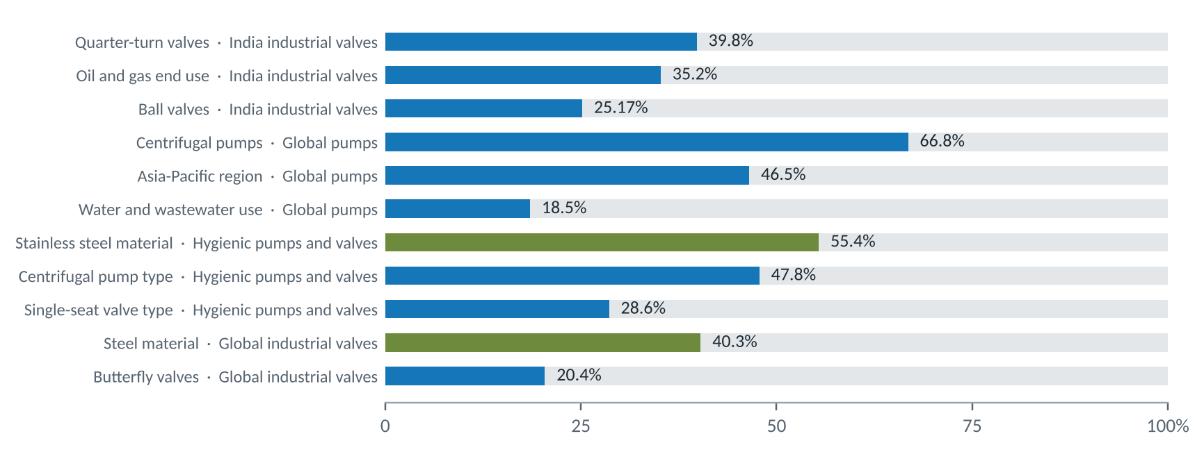
Figure 6. Published segment shares that matter for copper alloys (green = steel and stainless)
- Quarter-turn valves lead India at 39.8% of industrial valves, ball valves alone 25.2%. Ball-valve bodies and end caps are a natural C99700 product; the ball itself is usually wrought and plated.
- Centrifugal pumps are two-thirds of the world pump market. Their copper-alloy content sits in impellers, wear rings, sleeves and small-pump casings.
- Stainless holds 55.4% of hygienic pumps and valves. This is the share C97600 lost in dairy; it will not return while lead rules and acid cleaning apply.
- Water and wastewater is the biggest pump application (18.5%) but much of it is potable, where leaded alloys are excluded. Non-potable water, irrigation and fire service remain open.
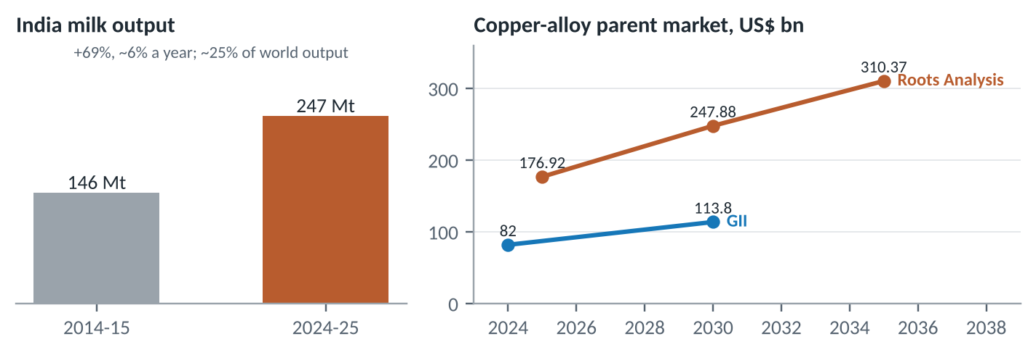
Figure 7. India's milk output and the parent copper-alloy market
India produced over 247 million tonnes of milk in 2024-25, about a quarter of world output, up 69% in a decade. Dairy keeps growing, but new plant is mostly stainless; the copper-alloy opening is in village collection, spares for older plant, and non-product-contact parts.

4. Valves: deep dive
Both data sheets name valves, so this is where the alloys meet. A valve is not one product but a set of castings, each with its own duty. The choice between C97600 and C99700 is best made part by part.

4.1 Why copper alloys are used in valves
- Pressure tightness: fine-grained castings with lead sealing the inter-dendritic pores pass shell tests with thin walls.
- Machinability: threads, seats and bores are cut quickly; lead in both grades gives short chips.
- Corrosion resistance in water and steam: better than iron and carbon steel at small sizes, with no coating needed.
- Galling resistance: copper alloys run against steel and stainless stems without seizing.
- Recyclability: swarf and scrap return straight to the melt, which offsets the metal price.

4.2 Valve families and which alloy fits
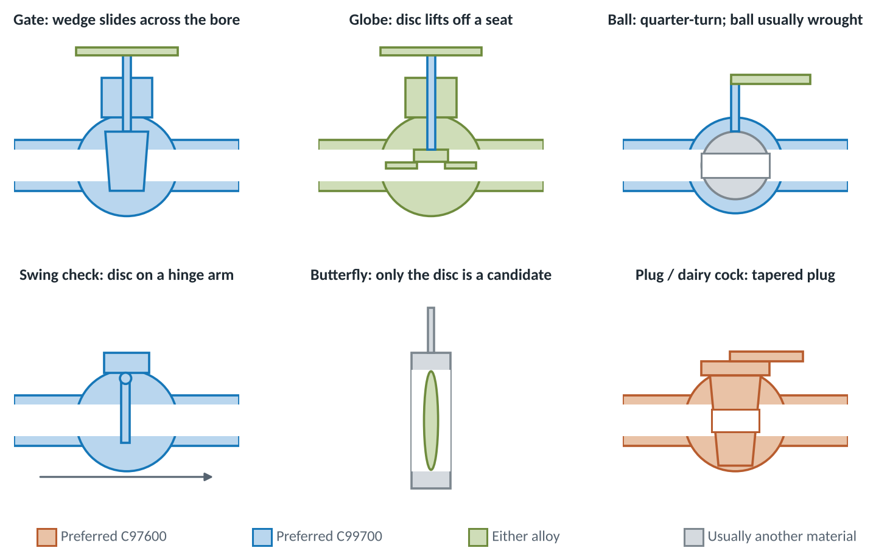
Figure 8. Six valve families, coloured by the preferred alloy for each main part
Valve family | Sizes | Service | C97600 | C99700 | Note
Globe and angle valve | DN8-DN65 | Water, steam, oil, process lines | 4 | 4 | Throttling duty; body, bonnet, disc and seat ring all castable
Gate valve (wedge) | DN15-DN80 | Water, low-pressure steam | 3 | 4 | Strength of C99700 suits larger bodies; wedge guides need wear resistance
Swing check valve | DN15-DN80 | Pump discharge, water lines | 3 | 4 | Body, cap, disc and hinge arm castable
Lift / spring check valve | DN8-DN50 | Compressors, instrument lines | 4 | 4 | Small precise castings; machinability matters
Ball valve (2- and 3-piece) | DN8-DN100 | General utilities, compressed air | 3 | 4 | Body and end caps; ball usually wrought and plated
Plug valve / dairy cock | DN15-DN80 | Dairy, beverage, chemical | 5 | 3 | The classic dairy-metal use; tapered plug laps into body
Needle / instrument valve | DN6-DN25 | Gauges, sampling, instrumentation | 3 | 3 | Fine threads favour leaded free-machining grades
Safety / relief valve | DN15-DN50 | Boilers, compressors, pumps | 4 | 3 | Nozzle and disc need corrosion resistance to hold set pressure
Butterfly valve disc | DN50-DN300 | Water, HVAC, seawater | 3 | 3 | Only the disc is a candidate; bodies are mostly cast or ductile iron
Marine sea-water valve | DN15-DN150 | Ship seawater, ballast, fire main | 4 | 2 | Nickel resists seawater; zinc-rich C99700 risks dezincification
Fire landing / hydrant valve | DN50-DN65 | Fire mains (non-potable) | 2 | 4 | Strength and cost matter; lead is not a drinking-water issue here
Foot valve and strainer | DN25-DN150 | Pump suction, wells, agriculture | 2 | 4 | Low-cost strength; silver colour irrelevant
Radiator / heating valve | DN10-DN25 | Hydronic heating, visible trim | 3 | 3 | Visible part benefits from silver colour without plating
Diaphragm valve body | DN15-DN100 | Process, slurry | 3 | 2 | Mostly cast iron or stainless; niche for copper alloys
Mix-proof / aseptic valve | DN25-DN100 | Dairy, pharma CIP lines | 1 | 1 | Stainless dominates; lead and acid cleaning rule both alloys out
Potable float / ball cock | DN15-DN50 | Drinking-water tanks | 1 | 2 | Lead limits for potable contact apply; use certified lead-free alloy
Table 6. Valve families, fit scores 1 to 5 (judgement)
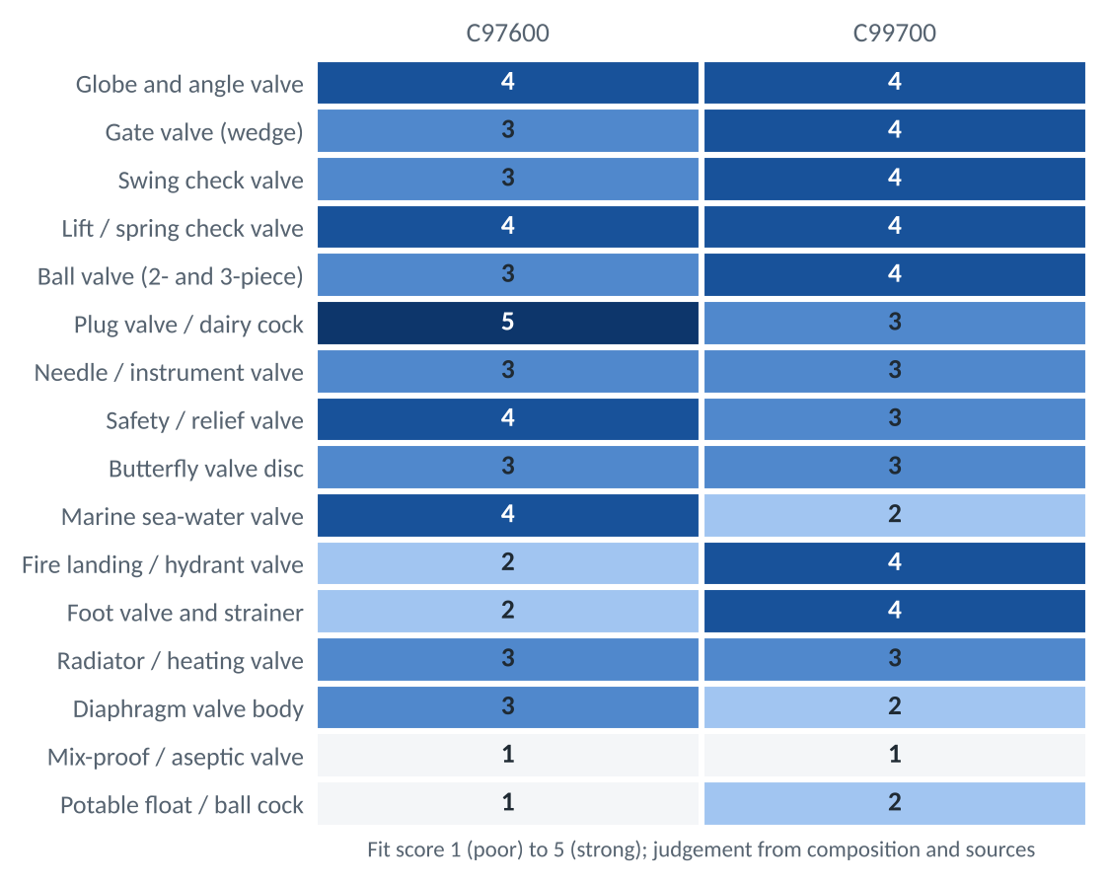
Figure 9. Valve-family fit by alloy (judgement)
- Strongest for C97600: plug valves and dairy cocks, globe and lift-check valves, relief-valve trim and marine sea-water valves, where nickel's corrosion resistance decides.
- Strongest for C99700: gate, swing-check and ball-valve bodies, foot valves and fire landing valves, where strength per rupee decides and the medium is not potable or seawater.
- Weak for both: mix-proof and aseptic valves (stainless territory) and potable float valves (lead rules).

4.3 Valve anatomy and sub-components
A bronze globe valve shows every castable part in one assembly. The colours mark the preferred alloy for each part.
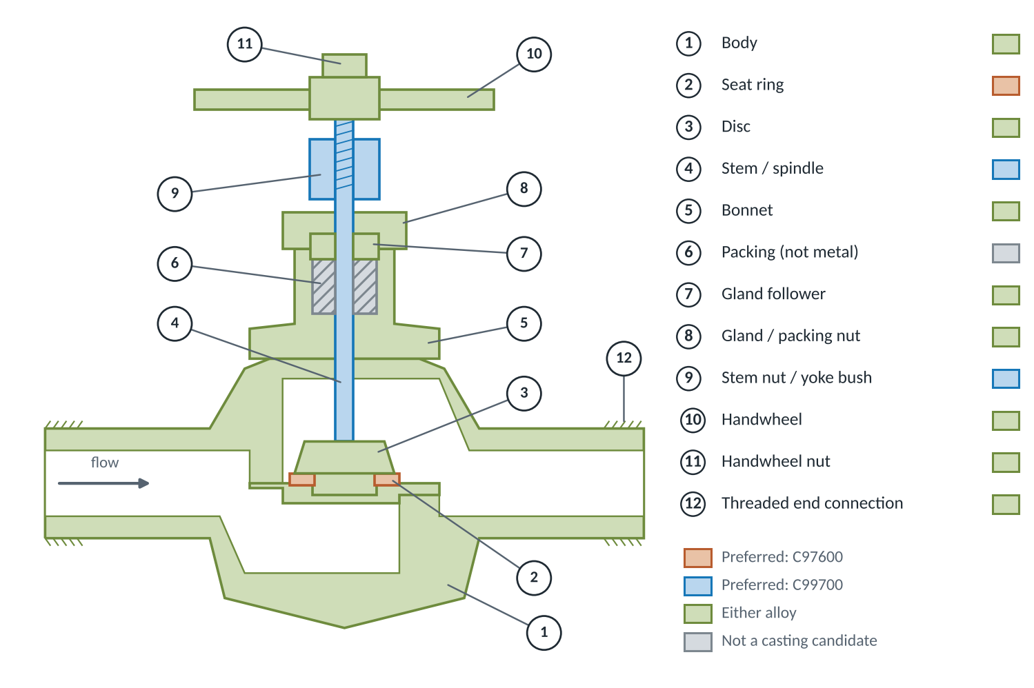
Figure 10. Cut-away schematic of a threaded globe valve with its sub-components
Sub-component | Function | Duty | Preferred | Why | Mass (kg)* | Evidence
Body | Holds pressure; carries end connections | Wetted, pressure | Both | C97600 for aggressive or hygienic media; C99700 for higher strength per rupee | 2.20 | Listed
Bonnet / cap | Closes the body; guides the stem | Wetted, pressure | Both | Same duty as the body; often cast in the same heat | 0.70 | Listed
Disc / wedge / plug | Shut-off or throttling element | Wetted, erosion | Both | Needs corrosion and erosion resistance at the sealing face | 0.25 | Inferred
Seat ring (renewable) | Sealing face the disc closes on | Wetted, erosion, wire-drawing | C97600 | Nickel raises erosion and corrosion resistance at the highest-velocity point | 0.08 | Inferred
Stem / spindle | Transmits torque and thrust | Wetted, threaded, sliding | C99700 | Higher strength; note most stems are wrought bar, not castings | 0.20 | Inferred
Stem nut / yoke bush | Threaded nut the stem runs through | Sliding, galling | C99700 | Patent context: white manganese bronze resists galling on stainless | 0.10 | Context
Gland / packing follower | Compresses the stem packing | Sliding, wetted at bore | Both | Small machined casting; lead helps free cutting | 0.08 | Inferred
Gland nut / packing nut | Holds the gland down | Threaded | Both | Free-machining threads; silver finish on visible valves | 0.06 | Inferred
Handwheel | Operator interface | Visible, impact | Both | Silver colour without plating; C99700 cheaper | 0.25 | Inferred
Union nut and tailpiece | Pipe connection | Wetted, pressure, threaded | Both | Threaded pressure parts machined from castings | 0.30 | Inferred
Hinge arm and pin (check) | Lets the check disc swing | Wetted, wear | C99700 | Wear and strength on a moving part | 0.05 | Inferred
Butterfly disc | Rotating closure element | Wetted, erosion | Both | Disc only; check seawater duty before using C99700 | 0.60 | Inferred
Body studs and nuts | Bolt bonnet to body | Threaded, load | C99700 | Strength matters; usually wrought fasteners | 0.08 | Inferred
Drain plug / cap / indicator | Small closures and position flags | Wetted or visible | Both | Small free-machining castings | 0.03 | Inferred
Table 7. Valve sub-components and the alloy each suits (*assumed mass for a DN50 bronze globe valve)
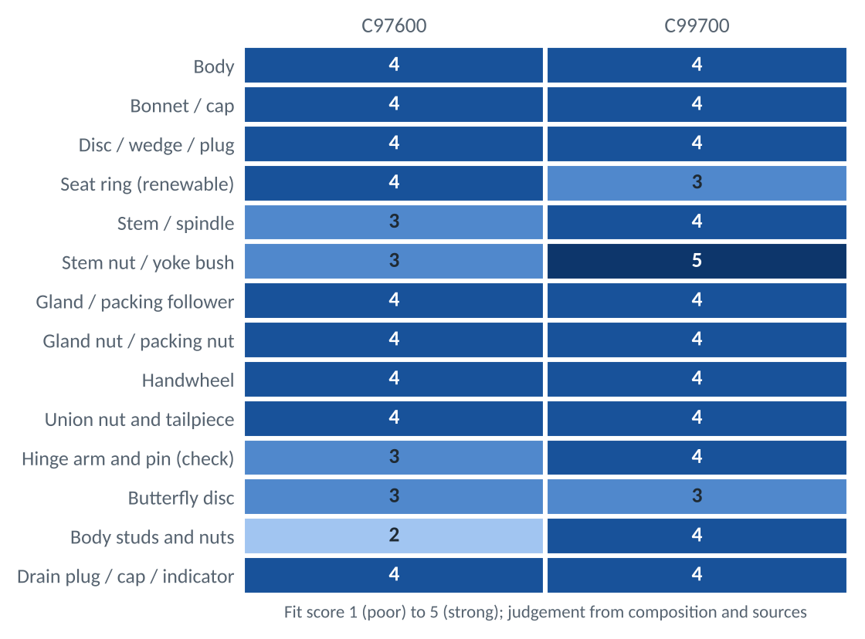
Figure 11. Sub-component fit by alloy (judgement)
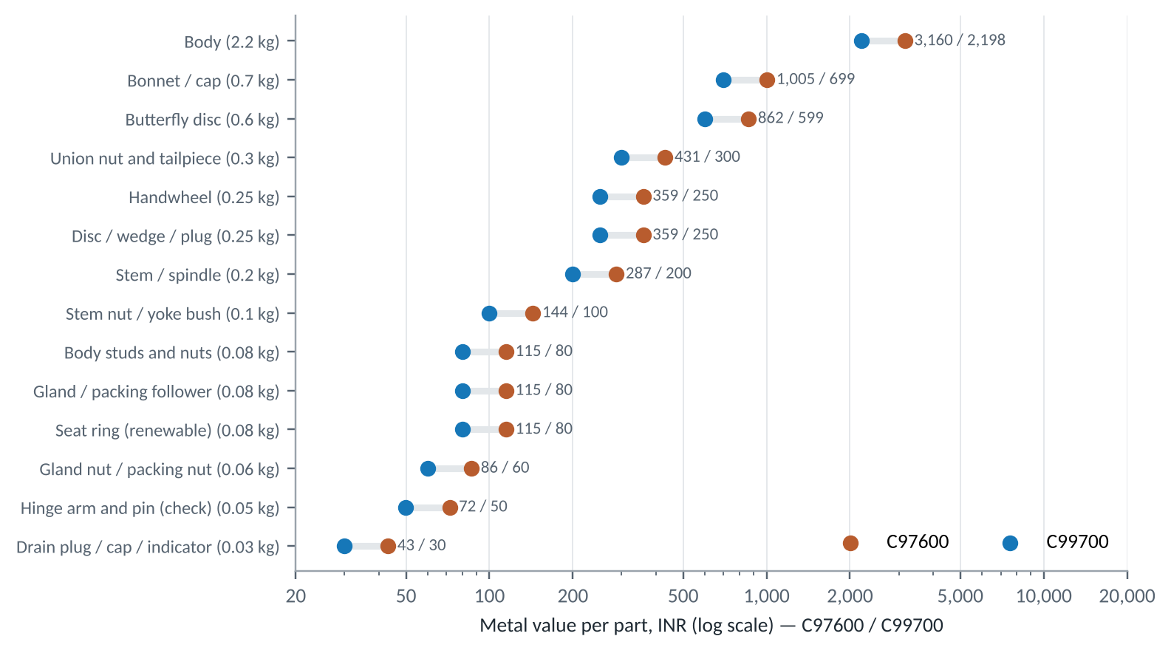
Figure 12. Metal value of each valve sub-component, C97600 against C99700
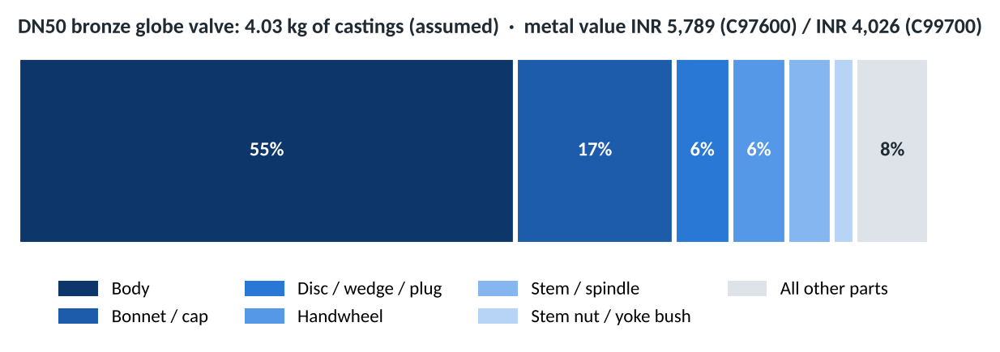
Figure 13. Where the metal sits in a DN50 globe valve (assumed masses)
Stems are usually machined from wrought bar (for example naval brass or silicon bronze) rather than cast, so the cast-stem row is a niche. The stem nut, which the stem threads through, is the stronger casting opportunity for C99700.

4.4 Size economics
Valve weight rises roughly with the cube of size, so metal value climbs steeply. One thousand DN50 valves need about 4 tonnes of alloy; the same number of DN80 valves need about 9.5 tonnes.
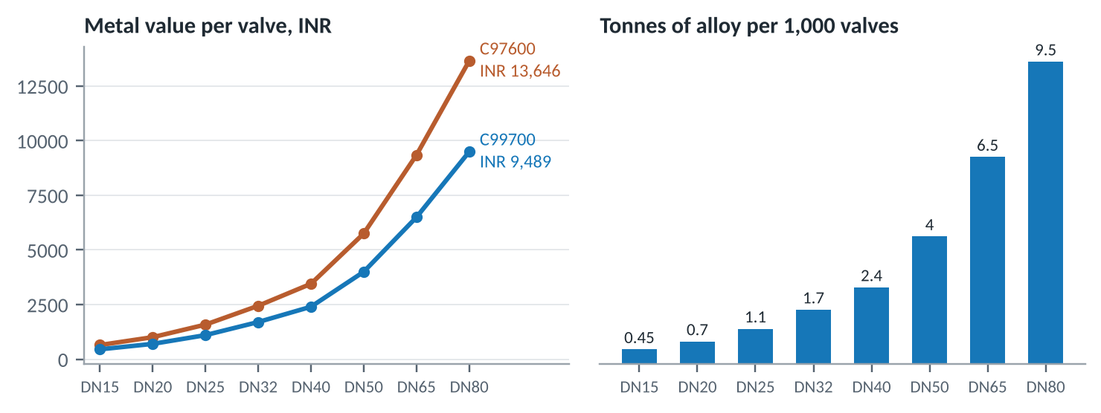
Figure 14. Metal value and alloy tonnage by valve size (assumed masses for bronze globe valves)
Size | Assumed mass (kg) | C97600 INR | C99700 INR | Saving with C99700
DN15 | 0.45 | 646 | 450 | 197
DN20 | 0.70 | 1,005 | 699 | 306
DN25 | 1.10 | 1,580 | 1,099 | 481
DN32 | 1.70 | 2,442 | 1,698 | 744
DN40 | 2.40 | 3,447 | 2,397 | 1,050
DN50 | 4.00 | 5,746 | 3,996 | 1,750
DN65 | 6.50 | 9,337 | 6,493 | 2,844
DN80 | 9.50 | 13,646 | 9,489 | 4,156
Table 8. Metal value per valve by size

4.5 Valve products catalogued
 | Product or part | Alloy | Evidence | Function | Why this alloy
 | Valve bodies and bonnets | C97600 | Listed | Fluid handling | Valve components named by suppliers
 | Valves (general) | C99700 | Listed | Fluid handling | Named in the ICAST data sheet
 | Valve seats, discs and trim | C97600 | Inferred | Fluid handling | Machinable, corrosion-resistant trim
 | Globe and angle valve bodies | Both | Inferred | Fluid handling | Throttling duty; whole body set castable
 | Gate valve bodies and wedges | C99700 | Inferred | Fluid handling | Strength for larger bodies at lower metal value
 | Swing and lift check valves | C99700 | Inferred | Fluid handling | Body, cap, disc and hinge arm
 | Ball-valve bodies and end caps | C99700 | Inferred | Fluid handling | Quarter-turn is the largest Indian valve segment
 | Plug valves and dairy cocks | C97600 | Inferred | Fluid handling | Tapered plug lapped into a corrosion-resistant body
 | Needle and instrument valves | C97600 | Inferred | Fluid handling | Fine threads favour leaded free-machining
 | Safety and relief valve nozzles and discs | C97600 | Inferred | Fluid handling | Corrosion resistance holds set pressure
 | Marine sea-water valves | C97600 | Inferred | Fluid handling | Nickel resists seawater
 | Fire landing and hydrant valves | C99700 | Inferred | Fluid handling | Non-potable; strength and cost lead
 | Foot valves and strainers | C99700 | Inferred | Fluid handling | Low-cost strength
 | Radiator and heating valve trim | C97600 | Inferred | Decorative and ornamental | Visible silver finish
 | Butterfly-valve discs | Both | Inferred | Fluid handling | Disc only; bodies are iron
 | Stem nuts and yoke bushes | C99700 | Context | Wear and sliding parts | Anti-galling against stainless stems
 | Gland followers and packing nuts | Both | Inferred | Fluid handling | Small free-machining parts
 | Valve handwheels | C97600 | Inferred | Hardware and fittings | Small castings on the same valves
 | Union nuts and tailpieces | Both | Inferred | Fluid handling | Threaded pressure parts
Table 9. Catalogue entries: valves (19)

5. Pumps: deep dive
Pumps put copper alloys in harder service than valves: continuous flow, rotating parts and tight running clearances. The alloy choice tracks three things: what the liquid does to the metal, whether parts slide against stainless steel, and whether the liquid is drunk or eaten.

5.1 Pump families
Pump family | Service | C97600 | C99700 | Note
Sanitary centrifugal (milk) pump | Dairy reception, CIP return | 4 | 2 | Listed for C97600 milk pump parts; stainless now dominant in new plant
End-suction centrifugal (water) | Building services, irrigation | 3 | 4 | 'Bronze-fitted' pumps use copper-alloy impellers and wear rings
Split-case fire pump | Fire protection | 3 | 4 | Bronze impellers and wear rings are common; strength helps
Marine / sea-water pump | Cooling water, bilge, ballast | 4 | 2 | Nickel resists seawater; check zinc-rich grades for dezincification
Rotary lobe pump | Food, viscous products | 3 | 4 | Rotors run close to stainless casings; anti-galling alloys are used
External gear pump | Oil, fuel, lubrication | 3 | 4 | Gears and bushes need strength and lubricity
Plunger pump / homogeniser | Dairy homogenising, high pressure | 3 | 3 | Valve seats, guides and glands
Agricultural sprayer pump | Knapsack and power sprayers | 2 | 4 | Low-cost strength; chemical exposure needs a check
Hand and well pump fittings | Rural water supply | 2 | 3 | Drinking-water use: lead rules apply
Hot-water circulator | Domestic heating, potable hot water | 1 | 2 | Potable markets need certified lead-free bodies
Fuel transfer pump | Diesel, lubricants | 1 | 3 | Strength and spark resistance; silver colour irrelevant
Table 10. Pump families, fit scores 1 to 5 (judgement)
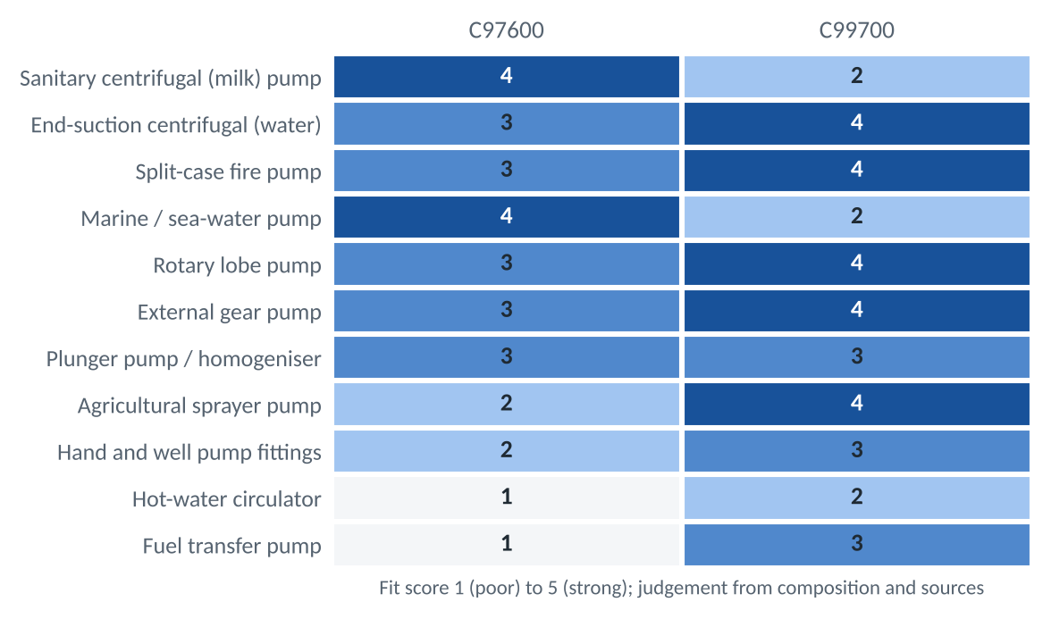
Figure 15. Pump-family fit by alloy (judgement)

5.2 Centrifugal pump anatomy and sub-components
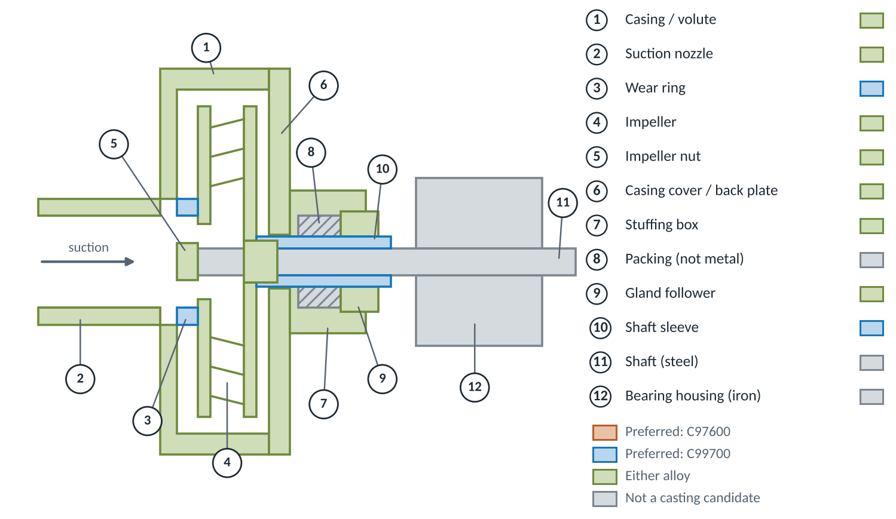
Figure 16. Section through an end-suction centrifugal pump with its sub-components
Sub-component | Function | Duty | Preferred | Why | Mass (kg)* | Evidence
Casing / volute | Converts velocity to pressure; holds pressure | Wetted, pressure | Both | Largest casting; C99700 cuts metal value about a third | 6.00 | Listed
Casing cover / back plate | Closes the casing; carries the seal | Wetted, pressure | Both | Cast alongside the casing | 2.50 | Listed
Impeller (closed) | Adds energy to the liquid | Wetted, erosion, cavitation | Both | C97600 for corrosive or hygienic duty; C99700 for strength | 1.20 | Inferred
Diffuser / guide vanes | Recovers pressure in multistage pumps | Wetted, erosion | C99700 | Strength for thin vanes | 1.00 | Inferred
Casing and impeller wear rings | Small running clearance that limits leakage | Sliding, galling | C99700 | Anti-galling against stainless; sacrificial and cheap to replace | 0.15 | Context
Shaft sleeve | Protects the shaft under the packing | Sliding, wetted | C99700 | Wear with lubricity | 0.25 | Inferred
Stuffing box / seal housing | Holds packing or mechanical seal | Wetted, pressure | Both | Machined bores and threads | 0.80 | Inferred
Gland follower and lantern ring | Compress and flush the packing | Sliding, wetted | Both | Small free-machining parts | 0.18 | Inferred
Mechanical-seal gland plate | Clamps the stationary seal face | Wetted, flat sealing faces | C97600 | Corrosion resistance at the seal | 0.30 | Inferred
Impeller nut | Locks the impeller on the shaft | Wetted, threaded | Both | Small part; colour-matched | 0.04 | Inferred
Rotary lobe rotors | Displace product in lobe pumps | Wetted, sliding vs stainless | C99700 | Patent context on galling against stainless in food equipment | 1.50 | Context
Gear-pump gears | Displace oil or fuel | Sliding, load | C99700 | 380 MPa strength and lubricity | 0.40 | Inferred
Sleeve bearings / bushes | Support the shaft | Sliding, load | C99700 | Lubricity against steel and stainless | 0.20 | Inferred
Plunger-pump valve seats and guides | Check valves inside the pump head | Wetted, impact | C97600 | Corrosion resistance at high cycle counts | 0.10 | Inferred
Priming / air-release valve body | Vents air on start-up | Wetted | Both | Small valve casting on the pump | 0.10 | Inferred
Suction strainer / foot valve | Keeps debris out; holds prime | Wetted, impact | C99700 | Strength and cost; colour irrelevant | 0.90 | Inferred
Table 11. Pump sub-components and the alloy each suits (*assumed mass, 3 kW pump or equivalent)
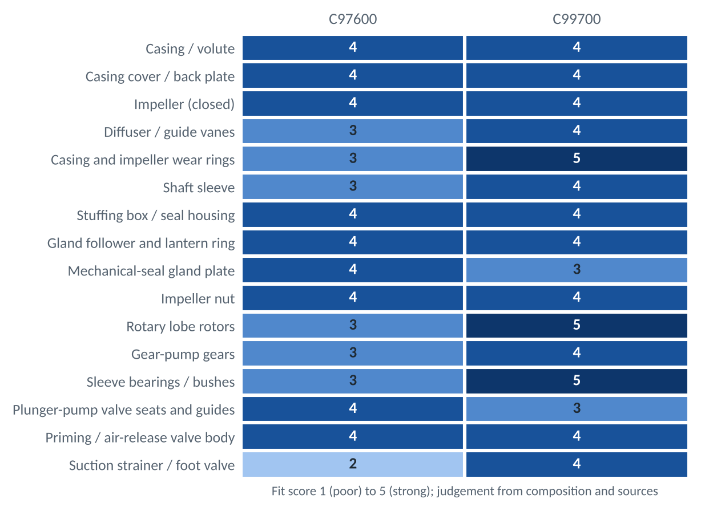
Figure 17. Pump sub-component fit by alloy (judgement)
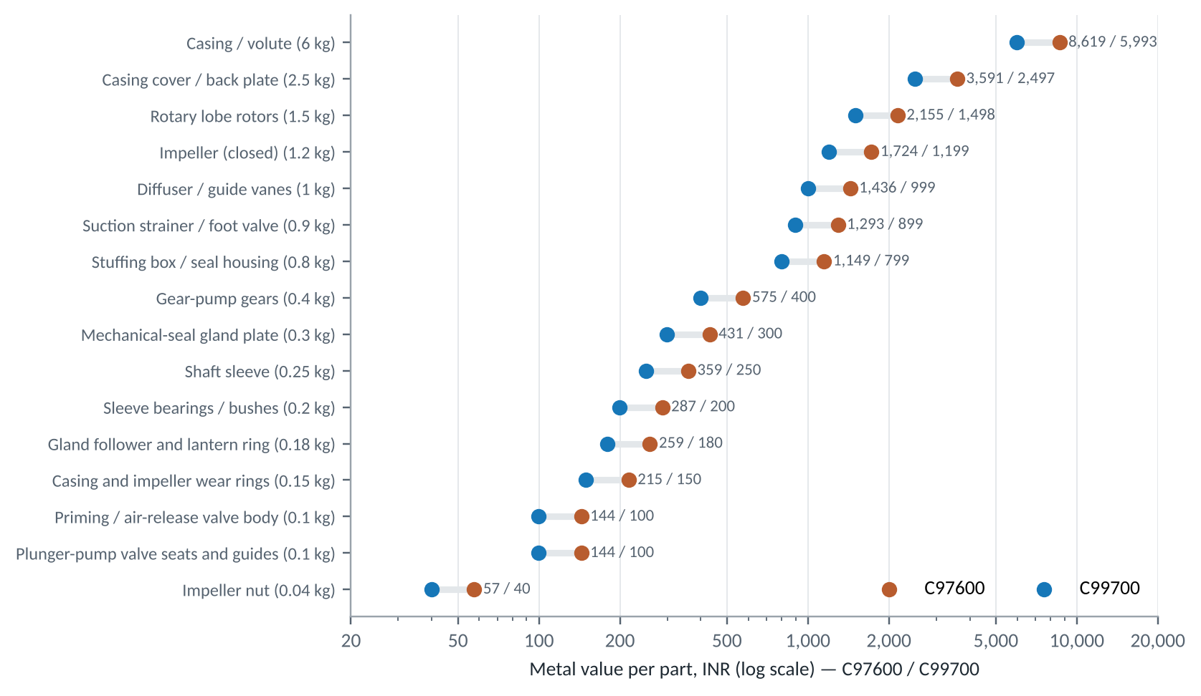
Figure 18. Metal value of each pump sub-component, C97600 against C99700
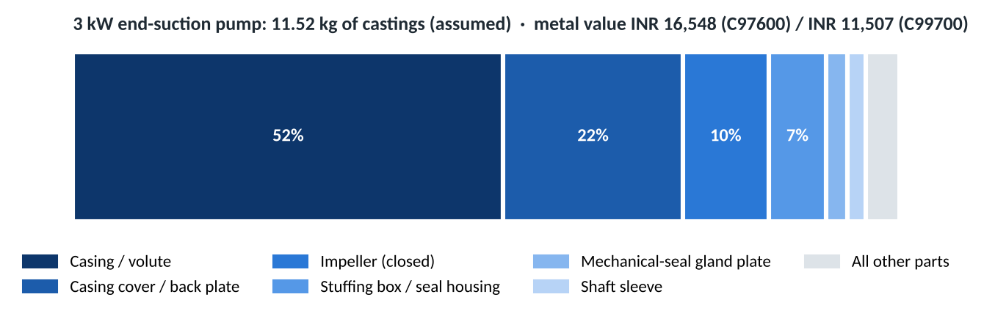
Figure 19. Where the metal sits in a 3 kW end-suction pump (assumed masses)
- Casing and cover are three-quarters of the metal. Switching them to C99700 saves about INR 3,700 of metal per pump at today's prices, if the liquid allows it.
- Wear rings and sleeves are the best C99700 fit. They slide, they are replaced at every overhaul, and the patent context on galling against stainless applies directly.
- Impellers sit in the middle. C97600 for corrosive or sea water; C99700 where strength and cost lead. Neither is a cavitation specialist; nickel-aluminium bronze is.

5.3 Positive-displacement pumps
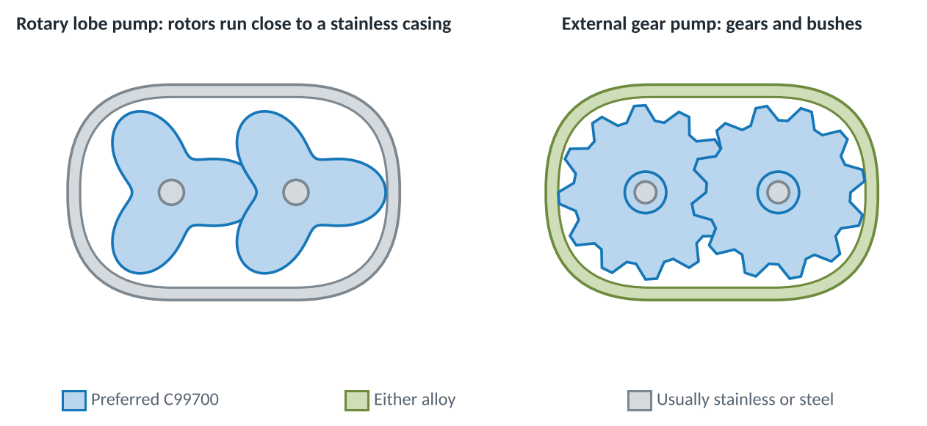
Figure 20. Rotary lobe and external gear pumps, coloured by preferred alloy
In a rotary lobe pump the rotors turn without touching, a fraction of a millimetre from a stainless casing. If they do touch, a galling-resistant rotor fails safely. This is the strongest single fit for C99700 in food equipment, and it is backed by patent context. In gear pumps the gears and bushes need the 380 MPa strength and lubricity; the casing can be either alloy.

5.4 Pump products catalogued
 | Product or part | Alloy | Evidence | Function | Why this alloy
 | Industrial pump parts | C97600 | Listed | Fluid handling | Pump components and fittings
 | Pump parts (general) | C99700 | Listed | Fluid handling | Named in the ICAST data sheet
 | Pump casings and volutes | Both | Inferred | Fluid handling | Largest casting in the pump
 | Closed impellers | Both | Inferred | Fluid handling | Bronze-fitted pump practice
 | Casing and impeller wear rings | C99700 | Context | Wear and sliding parts | Anti-galling, replaceable
 | Shaft sleeves | C99700 | Inferred | Wear and sliding parts | Wear with lubricity
 | Diffusers and guide vanes | C99700 | Inferred | Fluid handling | Strength for thin vanes
 | Stuffing boxes and seal housings | Both | Inferred | Fluid handling | Machined bores and threads
 | Rotary lobe pump rotors | C99700 | Context | Wear and sliding parts | Run close to stainless casings
 | Gear-pump gears and bushes | C99700 | Inferred | Wear and sliding parts | Strength and lubricity
 | Marine sea-water pump casings | C97600 | Inferred | Fluid handling | Seawater resistance
 | Fire-pump impellers | C99700 | Inferred | Fluid handling | Non-potable; strength
 | Plunger-pump valve seats and guides | C97600 | Inferred | Fluid handling | High-cycle corrosion resistance
 | Agricultural sprayer pump bodies | C99700 | Inferred | Fluid handling | Low-cost strength
Table 12. Catalogue entries: pumps (14)

6. Failure modes and design checks
Most field failures of copper-alloy valves and pumps fall into eight modes. The two alloys are exposed to them differently, which is a second way to choose between them.
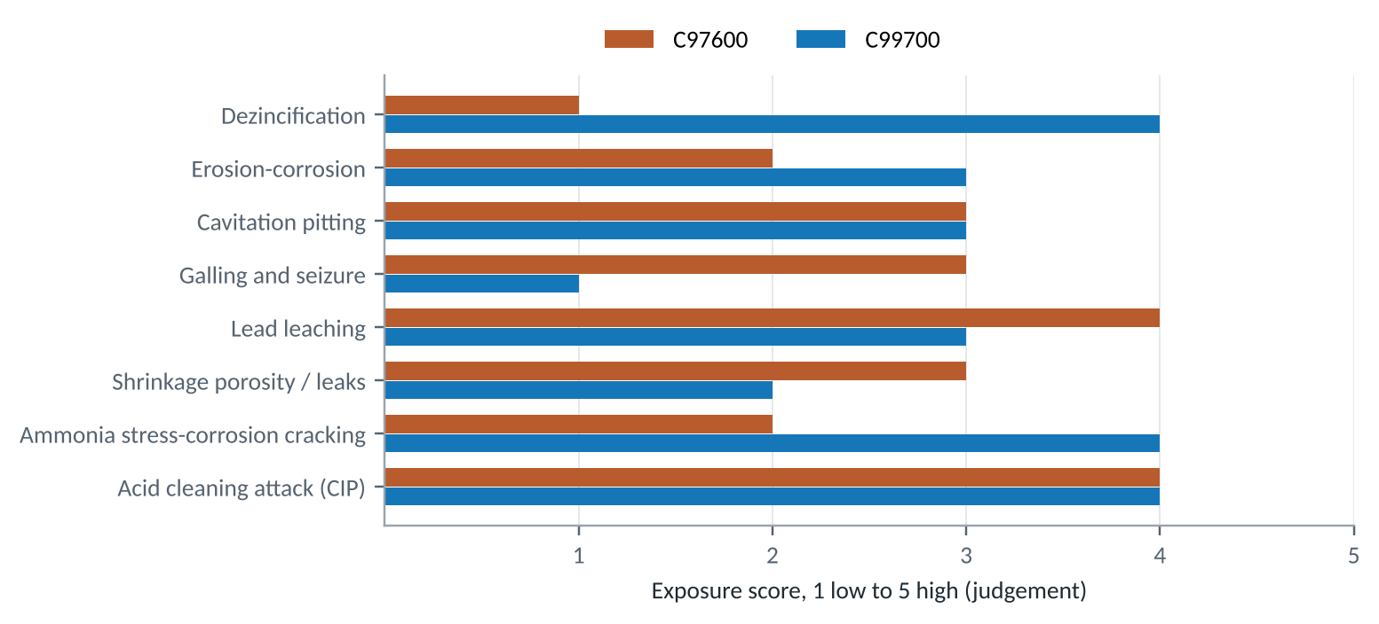
Figure 21. Exposure of each alloy to eight failure modes (judgement)
Failure mode | Where it bites | C97600 | C99700 | Why | Mitigation
Dezincification | Valve bodies, impellers in soft or chloride water | 1 | 4 | C99700 holds 19-25% Zn; C97600 only 3-9% | Specify C97600 or a DZR alloy for immersed service; test in the actual water
Erosion-corrosion | Seat rings, impeller eyes, elbows | 2 | 3 | High local velocity strips the protective film | Keep velocity within supplier limits; harder trim at the seat
Cavitation pitting | Impeller suction side | 3 | 3 | Collapsing vapour bubbles; neither alloy is a cavitation specialist | Raise NPSH margin; consider nickel-aluminium bronze impellers
Galling and seizure | Stem nuts, wear rings, lobe rotors | 3 | 1 | Patent context: white manganese bronze resists galling on stainless | Use C99700 against stainless mating parts
Lead leaching | Potable water and food contact | 4 | 3 | C97600 3-5% Pb; C99700 up to 2% Pb | Restrict to non-potable duty or move to a certified lead-free grade
Shrinkage porosity / leaks | Thick-to-thin body sections | 3 | 2 | Freezing range 35 deg C for C97600 vs 20 deg C for C99700 | Feeding and chill design; 100% hydrostatic shell test
Ammonia stress-corrosion cracking | Refrigeration, fertiliser plant | 2 | 4 | Zinc-rich brasses are susceptible under stress | Avoid C99700 in ammonia service; stress-relieve
Acid cleaning attack (CIP) | Dairy and food lines | 4 | 4 | Nitric or phosphoric acid cleaning attacks copper alloys | Check the plant's CIP chemistry before quoting
Table 13. Failure modes, exposure 1 (low) to 5 (high), judgement
The two that most often decide a quote: dezincification (rules C99700 out of immersed seawater and some soft waters) and acid clean-in-place (rules both out of most modern dairy product lines).

7. Standards and testing
Standard | Scope | Why it matters here
ASTM B505 | Copper alloy continuous castings | C97600 chemistry and properties (Concast cites B505-23)
ASTM B584 / B271 | Sand and centrifugal castings | Other routes for C97600; confirm the grade is in the current edition
ASTM B176 | Copper alloy die castings | C99700 (ICAST data sheet)
MSS SP-80 | Bronze gate, globe, angle and check valves | Pressure ratings and design of bronze valves
MSS SP-110 | Ball valves, threaded and socket-weld | Ball-valve bodies in copper alloys
IS 778 | Copper-alloy gate, globe and check valves for waterworks | Indian standard for the same valve families
API 598 / ISO 5208 | Valve inspection and pressure testing | Shell and seat tests before dispatch
NSF/ANSI 61 and 372 | Drinking-water components; lead content | Certification route for potable products
US Safe Drinking Water Act | 'Lead-free' = 0.25% weighted-average Pb on wetted surfaces | Rules out both leaded grades for US potable use
IS 10500 | Indian drinking-water quality; Pb limit 0.01 mg/L | Drives Indian utility specifications
3-A Sanitary Standards | Dairy equipment hygiene design | Generally specify stainless for product contact; check before quoting
Table 14. Standards a valve or pump buyer is likely to cite

Tests a valve or pump casting usually passes before dispatch
- Chemistry: spectrometer check against the ranges in Section 2; look-alike white alloys are easy to mix up.
- Hydrostatic shell test: typically 1.5 times rated pressure under API 598 or ISO 5208 practice; this is where porosity shows.
- Seat or closure test: typically 1.1 times rated pressure, or a low-pressure air test, for leakage past the seat.
- Dimensions and threads: gauges for end connections and stem threads.
- Lead certification: for any potable product, third-party NSF/ANSI 372 or equivalent; neither grade in this report will pass.

8. Application landscape
The catalogue now holds 102 entries in 14 sectors. Valves, pumps and dairy are the best documented; general engineering and automotive rest mainly on the C99700 data sheet.
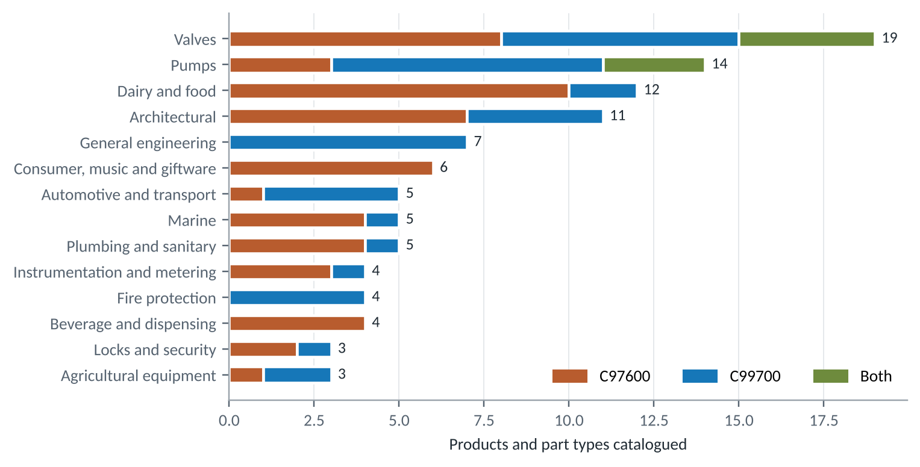
Figure 22. Entries per sector, split by alloy
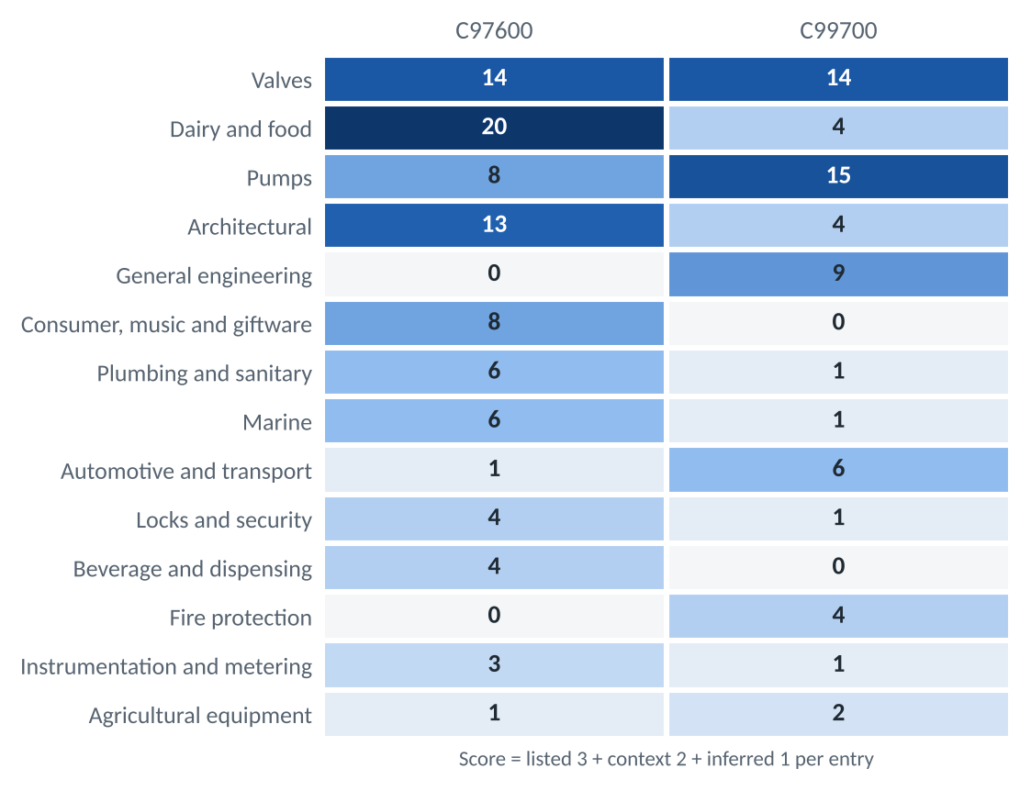
Figure 23. Evidence-weighted score by sector and alloy
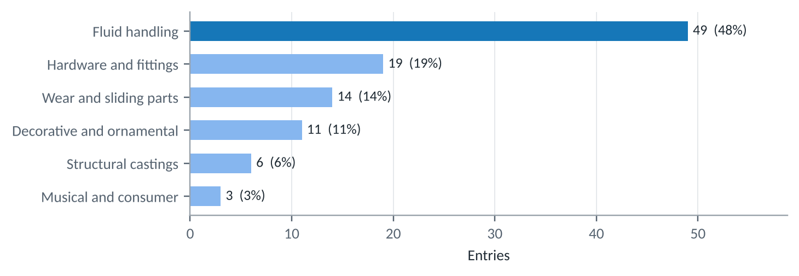
Figure 24. Entries by function

9. Sector deep dives

9.1 Dairy and food
This is the sector that gave C97600 its trade name. Suppliers say the 20% nickel grade meets sanitary requirements for milk pump components and other food-handling parts, and that it is heavily used for valves, fittings and gears in dairy plants.
Item | Detail
Main alloy | C97600
Evidence | Listed for C97600; patent context for C99700
Main driver | Corrosion resistance and a cleanable silver surface
Main constraint | Lead in food contact; stainless steel; acid CIP

- Milk handling: pump casings, valves and line fittings carry milk, cleaning chemicals and hot rinse water.
- Village collection: bulk-milk-cooler outlet valves and milking-machine parts are small, numerous castings; check the buyer's food-contact rules.
- C99700 in food equipment: a patent describes white manganese bronze for food-handling equipment with good lubricity against stainless steel.
Check the hygiene and lead rules in your market before specifying a leaded alloy for food contact. A lead-free white manganese bronze has been patented as a replacement.
 | Product or part | Alloy | Evidence | Function | Why this alloy
 | Milk pump casings and components | C97600 | Listed | Fluid handling | Named for milk pump components
 | Milk pump impellers | C97600 | Inferred | Fluid handling | Same corrosion duty as the casing
 | Dairy valves | C97600 | Listed | Fluid handling | The use that gave the name 'dairy metal'
 | Dairy pipe fittings and couplings | C97600 | Listed | Fluid handling | Fittings for milk lines
 | Sanitary ferrules and unions | C97600 | Inferred | Fluid handling | Hygienic line joints
 | Dairy equipment gears | C97600 | Listed | Wear and sliding parts | Gears named alongside valves
 | Food-handling machine parts | C97600 | Listed | Structural castings | Other food-handling parts
 | Sight-glass frames and flanges | C97600 | Inferred | Fluid handling | Cleanable inspection fittings
 | Sliding parts running on stainless | C99700 | Context | Wear and sliding parts | Patent: resists galling on stainless
 | Food-equipment structural parts | C99700 | Context | Structural castings | Patent: suited to food handling
 | Bulk milk cooler outlet valves | C97600 | Inferred | Fluid handling | Village collection centres; check lead rules
 | Milking-machine claw and pulsator parts | C97600 | Inferred | Fluid handling | Small wetted castings; stainless and polymer compete
Table 16. Catalogue entries: dairy and food (12)

9.2 Beverage and dispensing
Bars, breweries and drink dispensers use bright, corrosion-resistant fittings that people see and touch. This is a new, inferred sector for C97600.
Item | Detail
Main alloy | C97600
Evidence | Inferred
Main driver | Silver look without plating; corrosion resistance
Main constraint | Lead in beverage contact

- Visible parts: tap shanks and fonts suit the silver finish.
- Wetted parts: couplers and taps touch the drink; lead-free versions are now expected in many markets.
Offer C97600 for non-wetted visible parts; quote a lead-free alloy for anything the drink touches.
 | Product or part | Alloy | Evidence | Function | Why this alloy
 | Beverage and dispensing taps | C97600 | Inferred | Fluid handling | Silver finish and corrosion resistance
 | Beer tap shanks and fonts | C97600 | Inferred | Decorative and ornamental | Visible bar fittings that keep a bright finish
 | Keg couplers and coupler bodies | C97600 | Inferred | Fluid handling | Wetted castings; lead-free versions now expected
 | Water-cooler and dispenser fittings | C97600 | Inferred | Fluid handling | Potable use: lead limits apply
Table 18. Catalogue entries: beverage and dispensing (4)

9.3 Plumbing and sanitary
Suppliers list sanitary fittings for C97600. Decorative faucet trim and bathroom brackets are natural extensions because the alloy holds a bright finish.
Item | Detail
Main alloy | C97600
Evidence | Listed for sanitary fittings; others inferred
Main driver | Bright finish, corrosion resistance
Main constraint | Lead limits for drinking-water contact

- Wetted parts: any part touching potable water must meet the lead limit where it is sold (US: 0.25% weighted average).
- Non-wetted trim: brackets, escutcheons and shower arms face fewer limits.
- Drain and waste: non-potable, so C99700 can compete on cost.
Treat leaded grades as unsuitable for drinking-water contact unless the product is certified.
 | Product or part | Alloy | Evidence | Function | Why this alloy
 | Sanitary plumbing fittings | C97600 | Listed | Fluid handling | Sanitary fittings
 | Decorative faucet trim | C97600 | Inferred | Decorative and ornamental | Silver colour and sanitary record
 | Bathroom brackets and accessories | C97600 | Inferred | Hardware and fittings | Keep a bright finish
 | Shower arms and escutcheons | C97600 | Inferred | Decorative and ornamental | Non-wetted visible trim
 | Drain and waste fittings | C99700 | Inferred | Fluid handling | Non-potable; cost and strength
Table 20. Catalogue entries: plumbing and sanitary (5)

9.4 Fire protection
Fire mains carry non-potable water at high pressure, and the parts are bought on strength, reliability and price. Bronze and gunmetal are the incumbents; C99700 is an inferred competitor.
Item | Detail
Main alloy | C99700
Evidence | Inferred
Main driver | Strength and cost; lead is not a potable issue
Main constraint | Approval to fire-service standards; dezincification in stagnant water

- Landing valves and couplings: pressure castings with threads, impact loads and long idle periods.
- Fire-pump wear rings: the same anti-galling duty as in Section 5.
Fire products need type approval; budget for testing before the first order.
 | Product or part | Alloy | Evidence | Function | Why this alloy
 | Landing valve bodies | C99700 | Inferred | Fluid handling | Non-potable; strength and cost
 | Hose couplings and branch pipes | C99700 | Inferred | Hardware and fittings | Impact and thread strength
 | Sprinkler and deluge valve trim | C99700 | Inferred | Fluid handling | Small pressure castings
 | Fire-pump wear rings | C99700 | Inferred | Wear and sliding parts | Anti-galling ring pairs
Table 22. Catalogue entries: fire protection (4)

9.5 Architectural
The best-documented decorative use. Suppliers list ornamental castings, builders' hardware, and door and window hardware, including hardware for prison doors.
Item | Detail
Main alloy | C97600; C99700 as a colour match
Evidence | Listed for C97600
Main driver | Silver colour, tarnish and wear resistance
Main constraint | Cost against brass, zinc alloy and stainless hardware

- Visible hardware: handles, knobs, hinges and pulls are touched daily.
- Heavy-duty doors: panic bars, closer housings and secure-door hardware need strength; C99700 fits.
- Glazing fittings: patch fittings and spiders carry load and are seen.
White manganese brass is a lower-cost colour match, but its tarnish behaviour against nickel silver is not documented in the sources found.
 | Product or part | Alloy | Evidence | Function | Why this alloy
 | Ornamental castings | C97600 | Listed | Decorative and ornamental | Keep a silver finish
 | Builders' hardware | C97600 | Listed | Hardware and fittings | General building hardware
 | Door and window hardware | C97600 | Listed | Hardware and fittings | Includes prison-door hardware
 | Lock and latch castings | C97600 | Inferred | Hardware and fittings | Machinable, wear-resistant
 | Nameplates and plaques | C97600 | Inferred | Decorative and ornamental | Cast lettering stays bright
 | Door knobs and pulls | C97600 | Inferred | Hardware and fittings | Wear and tarnish resistance
 | Stair and rail brackets | C97600 | Inferred | Hardware and fittings | Visible fittings
 | White decorative hardware | C99700 | Inferred | Decorative and ornamental | Colour match to nickel silver
 | Cabinet and furniture castings | C99700 | Inferred | Hardware and fittings | White finish at lower metal value
 | Panic-bar and closer housings | C99700 | Inferred | Hardware and fittings | Strength for high-traffic doors
 | Glazing patch fittings and spiders | C99700 | Inferred | Structural castings | Load-bearing visible fittings
Table 24. Catalogue entries: architectural (11)

9.6 Marine
Suppliers list marine furniture for C97600. Nickel improves resistance to salt air and water.
Item | Detail
Main alloy | C97600; C99700 inferred
Evidence | Listed for C97600 only
Main driver | Corrosion resistance near seawater
Main constraint | Zinc-rich brasses can dezincify

- Deck fittings: cleats, fairleads, hatch and portlight hardware.
- Through-hull: seacocks and through-hull fittings are immersed; nickel beats zinc here.
- C99700: verify seawater performance before use.
Test or obtain supplier approval before using C99700 in immersed service.
 | Product or part | Alloy | Evidence | Function | Why this alloy
 | Marine furniture and fittings | C97600 | Listed | Hardware and fittings | Deck and cabin fittings
 | Portlight and hatch hardware | C97600 | Inferred | Hardware and fittings | Salt-air resistance
 | Marine hardware | C99700 | Inferred | Hardware and fittings | Verify seawater behaviour
 | Through-hull fittings and seacocks | C97600 | Inferred | Fluid handling | Immersed duty favours nickel over zinc
 | Fairleads, chocks and cleats | C97600 | Inferred | Hardware and fittings | Abrasion and salt spray
Table 26. Catalogue entries: marine (5)

9.7 Automotive and transport
The C99700 data sheet lists automotive parts but does not name them. Strength with machinability explains the interest.
Item | Detail
Main alloy | C99700
Evidence | Listed in general terms
Main driver | Strength near 380 MPa with machinability
Main constraint | Cost against steel, aluminium and zinc die castings

- Likely fit: small, corrosion-exposed housings, brackets and fuel-system fittings.
- Railways: coach fittings and bushes need wear resistance.
- Interiors: bus and coach hardware can use C97600's finish.
Treat the automotive rows as prompts for a supplier enquiry, not as a confirmed product list.
 | Product or part | Alloy | Evidence | Function | Why this alloy
 | Automotive parts | C99700 | Listed | Structural castings | Named in the data sheet
 | Housings and brackets | C99700 | Inferred | Structural castings | Strength with machinability
 | Fuel-system fittings | C99700 | Inferred | Fluid handling | Strength; colour irrelevant
 | Railway coach fittings and bushes | C99700 | Inferred | Wear and sliding parts | Wear parts and fittings
 | Bus and coach interior hardware | C97600 | Inferred | Hardware and fittings | Silver colour, touch-resistant
Table 28. Catalogue entries: automotive and transport (5)

9.8 General engineering
The C99700 data sheet lists general engineering, which in practice means machined castings that need strength and wear resistance.
Item | Detail
Main alloy | C99700
Evidence | Listed for general castings; others inferred
Main driver | Strength, lubricity, corrosion resistance
Main constraint | No manganese price hedge

- Sliding parts: bushings, wear plates, slide guides, textile and paper-machine guides.
- Power transmission: gear and worm-wheel blanks, lead-screw and press nuts.
Bearing and gear duty depends on load, speed and lubrication; confirm with a supplier before design-in.
 | Product or part | Alloy | Evidence | Function | Why this alloy
 | General engineering castings | C99700 | Listed | Structural castings | Named in the data sheet
 | Bearings and bushings | C99700 | Inferred | Wear and sliding parts | Lubricity against stainless
 | Gear and worm-wheel blanks | C99700 | Inferred | Wear and sliding parts | 380 MPa with machinability
 | Nuts and fasteners | C99700 | Inferred | Hardware and fittings | Corrosion-resistant white metal
 | Wear plates and slide guides | C99700 | Inferred | Wear and sliding parts | Sliding on harder parts
 | Textile and paper machine guides | C99700 | Inferred | Wear and sliding parts | Smooth sliding surfaces
 | Lead-screw and press nuts | C99700 | Inferred | Wear and sliding parts | Threaded sliding duty
Table 30. Catalogue entries: general engineering (7)

9.9 Agricultural equipment
Sprayers and irrigation fittings need cheap, rugged castings that tolerate water and agrochemicals. Colour is irrelevant, so C99700 leads.
Item | Detail
Main alloy | C99700
Evidence | Inferred
Main driver | Low-cost strength
Main constraint | Chemical attack by some agrochemicals; price competition from plastics

- Sprayer pumps: bodies and valves in knapsack and power sprayers.
- Irrigation: valve and coupling bodies in field service.
Check resistance to the specific chemicals sprayed; ammonia-based fertilisers threaten zinc-rich brasses.
 | Product or part | Alloy | Evidence | Function | Why this alloy
 | Sprayer pump bodies and valves | C99700 | Inferred | Fluid handling | Low-cost strength
 | Irrigation valve and coupling bodies | C99700 | Inferred | Fluid handling | Field-rugged fittings
 | Spray nozzle bodies | C97600 | Inferred | Fluid handling | Corrosion resistance to agrochemicals; verify
Table 32. Catalogue entries: agricultural equipment (3)

9.10 Instrumentation and metering
Gauges, sampling points and small instrument valves are precise, free-machined parts that touch process fluids.
Item | Detail
Main alloy | C97600
Evidence | Inferred
Main driver | Free machining with corrosion resistance
Main constraint | Potable meters need lead-free alloys

- Gauge sockets and cocks: small threaded wetted parts.
- Housings and bezels: visible parts that keep a silver finish.
- Meters: only industrial, non-potable meter bodies are open to these grades.
Water-utility meters in India and elsewhere increasingly specify lead-free bodies.
 | Product or part | Alloy | Evidence | Function | Why this alloy
 | Pressure-gauge sockets and cocks | C97600 | Inferred | Fluid handling | Small free-machining wetted parts
 | Sampling valves | C97600 | Inferred | Fluid handling | Corrosion-resistant small valves
 | Instrument housings and bezels | C97600 | Inferred | Decorative and ornamental | Silver finish without plating
 | Industrial (non-potable) meter bodies | C99700 | Inferred | Fluid handling | Pressure castings; potable meters need lead-free
Table 34. Catalogue entries: instrumentation and metering (4)

9.11 Consumer, music and giftware
One C97600 supplier lists piano keys. In India, 'German silver' (nickel silver) is widely used for decorative and religious articles, which is a larger, inferred market.
Item | Detail
Main alloy | C97600
Evidence | Listed (piano keys, with caution); others inferred
Main driver | Silver look, fine detail
Main constraint | Small volumes; lead in anything used for food

- Decorative and puja ware: idols, lamps, frames and ornaments in a silver look.
- Badges and buckles: fine cast detail.
- Tableware handles: plating base for non-food-contact parts only.
Do not use a leaded alloy for utensils that touch food or drink.
 | Product or part | Alloy | Evidence | Function | Why this alloy
 | Piano keys | C97600 | Listed | Musical and consumer | Listed by one supplier; keys are normally wrought
 | Musical instrument castings | C97600 | Inferred | Musical and consumer | Extension of the piano-key use
 | Decorative consumer castings | C97600 | Inferred | Decorative and ornamental | Trophies, ornaments, giftware
 | 'German silver' decorative and puja ware | C97600 | Inferred | Decorative and ornamental | Indian market for nickel-silver look; avoid food contact
 | Cutlery and hollowware handles | C97600 | Inferred | Musical and consumer | Plating base; non-food-contact parts only
 | Belt buckles, badges and insignia | C97600 | Inferred | Decorative and ornamental | Fine detail and silver colour
Table 36. Catalogue entries: consumer, music and giftware (6)

9.12 Locks and security
Supplier lists for prison-door hardware point to abuse resistance. Lock bodies and cylinder housings are inferred extensions.
Item | Detail
Main alloy | Both
Evidence | Listed for prison-door hardware; others inferred
Main driver | Strength (C99700); free machining and finish (C97600)
Main constraint | Zinc die castings and brass dominate on price

- Padlocks: strength and corrosion resistance outdoors.
- Cylinder housings: precise bores favour free-machining C97600.
Volume lock parts are price-driven; target premium and security segments.
 | Product or part | Alloy | Evidence | Function | Why this alloy
 | Padlock bodies | C99700 | Inferred | Hardware and fittings | Strength and corrosion resistance
 | Cylinder lock housings | C97600 | Inferred | Hardware and fittings | Free-machining for precise bores
 | Security and prison-door hardware | C97600 | Listed | Hardware and fittings | Listed as prison-door hardware
Table 38. Catalogue entries: locks and security (3)

10. Selection guide
A short decision path for a valve or pump part. It deliberately starts with the rule that is hardest to argue with: drinking water and food contact.
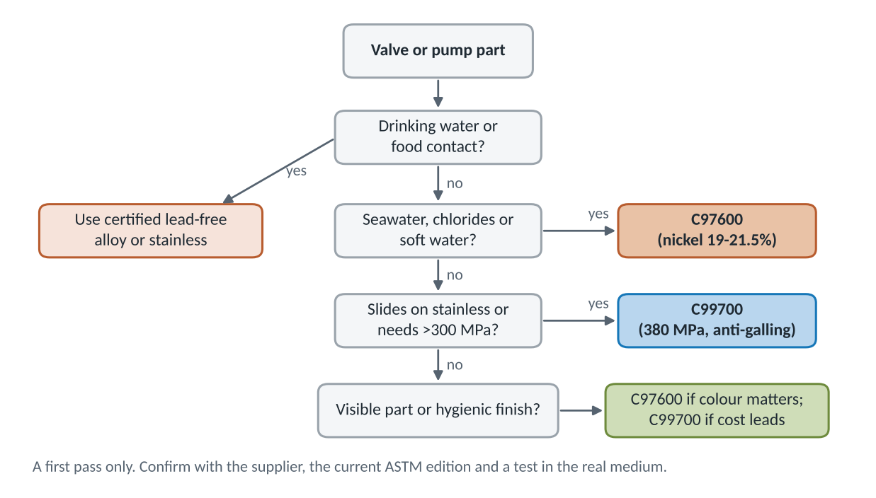
Figure 25. First-pass alloy selection for a valve or pump part (judgement, not a specification)
If the part... | Lean to | Because
touches drinking water or food | Certified lead-free alloy or stainless | Both grades contain lead
sits in seawater, chlorides or soft water | C97600 | 19-21.5% Ni, only 3-9% Zn
slides on stainless (nut, ring, rotor, bush) | C99700 | Patent context on anti-galling; 380 MPa
carries high load or impact | C99700 | Higher strength and 25% elongation
is visible and must stay silver | C97600 | Higher nickel holds colour
is bought mainly on price | C99700 | About 30% less metal value per kg
sees ammonia or acid cleaning | Neither without testing | Stress-corrosion and acid attack
Table 39. Rules of thumb

11. What a part costs in metal
Metal value is the LME price of the metals inside the alloy on 16 Oct 2026 at INR 96.5 per US$. Copper US$14,595/t, nickel US$15,170/t, tin US$50,700/t, zinc US$3,739/t, lead US$1,854/t, aluminium US$3,014/t. Manganese has no LME contract and is taken at an assumed US$2,000/t.
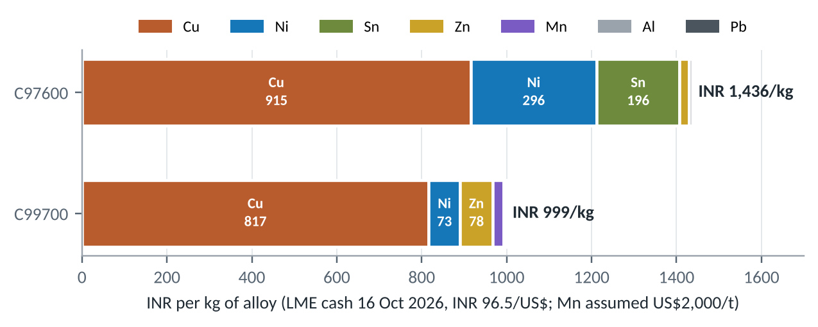
Figure 26. Metal value per kg, split by element
- C97600: copper 915, nickel 296 and tin 196 INR per kg. Tin is only 4% of the alloy but 14% of its metal value.
- C99700: copper is 82% of the value; manganese and zinc replace most of the nickel, which is why it is cheaper.
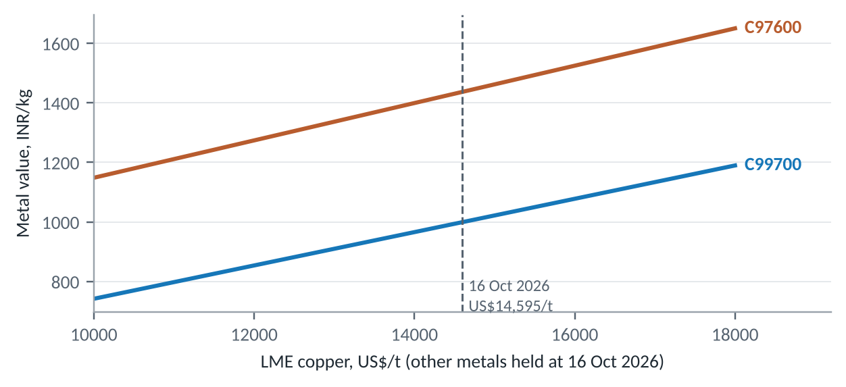
Figure 27. How metal value moves with the copper price
Every US$1,000/t move in copper shifts metal value by about INR 63 per kg for C97600 and INR 56 per kg for C99700.
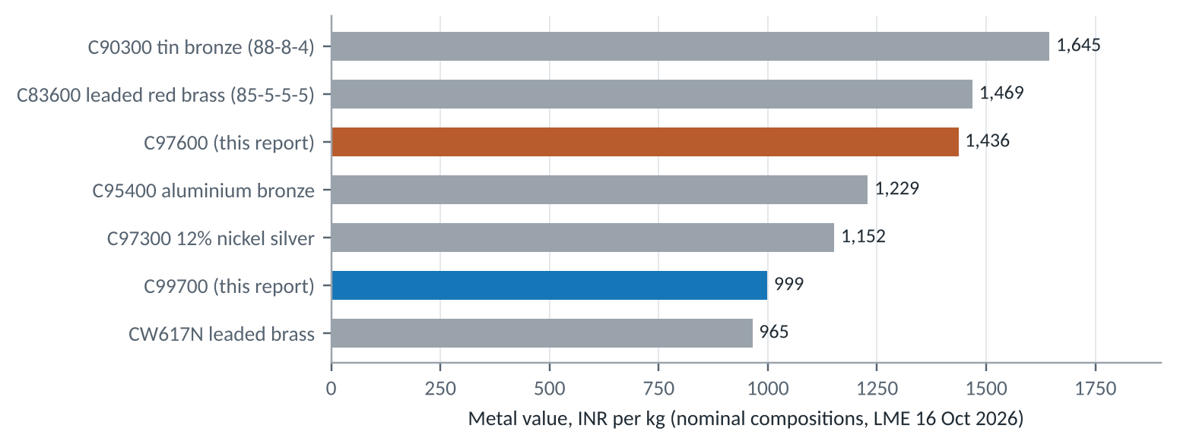
Figure 28. Metal value against other cast copper alloys (nominal compositions)
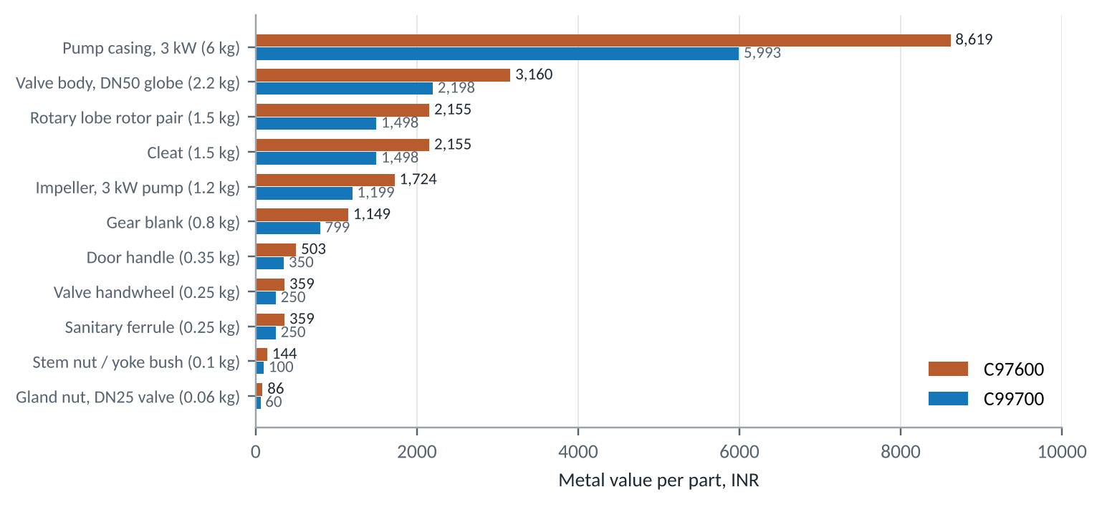
Figure 29. Metal value of eleven example parts
Example part | Assumed mass (kg) | C97600 INR | C99700 INR | Difference INR
Gland nut, DN25 valve | 0.06 | 86 | 60 | 26
Stem nut / yoke bush | 0.10 | 144 | 100 | 44
Sanitary ferrule | 0.25 | 359 | 250 | 109
Door handle | 0.35 | 503 | 350 | 153
Valve handwheel | 0.25 | 359 | 250 | 109
Gear blank | 0.80 | 1,149 | 799 | 350
Impeller, 3 kW pump | 1.20 | 1,724 | 1,199 | 525
Valve body, DN50 globe | 2.20 | 3,160 | 2,198 | 963
Cleat | 1.50 | 2,155 | 1,498 | 656
Rotary lobe rotor pair | 1.50 | 2,155 | 1,498 | 656
Pump casing, 3 kW | 6.00 | 8,619 | 5,993 | 2,625
Table 40. Metal value per part
Masses are illustrative and use the same casting mass for both alloys. Because C99700 is 9% less dense, a part cast to the same drawing weighs less in C99700, so the real saving is larger than shown. Metal value excludes melting loss, casting, machining, finishing, margin and tax.

12. What could replace them
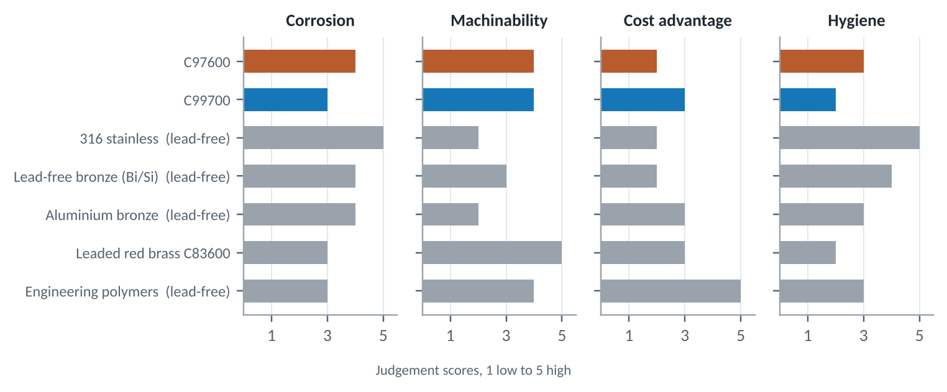
Figure 30. C97600, C99700 and five substitutes on four criteria (judgement)
Substitute | Where it competes | Trade-off
316 stainless steel | Dairy, food, sanitary, valves, pumps | Hygienic and lead-free; harder to machine, costlier to cast, can gall against itself
Lead-free bronze (bismuth or silicon) | Plumbing, potable valves, meters | Meets lead rules; machines less freely; the most direct threat in water
Aluminium bronze | Marine, pumps, wear parts | Strong, cavitation-resistant; not silver; harder to machine
Leaded red brass C83600 | General valves and fittings | Similar metal value to C97600; not white; less corrosion-resistant
Lead-free white manganese bronze | Food equipment, hardware | Patented replacement for C99700-type alloys where lead is a problem
Engineering polymers | Light-duty food, agri and hardware parts | Low cost; limited strength, temperature and creep
Table 41. Substitutes and where they compete

13. Risks and outlook
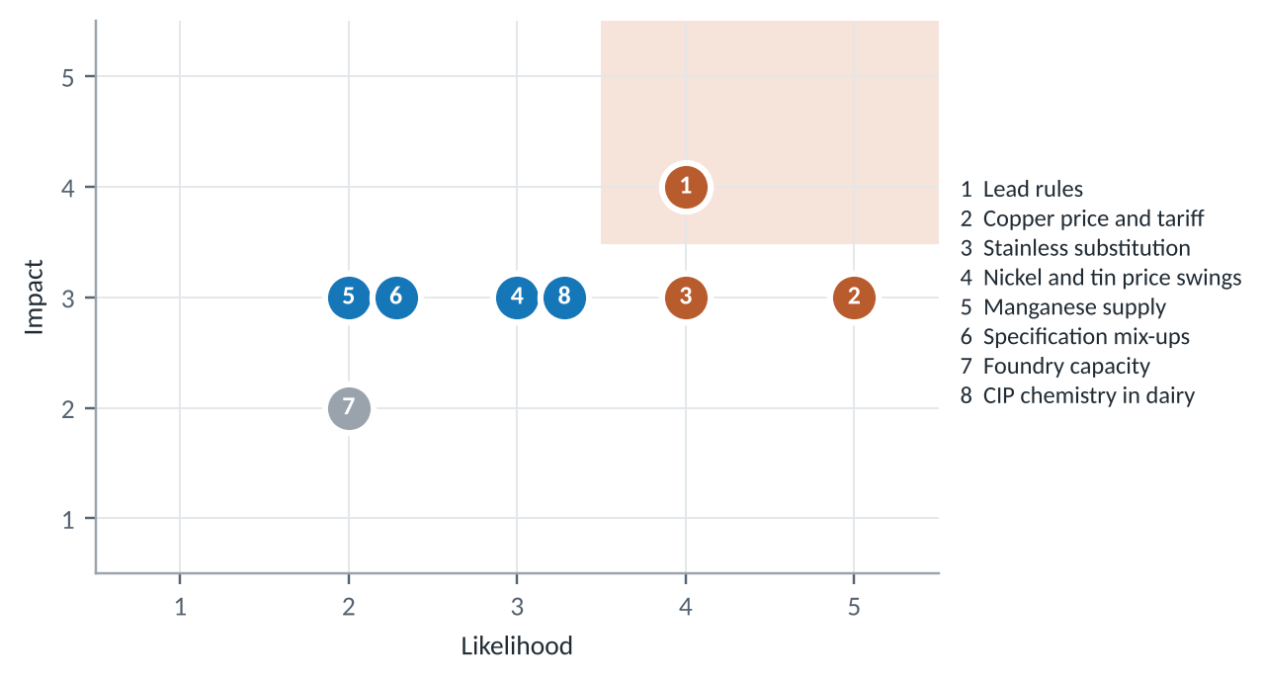
Figure 31. Risk matrix (judgement scores)
# | Risk | Likelihood | Impact | Comment
1 | Lead rules | 4 | 4 | Both grades contain lead; food and drinking-water contact are the exposed uses
2 | Copper price and tariff | 5 | 3 | LME copper US$14,595/t on 16 Oct 2026; US Section 232 tariff on copper content
3 | Stainless substitution | 4 | 3 | Holds 55% of the hygienic pump and valve market by material
4 | Nickel and tin price swings | 3 | 3 | C97600 carries both; tin is US$50,700/t
5 | Manganese supply | 2 | 3 | Matters for C99700; no LME benchmark
6 | Specification mix-ups | 2 | 3 | Look-alike white alloys are easy to confuse without analysis
7 | Foundry capacity | 2 | 2 | Niche grades, few specialist foundries
8 | CIP chemistry in dairy | 3 | 3 | Acid cleaning attacks copper alloys
Table 42. Risk register
The parent copper-alloy market is forecast to grow about 5.6-5.8% a year, but no source gives growth for these two grades. Outlook by application is judgement: steady to growing in non-potable valves, pump wear parts, fire protection, marine and architectural hardware; declining in food and potable-water contact as lead rules tighten; open to a lead-free white manganese bronze if one can be sourced or developed.

14. Opportunity map for a foundry
Plotting technical fit against market attractiveness turns the catalogue into a shortlist. Fit comes from Sections 4 to 6; attractiveness weighs market size, growth and how few rules stand in the way. Both axes are judgement.
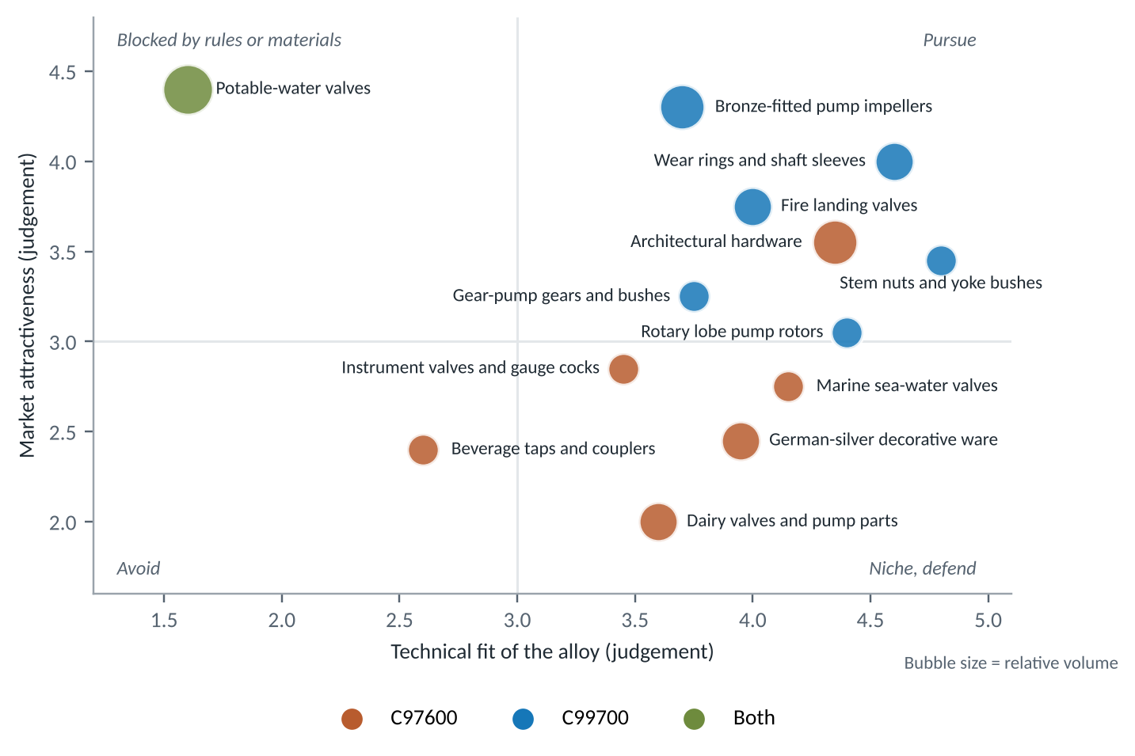
Figure 32. Opportunity map: technical fit against market attractiveness (judgement)
Application | Alloy | Fit | Attractiveness | Next step
Pump wear rings and shaft sleeves | C99700 | 4.6 | 4.0 | Approach pump OEMs and repair shops with a drop-in ring set
Bronze-fitted pump impellers | C99700 | 3.7 | 4.3 | Quote against C83600 and C90300 on metal value
Fire landing valves | C99700 | 4.0 | 3.8 | Check type-approval route; prototype one size
Stem nuts and yoke bushes | C99700 | 4.8 | 3.5 | Offer to valve makers using stainless stems
Architectural hardware | C97600 | 4.4 | 3.6 | Target premium and secure-door segments
Rotary lobe rotors | C99700 | 4.4 | 3.1 | Supply spares to food plants running lobe pumps
Marine sea-water valves | C97600 | 4.2 | 2.8 | Shipyard and ship-repair enquiries
Potable-water valves | Both | 1.6 | 4.4 | Large market, but needs a lead-free alloy, not these grades
Table 43. Shortlist with suggested next steps

15. From casting to finished part
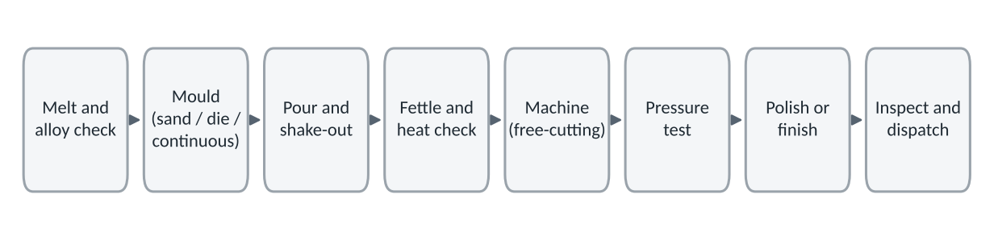
Figure 33. Typical production route for a valve or pump casting
Stage | What matters for these alloys
Melting and pouring | Hold composition in range; zinc and manganese losses shift C99700's analysis; C97600 pours about 240 deg C hotter
Moulding | Sand for bodies and casings; die casting (ASTM B176) suits small C99700 parts; continuous cast bar (B505) for C97600 rings and bushes
Machining | Lead gives free cutting in both; C97600 has more lead and a published rating of 70
Pressure testing | Shell and seat tests catch porosity; essential for every valve and pump casing
Finishing | Polishing brings out the silver colour; no plating needed
Inspection | Confirm grade by spectrometer; record heat numbers for traceability
Table 44. Production stages
Component | Usual casting route | Best alloy
Valve bodies and bonnets, DN15-DN80 | Sand or gravity die | Either
Pump casings and covers | Sand | Either
Small valve parts (gland nuts, caps, handwheels) | Pressure die (C99700) or sand | C99700 on cost
Wear rings, sleeves, bushes | Continuous or centrifugal tube, then machine | C99700
Impellers | Sand or investment | Either
Decorative hardware | Sand, investment or die | C97600
Table 45. Casting route by component

16. Manufacturing methods used
Both alloys are made into valve and pump parts by casting first and machining second. Which casting route is used depends on part size, shape and volume, and on the alloy: the specifications in Section 7 tie C97600 to continuous, sand and centrifugal castings and C99700 to die castings. The tables below summarise general foundry practice for these alloy families; they are engineering guidance, not data from a named plant.

Primary forming methods
Method | How it works | Typical parts | Suits
Sand casting | Molten metal is poured into a mould packed from bonded sand around a pattern; cores form internal passages | Valve bodies and bonnets, pump casings and covers, large impellers | Either alloy; best for low to medium volumes and complex shapes
Gravity (permanent-mould) die casting | Metal is poured by gravity into a reusable steel mould | Valve bodies DN15-DN80, mid-volume fittings | Either; the lower melting point of C99700 eases die life
Pressure die casting | Metal is injected into a steel die under pressure (ASTM B176 route) | Gland nuts, caps, handwheels, small hardware | C99700; suits high volumes of small, thin-walled parts
Continuous casting | Metal is drawn through a cooled die as bar or tube of fixed section (ASTM B505 route) | Stock for wear rings, bushes, sleeves and seats | C97600; parts are then cut from the bar and machined
Centrifugal casting | Mould spins while metal is poured, throwing metal outward to form dense tubes | Rings, sleeves, bushes, tube blanks | Either; dense structure helps pressure and wear parts
Investment (lost-wax) casting | A wax pattern is coated in ceramic, melted out, and metal is poured into the shell | Impellers, decorative and lock hardware, fine detail | Either; costly per part but needs little finishing
Shell moulding | Resin-coated sand is cured on a heated pattern to make a thin, accurate shell mould | Small to medium valve parts needing better finish than green sand | Either; mid-volume runs
Table 46. Primary forming methods for valve and pump parts

Secondary operations after casting
Operation | What it does | Alloy note
Fettling and gate removal | Cuts off runners and risers, grinds away flash and parting-line marks | Both; leaded grades are soft enough to grind cleanly
Machining | Turning, boring, drilling, tapping and milling bring seats, bores, flanges and threads to size | Free-cutting because of lead; C97600 rates 70 against 100 for free-cutting brass
Stress relief (where specified) | Low-temperature heating reduces residual stress in complex or heavily machined castings | Optional; confirm against the buyer specification
Impregnation (where specified) | Seals fine porosity that shows up as weeping in pressure tests | Used only when the specification allows it
Pressure testing | Hydrostatic shell and seat tests per API 598 or ISO 5208 | Both; the main check for porosity
Polishing and finishing | Buffing, barrel finishing or bead blasting for appearance | Silver colour needs no plating
Inspection | Spectrometer chemistry check, dimensional gauging, heat-number traceability | Needed to tell look-alike white alloys apart
Table 47. Secondary operations and where they apply

What drives the choice of method
- Volume: sand casting needs little tooling and suits runs of tens to hundreds; die casting needs costly dies and pays back only at thousands of parts.
- Shape: bodies with internal passages need sand cores; simple rings and bushes are better cut from continuous or centrifugal bar.
- Alloy melting point: C99700 pours about 240 deg C cooler than C97600, which favours die casting and lowers energy use; its manganese and zinc losses need control in the melt.
- Feeding and porosity: C97600 freezes over a wider range (35 against 20 deg C), so risers and chills matter more to avoid scattered pores.
- Surface and tolerance: investment and shell moulding cut the machining allowance; sand castings carry more stock to remove.
- Finish quality: visible hardware justifies investment casting or die casting; hidden internal parts do not.

Glossary and sources
Term | Meaning
Nickel silver | Copper-nickel-zinc alloy that looks silver but contains no silver; 'German silver' in India
White manganese brass | Brass with enough manganese and nickel to look white
Dairy metal | Trade name for C97600, from its dairy-plant use
Bronze-fitted pump | Iron-cased pump with copper-alloy impeller, wear rings and sleeve
Wear ring | Renewable ring that sets the small clearance between impeller and casing
Stem nut / yoke bush | Threaded nut in the valve yoke that the stem screws through
Dezincification | Selective loss of zinc from a brass in some waters
Galling | Surface seizure between sliding metals
CIP | Clean-in-place: circulating caustic and acid cleaning in food plants
DN | Nominal pipe size in millimetres
LME | London Metal Exchange

Sources
- C97600 composition, properties and uses: Concast data sheet, concast.com/files/C97600.pdf; Metaltek; Aviva Metals.
- C99700 composition and uses: ICAST ASTM B176 C99700 data sheet, icastllp.com; properties: MakeItFrom, makeitfrom.com (UNS C99700).
- Food-equipment context: US patent 6,149,739.
- LME cash settlement prices, 16 Oct 2026: Westmetall, westmetall.com.
- India pumps and India valves: IMARC Group, imarcgroup.com/india-pumps-market and /india-valves-market.
- India industrial valves and segment shares: Mordor Intelligence, mordorintelligence.com.
- Global pumps: IMARC Group, imarcgroup.com/pumps-market. Global industrial valves: Coherent Market Insights, coherentmi.com.
- Hygienic pumps and valves: Future Market Insights, futuremarketinsights.com. Dairy processing equipment: IMARC Group.
- India milk production: All India Radio News (newsonair.gov.in), citing Government of India data.
- Parent copper-alloy market: Roots Analysis and GII, as in the first edition.
- US Safe Drinking Water Act lead-free definition: Copper Development Association, copper.org; NSF.
- Part masses, fit scores, exposure scores and opportunity scores are the author's assumptions and judgement.

