BAJAJ ALLOYS, BHIWANI
BUSHES
Complete Industry & Product Report: Product, Types, Manufacturing, Market, B2B / B2C

Prepared by: Intern, Business Research
Date: October 2026
Status: Draft for management review

Contents
- 1. Executive summary
- 2. What is a bush?
- 3. Types of bushes
- 4. Materials
- 5. Manufacturing process
- 6. Quality and standards
- 7. Market size & growth
- 8. B2B and B2C market
- 9. Competition
- 10. Opportunity & recommendations for Bajaj Alloys
- 11. Data notes & sources

1. Executive summary
A bush (also called bushing or sleeve bearing) is a cylindrical sleeve placed between a rotating or sliding shaft and its housing. It reduces friction and wear, absorbs vibration and is cheaper to replace than the shaft or housing. Bronze, gunmetal, phosphor bronze and brass bushes are classic products of a copper-alloy foundry.
- Market proxy: No source gives a clean India figure for bronze bushes. Proxies: India automotive bearings about USD 503 million in 2024 growing 4.15% a year to about USD 726 million by 2033 (IMARC). Global automotive bushing market USD 172 billion (2025) to USD 218 billion (2030), CAGR 4.83% (Mordor Intelligence).
- Demand: Automobiles, tractors, pumps, motors, compressors, steel plants, earth-moving machinery, railways, textile and sugar machinery.
- Strength of aftermarket: Bushes wear out and are replaced, so replacement demand is steady. One report puts India bearing aftermarket growth near 14.7% a year.
- Recommendation: Focus on centrifugally cast and machined bronze/gunmetal bushes for pumps, motors, tractors and heavy machines; sell to OEMs and through industrial distributors; add standard-size catalogue for retail.
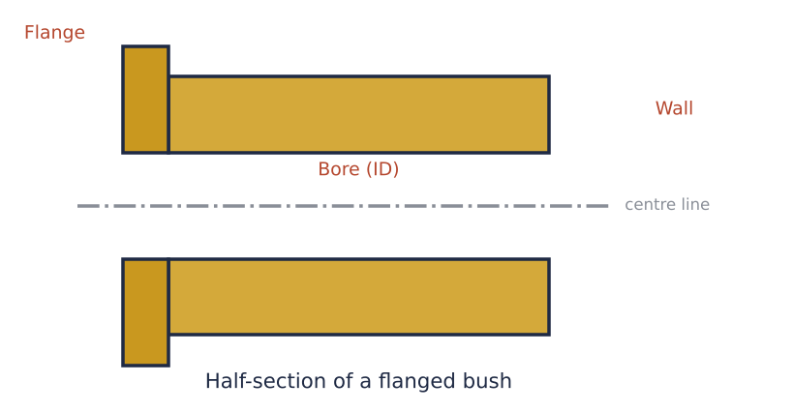
Figure 1: Half-section of a flanged bush

2. What is a bush?
A bush is a hollow cylinder, plain or flanged, press-fitted in a housing so the shaft turns inside it. The softer bush metal wears instead of the costly shaft, and a film of oil or grease keeps surfaces apart.

Functions
- Reduce friction between moving parts.
- Carry radial (and with flange, axial) loads.
- Dampen noise and vibration (rubber and polymer bushes).
- Act as replaceable wear parts.
- Guide and align shafts, pins and pivots.
Table 1: Basic terminology
Term | Meaning
Bush / bushing | Sleeve-type bearing, no rolling elements
ID / OD / length | Inner diameter, outer diameter, length
Interference fit | OD slightly bigger than housing so it is pressed in
Running clearance | Gap between shaft and bush bore, filled with lubricant
PV value | Pressure x velocity limit of the bush material

Bush vs ball bearing
Table 2: Comparison
Feature | Bush (plain bearing) | Ball/roller bearing
Friction | Higher; needs lubrication | Low
Load | High shock and heavy load | Moderate, precision
Cost | Low | Higher
Space | Compact | Larger
Noise | Quiet | Can be noisy
Life/replacement | Easy and cheap | Costlier

3. Types of bushes
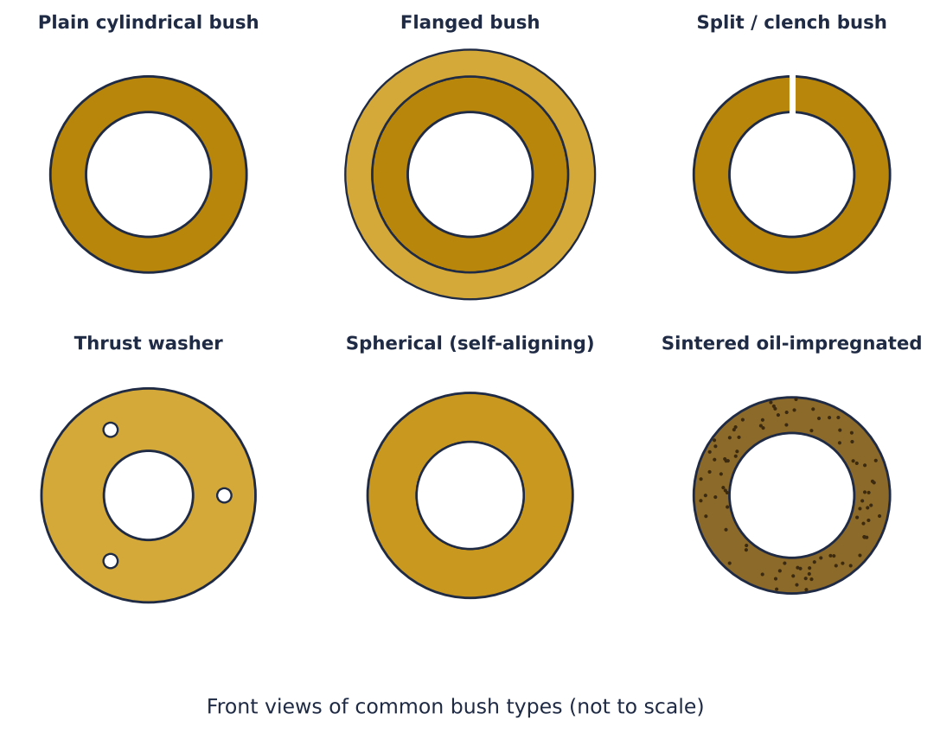
Figure 2: Front views of six common bush types
Table 3: Bush types
Type | Description | Used in
Plain cylindrical | Simple sleeve | Pumps, gearboxes, hinges
Flanged | Collar takes axial load | Automotive, machine tools
Split / clench | Rolled strip bush with seam | Engines, compact assemblies
Thrust washer | Flat ring for axial load | Gearboxes, transmissions
Spherical / self-aligning | Ball-shaped seat allows misalignment | Linkages, suspension
Sintered (oil-impregnated) | Porous metal holds oil; maintenance free | Fans, appliances, small motors
Bi-metal / composite | Steel back with bronze or polymer lining | Heavy machinery, hydraulics
Rubber / polyurethane | Elastomer bush for vibration | Suspension, stabiliser bars
Graphite plugged bronze | Solid lubricant plugs in bronze | High temp, slow heavy loads, steel plants

By material
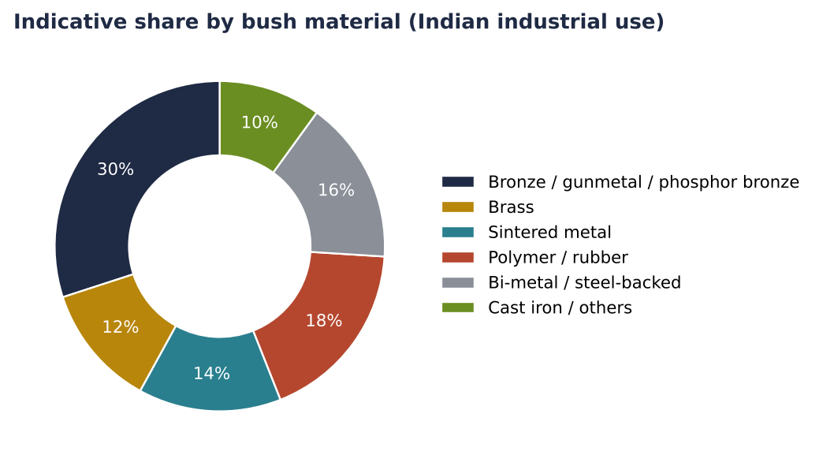
Figure 3: Indicative material split (intern estimate)

By application
- Automotive: suspension, engine, steering, gearbox
- Agriculture: tractors, harvesters, pumps
- Industrial: pumps, compressors, motors, gearboxes, presses
- Heavy equipment: excavators, cranes, mining
- Railways: wagons, locomotives, axle boxes
- Electrical: fans, appliances, small motors

4. Materials
Table 4: Copper alloys for bushes
Alloy | Typical composition | Properties | Typical use
Leaded gunmetal (LG2 / LTB2) | Cu 85, Sn 5, Pb 5, Zn 5 | Good wear, pressure-tight | Pump and valve bushes
Phosphor bronze (PB1 / PB2) | Cu 88 to 90, Sn 10 to 12, P 0.2 | Hard, fatigue-resistant | Gears, worm wheels, heavy loads
Leaded tin bronze (LB 5) | Cu 80, Sn 10, Pb 10 | Excellent for high speed, low friction | Engine and motor bearings
Aluminium bronze | Cu 80 to 88, Al 8 to 11, Fe, Ni | Very strong, corrosion resistant | Heavy load, marine
Brass (HB/SB) | Cu 60, Zn 40 | Economical, medium load | Light duty bushes
SAE 660 bearing bronze | Cu 83, Sn 7, Pb 7, Zn 3 | Standard continuous-cast bronze | General industrial

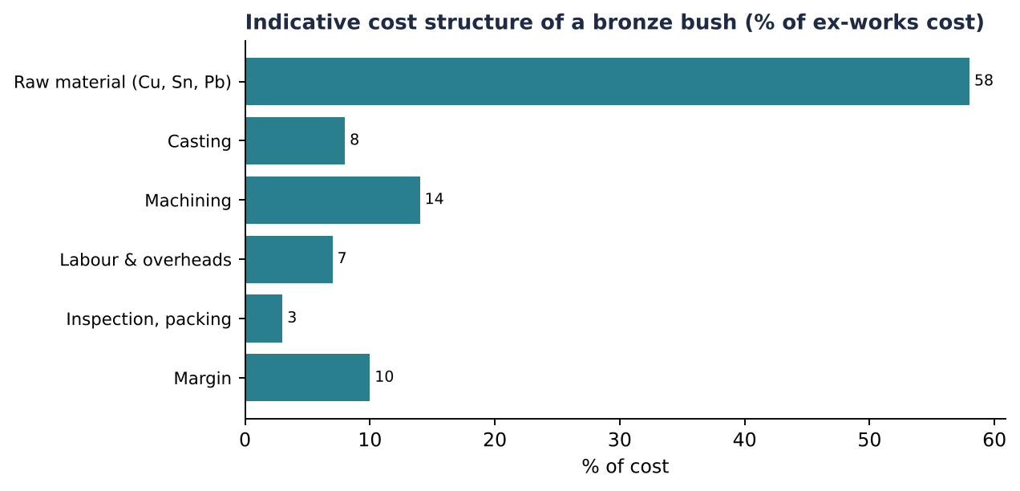
Figure 4: Indicative cost structure (illustrative)
Tin is expensive and volatile, so alloy choice (for example LG2 vs PB2) has a large effect on cost. Copper and bronze scrap recycling at Bajaj Alloys gives a cost advantage.

5. Manufacturing process
Bronze bushes are mainly made by (a) centrifugal casting of hollow tubes, (b) continuous casting of rods and tubes, (c) sand/permanent mould casting for special sizes, (d) powder metallurgy for sintered bushes, and (e) rolling from strip for split bushes.
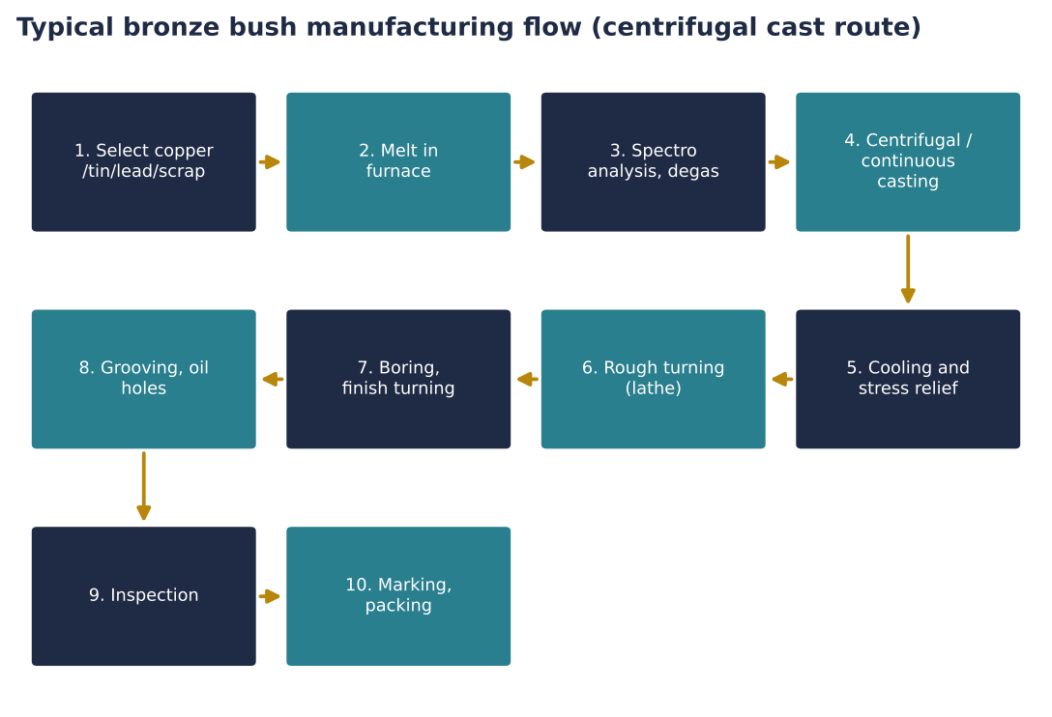
Figure 5: Process flow for a cast bronze bush
- Step 1: Charge preparation: Virgin copper, tin, lead, zinc and clean scrap are weighed to the target alloy.
- Step 2: Melting and refining: Induction/crucible furnace at 1,100 to 1,200 degrees C, flux and degassing, then sample to the spectrometer to adjust the composition.
- Step 3: Casting: Centrifugal casting: metal is poured into a spinning mould (about 600 to 1,500 rpm); centrifugal force gives dense, defect-free walls. Continuous casting draws hollow rods through a graphite die.
- Step 4: Machining: Tubes are cut, turned on CNC lathes to OD, bored to ID, faced to length, chamfered. Flanges, oil grooves and holes are added.
- Step 5: Sintering route (alternative): Metal powder is compacted in a die, sintered at about 800 degrees C, sized, and vacuum-impregnated with oil.
- Step 6: Inspection: Dimensional (go/no-go gauges), hardness, visual check for porosity, material certificates.
- Step 7: Packing: Oiled, VCI paper, boxed by size and lot.
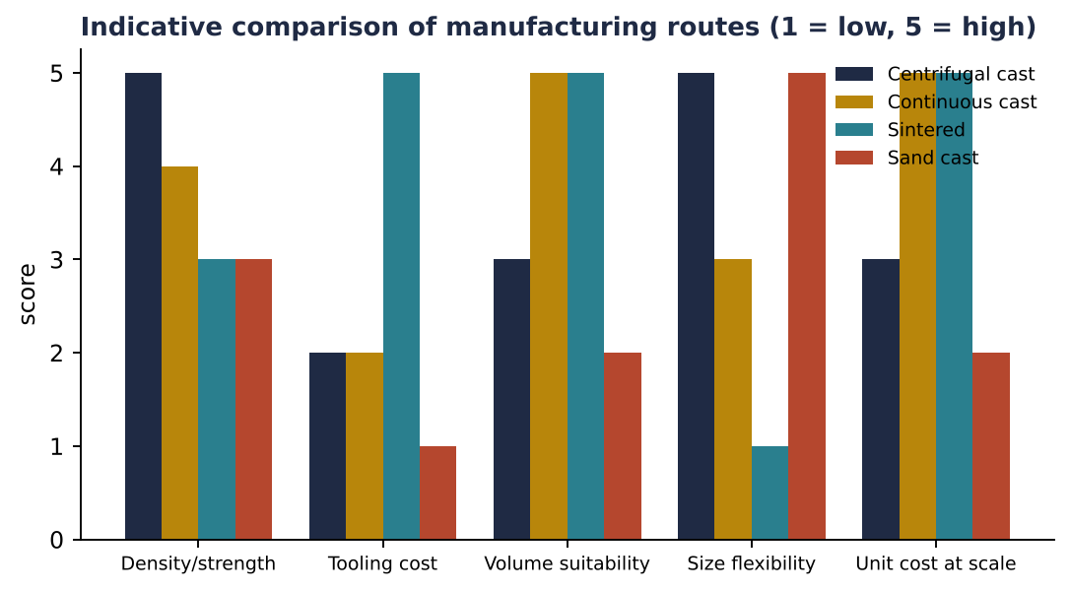
Figure 6: Qualitative scoring of routes (intern judgement)

6. Quality and standards
Table 5: Standards for bushes
Standard | Scope
IS 318 | Leaded tin bronze ingots and castings
IS 28 | Phosphor bronze ingots and castings
IS 7598 / IS 11620 | Plain bearing related standards
IS 4378 | Bearing bush related guides
ASTM B505 / SAE 660 | Continuous cast bronze
DIN 1494 / ISO 3547 | Dimensions of plain bearing bushes
ISO 9001 / IATF 16949 | Quality systems, automotive customers need IATF

Typical customer demands: chemical composition certificate, hardness (HB 60 to 120), dimensional tolerance (H7 bore, interference-fit OD), surface roughness, PPAP for automotive customers.

7. Market size and growth

7.1 Global and Indian proxies
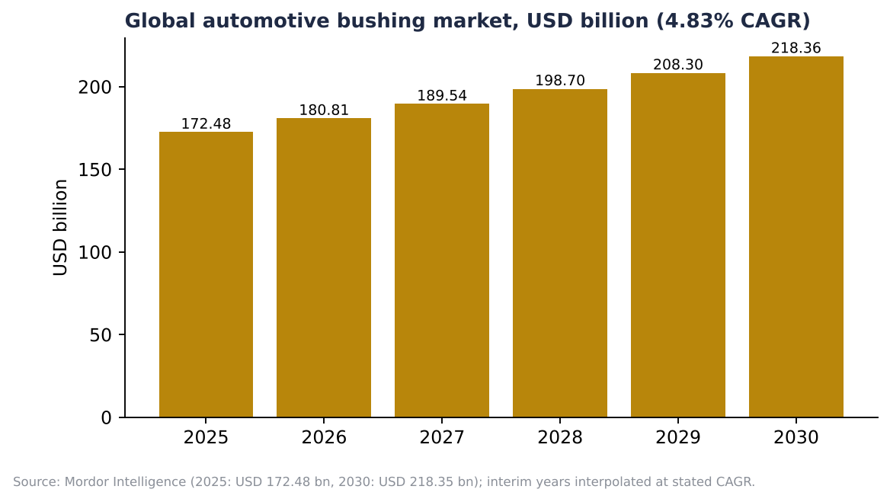
Figure 7: Global automotive bushing market
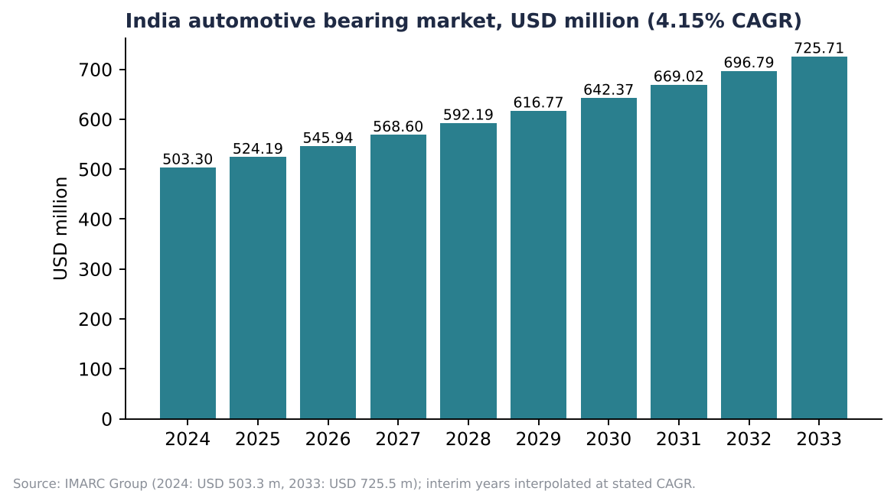
Figure 8: India automotive bearing market, a proxy for bush demand
Table 6: Published figures used as proxies
Indicator | Value | Source
Global automotive bushing 2025 | USD 172.48 bn | Mordor Intelligence
Global 2030 | USD 218.35 bn (CAGR 4.83%) | Mordor Intelligence
India automotive bearing 2024 | USD 503.3 m | IMARC
India automotive bearing 2033 | USD 725.5 m (CAGR 4.15%) | IMARC
India bearings overall growth | 3.2% (Technavio 2024 to 2029) to 9.7% (IMARC 2026 to 2034) | Technavio, IMARC
India bearing aftermarket growth | About 14.7% a year | Astute Analytica

Important: the global figure covers all automotive bushings (including rubber and polymer, and complete assemblies), so it is far bigger than the metal-bush segment a foundry serves. Treat it as direction of growth, not as Bajaj Alloys' addressable market. A bottom-up estimate (vehicles produced x bushes per vehicle x average price) should be built next.

7.2 Bottom-up illustration
Table 7: Method for building an addressable market (inputs to be validated)
Item | Illustrative value
India vehicle production (all categories, approx.) | About 28 to 30 million a year
Metal / bronze bushes per vehicle (average, varies hugely) | 5 to 20 pieces
Average price per bush | INR 20 to 150
Tractors, pumps, motors, industry | Additional millions of pieces a year

7.3 Demand drivers
- Rising vehicle and tractor production; EV shift reduces engine bushes but increases suspension and e-axle bushes.
- Pumps, motors and capex in water, steel, cement, power.
- Maintenance and replacement (aftermarket) growth.
- Import substitution and China+1 for machine components.
- Railways and defence indigenisation.
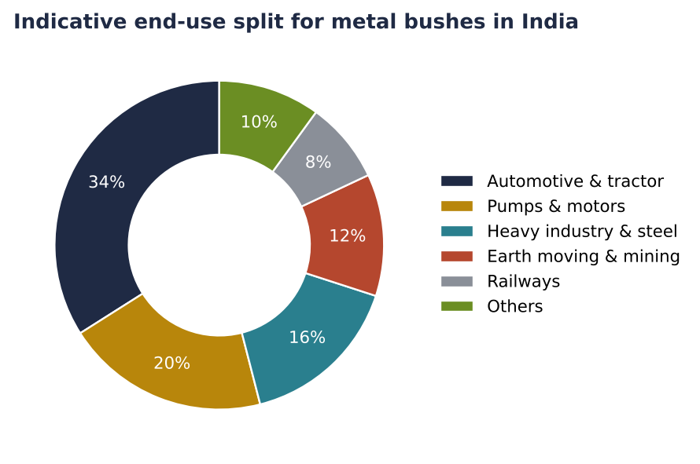
Figure 9: Indicative end-use split (intern estimate)

7.4 Regional clusters
- Ludhiana, Jalandhar (Punjab): auto components
- Rajkot, Ahmedabad (Gujarat): engineering castings, bearings
- Pune, Chennai, Coimbatore: OEM and pumps
- Gurugram, Faridabad, Bhiwani: NCR auto cluster, brass and bronze foundries

8. B2B and B2C market

8.1 B2B
Most bush sales are B2B: OEM supply to vehicle, tractor, pump and motor manufacturers; contracts with steel plants, railways and heavy machinery companies; and sales to industrial distributors.

8.2 B2C and retail aftermarket
B2C means mechanics, garages and individual owners buying replacement bushes (suspension, hinge, tractor and pump bushes) from spare-part shops or online. It is small in value for a foundry but offers higher margins and brand-building.
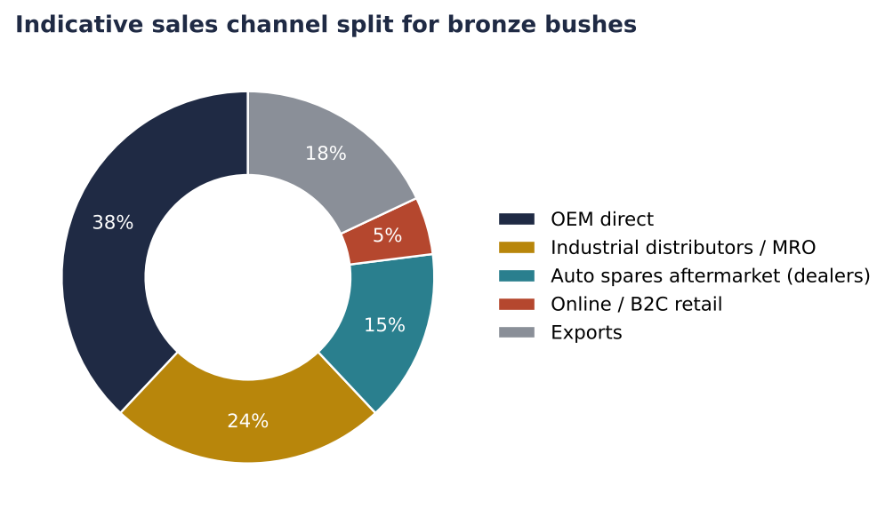
Figure 10: Indicative channel mix (illustrative)
Table 8: B2B vs B2C comparison for bushes
Factor | B2B (OEM / industrial) | B2C (aftermarket / retail)
Buyers | Auto OEMs, tractor makers, pump and motor makers, steel plants, railways | Mechanics, garages, farmers, small workshops
Order size | Thousands per month, annual contracts | Single pieces or small packs
Requirements | Drawing, PPAP, IATF, test certificates | Fit, availability, price, brand
Pricing | Cost-plus with metal price pass-through (LME copper) | MRP-based, margin for retailer
Margin | 10 to 18% | 25 to 40% (with distributor margins)
Payment | 45 to 90 days | Cash / short credit
Marketing | Key-account visits, approvals, trials (6 to 12 months) | Catalogue, mechanic meets, e-commerce, IndiaMART
Risk | Customer concentration, price squeeze | Spurious competition, many SKUs

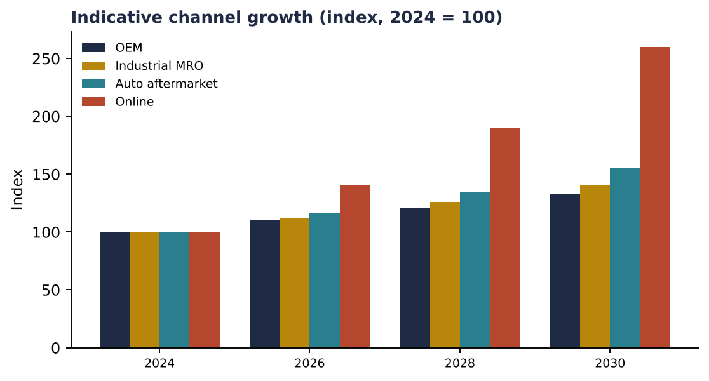
Figure 11: Illustrative channel growth (aftermarket and online faster than OEM)

9. Competition
Table 9: Competitive landscape (names for orientation only)
Segment | Players (examples)
Organised bearings and bushes | Schaeffler India, SKF India, NBC (National Engineering Industries), Timken India, FAG; Federal-Mogul/Tenneco bearings
Metal bush / bronze specialists | Many small and mid-sized foundries in Punjab, Gujarat, Maharashtra, Haryana
Sintered | Sundaram-Clayton group units, Hindustan Powder Metallurgy-type units and imports
Global | GGB, Saint-Gobain, Kolbenschmidt, Oilite, Igus (polymer)

The metal bush segment is fragmented and unorganised. Differentiation: consistent alloy chemistry, tight dimensions, certificates, and on-time supply.

10. Opportunity and recommendations for Bajaj Alloys
- Use in-house scrap and melting to produce continuous-cast and centrifugally cast bronze/gunmetal tube and rod: sell both as raw bush stock and as finished machined bushes.
- Target pump, motor and tractor OEMs in Haryana, Punjab, Rajasthan first.
- Add a standard catalogue (e.g. 50 common sizes) for distributors and e-commerce.
- Invest in CNC lathes, bore gauges and a spectrometer; pursue ISO 9001 and later IATF 16949.
- Hedge copper and tin price exposure through pricing formulas linked to LME/MCX.
- Risks: tin price swings, EV shift, Chinese imports, customer concentration.
Table 10: Indicative roadmap
Item | Action | Timeline
Product range and costing | 10 alloys/sizes, cost sheets | Month 1
Casting set-up | Centrifugal / continuous caster trial | Months 2 to 5
Machining cell | 2 CNC lathes, gauges | Months 3 to 6
Customer trials | 5 OEM and 10 distributors | Months 6 to 10
Certification | ISO 9001 / IATF | Months 6 to 12

11. Data notes and sources
Market numbers come from published research summaries (Mordor Intelligence for global automotive bushings, IMARC Group for India automotive bearings and India bearings, Technavio and Astute Analytica for India bearings growth). No source gave a clean India figure for bronze bushes specifically, so these are used as proxies, and the report says so. Interim yearly values in charts are interpolated at the stated CAGR. Charts labelled 'indicative' are intern estimates built from typical industry structure; they are not audited statistics and must be validated with plant and customer data. Diagrams are schematic drawings made for this report, not photographs.
- Mordor Intelligence: Automotive Bushing Market
- IMARC Group: India Automotive Bearing Market; India Bearings Market
- Technavio: India Bearings Market Analysis
- Astute Analytica: India Bearings Market
- BIS standards IS 318, IS 28; ISO 3547

