ALLOY OVERVIEW & MARKET REPORT
EN 1982 Leaded Tin Bronzes
Ingot economics · applications · market · strategy
Gunmetals CC490K · CC491K · CC492K · CC493K | Bearing bronzes CC494K · CC495K
Prepared for | Bajaj Alloys, Bhiwadi (Rajasthan)
Prepared by | Research Trainee
Report date | 5 October 2026 (Revision 6; supersedes Revision 5 of 4 October 2026)
Market data as of | LME official cash settlement 1 Oct 2026; US$/INR 2 Oct 2026. Cross-check 5 Oct 2026: LME copper 3-month ≈ US$ 14,259/t, tin ≈ US$ 54,277/t (within 0.5 % of the 1 Oct figures, so no price table was changed)
What Revision 6 is | A full rebuild after management review: ingot economics rewritten, every matrix recomputed from one data model, applications taken one level deeper, and the sections marked red or yellow rebuilt

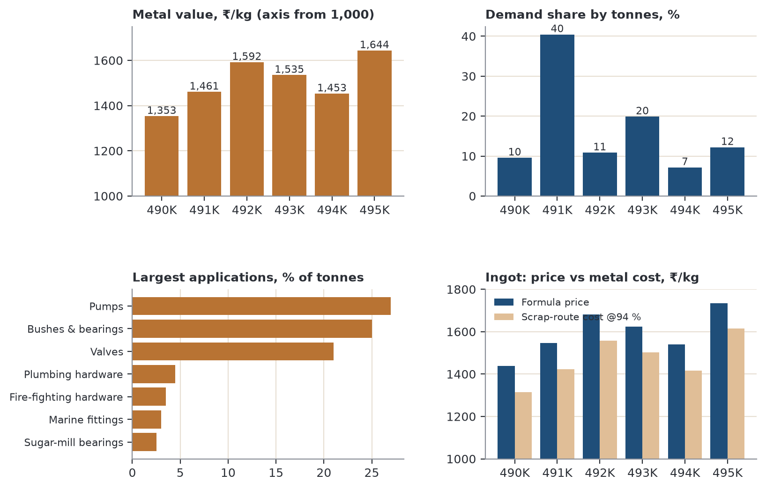
Figure 1. Revision 6 at a glance: metal value, demand share, largest applications and ingot price against scrap-route metal cost.
How to read this report
• Verified = taken from a named source or computed from verified inputs. Estimate = judgement or bottom-up model. Every table or chart based on estimates says so.
• Every number in the text, tables and charts comes from one data model (inputs in Section 17). Totals, averages and rankings are recomputed, not typed, so they cannot disagree with each other.
• Scores (1–5) follow written rules that are shown next to the matrix. If you disagree with a score, change the input and the whole matrix updates.

Contents
1 | Executive summary
2 | Alloys, composition and cross-references
3 | Mechanical properties
4 | Market demand and growth
5 | Export markets
6 | Ingot economics (rebuilt)
7 | Application demand: sizing and grade mix
8 | Applications deep dive: what each use needs, which grade fits, pumps and valves
9 | Bushes and bearings deep dive (incl. rebuilt price build-up)
10 | Minor applications deep dive (rebuilt scorecard, calendar, profiles)
11 | Competitive landscape
12 | PESTLE
13 | Porter's Five Forces by customer segment
14 | SWOT and TOWS
15 | GE–McKinsey and Ansoff
16 | Recommendations, roadmap and KPIs
17 | Data verification, change log and sources

What changed in Revision 6
Management marked parts of Revision 5 red (Sections 7.6, 8.2, 8.3) and yellow (8.1) and said that the ingot content was wrong, that items were missing, and that some data contradicted other data. Each point was traced to its cause. This table is the short answer; Section 17 has the full change log.
Table 1. Review points and what was done
Review point (Rev 5) | What was wrong | What Rev 6 does
“Ingot completely wrong” | Ingot cost was built only from LME primary metal, yet Bajaj buys scrap. Melt loss (2.5 %) and conversion (₹50/kg) were placeholders presented as the margin. The copper-error claim (“1 % is more than a quarter of the margin”) was arithmetically false (it is about 24 %, i.e. nearly a quarter, not more than a quarter). “CC495K gives the highest rupee margin” contradicted a fixed ₹50 conversion. | Section 6 rebuilds the ingot: grade sheet, metal value, formula price with a per-grade quote formula, a scrap-route cost model with payable-% scenarios, and separate sensitivity of price and of margin. Result: the scrap spread (₹74/kg at 94 % payable on CC491K) is larger than the ₹50 conversion premium.
Red: 7.6 Bush pricing | Build-up numbers (tube ₹2,000, bush ₹2,500) had no stated assumptions; an undated IndiaMART range was used to argue the market was “stale”; “closed loop that remelters cannot match” was unsupported. | Section 9.7 rebuilds the chain from explicit inputs (casting loss, conversion, turnings %, turnings credit, machining). Base case lands at ₹2,458/kg with a sensitivity band. IndiaMART argument removed; claims softened.
Yellow: 8.1 Scorecard | Scores did not follow the text: substitute-threat scores contradicted “High/Low” ratings; growth scores were non-monotonic (+3 %/yr scored higher than +5 %); hydro was “close to Bhiwadi” in text but scored 2 on proximity. | Section 10.1: every criterion now has a written rule (thresholds for share, growth, proximity; mapped rating for substitute threat). Hydro is 5 on proximity; marine drops to 1.
Red: 8.2 Calendar, 8.3 Profiles | Calendar and profiles mixed cited facts with guesses without saying which was which. | Sections 10.2–10.3: each row carries an evidence tag (Cited / Inferred / Field check). Eight profiles (top eight by the rebuilt scorecard) instead of six.
“One data against another” | 18 conflicts found (listed in Section 17.2): CC492K composition, zinc range, supplier power, nine-box vs recommendations, “close to Gujarat”, valve market vs export scope, and others. | All 18 resolved. The nine-box, scorecard and grade-fit matrices are recomputed from the same inputs, so zones, text and recommendations agree.
“Many things missing” | No ingot spec sheet, no scrap route, no use-level requirements, no distances, no sensitivity of margin, no 2030 share view. | Added: ingot sheet and quote formula (6.1, 6.7), scrap route (6.5), requirement-weight and grade-fit model (8.1–8.2), distance chart (9.4), growth contribution and 2030 shares (7.3), margin sensitivity (6.6).

1. Executive summary
The six EN 1982 grades CC490K to CC495K are copper–tin–lead casting alloys in two families. The gunmetals (CC490K–CC493K, 1.5–9.5 % zinc) go into pressure-tight pump, valve and fitting castings. The bearing bronzes (CC494K, CC495K, at most 2 % zinc and 8–11 % lead) go into bushes and plain bearings. Copper sets the price level of every grade (67–86 % of metal value); tin sets the price gap between grades.
Table 2. Key figures (all recomputed from the Rev 6 data model)
Key figure | Value | What it means
Grades covered | 6 | 4 gunmetals + 2 leaded bearing bronzes
Metal value | ₹1,353–1,644 /kg | LME 1 Oct 2026 at ₹96.18/US$, before melt loss, conversion and GST
Cheapest vs dearest | CC490K vs CC495K | ₹290/kg apart (+21 %); the gap is mostly tin
Ex-works ingot price (formula) | ₹1,437–1,735 /kg | Metal × 1.025 melt loss + ₹50 conversion; +18 % GST on top (placeholders)
Scrap-route spread (CC491K) | ₹62–185 /kg | Formula price minus metal cost when scrap is bought at 89–99 % of contained LME value; larger than the ₹50 conversion
Min. tensile strength (GC) | 270 → 200 MPa | Highest CC492K, lowest CC494K
Demand growth, six grades | 4.2 %/yr (2025–30) | Share-weighted from 18 applications; valves, bushes and fire-fighting hardware add the most
Largest grade by demand | CC491K 40 % of tonnes | CC493K 20 %, CC495K 12 %, CC492K 11 %, CC490K 10 %, CC494K 7 %
Five Forces pressure | 4.2/5 basic vs 2.0/5 specialised | Standards lock in the material for specialised makers
India exports 2023 | US$ 2.1 bn valves, 1.3 bn pumps | Bajaj's export route is through the foundries that make them

Key findings
- Two families, six grades. Gunmetals: CC490K (LG1, UNS C84400), CC491K (LG2, 85-5-5-5, UNS C83600, IS 318 LTB 2), CC492K (LG4, nearest UNS C92200), CC493K (Rg7, UNS C93200). Bearing bronzes: CC494K (LB4, UNS C93500), CC495K (LB2, UNS C93700).
- Composition and properties re-checked. All six compositions match the EN 1982 limits. Minimum GC mechanical values for all six were confirmed against a second source in Rev 6. Strength follows tin and the zinc/lead balance, not lead alone (Section 3).
- Ingot is a metal-management business. Metal (including melt loss) is about 97 % of the formula ex-works price. A 1 % error in buying copper costs ₹12/kg on CC491K, which is 24 % of the ₹50 conversion premium. Price risk passes through on a formula; margin is decided by scrap payable %, melt loss and conversion (Section 6).
- Scrap is the real lever. Bajaj buys copper and brass scrap. Delhi/Mumbai brass-scrap quotes imply 89–99 % of contained LME value. Each point of payable % is worth ₹12/kg on CC491K, so five points (₹61) outweigh the whole conversion premium.
- Where the metal goes. Pumps 27 %, bushes and bearings 25 %, valves 21 % of tonnes; 15 smaller uses make up the other 27 %. Valves (+6 %/yr), bushes (+5 %) and fire-fighting hardware (+7 %) add the most growth; pumps lose 1.6 points of share by 2030 and plumbing hardware shrinks (Section 7).
- Use-level fit (new). Requirement weights for 14 uses multiplied by computed grade property scores give the same best grades the earlier text recommended: CC491K for pumps, valves and fire hardware; CC493K as the default bush; CC494K for tractor and dirty duty; CC495K for heavy bearings; CC490K only for plumbing (Section 8).
- Bushes are the best-paying major use and the nearest large buyers are in Faridabad–Delhi–Ghaziabad (110–160 km). The Rajasthan cement belt is 500+ km away, not “nearest”, and Gujarat is about 900–1,050 km (Section 9).
- Minor uses, ranked by rule. Fire-fighting hardware and sugar-mill bearings (28/35), hydro (27), marine and defence (25), hydraulics (23). Plumbing and decorative castings are at the bottom (16 and 12). Hydro moved up because Noida, Prithla and Haridwar are close to Bhiwadi (Section 10).
- Specialised customers face less pressure. Five Forces averages 4.2/5 for basic-product makers and 2.0/5 for specialised makers. Supplier power is now rated the same for both (same metal suppliers), which moved the specialised average from 1.8 to 2.0.
- Recommendation. Lead with CC491K and CC493K ingot on an LME formula, certify every heat in EN + UNS + IS terms, sell to specialised and Faridabad–Delhi bush buyers first, treat marine, hydro and defence as approval plays, and prepare a low-lead gunmetal (Section 16).
Read this first
Composition limits are EN 1982 values. Mechanical figures are EN 1982 minimums for continuous (GC) casting; sand-cast minimums are lower. Metal prices are official LME cash settlements for 1 Oct 2026. Market sizes are publisher estimates. Application shares, grade splits, scores and weights are Bajaj-specific estimates (±30 %). Melt loss, conversion cost, casting and machining costs are placeholders to be replaced with Bajaj's own numbers. Section 17 flags every estimate.

2. Alloys, composition and cross-references
All six are cast copper–tin alloys with lead added for machinability and bearing performance. EN 1982 uses the suffix “K” for copper–tin–lead alloys. Ingot carries the prefix CB (e.g. CB491K) and castings CC. Bajaj Alloys supplies CB-grade ingot to foundries that cast CC parts.

2.1 Chemical composition (EN 1982 limits)
Table 3. EN 1982 composition limits, % (casting values; use the CB ingot table of the standard when certifying ingot)
Grade | EN symbol | Name | Cu % | Sn % | Pb % | Zn % | Ni % max | Family
CC490K | CuSn3Zn8Pb5-C | LG1 | 81–86 | 2–3.5 | 3–6 | 7–9.5 | 2.0 | Gunmetal
CC491K | CuSn5Zn5Pb5-C | LG2 | 83–87 | 4–6 | 4–6 | 4–6 | 2.0 | Gunmetal
CC492K | CuSn7Zn2Pb3-C | LG4 | 85–89 | 6–8 | 2.5–3.5 | 1.5–3 | 2.0 | Gunmetal
CC493K | CuSn7Zn4Pb7-C | Rg7 | 81–85 | 6–8 | 5–8 | 2–5 | 2.0 | Gunmetal
CC494K | CuSn5Pb9-C | LB4 | 80–87 | 4–6 | 8–10 | ≤ 2 | 2.0 | Bearing bronze
CC495K | CuSn10Pb10-C | LB2 | 78–82 | 9–11 | 8–11 | ≤ 2 | 2.0 | Bearing bronze

Checked against the Viiplus reproduction of EN 1982: all six grades match. Copper is the balance. Zinc across the gunmetals runs 1.5–9.5 % (CC492K goes down to 1.5 %; Rev 5 wrongly said 2 %). Further limits apply to Fe (0.2–0.5 % max), P (0.05–0.10 % max) and Sb, S, Al, Si; check them before certifying.
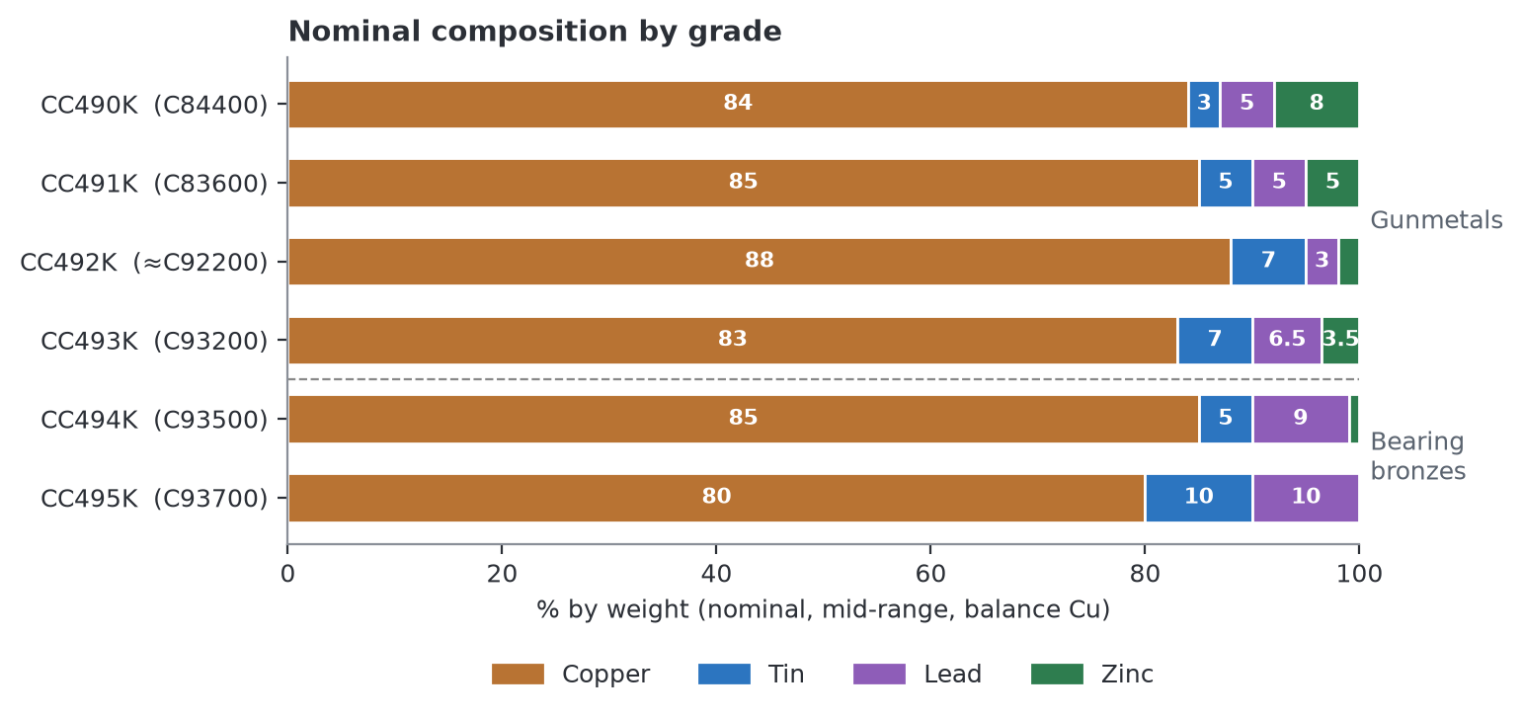
Figure 2. Nominal (mid-range) composition, normalised to 100 %. CC492K is 88-7-3-2 everywhere in this report (Rev 5 showed 87-7-3-3 in one heading and 88-7-3-2 in the price model).
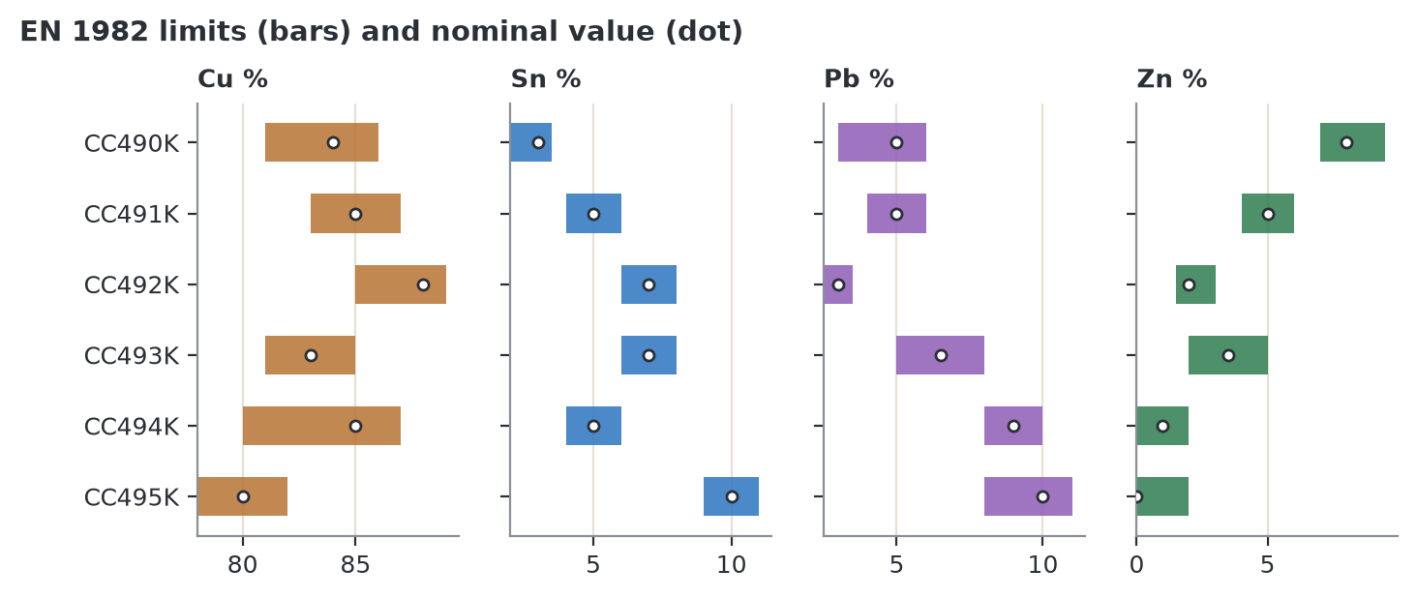
Figure 3. Each bar spans the EN 1982 min–max; the dot is the nominal value used in all calculations. Lead never exceeds 11 %; tin peaks at 9–11 % in CC495K.

2.2 EN, UNS and IS 318 cross-reference
US buyers and Indian exporters working to ASTM (B584 sand, B505 continuous, B271 centrifugal) specify by UNS number. Indian buyers specify IS 318 leaded tin bronze grades (LTB). The table maps each EN grade to its nearest UNS alloy and, where verified, to IS 318.
Table 4. Cross-reference
EN number | BS / DIN name | Nearest UNS | UNS composition / trade name | How close | IS 318
CC490K | LG1 | C84400 | 81-3-7-9 “valve metal” | Close; UNS carries more lead (6–8 %) | Confirm vs IS 318 text
CC491K | LG2 | C83600 | 85-5-5-5 “ounce metal”, SAE 40 | Equivalent | LTB 2 (verified: LTB 2 = LG2 = 85-5-5-5)
CC492K | LG4 | C92200 (nearest) | 88-6-1.5-4.5 “Navy M” | Approximate; CC492K has more tin and lead | Confirm vs IS 318 text
CC493K | Rg7 | C93200 | 83-7-7-3, SAE 660 | Near-equivalent | Confirm vs IS 318 text
CC494K | LB4 | C93500 | 85-5-9-1, SAE 66 | Near-equivalent | Confirm vs IS 318 text
CC495K | LB2 | C93700 | 80-10-10, SAE 64 | Equivalent | Confirm vs IS 318 text

Only LTB 2 ↔ CC491K could be verified from public sources in this revision. Rev 5 implied other IS 318 matches without a source; those are now marked “confirm”. A UNS or IS number is a cross-reference, not a certificate: certify each heat against the standard named on the order.

2.3 Role of each element
Table 5. Typical (nominal) contents and roles
Element | Gunmetals | Bearing bronzes | Role
Copper | 83–88 % | 80–85 % | The base metal; corrosion resistance and heat conduction. Biggest cost item in every grade: 67–86 % of metal value.
Tin | 3–7 % | 5–10 % | Strengthens and forms the hard delta phase that resists wear. 3.8× copper per kg: 32 % of CC495K metal value but 12 % of CC490K.
Lead | 3–6.5 % | 9–10 % | Insoluble soft islands: free machining, seals porosity, embeds dirt, protects the shaft if lubrication fails.
Zinc | 2–8 % | ≤ 1 % | Cleans the melt and aids flow; CC490K uses ~8 % to replace tin. Zinc also volatilises, so zinc-rich grades lose more metal in the furnace.
Phosphorus | ≤ 0.10 % | ≤ 0.10 % | Residual deoxidiser; kept low for pressure tightness.
Nickel | ≤ 2 % | ≤ 2 % | Optional; refines grain and helps spread lead evenly.

3. Mechanical properties
EN 1982 sets minimum properties by casting method: sand (GS), chill (GM), centrifugal (GZ) and continuous (GC). Continuous and centrifugal minimums apply to most bush and bar stock. In Rev 6 the GC values for all six grades were checked against a second public source and agree (CC491K, CC492K, CC493K, CC494K, CC490K and CC495K). Two details: CC495K elongation is 8 % for GC but 6 % for GZ, and the CC493K sand-cast minimum could not be confirmed (shown n/v).
Table 6. EN 1982 minimum properties
Grade | Rm GC, MPa | Rp0.2 GC, MPa | A GC, % | HB GC | Rm sand (GS) | Rp0.2 sand | A sand, % | Machinability index*
CC490K | 220 | 100 | 12 | 70 | 180 | 85 | 15 | 90
CC491K | 250 | 110 | 13 | 65 | 200 | 90 | 13 | 84
CC492K | 270 | 130 | 12 | 70 | 230 | 130 | 14 | ≈ 50 (est.)
CC493K | 260 | 120 | 12 | 70 | n/v | n/v | n/v | 70
CC494K | 200 | 100 | 9 | 60 | 160 | 60 | 7 | 70
CC495K | 220 | 110 | 8 | 70 | 180 | 80 | 8 | 80

* Machinability of the nearest UNS alloy, free-cutting brass C36000 = 100 (copper.org): C84400 90, C83600 84, C93200 70, C93500 70, C93700 80. CC492K has no close UNS match; its nearest alloy C92200 is rated 42, but CC492K carries more lead (2.5–3.5 % against 1–2 %), so ≈ 50 is used and flagged as an estimate. Rank grades with it; do not quote it.
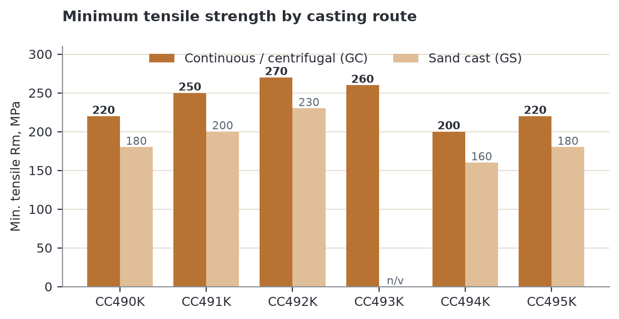
Figure 4. Minimum tensile strength by casting route. CC492K leads at 270 MPa (GC); CC494K is lowest at 200 MPa. Sand casting loses 20–50 MPa.
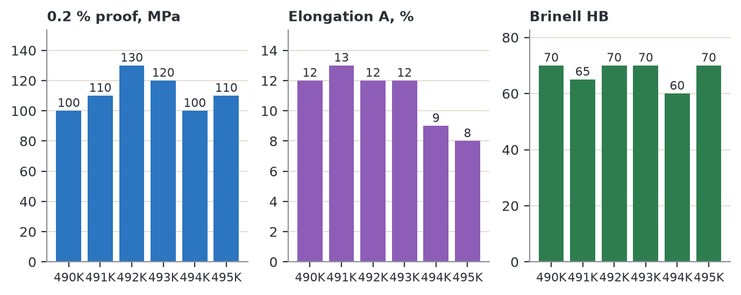
Figure 5. Proof strength, minimum elongation and hardness (GC). Elongation falls from 12–13 % in the gunmetals to 8–9 % in the bearing bronzes.
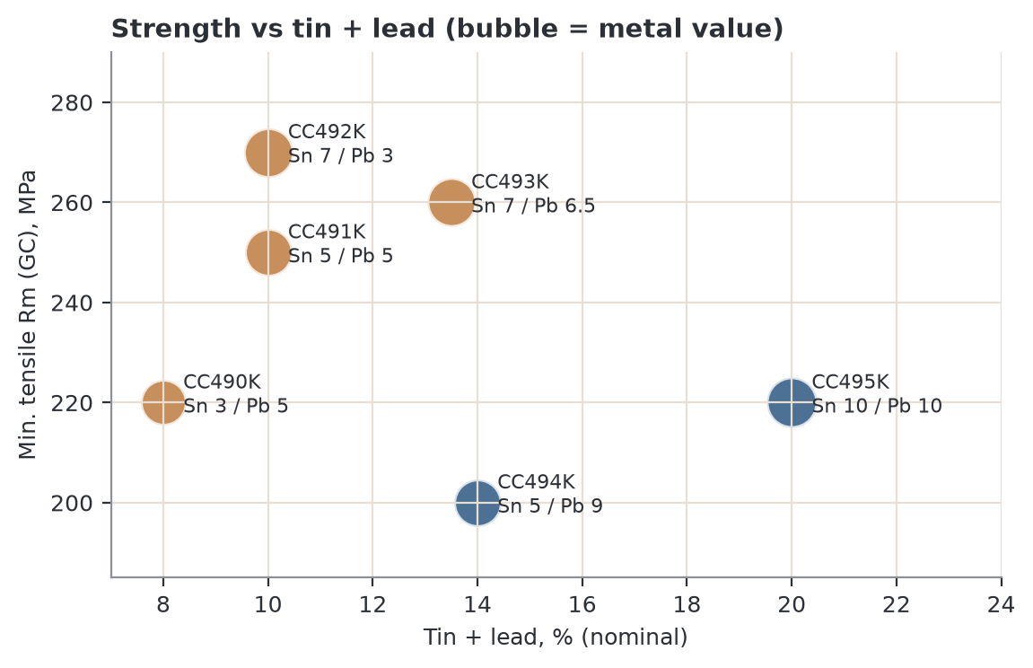
Figure 6. Strength against tin + lead. CC495K (20 % tin + lead) is no stronger than CC490K (8 %); CC492K, with the lowest lead of the four stronger grades, is the strongest. Rev 5 said strength falls “as lead rises”; the data say tin level and the zinc/lead balance matter as much.

4. Market demand and growth
Demand for these alloys follows the pump, valve and bush markets they feed. No publisher reports individual EN grades, so this section uses the feeding markets.
Table 7. Market size and growth (publisher figures; CAGR recomputed over 2025–2034)
Market | 2025 | 2034 | Publisher CAGR | Recomputed CAGR | Source
Pumps – Global | US$ 79.5 bn | US$ 101.5 bn | 2.7 % | 2.8 % | IMARC
Pumps – India | US$ 7.2 bn | US$ 8.8 bn | 2.2 % | 2.3 % | IMARC
Valves – Global | US$ 82.9 bn | US$ 136 bn | 5.7 % | 5.7 % | IMARC
Valves – India | US$ 2.8 bn | US$ 4.8 bn | 6.1 % | 6.2 % | IMARC
Bronze – Global | US$ 13.9 bn | US$ 21.2 bn | 4.8 % | 4.8 % | Market Data Forecast
Bearing bronze – Global | US$ 2.5 bn | US$ 3.8 bn | 5.0 % | 4.8 % | Verified Market Reports

Recomputed and published rates agree within 0.1–0.2 points except bearing bronze (4.8 % vs 5.0 %); the publisher figure is used in text.
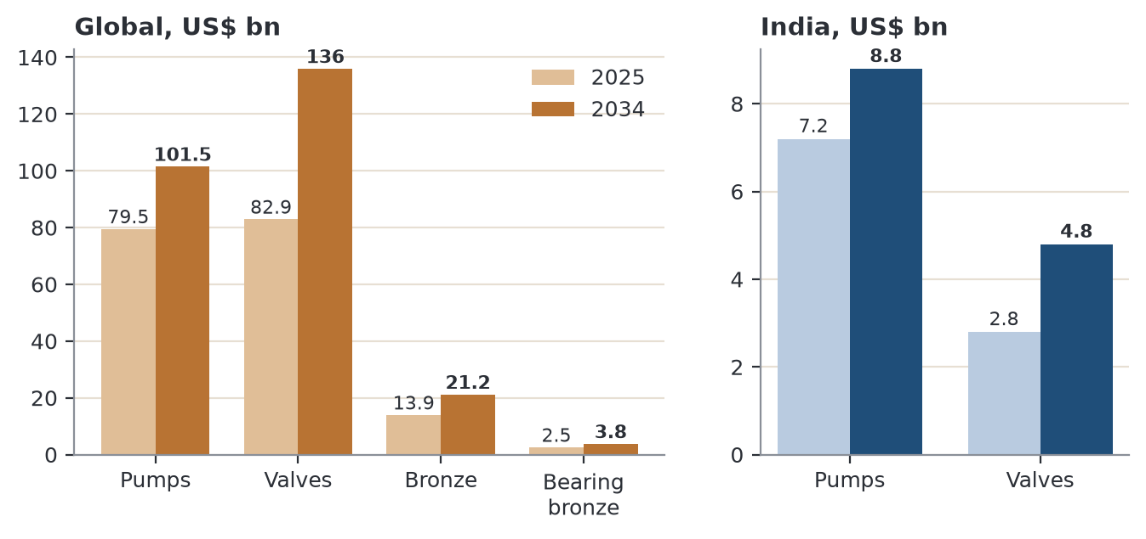
Figure 7. Pump, valve and bronze markets, 2025 vs 2034 (publisher estimates), global and India.
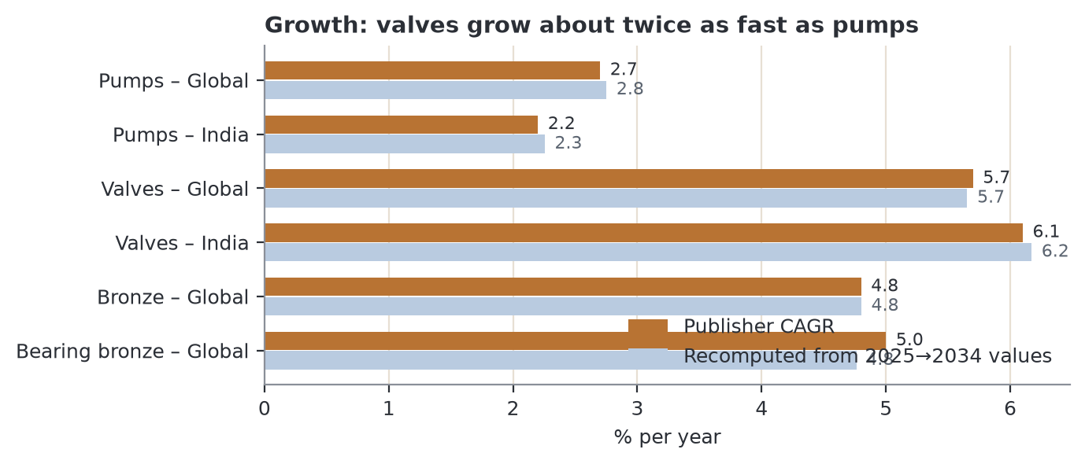
Figure 8. Growth rates: valves grow about twice as fast as pumps; India valves (6.1 %) slightly faster than global.
Scope warning (new)
IMARC's India valve market (US$ 2.8 bn in 2025) is smaller than India's 2023 exports of HS 8481 valves and parts (US$ 2.12 bn) would imply as a share (76 %). The two series do not measure the same thing: HS 8481 includes taps, cocks and valves of all materials, IMARC counts industrial valves. Use each only for its own purpose: IMARC for growth rate, UN Comtrade for export shares. Rev 5 quoted both without this caveat.

What this means for Bajaj Alloys
- Valves are the growth engine (5.7–6.1 %/yr). Pumps are steady volume (2–3 %/yr): India's pump clusters buy gunmetal every month. Bearing bronze grows ~5 %/yr with machinery, mining and infrastructure.
- India drivers: water supply and sanitation (Jal Jeevan Mission, Namami Gange), irrigation, fire-safety rules, industrial plants, railways and shipbuilding.

One headwind: lead rules for drinking water
In the USA the “lead-free” rule (≤ 0.25 % weighted-average lead in wetted surfaces) shuts all six grades out of potable-water taps, valves and fittings. The EU is less absolute: the 4MS positive list still accepts a gunmetal (GM1, referenced to CC491K) for drinking-water products subject to leaching tests, but the tap-water lead limit falls from 10 to 5 µg/l by 2036 and buyers are moving to low-lead gunmetal such as CuSn5Zn5Pb2 (CC499K). CC490K is most exposed because plumbing is its main use. Industrial, fire-fighting, marine, agricultural and bearing uses remain open.

5. Export markets
India exports very little bronze ingot (about US$ 14 m in 2023, HS 7403.22). The real export volume is in the products made from these alloys. Bajaj's export opportunity is to supply the Indian foundries and OEMs that export.
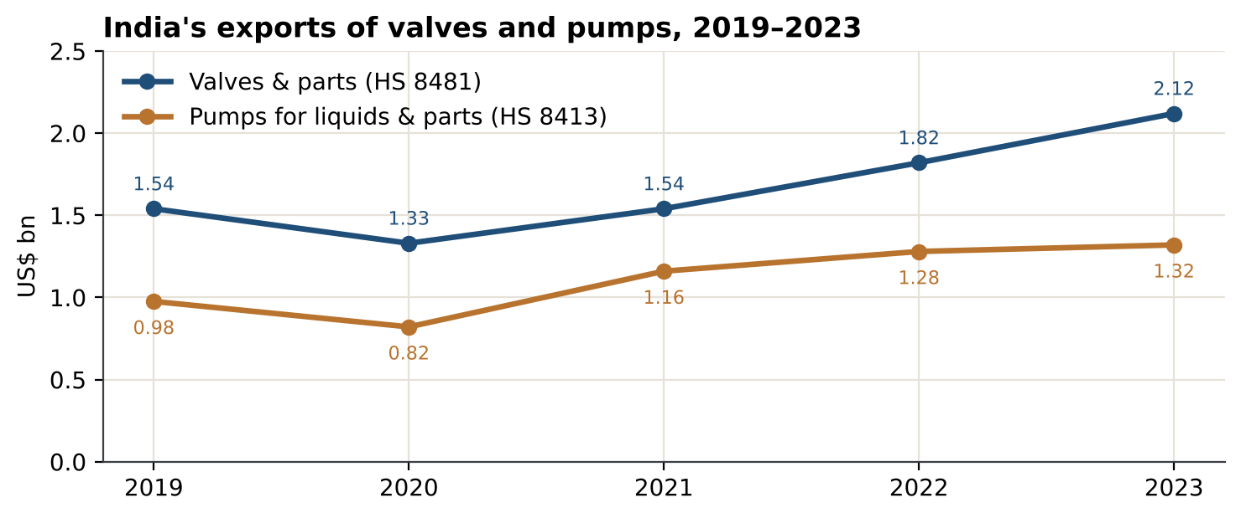
Figure 9. India's exports of valves and pumps, 2019–2023 (TrendEconomy, from UN Comtrade). Valves +38 %, pumps +35 % from 2019 to 2023.
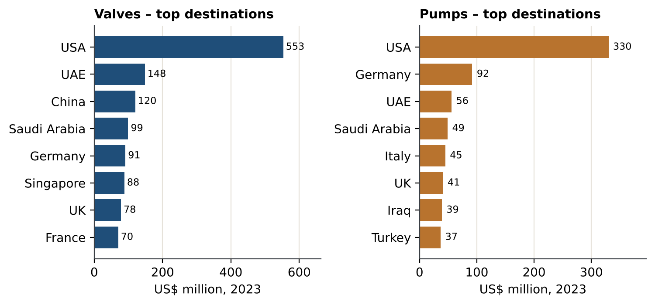
Figure 10. Top destinations, 2023. The USA buys more than the next three markets combined in both products.
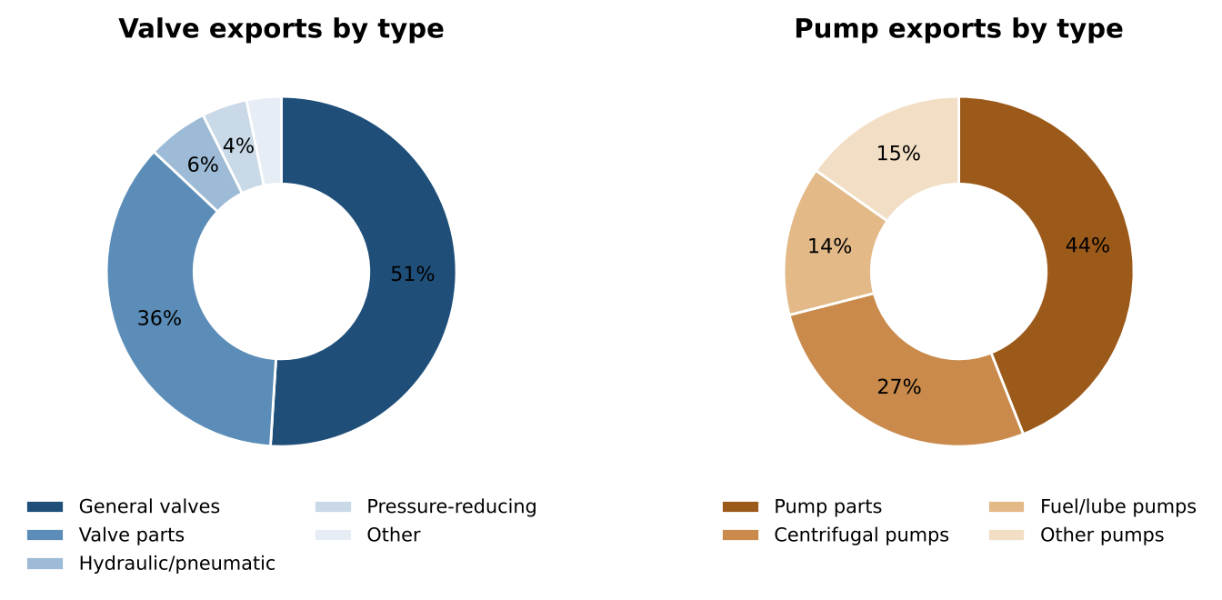
Figure 11. What is exported. Parts are 36 % of valve and 44 % of pump exports: impellers, bowls, valve bodies and bushes are where gunmetal and bearing bronze go.
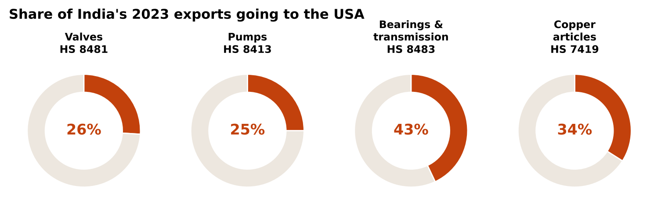
Figure 12. USA share of India's 2023 exports in each product group linked to these alloys.
Table 8. Export products linked to the six grades (2023)
Export product (HS) | India exports 2023 | Grades used | Top buyers | What buyers ask for
Valves & parts (8481) | US$ 2.12 bn | CC490K–CC493K | USA 26 %, UAE 7 %, China 6 %, Saudi 5 % | Material certificate to EN 1982 / ASTM; lead-free for US drinking water
Pumps & parts (8413) | US$ 1.32 bn | CC491K–CC493K, CC495K | USA 25 %, Germany 7 %, UAE 4 %, Saudi 4 % | UL/FM listing for fire pumps; traceable chemistry
Plain shaft bearings & housings (8483.30) | US$ 143 m | CC493K–CC495K | HS 8483 overall: USA 43 %, Germany 10 %, Italy 6 % | Dimensional and chemistry certificates
Other copper articles incl. castings (7419) | US$ 338 m | All six | USA 34 %, Indonesia 13 %, Colombia 6 % | Spec-grade chemistry
Bronze ingot (7403.22) | US$ 14 m | All six | Small, scattered | Spectro certificate

Export takeaways
• Follow the exporters. Pump-part and valve foundries in Coimbatore, Rajkot, Ahmedabad and Kolhapur ship to the USA, Gulf and Europe and need certified, consistent ingot. These clusters are 900–2,300 km from Bhiwadi (Section 9.4), so export-cluster selling is a market-development move after the NCR base is won.
• Fire safety is a niche worth chasing. Bronze-fitted fire pumps and IS 5290 hydrant valves use CC491K/CC492K; Gulf construction keeps demand steady.
• Watch US trade policy. The USA is the largest buyer in every group. US tariffs on Indian goods have changed several times since August 2025 (50 %, then about 18 % after the February 2026 deal, plus a 10 % Section 301 duty on many lines from July 2026). This was not re-verified in Rev 6: check the rate for the exact HS code before relying on US-bound volumes.

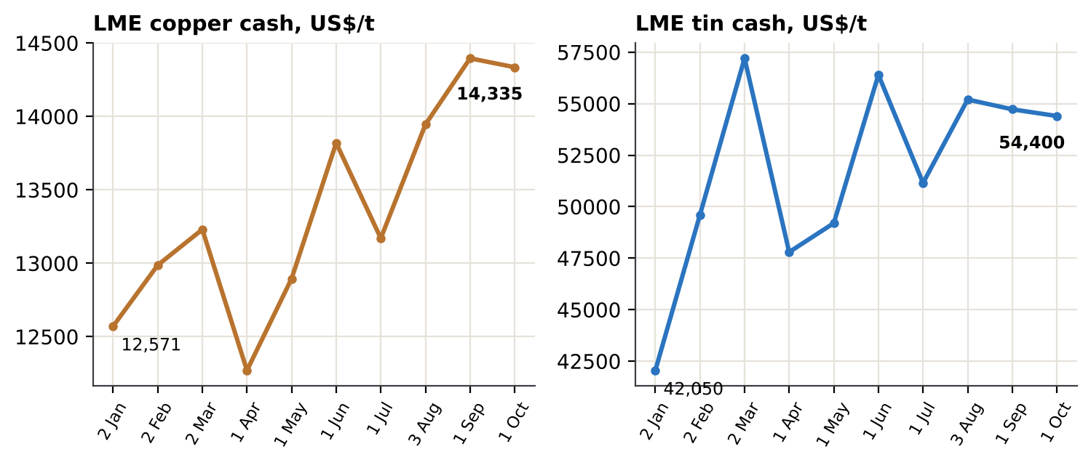
Figure 13. LME cash settlement on the first trading day of each month in 2026: copper +14 %, tin +29 % since 2 Jan.

6. Ingot economics (rebuilt)
This section replaces Rev 5 Sections 9 and 7.6's ingot lines. Bajaj Alloys sells ingot: cast bars or pigs of a certified alloy that foundries and bush makers remelt. Everything below is per kg of ingot. The model has three layers: (1) the metal value of the alloy at LME prices, (2) the formula price Bajaj quotes, and (3) Bajaj's own metal cost when it feeds the furnace with scrap.

6.1 The product: ingot grade sheet and quote formula
Table 9. Ingot sheet: what Bajaj certifies and how each grade is priced (nominal % are the coefficients of the price formula)
Grade (ingot code) | Nominal Cu-Sn-Pb-Zn, % | UNS / IS 318 | Main buyers | Quote formula, ₹/kg (metals at LME × ₹/US$ ÷ 1,000)
CC490K (CB490K) | 84-3-5-8 | C84400 / confirm | Plumbing, general hardware, budget impellers | (0.84×Cu + 0.03×Sn + 0.05×Pb + 0.08×Zn) × 1.025 + 50
CC491K (CB491K) | 85-5-5-5 | C83600 / LTB 2 | Pump, valve, fire, marine foundries | (0.85×Cu + 0.05×Sn + 0.05×Pb + 0.05×Zn) × 1.025 + 50
CC492K (CB492K) | 88-7-3-2 | ≈C92200 / confirm | High-duty pump, marine, railway | (0.88×Cu + 0.07×Sn + 0.03×Pb + 0.02×Zn) × 1.025 + 50
CC493K (CB493K) | 83-7-6.5-3.5 | C93200 / confirm | Bush makers, valve trim, hydraulics | (0.83×Cu + 0.07×Sn + 0.065×Pb + 0.035×Zn) × 1.025 + 50
CC494K (CB494K) | 85-5-9-1 | C93500 / confirm | Tractor, textile, conveyor bushes | (0.85×Cu + 0.05×Sn + 0.09×Pb + 0.01×Zn) × 1.025 + 50
CC495K (CB495K) | 80-10-10-0 | C93700 / confirm | Rolling-mill, crusher, sugar-mill, marine bearings | (0.8×Cu + 0.1×Sn + 0.1×Pb) × 1.025 + 50

What the buyer checks on every heat: spectrometer analysis against EN 1982 (main elements and the impurity limits Fe, Sb, S, Al, Si, P), lead distribution in the ingot fracture, and for bush makers the freedom from dross and gas. Impurities matter most for continuous-casting dies (Fe, Sb, S) and for pressure tightness (P, Al, Si). Ingot (CB) limits should be taken from the ingot table of EN 1982, not from the casting table shown in Section 2.

6.2 What was wrong in Revision 5
- Cost basis. Rev 5 priced every kg from primary LME metal. Bajaj's own procurement work (separate report, 4 Oct 2026) shows it buys copper and brass scrap: Delhi/Mumbai brass scrap was ₹890–990/kg. Primary-metal value is the right *customer price reference* but not Bajaj's *cost*.
- Placeholders as margin. 2.5 % melt loss and ₹50 conversion were stated as placeholders but then used to conclude that “metal is 94 % of price” and that CC495K gives “the highest rupee margin”. With a flat ₹50 conversion every grade earns the same ₹50 per kg; only a percentage mark-up would favour CC495K.
- Arithmetic. “1 % copper error costs more than a quarter of the conversion margin” was false: it is ₹12/kg, 24 % of ₹50.

6.3 Metal value by grade (LME, 1 Oct 2026)
Table 10. Inputs
Metal | US$/t | ₹/kg | Basis
Copper | 14,335 | 1,378.7 | LME official cash, 1 Oct 2026
Tin | 54,400 | 5,232.2 | LME official cash, 1 Oct 2026
Lead | 1,837 | 176.7 | LME official cash, 1 Oct 2026
Zinc | 3,834 | 368.8 | LME official cash, 1 Oct 2026
US$/INR | — | 96.18 | Market rate, 2 Oct 2026 (cross-check 5 Oct: copper 3M ≈ 14,259, tin ≈ 54,277)

Table 11. Metal value of one kg of alloy at nominal composition
Grade | Cu ₹ | Sn ₹ | Pb ₹ | Zn ₹ | Total ₹/kg | Cu share | Sn share
CC490K | 1,158 | 157 | 9 | 30 | 1,353 | 86 % | 12 %
CC491K | 1,172 | 262 | 9 | 18 | 1,461 | 80 % | 18 %
CC492K | 1,213 | 366 | 5 | 7 | 1,592 | 76 % | 23 %
CC493K | 1,144 | 366 | 11 | 13 | 1,535 | 75 % | 24 %
CC494K | 1,172 | 262 | 16 | 4 | 1,453 | 81 % | 18 %
CC495K | 1,103 | 523 | 18 | 0 | 1,644 | 67 % | 32 %

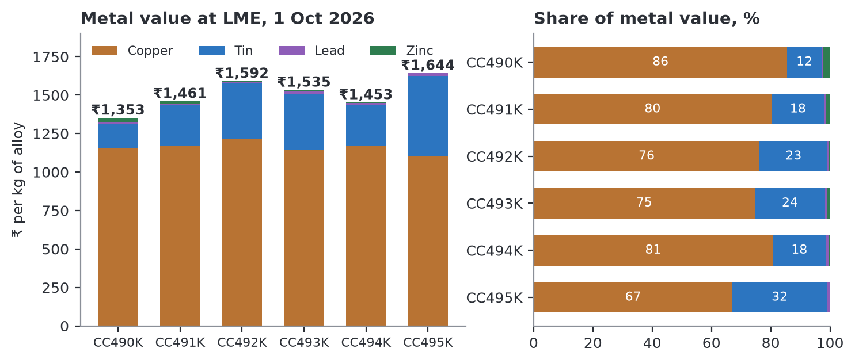
Figure 14. Metal value by element (left) and each element's share (right). Tin is a small share by weight but 12–32 % of value; copper is 67–86 %.

6.4 Formula price: what Bajaj quotes
Ex-works price = metal value × (1 + melt loss) + conversion premium. Melt loss (2.5 %) and conversion (₹50/kg) are placeholders. GST is 18 %.
Table 12. Formula price per grade
Grade | Metal ₹/kg | + melt loss | + conversion | Ex-works ₹/kg | With 18 % GST | Ex-works ₹ lakh/tonne
CC490K | 1,353 | 34 | 50 | 1,437 | 1,696 | 14.37
CC491K | 1,461 | 37 | 50 | 1,547 | 1,826 | 15.47
CC492K | 1,592 | 40 | 50 | 1,682 | 1,985 | 16.82
CC493K | 1,535 | 38 | 50 | 1,623 | 1,916 | 16.23
CC494K | 1,453 | 36 | 50 | 1,539 | 1,817 | 15.39
CC495K | 1,644 | 41 | 50 | 1,735 | 2,047 | 17.35

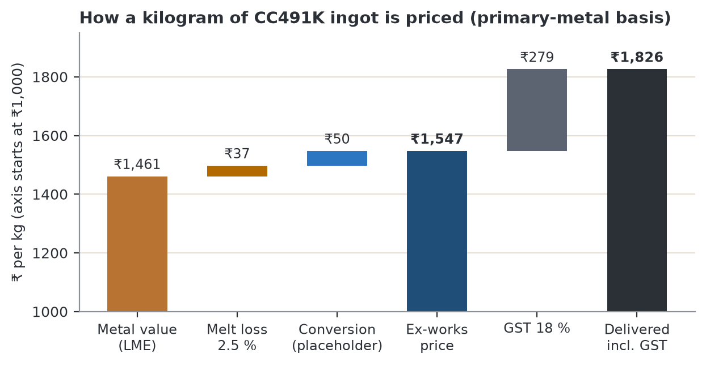
Figure 15. How a kilogram of CC491K ingot is priced on the primary-metal basis. Metal including melt loss is 97 % of the ex-works price; conversion is 3 %.
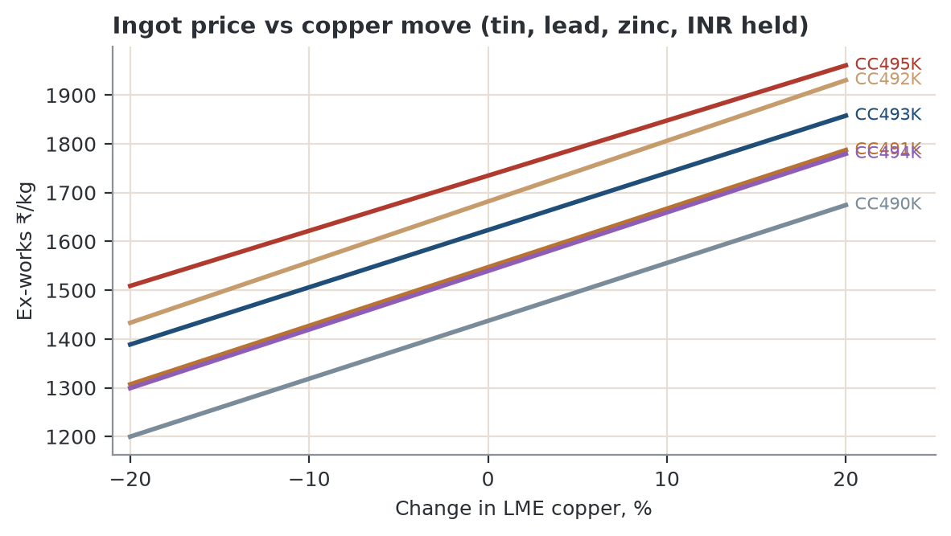
Figure 16. Formula price against LME copper, tin/lead/zinc and rupee held. A 20 % copper move shifts an ingot by about ₹225–250/kg, roughly five times the conversion premium.

6.5 Scrap route: Bajaj's real metal cost
Bajaj feeds the furnace with copper, brass and gunmetal scrap plus make-up tin, lead and zinc. The model keeps it deliberately simple: copper, lead and zinc enter at p × their contained LME value; tin enters at full LME value (fresh tin, or tin in scrap that is assumed to be paid at LME). Melt loss then applies as before.
Evidence for the payable factor p
Typical brass scrap (honey/yellow brass, assumed 63 % Cu / 37 % Zn) has a contained LME value of 0.63 × ₹1,378.7 + 0.37 × ₹368.8 = ₹1,005/kg. Delhi/Mumbai dealer quotes in the procurement report were ₹890–990/kg, i.e. 89–99 % of contained value (mid-point 94 %). These are indicative dealer quotes, not auction clearing prices. The base case uses 94 %; the charts show 89 % and 99 %. Replace p with the actual payable on Bajaj's scrap mix after freight and sorting losses.

Table 13. Gross spread, ₹ per kg of ingot (formula price minus scrap-route metal cost; includes the ₹50 conversion premium)
Grade | Formula price | Metal cost @ 99 % | @ 94 % (base) | @ 89 % | Spread @ 99 % | Spread @ 94 % | Spread @ 89 %
CC490K | 1,437 | 1,375 | 1,314 | 1,252 | 62 | 124 | 185
CC491K | 1,547 | 1,485 | 1,424 | 1,362 | 62 | 124 | 185
CC492K | 1,682 | 1,619 | 1,557 | 1,494 | 63 | 125 | 188
CC493K | 1,623 | 1,561 | 1,501 | 1,442 | 62 | 122 | 182
CC494K | 1,539 | 1,477 | 1,416 | 1,355 | 62 | 123 | 184
CC495K | 1,735 | 1,673 | 1,616 | 1,559 | 61 | 119 | 176

At the base case the scrap spread alone is ₹69–75/kg, more than the ₹50 conversion premium. The spread is nearly equal across grades because it depends on the copper, lead and zinc content, not on tin. So CC495K does not earn a higher rupee margin than CC491K; it earns a larger absolute value that must be financed (tin is 32 % of its metal value). The Rev 5 claim is withdrawn.
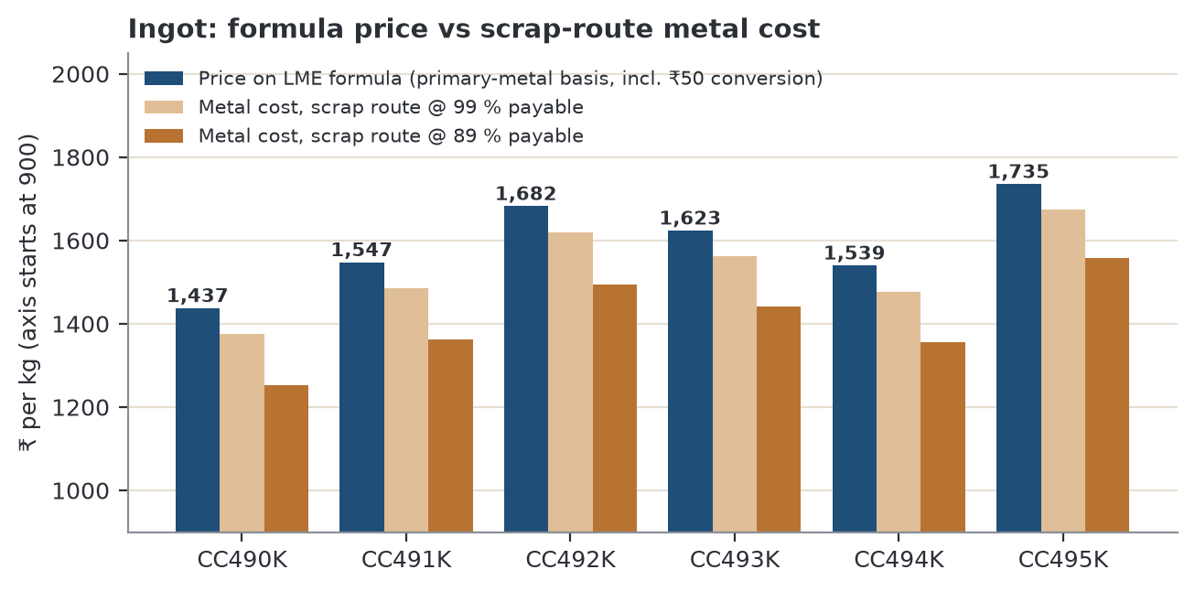
Figure 17. Ingot formula price against scrap-route metal cost at 99 % and 89 % payable (axis starts at ₹900).
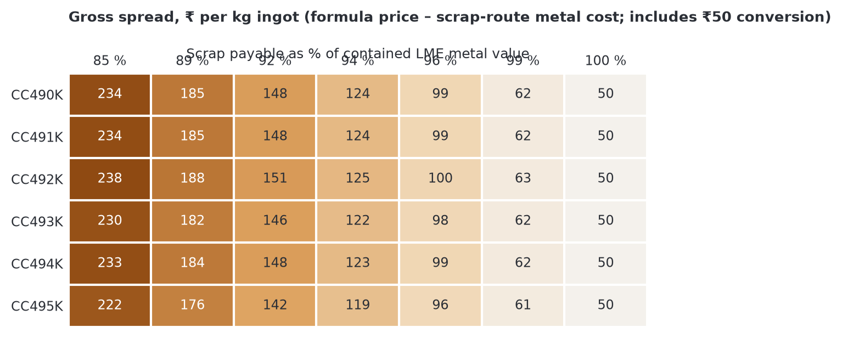
Figure 18. Gross spread by grade and payable %. Every point of payable % moves the spread by about ₹12/kg (₹11.5–12.6 across grades).

6.6 Sensitivity: what moves the price and what moves the margin
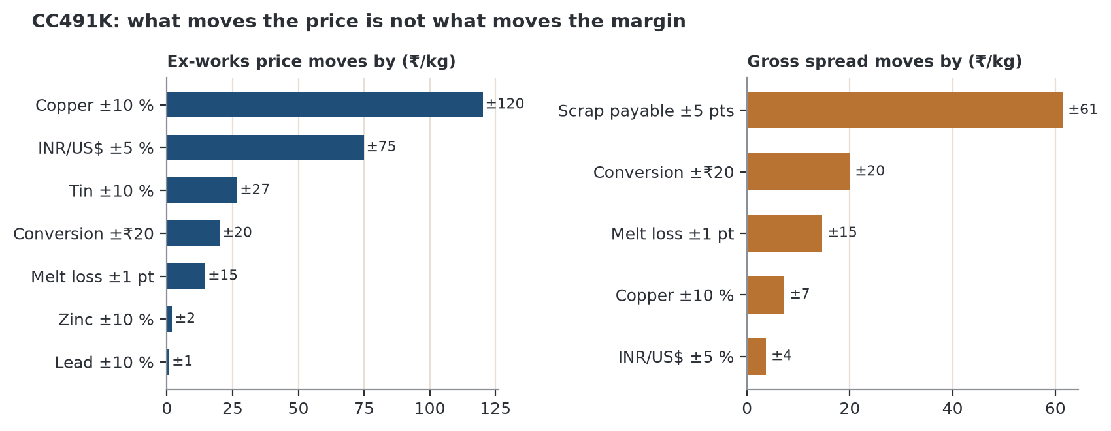
Figure 19. CC491K. Left: ex-works price. Right: gross spread. Copper and the rupee move the price most but hardly move the spread, because they move formula price and scrap cost together. Scrap payable %, conversion and melt loss decide the spread.
- Price risk is passed through on a formula. A 5 % copper move changes CC491K by ₹60/kg, or ₹6.0 lakh on a 10-tonne order; fixed-price quotes hand that risk to Bajaj.
- Margin risk is operational. Five points of payable % are worth ₹61/kg, one point of melt loss ₹15/kg. Track both per heat.
- Tin is the working-capital risk. Tin is 12–32 % of metal value: a 10 % tin move changes ex-works price by ₹16 (CC490K) to ₹54 (CC495K) per kg, and tin stock ties up cash. Buy tin against confirmed orders.

6.7 Rules for quoting, and what Bajaj must replace
- Quote every order on the formula in 6.1, with the LME and rupee reference dates written on the quote; refresh weekly; short validity.
- Offer customers fixed-price only with a premium that covers a hedge or an immediate metal purchase.
- Pass copper and rupee moves through; compete on certification and consistency, not on the conversion premium.
Table 14. Placeholders that must be replaced with Bajaj data before the model is used for decisions
Input | Used here | Replace with
Melt loss | 2.5 % flat | Measured per grade per furnace (zinc-rich CC490K likely higher, CC495K/CC492K lower)
Conversion premium | ₹50/kg | Fuel + labour + flux + overhead + target margin, per grade
Scrap payable % | 94 % (89–99 %) | Actual cost of the scrap mix delivered to Bhiwadi, incl. freight, GST/TCS, sorting loss
Tin source and premium | LME cash | Actual purchase price incl. premium and stock days
Credit and freight terms | not modelled | Customer terms and delivered pricing by cluster

7. Application demand: sizing and grade mix
Section 8 onward asks what each use needs. This section first sizes India's demand for the six grades by application. No publisher reports demand at this level. The shares are bottom-up estimates carried over from Rev 5 (end-market size and growth, bronze content per product, supplier and cluster evidence). Use them as ±30 % ranges. They were not changed in Rev 6, but every figure derived from them was recomputed and cross-checked.
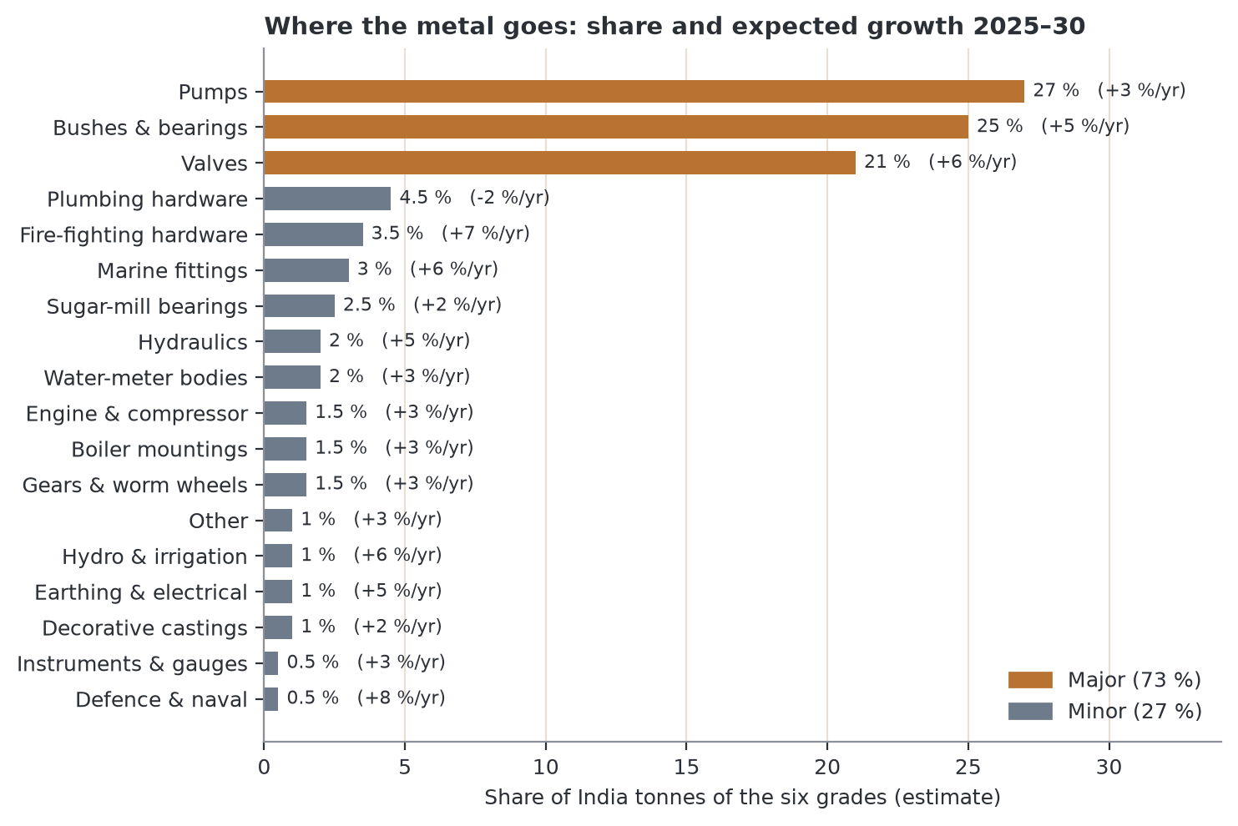
Figure 20. Share of tonnes and expected growth by application. Three major uses take 73 %; 15 smaller uses take 27 %.

7.1 Grade mix inside each application
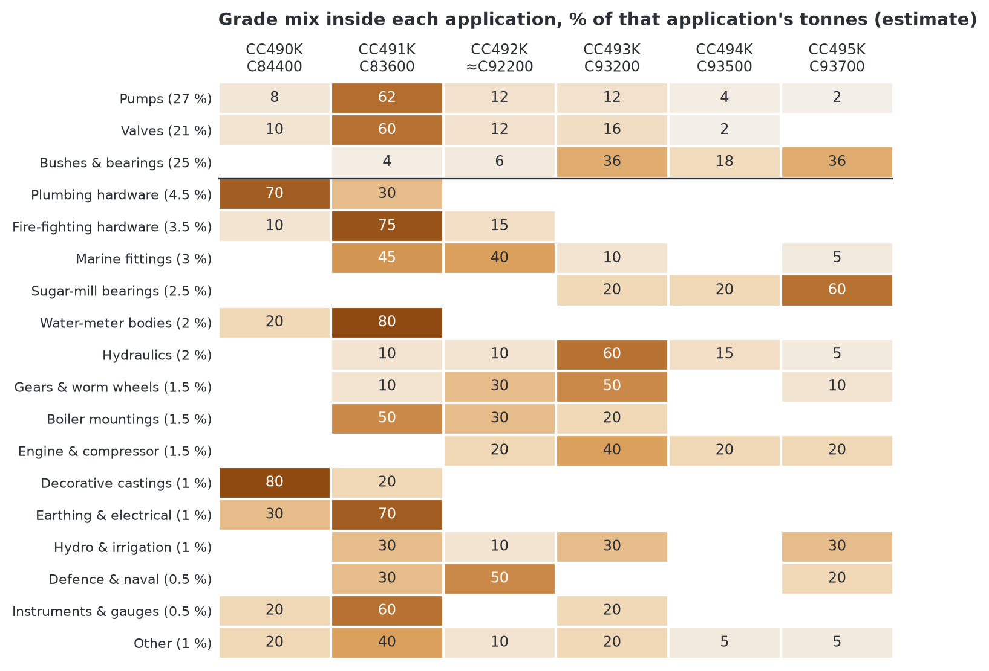
Figure 21. Grade split inside each application (% of that application's tonnes). The solid line separates the three major uses (above) from the minor uses (below).

7.2 Grade demand: reconciliation
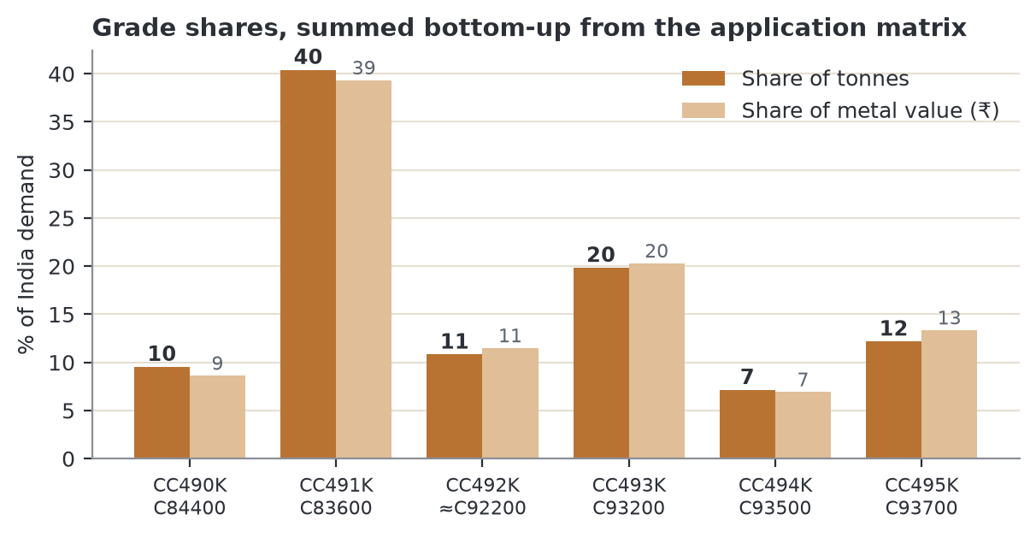
Figure 22. Grade shares summed bottom-up from Figure above. These reproduce the Rev 5 grade shares (CC491K 40 %, CC493K 20 %, CC495K 12 %, CC492K 11 %, CC490K 10 %, CC494K 7 %); value shares differ little because metal value per kg varies only ±10 % between grades.
Table 15. Applications: shares, growth and main grades (all 18 rows)
Application | Share of tonnes | Share of ₹ value | Growth %/yr | Main grade(s) (UNS)
Pumps (major) | 27 % | 26.6 % | +3 | CC491K (C83600)
Valves (major) | 21 % | 20.7 % | +6 | CC491K (C83600) / CC493K (C93200)
Bushes & bearings (major) | 25 % | 26.0 % | +5 | CC493K (C93200) / CC495K (C93700)
Plumbing hardware | 4.5 % | 4.2 % | -2 | CC490K (C84400) / CC491K (C83600)
Fire-fighting hardware | 3.5 % | 3.4 % | +7 | CC491K (C83600) / CC492K (≈C92200)
Marine fittings | 3 % | 3.1 % | +6 | CC491K (C83600) / CC492K (≈C92200)
Sugar-mill bearings | 2.5 % | 2.6 % | +2 | CC495K (C93700) / CC493K (C93200)
Water-meter bodies | 2 % | 1.9 % | +3 | CC491K (C83600) / CC490K (C84400)
Hydraulics | 2 % | 2.0 % | +5 | CC493K (C93200) / CC494K (C93500)
Gears & worm wheels | 1.5 % | 1.6 % | +3 | CC493K (C93200) / CC492K (≈C92200)
Boiler mountings | 1.5 % | 1.5 % | +3 | CC491K (C83600) / CC492K (≈C92200)
Engine & compressor | 1.5 % | 1.6 % | +3 | CC493K (C93200) / CC492K (≈C92200)
Decorative castings | 1 % | 0.9 % | +2 | CC490K (C84400) / CC491K (C83600)
Earthing & electrical | 1 % | 1.0 % | +5 | CC491K (C83600) / CC490K (C84400)
Hydro & irrigation | 1 % | 1.0 % | +6 | CC491K (C83600) / CC493K (C93200)
Defence & naval | 0.5 % | 0.5 % | +8 | CC492K (≈C92200) / CC491K (C83600)
Instruments & gauges | 0.5 % | 0.5 % | +3 | CC491K (C83600) / CC490K (C84400)
Other | 1 % | 1.0 % | +3 | CC491K (C83600) / CC490K (C84400)

7.3 Growth: who adds demand, and the 2030 picture
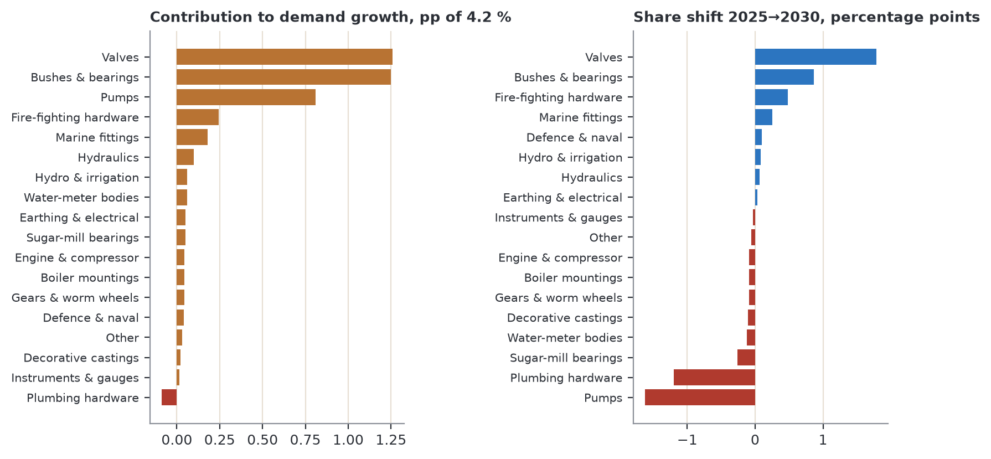
Figure 23. Left: each application's contribution to total demand growth (share × growth). Right: change in share of tonnes 2025→2030 if each application grows at its expected rate.
- The share-weighted growth of the six grades is 4.2 %/yr, which matches the market-average line used in earlier charts.
- Valves add the most growth (1.26 points) and gain 1.8 points of share by 2030; bushes add 1.25 points and gain 0.9; pumps, growing at 3 %, lose 1.6 points; plumbing hardware shrinks and loses 1.2.
- Fire-fighting hardware (+7 %/yr) is the fastest-growing sizeable niche: 3.5 % of tonnes now, 4.0 % in 2030.
- Grade shares in 2030 (computed): CC490K 9 %, CC491K 41 %, CC492K 11 %, CC493K 20 %, CC494K 7 %, CC495K 12 %. CC491K and CC493K stay about 60 % of demand.

8. Applications deep dive: what each use needs, and which grade fits
Rev 5 chose grades for each use with a qualitative heatmap. Rev 6 makes the choice explicit and auditable in three steps: (1) score each grade 1–5 on eight properties using the verified data; (2) state what each use needs as requirement weights; (3) multiply and add. For bearing and gear uses, a grade is eligible only if it is a true bearing or high-tin alloy (lead and tin thresholds below).

8.1 Step 1: grade property scores
Table 16. How the eight property scores are set
Property | Rule (score 1–5) | Basis
Strength | 1 + 4 × (Rm − 180)/90 using GC Rm | Verified EN 1982 minimum
Ductility | 1 + 4 × (A − 6)/7 using GC elongation | Verified EN 1982 minimum
Load capacity | 0.5 × tin % (cap 5) | Tin forms the hard delta phase
Emergency running | 0.5 × lead % (cap 5) | Lead smears if the oil film fails
Machinability | 1 + 4 × (index − 40)/60 | copper.org indices of nearest UNS alloys; CC492K ≈ 50 (est.)
Pressure tightness | Rating 2–5: CC491K and CC493K 5, CC490K and CC492K 4, CC494K 3, CC495K 2 | Judgement from supplier guidance (wide freezing range and lead segregation in the high-lead, high-tin grades)
Corrosion / sea water | Rating 3–5: CC492K 5, CC491K/CC493K/CC495K 4, CC490K/CC494K 3 | Judgement (high zinc and low tin are weaker in sea water)
Low metal cost | 5 − 4 × (value − ₹1,353)/(₹1,644 − ₹1,353) | Computed metal value, Section 6

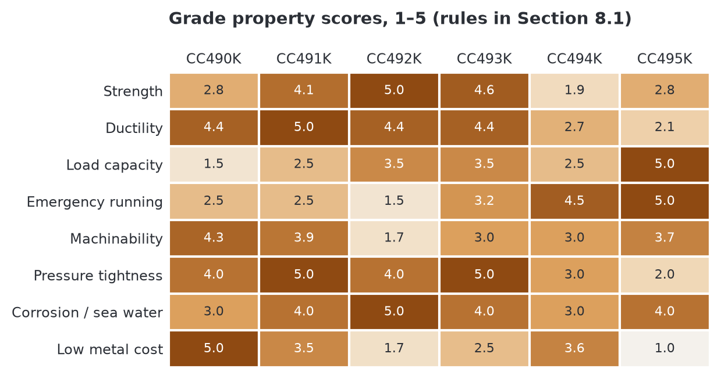
Figure 24. Computed grade property scores. CC492K is the strongest, CC491K the most ductile and best all-round gunmetal, CC495K the best bearing alloy and the dearest.

8.2 Steps 2 and 3: requirements and fit
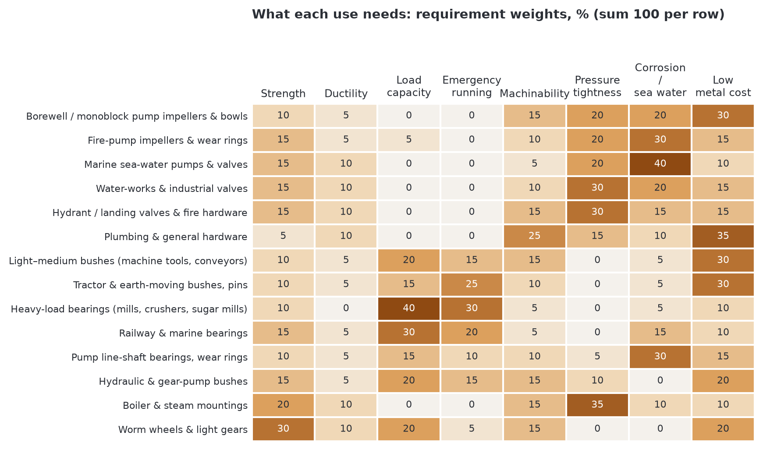
Figure 25. Requirement weights for 14 uses (each row sums to 100 %). Weights are judgement based on duty, standards and supplier guidance; change them and Figure below updates.
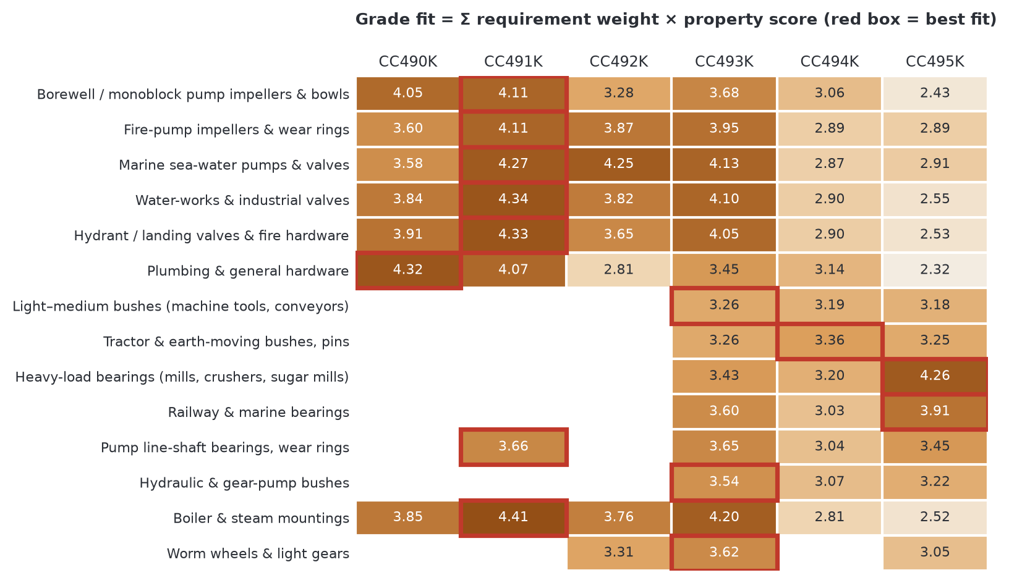
Figure 26. Grade fit scores (0–5). Blank = not eligible. Eligibility: bush, bearing and hydraulic uses need ≥ 6 % lead and ≥ 5 % tin (line-shaft bearings ≥ 5 % lead); worm wheels and gears need ≥ 6 % tin. Red box = best fit.
Table 17. Best and second-best grade by use (computed)
Use | Best fit | Second | Comment
Borewell / monoblock pump impellers & bowls | CC491K (4.11) | CC490K (4.05) | Near-tie: CC490K is the budget choice (0.06 behind) but risks dezincification in aggressive water
Fire-pump impellers & wear rings | CC491K (4.11) | CC493K (3.95) | Standby corrosion and wear; CC492K third (3.87)
Marine sea-water pumps & valves | CC491K (4.27) | CC492K (4.25) | Sea water: CC492K practically level (4.25 vs 4.27); choose by class rule and impingement duty
Water-works & industrial valves | CC491K (4.34) | CC493K (4.10) | Pressure tightness and ductility decide
Hydrant / landing valves & fire hardware | CC491K (4.33) | CC493K (4.05) | Hydrant valves are BIS-controlled; IS 318 LTB 2 = CC491K
Plumbing & general hardware | CC490K (4.32) | CC491K (4.07) | CC490K wins on cost and machinability; this is its natural use and it is exposed to lead-free rules
Light–medium bushes (machine tools, conveyors) | CC493K (3.26) | CC494K (3.19) | Default bush; CC494K (3.19) and CC495K (3.18) within 0.1, CC495K is 7 % dearer in metal
Tractor & earth-moving bushes, pins | CC494K (3.36) | CC493K (3.26) | Dirt and misalignment reward lead; CC494K edges CC493K
Heavy-load bearings (mills, crushers, sugar mills) | CC495K (4.26) | CC493K (3.43) | Load and shock dominate: CC495K clearly best (4.26 vs 3.43)
Railway & marine bearings | CC495K (3.91) | CC493K (3.60) | CC495K; CC492K fails the lead threshold (poor if lubrication fails)
Pump line-shaft bearings, wear rings | CC491K (3.66) | CC493K (3.65) | Water-lubricated: CC491K and CC493K are level (3.66 vs 3.65)
Hydraulic & gear-pump bushes | CC493K (3.54) | CC495K (3.22) | CC493K clearly ahead of CC495K (3.22)
Boiler & steam mountings | CC491K (4.41) | CC493K (4.20) | CC491K; CC492K/CC493K for higher pressure and temperature (the model weights strength only 20 %)
Worm wheels & light gears | CC493K (3.62) | CC492K (3.31) | Strength and wear: CC493K; CC492K second

The computed picks agree with the grade guidance in Section 2 and with supplier data sheets, which is the test of the model. Two points differ from Rev 5: CC492K is not a bush grade for lubrication-critical railway and marine bearings (3 % lead), and CC491K and CC493K are level for water-lubricated line-shaft bearings.

8.3 Pumps: which pump, which part, which grade
Bronze is used in pumps because it does not rust in water, resists sand and silt wear and does not seize against a steel shaft. Fire pumps must start after sitting idle for years, which is why NFPA 20 fire pumps are commonly “bronze-fitted”: a cast-iron casing with bronze impeller, wear rings and shaft sleeves.
Table 18. Pump types, duty, failure mode and what the ingot must deliver
Pump type | Bronze parts | Grade | Duty and failure mode | What the ingot must deliver
Borewell submersible (4"/6") | Impellers, diffusers, bowls, bearing bush | CC491K; bush CC493K | Sand-laden groundwater: abrasive wear, erosion at the impeller eye | Sound castings (low gas), tight Pb/Sn control for wear
Monoblock / openwell centrifugal | Impeller | CC491K; CC490K (budget) | Low cost, light duty; CC490K risks dezincification in aggressive water | Consistent chemistry; CC490K only for non-aggressive water
Vertical turbine (line-shaft) | Bowls, impellers, line-shaft bearings | CC491K / CC492K; bearings CC491K / CC493K | Continuous duty, water-lubricated bearings | Good lead distribution for bearings
Split-case fire pump (NFPA 20, UL/FM) | Impeller, casing wear rings, shaft sleeves | CC491K / CC492K | Long idle periods then sudden start: corrosion and seizure | Certified chemistry and traceability (UL/FM)
Marine sea-water pumps | Casings, impellers | CC492K / CC491K | Sea-water corrosion and impingement attack | Higher tin and low impurity levels; class certificates
Gear / rotary pumps | Bushes, side plates | CC493K / CC495K | Bearing surface against the gears; dirty oil | Even lead dispersion

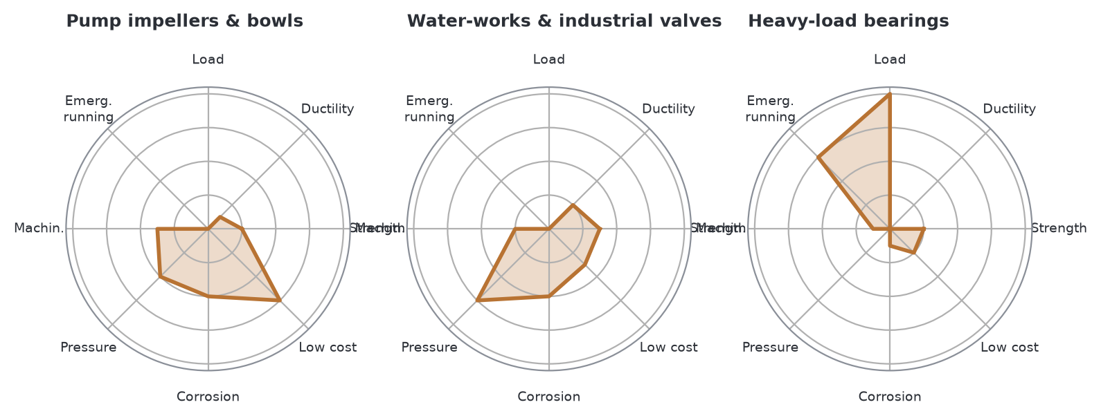
Figure 27. Requirement profile of pump impellers, valves and heavy bearings. Pumps and valves are pressure/corrosion/cost uses; heavy bearings are load and emergency-running uses. The same ingot does not serve both.

8.4 Valves
Table 19. Valve types, standards, grade and failure mode
Valve type | Standard / approval | Grade | Failure mode and note
Gate, globe, check valves (water works) | IS 778 | CC491K | Leaching and pressure leaks; leaded grades not allowed for drinking water in the EU/US
Fire hydrant / landing valves | IS 5290: body and bonnet in leaded tin bronze to IS 318 LTB 2 (= CC491K) or Al alloy / stainless; BIS marking | CC491K | BIS tests reject off-chemistry metal; gunmetal is the traditional material
Marine valves (globe, storm, sea-chest) | Class society (IRS, DNV, LR, ABS), EN 10204 3.1 | CC491K / CC492K | Sea-water corrosion, dezincification if zinc is high
Higher-pressure water and steam valves | Project and boiler codes | CC492K / CC493K | Strength at temperature; CC491K within its limit
Plumbing stop-cocks and fittings | Product standards; lead-free rules spreading | CC490K | Most exposed to lead-free rules
Valve trim: seats, glands, stem bushes | OEM drawings | CC493K | Wear and galling; machines freely

8.5 Grade-by-grade summary
Table 20. Where each grade is used, and where not to use it
Grade | Primary uses | Secondary uses | Avoid
CC490K | Plumbing and general hardware, low-pressure valves, budget impellers, decorative | Meter bodies, earthing fittings (where lead is allowed) | Potable water in the USA/EU; bearings (3 % tin)
CC491K | Pump impellers and bowls, water-works and hydrant valves, fire hardware, marine fittings, boiler mountings | Light bushes, graphite-plugged gate bushes | Heavy shock bearings
CC492K | High-velocity water and sea-water pumps, pressure valves, naval castings, gears | Railway and engine parts (with good lubrication) | Bearings where lubrication can fail (3 % lead)
CC493K | General bushes, hydraulic bushes, valve trim, line-shaft bearings, worm wheels | Pump and valve bodies, tractor bushes | Heavy shock, very dirty duty
CC494K | Tractor, implement, textile and conveyor bushes | Pump wear rings, sugar-mill light bearings | Heavy load (lowest strength, 200 MPa)
CC495K | Rolling-mill, crusher, sugar-mill, railway, marine bearings | Engine and hydro bushes | Pressure-tight castings; high-volume light duty (dearest)

9. Bushes and bearings deep dive
Bushes and plain bearings take about 25 % of India's demand for the six grades (25 % of tonnes; 26 % of ₹ value) and are the best-paying major use because buyers value certified chemistry and even lead distribution. This section looks at the bush market from Bajaj's sales point of view.

9.1 Why bronze bushes still win
- Lead is a built-in lubricant. The 5–11 % lead sits as soft islands that smear over the shaft if the oil film fails, so the bush does not seize.
- Tin gives the load capacity through hard delta-phase particles; CC495K (10 % tin) takes the heaviest duty.
- Embeddability and conformability: soft bronze swallows grit and adapts to slight misalignment instead of scoring a costly shaft.
- Better than rolling bearings for slow, heavy, shock, dirty and oscillating duty, and wherever a split bearing is needed.
- Design limit (cited): US catalogues rate C93200 (CC493K) plain bearings to 4,000 psi (27.6 MPa) load, 750 ft/min (3.8 m/s) sliding speed and PV 75,000 psi·ft/min (≈ 2.6 MPa·m/s) when lubricated (Bunting Bearings).

9.2 Bush types and what they need
Table 21. Bush types
Bush type | Typical size | Grades (UNS) | Made by | Main users
Plain sleeve bush | 10–300 mm bore | CC493K (C93200), CC494K (C93500) | Continuous-cast tube, machined | Machine tools, conveyors, gearboxes, pumps
Flanged bush | 10–150 mm bore | CC493K | Continuous-cast tube or bar | Linkages, hydraulic cylinders
Thrust washer | 20–300 mm OD | CC493K, CC495K | Cut from bar or tube | Tractor axles, gear pumps, engines
Split bearing / half-shell | 100–1,500 mm | CC495K (C93700) | Sand or centrifugal cast | Rolling mills, crushers, sugar mills, ships
Grooved oil / grease bush | Any | All bearing grades | Machined from tube | Cranes, presses, slow heavy pivots
Graphite-plugged bush | 20–600 mm | CC491K or CC493K base | Machined tube + plugs | Dam and sluice gates, hydro wicket gates
Wear / slide plate, gib | Plates | CC493K | Continuous-cast flat bar | Presses, die sets, machine-tool slides
Water-lubricated line-shaft bearing | 25–150 mm | CC491K, CC493K | Continuous-cast tube | Vertical turbine and borewell pumps
Bush stock (bar, tube) | 15–300 mm OD | CC493K, CC495K | Continuous casting | Stockists, job shops, maintenance stores

9.3 Who buys bushes
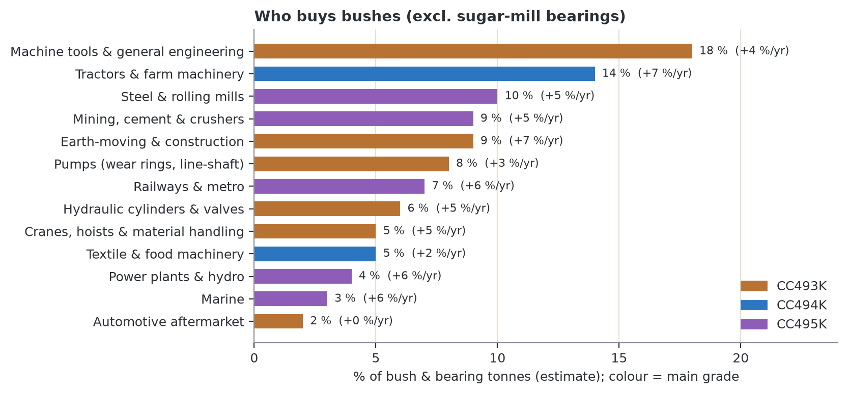
Figure 28. The bush segment split by end industry. Machine tools, tractors, steel mills, earth-moving and mining take 60 % of bush tonnes; tractors and earth-moving grow fastest (+7 %/yr). Estimate.
Table 22. Bush buyers, growth and the nearest cluster to Bhiwadi
End industry | Share | Growth | Main grade (UNS) | Buyer clusters (approx. km from Bhiwadi) | Nearest
Machine tools & general engineering | 18 % | +4 | CC493K (C93200) | Ludhiana (430), Pune (1,450), Rajkot (1,050), Coimbatore (2,300) | 430 km
Tractors & farm machinery | 14 % | +7 | CC494K / CC493K | Faridabad (110), Mohali (440), Pune, Chennai | 110 km
Steel & rolling mills | 10 % | +5 | CC495K (C93700) | Mandi Gobindgarh (≈ 400); Jharkhand, Odisha, Chhattisgarh (> 1,200) | ≈ 400 km
Earth-moving & construction | 9 % | +7 | CC493K / CC495K | Faridabad–Ballabgarh (110), Bengaluru, Pithampur, Kharagpur | 110 km
Mining, cement & crushers | 9 % | +5 | CC495K | Beawar (340), Chittorgarh–Nimbahera (540), MP, AP | 340 km
Pumps (wear rings, line-shaft) | 8 % | +3 | CC493K / CC494K | Ahmedabad (900), Kolhapur (1,650), Coimbatore (2,300) | 900 km
Railways & metro | 7 % | +6 | CC495K | Delhi-NCR workshops (125), Varanasi, Kolkata, Chennai | 125 km
Hydraulic cylinders & valves | 6 % | +5 | CC493K | Faridabad (110), Pune, Ahmedabad | 110 km
Textile & food machinery | 5 % | +2 | CC494K | Ludhiana (430), Bhilwara, Surat, Coimbatore | 430 km
Cranes, hoists & handling | 5 % | +5 | CC493K / CC495K | Faridabad (110), Mumbai, Kolkata | 110 km
Power plants & hydro | 4 % | +6 | CC495K / CC493K | Prithla (130), Noida (150), Haridwar (340), Bhopal | 130 km
Marine | 3 % | +6 | CC495K | Mumbai, Kochi, Visakhapatnam, Kolkata (> 1,300) | > 1,300 km
Automotive aftermarket | 2 % | 0 | CC493K | Delhi (125), Jalandhar (470) | 125 km

Industries that have a main buyer cluster within about 160 km of Bhiwadi account for 47 % of bush tonnes. Each cluster holds only part of its industry's national volume, so the scorecard (Section 10.1) assumes about 40 % of bush buyers are within 450 km.

9.4 Geography: which clusters are really near
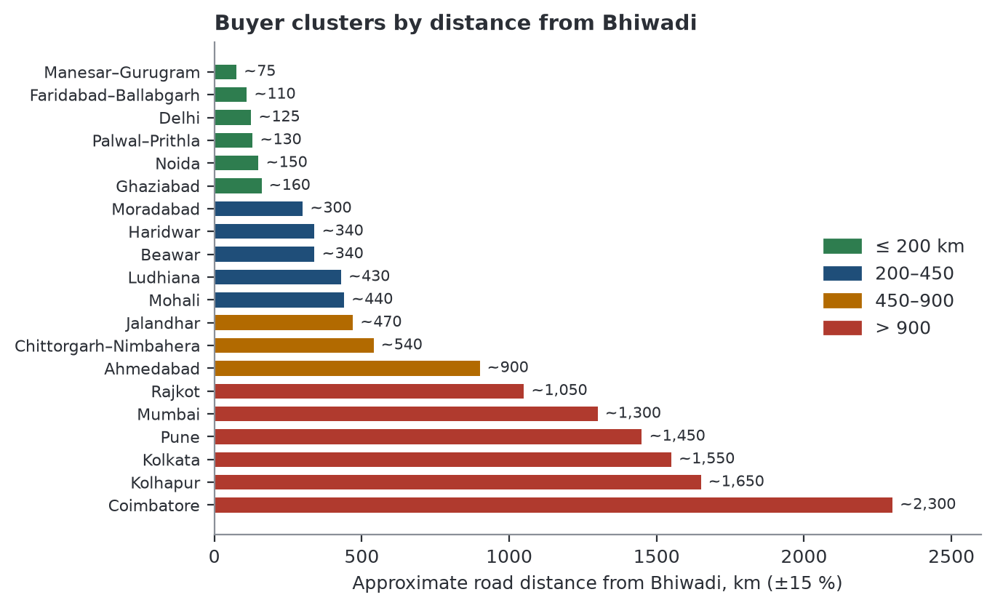
Figure 29. Approximate road distance from Bhiwadi to buyer clusters (±15 %; indicative). The Faridabad–Delhi–Ghaziabad–Noida–Prithla belt is 75–160 km; the Rajasthan cement belt is 340–540 km; Gujarat 900–1,050 km; Coimbatore 2,300 km.
Corrections to Revision 5
• Rev 5 called the Rajasthan cement belt (Chittorgarh–Nimbahera–Beawar) one of the “nearest” bush buyers. It is 340–540 km away. The nearest are Faridabad–Ballabgarh, Delhi, Ghaziabad, Noida and Prithla.
• Rev 5 said Bhiwadi is “close to Gujarat foundry clusters”. Rajkot and Ahmedabad are 900–1,050 km away; they are a market-development target, not the home base.

9.5 Choosing the grade for a bush
Section 8.2 computed the fit: CC493K is the default for light-to-medium bushes and hydraulics (3.26 and 3.54), CC494K edges ahead for tractor and dirty duty (3.36), CC495K is clearly best for heavy bearings and railway/marine (4.26 and 3.91). CC492K is excluded from lubrication-critical bearings (3 % lead).
Table 23. Grade by bush duty
Grade (UNS) | Strength in bushes | Watch-outs | Best bush uses
CC493K (C93200) | Best all-round: tin for load, lead for poor lubrication; machines freely | Not for heavy shock or very dirty duty | Machine-tool, gearbox, hydraulic, conveyor bushes; bush stock
CC495K (C93700) | Highest load and shock capacity; 10 % lead tolerates lubrication failure | Dearest (tin 32 % of metal value); lead must stay evenly spread in large castings | Rolling-mill, crusher, sugar-mill, railway and marine bearings
CC494K (C93500) | Most forgiving: 9 % lead embeds dirt and conforms to misalignment | Lowest strength (200 MPa); not for heavy load | Tractor, textile, conveyor and implement bushes; pump wear rings
CC492K (≈C92200) | Strongest, hardest gunmetal; good in sea water | Only 3 % lead: poor if lubrication fails | Well-lubricated railway and marine bushes (not lubrication-critical)
CC491K (C83600) | Cheap, corrosion-resistant, water-lubricated duty | Lower load capacity than the bearing bronzes | Pump line-shaft bearings, graphite-plugged gate bushes, light bushes

9.6 How bushes are made, and what the ingot must deliver
Table 24. Manufacturing routes (route shares are estimates from Indian bush-maker and US/UK bar catalogues)
Route | Size range | Share of bush tonnes | What the ingot must deliver | Sales angle
Continuous-cast bar and tube | 15–300 mm OD; to 3 m | ≈ 45 % | Low Fe, Sb, S so graphite dies last; clean, degassed melt; even lead so bars do not “sweat” lead | Bush-stock makers buy monthly; consistency matters most
Centrifugal tube | 100–1,500 mm OD | ≈ 35 % | Fine, even lead dispersion (lead segregates outward when spun); tight tin control | CC495K melt practice is the selling point; certify lead distribution
Sand casting | Large split bearings, odd shapes | ≈ 20 % | Low gas, good fluidity; chemistry within limits | Sugar-mill, kiln, ship bearings; seasonal and lumpy

9.7 Bush price build-up (rebuilt)
Rev 5 gave a tube price (₹2,000) and bush price (₹2,500) with no stated basis. Rev 6 builds the chain step by step from inputs that can each be replaced. It is a cost model, not a market price list. The result is validated only by internal consistency (it reproduces Rev 5's ≈ ₹2,500 and 1.5× ingot) and should be checked against two or three real bush-maker quotes.
Table 25. Inputs (base case CC493K)
Step | Input | Base case | Range tested | Source
Ingot | CC493K formula price (Section 6) | ₹1,623/kg | — | Computed
Casting | Casting loss; conversion + margin for continuous-cast tube | 3 %; ₹300/kg | — | Assumption (placeholder)
Machining | Turnings removed from tube | 30 % | 20–45 % | Rev 5 range 25–40 %; assumption
Turnings | Credit paid back, % of metal value | 85 % (₹1,305/kg) | 70–100 % | Rev 5; assumption
Machining | Machining cost + margin per kg finished | ₹200/kg | — | Assumption (placeholder)

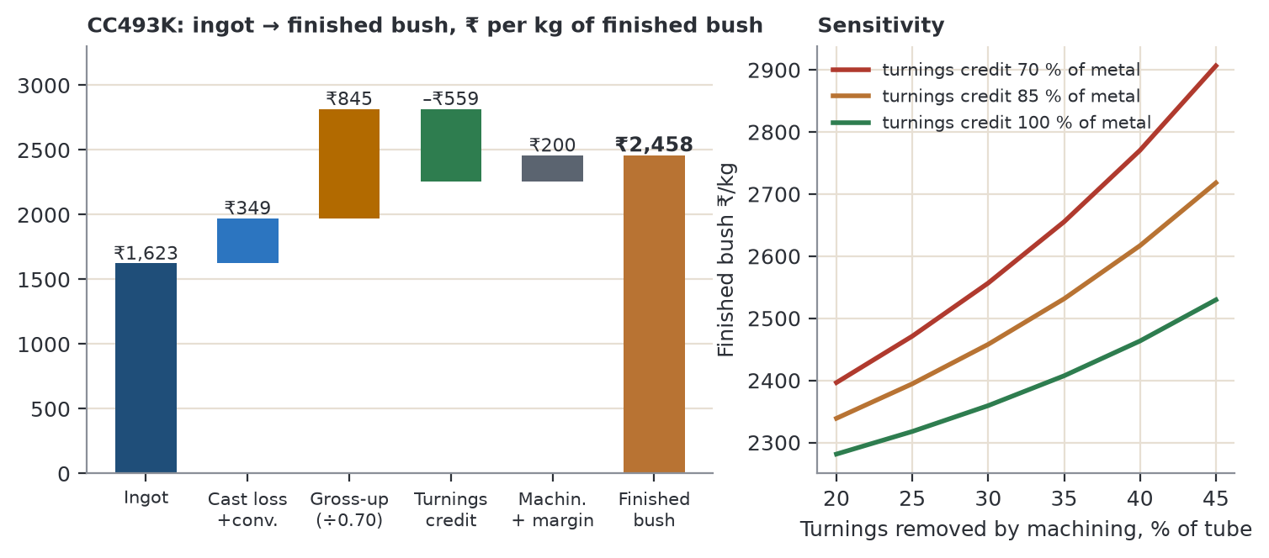
Figure 30. Left: ingot → finished bush for CC493K. Tube = ingot × 1.03 + ₹300 = ₹1,972/kg of tube; ÷ 0.70 for turnings = ₹2,817; less turnings credit ₹559; plus ₹200 machining/margin = ₹2,458/kg finished bush (1.51× ingot). Right: sensitivity.
- Turnings % moves the price moderately. At 85 % credit the finished price runs from ₹2,339 (20 % turnings) to ₹2,718 (45 %) per kg; the credit returns most of the metal.
- The credit rate moves the price by ₹197/kg between 70 % and 100 % at 30 % turnings. Bush makers will negotiate this hardest.
Turnings buy-back: where Bajaj's scrap skill meets a customer need (illustrative)
Turnings are same-alloy, known-chemistry scrap. If Bajaj credits 85 % of metal value (₹1,305/kg) and remelts them into CC493K ingot sold at ₹1,623, the gross spread is about ₹286/kg before oil, moisture and extra melt loss (not modelled). The advantage over a remelter is a certified same-alloy return; remelters and importers can also offer credit, so this is a service differentiator, not an exclusive “closed loop” (Rev 5 wording withdrawn). Pilot it with two bush makers before scaling.

- Online price lists are not used. The undated IndiaMART listings (₹425–1,100/kg for gunmetal and phosphor-bronze bushes) cannot be tied to a date, grade, size or unit, so they are not evidence of “stale” prices. Quote bush makers on the LME formula.

9.8 What competes with bronze bushes
Table 26. Substitutes
Substitute | Where it wins | Where bronze holds | Threat
Steel-backed bimetal (Cu-Pb-Sn lining) | Engines, truck and tractor high-volume small bushes | Large sizes, short runs, shock, dirt | High in automotive; low in heavy industry
Sintered bronze or iron (oil-impregnated) | Small motors, appliances, light pivots | Above light load or 50 mm bore | High in light duty only
Polymer / PTFE-composite | Dry-running pivots, hydraulics, food machinery | Heat, heavy or shock load, abrasive dirt | Medium
Rolling-element bearings | High speed, precision, low friction | Shock, oscillation, dirt, split housings, very large shafts | Medium
Cast iron or steel with grease | Cheap slow pivots | Corrosion, seizure resistance | Low

9.9 Where to sell bushes first
Order of attack (distances from Bhiwadi)
• Faridabad–Ballabgarh (≈ 110 km): tractor (Escorts Kubota), earth-moving (JCB), hydraulics and crane chains buy CC493K and CC494K bushes and thrust washers monthly.
• Delhi, Ghaziabad (125–160 km): sugar-mill bearing makers (CC495K liners bought ahead of the April–September off-season); railway workshops; aftermarket.
• Noida and Prithla (130–150 km): hydro OEMs; graphite-plugged CC491K/CC493K gate bushes; slow approval, loyal once approved.
• Bush-stock and continuous-cast bar makers (nationwide): the steadiest monthly ingot buyers; sell consistency.
• Next ring (340–540 km): Rajasthan cement belt (CC495K crusher and kiln bushes), Ludhiana–Mohali machine-tool and tractor chain, Haridwar.

10. Minor applications deep dive
Section 7 sized the 14 named minor applications (27 % of tonnes with “Other”). This section ranks them for Bajaj's sales team with a rule-based scorecard, shows when customers buy, and profiles the eight that score 22 or more.

10.1 Scorecard (rebuilt after the yellow flag)
Table 27. Scoring rules, each criterion 1–5
Criterion | Rule | Basis
Share | ≥ 4 %: 5; ≥ 3 %: 4; ≥ 2 %: 3; ≥ 1.5 %: 2; below: 1 | Section 7 shares
Growth | ≤ 0 %/yr: 1; ≤ 2: 2; ≤ 4: 3; ≤ 6: 4; > 6: 5 | Section 7 growth (market average 4.2 %)
Margin potential | Judgement 1–5: higher where buyers need certificates and are not price-driven | Rev 5 scores kept
Certification need | Judgement 1–5: standards, class rules, BIS, IBR | Rev 5 scores kept
Low substitute threat | Mapped from the stated rating: Low 5, Low–Medium 4, Medium 3, High 1 | Table in 10.4 and profiles
Near Bajaj | Share of buyers within ≈ 450 km: ≥ 50 %: 5; ≥ 35: 4; ≥ 20: 3; ≥ 10: 2; below: 1 | Cluster list, Section 9.4 (judgement)
Order size | Judgement 1–5: bigger, steadier orders score higher | Rev 5 scores kept

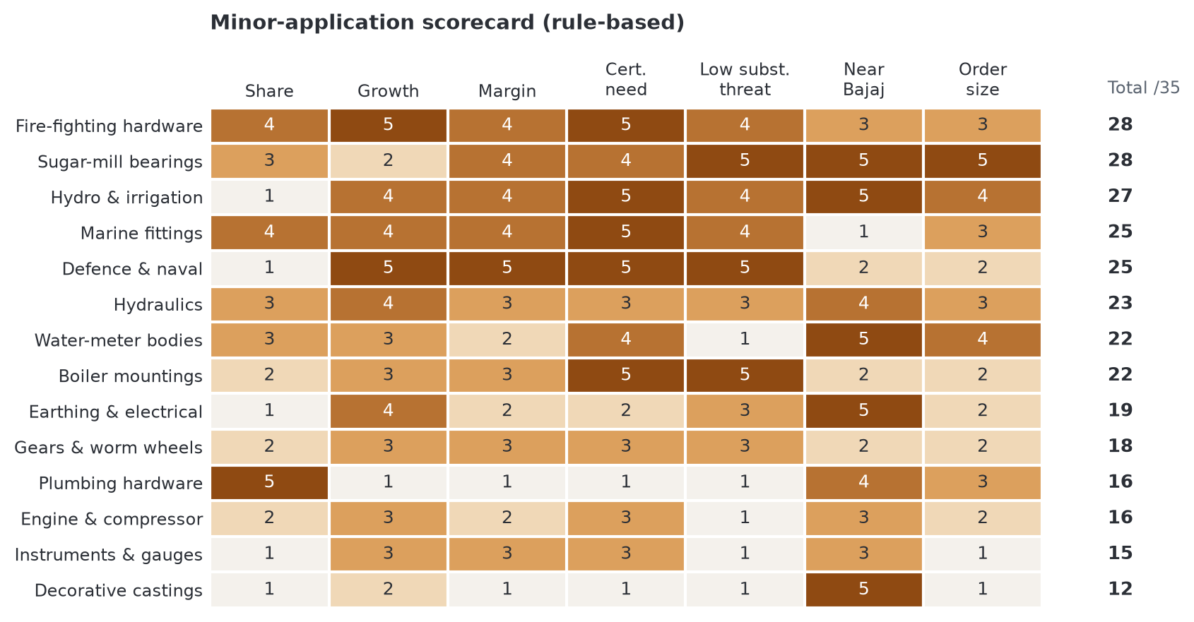
Figure 31. Minor-application scorecard. Fire-fighting hardware and sugar-mill bearings lead at 28; hydro 27; marine and defence 25. Plumbing (16) and decorative castings (12) trail.
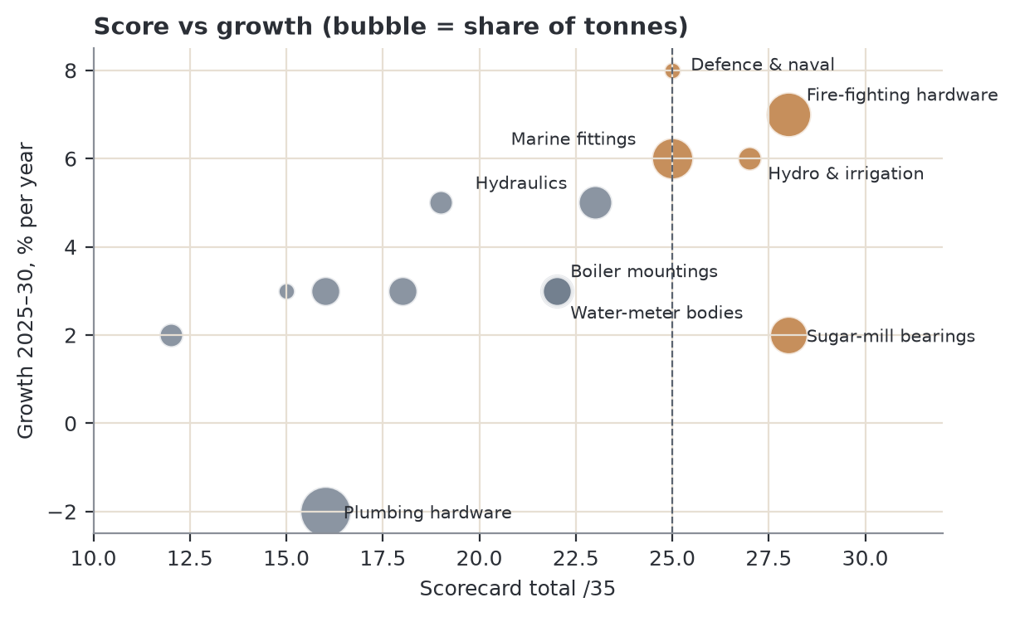
Figure 32. Score against growth (bubble = share of tonnes). The top-right group (fire, hydro, marine, defence) is high-growth and certification-led.
What changed against Rev 5
• Substitute-threat scores now follow the stated rating: meter bodies, instruments and decorative castings (High) are 1, not 2; boiler mountings (Low) is 5, not 4.
• Growth scores are monotonic: +3 %/yr no longer outranks +5 %/yr.
• Hydro scores 5 on proximity (Prithla 130 km, Noida 150, Haridwar 340) and rises from 25 to 27; marine falls to 1 on proximity (coastal buyers > 1,300 km) and from 27 to 25.
• Hydraulics (23), water-meter bodies (22) and boiler mountings (22) form the second tier.

10.2 When customers buy (rebuilt after the red flag)
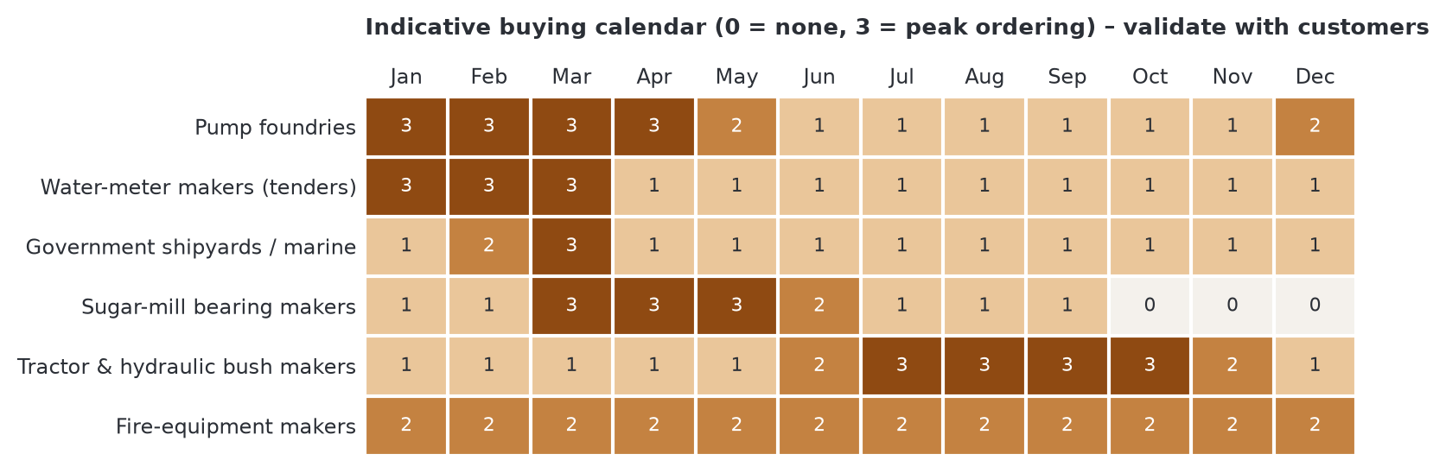
Figure 33. Indicative buying calendar. Pump foundries buy most from January to April ahead of summer irrigation; sugar-mill bearing makers March to June (off-season overhaul); tractor and hydraulic bush makers July to October; meter makers on tenders closing January–March; government shipyards peak at fiscal year-end.
Table 28. Evidence behind each calendar row
Segment | Basis for the pattern | Evidence
Pump foundries | Ordering ahead of summer irrigation and the kharif season | Inferred from the demand cycle
Water-meter makers | Municipal and smart-meter tenders close January–March | Inferred; check tender calendars
Government shipyards / marine | Fiscal-year-end spending (March) | Inferred
Sugar-mill bearing makers | Season crushes about October–March; overhaul April–September, so orders are placed March–May | Cited (season dates); lead time is a field check
Tractor & hydraulic bush makers | Festive and rabi demand; OEM schedules peak July–October | Inferred from tractor-sales seasonality
Fire-equipment makers | Project-driven, repeat monthly orders | Inferred

No row is a measured order book. Validate with five to eight customer calls before planning stock around it. The useful insight holds either way: sugar-mill and tractor bushes fill the monsoon months when pump-casting demand is lowest.

10.3 Profiles of the priority niches (rebuilt after the red flag)
Evidence tags: C cited from a named source in Section 17; I inferred from industry structure; F field check needed. Distances are approximate road km from Bhiwadi.
Fire-fighting hardware · 3.5 % of demand · +7 %/yr · score 28/35
Item | Detail
What is made | Landing and hydrant valves, instantaneous couplings, branch pipes, nozzles, sprinkler and deluge-valve parts [C]
Specification | IS 5290 landing valves: body and bonnet in leaded tin bronze to IS 318 LTB 2, or aluminium alloy or stainless steel. IS 903:2025 couplings, branch pipes and nozzles: gunmetal, stainless steel or aluminium. BIS (ISI) marking; NFPA, UL or FM for exports [C]
Grades | CC491K (= IS 318 LTB 2 = C83600, verified); CC492K (≈C92200) for higher-pressure parts [C/I]
Demand anchor | High-rise buildings, metros, refineries and warehouses under NBC 2016; Gulf EPC projects; +7 %/yr is an estimate [I]
Buyers and clusters | ISI-licensed fire-equipment makers in Rajkot and Ahmedabad (900–1,050 km), Mumbai (1,300), Delhi-NCR (125). Only about a quarter of activity is within 450 km [I]
Buying pattern | Year-round, project-driven, repeat monthly orders [I/F]
Substitute threat | Medium at the cheap end (aluminium couplings); low for ISI landing valves where gunmetal is the default [C]
How Bajaj wins | BIS factory tests reject off-chemistry metal: supply one certificate mapped to IS 318 LTB 2, EN CC491K and UNS C83600; freight-inclusive prices to Gujarat; NCR makers first [I]

Sugar-mill bearings · 2.5 % of demand · +2 %/yr · score 28/35
Item | Detail
What is made | Top-roller, side-roller and tail-bar bearing liners (“mill brasses”), pinion and trash-plate bushes [C]
Specification | Buyer drawings; usually leaded bronze to IS 318 or BS 1400 LB2 / LG2, checked for chemistry and hardness [C/I]
Grades | CC495K (C93700) top-roller liners; CC494K (C93500) and CC493K (C93200) lighter bearings [I]; fit model: CC495K 4.26 for heavy-load bearings
Demand anchor | 541 sugar mills crushed in 2025–26 (as cited in Rev 5; re-verify) [C]. Re-lining every one to three seasons is an estimate [F]
Buyers and clusters | Mill-bearing makers in Ghaziabad and Delhi (e.g. Ganesh Metal Industries, Kamaldeep Metals), 125–160 km; Coimbatore (Sri Sujay Engineering), Pune, Kolhapur. About 55 % of activity within 450 km [C/I]
Buying pattern | Orders March–May for the April–September overhaul; large single castings, seasonal and lumpy [C/F]
Substitute threat | Low: bronze kept for shock tolerance and juice-contamination resistance [I]
How Bajaj wins | Day-trip delivery to Delhi–Ghaziabad; stock CC495K ingot before April (tin working capital: Section 6); turnings buy-back [I]

Hydro & irrigation · 1 % of demand · +6 %/yr · score 27/35 (approval play)
Item | Detail
What is made | Wicket-gate and guide-vane bushes (often graphite-plugged), sluice-gate guides and nuts [I]
Specification | Project specifications and OEM drawings; heat traceability [I]
Grades | CC491K, CC493K, CC495K (30 % each in the grade matrix) [I]
Demand anchor | Pumped storage and canal projects; long tender cycles [I]
Buyers and clusters | Voith Hydro (Noida, ≈ 150 km), Andritz Hydro (Prithla, ≈ 130), BHEL Haridwar (≈ 340) and Bhopal, as named in Rev 5 [C; verify]. About 60 % of activity within 450 km
Buying pattern | Slow vendor approval (12–24 months, estimate), then loyal repeat orders [F]
Substitute threat | Low–Medium: self-lubricating polymers in some bushes [I]
How Bajaj wins | Start vendor registration now; the OEMs are among the nearest large buyers of any niche; small volume (1 %) so treat as an approval play, not a volume line

Marine fittings · 3 % of demand · +6 %/yr · score 25/35
Item | Detail
What is made | Sea-water globe, gate and storm valves, sea-chest strainers, pump casings, stern-tube and rudder bushes, deck fittings [C]
Specification | Class-society rules (IRS, DNV, LR, ABS) with EN 10204 3.1 certificates; naval specifications [C]
Grades | CC491K and CC492K (“Navy M” type) for valves and pumps; CC495K for bushes. Fit model: CC491K 4.27, CC492K 4.25 [C/I]
Demand anchor | ₹69,725 crore shipbuilding package (Sept 2025) targeting 4.5 million GT a year; naval programmes; fishing fleets [C]
Buyers and clusters | Valve and fitting makers in Mumbai, Kochi, Visakhapatnam, Goa and Kolkata (all > 1,300 km); export valve makers in Rajkot and Jamnagar (1,050–1,200) [C/I]. About 5 % of activity within 450 km
Buying pattern | Year-round; government yards peak at fiscal year-end [I]
Substitute threat | Low for valves; medium for pump casings (nickel-aluminium bronze, stainless) [C/I]
How Bajaj wins | Heat traceability and 3.1 certificates; freight-inclusive prices; approvals take time, so run in parallel with the NCR base. Distance is the main weakness

Defence & naval · 0.5 % of demand · +8 %/yr · score 25/35 (approval play)
Item | Detail
What is made | Naval pump and valve castings, gun-mount bushes [I]
Specification | DPSU and shipyard vendor registration; full traceability [I]
Grades | CC492K (≈C92200, 50 % in the matrix), CC491K, CC495K [I]
Demand anchor | Indigenisation lists; +8 %/yr is an estimate [I]
Buyers and clusters | GRSE (Kolkata), Mazagon Dock (Mumbai), Goa Shipyard, ordnance units, as named in Rev 5 [C; verify]. About 15 % of activity within 450 km
Buying pattern | Tender-driven, slow, high-margin [F]
Substitute threat | Low [I]
How Bajaj wins | Registration first, with traceability and 3.1 certificates in place; the smallest niche by volume, so the only goal is margin

Hydraulics · 2 % of demand · +5 %/yr · score 23/35
Item | Detail
What is made | Gear-pump bushes and side plates, cylinder rod-guide bushes, valve-spool sleeves, tractor hydraulic-lift bushes [C]
Specification | OEM drawings, often citing SAE 660 (UNS C93200) [C]
Grades | CC493K (60 %); CC494K for dirty duty (15 %) [I]; fit model: CC493K 3.54
Demand anchor | Record domestic tractor sales of 11.6 lakh units in FY26 (+23 %); construction-equipment growth [C]. Bronze per tractor is an estimate [F]
Buyers and clusters | Faridabad (Escorts Kubota chain, ≈ 110 km), Pune, Ahmedabad, Mohali and Ludhiana, Chennai. About 40 % of activity within 450 km [C/I]
Buying pattern | Monthly OEM schedules; peak July–October [I/F]
Substitute threat | Medium: sintered bronze, steel-backed bimetal and polymer bushes in small high-volume sizes [C]
How Bajaj wins | Faridabad is the closest OEM cluster; certify as “EN CC493K / UNS C93200 / SAE 660”

Water-meter bodies · 2 % of demand · +3 %/yr · score 22/35
Item | Detail
What is made | Multi-jet and single-jet meter bodies and couplings [C]
Specification | IS 779 domestic meters / ISO 4064; potable-water lead limits increasingly written into tenders [C/I]
Grades | CC491K (80 %), CC490K (20 %) traditionally; moving to low-lead gunmetal and brass [I]
Demand anchor | AMRUT 2.0 city water supply; about 1.5 million smart meters deployed under government schemes [C]
Buyers and clusters | Meter makers in Jalandhar (470 km), Delhi (125), Ahmedabad, Kolkata. About 50 % of activity within 450 km [I]
Buying pattern | Tender-driven; peaks January–March [I; check tender calendars]
Substitute threat | High: DZR brass and engineered-plastic bodies [C]
How Bajaj wins | Only with a low-lead gunmetal (Section 16); otherwise a price-only sale on a shrinking base

Boiler mountings · 1.5 % of demand · +3 %/yr · score 22/35
Item | Detail
What is made | Water-level gauge bodies, safety-valve bodies, steam stop, blow-down and feed-check valves [C]
Specification | Indian Boiler Regulations (IBR): material certificates and design approval; IS 318 gunmetal [C]
Grades | CC491K (50 %) within its temperature limit; CC492K (30 %) and CC493K for higher pressure [I]
Demand anchor | IBR boilers in sugar, textiles, food, chemicals and captive power [I]
Buyers and clusters | Boiler-mounting and valve makers in Ahmedabad, Rajkot, Mumbai and Coimbatore, all > 900 km. About 10 % of activity within 450 km [I]
Buying pattern | Regular small lots [I]
Substitute threat | Low: forged or stainless steel only at high pressure [I]
How Bajaj wins | Certificates that satisfy IBR inspectors; small-lot service. Distance limits it to selective selling

10.4 Other minor applications at a glance
Table 29. Remaining minor uses (zone from the GE–McKinsey model, Section 15)
Application | Specification | Main buyers | Substitute threat | Zone | Verdict
Earthing & electrical | IS 3043 practice; gunmetal clamps and fittings | Earthing and line-hardware makers, Delhi and Mumbai | Medium | Selective | Small, opportunistic
Gears & worm wheels | OEM drawings; heavy duty uses phosphor bronze CC483K (C90700) | Gearbox makers in Rajkot, Ahmedabad, Coimbatore | Medium | Selective | CC493K for light duty only
Engine & compressor | OEM drawings | Engine and compressor makers; aftermarket | High (bimetal) | Harvest | Aftermarket only
Instruments & gauges | Process-industry specs | Gauge and flow-meter makers | High (brass) | Selective | Ignore
Plumbing hardware | Lead-free rules spreading | Hardware casters, Jamnagar and Delhi | High | Selective | CC490K as price entry only; shrinking (−2 %/yr)
Decorative castings | None | Moradabad (300 km), Aligarh, Jamnagar artisans | High (brass) | Selective | Ignore; price-driven, scrap-based

What this means for Bajaj Alloys
• Account plans for the top eight (fire, sugar-mill, hydro, marine, defence, hydraulics, meter bodies, boiler mountings): 16 % of demand together.
• Two approval plays: hydro and defence (and marine for class approvals). Start registration now; orders follow in 12–24 months.
• Ignore instruments and decorative castings; sell plumbing and engine bushes only on enquiry.

11. Competitive landscape
India's market has organised ingot makers, integrated foundries that alloy their own melt, and a large unorganised sector that remelts scrap. The companies below appear in public sources for these grades. No reliable market-share data is published.
Table 30. Players
Company | Location | Relevant offer | Type
Bright Metals | India | Leaded bronze ingots, ~50 years in business | Ingot maker (direct competitor)
RJ Metal Industries | Kolkata | IS 318 LTB 1–5 leaded tin bronze ingots and castings | Ingot + castings
Conex Screws & Fasteners | India | CC491K / LG2 sand castings, exports | Foundry (potential customer)
Govind Metal | India | Bearing bronze | Bar/tube supplier
Concast, National Bronze, MetalTek, Busby, Aviva, Farmers Copper | USA | Continuous-cast bearing bronze bar and tube | Global benchmark
UK stockists (Holme Dodsworth, Copper Alloys Ltd) | UK | LG1, LG2, LG4, LB2, LB4 cast bar to EN 1982 | Export benchmark
Unorganised remelters | Jamnagar, Moradabad, Delhi-NCR | Scrap-based gunmetal ingot, often uncertified | Price competitors

Bajaj can beat the unorganised sector on certification and consistency (spectrometer-certified EN chemistry, tight lead and tin control, low impurities) and importers on lead time and rupee pricing. This matters most for CC490K and CC491K, where remelted scrap competes on price. Remelters share Bajaj's scrap-route cost advantage (Section 6.5), so the edge is certification, not metal cost.
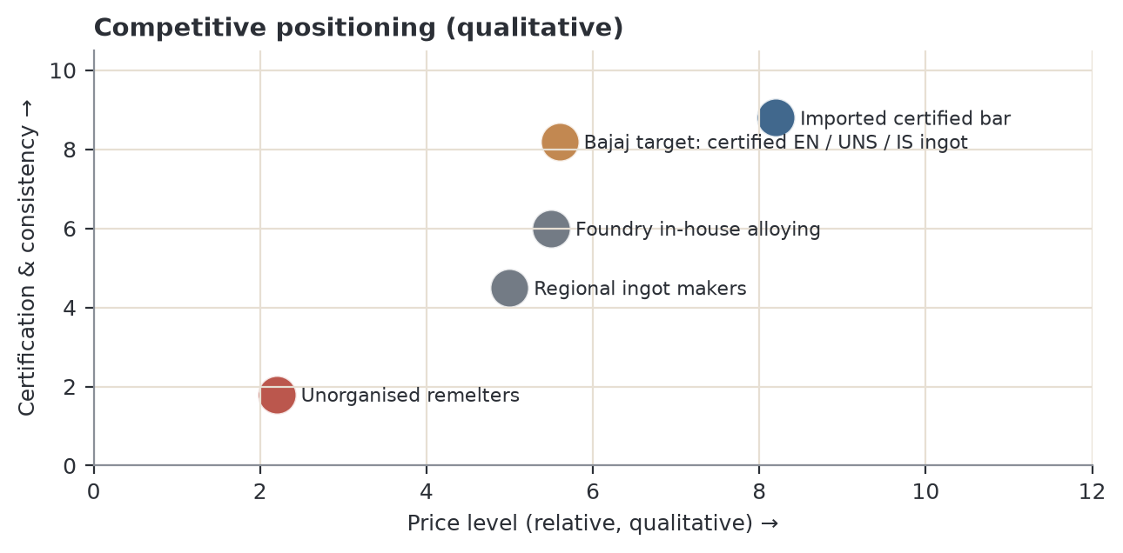
Figure 34. Qualitative positioning of supplier types by price and by certification and consistency. Bajaj's opening is certified EN/UNS/IS chemistry at Indian ingot prices.
Table 31. What each customer segment buys on (qualitative; H high, M medium, L low importance)
Segment | Price | Certified chemistry | Batch consistency | Credit terms | Lead time | Technical support
Export-oriented foundries | M | H | H | M | M | M
Fire-equipment makers (ISI) | M | H | H | M | M | M
Bush makers | M | H | H | M | H | M
Pump / valve foundries (standard) | H | M | H | M | H | L
Plumbing and hardware casters | H | L | L | H | M | L

The segments that value certification most (export foundries, fire-equipment makers, bush makers) are the ones remelters cannot serve. Sell there first.

12. External environment: PESTLE
Each factor is scored from −3 (serious threat) to +3 (strong opportunity) for its effect on Bajaj over the next two to three years. Scores are judgement. Dated facts below are carried over from Rev 5; the tariff and trade-deal items were not re-verified in Rev 6.
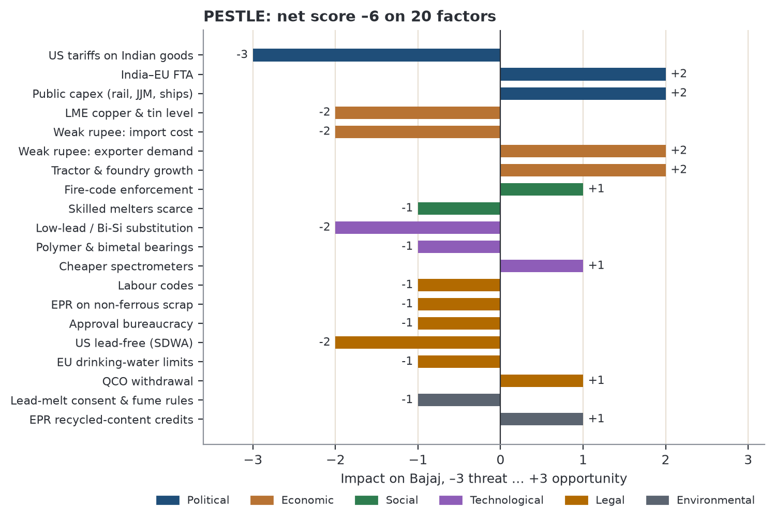
Figure 35. PESTLE impact scores. Net −6 on 20 factors. Biggest threat: US tariffs; biggest opportunities: public capex, India–EU FTA, farm-machinery demand and the weak-rupee boost for exporters.
Table 32. PESTLE factors
Factor | Development | Effect on Bajaj | Score
Political | US tariffs on Indian goods: 50 % (Aug 2025), about 18 % after the Feb 2026 interim deal, plus a 10 % Section 301 duty on many lines from July 2026 (not re-verified) | The USA buys about a quarter of India's pump and valve exports; customers' order books swing with tariff news | −3
Political | India–EU FTA concluded 27 Jan 2026; entry into force targeted for early 2027 | Lower EU duties help pump, valve and bush exporters | +2
Political | Record public capex: railways ₹2.93 lakh crore (FY27); Jal Jeevan Mission to Dec 2028; ₹69,725 crore shipbuilding package; PM-KUSUM to Mar 2027 | Steady demand for pump, valve, railway and marine castings | +2
Economic | LME copper US$ 14,335/t, tin US$ 54,400/t (1 Oct 2026); tin +29 % in 2026 | More working capital; buyers resist price rises; formula pricing essential | −2
Economic (imports) | Rupee ₹96.18/US$ against ≈ ₹90.7 in January; tin almost entirely imported | Every ₹1/US$ adds ≈ ₹15/kg to CC491K metal value; a 5 % rupee fall adds ≈ ₹73/kg | −2
Economic (exports) | Same weak rupee earns exporters more rupees per dollar | Exporting customers win orders and buy more ingot | +2
Economic | Tractor sales record 11.6 lakh (FY26, +23 %); foundry market forecast +9.4 %/yr to 2029 | More demand for bushes, hydraulic parts and castings | +2
Social | More high-rise buildings, metros, stricter fire-code enforcement | Supports fire-pump, hydrant-valve and fire-hardware castings | +1
Social | Experienced melters and moulders are scarce | Raises Bajaj's skill need, but makes consistent ingot more valuable | −1
Technological | Bismuth/silicon bronzes and low-lead gunmetal (CC499K type) replace leaded grades in potable water | Erodes CC490K and part of CC491K over time | −2
Technological | Polymer impellers and bimetal bearings | Take share in light-duty pumps and automotive bushes | −1
Technological | Cheaper optical-emission spectrometers and continuous casting | Raise buyers' quality expectations, favouring certified suppliers | +1
Legal: labour | Four Labour Codes in force 21 Nov 2025 | Higher statutory cost per worker, partly offset by simpler compliance | −1
Legal: recycling | EPR for non-ferrous scrap in force 1 Apr 2026; recycled-content minimums from 2028–29 | Registration and returns cost for Bajaj and its scrap suppliers; scrap may firm | −1
Legal: bureaucracy | Many separate approvals (SPCB consent, hazardous-waste authorisation, factory licence, EPR, GST on scrap, BIS, IBR, export documents) | Slow approvals delay capacity and new grades; fixed compliance cost | −1
Legal | US Safe Drinking Water Act: ≤ 0.25 % weighted lead | All six grades excluded from US potable-water products | −2
Legal | EU Drinking Water Directive: tap lead 10 → 5 µg/l by 2036 (4MS list); RoHS 6(c) exemption to June 2027 | EU potable-water demand drifts to low-lead gunmetal | −1
Legal | 13 Nov 2025 withdrawal of BIS quality-control orders on copper, tin, lead, zinc; nil copper-scrap duty | Cheaper imports of tin and copper; also lowers barriers for imported ingot | +1
Environmental | Lead-bearing melts need SPCB consent, fume extraction, hazardous-waste handling | Compliance cost, but also keeps new entrants out | −1
Environmental | EPR makes recycled content tradeable; ESG audits ask for it | Bajaj's scrap-based ingot can earn EPR credits and be sold as certified recycled content | +1

The weak rupee: two effects, not one
 | Import side (cost) | Export side (demand)
What happens | Tin, imported copper and imported scrap cost more in rupees | Indian pump, valve and bush makers earn more rupees per dollar
Size | ₹1/US$ ≈ ₹15/kg on CC491K; −5 % rupee ≈ +₹73/kg | A 5 % weaker rupee is like a 5 % price cut for the overseas buyer
What Bajaj does | Price on LME × ₹/US$ at the invoice date; buy tin against orders; short quote validity | Target exporting foundries harder while the rupee is weak
Net | Negative but passable to buyers | Positive

PESTLE verdict
• Net −6 on 20 factors, but the positives are structural (public capex, FTAs, farm machinery, export competitiveness) while most negatives are cyclical (metal prices, tariffs) or compliance costs that hit unorganised rivals harder.
• Three factors need action: metal and rupee exposure (formula pricing, tin against orders), lead rules (a low-lead gunmetal by 2027–28) and EPR (register early; sell recycled content).

13. Porter's Five Forces by customer segment
Intensity is rated out of 5 (5 = strongest pressure on Bajaj's margins) for two kinds of buyer. Change from Rev 5: supplier power concerns Bajaj's suppliers (LME metal, imported tin, scrap dealers), who are the same for every customer, so it is now rated 4/5 for both segments. What differs by segment is how much metal cost Bajaj can pass through; that is covered under buyer power and rivalry.
Table 33. Customer segments
Segment | Typical products | Share of demand (est.)
Basic / commodity | Plumbing fittings, low-pressure valves, budget monoblock impellers, light-duty bushes, meter bodies, decorative castings | ≈ 30 %
Standard industrial | General pumps, water-works valves, machine-tool and tractor bushes | ≈ 35 %
Specialised / specified | IS 5290 hydrant valves, IS 903 couplings, fire pumps, marine valves and pumps, heavy mill, crusher and sugar-mill bearings, IBR mountings, defence and hydro parts | ≈ 35 %

Cross-check: the minor uses that are clearly specialised (fire, marine, sugar-mill, boiler, defence, hydro) are 12 % of tonnes; adding heavy and railway bearings (about 9 % of tonnes) and IS 5290 hydrant valves inside the valve segment brings the total to the 30–40 % range, consistent with ≈ 35 % within the ±30 % tolerance.
Table 34. The five forces by segment
Force | Basic product makers | Specialised product makers | What it means for Bajaj
Supplier power | 4/5 · LME metal and imported tin; the same for all customers | 4/5 · same suppliers | Metal cost is ~97 % of price; manage scrap and tin buying
Buyer power | 4/5 · many sellers of uncertified ingot; buyers switch for ₹10/kg; refuse metal pass-through | 2/5 · changing ingot means re-testing and re-approval (ISI type tests, class surveys, OEM approval); accept formula pricing | Specialised accounts are sticky once won
Competitive rivalry | 5/5 · scrap remelters and regional ingot makers compete on price | 2/5 · few suppliers can certify every heat | Compete on certificates, not price
Threat of substitutes | 5/5 · brass/DZR, CPVC/PPR, polymer impellers, sintered and bimetal bushes | 1/5 · standards fix the material (IS 5290 names LTB 2 gunmetal; class rules and OEM drawings name the bronze) | Lead with specialised makers; basic buyers are volume filler
Threat of new entrants | 3/5 · any remelter can make uncertified ingot | 1/5 · approval history, spectro certificates and lead-melt consent take years | Keep consent and certification current
Average | 4.2/5 | 2.0/5

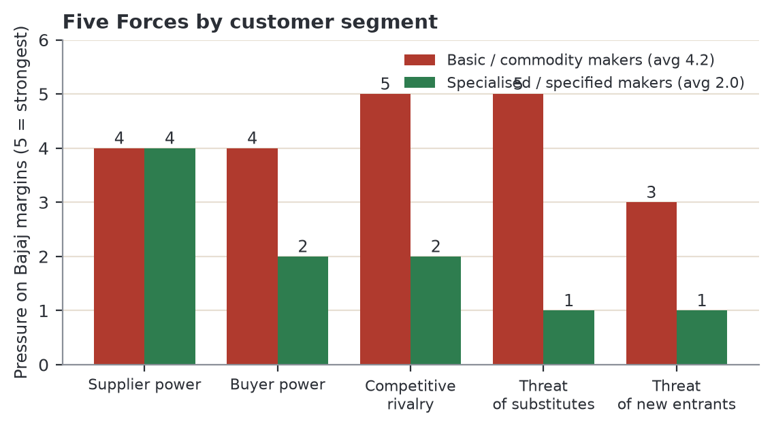
Figure 36. Five Forces by segment: average 4.2/5 for basic makers against 2.0/5 for specialised makers. The widest gap is substitutes (5 vs 1).

Threat of substitutes in detail
A plumbing-fitting caster can switch to brass or plastic overnight, and so can its customers. A hydrant-valve maker cannot: IS 5290 names the material and the BIS licence covers the approved design. A sugar-mill bearing maker will not risk a cheaper alloy on a roller that stops the mill if it seizes.
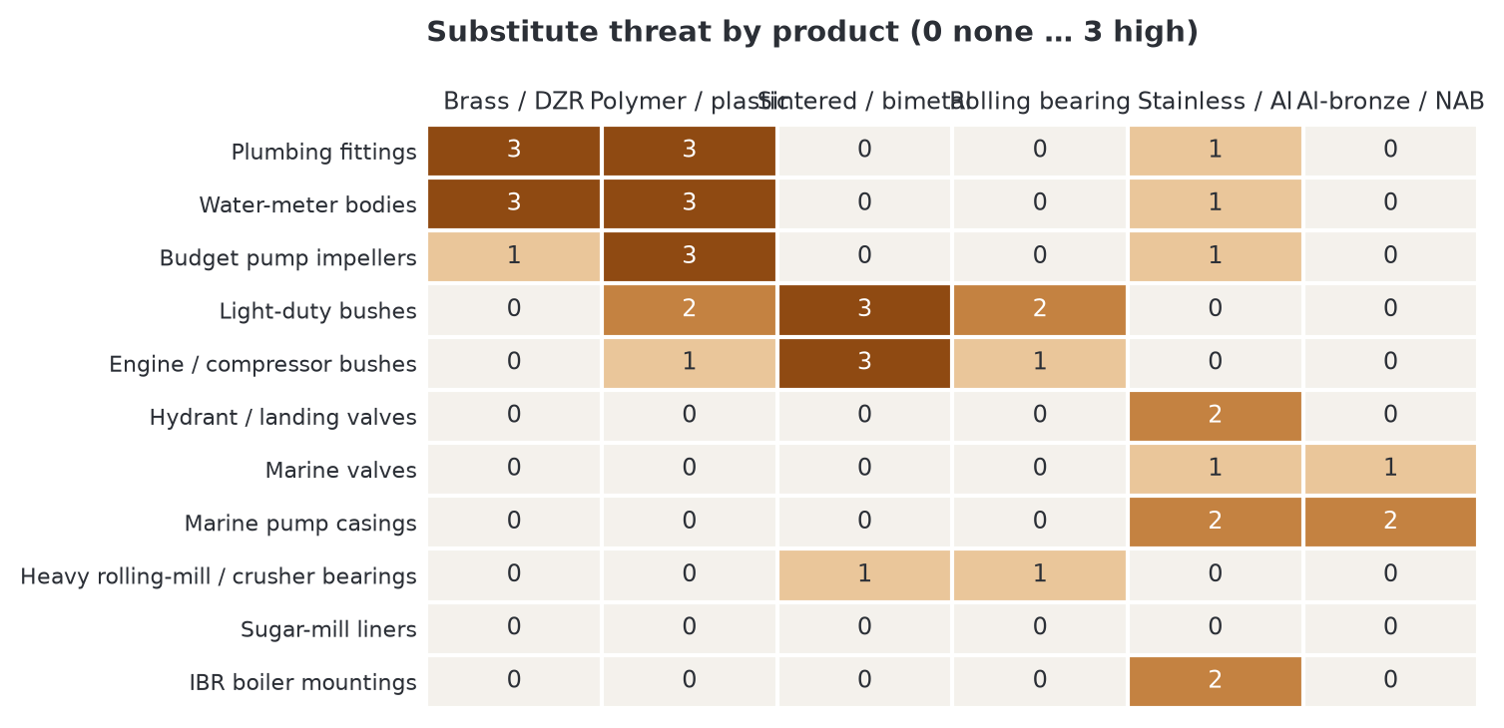
Figure 37. Substitute threat by product and substitute material (0 none … 3 high). Judgement, from standards and duty conditions.
How Bajaj should use the segmentation
• Prioritise specialised makers (≈ 35 % of demand): lower pressure on every force, stickier accounts, room for a certification premium.
• Serve standard industrial buyers (≈ 35 %) on formula pricing and consistency: the volume base.
• Sell to basic makers only at formula price with no credit risk; their demand shrinks under substitutes and lead rules.
• Develop a low-lead gunmetal so that meter and potable-water valve makers can move from the basic to the specified column.

14. SWOT and TOWS
Table 35. SWOT
Strengths (internal) | Weaknesses (internal)
• Existing brass and bronze melting, scrap sourcing and analysis capability (the scrap route in Section 6.5)  • Bhiwadi location: 75–160 km from the Manesar–Gurugram, Faridabad, Delhi, Ghaziabad, Noida and Prithla clusters  • Same furnace route covers all six grades; only the charge mix changes  • Pollution-control consent for lead-bearing melts in place | • Tin must be imported and is volatile (+29 % in 2026); holding it ties up working capital  • CC495K needs careful melt practice to keep 8–11 % lead evenly spread, especially for centrifugal bushes  • No EN or UNS-grade track record yet with export-oriented foundries  • Far from the Rajkot–Ahmedabad (900–1,050 km) and Coimbatore (2,300 km) clusters and from the coast
Opportunities (external) | Threats (external)
• Exporting foundries: US$ 2.1 bn valves and US$ 1.3 bn pumps exported in 2023  • Bushes (25 % of demand) with nearby buyers: Faridabad OEMs, Delhi and Ghaziabad sugar-mill bearing makers, Prithla–Noida hydro  • Specified niches (fire, marine, sugar mills, IBR) where standards lock in bronze  • India–EU FTA from 2027; EPR makes recycled ingot a selling point | • Lead-free drinking-water rules shrink plumbing and meter demand  • Tin supply shocks and copper near record highs; weak rupee raises import cost  • US tariff changes hit Bajaj's foundry customers  • Uncertified scrap remelters undercut in basic segments (and share Bajaj's scrap advantage)  • New labour, EPR and approval costs

TOWS: turning SWOT into strategy
S–O: use strengths to seize opportunities | W–O: fix weaknesses using opportunities
• Become the certified supplier to specialised fire, marine and bearing makers  • Serve Faridabad, Delhi-NCR and Prithla–Noida bush and valve buyers within 48 hours  • Use lead-melt consent and EPR registration to sell traceable recycled ingot | • Overcome the missing track record with trial heats at 3–5 export and specialised foundries, with spectro certificates in EN, UNS and IS terms  • Offset distance from Rajkot and the coast with freight-inclusive prices  • Fund tin through back-to-back purchases on confirmed orders
S–T: use strengths to blunt threats | W–T: minimise weaknesses, avoid threats
• Defend against remelters with certificates and heat-to-heat consistency, not price cuts  • Use LME × ₹/US$ formula pricing so metal and currency swings pass through  • Spread customers across domestic infrastructure, bushes and exports to limit US-tariff exposure | • Make CC494K and CC495K to order to avoid holding high-tin stock  • Develop a low-lead gunmetal before plumbing and meter customers are forced to switch  • Register for EPR early to avoid penalties and scrap-supply disruption

15. Where to sell: GE–McKinsey and Ansoff

15.1 GE–McKinsey nine-box, recomputed
Both axes are computed from stated inputs, so the zone of each application follows from numbers shown earlier. Attractiveness = 30 % size score + 30 % growth score + 25 % margin potential + 15 % low-substitute-threat score (Section 10.1 rules; for the three major uses, size is 5). Business strength = 35 % proximity (share of buyers within 450 km) + 25 % ease of entry (approvals and vendor registration) + 25 % certification advantage + 15 % melt-practice ease (penalty for the CC494K/CC495K share of the application). High ≥ 3.5, medium 2.5–3.5, low < 2.5 on both axes.
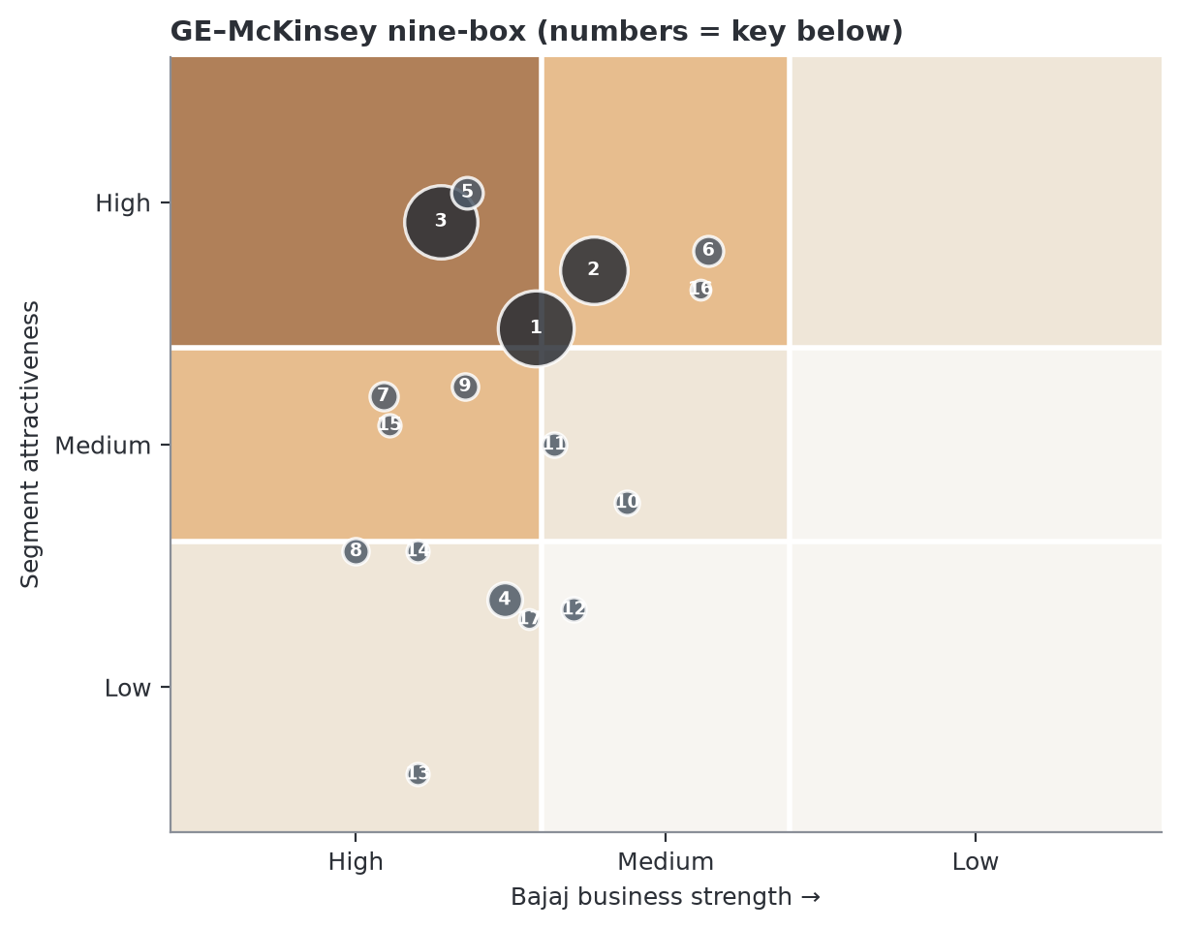
Figure 38. GE–McKinsey nine-box with bubble size = share of tonnes. Numbers are keyed in the table below. Zones: dark = Invest, mid = Build selectively, light = On enquiry, lightest = Harvest/avoid.
Table 36. Nine-box scores and zones
# | Application | Share | Growth | Attract. | Strength | Zone
1 | Pumps | 27 % | +3 | 3.60 | 3.52 | Invest
2 | Valves | 21 % | +6 | 3.90 | 3.29 | Build selectively
3 | Bushes & bearings | 25 % | +5 | 4.15 | 3.91 | Invest
4 | Plumbing hardware | 4.5 % | -2 | 2.20 | 3.65 | On enquiry
5 | Fire-fighting hardware | 3.5 % | +7 | 4.30 | 3.80 | Invest
6 | Marine fittings | 3 % | +6 | 4.00 | 2.83 | Build selectively
7 | Sugar-mill bearings | 2.5 % | +2 | 3.25 | 4.14 | Build selectively
8 | Water-meter bodies | 2 % | +3 | 2.45 | 4.25 | On enquiry
9 | Hydraulics | 2 % | +5 | 3.30 | 3.81 | Build selectively
10 | Gears & worm wheels | 1.5 % | +3 | 2.70 | 3.16 | On enquiry
11 | Boiler mountings | 1.5 % | +3 | 3.00 | 3.45 | On enquiry
12 | Engine & compressor | 1.5 % | +3 | 2.15 | 3.37 | Harvest / avoid
13 | Decorative castings | 1 % | +2 | 1.30 | 4.00 | On enquiry
14 | Earthing & electrical | 1 % | +5 | 2.45 | 4.00 | On enquiry
15 | Hydro & irrigation | 1 % | +6 | 3.10 | 4.12 | Build selectively
16 | Defence & naval | 0.5 % | +8 | 3.80 | 2.86 | Build selectively
17 | Instruments & gauges | 0.5 % | +3 | 2.10 | 3.55 | On enquiry

Table 37. Actions by zone
Zone | Applications | Action
Invest | Pumps, Bushes & bearings, Fire-fighting hardware | Dedicated sales effort; stock CC491K and CC493K; technical support
Build selectively | Valves, Marine fittings, Sugar-mill bearings, Hydraulics, Hydro & irrigation, Defence & naval | Named accounts or approval plays; invest where a customer or approval exists
On enquiry | Plumbing hardware, Water-meter bodies, Gears & worm wheels, Boiler mountings, Decorative castings, Earthing & electrical, Instruments & gauges | Serve at formula price when asked; no dedicated effort
Harvest / avoid | Engine & compressor | Do not chase

What changed against Rev 5 (and why the text now agrees with the chart)
• Hydro and defence were “Harvest/avoid” in the Rev 5 table but were recommended as approval plays in the same report. Computed, both are Build selectively.
• Pumps had business strength 4.0 in Rev 5 although the main pump clusters are 900–2,300 km away; the recomputed strength is 3.52, borderline Invest. Pumps remain a volume base but are not where Bajaj has the edge.
• Valves move from Invest to Build selectively (strength 3.29): the biggest valve clusters (Gujarat, Coimbatore) are far, so Bajaj should start with NCR, Haryana and Punjab valve makers.
• Marine is Build selectively, not On enquiry: attractive but distant; it needs approvals and freight-inclusive pricing.

15.2 Ansoff growth matrix
Market penetration (existing products, existing markets) | Product development (new products, existing markets)
• CC491K and CC493K ingot to existing brass and bronze foundry customers in NCR, Haryana, Punjab and Rajasthan  • Win share from remelters with certificates and LME-formula pricing  • Lowest risk; start now | • Low-lead gunmetal (Pb ≤ 3 %, CC499K type) for potable-water valves and meter bodies  • CC492K for higher-duty castings; CC495K for sugar-mill, steel-plant and crusher bushes  • Medium risk; needs trials and certification
Market development (existing products, new markets) | Diversification (new products, new markets)
• Same six grades to export-oriented clusters (Rajkot, Ahmedabad, Kolhapur, Coimbatore) and to bush buyers in the Rajasthan cement belt and Ludhiana–Mohali  • Fire-equipment, marine and hydraulic makers  • Medium risk; needs sales travel, samples, freight-inclusive pricing | • Continuous-cast bar and bush blanks for bush makers  • Turnings buy-back and EPR recycled-content service  • Highest risk and capex; feasibility study only in year 2

Table 38. Order of moves
Route | Risk | Investment | Timing | Priority
Market penetration | Low | Low (samples, certificates) | 0–6 months | 1
Market development | Medium | Medium (sales travel, stock point) | 3–12 months | 2
Product development | Medium | Medium (trials, test reports) | 6–18 months | 3
Diversification | High | High (casting machines) | 12–24 months, study first | 4

16. Recommendations for Bajaj Alloys
- Lead with CC491K and CC493K ingot. They are 60 % of demand, feed pumps, valves and bushes, and have the easiest melt practice. Label with EN, UNS and IS 318 designations (CC491K = LTB 2) so one ingot serves domestic and export foundries.
- Add CC490K as the economy gunmetal at ₹1,353/kg of metal, ₹108 below CC491K. Target plumbing, hardware and agricultural valve foundries; watch lead-free exposure.
- Offer CC492K for higher-duty and export castings (strongest grade; sea-water and high-velocity water). Quote on the LME formula only.
- Keep CC495K as the premium bearing grade for rolling-mill, crusher, sugar-mill, railway and marine bearings. It earns the same ₹50 conversion as other grades, so price it transparently and manage the tin stock (32 % of its metal value).
- Make CC494K to order as the forgiving grade for tractor, conveyor and textile bushes (fit 3.36 against CC493K 3.26 for tractor duty).
- Price on a published formula (Section 6.1): LME metals × ₹/US$ × (1 + melt loss) + conversion, refreshed weekly. Pass copper and rupee through.
- Run the scrap route as the profit engine. Measure payable % and melt loss per heat; each point of payable % is worth ₹12/kg on a gunmetal. Replace the placeholders in Section 6.7.
- Certify every heat in EN, UNS and IS terms with impurities included; this separates Bajaj from uncertified remelters.
- Sell specialised before basic (Five Forces 2.0/5 against 4.2/5); fire-fighting and sugar-mill bearings first (28/35 each).
- Build the bush book near home: named accounts in Faridabad–Ballabgarh (110 km), Delhi–Ghaziabad (125–160), Noida–Prithla (130–150) and bush-stock makers; offer a turnings buy-back pilot (Section 9.7). Then the cement belt, Ludhiana–Mohali and Haridwar.
- Treat hydro, defence and marine as approval plays: start registration now; budget 12–24 months.
- Go after exporting foundries in stages: NCR and Punjab first; Rajkot, Ahmedabad, Kolhapur and Coimbatore with certified samples and freight-inclusive prices once trials succeed.
- Plan for lead-free: develop one low-lead gunmetal (Pb ≤ 3 %) so the lead phase-out does not cost CC490K and CC491K accounts (meter, plumbing).
- Register for EPR and review exposures monthly: copper, tin, rupee, lead rules and US tariffs in each sales and purchase meeting.
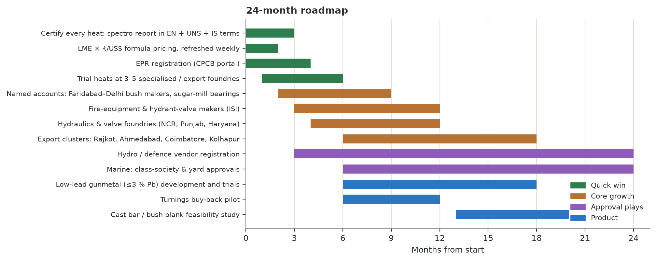
Figure 39. Phased plan for the next 24 months: quick wins first, then core growth, approval plays and product extensions.

KPIs to track
KPI | Target (12 months) | Why it matters
Heats with EN 1982 spectro certificate (with UNS and IS cross-reference) | 100 % | The basis of the edge over remelters
Active leaded-bronze accounts | ≥ 20, none above 15 % of volume | Limits dependence on any one customer
Share of volume to specialised makers | ≥ 35 % (stretch 45 %) | Lowest-pressure segment
Bush-segment accounts | ≥ 8, incl. 2 sugar-mill and 2 OEM-chain, ≥ 5 within 160 km | Best-paying major use; nearest buyers
Minor-niche share of volume | ≥ 10 % | Higher margin, less cyclical
Quotes on LME × ₹/US$ formula | 100 %, refreshed weekly | Passes metal and currency swings through
Scrap payable % (measured) | Within 1 point of plan | Each point = ₹12/kg on a gunmetal
Melt loss (measured) | At or below plan | Each point = ₹14–16/kg
Tin inventory | ≤ 15 days of use | Caps working capital and price risk
Heat rejection by customers | < 1 % | Consistency is the top buying criterion for bush makers
Gross spread per kg (price – scrap-route metal cost) | ≥ plan (₹124/kg at base case) | The margin an ingot maker controls

17. Data verification, change log and sources

17.1 Status of every data class
Table 39. Verification status
Status | Data item
Verified | Composition limits for all six grades (Viiplus EN 1982 reproduction). LME cash settlements 1 Oct 2026 and the 2026 monthly series (Westmetall); cross-check 5 Oct 2026: copper 3M ≈ US$ 14,259/t, tin ≈ US$ 54,277/t. US$/INR 96.18, 2 Oct 2026 (Trading Economics).
Verified (new) | Minimum GC mechanical properties for all six grades confirmed against a second public source set (MakeItFrom, supplier datasheets via search extracts); sand-cast values confirmed for five grades. Direct access to some datasheet sites was blocked; official standard text not checked.
Verified (new) | IS 318 LTB 2 = BS 1400 LG2 = 85-5-5-5 = UNS C83600 (Conex, Copper Alloys Ltd and other supplier pages).
Verified | India export values and destinations 2019–2023 (TrendEconomy / UN Comtrade). Market sizes for pumps and valves (IMARC). C93200 limits (Bunting Bearings). IS 5290 material clause; IS 903:2025 scope.
Carried over, not re-verified | US tariff timeline; India–EU FTA status; Labour Codes; EPR for non-ferrous scrap; QCO withdrawal; JJM, railway capex, shipbuilding package, PM-KUSUM; tractor sales; sugar-mill count; named companies and plants. These are as in Rev 5 with their original sources.
Estimate | Application shares and grade split (±30 %); growth by application; margin, certification and order-size scores; requirement weights; pressure-tightness and corrosion ratings; share of buyers within 450 km; cluster distances (±15 %); melt loss, conversion, casting and machining costs; scrap payable %; calendar; PESTLE and Five Forces scores; segment shares.
Proxy | Market sizes are for pumps, valves, bronze and bearing bronze overall. No grade-level market data exists publicly. IMARC India valves and HS 8481 exports are different scopes (Section 4).
Open: needs Bajaj data | Actual melt loss and conversion cost per grade; scrap mix and payable %; tin purchase terms; customer list by cluster; real bush-maker quotes to test Section 9.7; the CB ingot table of EN 1982; IS 318 mapping for LTB 1, 3, 4, 5.

17.2 Conflicts found in Revision 5 and how each was resolved
Table 40. Conflict log
# | Where | Conflict | Resolution
1 | Sec 5.2 vs Fig 1 and Sec 9 | CC492K nominal 87-7-3-3 in one heading, 88-7-3-2 in the chart and price model | 88-7-3-2 everywhere
2 | Exec summary vs Sec 2 | “Gunmetals contain 2–9.5 % zinc”; CC492K limit is 1.5–3.0 % | 1.5–9.5 %
3 | Exec/Sec 9 | “Metal is 94 % of ex-works price” while melt loss is added to metal | Metal incl. melt loss is 97 %; LME metal value alone is 94 %
4 | Sec 9 | “1 % copper error costs more than a quarter of the margin” | It is ₹12/kg = 24 % of ₹50: “nearly a quarter”
5 | Sec 16 | CC495K “highest rupee margin” vs a flat ₹50 conversion | Withdrawn; margin is similar per kg, financing need is higher
6 | Exec, Sec 3 | Strength “falls as lead rises”; CC495K (10 % Pb) is stronger than CC494K (9 %) and the lowest-lead grade CC492K is strongest | Strength follows tin and the zinc/lead balance
7 | Fig 21 vs 8.4 and profiles | Substitute-threat scores contradicted stated High/Low ratings | Rule-mapped scores
8 | Fig 21 | Growth scores not monotonic (+3 % outscored +5 %) | Threshold rule
9 | Fig 21 vs 8.4 | Hydro “close to Bhiwadi” in text, proximity score 2 | Proximity 5 (Prithla, Noida, Haridwar)
10 | Sec 15 vs Sec 8, 16 | Hydro and defence “Harvest/avoid” yet “approval plays: start registration now” | Computed Build selectively; approval plays
11 | Fig 33 vs Sec 14 | Pumps business strength 4.0 although main pump clusters are 900–2,300 km away | Recomputed 3.52
12 | Fig 33 vs Fig 21 | Marine 3rd on scorecard but “Selective” in nine-box | Recomputed Build selectively
13 | Exec, Sec 7 | Rajasthan cement belt listed among “nearest” bush buyers (340–540 km) | Nearest = Faridabad, Delhi, Ghaziabad, Noida, Prithla
14 | Sec 14 | Bhiwadi “close to Gujarat foundry clusters” (900–1,050 km) | NCR, Haryana, Punjab, Rajasthan
15 | Sec 13 | Supplier power rated differently by customer segment although suppliers are the same | 4/5 for both; specialised average 2.0 (was 1.8)
16 | Sec 4 vs Sec 5 | IMARC India valves US$ 2.8 bn vs HS 8481 exports US$ 2.12 bn (different scopes) | Caveat added
17 | Sec 2.2 | IS 318 equivalence implied for all grades without a source | Only LTB 2 verified; others “confirm”
18 | Sec 4 | Bearing-bronze CAGR 5.0 % vs 4.8 % recomputed | Both shown

17.3 Sources
- Viiplus — EN Casting Copper Alloy datasheet (EN 1982 compositions and minimum properties)
- Zollern — Rg5 / CC491K datasheet
- United Cast Bar — non-ferrous catalogue
- Total Materia — gunmetals and leaded bronzes
- Drysdale Brothers — CC492K gunmetal
- Copper Alloys Ltd — LG4 (CC492K), LG2
- Alumeco — CC495K, CC493K datasheets
- Bronzeoilless — CC493K casting bronze bushings
- Peerless Pump — AEF split-case fire pump
- Westmetall — LME copper, tin, lead and zinc cash settlement 2026
- Trading Economics — Indian rupee; X-Rates — USD/INR monthly averages 2026
- IMARC — India and global pumps; India and global industrial valves; India smart water meters
- Market Data Forecast — bronze market; Verified Market Reports — bearing bronze market; HTF MI — bearing bronze by application
- TrendEconomy — India exports HS 8481, 8413, 8483, 7419, 7403
- India Briefing — US–India interim trade deal; TIGI — India–US tariff timeline
- Copper Development Association — brass for European potable water (4MS); Normachem — RoHS 6(c)
- Argus (QCO withdrawal); PIB (Labour Codes); Down To Earth and Lexology (EPR); Business Standard (JJM); PRS India (railways); Maritime Gateway (shipbuilding); TractorGuru; ChiniMandi; ORF and CNBC (India–EU FTA); Franchise India (PM-KUSUM); Foundry Channel; IEEFA (tin)
- Bunting Bearings — C93200 load, speed and PV limits; BIS — IS 5290 and IS 903 manuals
- KVIC/PMEGP — gun metal bushes; Conex; Bright Metals; RJ Metal Industries; Smith Metal; Ganesh Metal Industries; Kamaldeep Metals; Sri Sujay Engineering; Rathod Precision Bearings
- Bajaj Alloys — Copper & Brass Scrap Procurement Report, 4 Oct 2026 (internal; brass-scrap quotes ₹890–990/kg, copper spot US$ 14,347/t on 2 Oct)
- New in Rev 6: MakeItFrom — EN CC490K, CC491K, CC492K, CC493K, CC494K datasheets (https://www.makeitfrom.com); KMM Bronze — EN 1982 alloy directory (https://kmmbronze.com/alloys-directory/); SteelNumber — CuSn alloys (http://www.steelnumber.com); Conex — LG2 / IS 318 LTB 2 (https://www.conexscrews.com); Mining.com and Metalcharts — LME 5 Oct 2026 cross-check
Prepared for internal use at Bajaj Alloys. Metal prices move daily: refresh the LME inputs before using any rupee figure in a quote.

