PROCUREMENT REPORT | RAW MATERIAL SOURCING
Copper & Brass Scrap Procurement
Prepared for Bajaj Alloys, Bhiwadi
Report date: 4 October 2026 | Basis: public web sources (Section 8) | Status: draft for buyer review

Summary
Copper and brass scrap is the main input covered in this report. Grades are traded under ISRI code names such as Barley, Candy, Birch, Cliff, Honey and Ebony, so every purchase order should quote the ISRI name and the copper percentage. Industrial sellers (PSUs, railways, large manufacturers) release scrap through e-auctions. Government lots run mainly on MSTC and IREPS. Private corporate lots run on platforms such as mjunction, Metaljunction and BidMyScrap.
Indicator | Value (source)
Copper price | US$14,347 per tonne spot on 2 Oct 2026. LME 3-month close on 4 Oct 2026: US$14,258.50 per tonne (MetalCharts, Trading Economics).
Import duty | Basic customs duty on copper and brass scrap is nil since Union Budget 2025-26. IGST 18% still applies (Recycling Today, Patron Accounting).
Railways scrap | About Rs 3,500 to 4,000 crore of scrap sold each year, 100% through e-auction (Indian Railways).
MSTC | Scrap is about 50 to 52% of MSTC e-commerce revenue (MSTC FY2025-26 results coverage).
Read this first. Several data sites (scrap price portals, trade-statistics sites, MSTC and mjunction pages) could not be opened directly in the research environment, so figures come from search-result extracts of those sites, not from the full pages. Every number carries its source. Section 7 lists figures that conflict or need a check before a purchase decision. Nothing was found about Bajaj Alloys' own volumes or product mix, so no company-specific consumption figure is stated.

1. Copper and brass scrap grades (ISRI)
ISRI (the Institute of Scrap Recycling Industries, now ReMA) publishes the Scrap Specifications Circular. It gives every grade a code word and a written specification, and it is the common language of international scrap trade. For a contract, the current Circular is the authority.
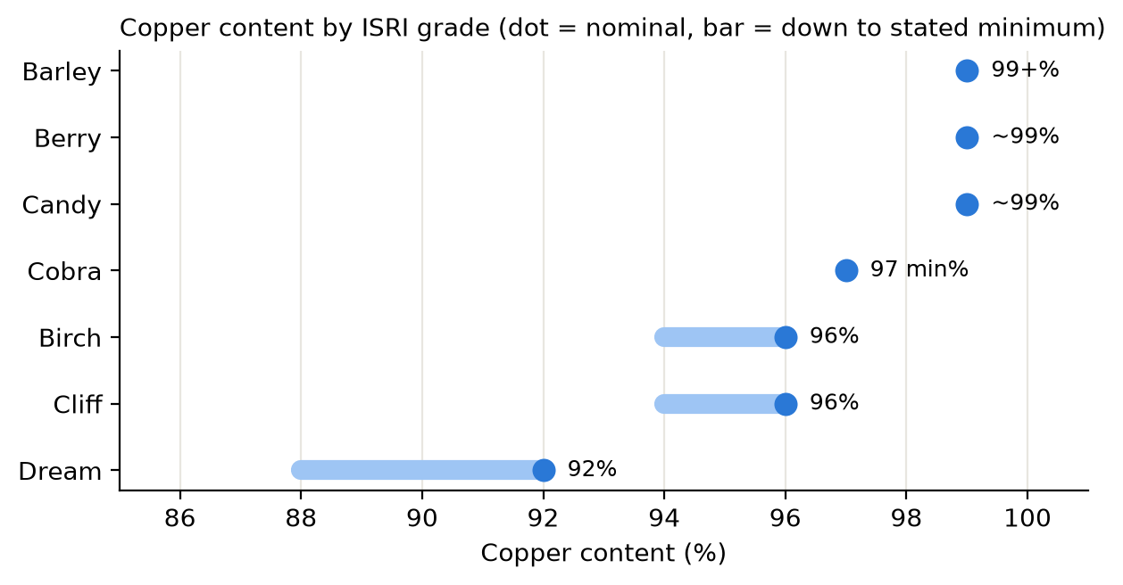
Figure 1. Copper content by ISRI grade. Axis starts at 85%.
ISRI code | Material | Specification in short
Barley | No. 1 bare bright copper wire | Bare, uncoated, unalloyed copper wire. 99%+ Cu. Highest-value wire grade.
Berry | No. 1 copper | About 99% Cu. Grouped with Candy in the source.
Candy | No. 1 heavy copper | Clean, unalloyed, uncoated clippings, punchings, bus bars, commutator segments and wire at least 1/16 inch thick. No brittle burnt wire. May include clean copper tubing.
Cobra | No. 2 copper wire nodules | Unalloyed No. 2 wire scrap nodules, 97% Cu minimum.
Birch | No. 2 copper wire | Miscellaneous unalloyed copper wire. Nominal 96% Cu, 94% minimum by electrolytic assay.
Cliff | No. 2 copper | Miscellaneous unalloyed copper scrap. Nominal 96% Cu, 94% minimum by electrolytic assay.
Dream | Light copper | Sheet copper, gutters and similar. Nominal 92% Cu, 88% minimum by electrolytic assay.
Honey | Yellow brass solids | Mixed yellow brass: castings, rolled brass, rod, tubing, miscellaneous yellow brasses, including plated brass. Clean, free of other metals.
Ebony | Composition or red brass | Red brass scrap, valves, machinery bearings and machinery parts. Alloys of copper, tin, zinc and/or lead.
Lake | Refinery brass | Brass grade for refinery feed.
Lamb | Brass small-arms shells | Clean, muffled (popped) 70/30 brass shells, free of bullets, iron and foreign material.
Ebulent | Lead-free bismuth brass solids | Castings alloyed with copper, tin, bismuth and zinc. Less than 0.2% alloyed lead.
The Indian trade also uses local names. Purja, Honey and Chadari (sheet) are the brass grades quoted in Delhi and Mumbai price lists. No official mapping from these names to ISRI codes was found, so confirm the grade against a sample.

2. Market indicators
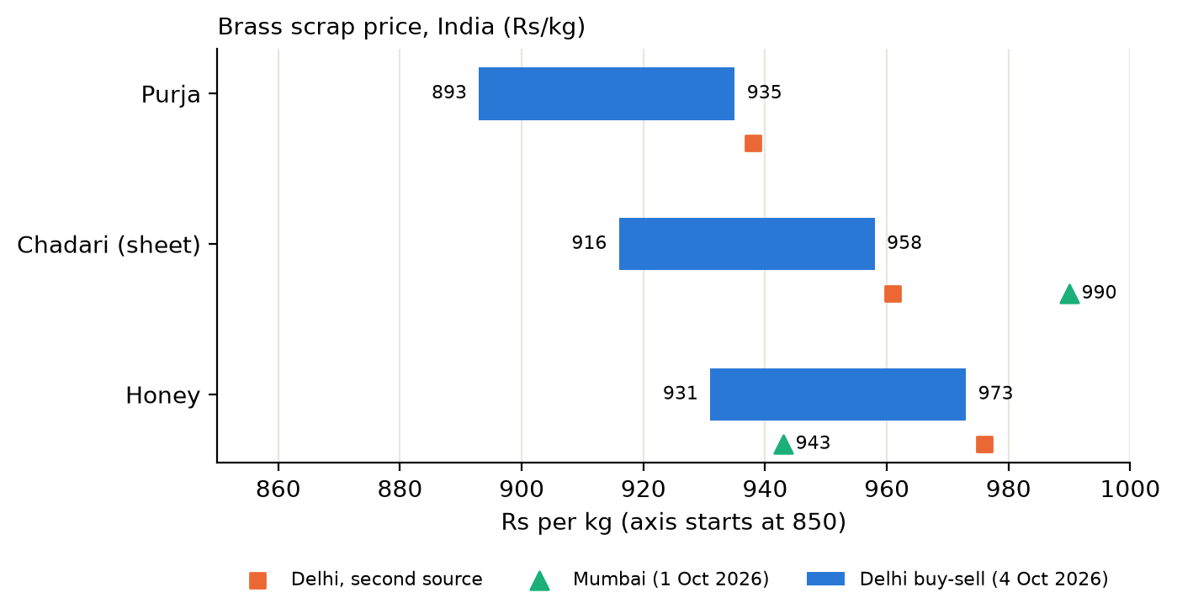
Figure 2. Brass scrap price, Delhi and Mumbai (Rs per kg). Sources: Shree Metal Prices, ScrapC and other Indian price portals. Quotes are dealer prices and indicative.
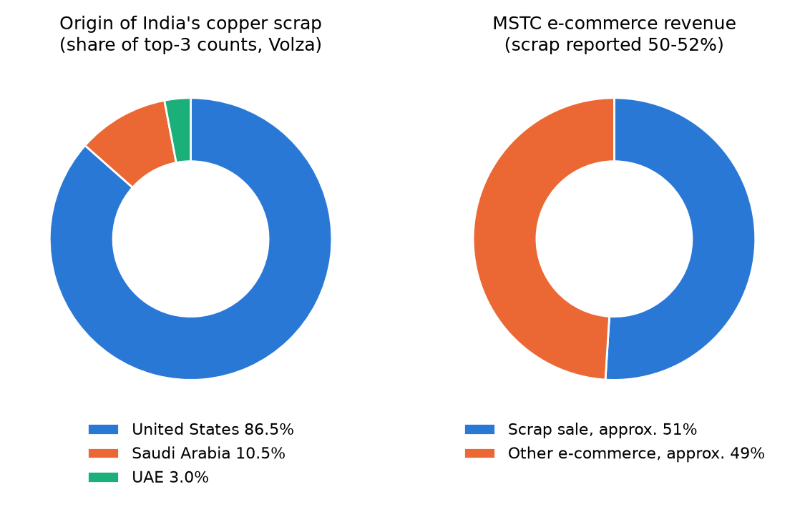
Figure 3. Left: origin of India's copper scrap imports (Volza). Right: MSTC e-commerce revenue split (midpoint of 50 to 52%).
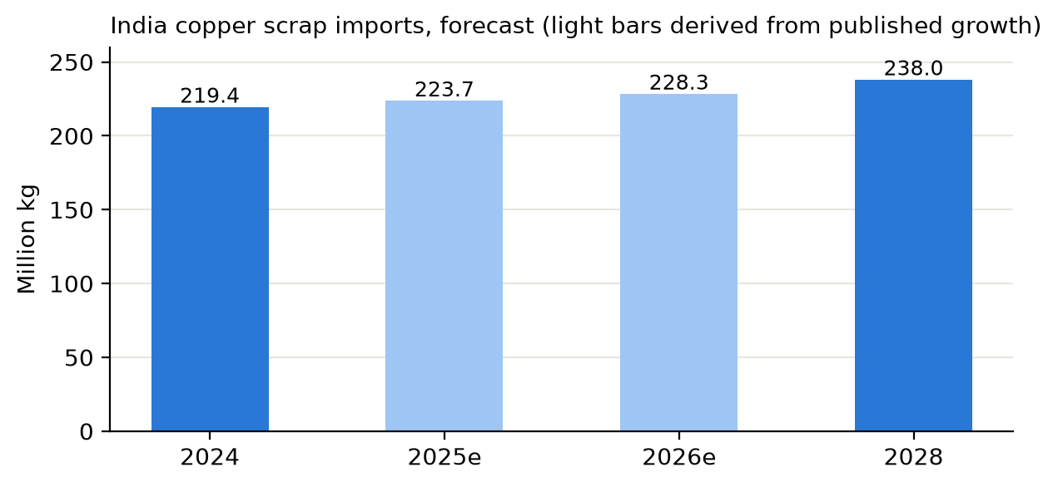
Figure 4. India copper scrap imports forecast, million kg. 2024 (219.44) and 2028 (238.0) are published; 2025 and 2026 are derived from the published +1.92% and +2.09% growth.

Other indicators
- Copper scrap imports into India rose 29% in the year to May 2025 (27,029 shipments, June 2024 to May 2025). India is the largest importer of copper scrap, mainly from the United States, Saudi Arabia and the UAE (Volza, SEAIR).
- India accounted for about 70% of global brass scrap import shipments (20,005 shipments) (Volza).
- India's copper demand was 1.878 million tonnes in FY2025, up 9.3% (Indian Copper Association).
- Budget 2025-26 removed basic customs duty on copper and brass scrap (HSN 7404, tariff items 74040012, 74040019, 74040022). IGST 18% and the social welfare surcharge still apply.
- Jamnagar in Gujarat is the brass-processing hub that sets national brass scrap prices (Indian price portals).
Note on Figure 3 (left). The three origin counts add up to more than the 27,029 total shipments quoted for the same trade, so they likely use a different period or counting basis. Use the chart for ranking, not absolute volumes.

3. Private scrap auction platforms
Corporate sellers (manufacturers, steel and engineering plants) run e-auctions or list material on these platforms. Registration usually needs company PAN and GST details and often a refundable deposit. Exact terms were not available from the sources, so check each site.
Platform | Operator | What the sources say | Relevance for Cu / brass
mjunction (mjunction.in) | Joint venture of SAIL and Tata Steel | Corporate scrap e-auction platform. More than Rs 1,50,000 crore GMV a year across the platform. Scrap includes vehicle parts, building supplies, surplus and recovered metals. | High. Large corporate sellers. Watch for mixed non-ferrous lots.
Metaljunction (auction1.metaljunction.com) | mjunction group | Open auction listings for ferrous and non-ferrous scrap, including aluminium scrap and burr. | High. Non-ferrous lots listed publicly.
BidMyScrap (bidmyscrap.com) | C1 India Pvt. Ltd. | Corporate scrap e-auction service with a manufacturing-scrap offering. | Medium. Process scrap, often turnings and offcuts.
Salasar Auction (salasarauction.com) | Private operator | Online scrap auctions. Has a general metal scrap price page with a copper category. | Medium. Useful as a price reference.
Metalbook (metalbook.com) | Private digital marketplace | Marketplace for ferrous and non-ferrous metals including copper and recycled metals. Real-time pricing, logistics and financing. Not an auction house. | Medium. Quote-based buying alongside auctions.
Auction India (auctionindia.com) | TVS group | Industrial surplus: metal, non-metal, machinery, e-waste, scrap. | Medium. Surplus lots with metal content.
SteelEZ, MSP Auction | Private operators | Nationwide e-auctions for steel and general scrap. | Low. Mostly ferrous.
Recykal | Private, Hyderabad, launched 2016 | Recyclables marketplace connecting more than 4,000 scrap dealers with recyclers. | Low. Dealer-level, small lots.
ScrapUncle was also found. It is a doorstep pickup service for households, not a bulk industrial source, so it is left out of the shortlist.

4. Government scrap auction platforms
Central ministries, PSUs, railways and defence units dispose of scrap by e-auction. Lots are large and terms are published.
Platform | Run by | What the sources say | Relevance
MSTC e-Auction (mstcecommerce.com) | MSTC Ltd, Miniratna Cat-I PSU under the Ministry of Steel | Runs scrap, surplus, coal and mineral e-auctions for PSUs, railways, defence and ministries. Scrap is about 50 to 52% of e-commerce revenue. FY2025-26 e-auction and e-sale revenue: Rs 321.29 crore of Rs 329.72 crore e-commerce revenue. | High. First place to register.
IREPS (ireps.gov.in) | Indian Railways | All railway scrap sold by e-auction, about Rs 3,500 to 4,000 crore a year. Bidders need IREPS registration and a Class III digital signature certificate. | High. Brass and copper items from depots and workshops.
GeM Forward Auction (gem.gov.in) | Government e-Marketplace | Disposal of government assets, including vehicles, by registered buyers. Growing across central ministries. | Medium. Occasional metal lots.
Institute and PSU own portals | Individual departments | Some bodies publish their own scrap e-auctions. Others route through MSTC. | Low. Case by case. Monitor via tender aggregators.

5. Platform comparison
What each source states about the platform. S = stated, I = implied, - = not shown. This is a reading of the sources, not measured data.
Platform | Type | Non-ferrous / copper shown | Corporate sellers | Govt / PSU sellers | Public listings or price page
MSTC | Govt | I | S | S | S
IREPS | Govt | I | - | S | S
GeM Forward Auction | Govt | - | - | S | I
mjunction | Private | I | S | - | I
Metaljunction | Private | S | S | - | S
BidMyScrap | Private | I | S | - | I
Salasar Auction | Private | S | I | - | S
Metalbook | Private | S | I | - | S
Auction India (TVS) | Private | I | S | - | I

6. Suggested sourcing approach
- Register on the government platforms first: MSTC and IREPS. IREPS needs a Class III digital signature certificate. Allow time for approval before the first auction you want.
- Register on the private platforms: mjunction and Metaljunction first, then BidMyScrap. Set keyword alerts for copper, brass, gunmetal, bronze, radiator, cable and turnings.
- Quote the ISRI grade in every bid and PO, for example "Honey, yellow brass solids, clean". Ask for a copper assay on Cu grades. Candy, Birch and Cliff differ by purity.
- Inspect before you bid. Auction lots are normally sold as seen. Visit the yard or request photos and a sample. Check for iron, lead, plastic and moisture.
- Set a ceiling price from LME plus a grade discount. Use the brass range in Section 2 as a cross-check against the local market.
- Include tax and freight: GST on scrap, TCS where applicable, loading, transport to Bhiwadi and deposit lock-up. Compare lots on delivered cost per kg of copper content.
- Keep an import option open. With nil basic customs duty, imported grades from the US, Saudi Arabia and the UAE are comparable with domestic lots on delivered cost.

7. Data limits and checks needed
- Direct page access was blocked for most price and statistics sites. Figures are from search extracts. Open each source link and confirm before use.
- Duty rate is reported two ways. Most sources say basic customs duty is nil on copper scrap. One says 2.5%. Confirm the current rate for HSN 7404 on the CBIC tariff.
- An older brass price conflicts. One source quotes brass scrap at Rs 280 to 320 per kg in Jamnagar for Q1 2026. October 2026 quotes are about Rs 890 to 990 per kg. The older figure looks outdated or in a different unit and is not used.
- Price portals publish dealer buy-sell quotes. They are indicative. Auction clearing prices differ.
- No auction results data was found. Past clearing prices for copper and brass lots on MSTC, IREPS and mjunction are not public in the sources found. Pull them from the live platforms after registration.
- Ocean, Cocoa, Clove, Drove and Tone were searched but no verified specification text was found, so they are not listed. Take them from the current ISRI Circular.
- Bajaj Alloys' own requirement (tonnes per month, grades used, products) is needed to size bids and rank the platforms.

8. Sources
- ISRI Scrap Specifications Circular (Scribd copy)
- ISRI Circular 2007 edition (Columbia)
- ISRI Circular 2008 edition
- MercatoMetalli: ISRI specifications
- Trading Economics: copper
- MetalCharts: LME copper
- Shree Metal Prices: Delhi scrap
- ScrapC: Delhi scrap price
- Volza: copper scrap imports India
- Volza: brass scrap imports India
- SEAIR: copper scrap import-export
- Reportlinker: import forecast
- Indian Copper Association
- Recycling Today: India drops scrap levies
- Patron Accounting: copper import duty
- MSTC e-auction services
- MSTC FY2025-26 results (Multibagg)
- Indian Railways e-auction for scrap
- IREPS
- mjunction
- Metaljunction auctions
- BidMyScrap
- Salasar Auction
- Metalbook
- Auction India
- Recykal (The Better India)

