BAJAJ ALLOYS, BHIWANI
VALVES
Complete Industry & Product Report: Product, Types, Manufacturing, Market, B2B / B2C

Prepared by: Intern, Business Research
Date: October 2026
Status: Draft for management review

Contents
- 1. Executive summary
- 2. What is a valve?
- 3. Types of valves
- 4. Alloys used in making valves
- 5. Manufacturing process
- 6. Quality testing & standards
- 7. Market size & growth
- 8. B2B and B2C market
- 9. Competition
- 10. Opportunity & recommendations for Bajaj Alloys
- 11. Data notes & sources

1. Executive summary
A valve is a mechanical device that starts, stops, regulates or directs the flow of liquids, gases, steam or slurries through a pipe. Valves are used in almost every industry: water supply, oil & gas, power, chemicals, pharma, food, HVAC, plumbing and the home. For a brass and copper-alloy foundry such as Bajaj Alloys, valves are one of the largest end-products for cast and forged brass: bodies, bonnets, stems, ball and seat parts are all made from brass, bronze and gunmetal.
- Market: India industrial valves was about USD 3.7 billion in 2024 and is forecast at about USD 5.9 billion by 2030 (about 7.7% CAGR, TechSci Research). Other publishers give USD 2 to 5.8 billion because of different scope.
- Where brass fits: Small and medium valves (up to about 4 inch / DN100) for water, plumbing, gas, HVAC and fire-fighting are mostly brass or bronze. Large process valves are mostly cast iron, steel or stainless steel.
- Channels: B2B (OEMs, contractors, industry, government) is the larger part of value. B2C (plumbing retail, hardware shops, online) is smaller in value but grows steadily with housing.
- Recommendation: Start with brass ball valves, gate valves and cocks for plumbing and agricultural use, and sell through distributors (B2B2C); then move to certified fire and gas valves and OEM supply.
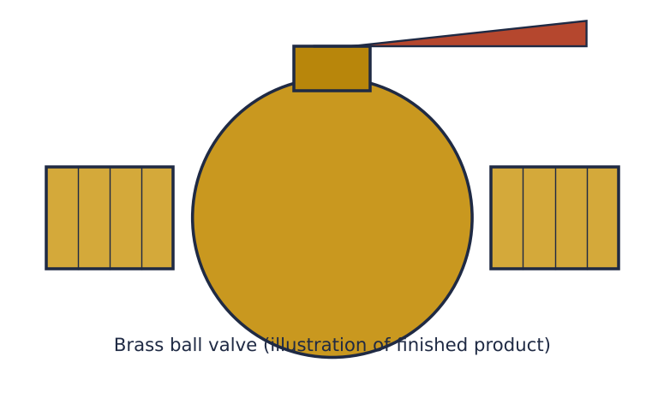
Figure 1: Brass ball valve, illustration of a typical finished product

2. What is a valve?
A valve is a flow-control device. Inside it, a movable element (gate, disc, ball, plug, flap or diaphragm) opens, closes or partly blocks a passage. An operator (hand lever, wheel, gear, motor, air cylinder or solenoid) moves that element.

Main parts of a valve
Table 1: Valve parts and materials
Part | Function | Usual material (brass valve)
Body | Pressure-holding shell with the flow passage | Forged or cast brass (CW617N, IS 292 / IS 318 grades)
Bonnet / cover | Closes the body and holds the stem | Brass
Stem / spindle | Transfers motion from handle to closure element | Brass, dezincification-resistant brass, stainless steel
Closure element | Gate, ball, disc or plug that stops the flow | Chrome-plated brass ball, bronze disc
Seat / seal | Gives leak-tight sealing | PTFE, nylon, rubber, metal seat
Handle / actuator | Moves the stem | Zinc/Al alloy, steel, or motorised/pneumatic
Gland / packing | Stops leakage around the stem | PTFE, graphite, O-ring

Why valves matter
- Isolation: shut off a section for repair.
- Regulation: control flow rate or pressure.
- Protection: stop back-flow or release over-pressure.
- Distribution: divert flow in different directions.

3. Types of valves
Valves are classified by motion of the closure element and by function.
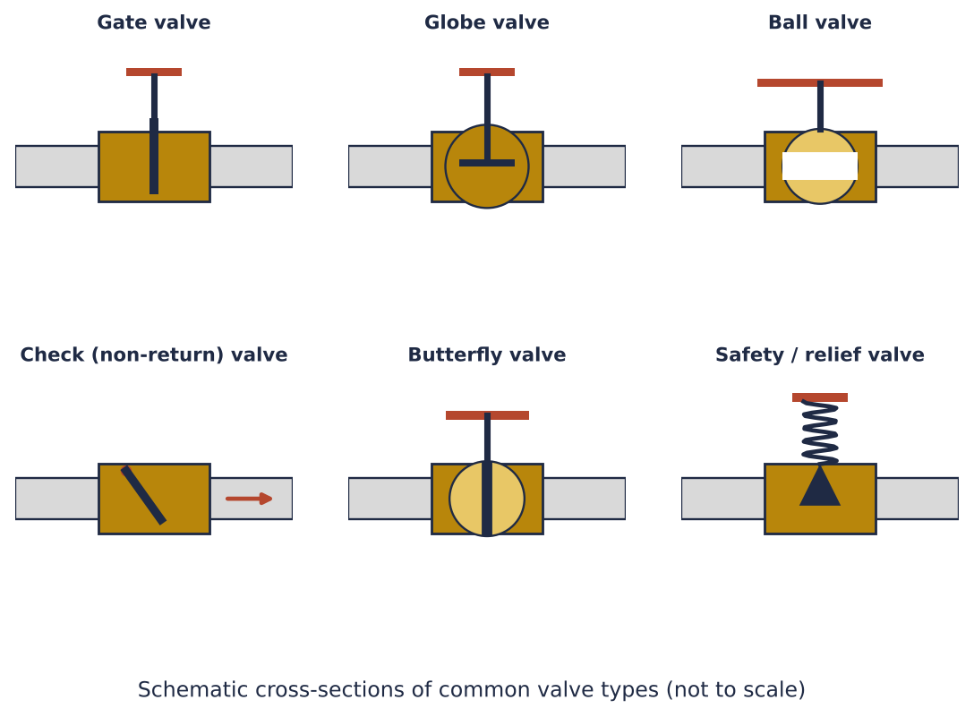
Figure 2: Cross-section schematics of six major valve types
Table 2: Comparison of common valve types
Valve type | Motion | Best use | Typical material | Size range
Gate valve | Linear (lift) | On/off isolation, low pressure drop | Brass, bronze, CI, steel | 15 mm to 600 mm+
Globe valve | Linear | Throttling and flow control | Brass, bronze, steel | 15 mm to 300 mm
Ball valve | Quarter-turn | Quick on/off, gas, water, LPG | Forged brass, SS, CS | 6 mm to 600 mm
Check valve | Self-acting | Prevents back-flow (pumps) | Brass, CI, SS | 15 mm to 600 mm
Butterfly valve | Quarter-turn | Large water lines, HVAC | CI, ductile iron, SS | 50 mm to 3000 mm
Plug / cock | Quarter-turn | Simple taps, gas cocks | Brass | 8 mm to 100 mm
Safety / relief valve | Self-acting (spring) | Over-pressure protection (boilers, compressors) | Bronze, steel | 15 mm to 300 mm
Solenoid valve | Electrical | Automation, appliances | Brass body + coil | 6 mm to 50 mm
Needle valve | Linear fine thread | Precise small-flow control, instrumentation | Brass, SS | 6 mm to 25 mm
Diaphragm valve | Linear | Pharma, food, corrosive media | SS, lined | 15 mm to 200 mm

By application
- Plumbing & sanitary: bib cocks, angle cocks, stop cocks, ball valves, float valves
- Agriculture & irrigation: foot valves, sluice valves, air valves, ball valves
- Industrial process: gate, globe, control and safety valves
- Fire-fighting: landing valves, hydrant valves, alarm check valves
- Gas & LPG: gas cocks, regulators, safety shut-off valves
- Automotive & appliances: solenoid valves, engine valves, water-heater valves

By material
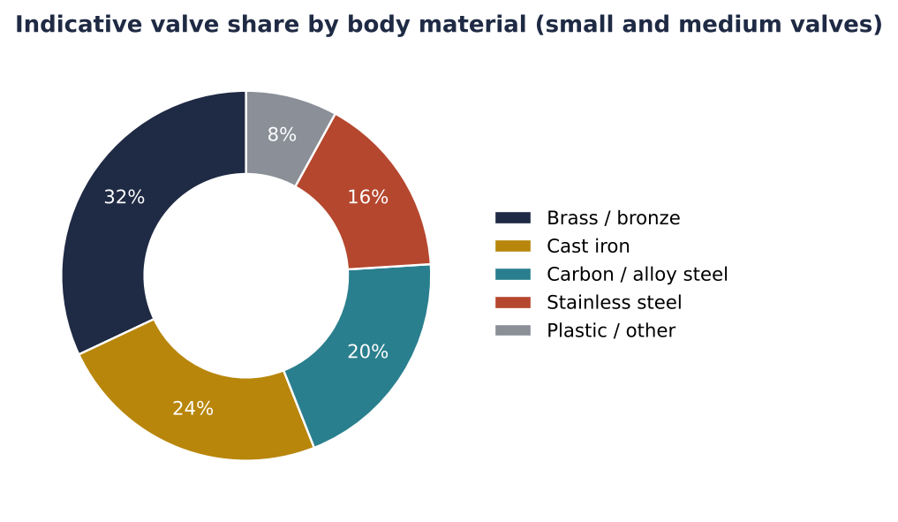
Figure 3: Indicative split of body materials (analyst estimate, intern compilation)

4. Alloys used in making valves
Valve alloys are chosen for the medium (water, steam, gas, oil, chemicals, sea water), pressure, temperature, process route (cast or forged), machinability and cost. Copper alloys dominate small and medium valves; iron, steel and stainless steel dominate large and high-pressure valves. Grades below are quoted by UNS/ASTM and EN number; the nearest IS grade should be confirmed against the Bureau of Indian Standards document before ordering or certifying. Compositions are nominal percentages.

4.1 Copper alloys for valve bodies, bonnets and trim
Table 3: Copper alloys used in valves (nominal values)
Alloy family | Grade (UNS / EN) | Nominal composition (%) | Process | Key properties | Typical valves / parts
Free-cutting brass | C36000 / CW614N | Cu 60, Zn 35, Pb 3 | Rod, machining | Best machinability; not for hot forging | Stems, cocks, nuts, fittings, small bodies
Forging brass | C37700 / CW617N | Cu 58, Zn 39, Pb 2 | Hot forging | Forges easily, good machinability | Ball valve bodies, angle valves, bib cocks
DZR brass | C35330 / CW602N | Cu 62, Zn 35, Pb 2, As 0.1 | Forging, casting | Resists dezincification in hot, aggressive water | Potable and hot-water valves, manifolds
Naval brass | C46400 | Cu 60, Zn 39, Sn 1 | Rod, forging | Corrosion resistance in sea water | Valve stems, marine parts
Leaded red brass | C83600 (85-5-5-5) | Cu 85, Sn 5, Pb 5, Zn 5 | Sand casting | Pressure-tight, easy casting and machining | Gate, globe, check valves for water, oil and steam (to about 200 C)
Tin bronze / admiralty gunmetal | C90500 | Cu 88, Sn 10, Zn 2 | Sand casting | Strong, wear and steam resistant | Steam valves, bodies, discs and seat rings
Yellow brass (casting) | C85800 | Cu 58, Zn 40, Sn 1, Pb 1 | Die casting | Economical, good finish | Plumbing taps and low-cost valves
Silicon bronze / lead-free | C87600 / C87500 | Cu 91 to 82, Zn 4 to 14, Si 3 to 5 | Casting | Lead-free, strong | Potable water valves meeting low-lead rules
Aluminium bronze | C95400 | Cu 85, Al 11, Fe 4 | Casting | High strength, wear and corrosion resistance | Heavy-duty valves, bushings, seats
Nickel aluminium bronze | C95800 | Cu 81, Al 9, Ni 5, Fe 4, Mn 1 | Casting | Excellent sea-water and cavitation resistance | Marine and desalination valves, pump valves
Cupronickel | C70600 (90/10) | Cu 88, Ni 10, Fe 1.5 | Casting, tube | Sea-water and biofouling resistance | Marine and offshore valves

4.2 Non-copper alloys used in valves (for comparison)
Table 4: Other alloys in valve construction
Material | Grade example | Where used | Why
Cast iron / ductile iron | IS 210 FG 260 / IS 1865 SG 500 | Large water, sewage and HVAC valves, butterfly and gate | Low cost, good for large sizes
Carbon steel | ASTM A216 WCB, A105 forged | Oil, gas, steam, power | High pressure and temperature
Stainless steel | CF8 (304), CF8M (316), 316 forged | Chemicals, food, pharma, sea water | Corrosion resistance, hygiene
Low-alloy / chrome-moly steel | WC6, WC9 | High-temperature steam and power | Creep strength
Duplex / super duplex | A890 4A / 5A | Offshore, sour service | Strength with corrosion resistance
Nickel alloys | Monel 400, Hastelloy, Inconel | Severe chemical and high-temperature duty | Resists acids, heat
Hard-facing alloys | Stellite 6, 21 | Seats and discs in severe service | Wear and galling resistance
Zinc / aluminium alloys | Zamak, LM6 | Handles, handwheels, light-duty bodies | Low cost, easy die casting

4.3 Alloy selection by valve type and part
Table 5: Alloy recommendations by valve
Valve / part | Preferred copper alloy | Alternative | Reason
Ball valve body (1/2 to 2 inch) | CW617N forged brass | DZR CW602N for drinking water | Forgeability, low porosity
Ball | C37700 or C36000, chrome plated | Stainless 304 | Hard, smooth finish for sealing
Gate valve body | C83600 leaded red brass | C90500, cast iron for large sizes | Pressure tightness
Globe valve body and disc | C83600; disc C90500 or stainless | Bronze C93200 disc | Wear resistance at throttle point
Check valve body and flap | C83600 body, brass or rubber-faced flap | SS flap | Cost and durability
Stem / spindle | C36000 or C46400 | SS 410/304, DZR rod | Strength; resistance to dezincification
Foot valve and strainer (agriculture) | C85800 or C83600 | Cast iron + brass seat | Cost and water resistance
Fire-fighting landing valve | C83600 / leaded gunmetal | Aluminium alloy (hydrants) | Strength, standards approval
Steam valve | C90500, C92200 (Navy M bronze) | WCB steel | Resists steam erosion up to 250 C
Marine and sea-water valve | C95800 NAB, C70600 | C90500, duplex SS | Sea-water corrosion resistance
Solenoid valve body | C37700 or C36000 | SS, plastic | Machinability, leak-free
Gas / LPG cock | CW617N forged brass | C36000 | Leak-tight, approved material

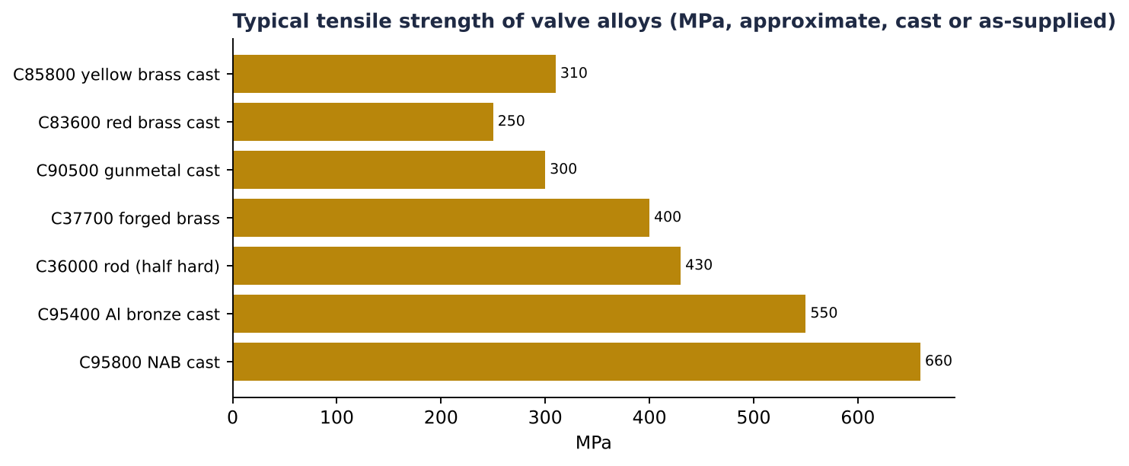
Figure 4: Typical tensile strength of selected valve alloys (approximate handbook values, verify with supplier data)
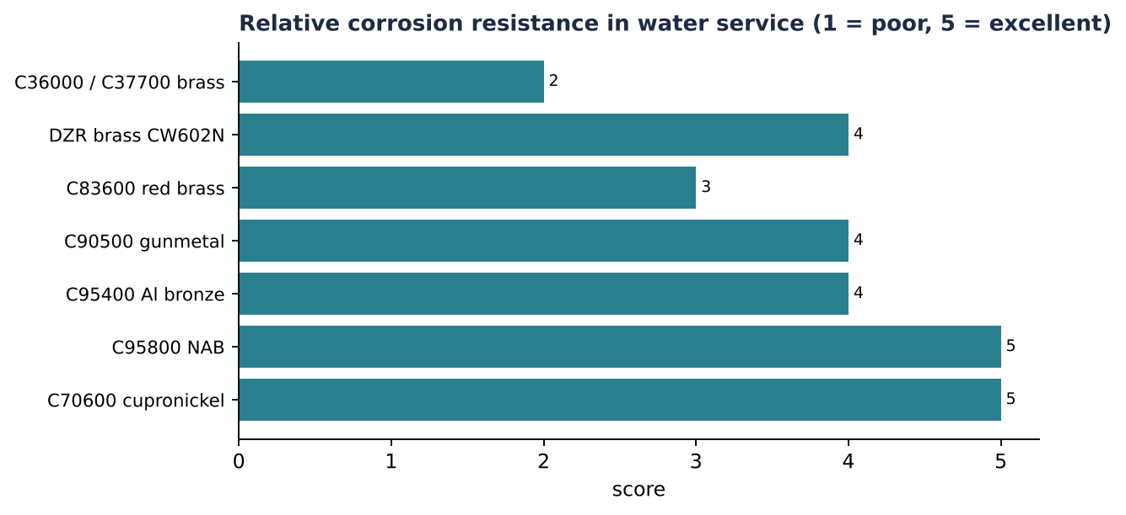
Figure 5: Qualitative corrosion ranking (intern judgement from standard references)

4.4 Key selection issues
- Dezincification: Ordinary brass with high zinc loses zinc in hot, soft or chlorinated water and turns porous. Use DZR brass or bronze for potable and hot water.
- Lead: Lead improves machining and casting but is restricted in drinking-water products in many markets. Lead-free silicon brass and bismuth brass are growing for exports.
- Pressure and temperature: Brass is generally limited to about 120 C and bronze to about 200 to 250 C; above that use steel.
- Sea water and cavitation: Aluminium bronze, NAB and cupronickel last longest.
- Cost: Copper price is the main cost driver; tin bronze costs more than brass because of tin.
- Scrap recycling: Brass and bronze scrap can be remelted if composition is controlled, which is the Bajaj Alloys advantage. Certified chemistry by spectrometer is essential.
Because brass is recycled readily, Bajaj Alloys' existing scrap procurement and melting set-up directly feeds ingots and rods for this product line.
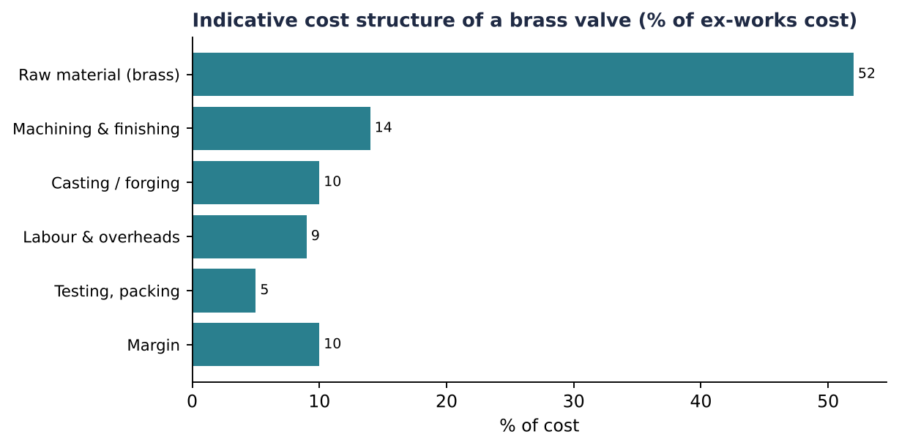
Figure 6: Indicative cost structure (illustrative, to be validated with plant data)

5. Manufacturing process
Brass valves are made either by sand/gravity die casting (gunmetal, gate and globe valves) or by hot forging (ball valve bodies, cocks).
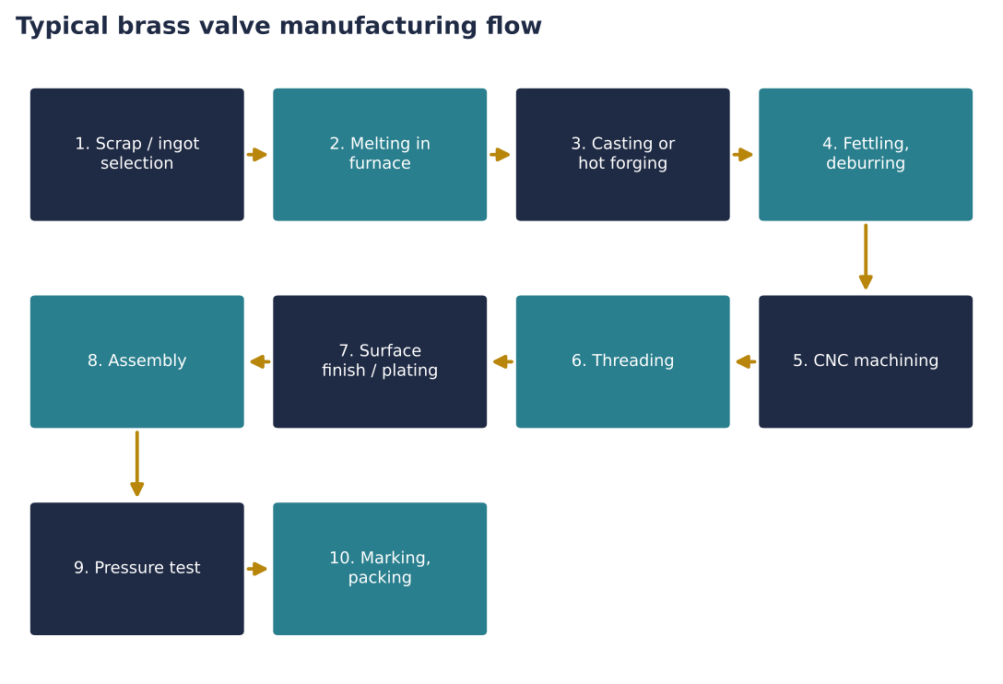
Figure 7: Process flow for a brass valve
- Step 1: Raw material and melting: Cu and Zn (or brass scrap) are charged in an induction or crucible furnace at 950 to 1050 degrees C. Composition is checked by spectrometer, then degassed and poured.
- Step 2: Casting or forging: Casting: molten metal into sand or permanent moulds, then cooled. Forging: brass billets are heated to about 750 degrees C and pressed in dies for denser, leak-free bodies.
- Step 3: Fettling and heat treatment: Runners/risers are cut, flash is removed by shot blasting; stress-relief annealing for forged parts.
- Step 4: Machining: CNC/VMC and transfer machines bore the body, cut threads (BSP/NPT), face seats and turn stems and balls.
- Step 5: Surface treatment: Pickling, polishing, nickel/chrome plating or lacquer.
- Step 6: Assembly: Seat, ball/disc, stem, O-rings, gland nut and handle are fitted on assembly lines.
- Step 7: Testing: 100% hydrostatic shell and seat test, and air-under-water test for leak-tightness.
- Step 8: Marking, packing and dispatch: Size, pressure rating (PN), brand and batch marking, then boxing.
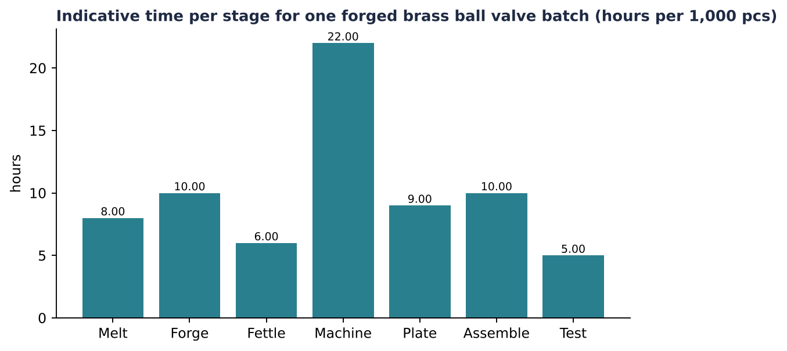
Figure 8: Indicative production time per 1,000 pieces (illustrative)

6. Quality testing and standards
Table 6: Standards relevant to brass valves
Standard / test | Scope
IS 778 | Copper alloy gate, globe and check valves for water works
IS 1703 | Copper alloy float valves
IS 319 | Free-cutting brass bars and sections
IS 318 | Leaded tin bronze ingots and castings
BIS (ISI) mark | Mandatory certification for many plumbing valves
API 598 / EN 12266 | Valve pressure testing
ISO 9001 | Quality management system
Lead-free / DZR requirement | Needed for potable water exports (EU, US)

Typical in-house tests: spectro chemical analysis, hardness, dezincification test, hydrostatic test, torque test, salt-spray for plating, and dimensional check.

7. Market size and growth

7.1 India
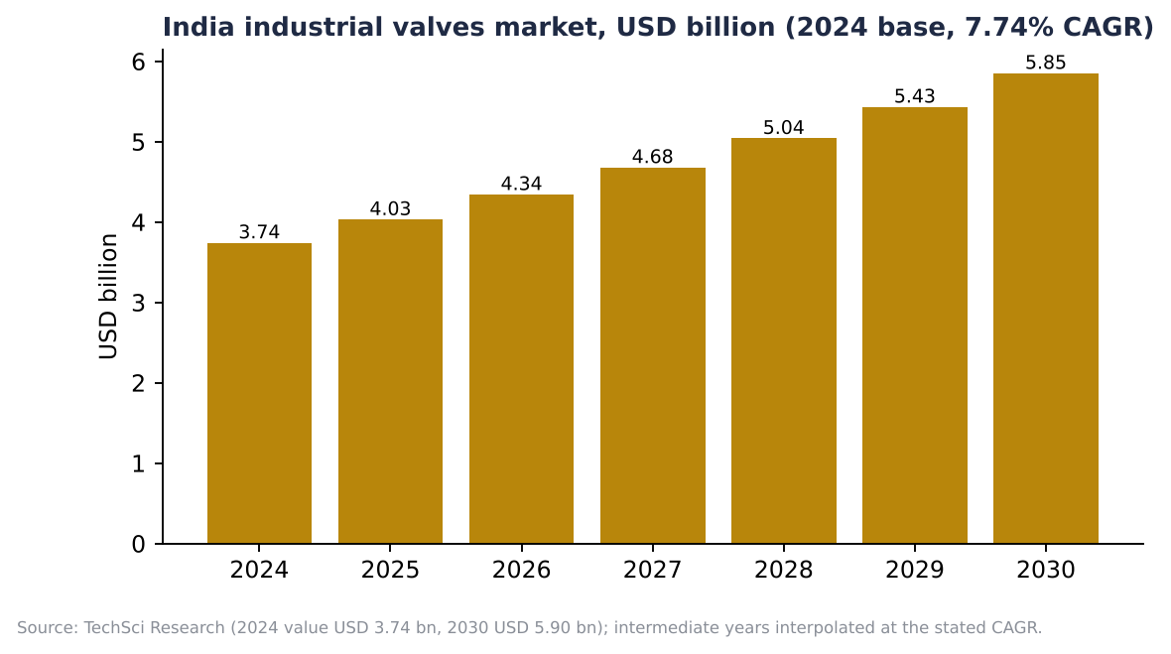
Figure 9: India industrial valves market forecast
Table 7: Published estimates differ because of scope
Publisher | Base year value | CAGR / forecast | Scope note
TechSci Research | USD 3.74 bn (2024) | 7.74% to USD 5.90 bn (2030) | Industrial valves
Verified Market Research | USD 3.74 bn (2024) | USD 6.1 bn by 2032 | Industrial valves
Data Bridge | USD 5.84 bn (2024) | About 8.96% to USD 9.97 bn (2032) | Industrial valves, wider scope
IMARC (industrial) | USD 3.4 bn (2025) | 6.64% (2026 to 2034) | Industrial valves
IMARC (valves) | USD 2.0 bn (2024) | 3.5% (2025 to 2033) | Valves, narrower definition
Mordor Intelligence | USD 1.56 bn (2025) | 6.96% (2026 to 2031) | Narrower segments

Take-away: all publishers agree on steady mid-to-high single-digit growth. A planning range of USD 3 to 4 billion today and 6 to 7% growth is reasonable.

7.2 Demand drivers
- Government water programmes (Jal Jeevan Mission, AMRUT) need millions of taps, valves and meters.
- Housing, real estate and Smart-City construction.
- Oil & gas, city-gas distribution and power capacity addition.
- Irrigation and agri-pumping.
- Chemicals, pharma and food capacity expansion; PLI schemes and 'Make in India'.
- Replacement demand from ageing plants.

7.3 Segmentation (indicative)
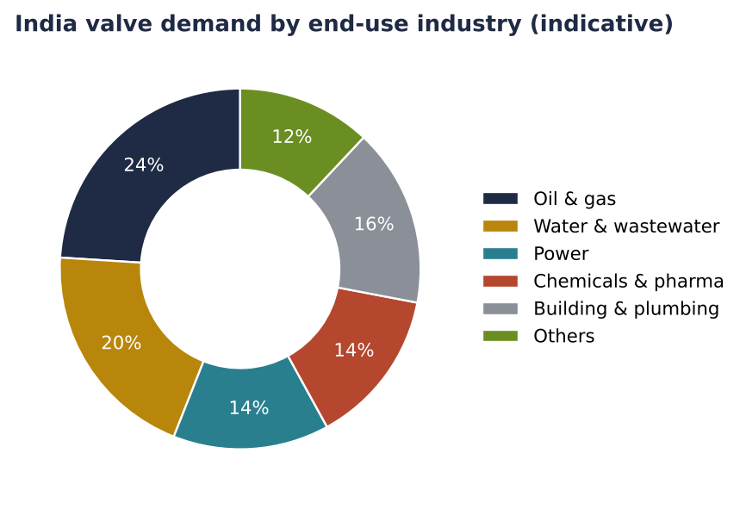
Figure 10: Indicative end-use split (analyst-style estimate; to be validated)
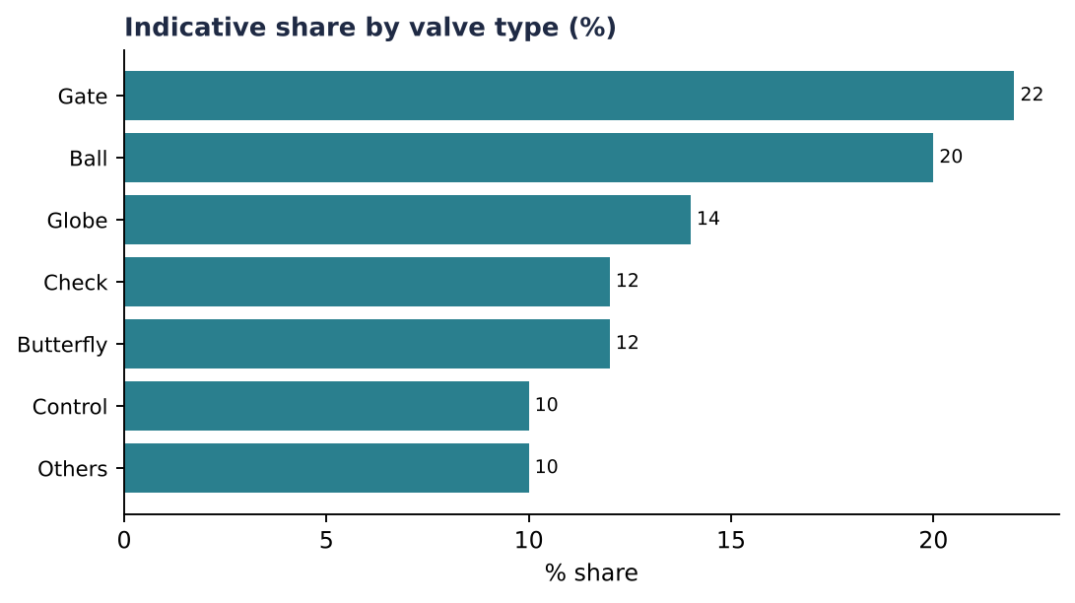
Figure 11: Indicative share by valve type

7.4 Regional clusters in India
- Jamnagar (Gujarat): brass parts and forgings hub
- Coimbatore (Tamil Nadu): pumps and industrial valves
- Pune and Mumbai: process valves, OEM
- Jagadhri (Haryana): brass and utensil / valve cluster near Bhiwani
- Delhi NCR, Faridabad, Bhiwani: brass casting, scrap recycling, fittings

7.5 Global picture
The global valve market is large (published figures are in the tens of billions of USD, roughly USD 80 to 100 billion depending on publisher and scope) and grows at about 4 to 6% a year. Asia-Pacific is the biggest and fastest growing region. India is a rising source for brass valves, forged parts and castings for Europe and the USA. These global numbers were not verified in this research round and should be confirmed before use.

8. B2B and B2C market

8.1 Definitions
- B2B (business to business): Valves sold to OEMs, EPC contractors, industries, government departments and distributors/wholesalers.
- B2C (business to consumer): Valves sold to households and small plumbers through hardware and sanitary shops, e-commerce and brand showrooms.
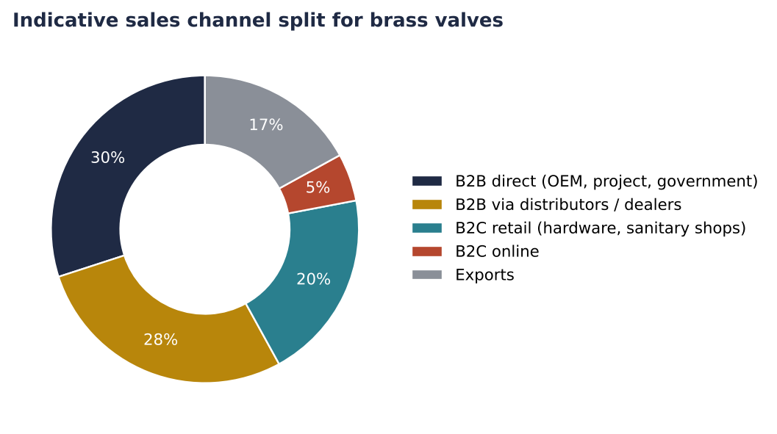
Figure 12: Indicative channel mix for a brass valve maker (illustrative)
Table 8: B2B vs B2C comparison for valves
Factor | B2B | B2C
Buyers | OEMs, contractors, industry, PSUs, distributors | Households, plumbers, small shops
Order size | Large, repeat, tender-based | Single pieces, small lots
Price sensitivity | High, tender L1 rates | Medium; brand and look matter
Quality need | Standards, test certificates, BIS/API | Finish, brand, warranty
Payment | Credit 30 to 90 days, LC | Cash/UPI quickly via retailer
Margin | Lower (8 to 15%) | Higher (20 to 35% brand margin)
Marketing | Key-account sales, tender, samples | Dealer network, mechanic schemes, digital marketing
Examples | L&T, Kirloskar, Larsen, BHEL supply chains; state water boards | Hardware shops, Amazon, IndiaMART retail

8.2 Digital B2B platforms
IndiaMART, TradeIndia, Alibaba and Udaan are active lead-generation channels for brass valves from Jamnagar and Haryana manufacturers.
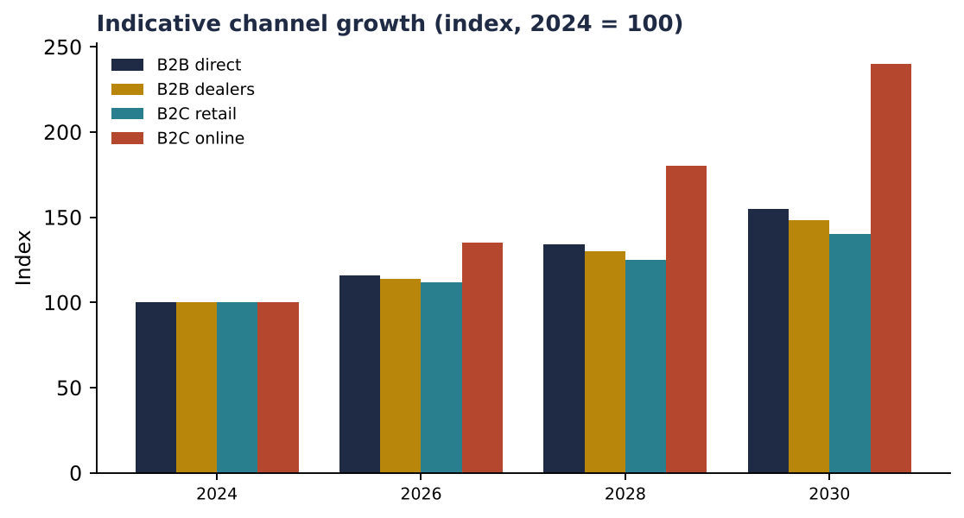
Figure 13: Illustrative growth: online grows fastest from a small base

9. Competition
Table 9: Competitive landscape (names for orientation only)
Segment | Players (examples)
Organised industrial valves | L&T Valves, Kirloskar Brothers, Audco (L&T), BEL Valves, Advance Valves, Fouress, Leader Valves
Brass / plumbing valves | Zoloto, Leader, Sant, Kitz-type imports, Jamnagar and Jagadhri small units
Global | Emerson, Flowserve, Crane, KITZ, Cameron/SLB, Spirax-Sarco

The brass valve segment is fragmented: hundreds of small units. Competition is on price, but certified quality and consistent supply are rare, which is the gap for a quality-focused foundry.

10. Opportunity and recommendations for Bajaj Alloys
- Phase 1: forged brass ball valves and cocks 1/2 to 2 inch. Use own brass rods and billets, forge, CNC machine and pressure test.
- Phase 2: gunmetal gate/globe valves and foot valves for irrigation and water boards (IS 778).
- Phase 3: DZR, lead-free grades for export and potable water; fire and gas valves with certification.
- Sell to distributors first (B2B2C), build a brand in Haryana/Rajasthan/Punjab, add IndiaMART and Amazon Business.
- Get BIS, ISO 9001 and a hydraulic test bench before approaching tenders.
- Risks: copper/zinc price swings, imports from China, working-capital in credit sales, lead regulations.
Table 10: Indicative roadmap
Item | Action | Timeline
Product range finalisation | Choose 5 SKUs, costing | Month 1
Tooling and dies | Forging dies, jigs | Months 2 to 4
Certification | BIS, ISO | Months 3 to 8
Pilot batch and test | Customer trials | Month 5
Dealer network | 20 distributors | Months 6 to 12

11. Data notes and sources
Market-size values for India come from published research summaries (TechSci Research, Verified Market Research, Data Bridge Market Research, IMARC Group, Mordor Intelligence). Figures differ because of scope; intermediate yearly values in charts are interpolated at the stated CAGR. Charts labelled 'indicative' (material share, end-use, valve type, channel mix, cost structure, production time) are intern estimates built from typical industry structure; they are NOT audited statistics and must be validated with plant and customer data before management decisions. Diagrams are schematic drawings made for this report, not photographs; replace them with company photographs where needed.
- TechSci Research: India Industrial Valves Market
- IMARC Group: India Valves Market, India Industrial Valves Market
- Data Bridge Market Research: India Industrial Valves Market to 2032
- Verified Market Research: India Industrial Valve Market
- Mordor Intelligence: India valves market
- Bureau of Indian Standards: IS 778, IS 318, IS 319

